**GIT**

Git is software for tracking changes (chronological) in any set of files, usually used for coordinating work among programmers collaboratively developing source code during software development.

**Making Local Git Repository**



**Git Add and Git Commit**

1. “Staging” is the process of keeping your code changes up-to-date locally.
2. The git add command adds a change in the working directory to the temporary staging area. It tells Git that you want to include updates to a particular file in the next commit. However, git add doesn't really affect the repository in any significant way—changes are not actually recorded until you run [git commit](https://www.atlassian.com/git/tutorials/saving-changes/git-commit).
3. The git commit command record the changes saved in the temporary staging area as a snapshot, and save it in the project’s history

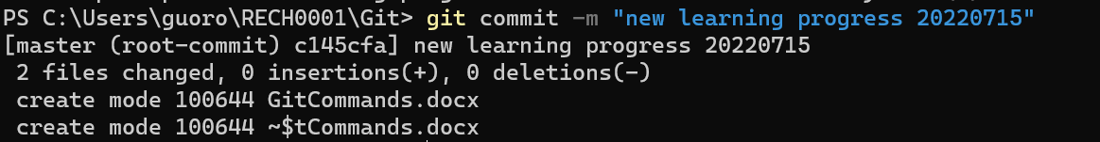

**GIT Push, Git Pull, and Online Collaboration**

1. What is a URL (Uniform Resource Locators)? A URL is nothing more than the address of a given unique resource on the Web.
2. The git push command is used to upload local repository content to a remote repository.

**GIT Branches**

Branches are essentially pointers to a snapshot of your changes. The main (master) branch is the major development branch. It is everybody’s duty to make main branch clear of questionable code. Different branch represents a different version of the code.

“Say you came up with a genius idea and you want to run an experiment on that idea. However, you are not sure if the code you’re about to write is going to corrupt the main code. In those situations, it is wise to create a separate ‘experimentation’ branch to testify your ideas.”

