**HashMap Complexities**

* HashMaps generally have O(1) time complexity to ADD;
* HashMaps generally have O(1) time complexity to GET;

**Saving Time Complexity**

* For searching-related questions, try creating extra memory on things you’ve already know (sacrifice space complexity) for better time performance

**Branch on Failure**

A popular approach for designing your for and while loops.

**Reversing a Linked List**

**Java Basics**

Character in java is type “char”;

Short-circuiting in logical expressions:

* B || timeConsumingCall() will NOT evaluate the right half if the first one already tells you the answer
* B | timeConsumingCall() will still evaluate the right half

Convert character to String in java:



Java substring method



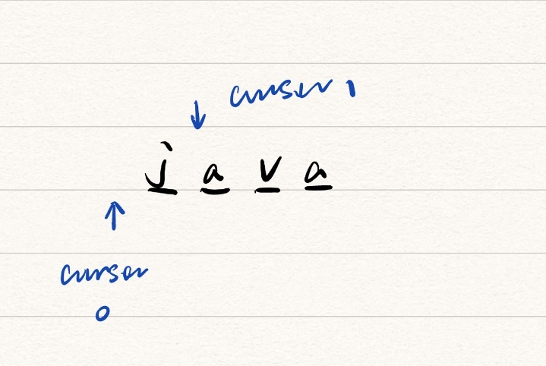

Begin indices and end indices are cursor indices.

The substring enclosed by two cursors indicated by the cursor indices.