**The analysis of the effect of compound exercise fitness on blood lipids of individuals in plateau**

**Abstract**

Our research objectives were to determine how compound exercise fitness affects blood lipid profiles of various age groups of males and females in plateau. Electronic database searches, cross-referencing, and expert assessment were used to find studies. We chose several studies based on the following criteria: (1) randomized controlled trials, (2) compound exercise fitness, (3) intervention ≥ 8 – 24 weeks, (4) different age groups of men and women, (5) studies published in English/any language, (6) studies published between 2006 and 2022, (7) evaluation of at least one or more of the following lipid and lipoprotein levels listed: total cholesterol (TC), high-density lipoprotein cholesterol (HDL-C), low-density lipoprotein cholesterol (LDL-C), and triglycerides (TG). The degree of the impact that exercise has on the different lipids was evaluated with the help of the effect size assessment known as Cohen's d. For TC, less than 50% of the studies indicated a positive impact, and more than 80% of the studies reported a positive impact for HDL-C, furthermore, 50% was observed for LDL-C and finally 54% for TG. We conclude that though most of the selected studies reported a beneficial effect of exercises on lipids levels, our study observed more negative effect sizes compared to positive effect sizes which might have affected the outcome of various lipids concentrations.

**Keywords:** Blood lipids, compound exercise, meta-analysis

**Section 1: Introduction**

Exercise alters how the body processes all macronutrients, including lipids, by causing a number of cellular and organismal changes. For years, exercise fitness has been utilized for various health reasons and as a replacement or a contributing factor to drug effectiveness. The type of compound exercises used in previous studies varies according to the use of multiple muscles, different levels of compatibility, and different genders, for example, compound exercises such as squats and deadlift (1). Although chronic adaptation may develop over time, once an individual has reached a plateau in their training, additional heavy training will not improve their performance any further because these individuals have typically trained for a number of years (2).

Even though the influence of exercise on blood lipids has been studied widely, relatively there is not much known about the impact that compound exercise fitness has on blood lipids in individuals who have reached a plateau in their fitness. In light of this, the objective of this study was to conduct a literature review on the effect of compound exercise in order to gain a better understanding of the processes by which this type of exercise contributes to changes in the levels of blood lipids and lipoproteins. Published data on the relationship between compound exercise and lipid and lipoprotein levels have reported favorable and unfavorable effects (3). Previous studies on the impact of aerobic exercise on lipid levels have found that prolonged intervention and session duration has resulted in more significant effects (4,5). A meta-analysis study has observed a linear association between total cholesterol (TC), high-density lipoprotein cholesterol (HDL-C) levels, and cardiovascular disease (CVD) mortality. According to the findings of this study, a high TC and LDL-C level in the serum are both associated with an increased risk of CVD mortality, but a high serum level of HDL-C has an inverse association with cardiovascular disease mortality (6). Thus, the appropriate management of abnormal blood lipids and lipoproteins is essential in the treatment of individuals who have cardiovascular disease, stroke, and other forms of atherosclerotic vascular disease (or who are at risk for these conditions). These abnormal blood lipids and lipoproteins can then be controlled by exercises. There is evidence to suggest that engaging in regular physical activity has a beneficial effect on the blood levels of triglycerides (TG). Aerobic exercise effectively decreased TG profile by targeting apoC3 levels in patients with coronary heart disease after 8 weeks of exercise (7). Therefore, the influence of exercise on TC, LDL-C, HDL-C, and the effects of intensity and amount of exercise on TG are well researched.

Although it makes sense to include exercise as a crucial part of maintaining a healthy lifestyle and managing lipid profiles, other factors, such as changes in the subjects' body weight during exercise training, smoking, etc. appear to have an impact on lipid profile changes (8,9). These can be of tremendous importance when it comes to the management of abnormal blood lipids and lipoproteins. However, in the present study, meta-analysis techniques were used to analyze existing research findings on the relationship between compound exercise and changes in lipid and lipoprotein levels. The paper consists of 4 sections, including the introduction. Section 1 constitutes the introduction, discussing the association between exercise and blood lipid levels. Section 2 briefly discusses the method of meta-analysis used; it provides information on meta-analytic techniques applied in this paper. Section 3 presents the results followed by a discussion of the findings in Section 4.

**Section 2: Methods**

There are three steps involved in applying meta-analysis to a corpus of research. Firstly, a thorough literature review. Second, the significant traits and conclusions of relevant studies are categorized and coded. Third, statistical methods are used to analyze the collected data. Descriptive, correlational, and inferential statistical analysis may also be used in this final step.

**2.1 Literature search**

A comprehensive search of the research literature was carried out for the purpose of this study in order to locate any RCTs (randomized controlled trials) that investigated the effects of compound exercises on the levels of blood lipids and lipoproteins. Studies were retrieved through computerized literature searches from the following databases (MEDLINE, PubMed, ResearchGate, BMJ) and cross-referencing from retrieved articles. Search terms used; blood lipids, resistance training/exercises, different age groups of men and women, and meta-analysis. The 12 studies included in this meta-analysis published between 2006 and 2022 were located by computer searches. PRISMA (Preferred Reporting Items for Systematic Reviews and Meta-Analyses) statement standards were followed in this review and analysis (10).

**2.2 Inclusion and Exclusion Criteria**

In this study, the criteria for inclusion were compound exercise training of individuals in plateau and measuring changes in blood lipid levels. The following constitutes the conditions for participation in this study: 1) compound exercise training of individuals in plateau, 2) nonexercised group, 3) randomized controlled trials, 4) different age groups of men and women, 5) studies published in the English/any other language, 6) studies published between 2006 and 2022, 7) lipid variables: total cholesterol (TC), low-density lipoprotein cholesterol (LDL-C), high-density lipoprotein cholesterol (HDL-C), triglyceride (TG). These are the factors that are often evaluated in clinical trials, therefore, we included these in our primary outcomes. The following criteria were used to exclude studies: (1) the evaluation consisted exclusively of an endurance performance measure; (2) animal subjects; or (3) the intensity of the training did not satisfy either the "supramaximal" or "maximal" criterion.

**2.3 Study Selection**

Following a search of internet-based databases and an evaluation of article reference lists, 1300 studies that were relevant to the topic were discovered (Figure 1). An evaluation of the research's title or abstract, in addition to the lack of a comparison group in the experimental design, led to the removal of 107 separate pieces of research papers. 11 of the 28 full-text publications that were reviewed were used in the meta-analysis.

**2.4 Variables coded**

Specific characteristics from multiple studies were recorded. The following are some of the most important categories of variables that were coded: 1) study characteristics, 2) subject characteristics, 3) features of lipid assessments, including early, intermediate, and final values of lipids and lipoproteins, 4) components of the training program, including the length of the workouts, 5) primary and secondary outcomes. This enables the statistical description of potential interactions between study parameters and distinct findings.

**2.5 Data Collection**

During a period of time ranging from 6 – 9 months, data were collected in the form of pre- and post-training intervention means, standard deviations (SDs), and sample sizes for a variety of compound exercises and control conditions. Analyzed variables or outcomes included TC, HDL-C, LDL-C, and TG reported in mg/dL. Only the final values for compound workouts were compared to the baseline in trials that reported intermediate and post-intervention values.

**2.6 Quality Assessment and Publication Bias**

Cochrane risk of bias tool (RoB2 assessment for individual randomized controlled trials) was used to assess the risk of bias and quality of each selected research. The domains used in the present study belong to random sequencing (selection bias), blinding to group assignment, identification of data that is absent from the results, selective outcome reporting, complete and incomplete outcome data, loss to follow-up, and other potential causes of bias. The Cochrane guideline manual states that the ratings of "yes," "no," and "unclear" correspond, respectively, to the low, high, and unknown risk of bias. "Yes" scores indicate a low risk of bias, whereas "no" values indicate a high risk of bias (11). As a result, each domain is ranked according to whether or not it poses a high, low, or uncertain risk of bias. For this study, the risk of bias was limited to the primary outcomes (TC, HDL-C, LDL-C, and TG). The extent to which individuals had already pre-enrolled in physical activity was also analyzed to determine the potential risk for bias.

**2.7 Subgroup analysis**

Considering that not all of these studies appeared to include people who smoked cigarettes, drank alcohol, or took medication that might influence lipid and/or lipoprotein metabolism, we did not perform any type of subgroup assessment for these factors. Additionally, we didn't carry out any diet subgroup comparisons, because in most studies subjects were instructed not to change their diets during the experiment, or strictly followed a dietary plan instructed by a registered dietician (12,13). In addition, we did not perform a subgroup analysis based on whether or not the participants were physically active prior to participating in the research because only one study indicated that some, but not all, of the individuals were physically active prior to participating in the study (14).

**2.8 Meta-Analysis**

In this research, all analyses were conducted using Graphad prism and SPSS for meta-analysis. All blood lipid indicators determined as HDL-C (mg/dL), LDL-C (mg/dL), TC (mg/dL), and TG (mg/dL), were considered continuous variables. Effect sizes (ES) were estimated using Cohen's d by subtracting the mean change in the control group from the mean change in the study group and dividing the result by the pooled standard deviation (SD) of baseline data to assess the magnitude of the effects of different compound exercises on blood lipid profiles. Random effects model was used because the different experimental parameters included in this study (such as the length of the intervention, the type of training, data collection methods, and participant characteristics) varied among investigations. It was determined whether the aggregated mean ES was small (0.2), medium (0.5), or large (0.8).

**Section 3: Results**

The findings of the meta-analysis that was conducted for this study are presented in the following section.

**3.1 Study characteristics**

Creating one's own meta-data is a crucial first step in the process of performing a meta-analysis. Given the large volume of research in exercises that is currently available, 1300 citations were reviewed and 11 studies were included in the present article, these studies representing 28252 subjects (1672 men, 1684 women, and randomly placed 24896 men and women). Unfortunately, due to an inadequate number of available studies conducted on the influence of compound exercise fitness on blood lipids profiles, we decided to concentrate only on the following: prolonged aerobic exercise, and different types of resistance training (endurance exercise, acute exercise, and strength training). Table 1 below presents an overall description of the characteristics of studies selected for our analysis. Further description of this process, including reasons for the inclusion and exclusion of studies, is shown in Figure 1 following the PRISMA flow diagram from (10).

**Table 1:** General characteristics of included studies

|  |  |  |  |  |  |  |  |
| --- | --- | --- | --- | --- | --- | --- | --- |
| Study and year | Country | Participants | Age (yrs.) | Exercise intervention | Duration | Lipids Assessed | Intervention Effect Size on Lipids |
| (15) | Greece | Healthy 1514 M & 1528 F | (M) 20 - 87  (F) 20 - 89 | Resistance exercise | NR | HDL-C, LDL-C, TG | HDL-C **-0.75,**  LDL-C **0.09**,  TG **-0.43** |
| (16) | NR | 36 Untrained M | Mean age of 31 (range 20 – 43) | Aerobic exercise & strength training | 12 weeks | TC, LDL-C, HDL-C | TC **-0.8**,  HDL-C **2**,  LDL-C **1.2** |
| (13) | NR | 50 F (overweight/obese) | 28 – 46 | Resistance and aerobic exercise | 8 weeks | TC, LDL-C, HDL-C and TG | TC **0.17**,  HDL-C **0.29,**  LDL-C **0.47**,  TG **0.32** |
| (17) | Isfahan | 40 randomly placed M & F  Control (20)  Study (20) | NR | Resistance exercise | 8 weeks | Cholesterol, LDL-C, HDL-C, TG | TC **-0.54,**  HDL-C **0.74**,  LDL-C **-0.19**,  TG-**0.32** |
| (12) | NR | 42 M & 58 F (healthy sedentary) | 50 – 75 | Endurance exercise | 24 weeks | HDL-C, LDL-C, TC, TG | TC **-1.17**,  HDL-C **4**,  LDL-C-**0.41**,  TG **-4.86** |
| (14) | NR | 30 M (healthy) | 35 – 40 | Strength and Endurance exercise | 8 weeks | TC, HDL, LDL, TG, non-HDL | TC **1.47**,  HDL-C **0.253**,  LDL-C **1.18,**  TG **0.788** |
| (18) | Iran | 40 F (obese pre-menopausal) | 38 – 52 | Resistance exercise | 10 weeks | TG, TC, HDL-C, LDL-C | TC **0.2**,  HDL-C **0.1**,  LDL-C **-0.1**,  TG **0.2** |
| (19) | Taiwan | 24856 M & F (randomized) | 30 – 70 | Aerobic and resistance exercise | NR | HDL-C | TC **0**,  HDL-C **0.235**,  LDL-C **0.168,**  TG **0.176** |
| (20) | NR | 10 M (healthy students) | 20 – 25 | Strength training | 8 weeks | TC, HDL-C, LDL-C, TG | HDL-C **0.85**,  LDL-C **0.72**,  TG **0.67** |
| (21) | USA | 10 M & 8 F (overweight/obese) | 39 – 54 | Acute (aerobic) exercise | 12 weeks | TC, HDL-C, LDL-C, TG | TC**-0.41**,  HDL-C **0,**  LDL-C **0.62**,  TG **0.32** |
| (22) | Brazil | 30 M (healthy untrained) | NR | Resistance exercise | Acute | TG, HDL-C, LDL-C, TC | TC **-0.13,**  HDL-C **1.1,**  LDL-C **-1.24,**  TG **-0.88** |

Female (F); Men (M); Not reported (NR); Total cholesterol (TC); High-density lipoprotein cholesterol (HDL-C); Low-density lipoprotein cholesterol (LDL-C); Triglycerides (TG)

Articles identified through PubMed, ResearchGate, BMJ searching

(n= 1300)

Identification

No. of articles screened

(n= 135)

Screening

No. of records excluded

(n=107)

No. of full-text articles assessed for eligibility

(n=28)

Eligibility

No. of full-text articles excluded, with reasons

(n=15)

No. of studies included in quantitative synthesis (meta-analysis)

(n=12)

Included

**Figure 1:** Preferred Reporting Items for Systematic Reviews and Meta-Analyses (PRISMA) flow diagram adapted from (10).

**3.2 Quality Assessment**

According to the Cochrane assessment tool, we evaluated the quality of the included articles. The overall bias score of the included literature is as follows: low risk (63.2%), some concerns (18.2%), and finally high risk (18.2%). Figure 2 displays the findings of the analysis of potential bias. All of the studies were considered to be at low risk of bias with respect to missing outcome data.

**Figure 2**: Cochrane Collaboration’s tool for assessing the risk of bias

**3.3 Subject, Training Program Characteristics, and Lipid Assessment**

**3.3.1 Subject Characteristics**

***Gender***

Three studies included only females (13,18,23), four included only males (14,16,20,22) while the remaining five involved both males and females (12,15,17,19,24). Four studies reported healthy subjects, two reported untrained subjects, two reported overweight/obese subjects, one study reported coronary artery disease patients and another one reported menopausal women, lastly, two studies reported that their subjects were randomized.

***Country of Origin and Race***

Not all studies specifically included the country of origin or race, however, we have included studies conducted in Brazil (22,23), Taiwan (19,24), Iran (18), Isfahan (17), and Greece (15). One study included 75 Caucasians, 19 African Americans, and 6 other races (12).

***Medication***

In five studies, participants described not using any drugs or medication known to alter lipid or lipoprotein profiles (13–16,18) while one study recorded data regarding consumed medications (17) and another with medications not affecting plasma protein (12). The rest of the studies did not specify whether a medication that might affect lipids and lipoproteins was taken by the subjects or not.

***Smoking/Alcohol***

None of the participants in five different investigations were smokers, according to the reports (12–14,16,17) while an additional three described that some of the subjects smoked cigarettes (15,19,24). Two studies reported that some of the subjects were consumers of alcohol (19,24).

***Comorbidities***

One study reported that subjects were diabetic (15) while another reported diabetes, hypertension, hyperlipidemia, and stroke (24). Other studies reported that the participants had no history of chronic metabolic diseases or cardiovascular disease (CVD) in these studies, endocrine and circulatory abnormalities were used as an exclusion criterion (12–14,16,18).

***Diet/Physical activity/Supplementation***

None of the studies reported changes in diet, however, participants were ordered to continue their accustomed dietary routines throughout the study or followed a standardized diet. In addition, one research stated that participants needed to have been engaged in coach-supervised recreational exercise for at least 2 years prior to the study's admission (14).

**3.3.2 Training Program Characteristics**

4 studies represent resistance (15,17,18,22), 1 aerobic (21), 1 endurance exercise (12), and 1 strength training (20). Furthermore, 2 studies represent a combination of resistance and aerobic exercises ((13,19); 1 report with both strength training and aerobic exercises combined (16) and lastly 1 study with a combination of strength training and endurance exercise (14).

**3.3.3 Primary Outcomes: Lipid Assessment Characteristics**

For this study, we used Cohen's d which categorized the effect size as follows: small effect (0.2), medium effect (0.5), and large effect (0.8). The overall results for lipids and lipoproteins from each study are shown in Figure 3 - 6.

***Impact of different compound exercises on TC***

Figure 3 depicts the TC outcome and provides a summary of the findings. The below figure showed Cohen’s d effect measurement on TC with most of the studies indicating a negative effect (-0.54, -0.8, -0.41, -0.13, -1.17) which means the intervention had a negative impact or made the outcome worse. On the other hand, the following positive effect (0.17, 0.2, 0.0, and 0.12) Ambroży *et al.*, 2022 indicates that the intervention had a positive impact or made the outcome better. Also, 1.47 indicates the intervention had a positive impact and therefore, made the outcome better.

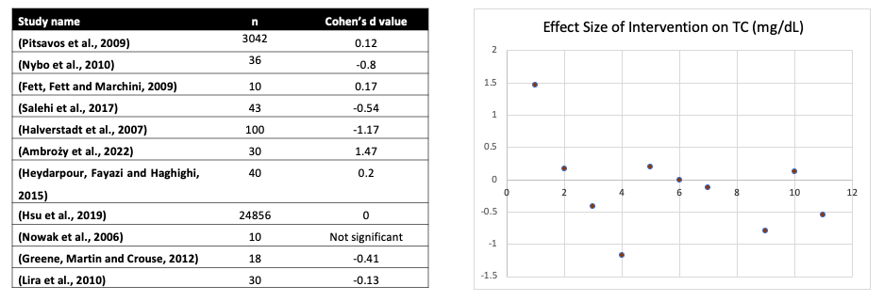

**Figure 3**: Cohen’s d effect measurement on total cholesterol.

***Impact of different compound exercises on HDL-c***

Figure 4 of Cohen’s d measurement of effect size indicated a negative effect (-0.74, -0.75) which means the intervention had a negative impact or made the outcome worse. On the other hand, the following positive effect (0.17, 0.2, 0.0, and 0.12, 1.1, 2.0, and 4.0) indicates that the intervention had a positive impact or made the outcome better on HDL-c (Lira *et al.*, (2010); (16) and (Halverstadt *et al.*, (2007) respectively. The total HDL-c ratio correlated strongly with time, the greater the time spent exercising.

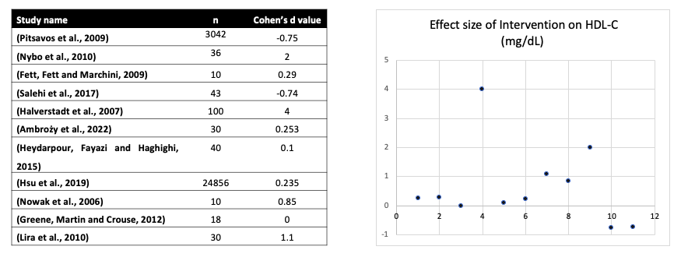

**Figure 4:** Cohen’s d effect measurement on HDL-C.

***Impact of different compound exercises on LDL-C***

The figure below of Cohen’s d measurement of effect sizes indicated a negative effect (-0.62, -0.41, -0.1, -1.24) the negative effect means the intervention had a negative impact or made the outcome worse. On the other hand, the following positive effect (0.10, 0.47, 0.168, 0.72, and 0.09) indicates that the intervention had a positive impact or made the outcome better.

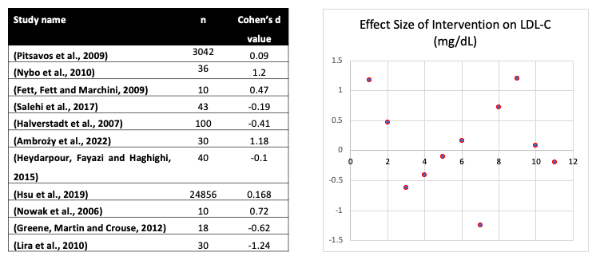

**Figure 5:** Cohen’s d effect measurement on LDL-C.

***Effect of different compound exercises on TG***

Figure 4 of Cohen’s d measurement of effect (-4.86, -0.32, -0.88, -0.43) indicated a negative effect which means the intervention had a negative impact or made the outcome worse. On the other hand, the following positive effect (0.32, 0.32, 0.2, 0.176, 0.788, and 0.67) indicates that the intervention had a positive impact or made the outcome better.

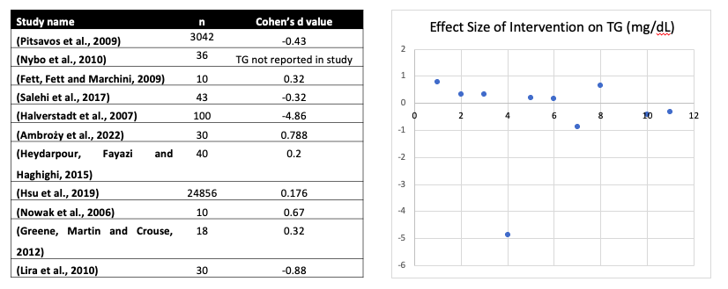**Figure 6:** Cohen’s d effect measurement on TG.

**Discussion**

This study reviewed 11 relevant research articles and measured the effect of exercise on TC, HDL-C, LDL-C, and TG to determine their ES using Cohen's d. Each lipid (TC, HDL-C, LDL-C, and TG) was computed based on their calculated effect sizes and was determined whether the aggregated mean effect size (ES) was small (0.2), medium (0.5), or large (0.8) (Figure 3 – 6). This study described the results for TC of all studies using the Cohen’s d effect size measurement and found most of the studies indicated a negative effect size with Salehi *et al.*, 2017 (-0.54), Nybo *et al.*, 2010 (-0.8), Greene, Martin and Crouse, 2012 (-0.41), Lira *et al.*, 2010 (-0.13) and Halverstadt *et al.*, 2007 (-1.17). This indicated the intervention with respect to TC had a negative impact or made the outcome worse. The positive (beneficial effects) of the intervention on Total Cholesterol recorded by Fett, Fett and Marchini, 2009 (0.17), Heydarpour, Fayazi and Haghighi, 2015 (0.2), Hsu *et al.*, 2019 (0.0), Pitsavos *et al.*, 2009 (0.12) and Ambroży *et al.*, 2022 (1.47) all showed that the intervention had a positive impact or made the outcome better (Figure 3). On the other hand, HDL-C of the selected studies computed for effect sizes using the Cohen’s d measurement of effect size and indicated a negative effect size on the following Pitsavos *et al.*, 2009, (-0.75) and Salehi *et al.*, 2017 (-0.74) and this means the intervention in their study had a negative impact or made the outcome worse (Figure 4)]. Also, (12–14,16,18–22) all indicated a positive effect size meaning that the intervention had a positive impact or made the outcome better on HDL-C. in Figure 4. The total HDL-C ratio correlated strongly with time, the greater the time spent during exercising. The effect sizes of the intervention on LDL-C from the selected studies have the following as having negative effect sizes (12,17,18,22) the negative effect sizes mean the intervention on LDL-C had a negative impact or made the outcome worse (Figure 3). On the other hand, the following studies (13–16,19,20) showed a positive effect size indicated that the intervention in their studies on LDL-C had a positive impact or made the outcome better. On TG, Cohen’s d measurement of effect sizes in the following selected studies (12,15,17,22) indicated a negative effect size which means, that the intervention had a negative impact or made the outcome worse in regard to LDL-C. On the other hand, the following positive effect was observed with (13,14,18–21) in Figure 6. This indicated, that the intervention had a positive impact or made the outcome better.

In their study, Hsu *et al.*, 2019 demonstrated the impact of regular aerobic exercise and non-aerobic (Strict aerobic exercise, ball game, resistance training, and mixed exercise) especially, resistance exercise to have a positive effect on HDL-C among adult participants significantly at p-value < 0.05. This correlated with our study where Cohen’s d measurement of effect size indicated a positive impact. The positive impact on HDL-C among adults may likely be due to the large number of study participants they considered in their study. Pitsavos *et al.*, 2009 also found an association of resistance training on various lipoproteins with vigorous activities of 1500 minutes/week (3 days) and 3000 minutes/week (≥7 days) however, their study did not indicate specifically the lipoproteins impacted upon by the resistance exercises. Halverstadt *et al.*, 2007 observed a positive impact of intense exercise on lipoproteins among participants that engaged in an exercise with and without diet for 24 weeks with a significant p value<0.05. Fett, Fett and Marchini, 2009 observed positive changes in lipoproteins after 60 minutes of training for 3 days/week in the first month and 4 days/week of training in the second month significantly at a p value < 0.05. Ambroży *et al.*, 2022 found no change in HDL-C among the participants of the control group after 60 minutes of exercise of 3 days/week for 8 weeks however, their study observed a significant decrease of 7.4% on TC. Heydarpour, Fayazi and Haghighi, 2015 found significant changes among the participants (Premenopausal women) with p < 0.05 in TC after 10 weeks of exercise 3 times per week with no significant changes on other lipoproteins. However, Lira *et al.*, 2010 reported contrasting results regarding high-intensity exercise and its effect on lipoproteins after observation for 1, 24, 48, and 72 hours, their study found low and moderate exercises to be more beneficial on lipoproteins among the study participants. Nowak *et al.*, 2006 also observed a positive impact of resistance exercise on lipoproteins after 8 weeks with a p< 0.05. In their study, Nybo *et al.*, 2010 found that intense interval (INT) running of 12 weeks has a positive effect on lipids however, the low intense training has a negative impact or no effect on the lipids as observed in their study. In their study, Greene, Martin and Crouse, 2012 observed positive changes in blood lipids after 12 weeks of intense exercises significantly at a p<0.05 among study participants however, they observed less effect on participants with acute exercises.

**Conclusion**

We conclude in this study that though, most of the selected studies reported a beneficial effect of exercises on lipids levels, our study observed more negative effect sizes compared to positive effect sizes. Our study observed variation in study designs from the selected studies which might have affected the outcome of various lipids concentrations in some of the studies because some of the studies used questionnaires to collect data on exercise time and period while other studies observed the experimental and control groups during the study period.

**Recommendations**

We recommend that further studies on the effect of compound exercises on lipids and lipoproteins should be based on randomized control trials (RCT) to determine the actual amount of exercise, time, and period in which beneficial effect can be observed to help for better prescription of such exercises to those who might need it.

**References:**

1. Barnes MJ, Miller A, Reeve D, Stewart RJC. Acute Neuromuscular and Endocrine Responses To Two Different Compound Exercises: Squat Vs. Deadlift. J Strength Cond Res. 2019;33(9):2381–7.

2. Gelman R, Berg M, Ilan Y. A Subject-Tailored Variability-Based Platform for Overcoming the Plateau Effect in Sports Training: A Narrative Review. Int J Environ Res Public Health. 2022;19(3).

3. Buzdagli Y, Tekin A, Eyipinar CD, Öget F, Siktar E. The effect of different types of exercise on blood lipid profiles: A meta-analysis of randomized controlled studies. Sci Sport. 2022;37(8):675–87.

4. Wang Y, Xu D. Effects of aerobic exercise on lipids and lipoproteins. Lipids Health Dis. 2017;16(1):1–8.

5. Mann S, Beedie C, Jimenez A. Differential effects of aerobic exercise, resistance training and combined exercise modalities on cholesterol and the lipid profile: review, synthesis and recommendations. Sport Med. 2014;44(2):211–21.

6. Jung E, Kong SY, Ro YS, Ryu HH, Shin S Do. Serum Cholesterol Levels and Risk of Cardiovascular Death: A Systematic Review and a Dose-Response Meta-Analysis of Prospective Cohort Studies. Int J Environ Res Public Health. 2022;19(14).

7. Wang Y, Shen L, Xu D. Aerobic exercise reduces triglycerides by targeting apolipoprotein C3 in patients with coronary heart disease. Clin Cardiol. 2019;42(1):56–61.

8. Magnussen CG, Thomson R, Cleland VJ, Ukoumunne OC, Dwyer T, Venn A. Factors affecting the stability of blood lipid and lipoprotein levels from youth to adulthood: Evidence from the childhood determinants of adult health study. Arch Pediatr Adolesc Med. 2011;165(1):68–76.

9. Muga MA, Owili PO, Hsu CY, Chao JCJ. Association of lifestyle factors with blood lipids and inflammation in adults aged 40 years and above: A population-based cross-sectional study in Taiwan. BMC Public Health. 2019;19(1):1–12.

10. Moher D, Liberati A, Tetzlaff J, Altman DG. Preferred reporting items for systematic reviews and meta-analyses: The PRISMA statement. BMJ [Internet]. 2009;339(7716):332–6. Available from: http://dx.doi.org/doi:10.1136/bmj.b2535

11. Higgins JPT, Altman DG, Gøtzsche PC, Jüni P, Moher D, Oxman AD, et al. The Cochrane Collaboration’s tool for assessing risk of bias in randomised trials. BMJ. 2011;343(7829):1–9.

12. Halverstadt A, Phares DA, Wilund KR, Goldberg AP, Hagberg JM. Endurance exercise training raises high-density lipoprotein cholesterol and lowers small low-density lipoprotein and very low-density lipoprotein independent of body fat phenotypes in older men and women. Metabolism. 2007;56(4):444–50.

13. Fett CA, Fett WCR, Marchini JS. Circuit weight training vs jogging in metabolic risk factors of overweight/obese women. Arq Bras Cardiol [Internet]. 2009;93(5):519–25. Available from: http://www.ncbi.nlm.nih.gov/pubmed/20084314

14. Ambroży T, Rydzik Ł, Obmiński Z, Spieszny M, Szczepanik A, Ambroży D, et al. Effect of High-Intensity Strength and Endurance Training in the Form of Small Circuits on Changes in Lipid Levels in Men Aged 35–40 Years. J Clin Med. 2022;11(17).

15. Pitsavos C, Panagiotakos DB, Tambalis KD, Chrysohoou C, Sidossis LS, Skoumas J, et al. Resistance exercise plus to aerobic activities is associated with better lipids’ profile among healthy individuals: The ATTICA study. Qjm. 2009;102(9):609–16.

16. Nybo L, Sundstrup E, Jakobsen MD, Mohr M, Hornstrup T, Simonsen L, et al. High-intensity training versus traditional exercise interventions for promoting health. Med Sci Sports Exerc. 2010;42(10):1951–8.

17. Salehi Z, Salehi K, Moeini M, Kargarfard M, Sadeghi M. The effect of resistance exercise on lipid profile of coronary artery disease patients: A randomized clinical trial. Iran J Nurs Midwifery Res. 2017;22(2):112–6.

18. Heydarpour P, Fayazi S, Haghighi S. Resistance Training Effect on Lipid Profile and Body Fat Percentage of Premenopausal Women. Jundishapur J Chronic Dis Care. 2015;4(2):0–5.

19. Hsu CS, Chang ST, Nfor ON, Lee KJ, Lee SS, Liaw YP. Effects of regular aerobic exercise and resistance training on high-density lipoprotein cholesterol levels in taiwanese adults. Int J Environ Res Public Health. 2019;16(11):1–8.

20. Nowak A, Pilaczyńska-Szcześniak Ł, Wieczorek A, Kaczmarek D, Stemplewski R. Changes in Blood Lipids and Lipoproteins Following a Strength Training Intervention. Stud Phys Cult Tour [Internet]. 2006;13:153–5. Available from: http://0-search.ebscohost.com.library.ucc.ie/login.aspx?direct=true&db=s3h&AN=24737813&site=ehost-live

21. Greene NP, Martin SE, Crouse SF. Acute exercise and training alter blood lipid and lipoprotein profiles differently in overweight and obese men and women. Obesity. 2012;20(8):1618–27.

22. Lira FS, Uchida MC, Zanchi NE, Gualano B, Martins E, Caperuto EC, et al. Low and moderate, rather than high intensity strength exercise induces benefit regarding plasma lipid profile. Diabetol Metab Syndr. 2010;2(1):1–6.

23. Correa CS, Teixeira BC, Bittencourt A, Reischak-Oliveira Á. Effects of strength training on blood lipoprotein concentrations in postmenopausal women. J Vasc Bras. 2014;13(4):312–7.

24. Ho CC, Nfor ON, Chen YT, Lin CF, Lu WY, Wu MC, et al. Jogging and weight training associated with increased high-density lipoprotein cholesterol levels in Taiwanese adults. J Int Soc Sports Nutr [Internet]. 2022;19(1):664–76. Available from: https://doi.org/10.1080/15502783.2022.2145232