**LAB4: Arudino Tinkering  
  
All Resources are in:** <https://drive.google.com/drive/folders/1GloZigOJC3NQG957wVtzXEbvQWInb9ec?usp=sharing>

**Part A. Revisiting Blink**

**1**. Blinking LEDs with Arduino

a. Lines 28, 33, 35 were changed: LED_BUILTIN -> 9

b. could either change link 36 or 34 to change the on or off times

c. Resister

- [video](https://drive.google.com/open?id=1lbh7yceLAuCYsFhd6juYN_JcbhkcG0An)

**2**. Digitally toggle LEDs on and off using the Arduino

a. [video](https://drive.google.com/open?id=1GvdXZLwH0gN5kCiv21Fmfwe5F-PKa3DY)

**3**. Fading LEDs on and off using Arduino

a. Didn’t modify any code

b. **fadeValue**

c. change the delay from 30 to 1000 to give more delays before the next value. And effectively, if you change the fadeValue to be higher than 5, you’ll see better cascading effect.

- [video](https://drive.google.com/open?id=19j6_gWnKitO6jRUaHv6Zc8U5oz66KZfe)

**Part B. Advanced Inputs**

**1**. Potentiometer

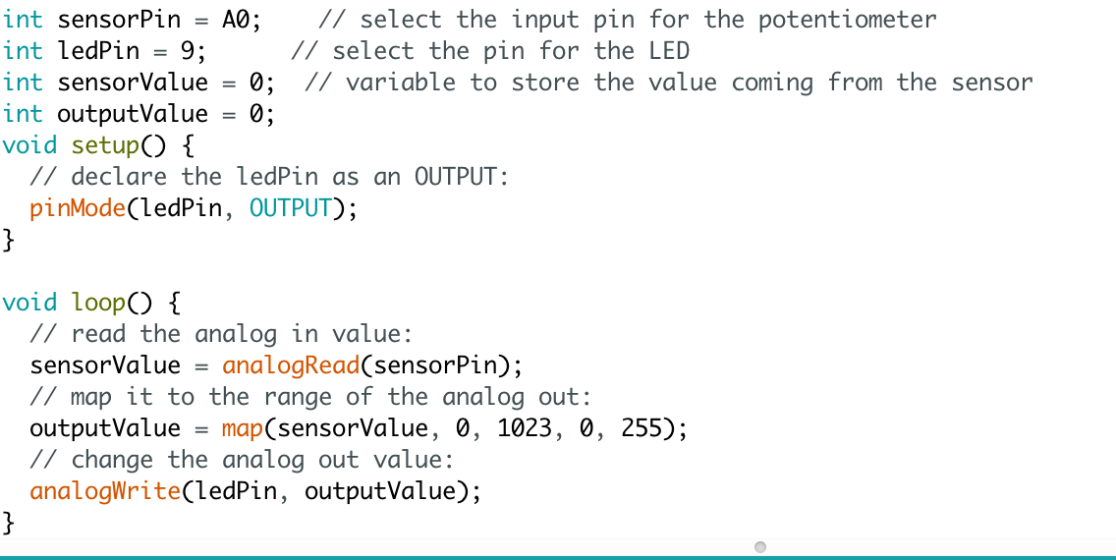

*-* [*video*](https://drive.google.com/open?id=1Ctyu413A0xHIv6_r8IQlmlA2T3Wy0OCx)

2. Force Sensitive Sensor

**a**. 0 - 1024

**b**. linear

*-* [*video*](https://drive.google.com/open?id=1cHFcPq8gbPh811Vft6UZJXJx71Wxy_3i)

**Part C. Writing to the LCD**

**a**. 5v to power the display. 3v to power the backlight

**b**. I read the pin holes backwards. (outer most was pin 1 but when I started to wire things I mistook that pin for 16.) I went to adafruit and saw the schematics and realized I read the diagram wrong and once I got that sorted out everything started to work as it should.

**c**. I copied a source code from ada-fruit and changed the input to ‘lcd.print()’ function

**d**. 1.76kOhm

**e.** [**Han losing**](https://drive.google.com/open?id=110oGKEo7xvd-IGj8jT8rygmbktRtAYt0)

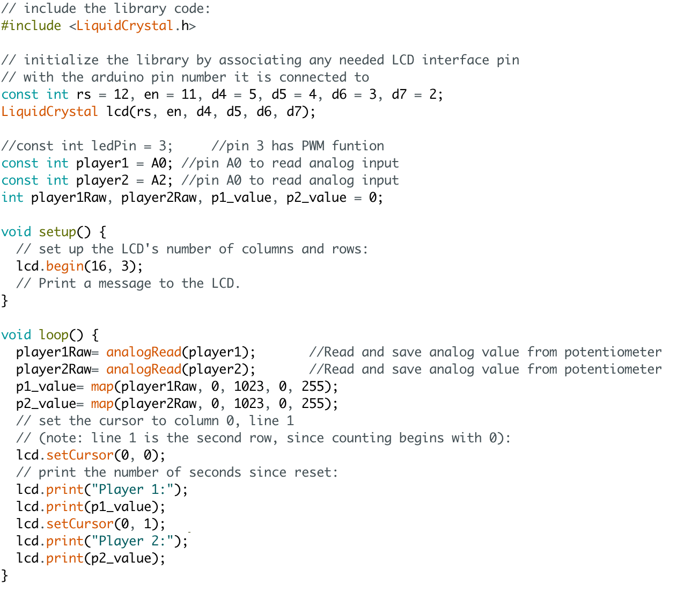

**Part D & E. Timer**

[*video*](https://drive.google.com/open?id=1ywDgdDL5AkaSR5OpbOBZdDnEdgVM1QDR)