# Results

**General Performance.** All groups performed well with more than 80% accurate choices, without large differences between groups (White Noise (WN): 0.826± 0.9, Monetary Loss (ML): 0.817±0.4, Reward (R): 0.831±0.6). All groups performed above chance level (*binomial test: WN p=.0206, ML p=.0206, R p=.000018*). With respect to reaction time though, we observed a clear trend for faster responses in the WN group, but testing more subjects is necessary to confirm this difference (WN: 1628±63ms, ML: 1867±202ms, R: 1707±130ms; Figure 1).

**Figure 1:**

**a.** **Overall accuracy rate.** The rate of correct choices according to designated probabilities from all trials. Y axis is the accuracy rate and X axis is the group condition. Dotted points are participants' averages and blue triangles are group means.

**b.** **Accuracy on learning trials vs testing trials.** Y axis is the accuracy rate and X axis is the learning/testing trials condition. Thicker lines and thicker dots represent group average.

**c.** **Overall reaction time in milliseconds.** Reaction time is the amount of time between the appearance of stimuli and the choice time. Y axis is the reaction time in milliseconds and X axis is the group condition. Dotted points are participants' averages and blue triangles are group means.

**d.** **Reaction time on learning trials vs testing trials.** Reaction time is the amount of time between the appearance of stimuli and the choice time. Y axis is the reaction time in milliseconds and X axis is the learning/testing trials condition. Thicker lines and thicker dots represent group average.

Additionally, we analyzed the differences in accuracy and reaction time between learning trials and testing trials. Overall, subjects in all groups maintained high performance in learning and testing trials alike which suggests a preservation of the knowledge acquired on learning phases (*binomial test: WN p=.0206, ML p=.0206, R p=.000018*). We also observed a small trend in the white noise group of higher accuracy and lower Rt levels in the testing trials compared with learning trials (accuracy: 0.821 - 0.841, Rt: 1635 - 1615), yet again testing more subjects is necessary to confirm this observation. No similar difference observed in reward and monetary-loss groups (Figure 1).

**Changes in accuracy over time.** because over time habituation can lead to differences in accuracy over days, we examined how much choices were accurate as a function of days. For both punishment groups, accuracy on learning trials fluctuated from day to day but without a clear trend and average remained above chance for every day (*binomial test: WN p=.0206, ML p=.0206*). The same was for the accurate choices in testing trials for stimuli learned in different days, they also were above chance level for both punishment groups (*binomial test: WN p=.0206, ML p=.0206*) and varied without large difference between groups (Figure 2).

**Figure 2:**

**a.** The rate of correct choices according to designated probabilities in learning trials of stimuli as a function of the day they were learned. On the X axis is the day that a stimulus was learned and on the Y axis the average accuracy of its learning trials. The dots are subjects' averaged accuracy on all stimuli that were learned that day. Squares represent group average. For the reward group instead of subjects' data points we added SE to the averages.

**b.** The rate of correct choices according to designated probabilities in testing trials of stimuli as a function of the day they were learned. On the X axis is the day that a stimulus was learned and on the Y axis the average accuracy of its testing trials. The dots are subjects' averaged accuracy on all stimuli that were learned that day. Squares represent group average. For the reward group instead of subjects' data points we added SE to the averages.

**Learning curve.** Averaging over all session for each trial in the learning game gave us a learning curve for each group that indicates how learning changed throughout the game. The curves start from over 70% accuracy as some games consisted of stimuli that were already learned in past games. We observed a gradual improvement in group averaged accuracy as the game proceeded, which may suggest that learning continued as game trials continued. We also observed a trend in which the WN group curve was higher compared to the MN and Reward groups throughout the game (Figure 3).

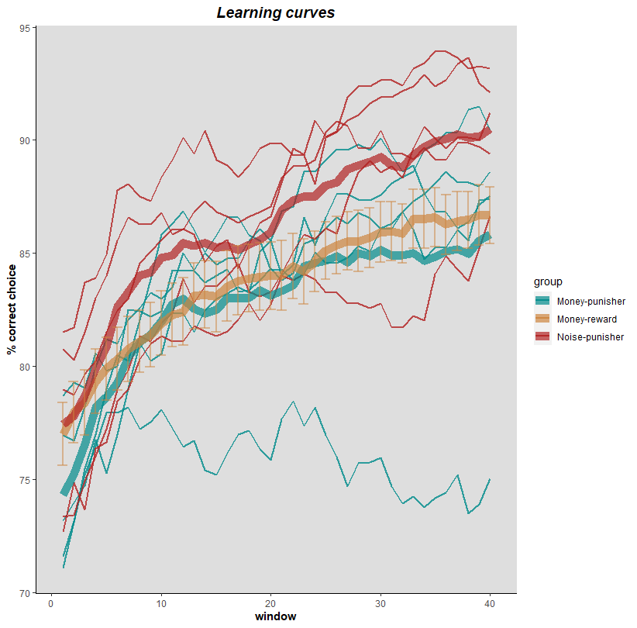

**Figure 3: Learning curves.** how learning changes throughout a learning game? On the Y axis the percentage of accurate choices, on the X axis are the sliding windows, where each window corresponds to a chunk of 10 trials (window 1 = trial 1-10, window 2 = trial 2-11, window 3 = trial 3-12 and so on). Thin lines are subjects' curves and thick lines are group curves. For the reward group instead of subjects' curves we added SE to each data point.

**Stimuli recall.** Looking at the proportion of accurate choices on testing trials as a function of how many hours passed since stimuli learned revealed a clear trend in both punishment groups of a good recall for almost all stimuli value long after learning them, as accuracy levels in testing remained high on average even 75 hours after learning (Figure 4).

**Figure 4:** percentage of correct choices according to designated probabilities on testing phase as a function of how many hours passed since stimuli were learned for each subject on each group. Y axis is averaged accuracy and on the X axis the number of hours since learning.

**Heartrate Responses.** Looking at the implicit emotional impact to the aversive stimulus we checked for the patterns of heartrate responses during the 10 seconds after feedback was given. Similar to what was shown in Eldar et al's paper (2018, see Figure 5), we observed in both groups a deceleration in heartrate responses after outcome was given (*binomial test: WN p=.0206, ML p=.0206*) and a clear trend of modulation after 3-5 seconds (Figure 5).

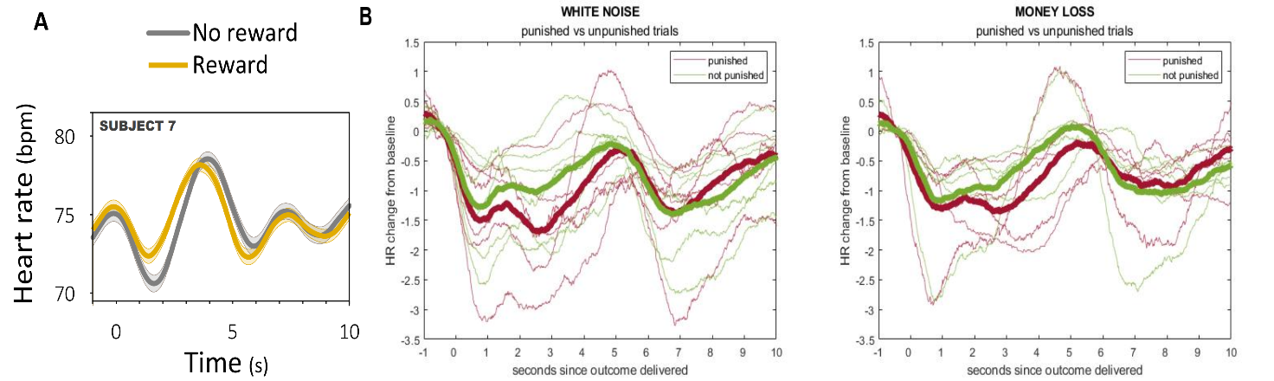

**Figure 4:**

**A. Heartrate responses to reward vs no-reward trials of a subject from Eldar et al 2018.** An example of subject's heartrate responses from 1 second before feedback given till 10 seconds after.

**B. Heartrate responses to punished vs non-punished trials of both groups.** The change in heartrate responses from baseline - averaged responses for the second before outcome presented, over the 10 seconds after feedback. Thin lines are subjects and thick lines are group averages. On the Y axis we see the change of heartrate responses from baseline. On the X axis is the time in seconds since outcome presented.

**Self-report questionnaire.** As subjects finished the experiment, they filled a self-report questionnaire that requested them to rate (between 0 to 3) how they agree to an assertion about their experience during the experiment. Both groups rated high their motivation to avoid punishments while playing the game (WN: 2.5, ML: 2.4) and that in testing trials their choices were based on memory rather than guessing (WN: 2.5, ML: 2.4). Interestingly, they rated less their success in identifying the worst images that are likely to produce punishments during the learning trials (WN: 2, ML: 1.6).