**EXERCISE 3**

Open your xampp application and start the apache and mysql

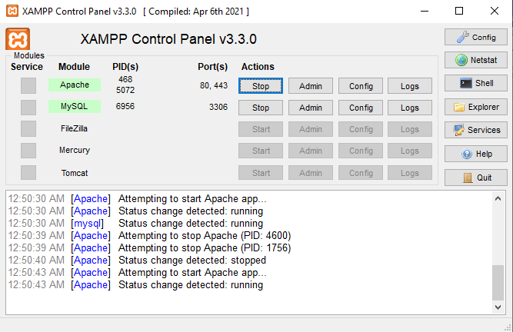

Open your myphpadmin (<http://localhost/phpmyadmin/>)

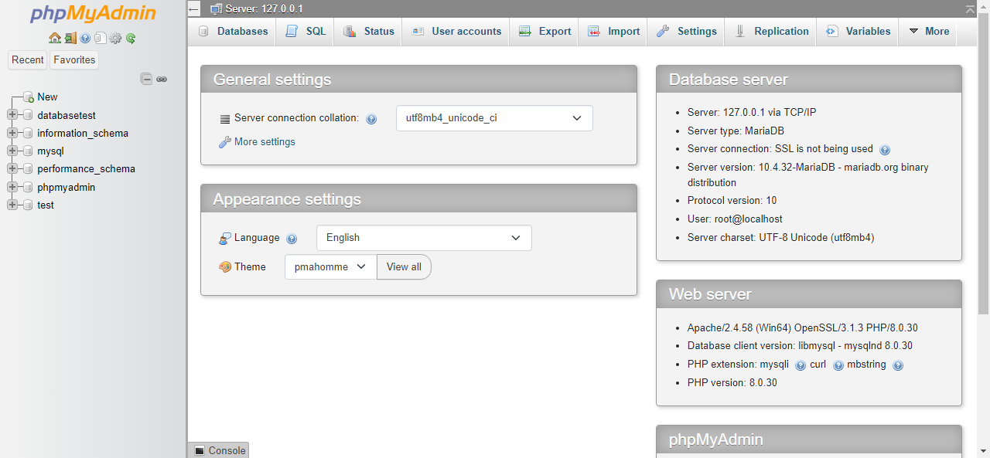

Click the New on the left side of your screen and create your Database. (Database name is your surname)

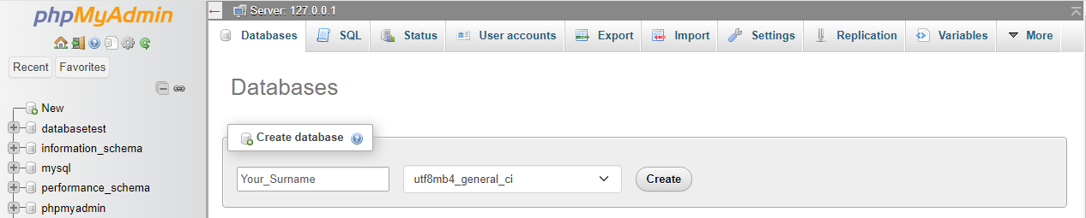

now, create 2 table. (table1 name is student_info, table2 name is student_list).

Create your structure of your first table (student_info).

Your first table should include the following:

* Student_ID (PK)
* Student_name
* Age
* Course

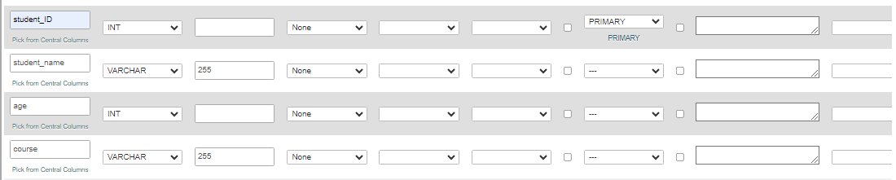

If your done on the first table, here the second table (student_list)

Your second table should include the following:

* Student_ID (PK)
* Full_name

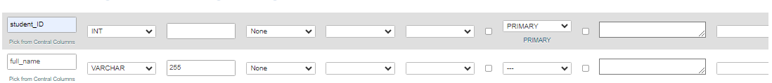

Congratulation! You’ve created 2 table (Nice)

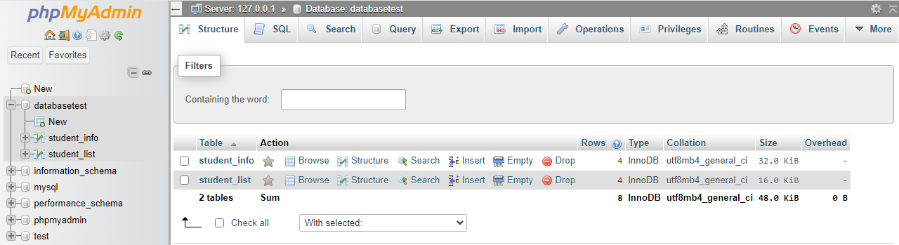

In the first table (student_info) insert student_id, full_name, age, and course.

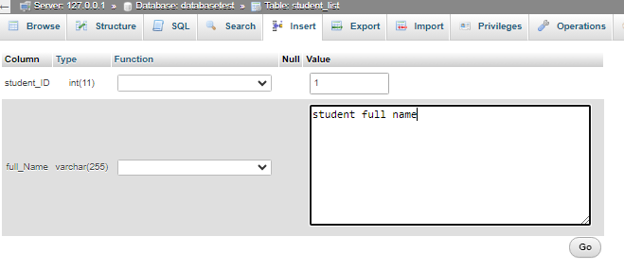

In the second table (student_list) insert student_id, student_name, age, and course

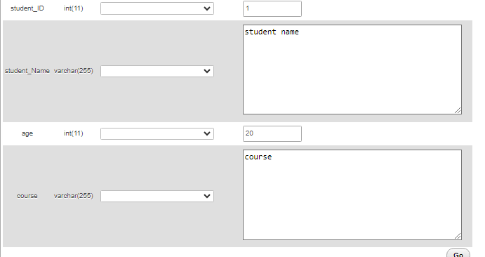

Click the first table (student_info).

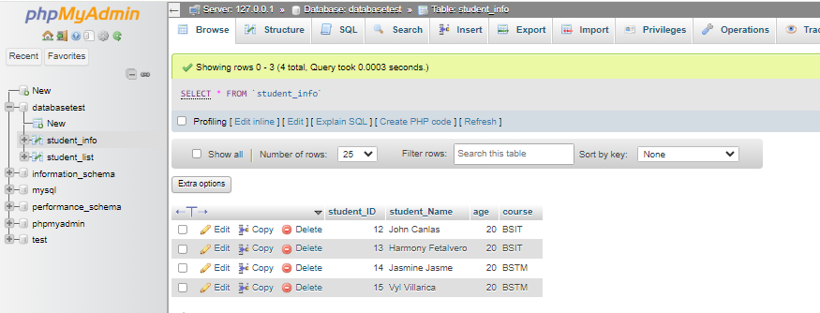

And click the sql on the menu bar (top middle)

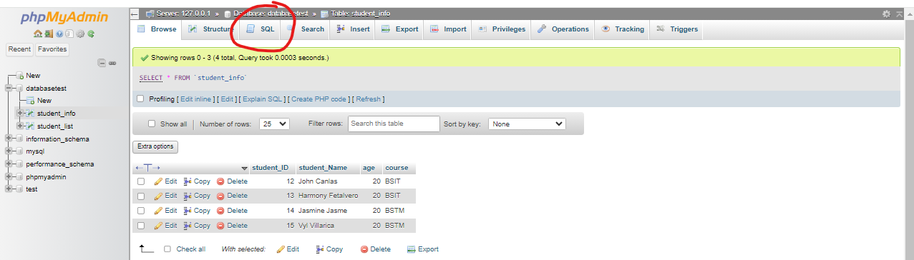

Use the inner join query.

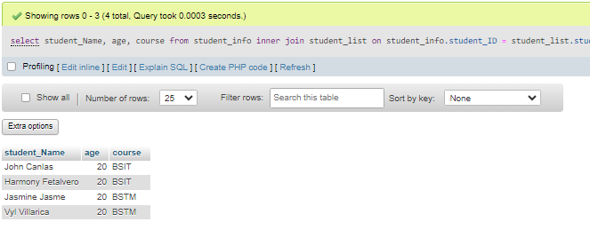

Tapos kana nice, congrats, galing, wow.