

**Tribhuvan University**

**Faculty of Humanities and Social Sciences**

**“Rental Cycle”**

**A FINAL PROJECT REPORT**

**Submitted to:**

**Department of Computer Application**

**Nist College**

**In partial fulfillment of the requirement for the degree of Bachelor in Computer Application**

Submitted by:

Abhishek Humagain (101402068)

2081/07/30

**Under the Supervision of**

**Yubaraj Neaupane**



**Tribhuvan University**

**Faculty of Humanities and Social Sciences**

**Nist College, Banepa**

**Supervisor’s Recommendation**

I hereby recommend that this project prepared under my supervision by “**Abhishek Humagain** ” entitled “**Rental Cycle**” in partial fulfillment of the requirements for the degree of Bachelor of Computer Application is recommended for the final evaluation.

………………….

**SIGNATURE**

**Yubaraj Neaupane**

**Supervisor**

Department of Computer Application

Nist College

Banepa, Kavre



**Tribhuvan University**

**Faculty of Humanities and Social Sciences**

**Nist College**

# LETTER OF APPROVAL

This is to certify that this project is prepared by “**Abhishek Humagain”** entitled “**Rental Cycle”** in partial fulfillment of the requirements for the degree of Bachelor in Computer Application has been evaluated. In our opinion it is satisfactory in the scope and quality as a project for the required degree.

|  |  |
| --- | --- |
| **……………………………….**  **Mr. Yubaraj Neaupane**  **Supervisor** | **……………………………….**  **Mr. Samish Shrestha**  **Coordinator** |
| **……………………………….**  **Internal Examiner** | **……………………………….**  **External Examiner** |

# ABSTRACT

The Online Rental Cycle System is a web-based application designed to simplify and enhance the experience of renting bicycles. Built using React for a dynamic, responsive frontend and Express.js for a robust backend, this system offers a user-friendly interface where individuals can browse available bikes, view rental rates, and make secure reservations.Users can easily search for bicycles based on their preferences, select rental periods, and complete transactions online. The platform is geared toward a wide range of users—from commuters to fitness enthusiasts—providing a convenient solution for short- or long-term bike rentals.

# ACKNOWLEDGEMENT

I take this occasion to thank God, almighty for blessing us with his grace and taking our endeavor to a successful culmination.

I extend my BCA and heartfelt thanks to our esteemed guide, Mr. **Yubaraj Neupane** , for providing us with the right guidance and advice at the crucial junctions and for showing us the right way.

I would like to thank the other faculty member also, at the occasion. Last but not the least, I Would like to thank my friends for the support and encouragement they have given us during the course of our project.

Yours Sincerely Abhishek Humagain

**Table of Contents**

LETTER OF APPROVAL ii

ABSTRACT iii

ACKNOWLEDGEMENT iv

Chapter 1:Introduction 1

1.1 Introduction 1

1.2 Problem statement 1

1.3 Objectives 2

1.14 Scope And Limitation 2

1.5 Development Methodology 2

1.6 Report Organization 4

Chapter 2. Background Study and Literature Reviews 5

2.1 Background Study 5

2.2 Literature Review 5

Chapter 3. System Analysis and Design 6

3.1 System Analysis 6

3.1.1 Requirement Analysis 6

3.1.2 Feasibility Study 8

3.2 System Design 12

Chapter 4: Implementation and testing 18

4.1 Implementation 18

JavaScript 18

React 18

4.2 Testing 20

4.2.1 Test cases for Unit Testing 20

Table 1: Test Cases for User Login 20

4.2.2 Test cases for System Testing 21

Table 2: Test Cases for Admin Login 21

Chapter 5: Conclusion and Future Recommendation 21

3.1. Conclusion 21

5.2 Lesson learnt / Outcome 22

5.3 Future Recommendations 22

Appendices: 23

Gantt Chart 24

References 24

Figure 1.1 : Waterfall Model 4

Figure 1.2 :Gantt Chart 4

Figure 3.1 :Use Case Diagram 8

Figure 3.2 :Data Modelling : ER Design 10

Figure 3.3 :0 Level DFD 10

Figure 3.4 :Level 1 DFD 11

Figure 3.5 :Flow Chart 12

Figure 3.6 :Architectural Diagram 13

Figure 3.7 :Database Schema Design 14

Figure 3.8:Register Page 15

Figure 3.9: Login Page 16

Figure 3.10:Home Page 16

Figure 3.11:Recommended Cycles 17

Figure 3.12:Available Cycles 17

# Chapter 1:Introduction

## 1.1 Introduction

A cycle rental, or hire, business offers bicycles for rent on a short-term basis, typically by the hour or day, catering to locals as well as visitors. Although many rental services are operated as an add-on by cycle shops focused primarily on sales and repairs, some businesses specialize exclusively in cycle rentals. These businesses provide an accessible option for individuals who may not own a bike but want to experience cycling temporarily—for commuting, recreational activities, or fitness.

Unlike traditional assumptions that cycle rentals are primarily for tourists, these services are popular among local residents who use them to explore neighborhoods, commute short distances, or simply enjoy the outdoors without the commitment of owning a bicycle. This trend has made cycling an increasingly appealing mode of local exploration, even in areas where public transport or car usage is high.

Despite its origins as a classic form of transport, cycling remains relevant today, with cycle tourism becoming increasingly popular. This form of tourism allows individuals to explore cities and natural areas at their own pace, making cycling a sustainable, health-conscious, and enjoyable choice for short journeys. As cycling’s popularity continues to rise, rental businesses help make this experience accessible to a broader audience, supporting an eco-friendly way to travel that benefits both residents and visitors alike.

## 1.2 Problem statement

Running a successful cycle rental business depends on several key factors, starting with selecting the ideal location. Positioning your business in a high-traffic area—such as near tourist hot spots , parks, beaches, or popular landmarks—can significantly boost visibility and attract both visitors and locals looking for convenient transportation. Being close to attractions also makes it more likely for customers to rent bikes on impulse, adding to your customer base and helping your business thrive.

The condition and maintenance of your bicycles are equally important. Providing high-quality, well-maintained bikes can make a big difference in customer satisfaction and safety. Regular maintenance is essential to avoid mechanical issues and ensure each bike is safe to ride, which will enhance your customers’ experience and reduce the chances of breakdowns. Establishing a maintenance routine—such as checking tire pressure, brakes, and chains before each rental—shows professionalism and helps build trust with customers.

## 1.3 Objectives

* To allow customers to book vehicle services online and provides doorstep pickup for servicing.
* To promote sustainability and healthy living by encouraging the use of bicycles as an eco-friendly mode of transportation.

## 1.14 Scope And Limitation

Scope:

* The scope of rental cycles is vast, covering a wide range of business models, geographic regions, and technologies, while also addressing environmental, social, and economic considerations.
* The industry is growing rapidly, driven by increasing interest in sustainable transportation and the rise of tech-enabled solutions.

**Limitation:**

* While bike rental services have become a popular solution for urban mobility, they face a number of challenges that can impact their growth and effectiveness.
* Addressing these limitations requires investments in infrastructure, maintenance, technology, and regulatory frameworks to ensure that rental cycles remain a viable and attractive option for a broad range of users.

## 1.5 Development Methodology

• **Requirement Gathering and Analysis**

In this phase, all project requirements are gathered, documented, and thoroughly analyzed.A detailed specification document is created, which outlines what the project will accomplish and any constraints or dependencies.Stakeholders’ needs are translated into system requirements to ensure clarity and alignment.

· **System Design**

Based on the requirements document, the system’s architecture and design are outlined.This phase involves creating technical specifications, data models, user interfaces, and system designs that will guide development.Design is often split into **high-level design** (system architecture) and **detailed design** (more granular component specifications).

· **Implementation (Coding)**

· Developers start coding according to the design specifications.The system is built in small, individual units or modules, which are later integrated to form the complete application.Unit testing may also occur at this stage to ensure that each module functions as expected.

· **Integration and Testing**

Once all modules are developed, they are integrated into a complete system.Testing is performed on the integrated system to identify and fix any issues.Various testing methods, including functional, integration, system, and acceptance testing, are applied to ensure the system meets the original requirements.

**Maintenance**

Maintenance for the rental cycle site involves regular system checks, bug fixes, and updates to ensure smooth operation. This includes monitoring performance, resolving any issues that arise, and updating features to enhance user experience. Maintenance efforts help keep the site secure, reliable, and aligned with evolving user needs and business goals.

·

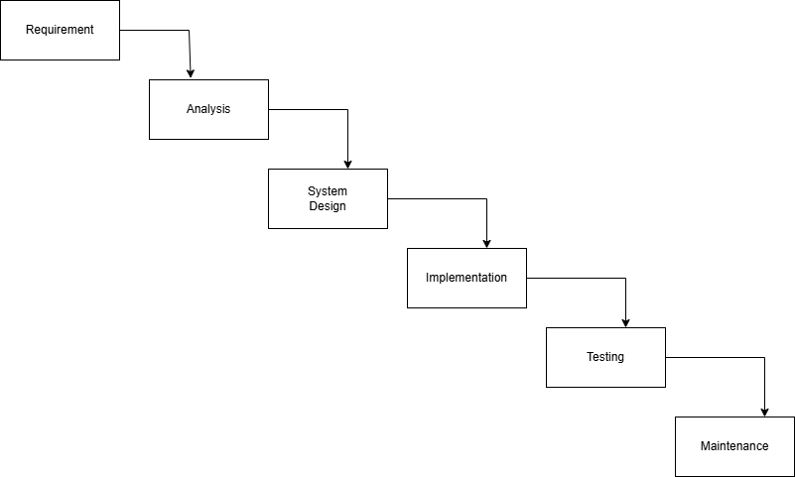

Figure 1: Waterfall Model

# Gantt Chart

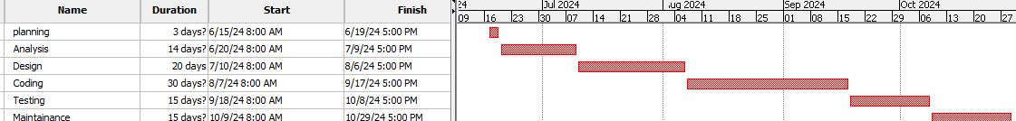

Figure 2:Gantt Chart

## 1.6 Report Organization

Report organizations These organizations play an essential role in reporting on and analyzing the rental cycle industry. They provide valuable insights into market trends, challenges, and the overall development of bike-sharing and rental services. Reports from these entities can help stakeholders—such as governments, businesses, and advocacy groups—make informed decisions about investments, policy creation, and business strategies related to cycling and shared mobility.the scope of rental cycles is vast, covering a wide range of business models, geographic regions, and technologies, while also addressing environmental, social, and economic considerations. The industry is growing rapidly, driven by increasing interest in sustainable transportation and the rise of tech-enabled solutions.

# Chapter 2. Background Study and Literature Reviews

## 2.1 Background Study

The rental cycle industry has grown quickly, driven by urbanization and a desire for sustainable commuting options. Many cities and private companies now offer cycle rental services that allow people to rent bicycles for short trips, catering to commuters, tourists, and fitness enthusiasts. There are two main types of systems: docked, where bikes are picked up and returned to designated stations (like Citi Bike), and dockless, where users locate and unlock bikes via GPS, offering greater flexibility.

Developing a rental cycle system involves creating a user-friendly frontend (often with React) and a backend (such as Express.js) to handle requests and data storage. MongoDB is suitable for managing user and rental data due to its flexible structure. Key features include a map for cycle availability, booking and payment integration, rental management, and user feedback. Real-time GPS tracking and JWT-based authentication are also essential to secure and streamline the user experience.[1]

Despite its advantages, the system faces challenges, like ensuring cycle maintenance, achieving accurate GPS tracking, and promoting responsible parking, especially in dockless models. Learning from competitors like Lime and Jump by Uber can provide insights into best practices in user experience and operational logistics. Overall, rental cycles support eco-friendly urban mobility, reduce emissions, and encourage healthier lifestyles.

## 2.2 Literature Review

Review on factors influencing bicycle-metro integration (Jay Panchal, Bhandhan Bhandhu Majumdar,,This section is intended to provide a brief review of existing research literature available related to bicycle and metro integration. Among existing researches, Rietveld put forward that bicycle can be an attractive access mode for the railways as it saves the users time at bus or tram stops.

V.Vinayaka Ram He discovered that at the home end of the trip, bicycles seem to play an important role as it gets a share of 35% as an access mode, whereas the share is much lower at the activity end. He also finds that potential bicycle users may get discouraged to ride bicycle to metro because of the insufficient parking facilities for bicycles and high risk of bicycle get stolen at the railway stations.[2]

Debasis Basu0 Parkin et al.reported that an individual and the socio-economic characteristics like gender, car owners, age, number of students within the population, culture, standard of class of the people and income plays a significant role towards one’s choice to bicycle. A few other factors such as physical determinants like journey distance, degree of the areas density, terrain structures (hilly / mountainous etc.) and weather influenced attributes such as temperature and rainfall have been significantly influencing the bicycle mode choice in an effective manner[3]

# Chapter 3. System Analysis and Design

## 3.1 System Analysis

The system analysis for a rental cycle platform involves examining functional requirements, non-functional requirements, key system components, and expected user interactions. This analysis helps in designing a robust, scalable, and user-centric solution.

## 3.1.1 Requirement Analysis

### i. Functional Requirements

* Admin dashboard to manage and view user profiles and rental history.
* Admin can view user information (name, contact, rental status)
* Registration page for new users to sign up with necessary fields (name, email, password).
* Login page to authenticate users with email and password.
* Form validation (both client-side and server-side) to ensure required fields are completed.
* Error messages for missing fields
* Search function to filter cycles by type, availability, rental duration, etc.
* Users can choose cycles and make bookings based on availability
* Confirmation email sent to users upon successful booking with rental details (cycle, rental dates, cost, etc.).

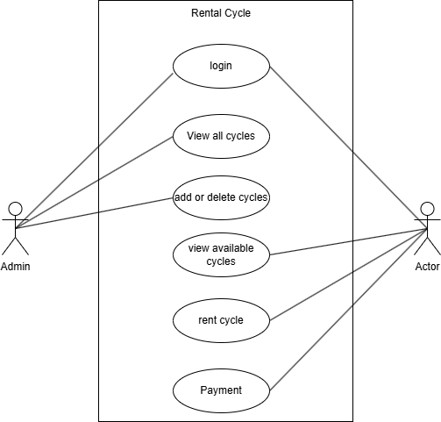

Figure 3:Use Case Diagram

### Ii. Non – Functional Requirement

* Ensure quick response time even with many users searching and booking cycles simultaneously.
* 24/7 availability for users to book or cancel rentals at any time.
* The system should handle increasing user load and more cycles being added as the business grows.
* Intuitive and user-friendly interface for both users and administrators.
* Use database transactions to ensure consistency, preventing double-booking of cycles.

## 3.1.2 Feasibility Study

### i .Technical Feasibility

cycle, two-wheeled steerable machine that is pedaled by the rider feet. On a standard bicycle the wheels are mounted in-line in a metal frame, with the front wheel held in a rota table fork. The rider sits on a saddle and steers by leaning and turning handlebars that are attached to the fork.

### ii . Operational Feasibility

Operational feasibility is the measure of how well a proposed system solves problems and takes advantage of the opportunities identified during scope definition and how it satisfies the requirements identified in the requirements analysis phase of system development.

**iii. Economic Feasibility**

Economic feasibility for a rental cycle business examines whether the project is financially viable, considering factors such as initial investment, operational costs, revenue potential, and return on investment. It assesses the cost-effectiveness of the proposed system, including expenses related to technology, maintenance, staffing, and marketing, and evaluates if expected revenue can cover these costs over time. This analysis helps determine whether the business model is sustainable and profitable, ensuring a balanced financial approach that aligns with the business’s long-term objectives.

### 3.1.3 Data Modelling : ER Design

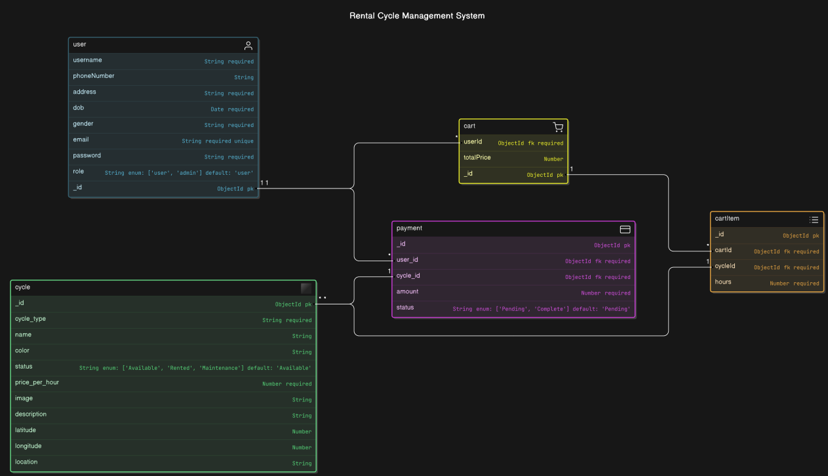

Figure 4:Data Modelling : ER Design

### 3.1.4 Process Modeling (DFD)

Data Flow Diagrams show the flow of data from external entities into the system, and from one process to another within the system. Following are the Data Flow Diagrams for the current system. Each process within the system is first shown as a context level DFD and later as a Detailed DFD. The Context Level DFD provides a conceptual view of the process whereas Detailed DFD provides a more detailed and comprehensive view. Which is explain below in figure:

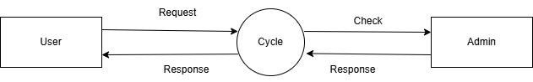

Figure 5:0 Level DFD

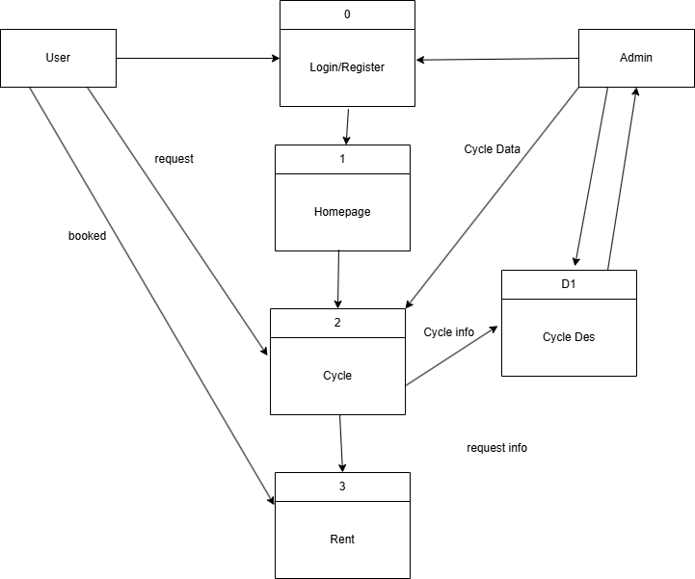

Figure 6:Level 1 DFD

### **3.1.5 Flow Chart**

### 

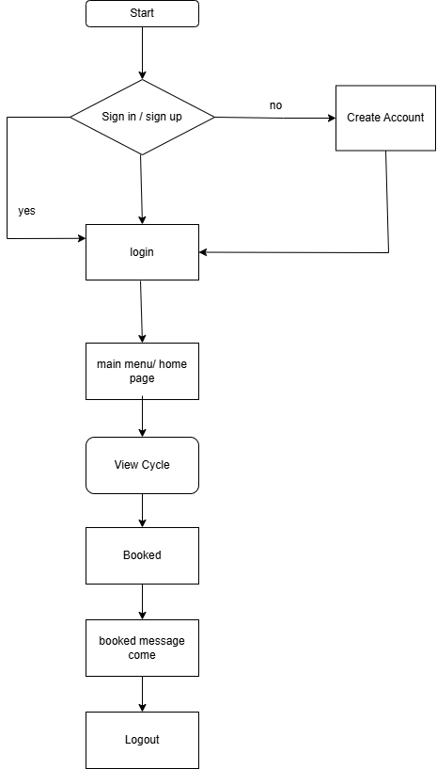

Figure 7:Flow Chart

## 3.2 System Design

### 3.2.1Architecture Design

The system architecture which shows the structure behavior and more view of a system. It is the representation of a system organized in a way that supports reasoning about the structure and behavior of the system.

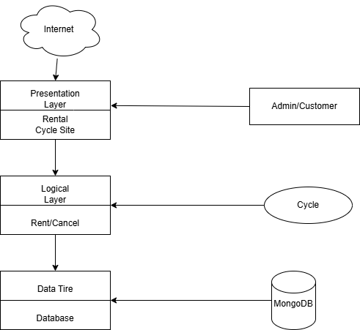

Figure 8:Architectural Diagram

### 

### 3.2.2. Database Schema Design

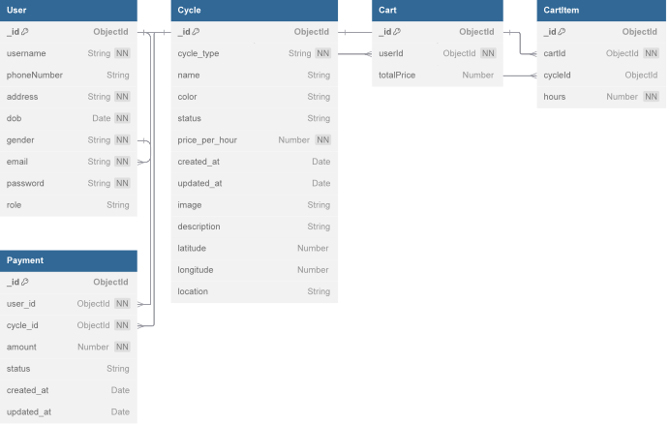

Figure 9:Database Schema Design

### 3.2.3. Interface Design(UI Interface/Interface Structure)

Before implementing the actual design of the project a few user interface designs are constructed to visualize the user interaction with the system. The user interface design will follow the following prototypes:

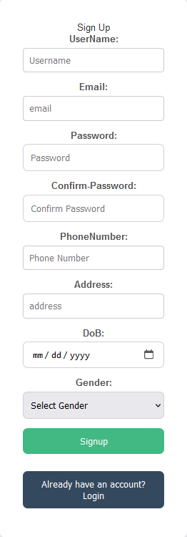

Figure 10:Register Page

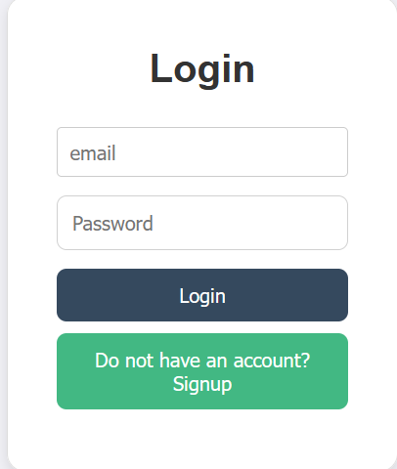

Figure 11: Login Page

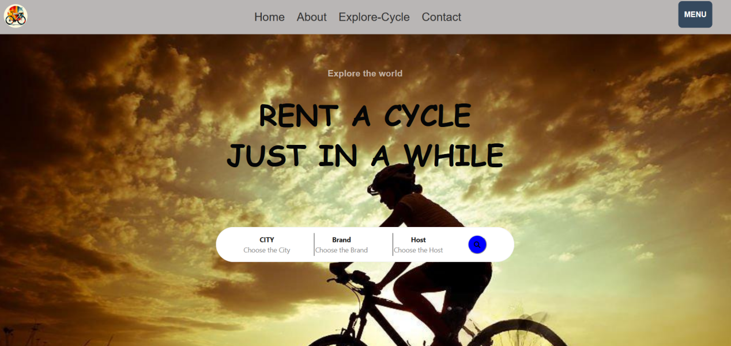

Figure 12:Home Page

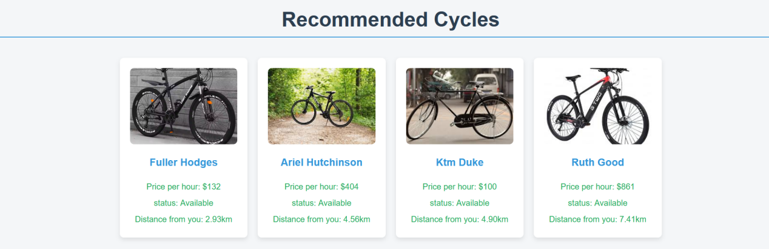

Figure 13:Recommended Cycles

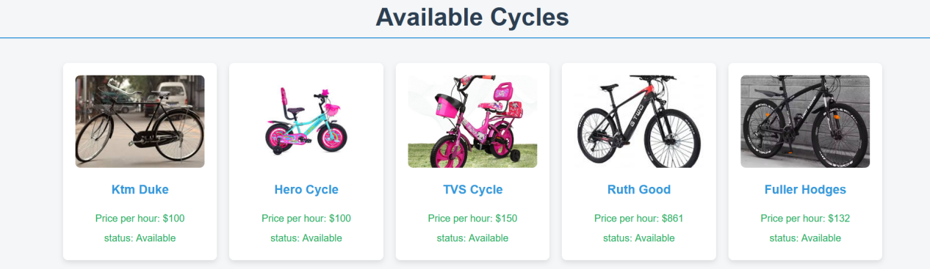

Figure 14:Available Cycles

### 3.3 Algorithm

The Haversine algorithm is used to calculate the great-circle distance between two points on the Earth's surface, given their latitudes and longitudes. This is particularly useful for determining distances in applications like mapping, GPS, and location-based services. The formula takes into account the Earth's curvature, making it more accurate than simple Euclidean distance for larger distances.

### Haversine Formula

Given two points on Earth:

* Point 1: Latitude = lat1, Longitude = lon1
* Point 2: Latitude = lat2, Longitude = lon2

The Haversine formula calculates the distance d between these two points as follows:

Convert latitudes and longitudes from degrees to radians:

lat1,lon1,lat2,lon2\text{lat1}, \text{lon1}, \text{lat2}, \text{lon2}lat1,lon1,lat2,lon2

Calculate differences in latitude and longitude:

Δlat=lat2−lat1\Delta \text{lat} = \text{lat2} - \text{lat1}Δlat=lat2−lat1 Δlon=lon2−lon1\Delta \text{lon} = \text{lon2} - \text{lon1}Δlon=lon2−lon1

Apply the Haversine formula:

a=sin⁡2(Δlat2)+cos⁡(lat1)⋅cos⁡(lat2)⋅sin⁡2(Δlon2)a = \sin^2\left(\frac{\Delta \text{lat}}{2}\right) + \cos(\text{lat1}) \cdot \cos(\text{lat2}) \cdot \sin^2\left(\frac{\Delta \text{lon}}{2}\right)a=sin2(2Δlat​)+cos(lat1)⋅cos(lat2)⋅sin2(2Δlon​) c=2⋅atan2(a,1−a)c = 2 \cdot \text{atan2}\left(\sqrt{a}, \sqrt{1 - a}\right)c=2⋅atan2(a​,1−a​) d=R⋅cd = R \cdot cd=R⋅c

Where:

* RRR is the Earth's radius (mean radius ~ 6,371 km or ~ 3,959 miles)
* ddd is the distance between the two points along the Earth's surface

# Chapter 4: Implementation and testing

4.1 Implementation

Implementation basically means the phase where the system is actually being built. In this the information gathered is studied and analyzed and implemented in operation for users. All the physical design of the project is turned into working computer code.Many tools and technology that were utilized to develop the system were discussed in the preceding chapter.

### 4.1.1. Tools Used

The various system tools that have been used in developing both the front-end and back-end of the project are being discussed in this chapter.

**Draw.io**

Draw.io is a basic diagram web application that utilizes a large amount of equally basic images to create a project. With simple drag and drop techniques, it is easy to use this website that provides a method for design that virtually anyone can use. We have used this web application to create most of the diagrams for this project.

**JavaScript**

JavaScript is a dynamic computer programming language. It is most commonly used as a part of web browsers, whose implementations allow client-side scripts to interact with the user, control the browser, communicate asynchronously, and alter the document content that is displayed. JavaScript is used to create popup windows displaying different alerts in the system like “Are you sure to delete this user?”, “search functionality”, etc.

**React**

React is primarily used for building UI components and is based on the idea of breaking down complex UIs into smaller, reusable components. It efficiently updates the UI by utilizing a virtual DOM, allowing for fast rendering even with complex applications..React is a powerful JavaScript library for building modern web applications with dynamic, interactive UIs. It promotes the use of reusable components and helps developers manage application state and side effects in an efficient way. Whether building small applications or large-scale projects, React offers flexibility, performance, and scalability.

* **Express.js**

Express.js is a web framework built for Node.js, designed to handle HTTP requests, routing, middleware, and more. It makes it easy to build web applications and APIs by providing a simple, unopinionated, and extensible approach. Express simplifies many tasks in web development, such as handling routing, managing sessions, serving static files, and handling middleware for logging, validation, and authentication.

* **MongoDB**

MongoDB is a NoSQL database designed for handling large volumes of unstructured data, making it ideal for modern applications that require flexibility and scalability. It stores data in JSON-like documents, allowing for complex hierarchical data structures and dynamic schemas. This document-based model enables MongoDB to handle changes in data structure over time without the rigid constraints of traditional relational databases. MongoDB also supports horizontal scaling, high availability, and powerful query capabilities, making it well-suited for applications that need to handle vast amounts of data and evolve quickly with changing requirements.

### 4.1.2. Implementation Details of Modules

* **Login modules:** This module is responsible for registered user to login to the website.
* **Sign up module:** This module is responsible for registering a new user.
* **Admin module:** This module is responsible for updating, viewing and deleting the Rental Cycle.
* **Rent module:** This module is responsible for renting the cycle.
* **Logout module:** The user can logout from the websites anytime whenever they want.

## 4.2 Testing

For the website to deployed it has to tested. Hence test case will be written to test this website. There are many type of test to carried out on a website from performance, functionality, response time and many others. We will be carrying only important one for the website considering limited time to present the project. We will focus the test case on functionality and performance.

## 4.2.1 Test cases for Unit Testing

Unit testing is a method of testing individual units or components of a software application. It is typically done by developers and is used to ensure that the individual units of the software are working as intended. Unit tests are usually automated and are designed to test specific parts of the code, such as a particular function or method.

|  |  |  |  |  |
| --- | --- | --- | --- | --- |
| **S.N** | **Test Case Description** | **Input/Action** | **Output** | **Remarks** |
| 1. | User Authentication | Valid username and password. | Successfully login | pass |
| 2. | User Authentication | Invalid username and password. | Unsuccessful login | Pass |
| 3. | Sign up Authentication | Added with data | Successfully data registered | pass |
| 4. | Sign up Authentication | Added without data | All fields are required | pass |

Table 1:Test Cases for User Login

## 4.2.2 Test cases for System Testing

The system testing past of a testing methodology involves testing the entire system for errors and bugs. System testing is carried out on the whole system in the context of interfacing the hardware and software components of the entire system, and then testing it as a whole.

|  |  |  |  |  |
| --- | --- | --- | --- | --- |
| **S.N** | **Test Case Description** | **Input/Action** | **Output** | **Remarks** |
| 1. | Admin Authentication | Valid username and password. | Successfully login | pass |
| 2. | Admin Authentication | Valid username and password. | Unsuccessfully login | pass |

Table 2:Test Cases for Admin Login

# Chapter 5: Conclusion and Future Recommendation

## Conclusion

In conclusion, our **Rental Cycle System** is designed to offer a smooth, accessible web platform where users can easily browse, book, and manage cycle rentals. Using **React** for the front-end, we provide an intuitive interface with dynamic components, allowing users to check cycle availability and complete bookings without page reloads, making the process fast and user-friendly.

On the back-end, **Express.js** manages routes for user registration, authentication, cycle booking, and cancellations. With a connected database such as **MongoDB** . we securely store cycle details, bookings, and user information. **JWT** authentication ensures secure access to user accounts and features.

Future improvements could include real-time availability updates, online payment integration, and an **admin dashboard** for cycle management and user feedback. Together, React and Express.js form a flexible and efficient foundation for this **Rental Cycle System**, ready to support growth and enhancements.

## 5.2 Lesson learnt / Outcome

When the project is completed then the users can register and log in to their account in this websites and can easily book their choice of cycle in this system. This system also helps to minimize the work of the staff by digitally storing records. It also increases the reservations of the Store. People can rent cycle from anywhere at any time. The well-developed website creates a user-friendly environment which makes it easy to use the website.

## 5.3 Future Recommendations

To support growth, the rental cycle system could enhance usability and expand features. Adding personalized recommendations, smart locks, and trip planning would improve the user experience. Predictive maintenance and demand forecasting could help keep cycles available and in good condition, while introducing e-bikes could expand options for users. Improved payment options—like subscriptions and transit card integration—would offer flexibility.

Security measures like geofencing and anti-theft tools would ensure responsible use. Emphasizing sustainability with eco-friendly materials and carbon offsets would attract environmentally-conscious users. Integrating with public transit and smart city infrastructure, along with scalable backend architecture, would enable easy expansion and provide a seamless urban mobility solution.

**Appendices:**

|  |  |  |  |  |
| --- | --- | --- | --- | --- |
| **S.N** | **Date** | **Task Done** | **Task to do** | **Remarks** |
| 1 | 22/01/2081 | Brief Explanation of the project | Literature Review |  |
| 2 | 15/02/2081 | Literature Review | Design Specification |  |
| 3 | 12/03/2081 | Design and Specification | Debugging |  |
| 4 | 25/03/2081 | Coding(Fronted) | Debugging |  |
| 5 | 28/03/2081 | Coding(Back-end) | Debugging |  |
| 6 | 18/04/2081 | Debugging | Feature Add |  |
| 7 | 22/04/2081 | Feature Added | Complete Documentation |  |
| 8 | 28/04/2081 | Completed Documentation | Report |  |

Table 3: Supervisor's Visit Log Sheet

# References

1. P. Rietveld, "The accessibility of railway stations: the role of the bicycle in The Netherlands," Transportation Research Part D: Transport and Environment, vol. 5, no. 1, pp. 71-75, 2000, doi: 10.1016/S1361-9209(99)00019-X.
2. J. Panchal, B. Majumdar, V. V. Ram, and D. Basu, "Analysis of user perception towards a key set of attributes related to Bicycle-Metro integration: A case study of Hyderabad, India," Transportation Research Procedia, vol. 48, pp. 3532-3544, 2020, doi: 10.1016/j.trpro.2020.08.098.
3. P. Adsule and B. R. Kadali, "Analysis of contributing factors in decision to bicycle in developing countries context," Transport Policy, vol. 147, pp. 50-58, 2024, doi: 10.1016/j.tranpol.2023.12.015.