Ludum Dare 32 Design document Ronin748_ 2015

Theme: An Unconventional Weapon

Concept

An amalgamation of Companion and An Unconventional Weapon. The player itself is defenseless, but his Companion will attack any potential threats. There will be 2 different modes: attack & defense. In defense mode, your Companion will attack any aggressive entities that are inside a certain range from you. In attack mode, your Companion aggressively attacks any entity it can see.

The setting, atmos and mechanics

The game will take place in a forest, and your objective is to find your way back to your cabin as you have been lost. All kinds of different creatures roam the woods that are constantly changing around you. There is rain and thunder. And darkness.

There will be a day-night cycle which will limit the time in which you have to find your way back. At night darkness will fall the only thing you can see is the eerie glow of the horrid monsters coming for you. You also have a lantern you can use to scare the darkness away, but it has a rather limited oil supply after which the darkness will consume you. You are looking for the comforting glow of your cabin's windows.

The monsters are mostly creatures of the forest. Wolves, bears and moose. There are also non-aggressive creatures such as squirrels, butterflies and bunnies. Creatures drop things such as health and you gain xp.

Xp can be used to level up and unlock new Companions. You can also train your Companions in strength, defense, speed and (agility).

The Companions could be for instance dogs, cats, ferrets and snakes. They will have random scientist names and their appearance will be random. They can be unlocked in that order with the starting Companion being a dog. The Companions have a collar to which a leash can be attached. The leash will prevent your Companion from wandering away and will keep it a certain distance away from you.

Controls and GUI

WASD – movement
R – leash (your Companion will come back to you after which the leash will be attached)
F – lantern (there will be a bar to indicate amount of oil it has)
E – Attack
Q – Defend
Space – activate things (such as enter your cabin)
(Shift – sprint)

There will be a health bar and your Companion(s) also has one on top of its head. An xp bar will indicate the xp point you have collected and your current level. An oil-o-meter shows the remaining oil in your lantern (how long you can survive after dark). A clock could also be implemented so that you would be able to tell the time you have left. In the bottom corners the attack modes and their levels could be seen.
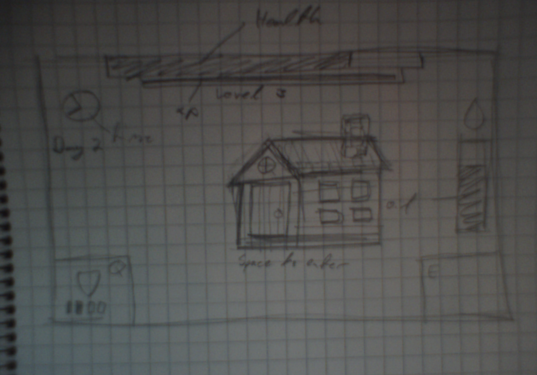
Technical comments

The forest changes because the pcg generator will not save the previous areas. Monsters and the cabin will appear randomly through this method.

Higher change of getting same textures in adjacent tiles to create "biomes"

Each day you get a certain amount of oil

Days will become shorter

Cabin will be further away

More monsters will spawn

Lost with Companion

You're not alone in the woods

Lost in the woods

Daunting Disorientation

The game is sort of an amalgamation of An Unconventional Weapon and Companion. Cats and dogs are companions to us humans, but why not use them as weapons?

You are lost in the woods and the night is falling. You have to find your way back to your cabin, but can't recall where you came from. It's as if the forest around you is changing... There are monsters that roam the vast wilderness and you don't seem to have any weapons on your person...

There are 2 commands: attack (E) and defend (Q). These will alter your companion's behaviour. In attack mode your companion will attack everything and might wander off if the leash is not attached. In defense mode your companion will stay close to you and attack only aggressive animals. Attaching the leash by pressing R will cause your companion to follow you (even in attack mode). When it gets dark, you must defend yourself from the darkness by turning on your lantern (press F).
Each day the cabin will be further away and more monsters will spawn. Sleeping in your cabin restores health, oil and you gain xp. You can also upgrade your companion's stats (attack, defense, speed).

Controls:

WASD move
E attack mode
Q defend mode
F lantern
R leash
Space activate
Esc quit

IMPORTANT NOTE: changing out of the window will mess up texture alpha values (screen goes completely black), restart to fix

Sorry, didn't have time to draw cat sprites so you can't have cats named "Schrödinger"

