Organizations for by-laws investigation

Organization/Assignee name

* [Earth Science Information Partners (ESIP)](http://esipfed.org) ([by-laws](https://github.com/ESIPFed/Governance)) / Anne Thessen (and I can also ask my friend with a non-profit management MBA)
  + Things I think are useful for Ronin:
    - Maintained in GitHub by a governance committee. Committee activities are transparent (recorded in a wiki)
    - Sections of bylaws are pasted below - seem like basic non profit stuff
    - Sections are minimalist
    - Specifics about voting, defining a quorum, membership, resignations
    - Duty of care and conduct stuff
    - Policies and procedures and position descriptions are separate from the bylaws
  + Things I think are not useful for Ronin
    - All the stuff about meetings

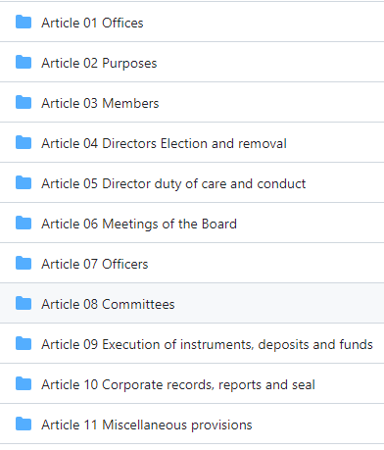

* Here is a link to [bylaws](https://drive.google.com/file/d/1089ESSSYF9sWCGD0YoD0-GLsx5JLMT2d/view?usp=sharing) for a cat rescue. They have things like term limits and something about pronouns that we may want to include. Also an indemnification section and section on parliamentary procedure
* [Research Data Alliance (RDA)](https://www.rd-alliance.org/) ([by-laws](https://zenodo.org/records/3759616#.Xp8XZsgzY2w)) / Rebecca Koskela
* [The Practicing Institute of Engineering, Inc.](https://practicinginstitute.org/) /
* [American Society of Civil Engineers](https://www.asce.org/) ([by-laws](https://www.google.com/url?sa=t&source=web&rct=j&opi=89978449&url=https://www.asce.org/-/media/asce-images-and-files/about-asce/governance-guiding-documents/asce-bylaws.pdf&ved=2ahUKEwi5_cS6lrSGAxWIFmIAHWFiD5gQFnoECAYQAQ&usg=AOvVaw3t6EeS8D4t2DaV8PR1Dg2f)) /
* [American Geophysical Union (AGU)](https://www.agu.org/) ([by-laws](https://www.agu.org/Learn-About-AGU/About-AGU/Governance/Bylaws)) /
* <https://www.nolo.com/legal-encyclopedia/nonprofit-bylaws.html> / Jorrit
* New Jersey-Based Non-Profit Bylaws / Jovita
  + Not-For-Profit Governance and “Best Practices Guide with sample forms (NY) ( <https://www.weil.com/-/media/files/pdfs/2024/may/2024-guide-to-not-for-profit-governance_final.pdf> )
  + Nonprofit & Social Service Organizations Desk Reference Manual (Third Edition – 2013) Prepared by Sobel & Co, LLC CPAs <https://static.wilentz.com/docs/desk-reference-manual-for-nonprofit-and-social-service-organizations-2013.pdf>
  + Northwest Registered Agent **New Jersey Bylaw Template https://www.northwestregisteredagent.com/nonprofit/new-jersey/bylaws**
  + **New Jersey City State College Development Fund, Inc Bylaws https://www.njcu.edu/about/support-njcu/njcu-foundation/njcu-foundation-bylaws**
  + DVRPC Foundation for New Jersey, (a trust) Inc<https://cdn.dvrpc.org/sites/default/files/inline-images/4502_DVRPC-Foundation-for-NJ-Bylaws.pdf>
  + Neuromatch (Delaware Bylaws) https://drive.google.com/file/d/1m8S6Zgz2YooNiF4plVLNnp5RGKoNVfnH/view
* International Society for Transgenic Technology (bylaws)(<https://www.transtechsociety.org/index.php>)/ Elena
* Tangentially it may be worth reviewing NSF guidelines for grantees so that we may incorporate them into the new bylaws: (Rami Saydjari) <https://www.nsf.gov/pubs/policydocs/pappguide/nsf14001/aag_4.jsp>
* NSF procedures for Grant Administration Disputes and Misconduct: <https://www.nsf.gov/pubs/policydocs/pappguide/nsf10_1/aag_7.jsp> (Rami Saydjari)
* Plan to call, ask specifics about what we as members of Ronin could and couldn't do to keep Ronin open, given the bylaws we have <http://www.njnonprofits.org/> Elena- they do not accept calls, only email so sent email to [center@njnonprofits.org](mailto:center@njnonprofits.org) 6/11/24, 1 hr before receiving the “Ronin Institute Update” email from the Ronin Board of Directors
* [Neuromatch Institute](https://drive.google.com/file/d/1m8S6Zgz2YooNiF4plVLNnp5RGKoNVfnH/view)/Nick Jackson
  + Neuromatch seems to have an innovative structure whereby the Board holds day-to-day governance power but one member is is selected by Neuromatch Academy, one by Neuromatch Conference, and the remainder by a majority vote of members.
  + Removal of board members occurs at a meeting of Members, but it seems that the board has control over scheduling those meetings.