Confidentiality Policy
Ronin Institute for Independent Scholarship 2.0 (RIIS 2.0)
California Nonprofit Public Benefit Corporation (Incorporated 2025)
Approval Date: 2025-09-30 • Effective Date: 2025-09-30 • Version: 1.0
Approved by: Interim Council 2025-09-30

1. Purpose
The purpose of this policy is to protect the confidentiality of sensitive information shared within the Council and Working Groups of RIIS 2.0. Maintaining confidentiality ensures trust, compliance with legal and fiduciary obligations, and the effective governance of the Institute.

2. Scope
This policy applies to:
- All members of the Council (Interim or Elected).
- All members of the Working Groups established by the Council.
- Any other individuals granted access to Council or Working Group deliberations or records.

3. Definition of Confidential Information
Confidential information includes, but is not limited to:
- Draft policies, internal reports, or documents not yet approved for public release.
- Financial information, donor records, and membership data.
- Legal advice, contracts, and matters under the attorney–client privilege.
- Personal or sensitive information about Fellows, Associates, staff, or volunteers.
- Deliberations of the Council and Working Groups, including votes and internal discussions, except where explicitly authorized for public dissemination.
- Sensitive security information related to core technical infrastructure, passwords, access keys, etc.

4. Obligations
4.1 Duty of Care: Members must treat confidential information with the highest degree of care and discretion.
4.2 Use Restrictions: Confidential information shall only be used for purposes directly related to RIIS 2.0 governance, operations, or scholarly mission.
4.3 Non-Disclosure: Members may not disclose confidential information to unauthorized persons, including other Affiliates or the public, unless specifically authorized by the Council.
4.4 Records Handling: All confidential records must be stored securely. Members shall comply with RIIS 2.0’s Privacy Policy, Document Retention Policy, and applicable law in handling such records.
4.5 Council Transparency Exception: Consistent with RIIS 2.0’s values of transparency, summaries of Council decisions approved for release may be shared with the Fellows, provided such disclosures do not reveal confidential or sensitive material.

5. Exceptions
Confidential information may be disclosed only when:
- Required by law, regulation, or court order.
- Authorized in writing by the Council.
- Necessary to carry out fiduciary duties, provided appropriate safeguards are observed.

6. Duration of Obligation
The duty of confidentiality continues indefinitely, even after a member’s service on the Council or a Working Group has ended.

7. Violations
Breaches of this policy may result in corrective action, including but not limited to removal from a Working Group, removal from the Council (in accordance with Bylaws), or termination of membership in RIIS 2.0, subject to the Conflict Resolution Policy.

8. Acknowledgment
All Council members and Working Group members shall annually sign or electronically acknowledge this policy, affirming that they:
- Have received a copy of the policy.
- Have read and understood the policy.
- Agree to comply with the policy.

9. Review and Amendments
This policy shall be reviewed at least every three years or sooner if required by law, organizational needs, or upon recommendation by the Council.

10. Document History:
Document created by Rami Saydjari 2025-09-18
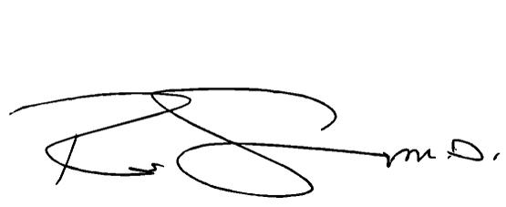
Council Approval: 2025-09-30
Signed:

___________________________
Rami Saydjari
Secretary of RIIS 2.0

