


Project and Professionalism (6CS007)
Artefact Design

Soluna: Mental Health Wellness Platform

Full Name: Luniva Shrestha
Student Number: 2433240
Course: BSc (Hons) Computing
University Email Address: L.Shrestha8@wlv.ac.uk
Supervisor: Siddhartha Thapa
Reader: Durga Pokharel
Date of Submission: 2025/12/25
Abstract
Soluna is a digital mental wellness system which helps people manage their emotions through integrated self-help tools. The application solves worldwide mental health problems through its straightforward system which unites mood tracking with affirmations, reflective journaling, chatbot assistance, self-care resources and progress monitoring into one platform. Soluna provides an all-in-one solution which unites preventive care with resilience development and long-term self-care maintenance in contrast to current systems that separate these elements. The modern technology stack of React, Node.js, MySQL and supportive libraries helps in Soluna's user-centered design, real-time data visualization and personalized guidance features. The project uses Kanban methodology to create an adaptable development process which allows for ongoing enhancements through feedback loops. Soluna provides immediate help to people while teaching them to understand themselves better and build emotional strength.

Table of Contents
1. Introduction 1
1.1. Purpose 1
1.2. Subsystems 1
1.2.1. User Management System 1
1.2.2. Mood Tracking and Affirmation 1
1.2.3. Journaling 1
1.2.4. Chatbot 1
1.2.5. Self-Care Library 2
1.2.6. Progress Report 2
1.2.7. Admin Panel 2
1.3. Functional Decomposition Diagram (FDD) 2
2. Overall Description 3
2.1. Product Perspective 3
2.2. Product Functions 3
2.3. Stakeholders 3
2.4. Operating Environment 3
2.5. Design and Implementation 4
2.6. Assumptions and Dependencies 4
3. System Requirements 5
3.1. User Management System (UMS) 5
3.2. Mood and Affirmation Tracking System (MATS) 8
3.3. Journaling System (JS) 11
3.4. Chatbot Support System (CSS) 13
3.5. Self-Care Library System (SCLS) 15
3.6. Progress Report System (PRS) 17
3.7. Admin Panel System (APS) 19
4. System Design (Whole System Level) 21
5. Entity Relationship Diagram (ERD) 23
6. Data Dictionary 24
6.1. User Table 24
6.2. Contact Table 24
6.3. Mood Table 24
6.4. Journal Table 25
6.5. Chatbot Table 25
6.6. Self-Care Table 25
6.7. Progress Report Table 26
6.8. Admin Table 26
6.9. Content Table 26
7. Wireframes 27

Introduction

Purpose
This SRS document specifies the functional, non-functional, and usability requirements for Soluna, a web-based mental health wellness platform. Soluna combines mood tracking, affirmations, journaling, chatbot support, self-care libraries, and reporting of users' progress and managing their emotional well-being. The organization of this SRS is done according to the subsystems as shown in the Functional Decomposition Diagram (FDD). The Agile Kanban approach is followed for development, which allows for a continuous workflow, incremental delivery, and iterative enhancement by dealing with one subsystem at a time.

Subsystems
Soluna includes the following subsystems:

User Management System
It is in charge of the secure authentication as well as user registration, login, logout, and profile management.

Mood Tracking and Affirmation
This subsystem allows users to log the mood on a daily basis, receive mood-based affirmations, and view the trends through charts and heatmaps.

Journaling
It is possible for users to create, edit, delete, and search personal journal entries, while ensuring privacy.

Chatbot
It uses the third-party chatbot API for providing supportive and empathetic conversations.

Self-Care Library
The library includes self-care activities guided by breathing exercises, meditation, calming sounds, and art therapy.

Progress Report
It creates weekly and monthly reports that include mood, journaling, and self-care usage data.

Admin Panel
It is a platform for the administrators to control user access, watch over the system usage, add self-care content, and ensure the platform is secure.

Functional Decomposition Diagram (FDD)
The Functional Decomposition diagram is given below:
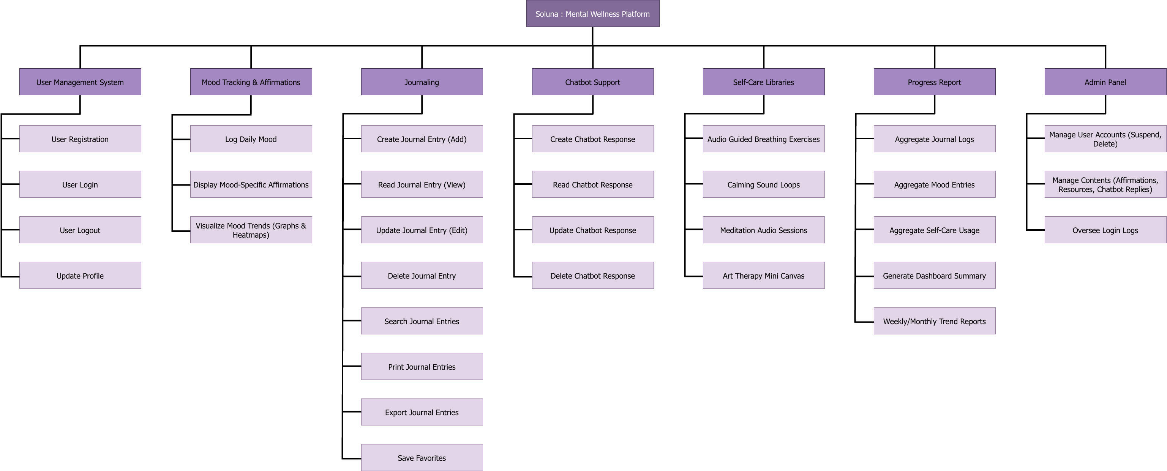
Figure 1 FDD Diagram

Overall Description

Product Perspective
Soluna is a digital mental wellness platform addressing global mental health challenges, integrating mood tracking, affirmations, journaling, chatbot support, self-care resources, and progress monitoring in one app. Unlike single-purpose apps, it promotes preventive care and long-term resilience, built with React, Node.js, MySQL, and managed via Kanban for flexible development.

Product Functions
- Users register/login, track moods with affirmations, journal reflections, chat with AI for guidance, access self-care resources, and view progress reports.
- Admins manage users (suspend/unban) and content (add/edit self-care resources).
- System ensures secure data handling and real-time visualizations.

Stakeholders
- End Users: End users are people who register and log in to use Soluna.
- Admin: Admin refers to administrators who manage users, content, and system security.
- Guests: Guests are visitors who do not log in.

Operating Environment
- Frontend: React.js, works on modern browsers.
- Backend: Node.js with Express.
- Database: MySQL for storing data.
- Third-Party: Ollama AI (chatbot), Chart.js (visuals), Quill (journal), etc.
- Network: Internet required; HTTPS-secured.

Design and Implementation
- Use Kanban methodology for development.
- Ensure data privacy and user consent.
- Chatbot is supportive only, not therapy.
- Web-based only; no native mobile app.

Assumptions and Dependencies
- Users have stable internet access for real-time features.
- Third-party APIs (e.g., Ollama, Google OAuth) are available and stable.
- Database handles relational data efficiently.
- No integration with external medical systems.

System Requirements
Requirements are grouped by subsystem, each with a code (e.g., UMS-F-1.0), description, and use case.
Legend:
Types of Requirements
- F: Functional Requirement
- NF: Non-Functional Requirement
- UR: Usability Requirement
Subsystems
- UMS: User Management System
- MATS: Mood and Affirmation Tracking System
- JS: Journaling System
- CSS: Chatbot Support System
- PRS: Progress Report System
- APS: Admin Panel System

User Management System (UMS)
Code | Descriptions | Use Case
UMS-F-1.0 | Users can register with email, password, or Google OAuth. | Register user
UMS-NF-1.1 | Registration data must be encrypted before transmission. | Register user
UMS-NF-1.2 | Passwords must include letters, numbers, and special characters. | Register user
UMS-UR-1.1 | Password fields shall have hide/unhide options. | Register user
UMS-UR-1.2 | Real-time validation for email uniqueness and password strength. | Register user
UMS-F-2.0 | Users can log in with email/password or Google. | Login user
UMS-NF-2.1 | Sessions must use JWT for secure authentication. | Login user
UMS-F-3.0 | Users can reset passwords via email link. | Reset password
UMS-UR-3.1 | Reset form validates that new password matches confirmation. | Reset password
UMS-F-4.0 | Users can update profiles (e.g., name, preferences). | Update profile

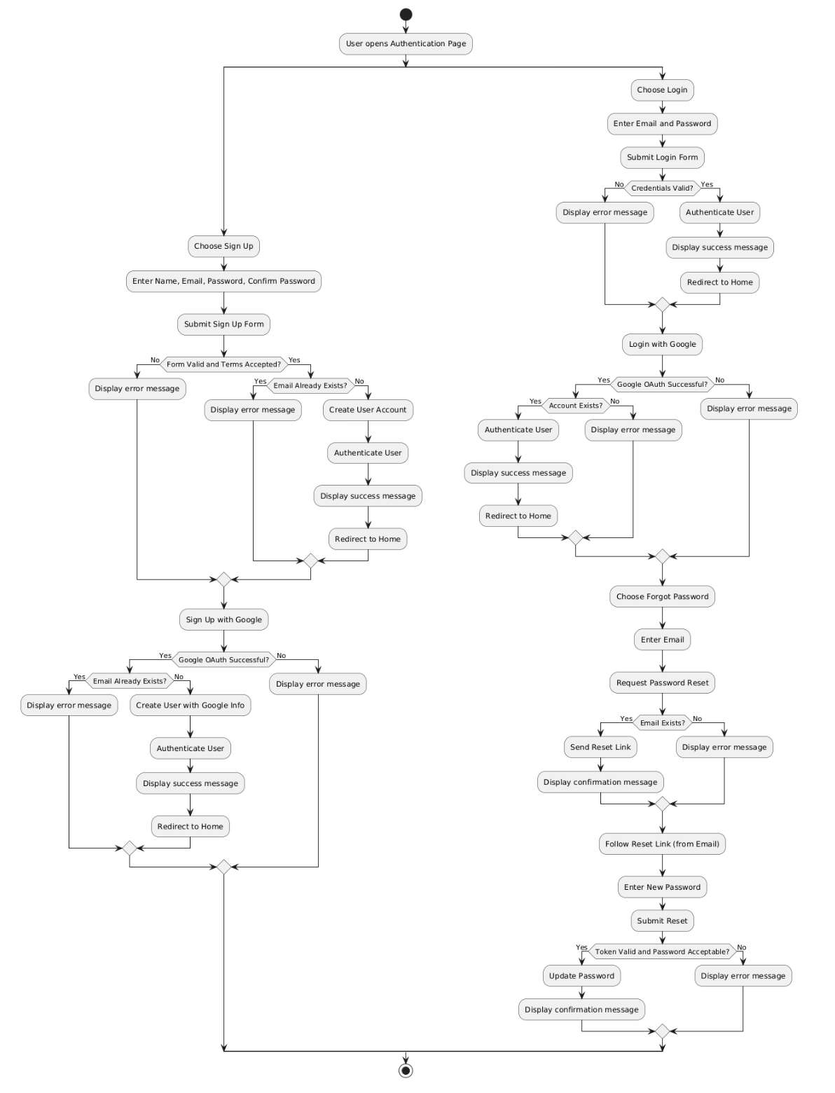
Figure 2 Activity Diagram for UMS

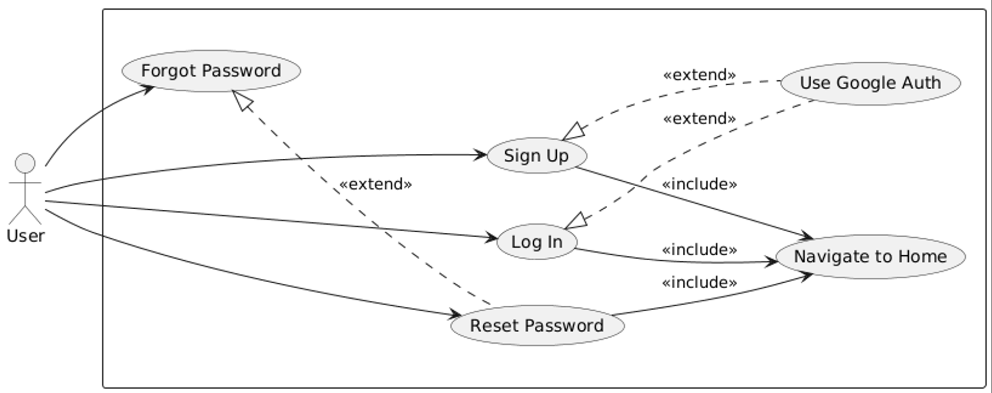
Figure 3 Use-Case Diagram for UMS
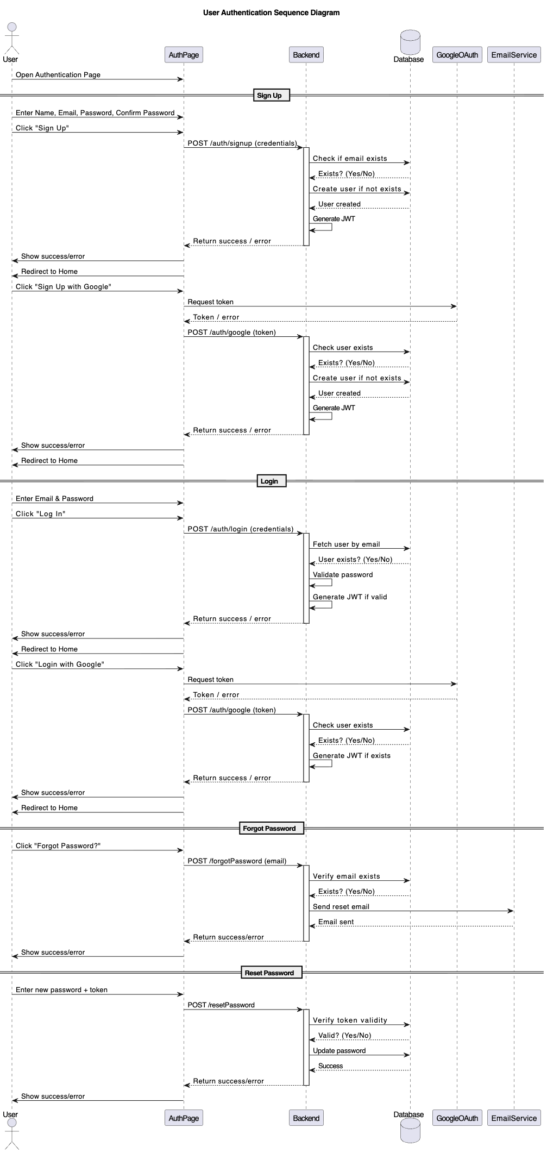
Figure 4 Sequence Diagram for UMS

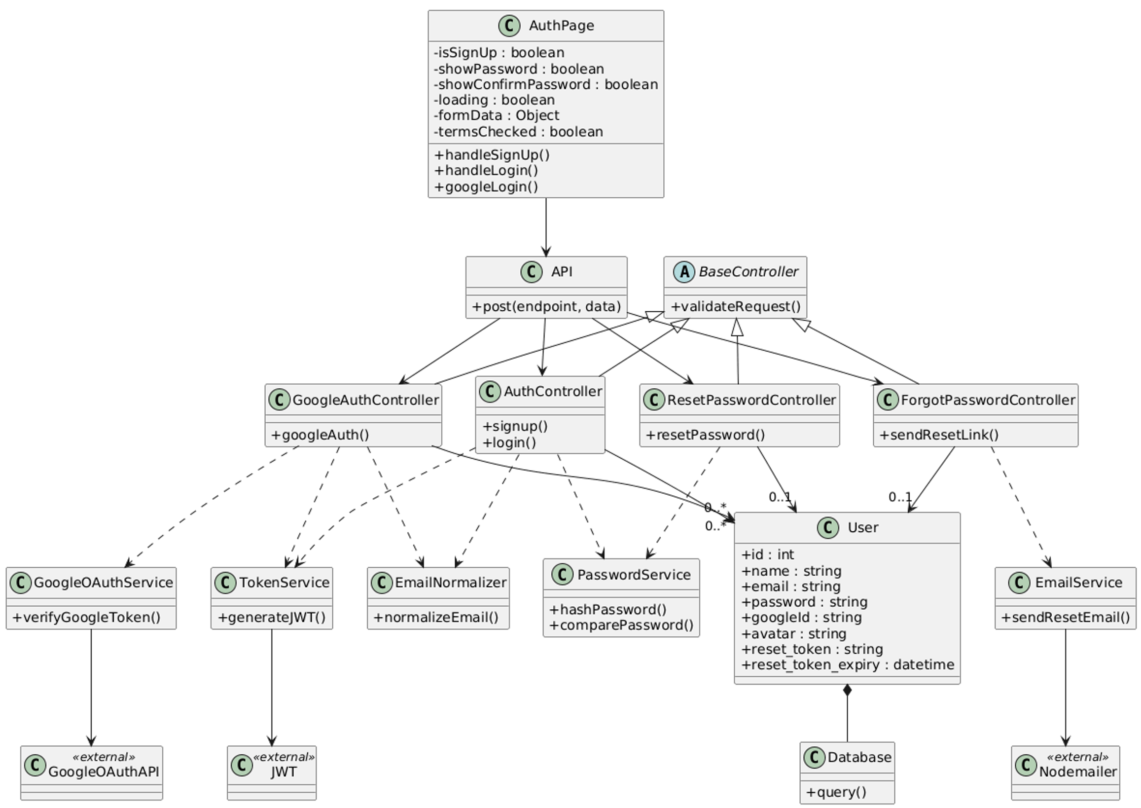
Figure 5 Class Diagram for UMS

Mood and Affirmation Tracking System (MATS)
Code | Descriptions | Use Case
MATS-F-1.0 | Users can log daily moods with emojis or sliders and the slider to be disabled if already logged the mood. | Log mood
MATS-NF-1.1 | Mood data must be stored securely and privately. | Log mood
MATS-UR-1.1 | Mood entry shall be simple with quick submission. | Log mood
MATS-F-2.0 | System generates mood-based affirmations. | Generate affirmation
MATS-NF-2.1 | Affirmations must be positive and contextually relevant. | Generate affirmation
MATS-F-3.0 | Display mood trends via line graphs and heatmaps. | View mood trends
MATS-UR-3.1 | Visualizations shall be interactive. | View mood trends

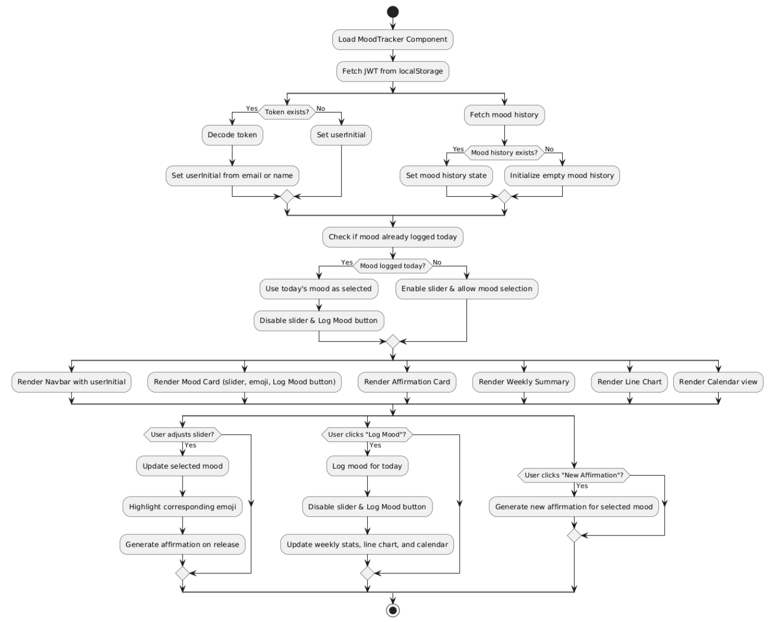
Figure 6 Activity Diagram for MATS

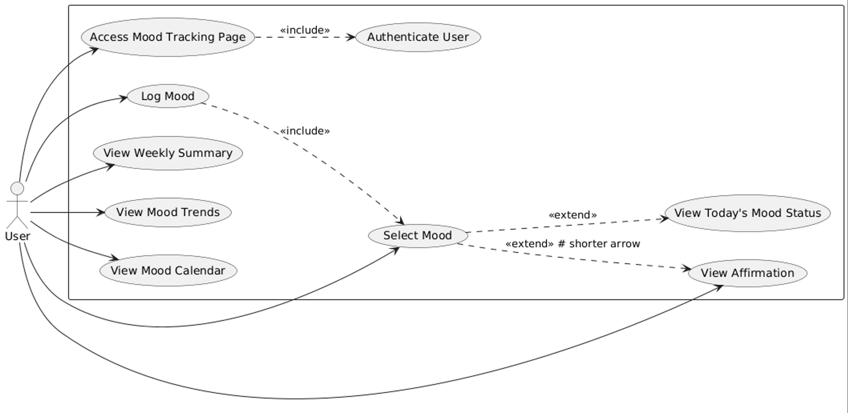
Figure 7 Use-Case Diagram for MATS

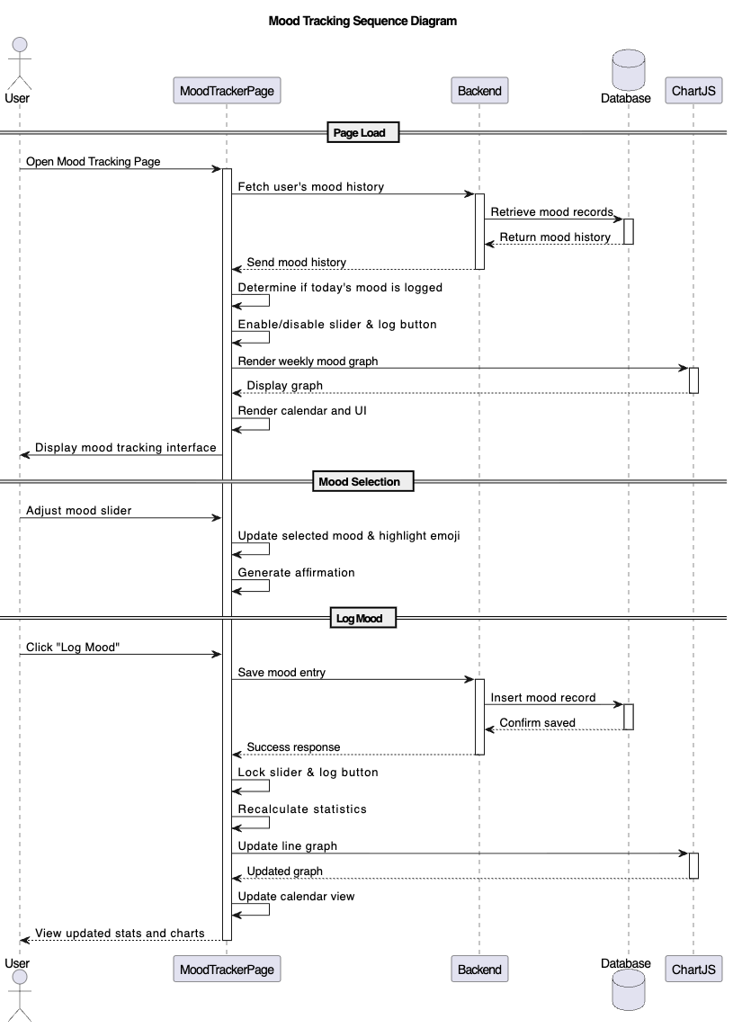
Figure 8 Sequence Diagram for MATS

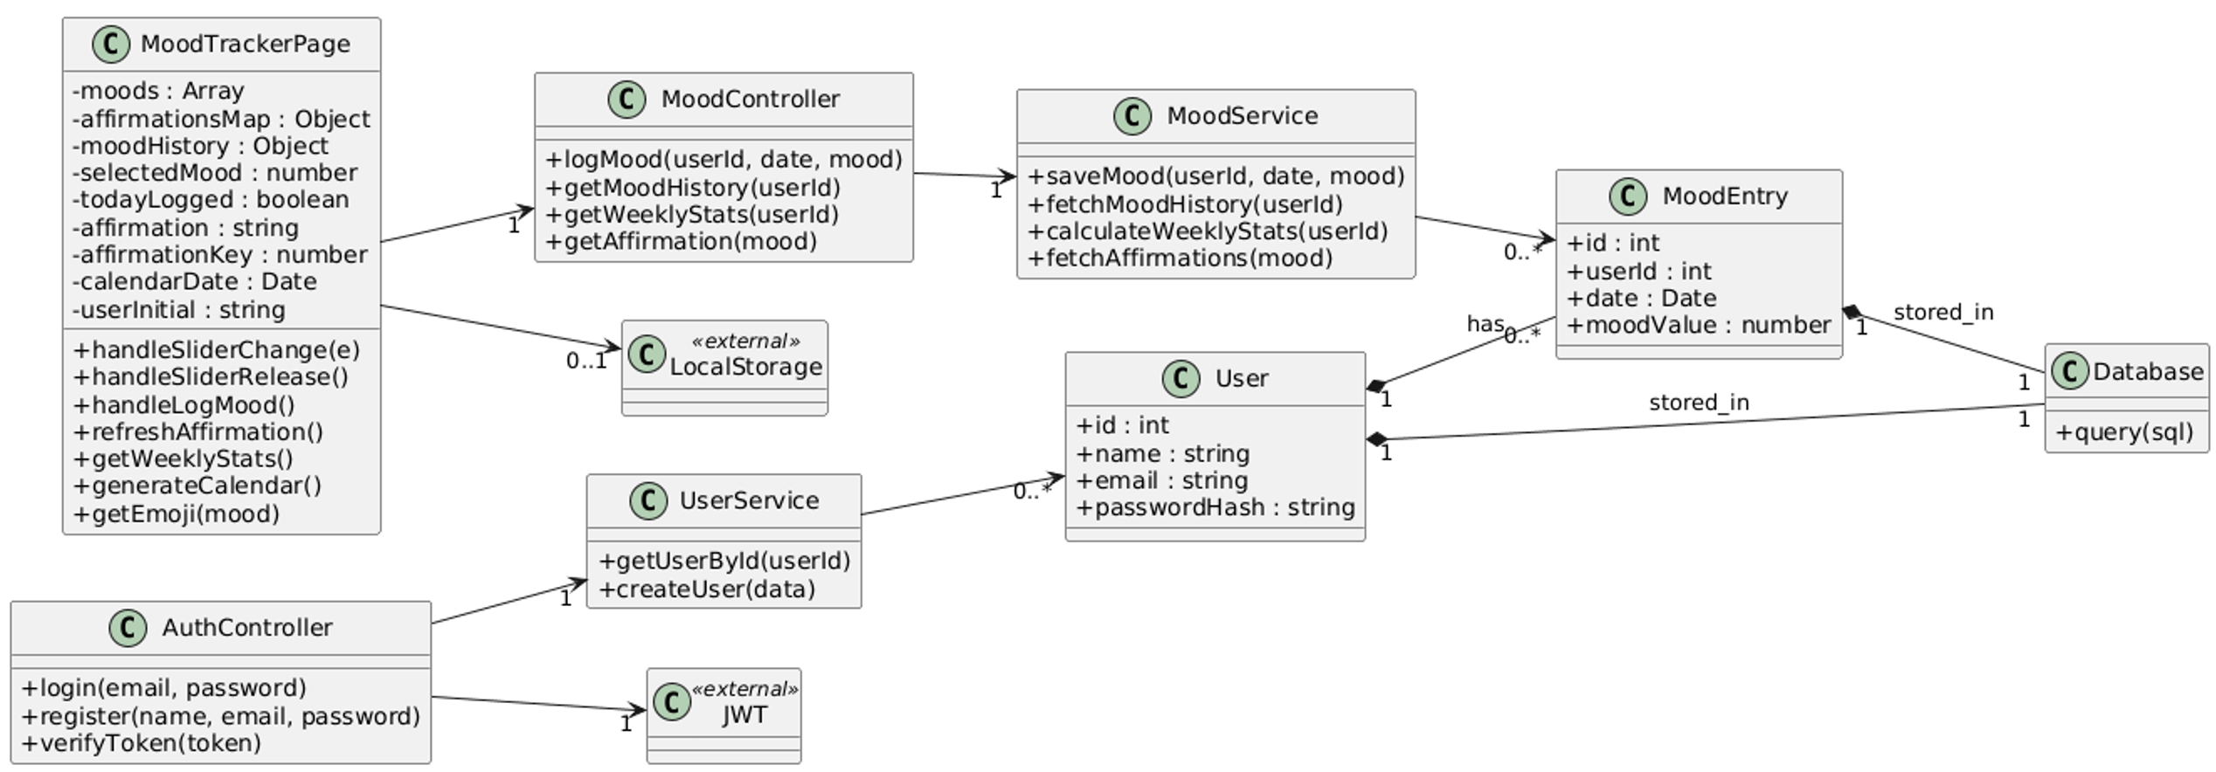
Figure 9 Class Diagram for MATS

Journaling System (JS)
Code | Descriptions | Use Case
JS-F-1.0 | Users can create, edit, and delete journal entries. | Manage journal
JS-NF-1.1 | Journal entries must be private and encrypted. | Manage journal
JS-UR-1.1 | Editor shall support rich text formatting. | Manage journal
JS-F-2.0 | Display a searchable list of past entries. | View journals
JS-UR-2.1 | Search by title with auto-complete. | View journals
JS-F-3.0 | Users can export journal entries. | Export journals
JS-F-3.1 | Users can print journal entries. | Print journals
JS-F-3.2 | Journal entries auto-save every time the user types. | Auto-save journals

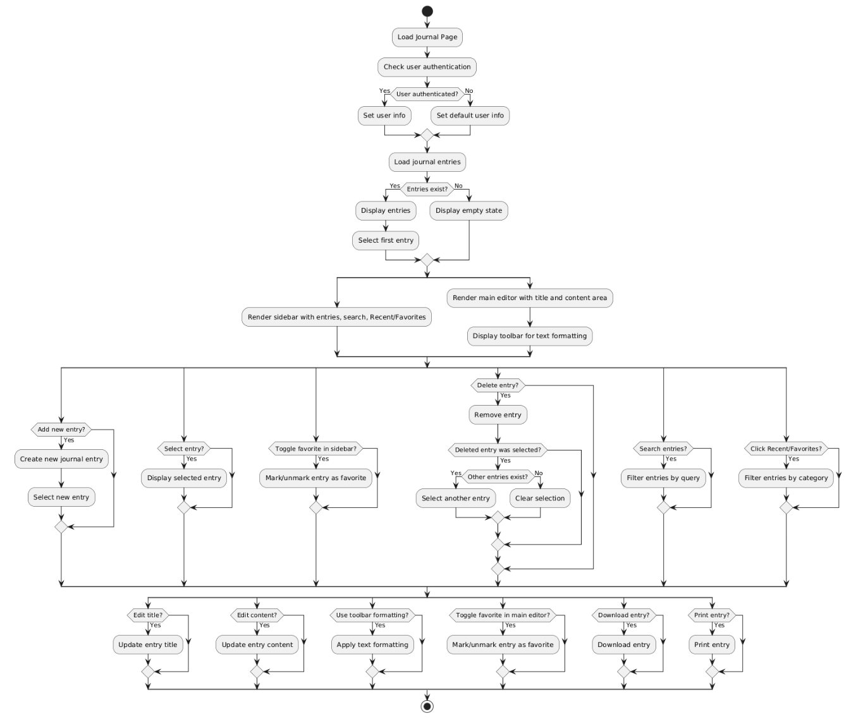
Figure 10 Activity Diagram for JS

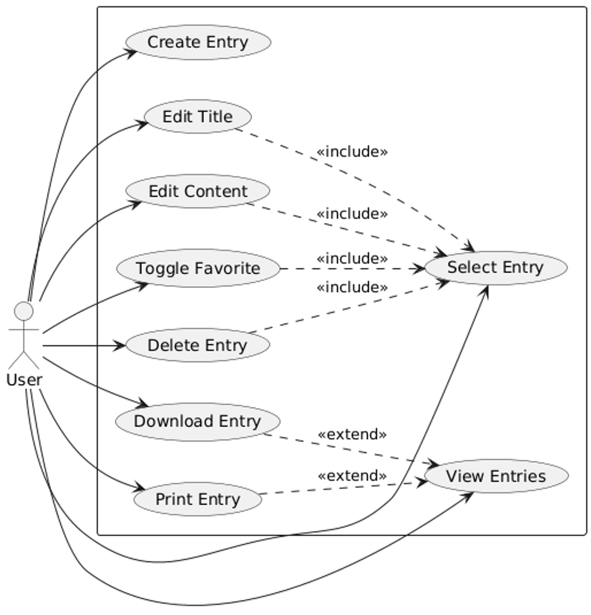
Figure 11 Use-Case Diagram for JS

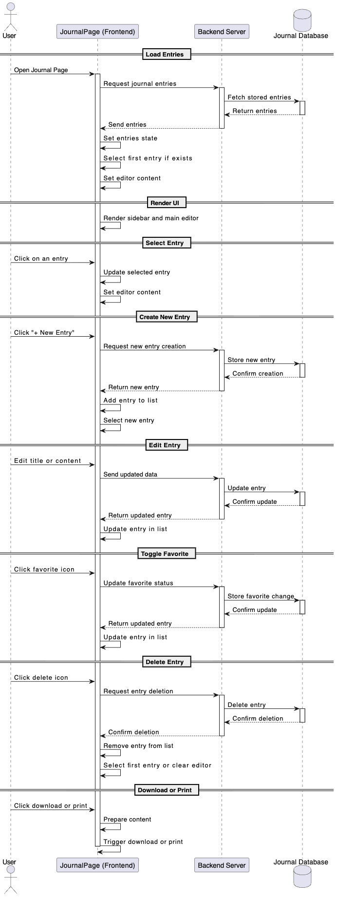
Figure 12 Sequence Diagram for JS
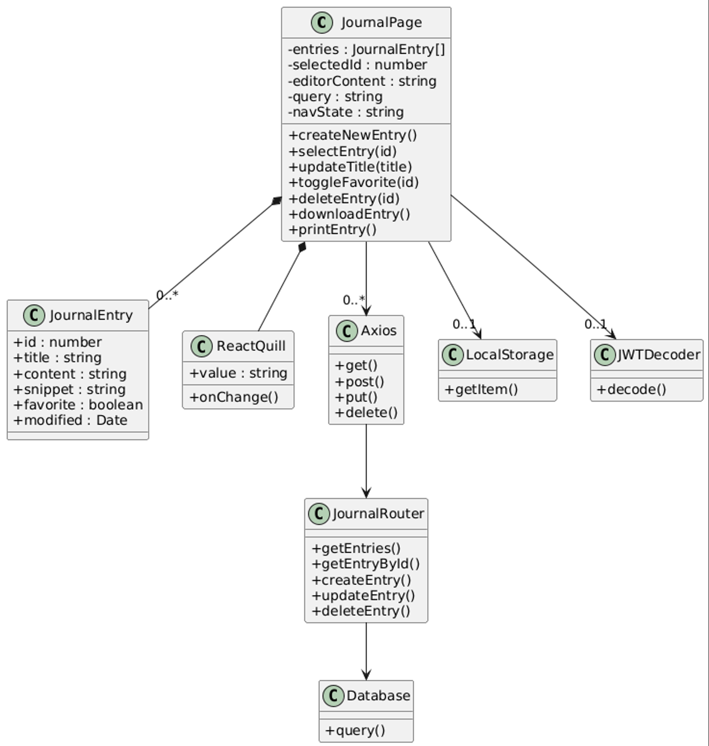
Figure 13 Class Diagram for JS

Chatbot Support System (CSS)
Code | Descriptions | Use Case
CSS-F-1.0 | Provide AI chatbot for empathetic guidance. | Chat with bot
CSS-NF-1.1 | Responses must detect crises and suggest helplines. | Chat with bot
CSS-UR-1.1 | Chat interface shall be conversational. | Chat with bot
CSS-F-2.0 | Store chat history for user review. | View chat history
CSS-NF-2.1 | History must be deletable and private. | View chat history

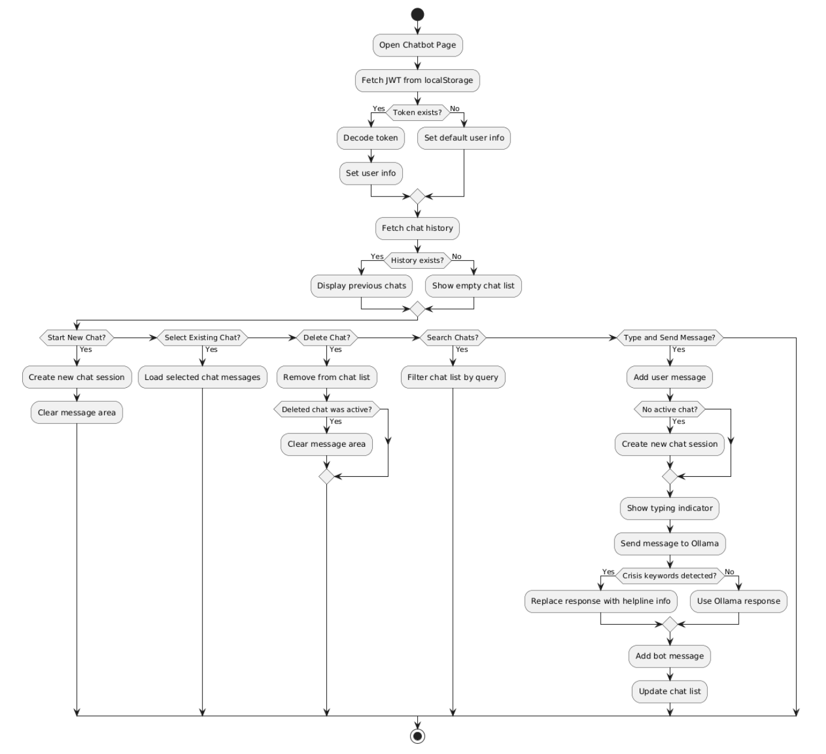
Figure 14 Activity Diagram for CSS
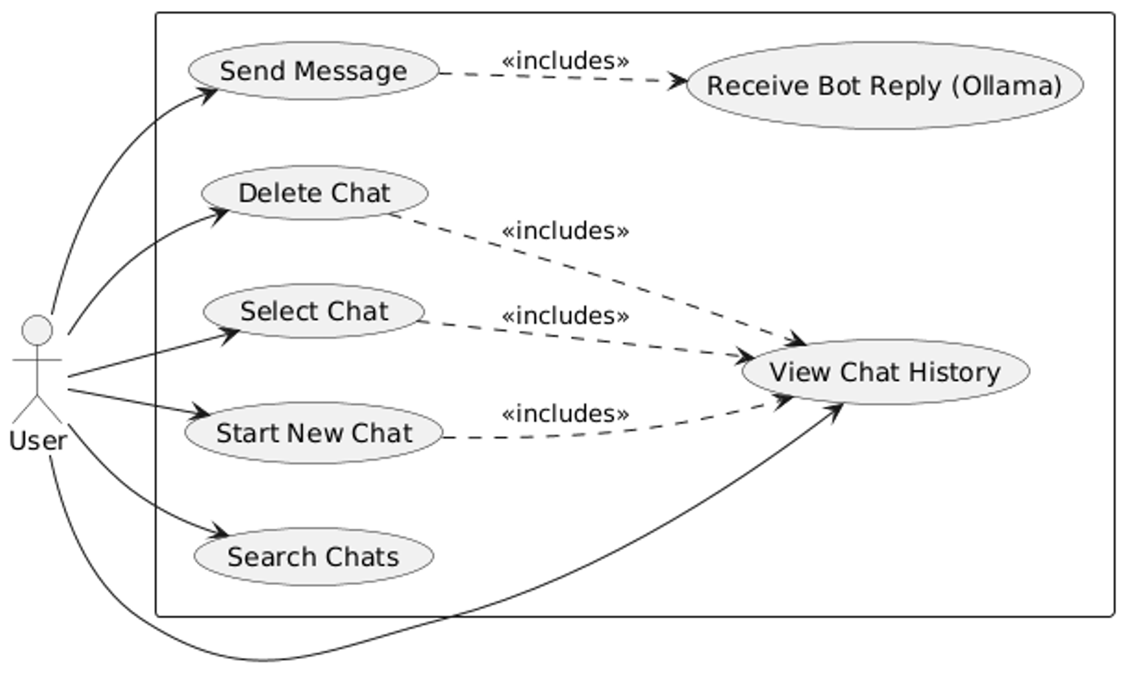
Figure 15 Use-Case Diagram for CSS

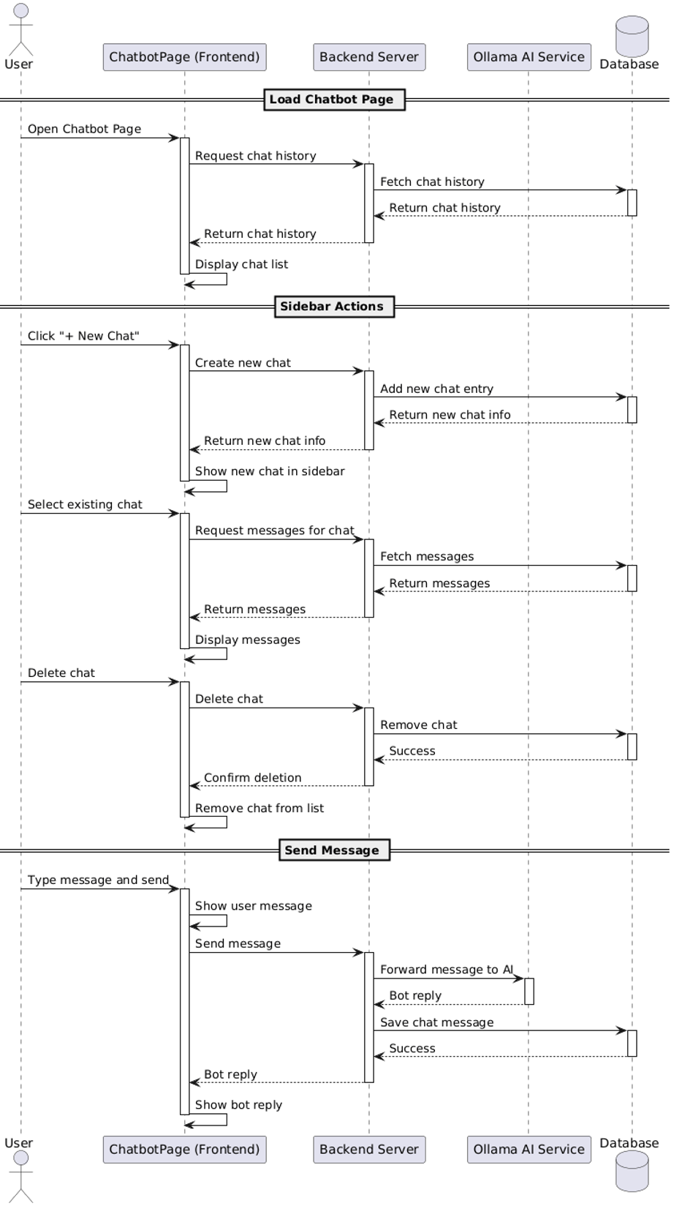
Figure 16 Sequence Diagram for CSS
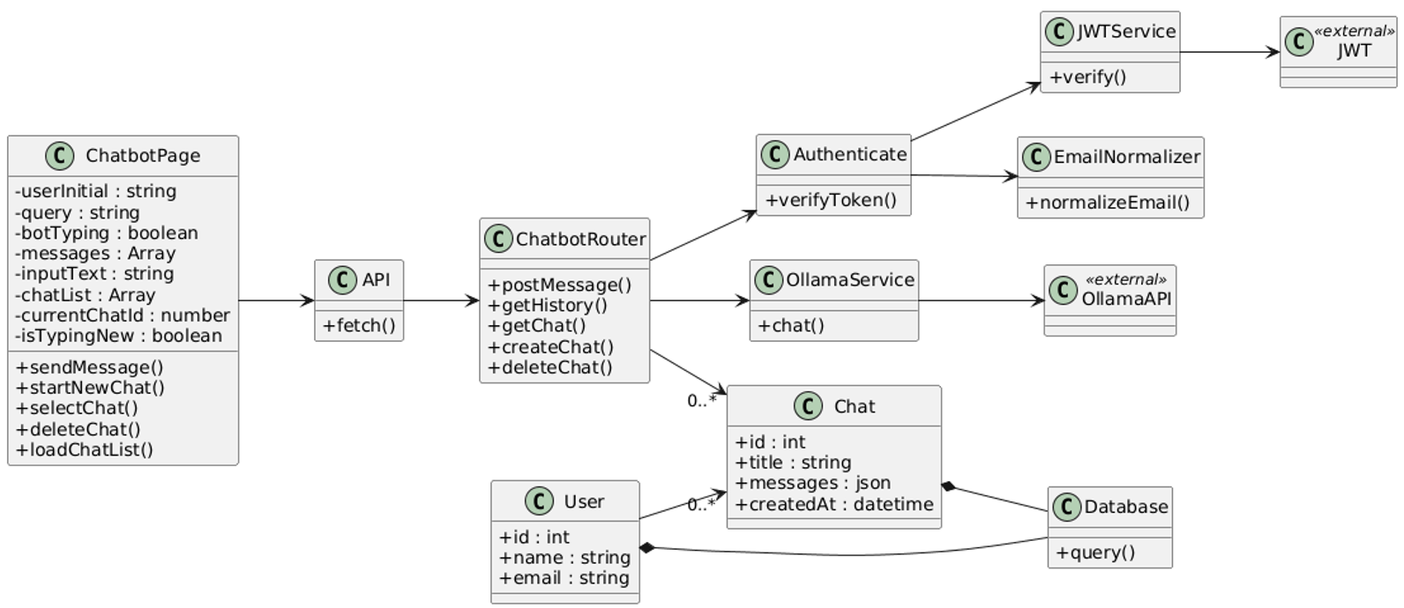
Figure 17 Class Diagram for CSS

Self-Care Library System (SCLS)
Code | Descriptions | Use Case
SCLS-F-1.0 | Provide guided breathing exercises. | Perform breathing
SCLS-UR-1.1 | Interface shall include timers and animations. | Perform breathing
SCLS-F-2.0 | Offer calming sounds for playback. | Play sounds
SCLS-NF-2.1 | Sounds must load quickly. | Play sounds
SCLS-F-3.0 | Provide audio meditations. | Play meditation
SCLS-UR-3.1 | Allow pause/resume and track progress. | Play meditation
SCLS-F-4.0 | Include art therapy canvas for drawing. | Use art canvas
SCLS-NF-4.1 | Save drawings securely. | Use art canvas
SCLS-F-5.0 | Log self-care session completions. | Log self-care

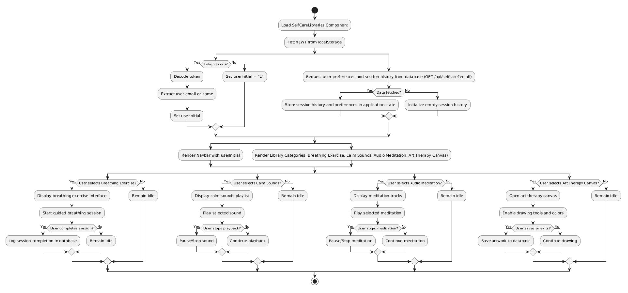
Figure 18 Activity Diagram for SCLS
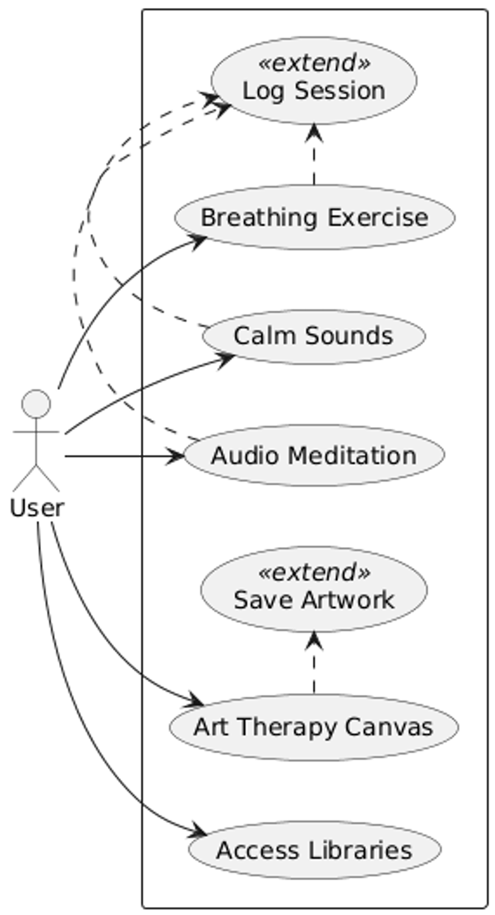
Figure 19 Use-Case Diagram for SCLS

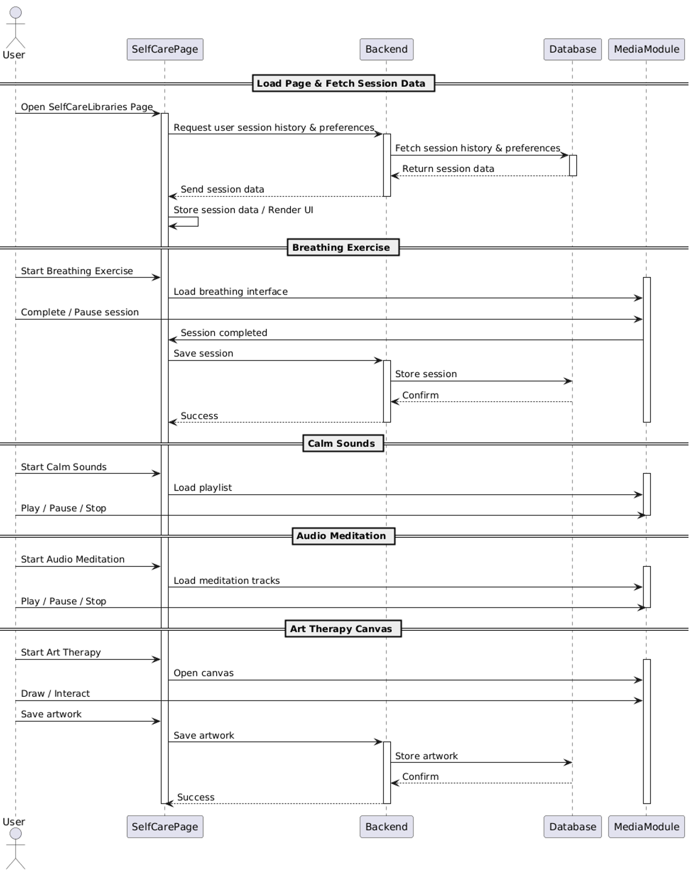
Figure 20 Sequence Diagram for SCLS

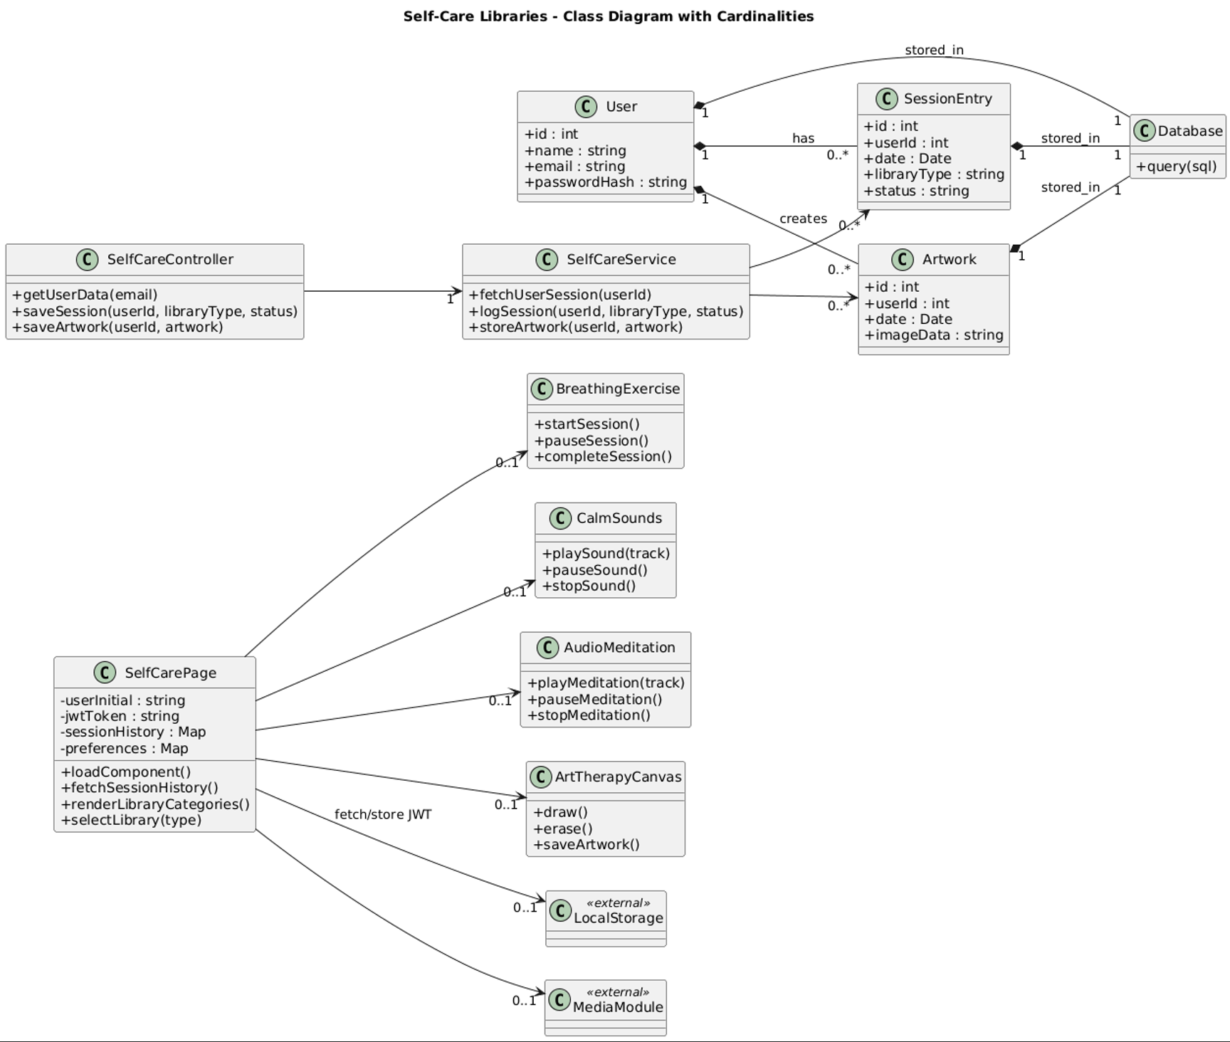
Figure 21 Class Diagram for SCLS

Progress Report System (PRS)
Code | Descriptions | Use Case
PRS-F-1.0 | Generate weekly/monthly reports from data. | Generate report
PRS-NF-1.1 | Reports must be accurate and based on user permission. | Generate report
PRS-UR-1.1 | Include charts/tables for easy viewing. | Generate report
PRS-F-2.0 | Allow report export (e.g., PDF). | Export report

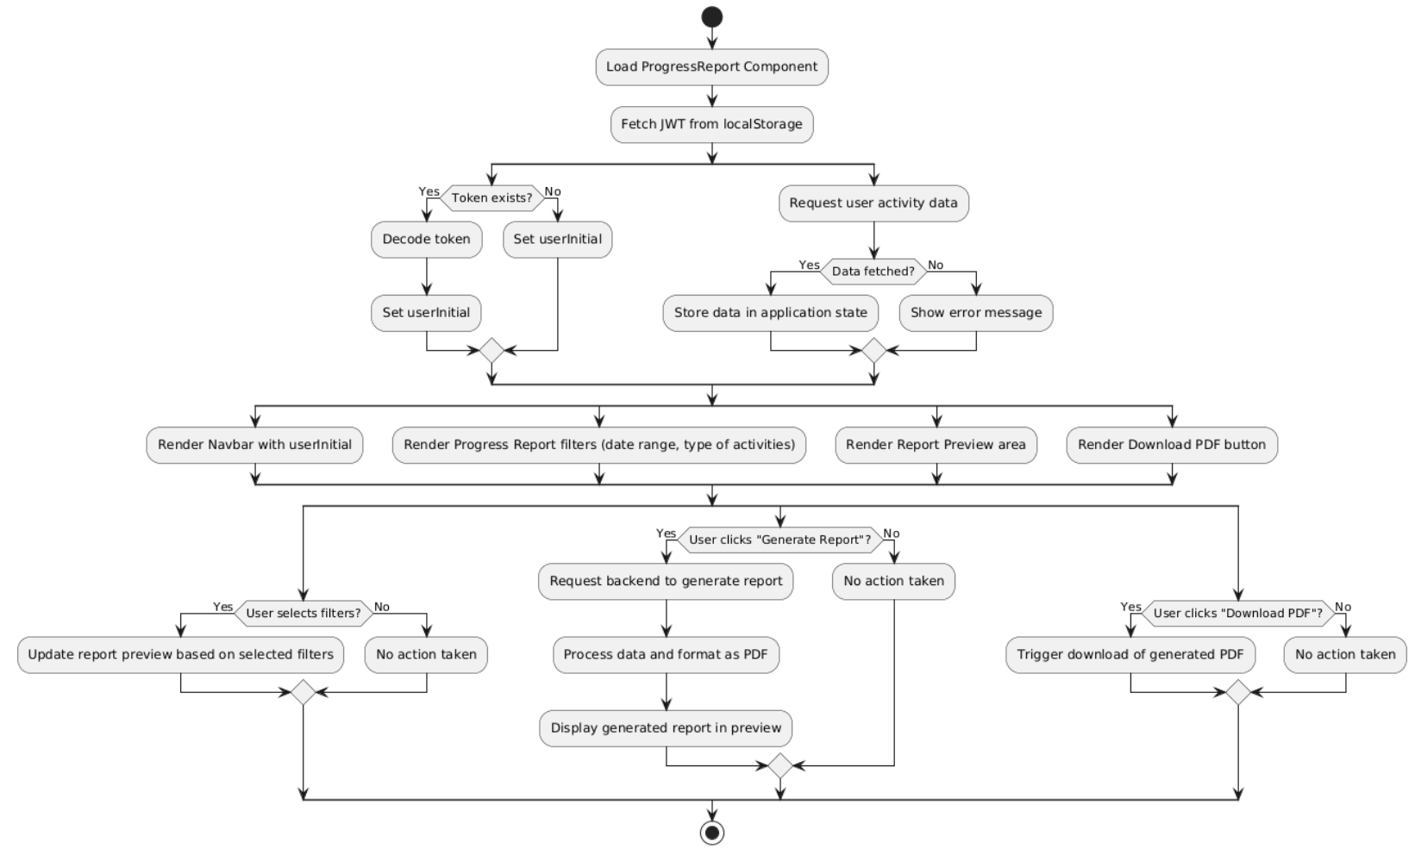
Figure 22 Activity Diagram for PRS
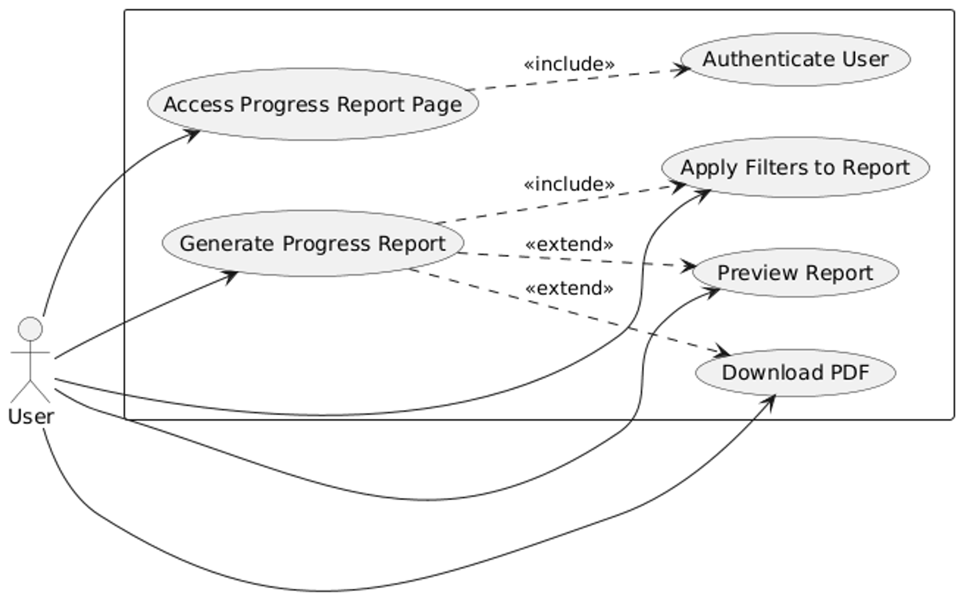
Figure 23 Use-Case Diagram for PRS

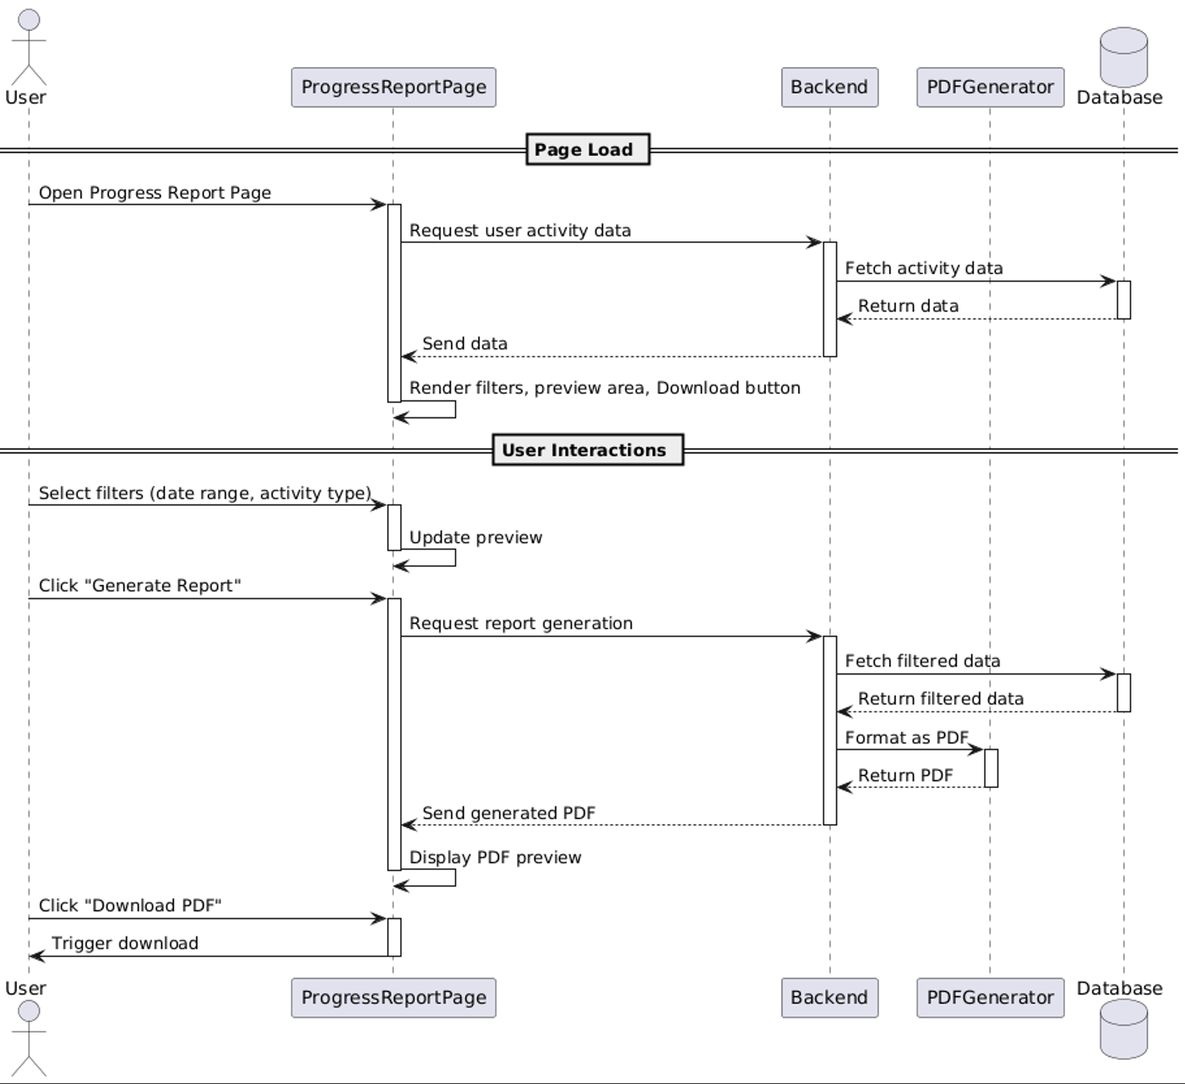
Figure 24 Sequence Diagram for PRS

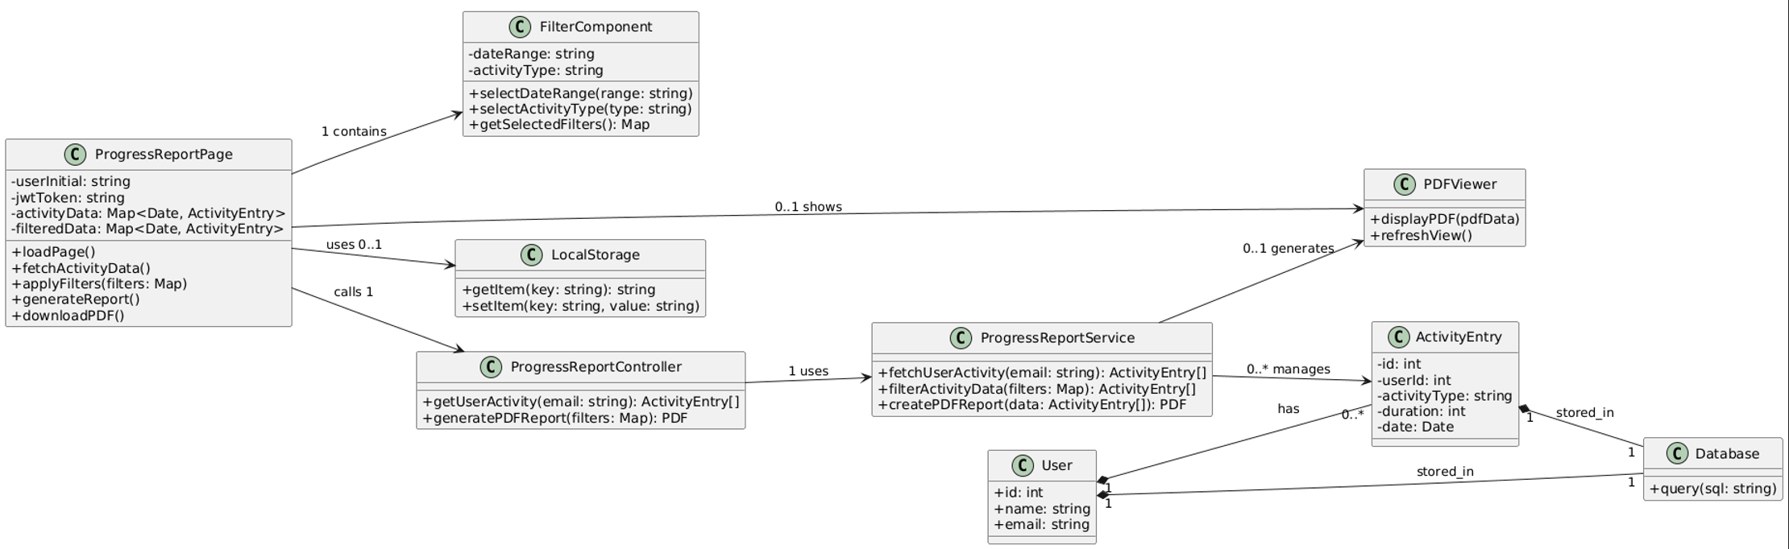
Figure 25 Class Diagram for PRS

Admin Panel System (APS)
Code | Descriptions | Use Case
APS-F-1.0 | Allow admin to view and suspend/unban users. | Manage users
APS-NF-1.1 | Admin actions must be logged for auditing. | Manage users
APS-UR-1.1 | Dashboard shall show user stats and support search. | Manage users
APS-F-2.0 | Allow admins to add/edit self-care content. | Manage content
APS-NF-2.1 | Content updates must not exceed file size limits. | Manage content
APS-UR-2.1 | Provide preview before publishing content. | Manage content

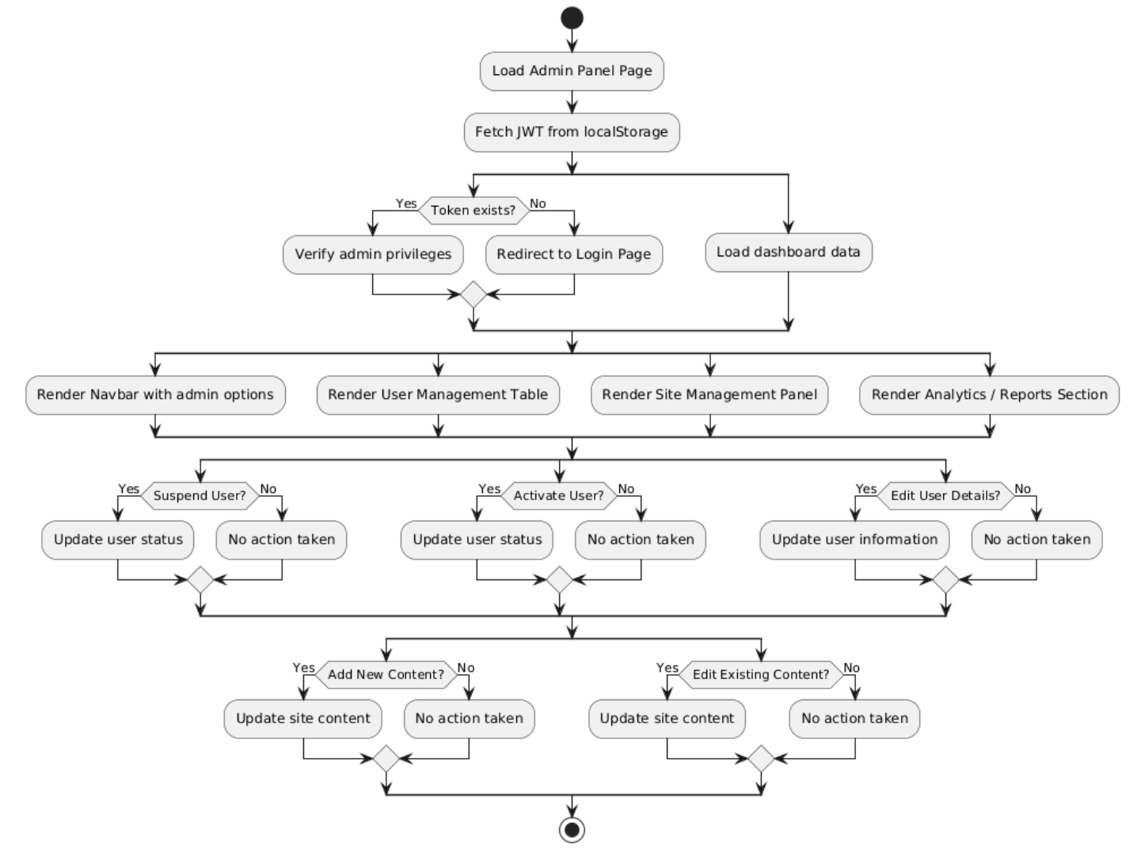
Figure 26 Activity Diagram for APS

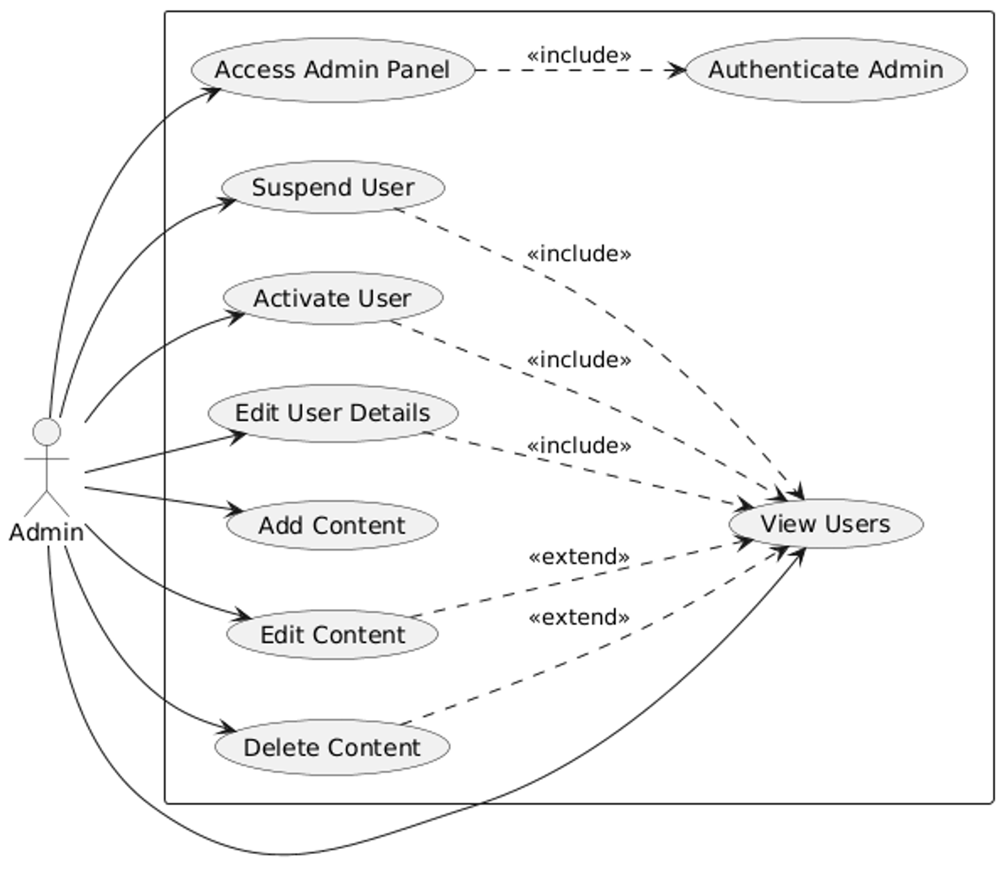
Figure 27 Use-Case Diagram for APS
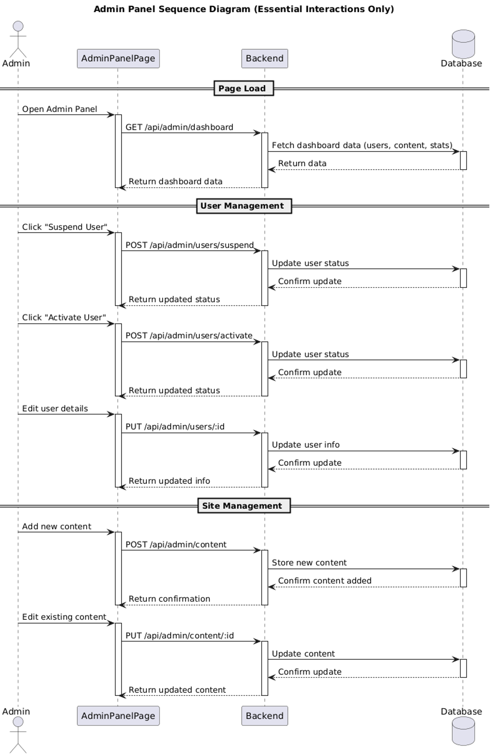
Figure 28 Sequence Diagram for APS

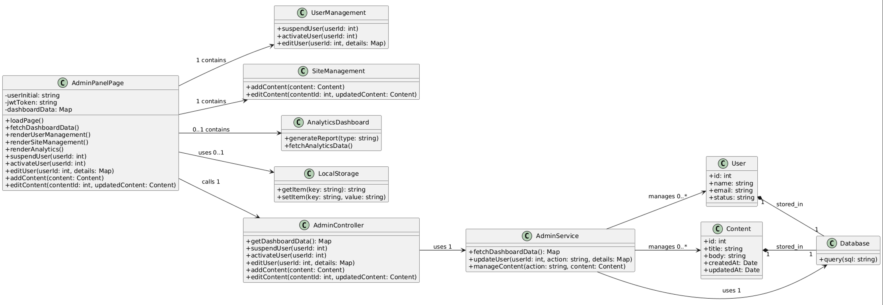
Figure 29 Class Diagram for APS

System Design (Whole System Level)
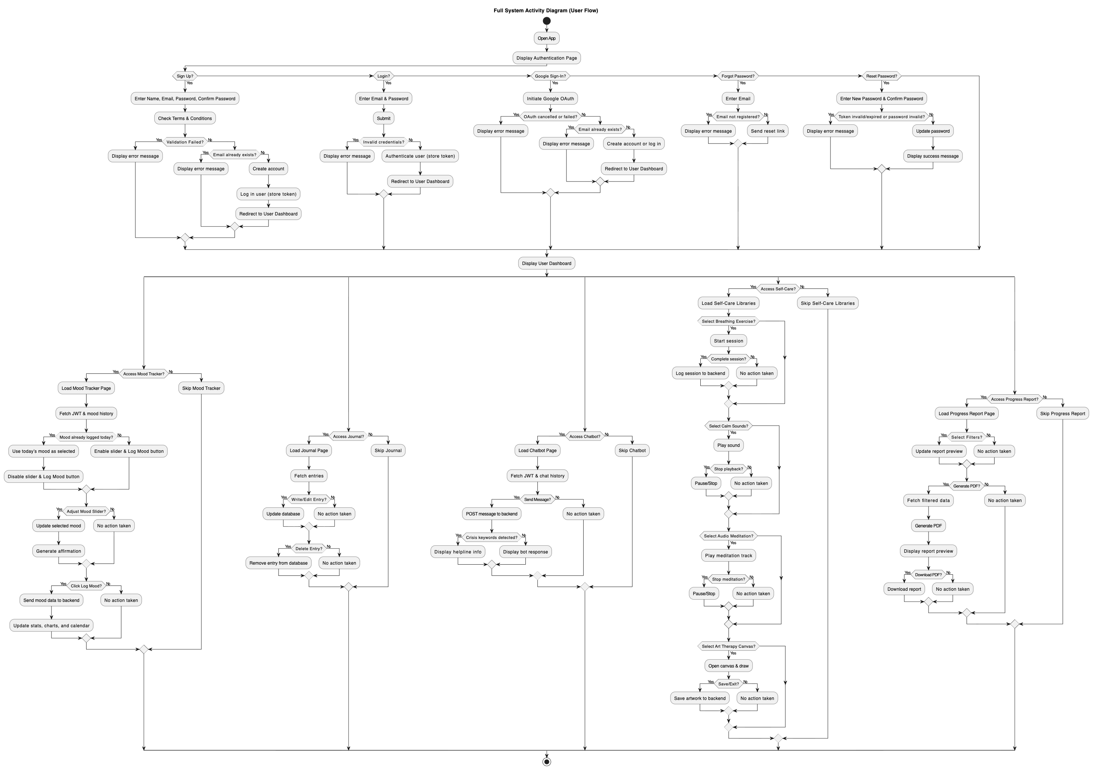
Figure 30 Activity Diagram for the Whole System

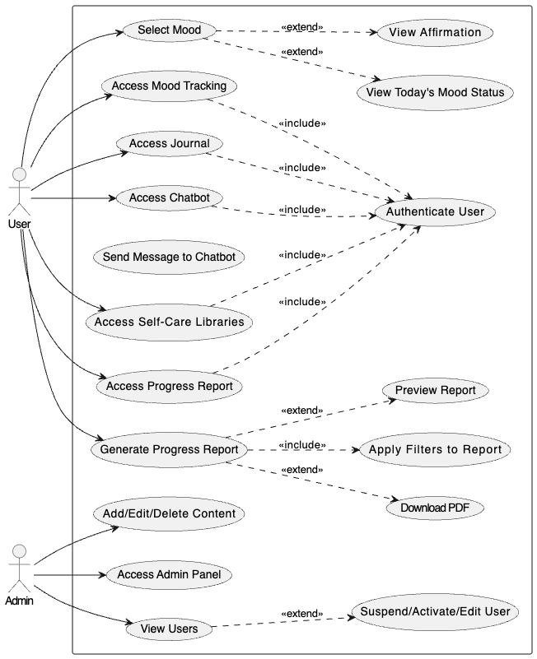
Figure 31 Use-Case Diagram for the Whole System
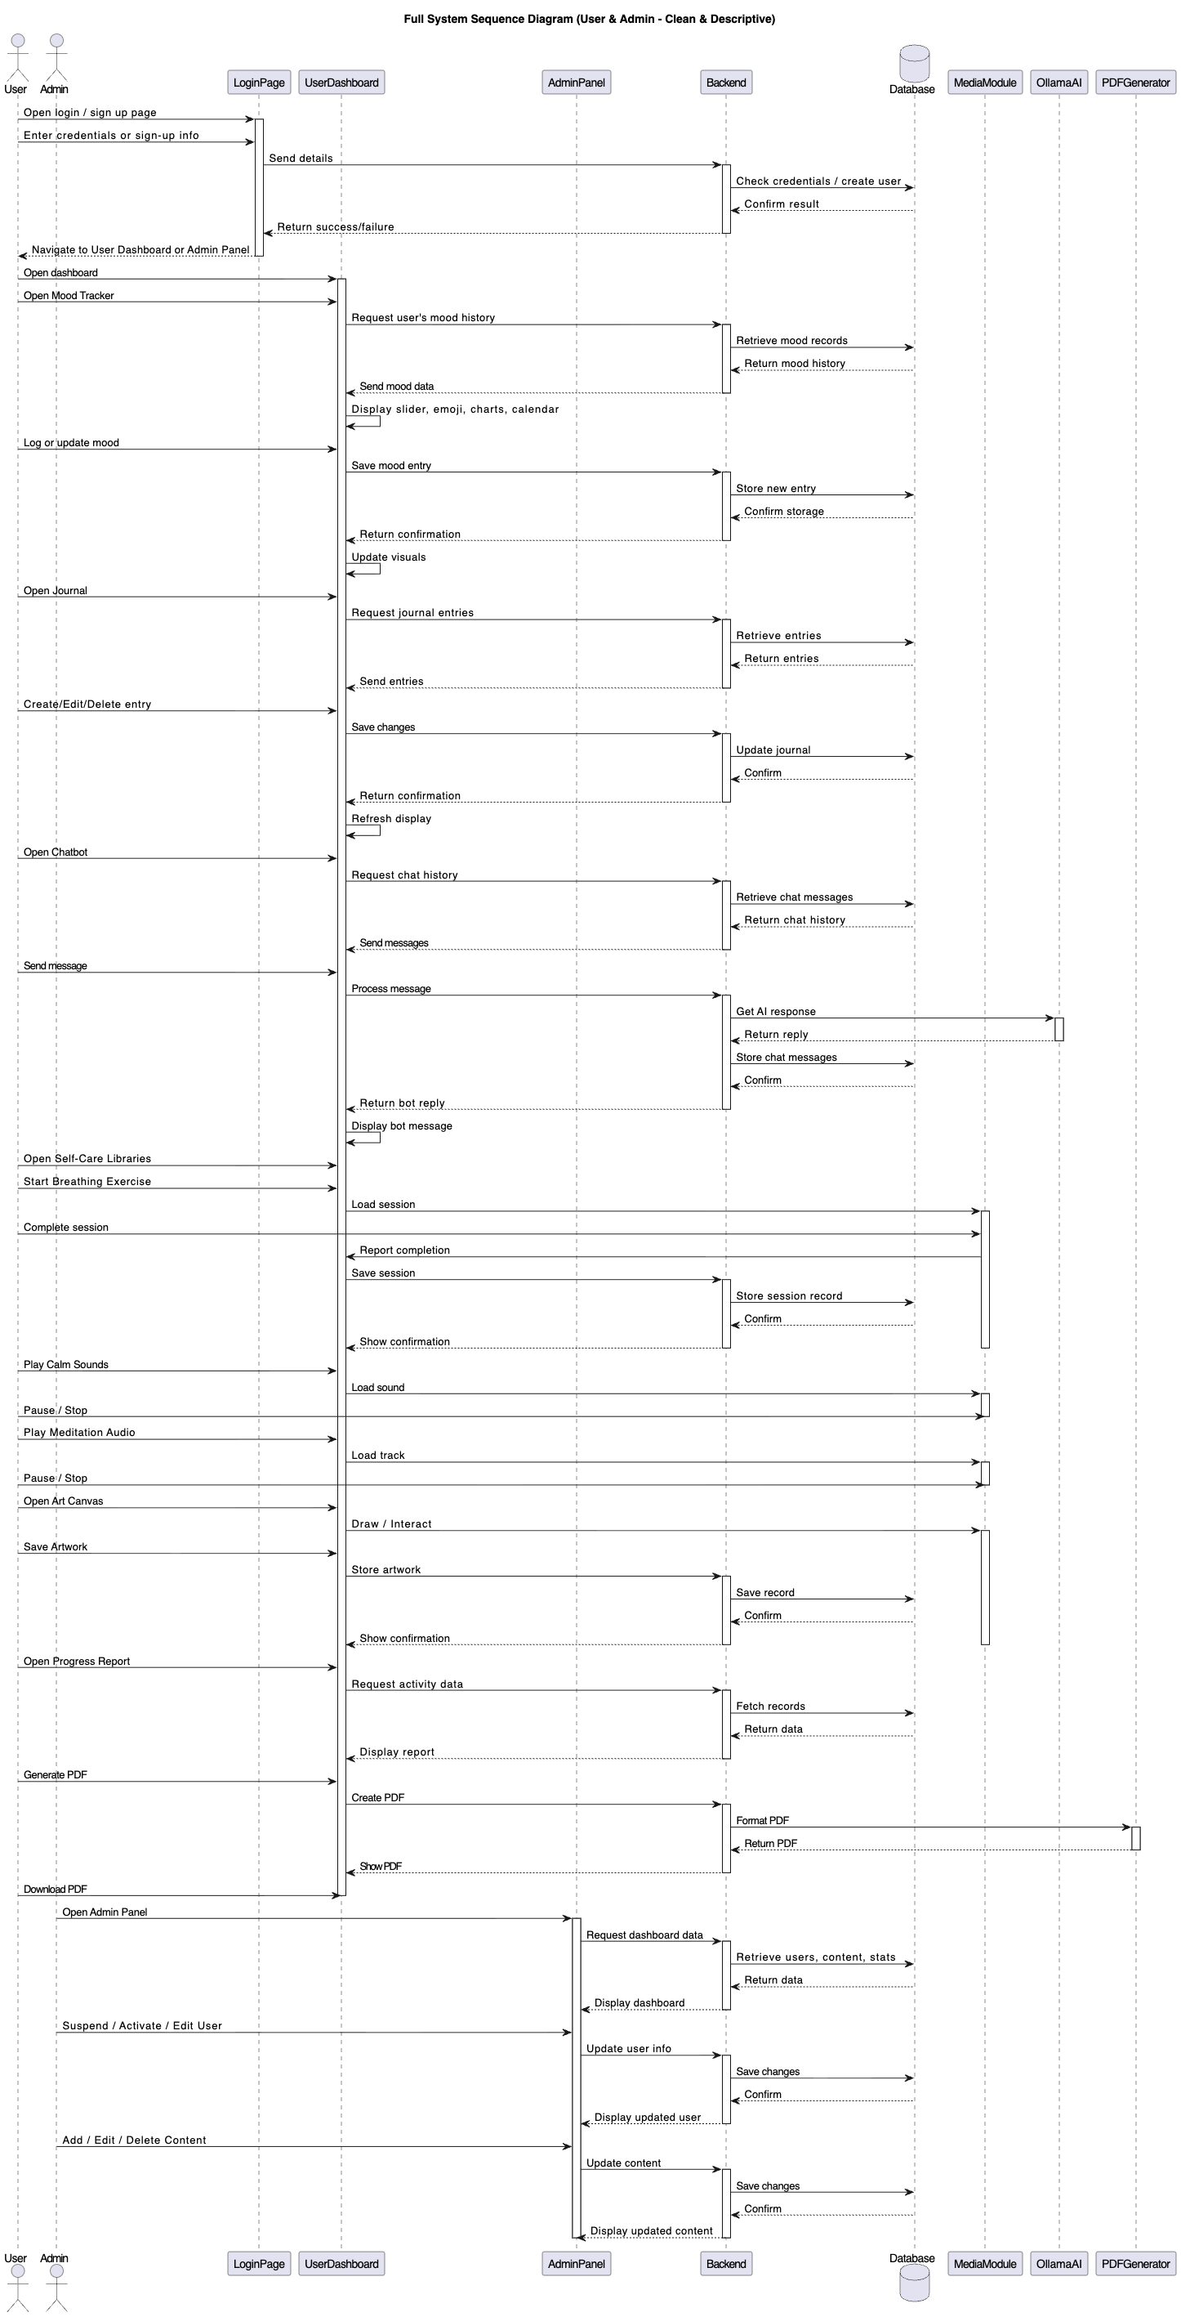
Figure 32 Sequence Diagram for the Whole System
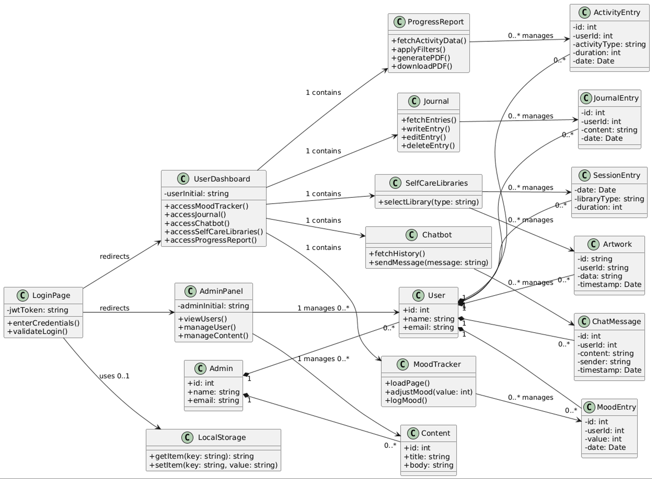
Figure 33 Class Diagram for the Whole System

Entity Relationship Diagram (ERD)
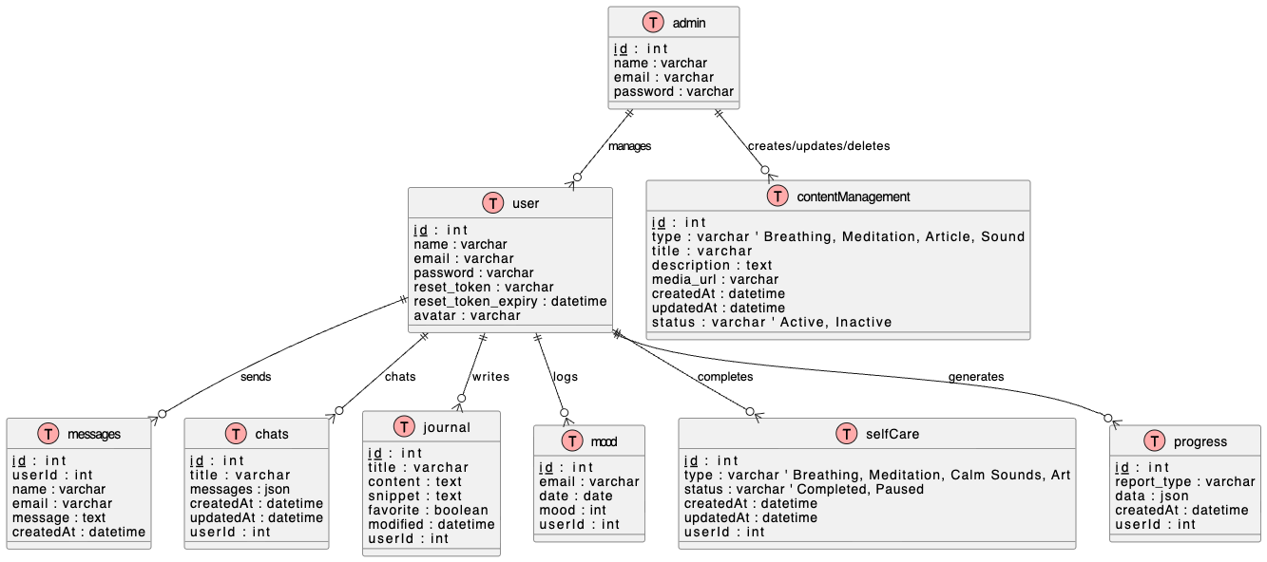
Figure 34 Entity Relationship Diagram (ERD)

Data Dictionary

User Table
Field | Type | Null | Key | Description
id | int | No | PK | Unique identifier for each user
name | varchar(255) | No |  | Full name of the user
email | varchar(255) | No | Unique | User email for login
password | varchar(255) | No |  | Hashed password
reset_token | varchar(255) | Yes |  | Token for password reset
reset_token_expiry | datetime | Yes |  | Expiry date/time for reset token
avatar | varchar(255) | Yes |  | Profile picture URL

Contact Table
Field | Type | Null | Key | Description
id | int | No | PK | Unique identifier for each contact message
name | varchar(255) | No |  | Name of the sender
email | varchar(255) | No |  | Email of the sender
message | text | No |  | Message content

Mood Table
Field | Type | Null | Key | Description
id | int | No | PK | Mood entry ID
date | date | No |  | Date of mood entry
mood | int | No |  | Mood rating (1-5 or scale)
userId | int | No | FK | References User.id

Journal Table
Field | Type | Null | Key | Description
id | int | No | PK | Journal entry ID
title | varchar(255) | No |  | Entry title
content | text | No |  | Full journal content
snippet | text | Yes |  | Short preview of content
favorite | boolean | No |  | Mark entry as favorite
modified | datetime | No |  | Last modified timestamp
userId | int | No | FK | References User.id

Chatbot Table
Field | Type | Null | Key | Description
id | int | No | PK | Unique chat ID
title | varchar(255) | No |  | Chat title or topic
messages | json | No |  | All messages in the chat
createdAt | datetime | No |  | Chat creation timestamp
updatedAt | datetime | No |  | Last update timestamp
userId | int | No | FK | References User.id

Self-Care Table
Field | Type | Null | Key | Description
id | int | No | PK | Self-care session ID
type | varchar(255) | No |  | Session type
status | varchar(50) | No |  | Status: Completed, Paused
createdAt | datetime | No |  | Session start timestamp
updatedAt | datetime | No |  | Session update timestamp
userId | int | No | FK | References User.id

Progress Report Table
Field | Type | Null | Key | Description
id | int | No | PK | Report ID
report_type | varchar(255) | No |  | Type of report
data | json | No |  | Data used to generate report
createdAt | datetime | No |  | Report creation timestamp
userId | int | No | FK | References User.id

Admin Table
Field | Type | Null | Key | Description
id | int | No | PK | Unique identifier for admin
name | varchar(255) | No |  | Full name of the admin
email | varchar(255) | No | Unique | Admin email for login
password | varchar(255) | No |  | Hashed password

Content Table
Field | Type | Null | Key | Description
id | int | No | PK | Content ID
type | varchar(255) | No |  | Content Type
title | varchar(255) | No |  | Title of content
description | text | Yes |  | Description or instructions
media_url | varchar(255) | Yes |  | Link to media file
createdAt | datetime | No |  | Timestamp content was created
updatedAt | datetime | Yes |  | Timestamp content was updated
status | varchar(50) | No |  | Active or Inactive

Wireframes
The wireframes for my system is given below:
Landing Page:
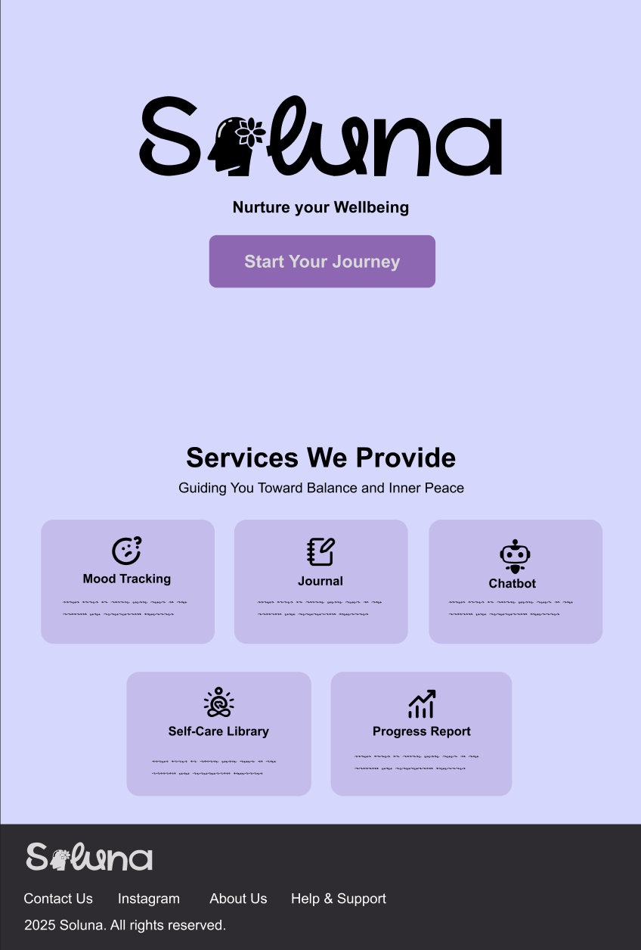
About Us Page:
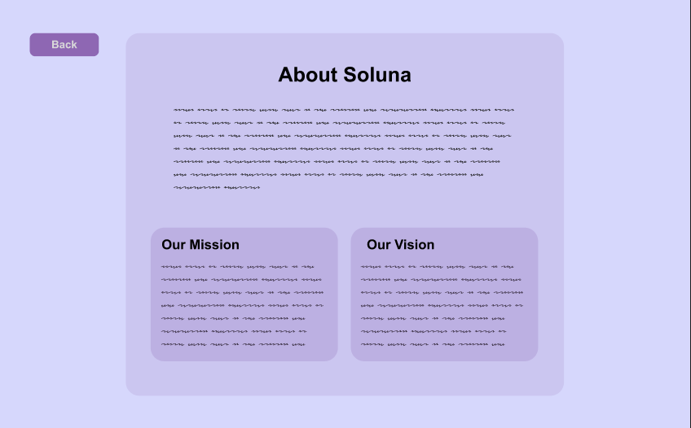
Help & Support Page:
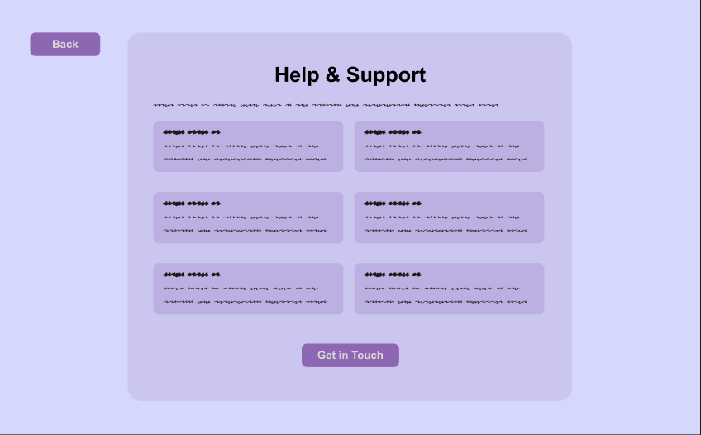
Contact Page:
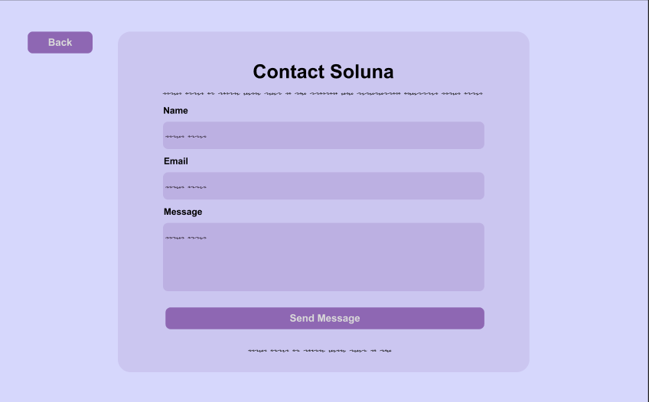
Create Account:
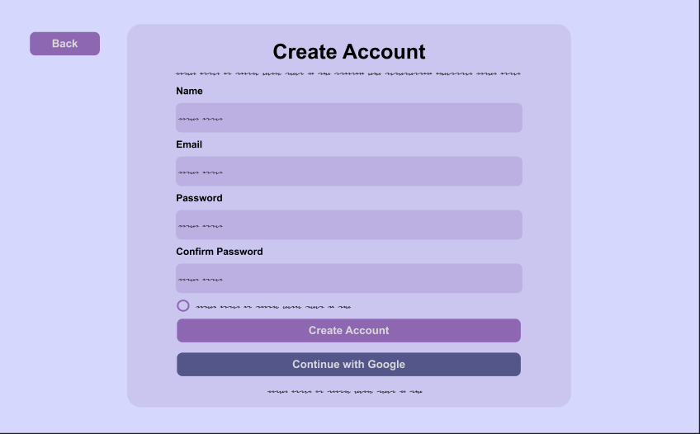

Log In:
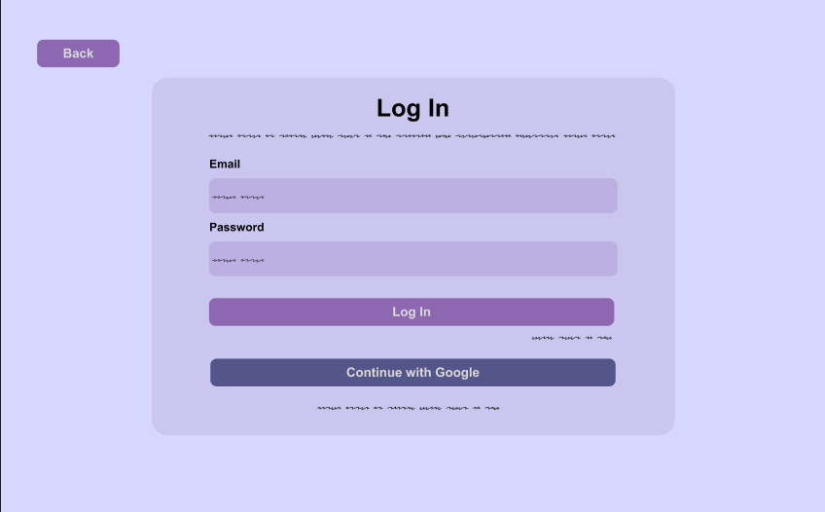
Forgot Password:
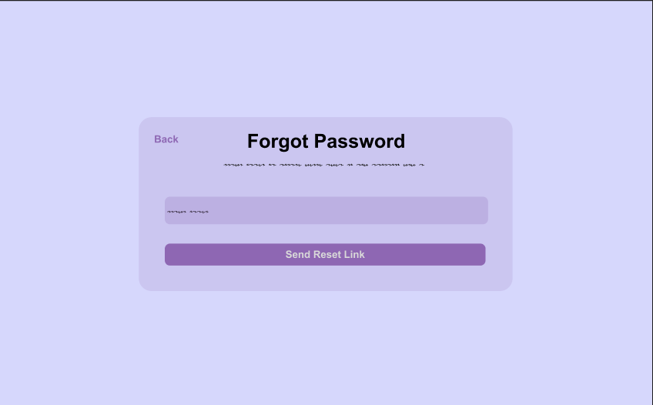
Terms & Conditions:
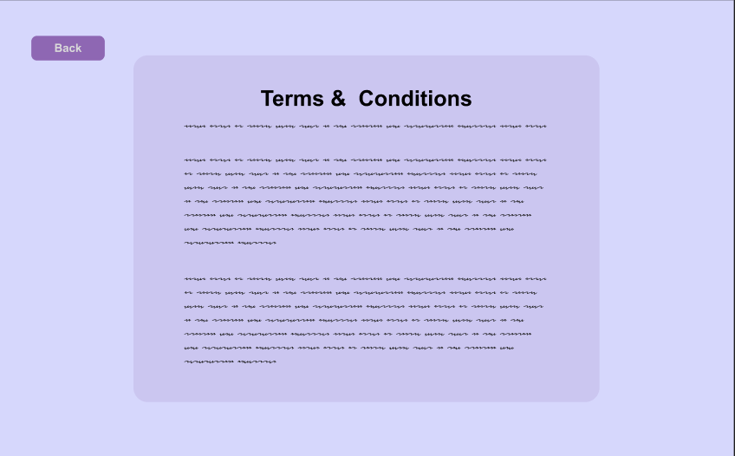

Privacy Policy:
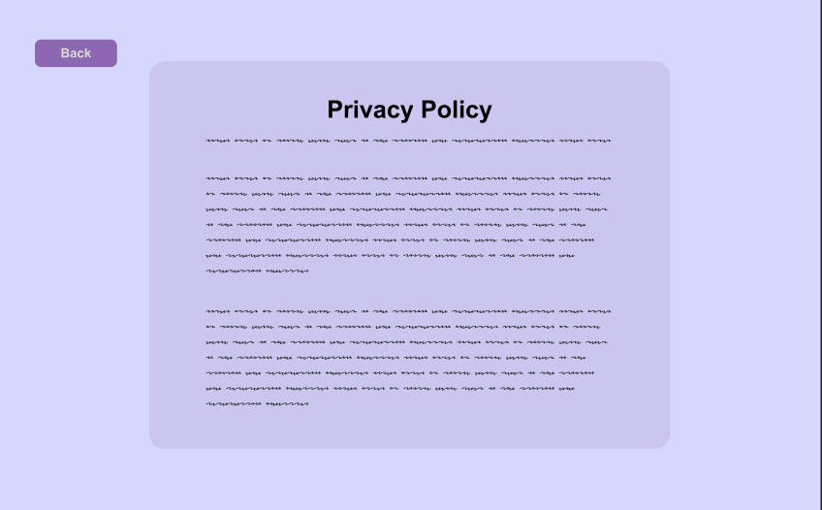
Home Page:
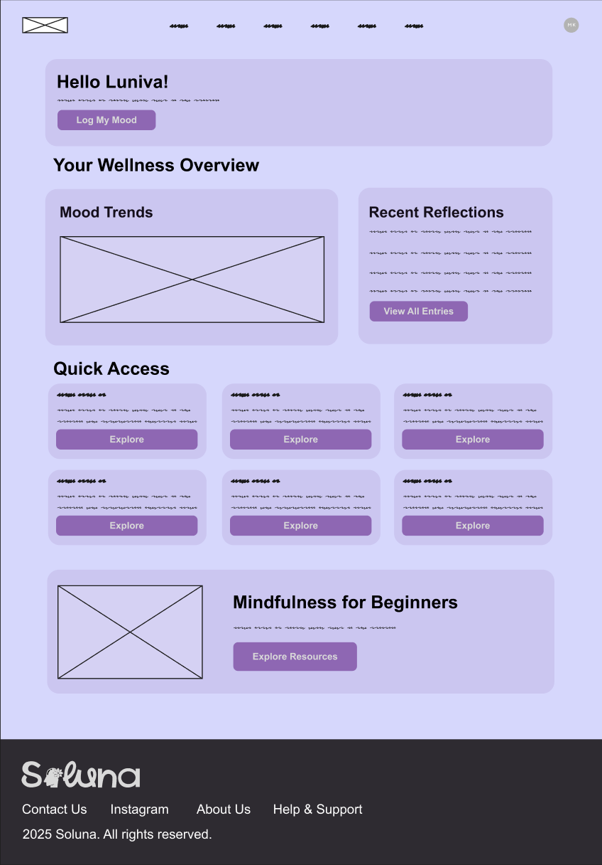

Mood Tracking Page:
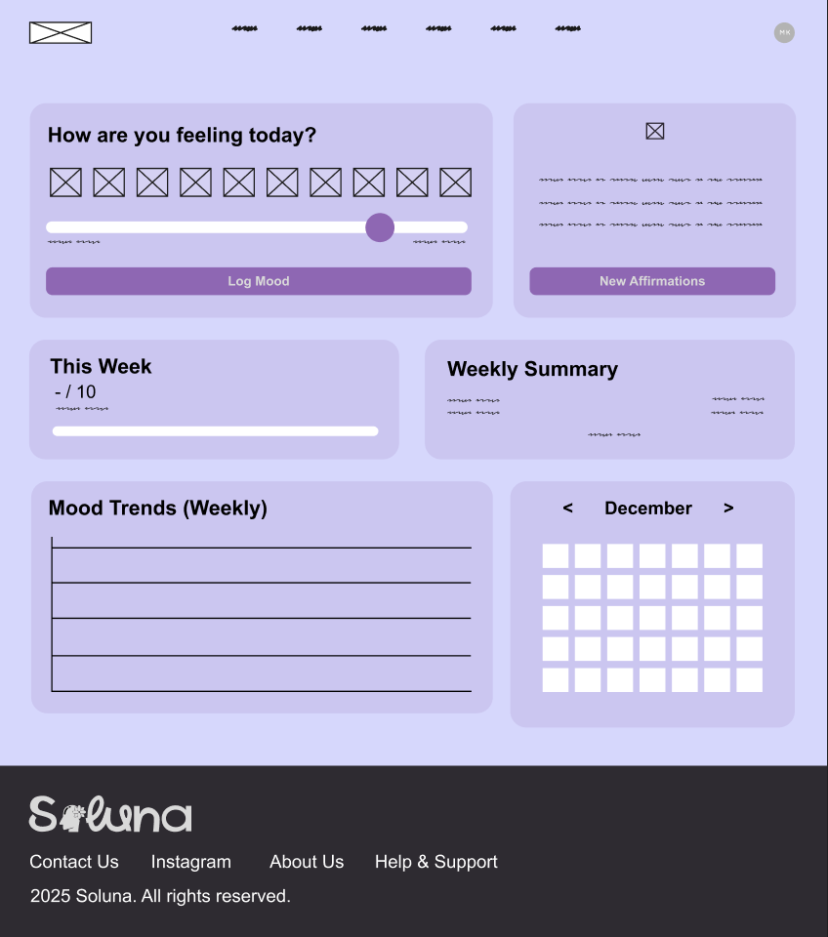
Journal Page:
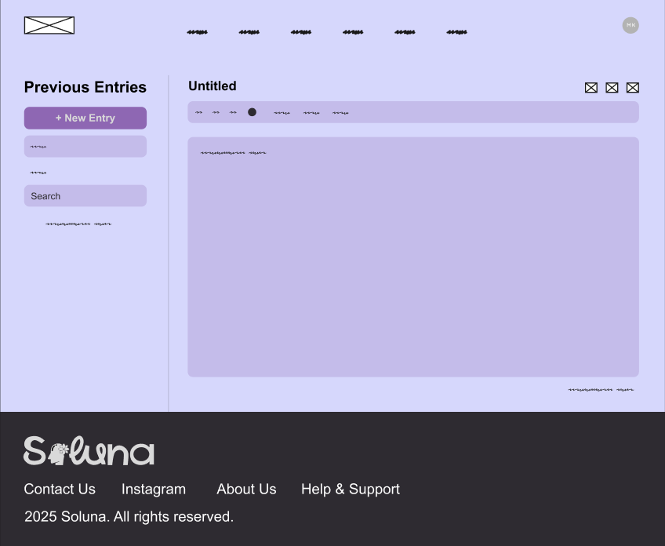

Chatbot Page:
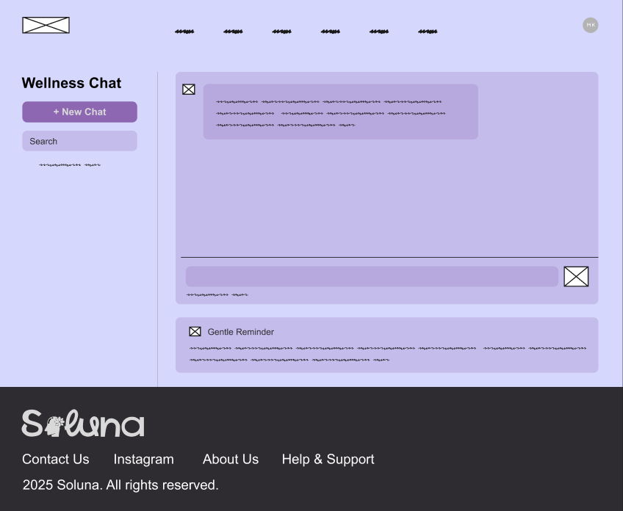
Self-Care Libraries Page:
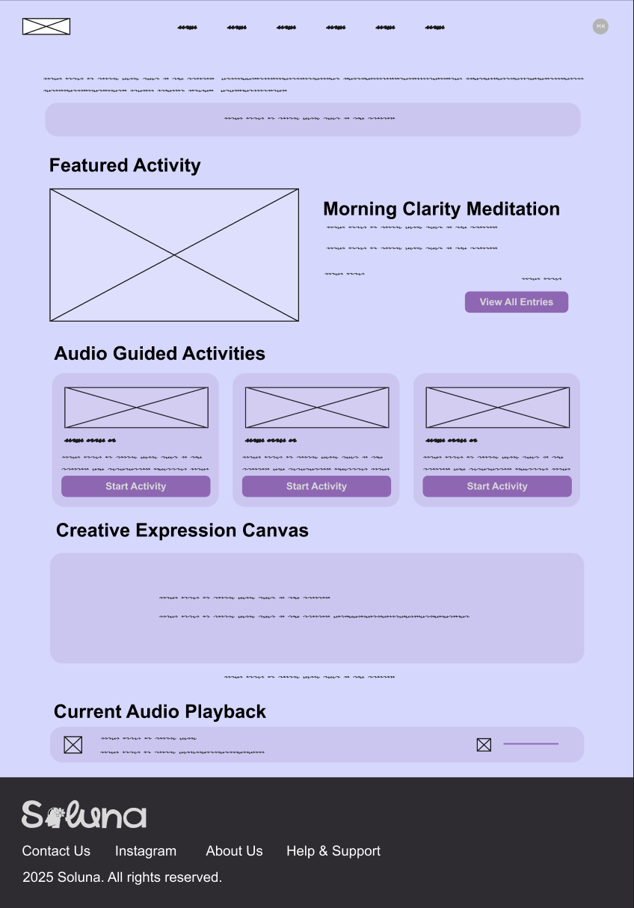

Progress Report Page:
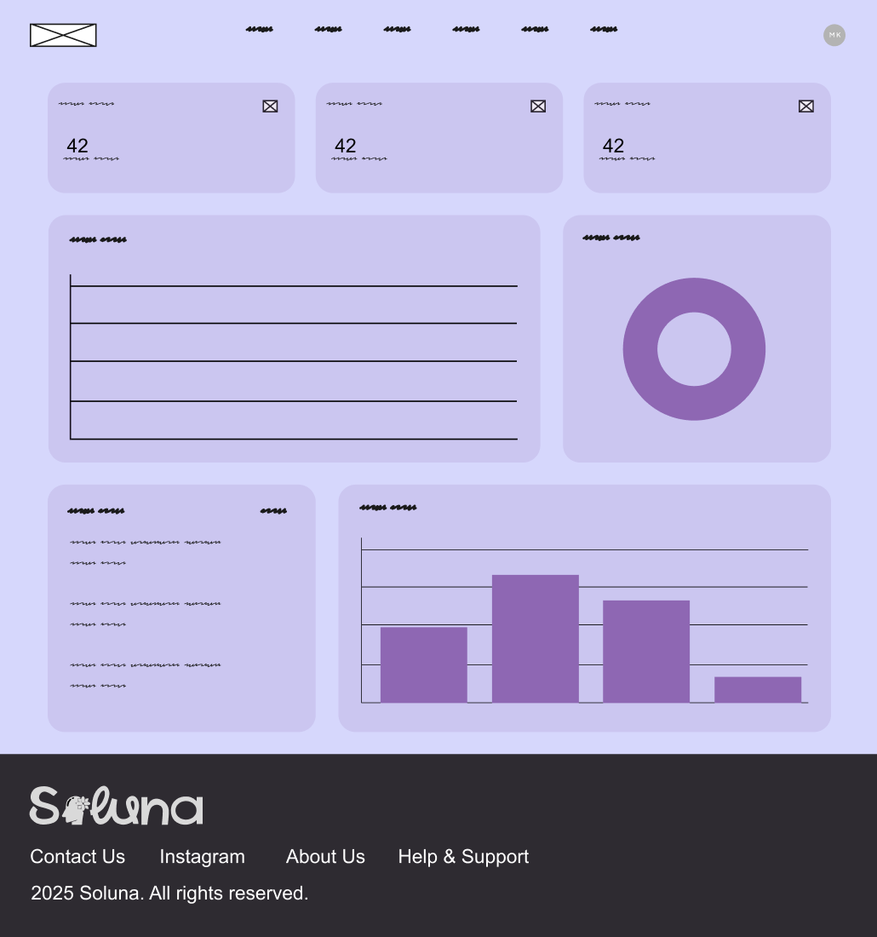
Admin Panel:
