LAB – 1 :::: PYTHON BASIC PRACTICE – I

1. Assigning Values to Variables
counter = 100 # An integer assignment
miles = 1000.0 # A floating point
name = "John" # A string
print (counter)
print (miles)
print (name)

2. Multiple Assignment
Python allows you to assign a single value to several variables simultaneously.
For example:
a = b = c = 1
a, b, c = 1, 2, "john"

3. Standard Data Types
Python has five standard data types:
□ Numbers
□ String
□ List
□ Tuple
□ Dictionary

4. Python Numbers
a = 5 # integer assignment
b= 4.56 #floating point assignment
#mathematical operations with scalar variables
print (5*a), would give the result 25
print (a/2) , would give the result 2.5
print(a**2), is the power (squaring operation) would give the result 25

5. Python Strings
str = 'Hello World!'
print (str) # Prints complete string
print (str[0]) # Prints first character of the string
print (str[2:5]) # Prints characters starting from 3rd to 5th
print (str[2:]) # Prints string starting from 3rd character
print (str * 2) # Prints string two times
print (str + "TEST") # Prints concatenated string

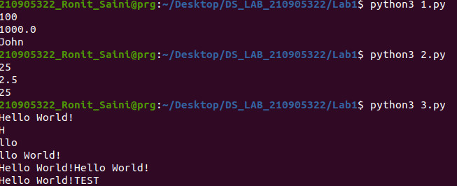
EXAMPLES WITH ANSWERS ALREADY GIVEN

6. Updating a string
var1 = 'Hello World!'
print ("Updated String :", var1[:6] + 'Python')
Ans: Updated String :Hello Python

7. String formatting operator
One of Python's coolest features is the string format operator %. This operator is unique to
strings and makes up for the pack of having functions f rom C's printf() family. Following is a simple example:
print( "My name is %s and weight is %d kg!" % ('Abay', 55))
My name is Abay and weight is 55 kg!

8. Built−in String methods
capitalize() , the first character of the string is converted to upper case.
str = "this is string example wow!!!";
print (str.capitalize())
Ans: This is string example wow!!!

lower(),returns a copy of the string in which all case−based characters have been
lowercased.
str = "THIS IS STRING EXAMPLE ... WOW!!!";
print (str.lower())
this is string example... wow!!!

replace(), this method returns a copy of the string with all occurrences of substring old
replaced by new.
str = "this is string example ... wow!!! this is really string";
print (str.replace("is", "was"))
Ans: thwas was string example ... wow!!! thwas was really string

swapcase(), this method returns a copy of the string in which al l the case−based characters
have had their case swapped.
str = "this is string example ... wow!!!";
print (str.swapcase())
Ans: THIS IS STRING EXAMPLE ... WOW!!!"

title(),returns a copy of the string in which first characters of all the words are capitalized.
str = "this is string example ... wow!!!";
print (str.title())
Ans: This Is String Example ... Wow!!!

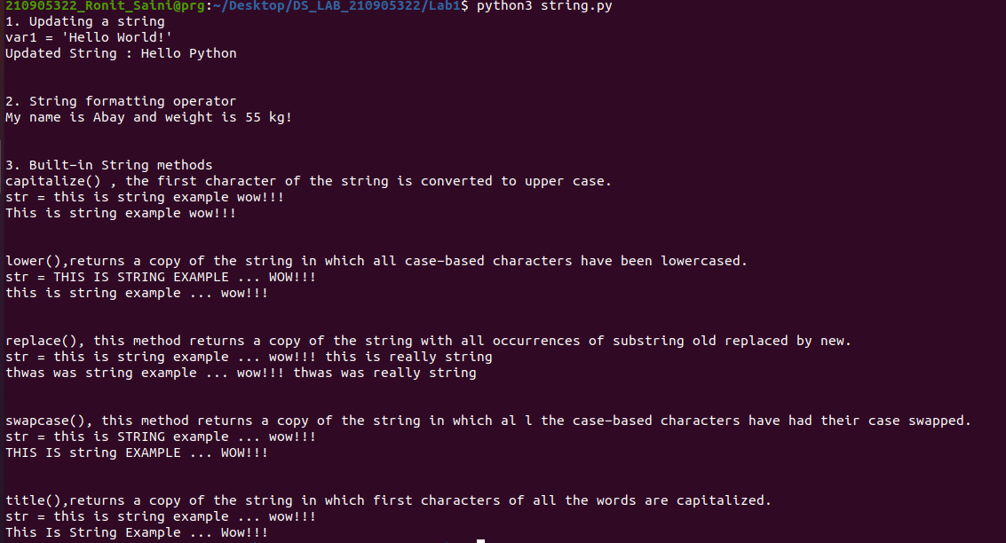

9. Python LIST
Lists are the most versatile of Python's compound data types. A list contains items
separated by commas and enclosed within square brackets ([]). To some extent, lists are
similar to arrays in C. One difference between them is that all the items belonging to a list
can be of different data type.
The values stored in a list can be accessed using the slice operator ([ ] and [:]) with indexes
starting at 0 in the beginning of the list and working their way to end −1. The plus (+) sign is the
list concatenation operator, and the asterisk (*) is the repetition operator. For example:
list = [ 'abcd', 786 , 2.23, 'john', 70.2 ]
tinylist = [123, 'john']
print (list) # Prints complete list
print (list[0]) # Prints first element of the list
print (list[1:3]) # Prints elements starting from 2nd till 3rd
print (list[2:]) # Prints elements starting from 3rd element
print (tinylist * 2) # Prints list two times
print (list + tinylist) # Prints concatenated lists
Output will be like this
['abcd', 786, 2.23, 'john', 70.200000000000003]
abcd
[786, 2.23]
[2.23, 'john', 70.200000000000003]
[123, 'john', 123, 'john']
['abcd', 786, 2.23, 'john', 70.200000000000003, 123, 'john']
Note: LIST is mutable data type

Functions & Methods in LIST
list = ['physics', 'chemistry', 1997, 2000];
list.append(‘maths’)
Ans: ['physics', 'chemistry', 1997, 2000, ‘maths’];

To delete an element in a list
del list[2], will remove 1997 record from the list.

To check a data in a list,
‘physics’ in list, will return ‘True’
‘english’ in list, will return ‘False’
len(list), will return total items in list
list.count(‘physics’)
Ans: 1

list.pop (), will remove and return the last item from the list.
list = ['physics', 'chemistry', 1997, 2000];
list.pop()
Ans: ['physics', 'chemistry', 1997]

list.insert() , will insert an item in the specified index
list = ['physics', 'chemistry', 1997, 2000];
list.insert (2, ‘maths’)
Ans: ['physics', 'chemistry', ‘maths’, 1997, 2000];
list = ['physics', 'chemistry', 1997, 2000];
list.remove(‘chemistry’), will remove the item specified.
Ans: = ['physics', 1997, 2000];
list = ['physics', 'chemistry', 1997, 2000];
list.reverse(), will reverse the objects of the list in place.
Ans: [2000, 1997, ‘chemistry’,’physics’]

10. Python TUPLE
A tuple is another sequence data type that is similar to the list. A tuple consists of a number
of values separated by commas. Unlike lists, however, tuples are enclosed within
parentheses.
The main differences between lists and tuples are: Lists are enclosed in brackets ( [ ] ) and
their elements and size can be changed, while tuples are enclosed in parentheses ( ( ) ) and
cannot be updated. Tuples can be thought of as read-only lists.
tuple = ( 'abcd', 786 , 2.23, 'john', 70.2 )
list = [ 'abcd', 786 , 2.23, 'john', 70.2 ]
tuple[2] = 1000 # Invalid syntax with tuple
list[2] = 1000 # Valid syntax with list

Looping & Conditional Branches in Python
Eg.1
num=float(input(‘Enter a number:’))
if num>0:
print(‘pos number’)
elif num==0:
print(‘zero’)
else:
print(‘Neg number’)

Eg.2
x=float(input(‘Enter a number:’))
if x<10:
print(‘smaller’)
if x>20:
print(‘bigger’)
print(‘Finished’)

Eg.3
x=5
print(‘Before 5’)
if x==5:
print (‘this is 5’)
print(‘still 5’)
print(‘After 5’)
print(‘Before 6’)
if x==6:
print(‘this is 6’)
print (‘After 6’)

Eg.4: which will never print?
x=float(input(‘Enter a number:’))
if x<20:
print(‘Below 20’)
elif x<10:
print(‘Below 10’)
else:
print(‘something else’)
Ans: Below 10

Eg.5: Nested Decisions
x=42
if x>1:
print(‘above one’)
if x<100:
print(‘less than 100’)
print(‘All done’)

Eg.6: Ternary operator
age=15
b=(‘kid’ if age<18 else ‘adult’)
print(b)
#this will print ‘kid’

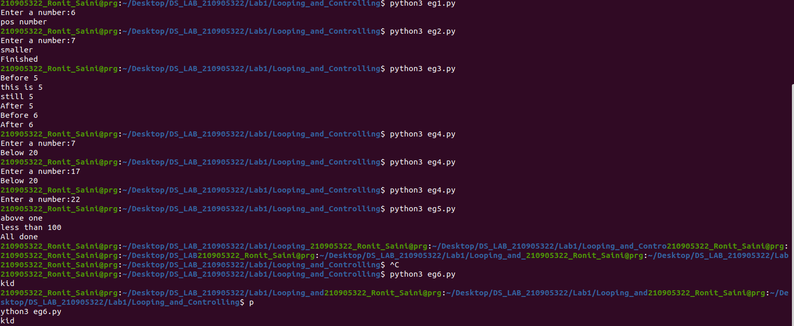

Usage of For-loop

Eg.1
for val in [5,4,3,2,1]:
print(val)
print (‘Done’)

Eg.2
stud=[‘Ram’,’Vijay’,’Nithya’,’Anu’,’Ramesh’,’suja’]
for k in stud:
print(‘Hello:’, k)
print(‘done’)

Eg.3for i in range(5):
print(i)
If i>2:
print(‘Bigger than 2’)
print(‘Done with i’,i)

Eg.4: Calculate factors of a number
x=int(input(‘Enter a number:’))
for i in range(1,x+1):
if x%i ==0:
print(i)
x=10
1,2,5,10

Eg.5: Calculate largest number in an array
from math import *
Let x= [9, 41, 12, 3, 74, 15]
Largest=−inf
for i in x:
if i>Largest:
Largest=i
Print(Largest)

Eg.6: Calculate smallest number in an array
from math import *
Let x= [9, 41, 12, 3, 74, 15]
smallest=inf
for i in x:
if i<smallest:
smallest=i
print(smallest)

Eg.7: Calculate the count, sum and average of numerical array
Let x= [9, 41, 12, 3, 74, 15]
count=sum=avg=0
for i in x:
count=count+1
sum=sum+1
avg=sum/count
print(count)
print(sum)
print(avg)

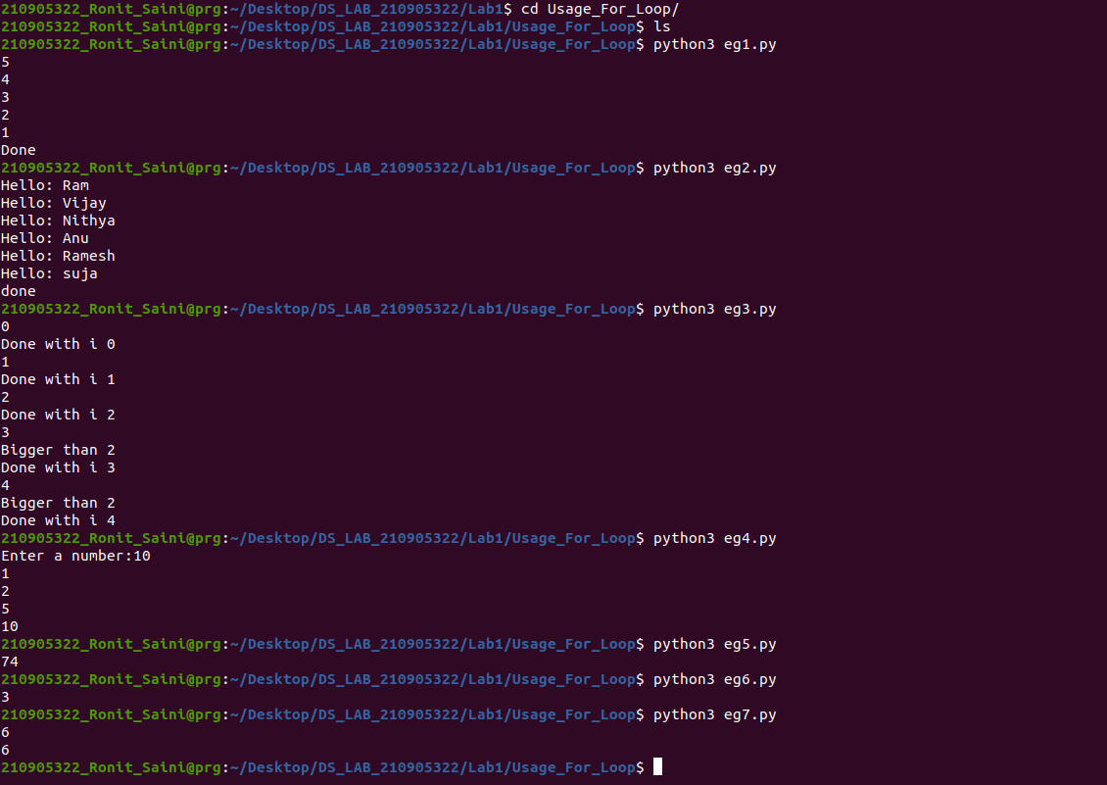

Eg.8: Filtering in a loop (print all numbers >20)
Let x= [9, 41, 12, 3, 74, 15]
for i in x:
if i>20:
print (i)

Eg.9: For the above problem, instead of printing the result, store the elements in a
variable (object)
Let x= [9, 41, 12, 3, 74, 15]
res=[]
for i in x:
if i>20:
res.append(i)

Eg.10: For the above x, replace all elements <20 into zero. Store the result in different
variable (object)
y=np.zeros(len(x))
for i in range(len(x)):
if x[i]>20:
y[i]=x[i]
print(y)

Eg. 11: Program using elif to check more than one condition.
price = 1011
if price > 100:
print("price is greater than 100")
elif price == 100:
print("price is 100")
elif price < 100:
print("price is less than 100")
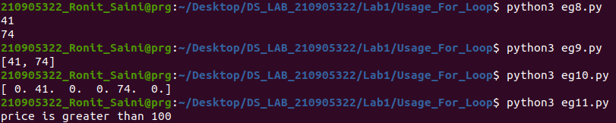

Eg. 12: Program using while loop -
program to display numbers from 1 to 5
# initialize the variable
i = 1
n = 5
# while loop from i = 1 to 5
while i <= n:
print(i)
i = i + 1
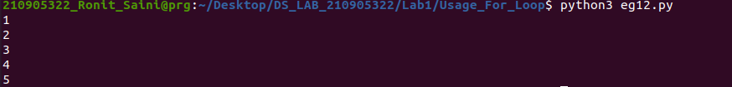

Eg. 13:Take input from user , until user enters zero and calculate the sum of entered numbers.

total = 0
number = int(input('Enter a number: '))
# add numbers until number is zero
while number != 0:
total += number # total = total + number
# take integer input again
number = int(input('Enter a number: '))
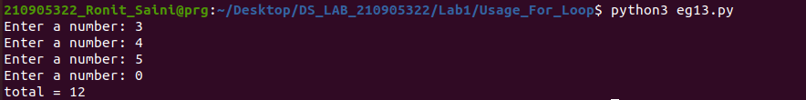
print('total =', total)

