IBM BOBATHON 2026
ChainSentinel
A Supply Chain Disruption Assistant & Fleet Utilisation Optimizer
Solution Blueprint — Problem Statement L2 (Logistics & Ports, "Ongoing Pain")
Document purpose
This blueprint is the single source of truth for the team: the problem, the solution design, the AI/ML decisions, the architecture, the datasets, the end-to-end workflow, and the evaluator-facing justification. Content maps directly onto the four required docs/ files in the Bobathon submission template (problem-statement.md, solution-overview.md, architecture.md, setup-guide.md) — see Section 10.
Team: [Team Name] · Track: AI · Prepared: September 2026

0. Note on This Document
This blueprint was produced from two authoritative sources you supplied: the official Industry Problem Statements 2026 (source of truth for what must be built) and the Bobathon Submission Template Guide (source of truth for how the project must be packaged and how it will be scored). A third "reference project document" was referenced in your instructions but was not actually included in the upload — only the instructions file itself and the two PDFs above were attached. Rather than inventing a reference document's style, this blueprint is structured to satisfy the submission guide's own docs/ requirements directly (problem statement → solution overview → architecture → workflow → evaluation readiness), which is the most defensible structure for this specific hackathon.
Every claim below is labeled as one of the following, so the team always knows what is confirmed versus proposed:
- [OFFICIAL] — taken directly from the Industry Problem Statements or Submission Guide.
- [PROPOSED] — a design decision made by this blueprint to satisfy an official requirement; not mandated by the organisers but recommended.
- [ENHANCEMENT] — an optional stretch feature beyond the official challenge, only worth attempting after the core four requirements work end-to-end.
- [ASSUMPTION] — a fact not stated in the official documents (e.g., a specific regulatory temperature threshold) where a reasonable placeholder is used and must be confirmed or configured by the team, not treated as verified fact.

1. Official Problem Statement
Sector: Logistics & Ports ID: L2 Category: Ongoing Pain

1.1 Title
Supply Chain Disruption Assistant & Fleet Utilisation Optimizer

1.2 The Pain (as stated)
Supply chain disruptions — weather events, port strikes, geopolitical crises — cascade across hundreds of active shipments in ways that are impossible to track manually. Fleet assets (trucks, containers, vessels) sit idle while other routes are overloaded. Cold chain shipments (vaccines, perishables) are especially vulnerable — a single temperature excursion across any leg can spoil cargo worth $500K or more, but breaches are only discovered at delivery, when it is too late to act.

1.3 The Challenge (as stated)
Build a Bob solution that:
- Identifies which shipments are affected by an active disruption.
- Recommends re-routing or carrier alternatives.
- Identifies idle fleet assets for redeployment.
- Monitors cold-chain IoT sensor logs to detect temperature excursions and classify their regulatory severity before delivery.

1.4 What Is Explicitly In Scope vs. Not Stated
Aspect | Status
Four capabilities above | [OFFICIAL] Mandatory — these are the four things evaluators will look for.
Specific tech stack (watsonx, MCP, etc.) | [ASSUMPTION-FREE] Not mandated in the problem statement itself; IBM Bob integration is mandated by the hackathon generally (see Submission Guide §7, 10 pts).
Real disruption / fleet / IoT data source | Not provided. No dataset is attached to the problem statement, so the team must generate or source data — see Section 6.
Exact cold-chain temperature/regulatory thresholds | Not specified. [ASSUMPTION] used in Section 4.6, configurable, and must be labeled as illustrative in the submission.
UI requirements | Not specified — the team has freedom here, guided by the Submission Guide's expectation of a working, demoable app.
The problem statement itself carries no numeric KPI targets or named regulatory bodies (unlike, for example, P1's explicit reference to ICH E6 GCP). No such figures are invented here.

2. Problem Deep Dive

2.1 Who experiences this problem
Role | What they currently do | Why it breaks down
Logistics / Supply Chain Ops Manager | Watches news and carrier alerts, then manually cross-checks shipment manifests in spreadsheets or a TMS to see who is affected. | Manual cross-checking does not scale past a handful of shipments; by the time impact is understood, the disruption window has often passed.
Fleet / Transport Manager | Tracks trucks, containers, and vessels through dispatch boards; redeployment happens mostly by phone calls and tribal knowledge of "who's free." | Idle assets near an overloaded lane are invisible unless someone happens to remember or notice — utilisation stays low even during disruptions that need more capacity.
Cold-Chain / QA Compliance Officer | Reviews temperature logs after the shipment arrives, usually from a data-logger download or a summary report. | Excursions are found retroactively, at delivery — the cargo is already at risk or already spoiled. There is no in-transit early warning.

2.2 Why the current approach is insufficient
- Disruption impact assessment is a manual, human-memory-bound correlation problem across hundreds of shipments and constantly changing routes — it does not scale and is reactive rather than proactive.
- Fleet utilisation decisions are made without a system-wide, real-time view of idle capacity, so assets sit idle in one region while another region is short of capacity during the same disruption.
- Cold-chain monitoring is typically an after-the-fact audit, not a live control — the $500K+ cargo the problem statement references is already lost by the time anyone looks at the log.
[OFFICIAL] These three points map directly onto the "ongoing pain" language of the problem statement, not an invented narrative.

2.3 What changes with ChainSentinel
ChainSentinel does not replace the ops manager, fleet manager, or QA officer — it removes the manual correlation step that currently sits between "a disruption happened" and "here is what to do about it," and it moves cold-chain monitoring from post-delivery audit to in-transit alerting. The system's job is to narrow hundreds of shipments and dozens of fleet assets down to a short, ranked, explainable set of recommendations that a human then approves.

3. Solution Overview — ChainSentinel
One-line pitch
ChainSentinel is an IBM Bob–powered operations copilot that, the moment a disruption is reported, tells an ops team exactly which shipments are at risk, what to reroute them onto, which idle trucks/containers/vessels can absorb the overflow, and which cold-chain shipments are already breaching safe temperature — as one conversational, explainable brief instead of four separate manual investigations.

3.1 The four pillars (mapped to the official challenge)
# | Official requirement | ChainSentinel component
1 | Identify shipments affected by an active disruption | Disruption Matching & Risk Scoring engine
2 | Recommend re-routing or carrier alternatives | Route / Carrier Optimizer
3 | Identify idle fleet assets for redeployment | Fleet Redeployment Matcher
4 | Monitor cold-chain IoT logs; detect and classify excursions | Cold-Chain Excursion Monitor
All four are [OFFICIAL] requirements — none is optional for a credible submission. IBM Bob sits on top of all four as the conversational interface and the synthesiser that turns four outputs into one operator-ready brief (mirroring the BLUF pattern the organisers use in other problem statements, applied here as a [PROPOSED] presentation choice, not a stated L2 requirement).

3.2 What makes it different from a generic TMS dashboard
- It is disruption-first, not report-first: the entry point is "a disruption just happened," and the system proactively computes impact rather than waiting for someone to run a query.
- It closes the loop across three normally-siloed functions (routing, fleet, cold-chain compliance) in one workflow instead of three separate tools.
- Every recommendation is explainable: each rerouting, redeployment, or severity classification is backed by the specific rule or feature values that produced it, not a black-box score — this directly answers the evaluator question "how do we know a recommendation is good?" (Section 9).

3.3 [ENHANCEMENT] Ideas beyond the core four (attempt only after core works)
- Sensor-malfunction vs. real-excursion anomaly detection on IoT streams (Section 4.9).
- A learned carrier-reliability score that updates from simulated on-time/delay outcomes over the demo dataset.
- A "what-if" simulator letting an ops user drag a disruption polygon on the map and see impact recompute live.

4. AI / ML Decision Analysis
Each capability below was evaluated on its own merits. Nothing is forced into being "AI" just because this is an AI hackathon — several genuinely correct answers below are deterministic rules or optimisation, and that is stated plainly.
4.1 Disruption-to-Shipment Matching RULE-BASED
Determines which active shipments have a leg passing through, or scheduled to pass through, a disrupted region/port/lane within the disruption's active time window.
- Why not ML: this is a deterministic geospatial/temporal intersection — does shipment leg L pass through region R during window W? There is no pattern to learn; a wrong answer here is simply a bug, and using ML would add unpredictability to something that must be exactly correct.
- Approach: PostGIS spatial queries (or a simple bounding-box/route-waypoint containment check if PostGIS is not set up in time) joined against the disruption's affected-region geometry and active time window.
- Output: a filtered, deterministic list of affected shipment IDs with the specific leg and reason ("leg 2 passes through Suez Canal region, disruption active 12–18 Sept").
4.2 Shipment Risk Scoring HYBRID — rules baseline + optional ML
Once a shipment is flagged as affected, it must be ranked by how urgently it needs attention.
Question | Answer
What problem does it solve? | Ranks affected shipments so ops attention goes to the highest-risk cargo first (high value, perishable, low schedule buffer) rather than a flat alphabetical or chronological list.
Why might ML help here? | Whether a shipment actually gets delayed depends on interacting factors (disruption severity × distance from disruption × existing schedule buffer × carrier's historical reliability) that are hard to hand-tune as fixed thresholds without either being too conservative (everything flagged "high risk") or too loose (real risks missed).
Why not ML alone? | A transparent baseline is required first: evaluators and ops users must be able to see why something is high-risk. A pure black-box score fails the explainability bar this problem needs (cargo worth $500K+ is at stake).
Input features (if ML variant used) | disruption severity (1–5), distance/time from disruption epicentre to the shipment's current position, remaining schedule buffer in days, cargo value, cargo perishability flag, carrier historical on-time rate.
Output | A 0–100 risk score plus the top contributing factors (from the rule baseline; from a trained model, this would be feature importances/SHAP values).
Training data | [ASSUMPTION] No real historical delay-outcome dataset exists for this hackathon. A synthetic historical shipment log with injected outcomes (delayed / on-time) can be generated (Section 6) so a simple model (logistic regression or gradient-boosted trees) can be trained and demoed — but this is explicitly a proof-of-concept on synthetic data, not a validated production model.
Evaluation | On synthetic data only: precision/recall of the model's "delayed" prediction against the synthetic ground-truth label. No real-world accuracy claim is made.
Feasible in a hackathon? | Yes for the rule baseline (build first, always works). The ML variant is feasible as a lightweight scikit-learn model trained in minutes on synthetic data, and should be framed to evaluators as "illustrative of how this would work with real historical data," per the official caution against inventing accuracy claims.
- Recommended build order: ship the rule-based weighted score first (always demoable, fully explainable); add the ML variant as a toggle ("risk score: rule-based vs. model-based") only if time remains — this satisfies both the innovation criterion and the working-demo criterion without risking a broken core feature.
4.3 Route / Carrier Recommendation OPTIMIZATION (constraint scoring), not ML
For each affected, high-risk shipment, recommend the best alternate route and/or carrier from the set of feasible alternatives.
- Why not ML: this is a multi-criteria decision over a small, known candidate set (alternate carriers/lanes serving the same origin–destination pair) — a transparent weighted-scoring or constraint-based ranking (cost, added transit time, carrier reliability, capacity availability) is both more explainable and more correct than a learned ranker with no real training signal for "good reroute" outcomes.
- Approach: filter candidate carriers/lanes by hard constraints (do they avoid the disrupted region? do they have capacity?), then rank survivors by a weighted score of cost delta, transit-time delta, and carrier reliability. Weights are configurable, not hidden.
- Output: ranked list of 1–3 alternatives per shipment with the specific trade-off shown (e.g., "+2 days transit, −18% cost, carrier reliability 94%").
4.4 Idle Fleet Identification RULE-BASED
Flags fleet assets (trucks/containers/vessels) that are idle beyond a configurable threshold and geographically near an overloaded or affected lane.
- Why not ML: "idle" is a defined state (no active assignment, elapsed time since last movement exceeds a threshold) and "near" is a distance calculation — both deterministic.
4.5 Fleet-to-Need Matching OPTIMIZATION (assignment heuristic)
Matches idle assets to shipments/lanes that need extra capacity.
- Why optimisation, not ML: this is a classic bipartite assignment problem (which idle asset should go where, given capacity, distance, and asset type compatibility) with a well-understood deterministic solution — a greedy nearest-compatible-asset heuristic, or a small linear-assignment solver if time allows, is the correct tool, not a learned model with no training signal.
- Output: a redeployment plan: asset → destination lane, with distance and estimated time-to-availability.
4.6 Cold-Chain Excursion Detection & Severity Classification RULE / FORMULA-BASED
Reads IoT temperature (and optionally humidity) logs per shipment leg and flags when cargo has been outside its safe range.
- Why not ML: cold-chain excursion rules are a solved, standardised domain problem (not a pattern-recognition problem) — the industry already uses deterministic formulas such as Mean Kinetic Temperature (MKT) and fixed allowable-range/duration thresholds (as referenced in general pharma cold-chain guidance, e.g., WHO PQS and USP <1079>-style frameworks). Reimplementing this as ML would be both unnecessary and less trustworthy to a compliance officer than a formula they can audit.
- [ASSUMPTION] Thresholds used for the demo: e.g., 2–8°C allowable range for a vaccine-class shipment, minor excursion = brief single-reading deviation, major = sustained deviation beyond N minutes, critical = deviation large enough or long enough to materially affect MKT / product viability. These exact numbers are placeholders for the demo and must be clearly labeled as configurable, not asserted as the real regulatory standard for any specific product, since no such figures were provided in the official documents.
- Output: per-leg excursion flag, severity (minor/major/critical), duration and magnitude of breach, and the shipment(s)/cargo affected.
4.7 Unstructured Disruption-Text Extraction GENERATIVE AI — genuinely needed
Disruptions in the real world arrive as unstructured text — a news snippet, a port authority notice, an email. Converting "Typhoon closes Port of Ningbo for 5 days starting Sept 20" into a structured event (region, type, start date, estimated duration, severity) is exactly the kind of task deterministic rules handle poorly (unbounded phrasing) and an LLM handles well.
- Why ML/GenAI is justified here: natural language is not enumerable by fixed patterns; an LLM's extraction capability (with a constrained output schema) is the right tool, whereas the downstream matching in 4.1 is deliberately kept rule-based once the event is structured.
- Feasibility: IBM Bob's underlying model, prompted with a strict JSON schema and a handful of few-shot examples, can perform this extraction directly — no separate model training is required, which keeps it hackathon-feasible.
4.8 Conversational Synthesis & Explanation (IBM Bob) GENERATIVE AI — genuinely needed
Turning four separate structured outputs (affected shipments, reroute options, redeployment plan, cold-chain alerts) into one coherent, prioritised, natural-language brief for a human operator is a language-generation task, not a retrieval or classification task — this is Bob's core value-add and is covered in Section 8.
4.9 [ENHANCEMENT] Sensor Anomaly Detection ML — optional, not core
Distinguishing a genuine temperature excursion from a malfunctioning/disconnected sensor (e.g., an implausible spike to 45°C for one reading) could use a simple unsupervised anomaly detector (e.g., Isolation Forest) over the sensor's own recent readings.
- Why it's optional, not core: the official requirement is to detect and classify excursions, not to filter sensor faults — this is a genuine value-add but is explicitly out of scope for the four mandatory capabilities, so it should only be attempted after the core rule-based excursion detection (4.6) is solid and demoable.

5. System Architecture
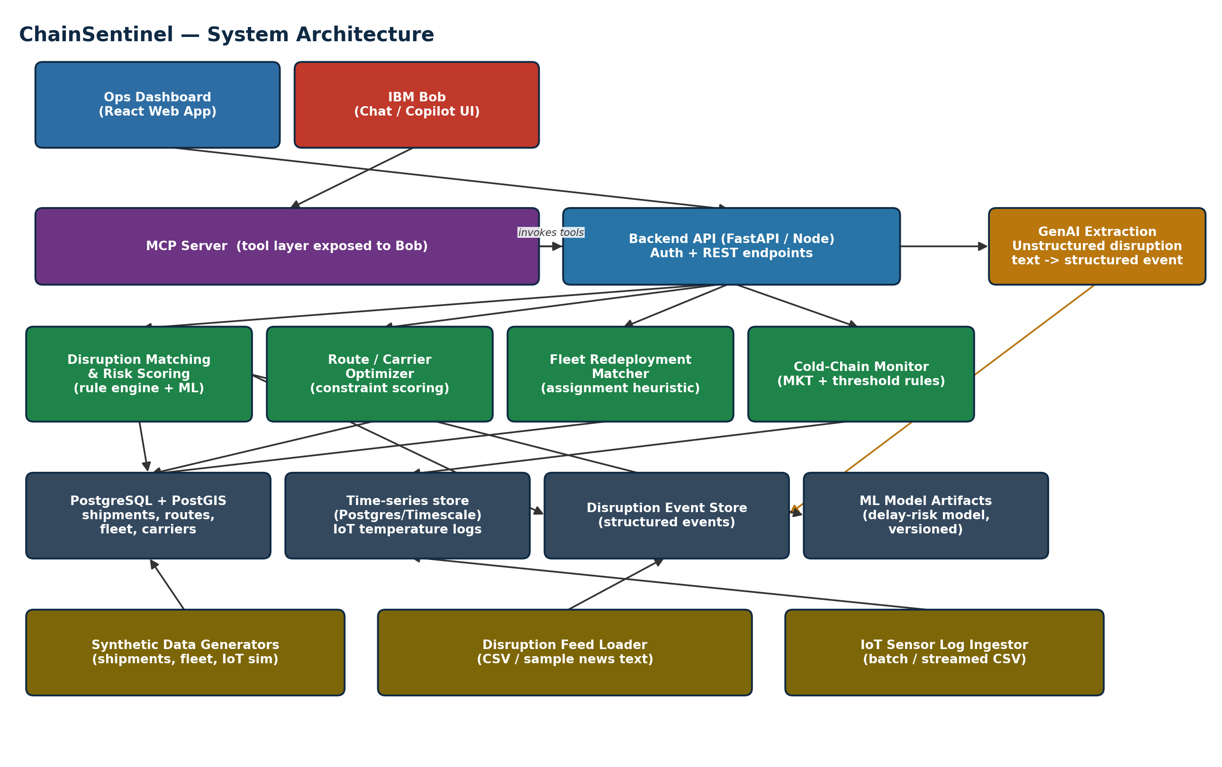
Figure 1 — ChainSentinel component architecture. Arrows show call/data direction.

5.1 Layer responsibilities
Layer | Technology | Responsibility | Why this choice
Client | React (Ops Dashboard) + IBM Bob chat UI | Map/list view of shipments, disruptions, fleet; alert panel; conversational entry point. | React gives a fast, demoable SPA; Bob chat is the mandated conversational surface.
Tool layer | MCP server | Exposes backend capabilities as callable tools to Bob (get_affected_shipments, recommend_reroute, find_idle_fleet, check_coldchain_status, extract_disruption_event). | MCP is the standard way to make Bob's integration genuinely load-bearing (Submission Guide §7, 10 pts) rather than a cosmetic chat wrapper.
Backend API | FastAPI (Python) or Node/Express | REST endpoints backing both the dashboard and the MCP tools; houses the rule engine and optimisation logic. | Python (FastAPI) keeps rule engine, optimisation, and ML model code in one language; Node is a fine alternative if the team is stronger there.
GenAI extraction | Bob's underlying LLM via a constrained prompt/schema | Converts unstructured disruption text into a structured event object. | Justified in Section 4.7 — this is the one place NLU is genuinely required.
Data | PostgreSQL + PostGIS; time-series table for IoT logs | Stores shipments, routes, fleet, carriers, disruption events, and IoT temperature readings. | PostGIS gives correct, fast geospatial matching for Section 4.1 instead of hand-rolled geometry code.
ML artifacts | scikit-learn model file(s), versioned on disk | Optional delay-risk model (4.2) and optional anomaly detector (4.9). | Kept separate from the rule engine so the rule-based path always works even if the model is disabled.

5.2 IBM Bob's role, precisely
Bob is not a chat wrapper bolted on top of a dashboard. It is the orchestration layer that (a) extracts structured disruption events from unstructured text, (b) calls the four backend tools in the right order for a given query, and (c) synthesises their outputs into a single explainable brief. Removing Bob would remove the natural-language interface and the text-extraction capability — the dashboard would still show data, but the assistant behaviour described in the problem statement's title would be gone. This is the direct answer to evaluator criterion 5 ("Is IBM Bob load-bearing?").

6. Data & Data Engineering
Data provenance
No real dataset was provided with the L2 problem statement. All data below is [ASSUMPTION]/[PROPOSED] synthetic data generated by the team, designed to be internally consistent — it must never be presented to evaluators as real industry data.

6.1 Core datasets
Dataset | Key columns | Purpose
shipments | shipment_id, origin, destination, cargo_type (standard/cold_chain), cargo_value, carrier_id, route_id, current_leg, eta, schedule_buffer_days | The core entity being tracked and risk-scored.
routes / legs | route_id, leg_seq, mode (sea/air/road), origin_port, dest_port, waypoints (lat/long), planned_duration_days | Defines the geography each shipment travels through, used for disruption matching.
disruptions | disruption_id, type (weather/port_strike/geopolitical), affected_region geometry, start_time, est_duration_days, severity (1–5), source_text (if extracted) | Structured disruption events, either loaded directly or produced by the GenAI extraction step.
carriers | carrier_id, name, coverage_regions, historical_on_time_pct, cost_index | Used by the route/carrier optimizer to rank alternatives.
fleet_assets | asset_id, type (truck/container/vessel), current_location, status (idle/active/maintenance), last_active_at, capacity_units | Used for idle-fleet identification and redeployment matching.
coldchain_iot_logs | shipment_id, leg_id, sensor_id, timestamp, temperature_c, humidity_pct | Time-series sensor readings used for excursion detection.

6.2 Relationships
- shipments.route_id → routes; a shipment moves leg-by-leg through routes/legs.
- routes/legs geometry is checked against disruptions.affected_region to compute the affected-shipment set (Section 4.1).
- shipments.carrier_id → carriers, used when scoring reroute alternatives.
- coldchain_iot_logs.shipment_id → shipments, filtered to cargo_type = cold_chain.
- fleet_assets are matched to shipments/legs by current_location proximity and capacity/type compatibility, not a direct foreign key.

6.3 Synthetic data generation approach
[PROPOSED] A Python generation script builds a small, realistic world rather than random noise:
- 4–6 recognisable trade lanes (e.g., Shanghai–Los Angeles, Rotterdam–New York, Mumbai–Jebel Ali), each with 2–3 legs and plausible waypoints.
- 150–300 active shipments distributed across those lanes, ~15% flagged cold_chain.
- 30–50 fleet assets distributed near the lane endpoints, with a realistic idle/active split (e.g., 20–30% idle at any time, matching the problem statement's premise that idle capacity already exists).
- 2–4 disruption events injected at demo time (one weather event, one port strike, one geopolitical/customs event), each overlapping several shipments' legs so the matching and reroute logic has real work to do.
- IoT logs generated with a normal in-range profile for most cold-chain shipments, with 2–3 shipments given an injected excursion (one minor, one major/critical) so the classification logic is demonstrably exercised.
This mirrors the demo requirement in the Submission Guide (§4.5) that the video show "actual output being produced, not mocked" — the injected scenarios make the demo deterministic and repeatable without faking the underlying computation.

7. End-to-End Workflow

7.1 Normal operational flow (no active disruption)
- Shipments, fleet, and carrier data are loaded/refreshed into the database.
- IoT temperature logs stream in continuously for cold-chain shipments; the excursion check (4.6) runs on every new reading.
- The dashboard shows a live map of shipments, fleet status, and any cold-chain alerts — no disruption-specific logic is triggered.
- An ops user can ask Bob general questions at any time ("how many cold-chain shipments are in transit right now?") answered directly from current data.

7.2 Disruption-response flow
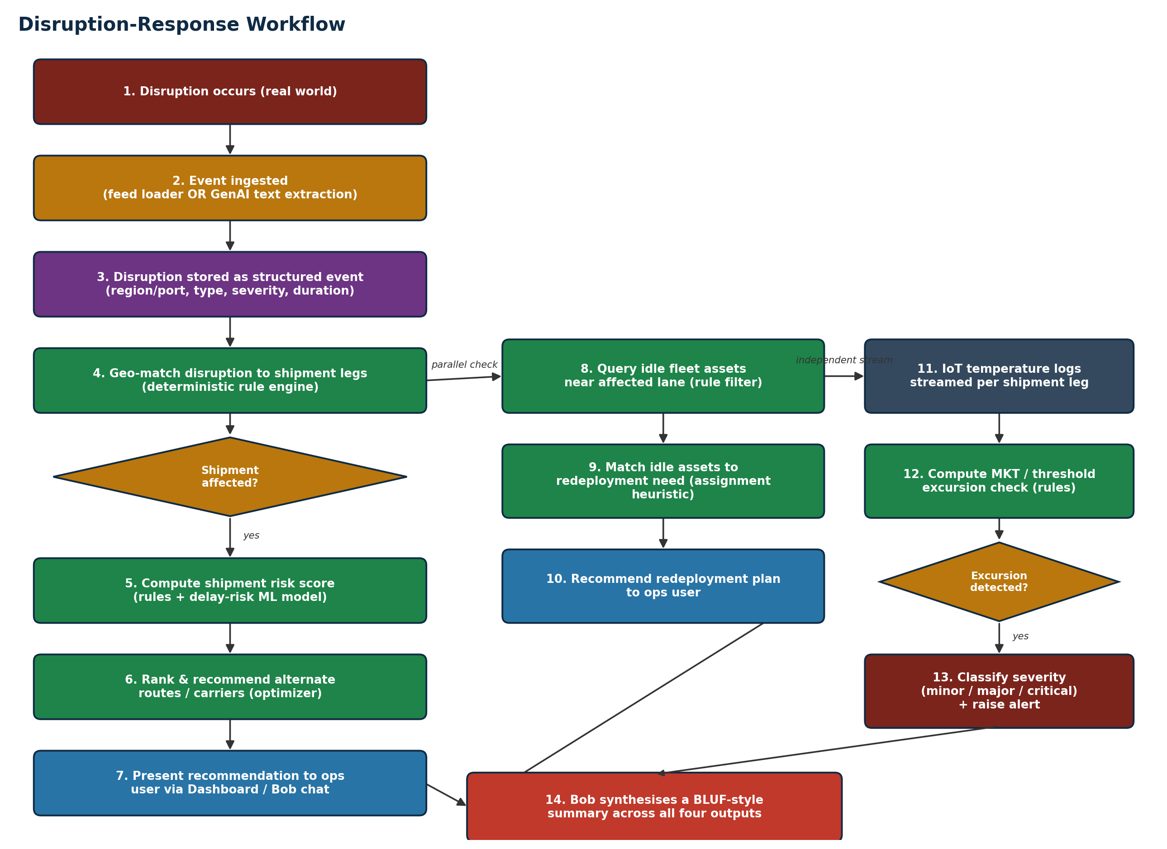
Figure 2 — End-to-end sequence from disruption occurrence to synthesized operator brief. The fleet-redeployment and cold-chain branches run independently of, and in parallel with, the shipment reroute branch.
Steps 1–7 (left column) handle the reroute/carrier requirement; steps 8–10 (middle column) handle fleet redeployment; steps 11–13 (right column) run continuously for cold-chain monitoring and are not dependent on a disruption occurring at all — an excursion can be flagged even with no active disruption. Step 14 is where Bob adds its distinct value: combining outputs that were computed by three independent, auditable components into one coherent, prioritised narrative for the human operator, who makes the final call.

8. IBM Bob & MCP Tool Integration
Five MCP tools back the assistant. Each wraps a backend capability described in Section 4/5 — Bob decides which to call and in what order based on the operator's question, then narrates the combined result.
Tool | Inputs | Output | Backing component
get_affected_shipments | disruption_id (or raw disruption text) | List of shipment IDs, affected leg, reason | 4.1 Disruption Matching
score_shipment_risk | shipment_id list | Risk score + top contributing factors per shipment | 4.2 Risk Scoring
recommend_reroute | shipment_id | Ranked alternate routes/carriers with trade-offs | 4.3 Route/Carrier Optimizer
find_idle_fleet | region or lane | Idle assets nearby with type/capacity, and a redeployment match if one exists | 4.4 / 4.5 Fleet Matcher
check_coldchain_status | shipment_id (or "all active") | Excursion flag, severity, duration/magnitude per shipment | 4.6 Cold-Chain Monitor
A sample multi-tool exchange: an operator types "A typhoon just closed Ningbo for 5 days — what do we do?" Bob first calls the GenAI extraction step to structure the event, then get_affected_shipments, then score_shipment_risk and recommend_reroute for the high-risk subset, then find_idle_fleet for any lanes now needing extra capacity, then check_coldchain_status for any affected cold-chain cargo — and finally produces one prioritised brief, each claim traceable back to a specific tool call and its structured output.

9. Evaluator-Level Q&A
Anticipated hard questions, answered directly rather than with marketing language.
Q: Why does this problem need AI at all?
A: Most of the system is deliberately not ML (Section 4) — the genuine AI need is (1) extracting structured disruption events from unstructured text, which cannot be done with fixed rules, and (2) synthesising four structured outputs into one coherent natural-language brief. Both are language tasks a rule engine cannot perform.
Q: Why not just a dashboard with filters?
A: A dashboard answers "show me shipments in region X" — it does not answer "given this disruption, what should I do," which requires geo-matching, risk ranking, optimisation, and cross-function synthesis chained together. That chaining, exposed conversationally, is the actual product.
Q: Why not simple if-else conditions everywhere?
A: If-else conditions are exactly what we use for disruption matching, idle-fleet filtering, and excursion thresholds (Sections 4.1, 4.4, 4.6) — because those are genuinely deterministic. We do not claim ML is used where it is not; the risk-scoring and reroute-ranking steps use weighted scoring/optimisation because they involve trade-offs across multiple criteria that a single if-else chain would hard-code brittlely.
Q: Where exactly is ML used, and why there specifically?
A: Optionally in shipment delay-risk scoring (4.2), where interacting factors are hard to hand-tune as fixed thresholds, and in the proposed sensor-anomaly enhancement (4.9). Both are labeled as illustrative on synthetic data, not production-validated.
Q: What's innovative here versus existing logistics software?
A: Existing TMS/fleet software typically silos routing, fleet management, and cold-chain compliance into separate modules or separate tools entirely. ChainSentinel's innovation is the cross-function correlation — one disruption event automatically drives reroute, redeployment, and cold-chain checks together, narrated by Bob as a single operator brief.
Q: How do we know a recommended route is good?
A: Every recommendation shows its scoring inputs (cost delta, transit-time delta, carrier reliability) rather than a bare score, so an ops user can audit the trade-off, not just trust a number.
Q: How do we validate fleet redeployment recommendations?
A: The assignment heuristic's output (asset → lane) is checked against hard constraints (capacity, asset type compatibility, distance) before being shown — an invalid match is filtered out before it ever reaches a user, and the distance/ETA shown lets a human sanity-check it.
Q: How do we classify cold-chain excursions?
A: Via a deterministic threshold/MKT-style calculation against the assumed allowable range and duration for the cargo class (Section 4.6) — thresholds are configuration, not hard-coded, and are explicitly labeled as demo placeholders pending real regulatory/product data.
Q: How does IBM Bob add genuine value, not just branding?
A: Bob performs the one task nothing else in the system can do — turning unstructured disruption text into a structured event, and turning four structured outputs into a single coherent, prioritised narrative. Remove Bob and the backend tools still work individually, but the assistant experience described in the problem title disappears (Section 5.2).
Q: What happens if the ML model is wrong?
A: The rule-based baseline risk score is always computed and shown alongside the model score, so a wrong model prediction does not silently drive a bad reroute decision — and because rerouting/redeployment/excursion logic downstream of risk scoring is itself deterministic, an ML miss changes prioritisation, not correctness of the underlying recommendations.
Q: Can this work with real-world data?
A: The schema (Section 6) is designed to be realistic and would accept real shipment, fleet, and IoT feeds with the same column shapes; PostGIS matching and the MKT-style excursion formula are industry-standard techniques, not hackathon shortcuts. The delay-risk ML model would need retraining on real historical outcome data before any real accuracy claim could be made.
Q: How does this scale beyond a hackathon demo?
A: The architecture already separates ingestion, storage, rule/optimisation logic, and the ML layer, so a production version would mainly need real data feeds (carrier APIs, IoT platforms, weather/port-status feeds) behind the same interfaces, plus authentication and multi-tenant data isolation, which are noted as out of scope for the hackathon build (Section 11).

10. Submission Mapping & Demo Plan

10.1 Where each part of this blueprint goes in the required repo
Template file | Sourced from this blueprint
submission.yaml | Section 3.1 (one-line pitch, key_features = the four pillars).
README.md | Sections 1–3 condensed to the required 2–3 sentence problem/solution summaries.
docs/problem-statement.md | Sections 1 and 2 in full.
docs/solution-overview.md | Section 3, plus the "why different from naive alternatives" content in 3.2 and 9.
docs/architecture.md | Section 5 in full, including Figure 1, the component table, and Section 8's tool table.
docs/setup-guide.md | Not written here (it depends on the team's actual final tech choices and commands) — write this last, and test it on a clean machine per the guide's own instruction.
demo/ (video, screenshots, live URL) | Follow the demo script in 10.2 below.
presentation/slides.pdf | Problem → Solution → Demo/architecture → IBM Bob integration → Impact, per the guide's required slide order — map directly to Sections 2, 3, 5/7, 8, and 3.3/11.

10.2 Suggested 3–5 minute demo script
- 0:00–0:30 — Show the live dashboard with the synthetic world already loaded: shipments on a map, fleet assets, a couple of quiet cold-chain shipments.
- 0:30–1:30 — Trigger (or paste in) an unstructured disruption text; show Bob extracting the structured event, then listing the affected shipments with reasons.
- 1:30–2:30 — Ask Bob for reroute recommendations on the highest-risk shipment; show the ranked alternatives and their trade-offs.
- 2:30–3:15 — Ask Bob to find idle fleet for the overloaded lane; show the redeployment match.
- 3:15–4:00 — Switch to a cold-chain shipment with an injected excursion; show the severity classification and alert.
- 4:00–4:30 — Close on Bob's single synthesized BLUF-style brief pulling all four outputs together — this is the moment that should land hardest with evaluators.

10.3 Score-criteria self-check
Criterion (pts) | How this blueprint addresses it
Technical Implementation Quality (25) | Section 5 gives a real, defensible architecture with clear layer separation, not a single monolith script.
Innovation & Differentiation (25) | Section 3.2/9 articulate the cross-function correlation as the genuine differentiator, anchored in actual code paths, not marketing language.
Problem Depth & Vision (15) | Section 2 grounds the solution in named roles, current behaviour, and why it fails — not a restatement of the spec.
Working Demo & Functionality (15) | Section 6.3's injected-scenario synthetic data and Section 10.2's demo script are designed to make the core loop reliably demoable.
IBM Bob Integration (10) | Section 8 makes Bob's role structurally load-bearing (extraction + orchestration + synthesis), addressed directly in Section 9's "genuine value" answer.
Documentation & Reproducibility (10) | Section 10.1 maps every required doc file to specific blueprint content; docs/setup-guide.md must still be hand-written and tested per the guide's own instruction.

11. Assumptions, Known Limitations & Future Enhancements

11.1 Assumptions made (must be confirmed or configured, not presented as fact)
- Cold-chain temperature range and excursion-duration thresholds (Section 4.6) are illustrative placeholders, not sourced from a specific regulatory document.
- All shipment, fleet, carrier, and IoT data is synthetic (Section 6) — no real industry dataset was supplied with the problem statement.
- The specific reliability/cost figures used to rank carriers are synthetic and only meaningful relative to each other within the demo dataset.

11.2 Known limitations, stated honestly (per the Submission Guide's own advice that honest known_limitations are respected)
- The delay-risk ML model (4.2), if built, is trained and evaluated only on synthetic data and carries no real-world accuracy claim.
- Disruption geometries are simplified (region/port-level, not live weather/port-status feeds) — there is no live external data integration in the hackathon build.
- Authentication, multi-tenant data isolation, and production-grade deployment are out of scope for the hackathon timeline.
- The route/carrier optimizer uses a weighted-scoring heuristic, not a formally verified optimal solver — acceptable for the candidate-set sizes in the demo, but not guaranteed globally optimal at scale.

11.3 Proposed future enhancements (beyond the hackathon)
- Live data integration: real carrier/port-status APIs, weather feeds, and IoT platform connections replacing the synthetic loaders.
- Sensor-fault anomaly detection (Section 4.9) to reduce false cold-chain alerts.
- A learned carrier-reliability model updated continuously from real on-time/delay outcomes, replacing the static synthetic figure.
- A "what-if" simulation mode for ops managers to test disruption scenarios before they happen.

Next Steps for the Team
- Confirm the four pillars in Section 3.1 against the official challenge text one more time before building — do not let scope drift.
- Build order: rule-based core (4.1, 4.4, 4.6) → optimizer (4.3, 4.5) → MCP tool wrappers (Section 8) → Bob synthesis → optional ML variant (4.2) → optional enhancements (Section 3.3/4.9), only if time remains.
- Generate the synthetic dataset (Section 6.3) early — everything downstream depends on it, and the injected disruption/excursion scenarios are what make the demo repeatable.
- Write docs/setup-guide.md last, and test it on a clean machine, per the Submission Guide's own instruction.

