BACKEND ENGINEERING / LEARNING NOTES

QueueFlow
Amazon SQS • Architecture • Failure Handling • Practical Decisions • Interview Notes
Complete study record from our conversation | November 2026
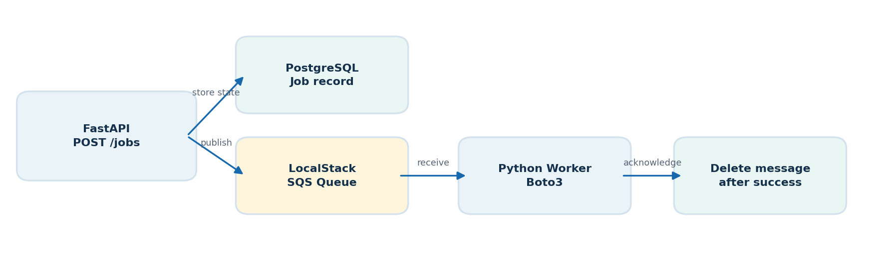
Figure 1 — QueueFlow at a glance: API, durable job state, message queue, and workers.
Purpose: consolidate everything we built, discussed, tested, and intentionally skipped. This is a theory-first document with key technical terms, conceptual diagrams, and implementation decisions—but no code blocks.
KEY POINT | QueueFlow is an SQS learning project, not an attempt to build a production-grade job platform.

Reading guide
The first chapters reconstruct the implementation journey. Later chapters explain SQS theory, design decisions, incident scenarios, operational concerns, and interview-ready answers. “Implemented,” “discussed,” and “not confirmed” are intentionally distinguished.

1 Scope, stack, and architectural choices
Decision | What we chose / why
Learning objective | Understand SQS from fundamentals through realistic worker failure scenarios, at fresher interview depth.
Execution environment | LocalStack only; no real AWS or credit-card-dependent steps.
Language and API | Python, FastAPI for HTTP endpoints, Boto3 for SQS interaction.
Queue type used in implementation | Standard queue: queueflow-jobs. FIFO studied theoretically; a FIFO experiment was proposed but not completed.
Persistent state | PostgreSQL with SQLAlchemy; SQS handles delivery, PostgreSQL tracks job lifecycle.
Database migrations | Alembic introduced after initial create_all approach; migration baseline stamped.
Scope control | Avoid production-level outbox implementation, complex retry engines, deep IAM deployment, stale-worker simulation, and extensive test scaffolding.

2 QueueFlow architecture
Figure 2 — API publishes work; SQS delivers; worker claims a database job and acknowledges only after success.
Request path: a client calls POST /jobs. The API persists job metadata and sends a message containing the job identifier to queueflow-jobs, returning HTTP 202 Accepted for asynchronous processing. GET /jobs/{job_id} reports stored status. /health provides a basic health check.
Worker path: a long-polling Python consumer receives a message using Boto3, extracts job_id, atomically claims the corresponding database record, performs process_job(), records the result, and calls DeleteMessage only when processing is successfully finalized.
KEY POINT | A successful HTTP 202 means work was accepted for asynchronous handling, not that the job has finished.

3 Job state and database design
Field / term | Purpose
id | Stable job identifier; used to correlate API, PostgreSQL, and SQS.
job_type | Selects business task.
payload (JSONB) | Stores job-specific parameters.
status | queued → processing → succeeded, or failed.
attempts | Application/database claim count; separate from SQS ApproximateReceiveCount.
last_error | Most recent recorded error.
timestamps | Track creation and updates.
lease_expires_at | Time after which abandoned processing may be reclaimed.
lease_token | Unique claim ownership token used to fence completion.
Originally, schema initialization used Base.metadata.create_all(bind=engine). We later installed Alembic, configured migrations/env.py to load DATABASE_URL and SQLAlchemy Base.metadata, autogenerated an empty baseline for the existing schema, and used alembic stamp head. A later autogenerated migration added lease_expires_at and lease_token, then alembic upgrade head applied it.
KEY POINT | Caveat: an empty stamped baseline reflects the pre-existing database; it does not by itself recreate all original tables from scratch on a fresh database.

4 SQS lifecycle and core operations
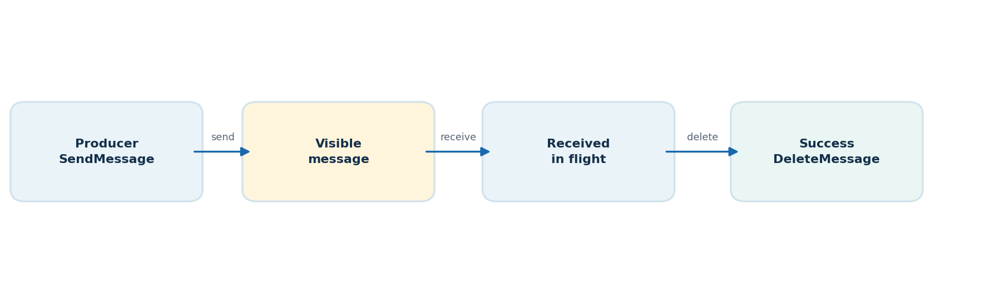
Figure 3 — Normal SQS message lifecycle.
Term | Meaning
SendMessage | Producer publishes a message.
ReceiveMessage | Worker polls messages; receiving does not remove the message permanently.
ReceiptHandle | Receive-specific token required for deletion or changing visibility.
VisibilityTimeout | Period during which a received message is hidden from other consumers.
DeleteMessage | Acknowledges successful handling and removes the message.
WaitTimeSeconds | ReceiveMessage long-poll duration (0 to 20 seconds).
MaxNumberOfMessages | Maximum messages requested in one receive call (up to 10).
If the consumer does not delete the message, it becomes eligible for redelivery after its visibility timeout. SQS Standard queues offer at-least-once delivery, so duplicate deliveries must be expected.

5 Idempotency, atomic claims, and duplicate delivery
We observed repeated job identifiers and distinguished repeated delivery of the same job from the generation of a new job. The database stores state across attempts. A succeeded job should not execute its business operation again; its stray duplicate SQS message can be safely acknowledged.
The claim_job() path was changed to use an atomic conditional SQLAlchemy UPDATE ... RETURNING pattern instead of read-then-write. Its eligibility rules initially include queued and failed, and later also include processing jobs whose lease expired. This prevents two workers from simultaneously claiming the same eligible database job under normal race conditions.
A worker may still execute a business side effect and crash before recording success. The database claim alone cannot guarantee exactly-once external effects. Payment, email, and similar operations need business-level idempotency keys or downstream support.
Concept | Guarantee / limitation
At-least-once delivery | A message may be delivered more than once.
Atomic claim | Protects the database state transition from competing workers.
Completed-job guard | Skips work when database status is already succeeded.
Business idempotency | Prevents repeated external effects even across crashes.
FIFO deduplication | Suppresses duplicate sends within a bounded five-minute window; not exactly-once business execution.

6 Worker crash recovery: SQS timeout vs database lease
We explored the failure after a worker starts processing but crashes before marking a database job succeeded. A true process death does not run the Python exception handler. Without recovery, PostgreSQL may remain stuck at processing while SQS makes the message available again.
We introduced processing leases: lease_expires_at records temporary ownership expiry, and lease_token identifies the current owner. claim_job() may reclaim an expired processing job. complete_job() uses both the job status and matching lease token and requires the lease to be valid; fail_job() similarly checks ownership.
The worker crash recovery simulation was completed. A separate stale-worker simulation was intentionally skipped, even though token fencing was added as a safeguard.
Failure stage | Expected behavior / concern
Before the worker claims | Message returns after visibility timeout; job remains available.
After claim, before work | Database processing lease expires; later worker can reclaim.
After side effect, before DB success | Message may be retried; external side effect can repeat without business idempotency.
After DB success, before SQS deletion | Duplicate delivery finds succeeded and deletes without redoing business work.
Slow worker past visibility timeout | Another worker may receive; processing lease ownership helps DB correctness but visibility and lease durations still need coordination.
KEY POINT | SQS visibility timeout controls message delivery. PostgreSQL lease controls ownership of application job state. They are separate clocks and mechanisms.

7 Retries and Dead-Letter Queues
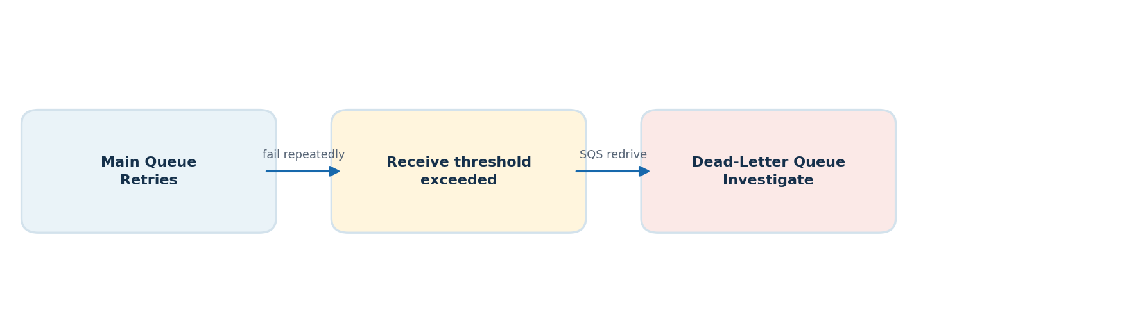
Figure 4 — Repeated failure can move a message from the primary queue into its DLQ.
A queueflow-dlq was configured as a Dead-Letter Queue and linked through the primary queue RedrivePolicy with maxReceiveCount = 3 in our exercise. The user confirmed the DLQ part was completed successfully, including the message-handling/replay learning step.
On business failure, the worker records failed / last_error when possible and deliberately does not delete the SQS message. Visibility timeout makes it eligible for another receive. Once the receive-count redrive threshold is exceeded, SQS moves it to the DLQ. The DLQ itself does not repair messages or automatically replay them.
DLQ options: investigate manually; run a dedicated DLQ consumer; or initiate managed SQS redrive from the DLQ to a destination. We also studied manual replay: receive from DLQ, send message body to the source queue, then delete the DLQ copy after the send succeeds. Manual replay is different from StartMessageMoveTask managed redrive.
Important replay considerations: fix the underlying cause first; sending and deleting are not atomic; duplicate replay is possible; preserving message attributes may matter; FIFO destinations require group/deduplication handling. PostgreSQL failed status may be reclaimable by claim_job(), but the DB attempts counter is not automatically reset and DLQ movement does not update PostgreSQL.
Term | What it controls
RedrivePolicy | Source queue’s DLQ destination and maximum receive count.
maxReceiveCount | ApproximateReceiveCount threshold used for DLQ movement.
DLQ message retention | How long messages remain available before expiry.
StartMessageMoveTask | Managed asynchronous movement of DLQ messages back to supported destinations.
Manual replay | Application script manually republishes and deletes messages.
Retry queue | Separate design for scheduled retry; DLQ alone is not a retry scheduler.

8 Standard vs FIFO: ordering, groups, and deduplication
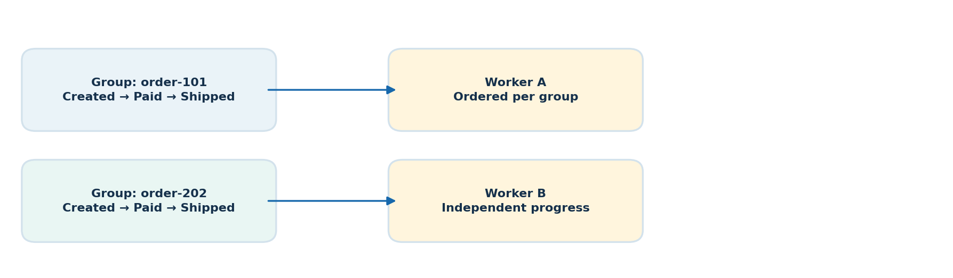
Figure 5 — FIFO preserves order within a group while independent groups can progress concurrently.
Characteristic | Standard | FIFO
Delivery | At least once | At least once
Order | Best effort | Ordered within MessageGroupId
Duplicate publish handling | No five-minute built-in deduplication | Deduplication ID / body-based five-minute window
MessageGroupId | Not used for FIFO ordering | Required for FIFO messages
Good examples | Background tasks and notifications | Ordered order events and per-entity workflows
MessageGroupId groups events that must preserve sequence, such as created → paid → shipped for one order. Different groups may be processed independently. A slow in-flight message holds up later messages from its group. Putting every event in one group can unnecessarily restrict concurrency.
MessageDeduplicationId identifies a logical send for FIFO publish deduplication. A second send using that ID during the five-minute interval is acknowledged but suppressed; the interval is not extended by duplicate sends. A send after the window can be accepted as a fresh message. With ContentBasedDeduplication, SQS hashes the message body, not its message attributes.
Crucial distinction: the five-minute deduplication window concerns duplicate SendMessage calls. It does not prevent a previously delivered message from being redelivered after visibility timeout. Thus consumer idempotency remains mandatory. Moving a poison message to DLQ may allow later messages in its group to proceed, which can matter for business sequencing.
KEY POINT | Decision: FIFO was covered in theory only. Suggested LocalStack FIFO ordering/deduplication experiments were not run.

9 Polling, delays, visibility, and retention
Feature | How it works | Key limit / detail
Short polling | SQS responds immediately, sometimes empty. | WaitTimeSeconds = 0
Long polling | SQS waits briefly for messages to reduce empty receives. | WaitTimeSeconds 1–20; QueueFlow uses 20.
DelaySeconds | Hides a newly sent message before initial delivery. | 0–900 s (15 min); per-message delay not supported on FIFO.
Visibility timeout | Hides a message after a worker receives it. | Up to 12 hours; processing time must be considered.
MessageRetentionPeriod | Determines how long undeleted messages are stored. | 60 seconds–14 days; default 4 days.
MaximumMessageSize | Maximum message body size. | Up to 1 MiB.
DelaySeconds and VisibilityTimeout solve different problems. Delay controls initial eligibility; visibility controls in-flight redelivery. Long polling is efficient for mostly empty queues and does not mean a 20-second delay for every message: SQS can respond earlier when a message arrives.

10 IAM, monitoring, and scaling — theory only
IAM principle of least privilege: producer typically needs sqs:SendMessage; worker typically needs sqs:ReceiveMessage, sqs:DeleteMessage and possibly sqs:ChangeMessageVisibility. Read permissions such as sqs:GetQueueAttributes and sqs:GetQueueUrl depend on implementation. Real AWS deployments should prefer roles / temporary credentials over embedded long-lived keys; QueueFlow uses LocalStack test credentials.
CloudWatch metric | Interpretation
ApproximateNumberOfMessagesVisible | Available backlog.
ApproximateNumberOfMessagesNotVisible | Messages currently in flight.
ApproximateAgeOfOldestMessage | Oldest eligible message age; processing delay indicator.
NumberOfMessagesSent | Publish activity.
NumberOfMessagesDeleted | Successful delete requests, not necessarily unique business jobs.
NumberOfEmptyReceives | Polls returning no messages.
If backlog grows, inspect producer input rate, worker logs, failures, in-flight counts, oldest message age, and DLQ depth. Scaling SQS infrastructure is managed by AWS, but a custom Python worker fleet does not automatically scale merely because it uses SQS. Consumer scaling must be configured independently.

11 Decisions and experiment ledger
Item | Record / outcome
Boto3 producer and worker | Implemented and integrated with LocalStack.
FastAPI POST /jobs, GET /jobs/{job_id}, /health | Implemented as the basic request / status interface.
PostgreSQL state and SQLAlchemy | Implemented.
claim_job() atomic conditional claim | Implemented and race tested.
Status guard for succeeded jobs | Implemented.
Crash after business work discussion | Explored; motivated lease design and external idempotency caveat.
Processing lease and lease_token | Implemented; worker crash recovery tested.
Stale-worker experiment | Explicitly skipped.
Alembic migration baseline and lease migration | Completed.
DLQ / retry redrive | User confirmed DLQ module done; failure/replay mechanisms studied.
FIFO ordering, groups, five-minute deduplication | Theory completed; experiments explicitly skipped.
Long polling, delay, retention, queue attributes | Theory completed; long polling used in worker.
IAM, CloudWatch, scaling | Theory covered; no real AWS deployment.
Production outbox and complex retry engine | Intentionally excluded from learning scope.
Real AWS account/permissions | Not used; LocalStack remains required.

12 Key failure scenarios: interview playbook

Worker dies without deleting
The message becomes available after visibility timeout. If database lease exists, a later worker may reclaim once lease expires.

Two workers receive/retry the same job
Atomic claim_job() prevents simultaneous ownership of eligible DB state. It does not itself make an external side effect exactly once.

Worker completes DB success but DeleteMessage fails
SQS can redeliver. The succeeded-job guard avoids rerunning the operation and deletes the redundant message.

API stores job but SQS publish fails
Database and SQS are not one transaction; the current architecture has a dual-write gap. A transactional outbox is a possible production remedy but was intentionally not implemented.

Producer sends duplicate FIFO ID after five minutes
SQS may accept it as a new message; application idempotency still required.

Message fails repeatedly
It can be retried following visibility timeout and moved to DLQ once configured receive threshold is exceeded.

Queue backlog increases
Monitor visible count and oldest age, investigate worker capacity, faults and processing throughput.

FIFO group’s first message is stuck
Later messages in the same group wait while that message is in flight; other groups may progress.

13 Key terms to recognize in code reviews
FastAPI; HTTP 202 Accepted; POST /jobs; GET /jobs/{job_id}; /health; boto3.client("sqs"); QueueUrl; MessageBody; SendMessage; ReceiveMessage; DeleteMessage; ReceiptHandle; VisibilityTimeout; WaitTimeSeconds; MaxNumberOfMessages; MessageGroupId; MessageDeduplicationId; ContentBasedDeduplication; RedrivePolicy; deadLetterTargetArn; maxReceiveCount; ApproximateReceiveCount; StartMessageMoveTask; SQLAlchemy SessionLocal; Job; claim_job(); complete_job(); fail_job(); process_job(); UPDATE ... RETURNING; lease_expires_at; lease_token; alembic revision --autogenerate; alembic stamp head; alembic upgrade head; LocalStack endpoint_url; IAM; CloudWatch.

14 Final summary: the lessons that matter
- SQS provides durable asynchronous message delivery and decoupling; it does not store the complete business truth of a job.
- Delete messages only after confirming successful handling; a receive is not an acknowledgement.
- Expect duplicate deliveries and failure at any boundary, including between side effects and state updates.
- Database ownership, SQS visibility, and external idempotency solve different problems.
- FIFO guarantees ordered delivery within groups and bounded publish deduplication—not exactly-once business processing.
- DLQs isolate repeatedly unsuccessful messages; recovery requires investigation and intentional replay.
- Metrics reveal backlog and failure; workers need their own scaling and permissions.
- QueueFlow’s deliberate design keeps hands-on SQS learning focused while clearly identifying omitted production-grade protections.
Document scope: reconstructed from the conversation summary and the recorded QueueFlow progress. Statements about experiment completion follow the user’s confirmations; where a run was not confirmed, it is identified accordingly.

