**EssentialMart**

**‘Pantry System’**

**Actors and Actions:**

Guest User:

* Browse ABC Pantry categories.
* View product details and prices.
* Access special offers and advertisements.
* Add items to a temporary shopping cart.

Registered Customer:

* Log in to their account.
* Save favorite products or create a wishlist.
* View order history and track deliveries.
* Receive personalized recommendations.
* Utilize special discounts and offers.
* Provide feedback and ratings on purchased items.

Marketing Team:

* Create and manage advertisements.
* Design and promote special offers.
* Monitor the performance of marketing campaigns.
* Analyze customer behavior and preferences.
* Collaborate with IT for seamless integration of advertisements.

IT Department:

* Develop and implement the ABC Pantry feature.
* Ensure the security and integrity of user data.
* Provide technical support for users.
* Implement and maintain payment processing systems.
* Collaborate with other departments for system integration.

Delivery and Logistics Team:

* Confirm and fulfill orders.
* Optimize delivery routes and logistics.
* Provide real-time order tracking for customers.
* Handle returns and customer inquiries related to delivery.

Finance Team:

* Manage financial transactions on the platform.
* Implement and monitor pricing strategies.
* Generate financial reports on sales, expenses, and profitability.
* Ensure compliance with financial regulations.
* Collaborate with IT for secure payment processing.

Company Management:

* Set project vision and goals for ABC Pantry.
* Approve budget and allocate resources.
* Set performance metrics for the success of ABC Pantry.
* Make decisions on changes or enhancements to the project.
* Review and approve final deliverables.

As in map

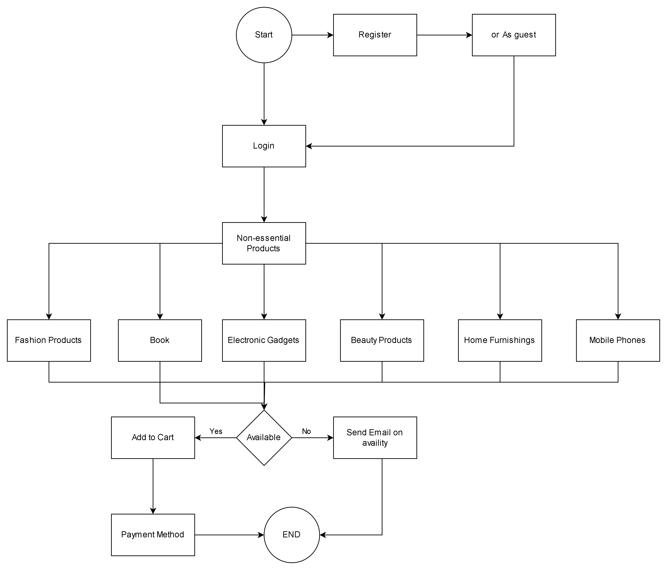

Future Process Map

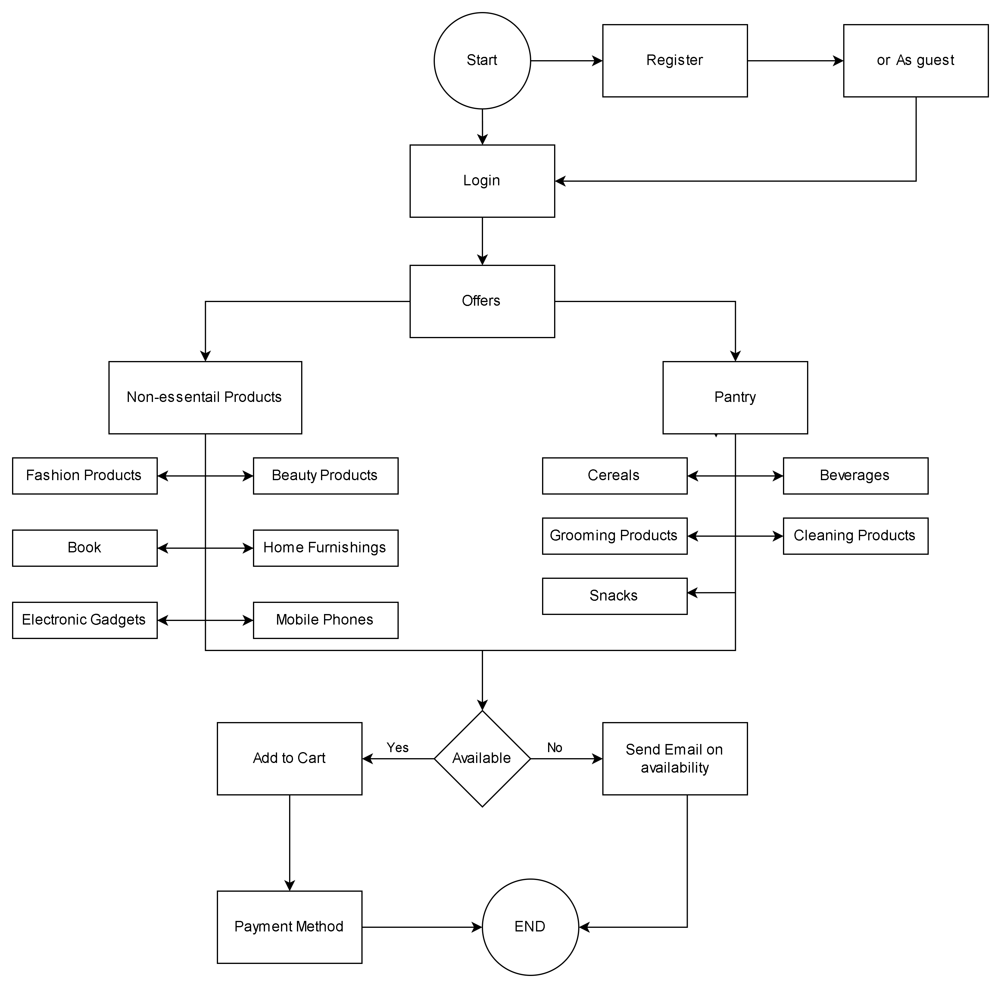

**Write the main features that need to be developed.**

The scope of the ABC Pantry feature involves the development of various components and functionalities to create a seamless and effective user experience. Here are the main features that need to be developed for ABC Pantry:

ABC Pantry Integration:

Develop and integrate the ABC Pantry feature into the existing website and app.

Ensure the feature is accessible from a prominent and visible area of the platform.

Category Management:

Implement logical grouping of daily essential products into specified categories.

Allow for easy navigation and search within each category.

Advertisements Display:

Integrate a system to display up to five non-intrusive advertisements.

Ensure advertisements do not disrupt the user's interaction with ABC Pantry.

Special Offers:

Develop a feature to showcase and manage special offers for customers.

Highlight discounted products and promotions.

Shopping Cart Functionality:

Enable customers to add daily essential items to their shopping cart.

Integrate the shopping cart with the existing system to include non-essential items.

Order Amount Restriction:

Implement a minimum order amount of $30 to proceed with checkout.

Validate individual items and the total order amount against the minimum requirement.

Free Delivery Threshold:

Set a threshold of $50 for free delivery.

Communicate to users when they qualify for free delivery.

City Presence Management:

Limit the presence of ABC Pantry to specified cities as mentioned in the data sets.

Define and manage the list of cities where ABC Pantry is available.

Zone-Based Categorization (US Market):

Categorize cities in the US market into four zones based on sales.

Use zone information for targeted marketing and logistics optimization.

Reporting Module:

Develop a reporting module to generate various reports requested by the management.

User Feedback Mechanism:

Implement a mechanism for customers to provide feedback on products, delivery, and overall experience.

Responsive Design:

Ensure the feature has a responsive design for seamless user experience across various devices.

Security Measures:

Implement robust security measures to protect user data, especially during payment processing.

Integration with Existing Systems:

Collaborate with other departments for smooth integration with existing systems such as finance, marketing, and logistics.

User Authentication and Authorization:

Implement secure user authentication and authorization mechanisms to protect user accounts and transactions.

Week-wise Sales Tracking:

Develop a mechanism to track total sales on a weekly basis for each city.

Day-wise Sales Tracking:

Track and analyze sales data to identify the day of the week with the highest customer activity.

**Scope of ABC Pantry Feature:**

**In-Scope:**

* Addition of "ABC Pantry" feature to the existing website/app.
* Prominent placement of the feature for visibility.
* Logical grouping of daily essential products into specified categories.
* Display of advertisements (non-intrusive) to generate advertising revenue.
* Presentation of special offers to attract customers.
* Shopping cart functionality with the ability to include non-essential items.
* Order amount restriction: Minimum order amount of $30.
* Free delivery for orders exceeding $50.
* Presence limited to specified cities in the US.

**Out-of-Scope:**

* International expansion beyond specified cities.
* Physical store implementation.
* Inclusion of non-daily essential product categories.
* Integration with third-party platforms.

**Business Requirements:**

**Functional Requirements:**

* Display ABC Pantry feature prominently on the website/app.
* Group daily essential products into specified categories.
* Show up to five non-intrusive advertisements.
* Highlight special offers to customers.
* Allow customers to add items to the shopping cart.
* Implement minimum order amount of $30.
* Offer free delivery for orders exceeding $50.
* Restrict ABC Pantry presence to specified US cities.

**Non-functional Requirements:**

* User-friendly interface for easy navigation.
* Responsive design for various devices.
* Advertisements should not affect user experience.
* Secure and reliable payment processing.
* Fast and efficient order processing and delivery.

Wire Frame:-

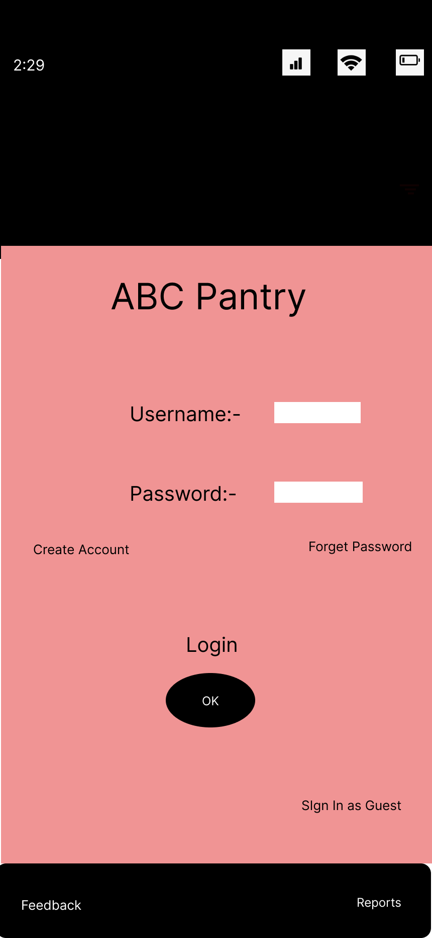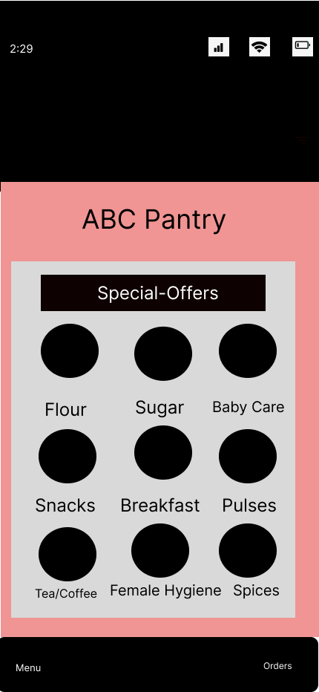

**Project Task: Week 2 (agile scrum concepts )**

**Product Backlog:**

* **User Story: As a Guest User, I want to browse ABC Pantry categories so that I can explore available daily essential products.**

**Acceptance Criteria:**

* + 1. The guest user can access ABC Pantry from the homepage.
    2. Categories are displayed prominently.
    3. Clicking on a category shows a list of relevant products.
* **User Story: As a Registered Customer, I want to view special offers on ABC Pantry so that I can avail discounts on my purchases.**

**Acceptance Criteria:**

* + 1. Special offers are clearly visible on the ABC Pantry interface.
    2. Details of each offer, including discounts, are displayed.
    3. The customer can easily apply offers to their cart.
* **User Story: As a Customer, I want to add daily essential items to my shopping cart so that I can proceed with the purchase.**

**Acceptance Criteria:**

* + 1. The customer can add items to the shopping cart from the product details page.
    2. The shopping cart updates dynamically with the added items.
    3. Cart total is displayed.
* **User Story: As a Customer, I want to view and manage my shopping cart, including both essential and non-essential items.**

**Acceptance Criteria:**

* + 1. The shopping cart is accessible from any page within ABC Pantry.
    2. Both essential and non-essential items are displayed.
    3. The customer can update quantities and remove items.
* **User Story: As a Customer, I want to proceed to checkout only if my total order amount exceeds $30.**

**Acceptance Criteria:**

* + 1. The checkout button is enabled only if the total order amount is $30 or more.
    2. A message is displayed if the order amount is below $30.
* **User Story: As a Customer, I want to receive free delivery if my total order exceeds $50.**

**Acceptance Criteria:**

* + 1. The system recognizes when the total order amount is $50 or more.
    2. Free delivery option is provided during the checkout process.
* **User Story: As a Marketing Team member, I want to create and manage advertisements for ABC Pantry so that I can promote products effectively.**

**Acceptance Criteria:**

* + 1. A user interface is provided for the Marketing Team to create and upload advertisements.
    2. Advertisements are displayed in a non-intrusive manner on ABC Pantry.
* **User Story: As a Logistics Team member, I want to optimize delivery routes for ABC Pantry orders so that we can improve delivery efficiency.**

**Acceptance Criteria:**

* + 1. The system provides real-time order data to optimize delivery routes.
    2. Delivery routes are dynamically updated based on order data.
* **User Story: As a Finance Team member, I want to generate financial reports on ABC Pantry sales for better financial management.**

**Acceptance Criteria:**

* + 1. The system provides a reporting module with options for financial reports.
    2. Reports include total sales, expenses, and profitability.
* **User Story: As a Customer, I want to provide feedback on products and the overall ABC Pantry experience.**

**Acceptance Criteria:**

* + 1. A feedback mechanism is available on the ABC Pantry interface.
    2. Customers can rate products and provide comments on their experience.
* **User Story: As a Customer, I want to track the delivery status of my ABC Pantry order in real-time.**

**Acceptance Criteria:**

* + 1. The system provides a tracking feature accessible from the customer's account.
    2. Real-time updates on the delivery status are displayed.

**Dashboard for senior management for Chicago to view sales of personal care products for the last 6 months.**

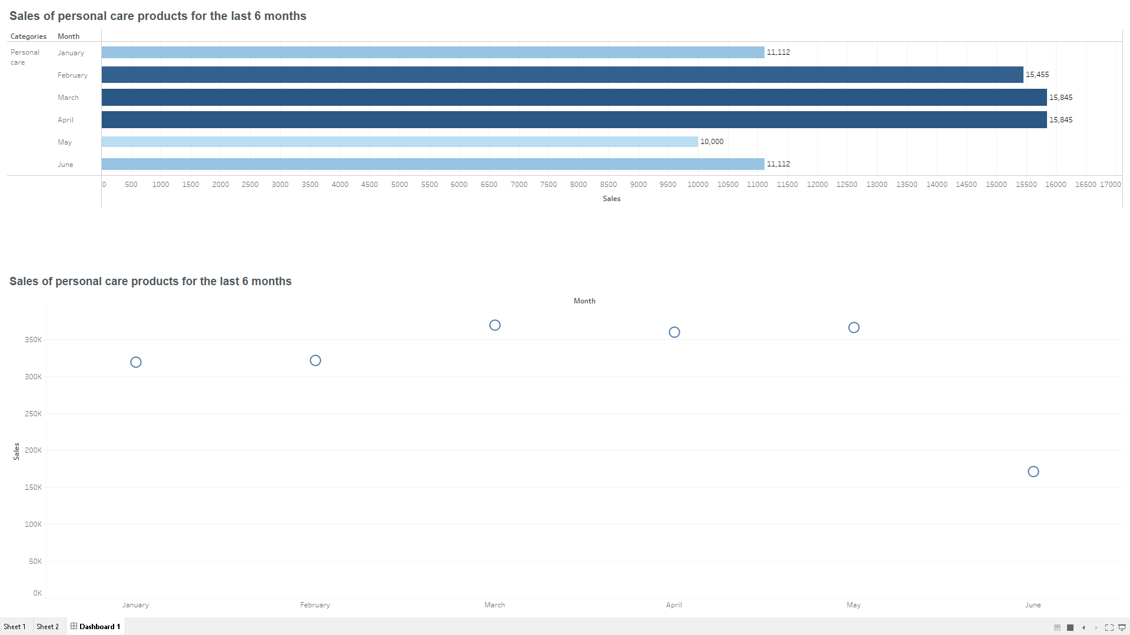

Dashboard to show Senior Management for Chicago to view sales of breakfast products for the last six months.

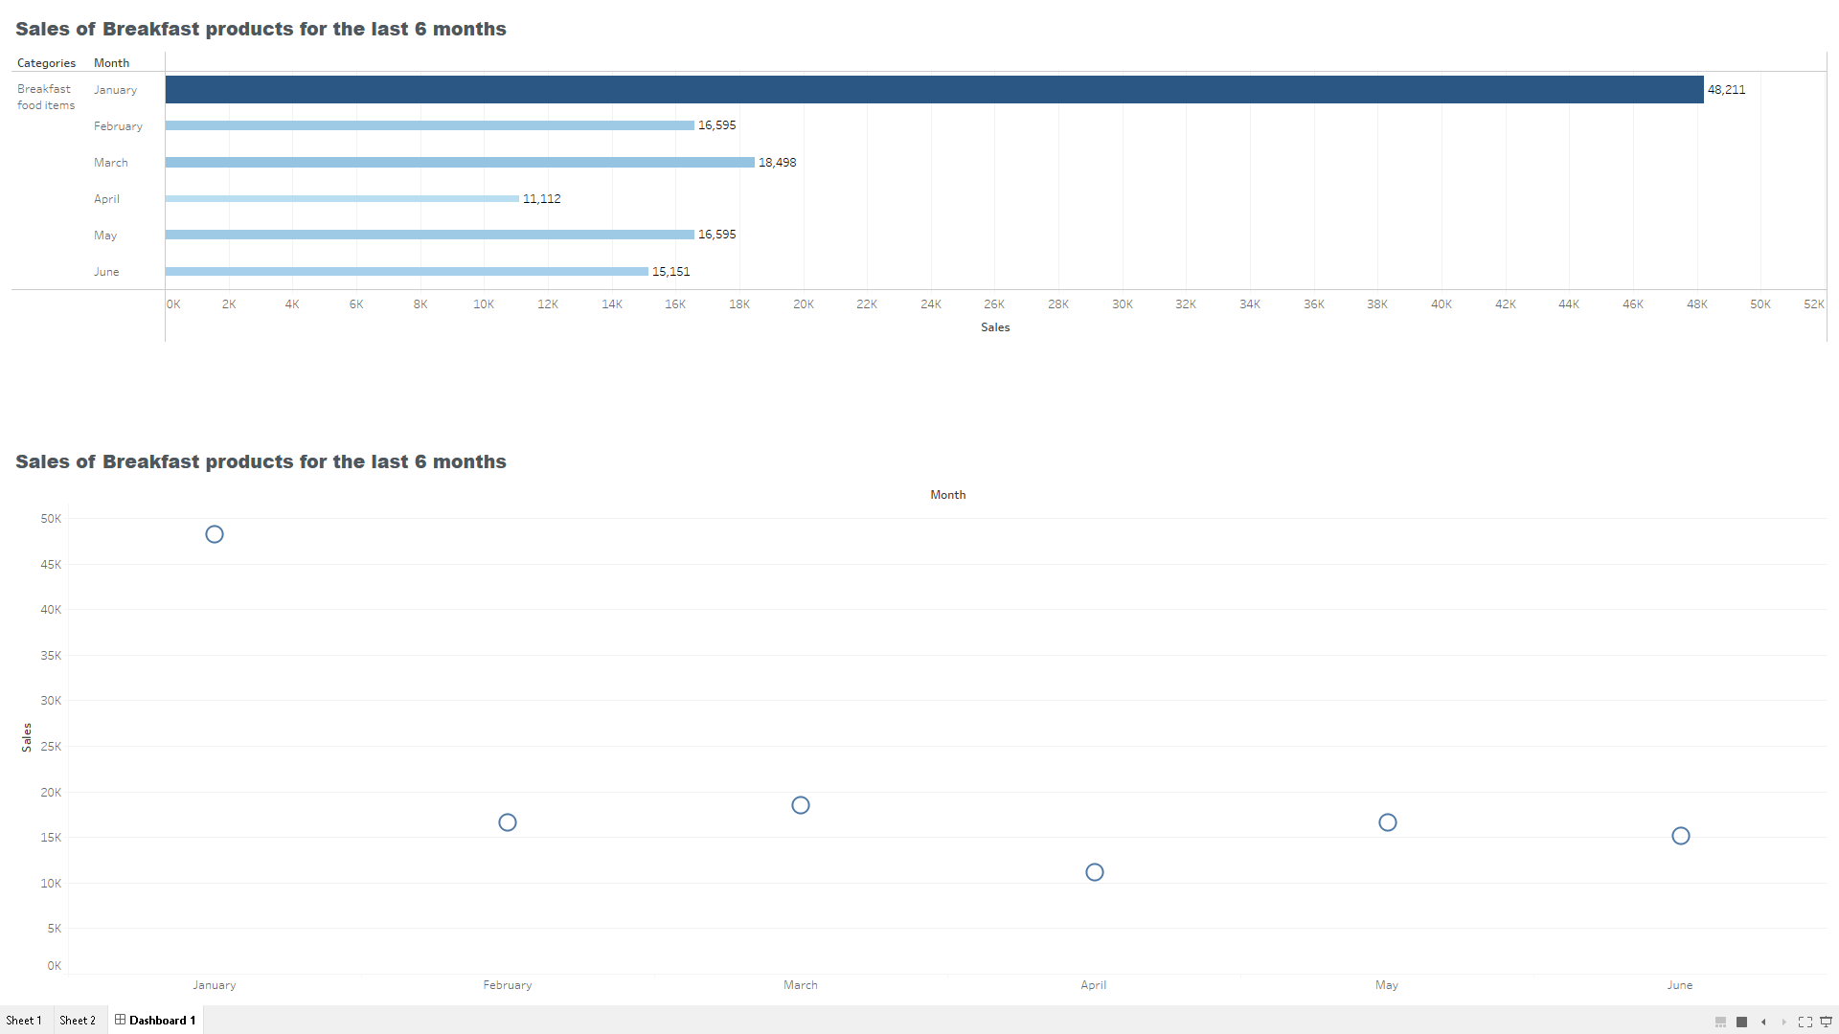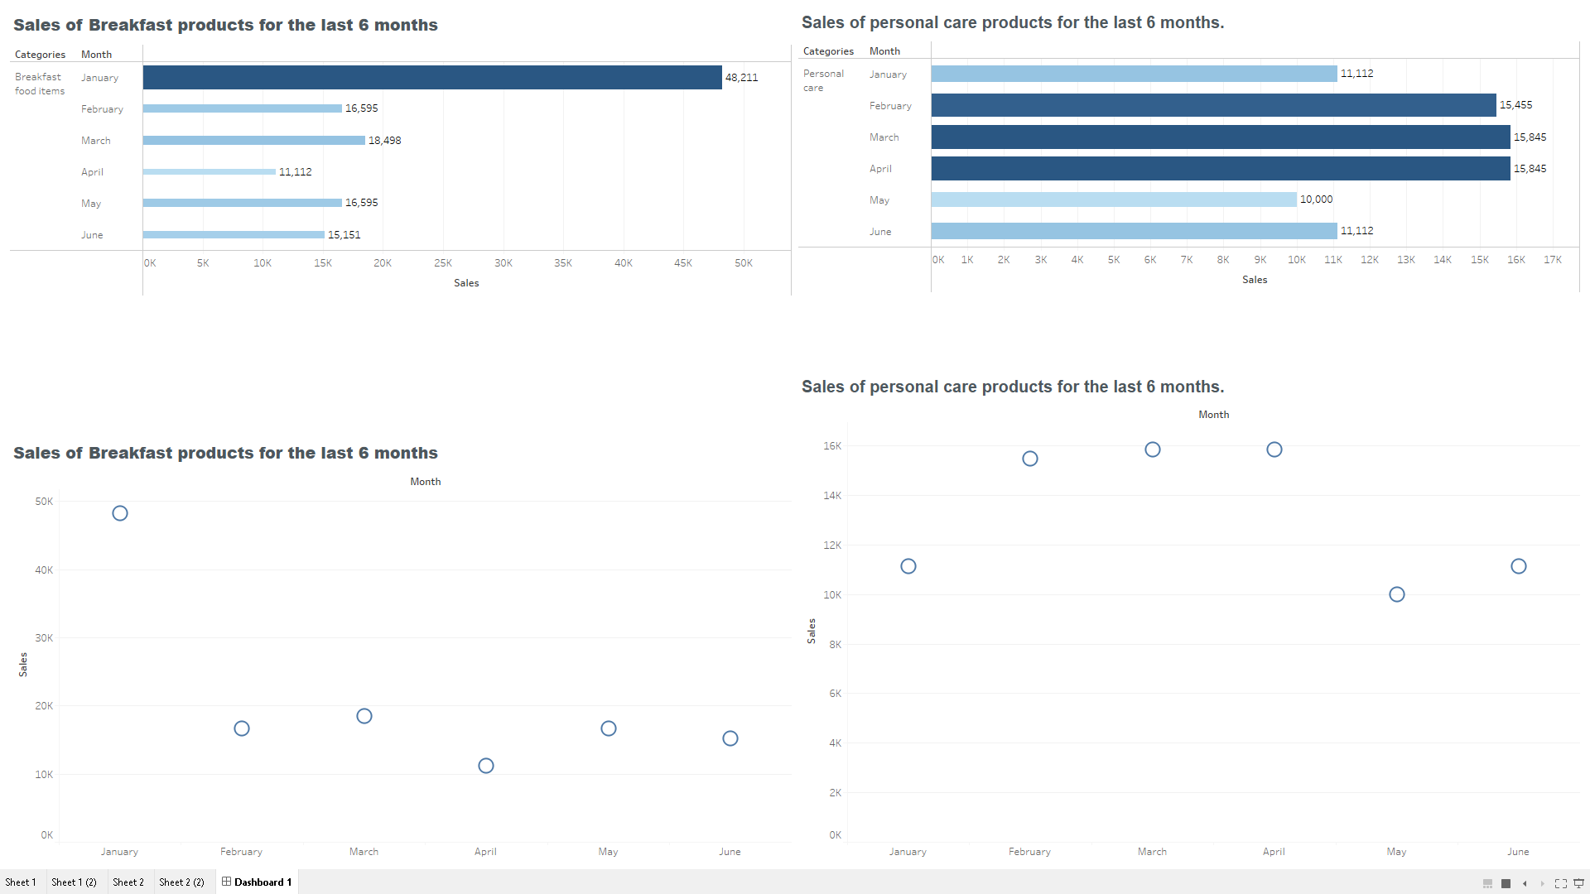

<https://public.tableau.com/views/Book1_17041798565610/Dashboard1?:language=en-US&publish=yes&:display_count=n&:origin=viz_share_link>

**Task**

1. Bar graph showing the sales. Label the chart correctly so that senior management gets a clear report of sales.
2. Arrange the data in excel

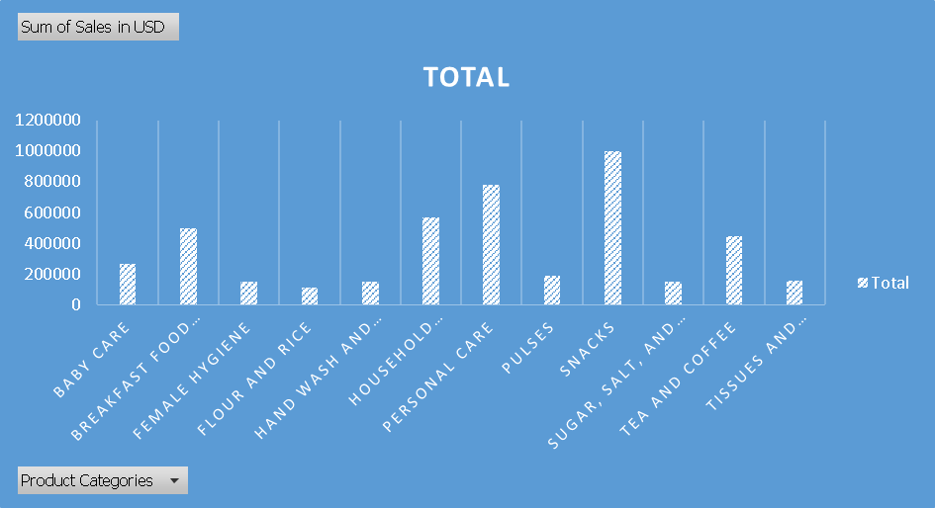

Ascending -Order

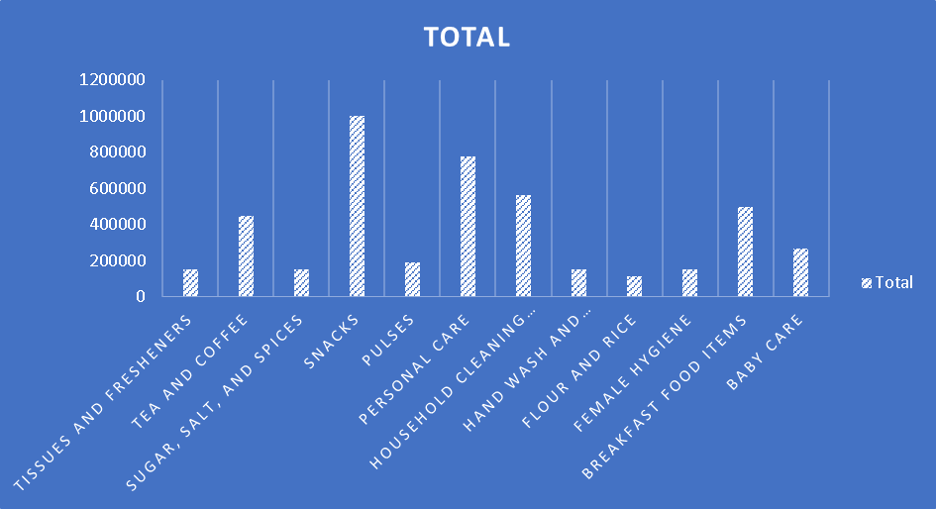

**Descending-Order**

**Question 2**

1. Create bar graphs of sales for zone 1 cities
2. Find total sales across all cities

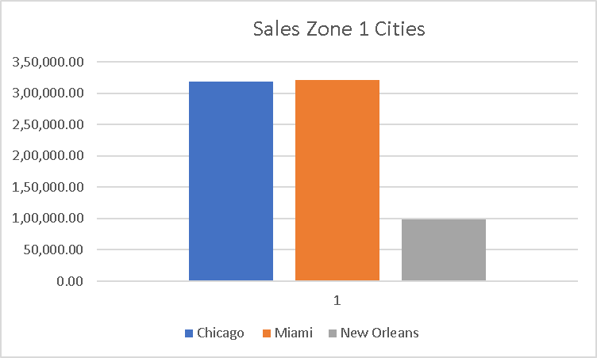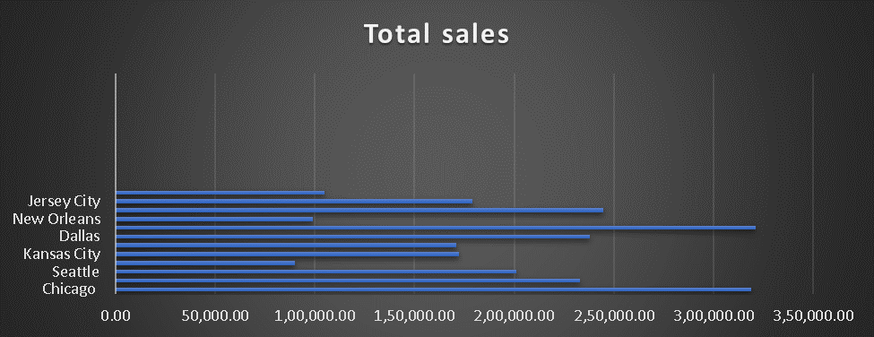

1. Using vlookup for product code HS, find sales in Phoenix

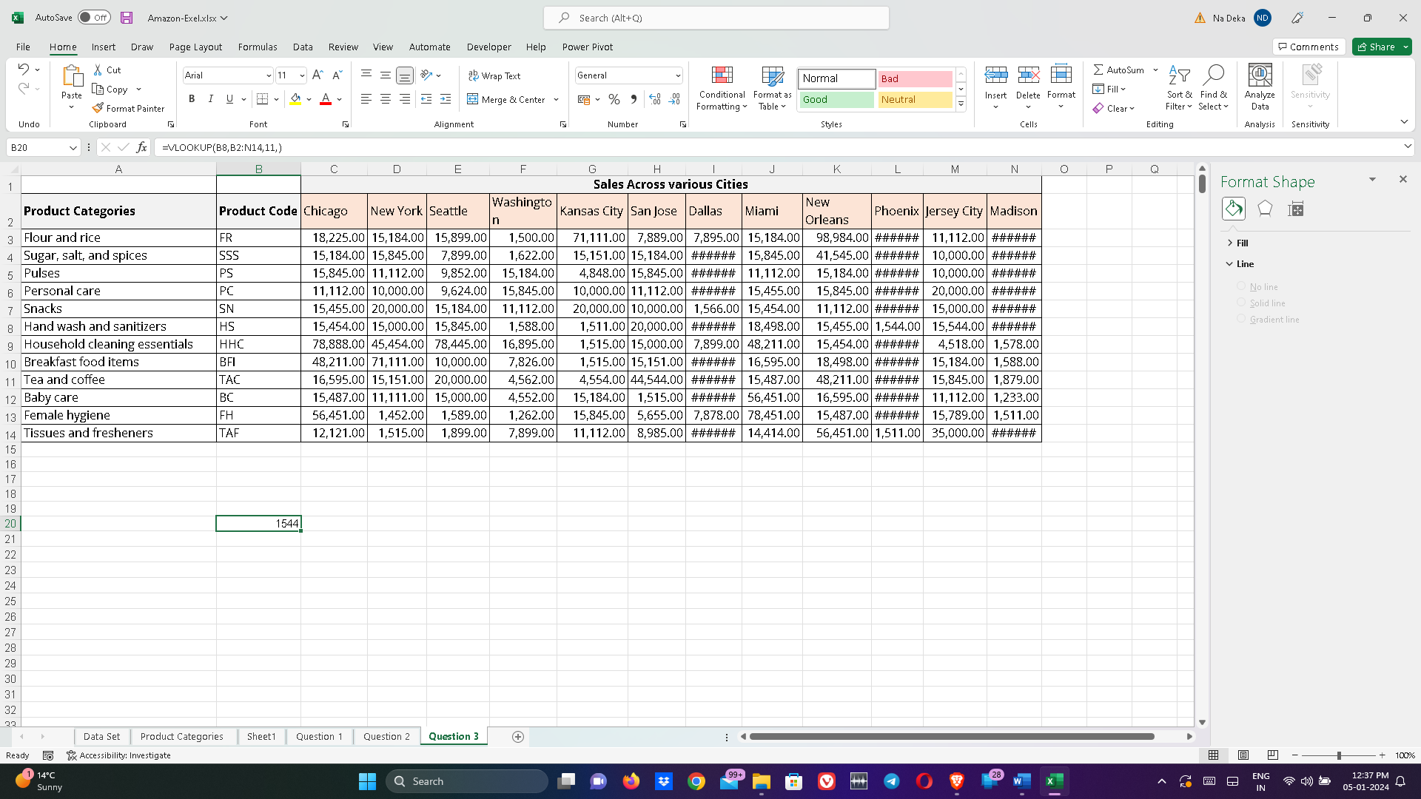

=VLOOKUP(B8,B2:N14,11,)

1. Using vlookup for product code FR, find sales in Dallas

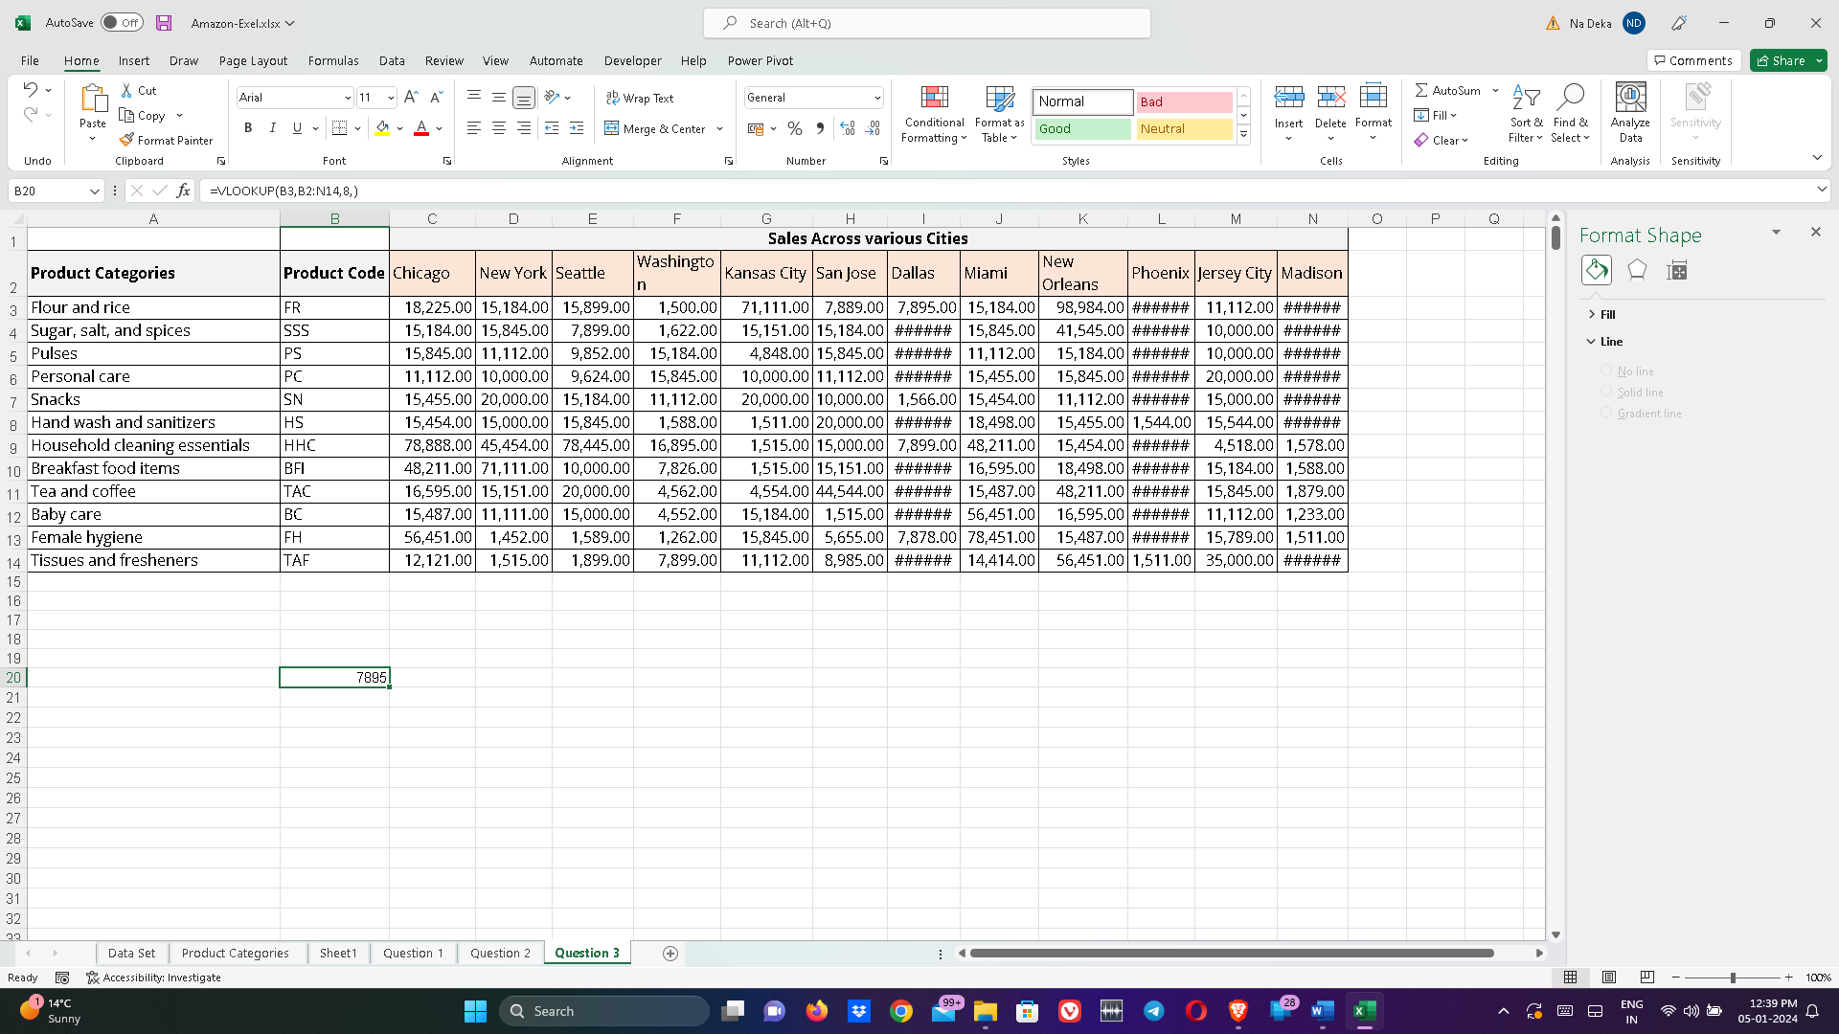

**=VLOOKUP(B3,B2:N14,8,)**