## Results

*Figure 1. Total Loss from 0 Steps to 160,000 Steps*

*This is a graph of the progression of Loss (inaccuracy) on the y-axis over time measured in training steps on the x-axis.*

The whole experiment or training of the model ran for about 3 hours and 160,000 steps. In the end, the model reached a loss or inaccuracy of about 11.37%. This means the model can accurately read one of the 12 characters from the Digital Shorthand Key.

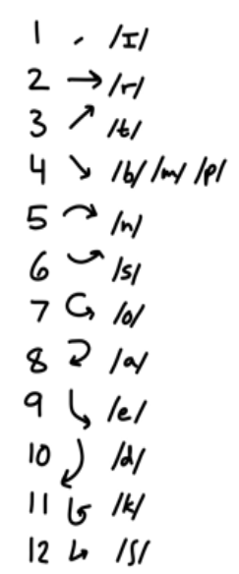 To check the validity of the model, and to confirm these results were not the product of random chance, a One Proportion Z-Test can be used to find a P-value (One Sample Test of Proportions, 2016).

*Figure 2. Digital Shorthand Key Characters*

*The following is a list of all 12 Digital Shorthand Key characters and their corresponding phoneme and symbol.*

$$z= \frac{\hat{p}-p_{0}}{\sqrt{\frac{p_{0}(1-p_{0})}{n}}}$$

$$\hat{p}=Observed Population$$

$$p_{0}=Null Hypothesized Value$$

$$n=Sample Size$$

$$z=Z Score$$

In this project, the observed population was $\frac{154}{174}$ because there were 174 characters in the test directory of which 20, ~11% of 174, were incorrectly identified. Conducting this test on the data yielded a z-score of ~39.08 standard deviations from the mean. This translates to a $P≤0.00001$, which shows the recognition accuracy of the model is significant ($P≤0.05$). It is most probable these results are not due to random chance, and thus the Machine Learning algorithm is effective when applied to the shorthand.

Furthermore, when compared to similar systems made for Gregg Shorthand and Pitman Shorthand, the Digital Shorthand Key meets the benchmark for accuracy despite only being trained for about 500 samples.

*Table 1. Comparison of Machine Learning Models Across Shorthands*

*This Table compares the Digital Shorthand Key, Gregg, and Pitman in terms of Loss, Training Size, and Information Density. Higher Information Density indicates a more efficient Shorthand and more efficient Algorithm as well.*

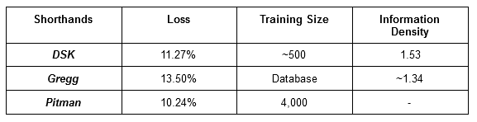

However, the real strength of using Machine Learning for the Digital Shorthand Key lies in the Information Density of the Shorthand. To support the notion that the Digital Shorthand Key is also more Informationally Dense than Gregg Shorthand as part of the work last year, a Student’s T-Test was conducted to measure the probability that the ranges of the Information Densities of different experimental groups could overlap. Speed Score was calculated by dividing the unused pixels as part of the RGB average of a sample by the number of strokes.

*Figure 3. Ranges of Information Density Between Experimental Groups and Gregg*

*This number line shows where the Information Density of each group ( $±3$ standard deviations) lies.*

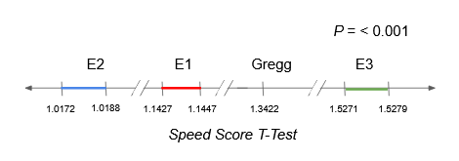

In this statistical test done last year, each experimental group contains 30 samples except for Gregg Shorthand, since Gregg Shorthand samples were obtained from an Online Translator (Šarman, n.d.). This translates to a $P≤0.0001$, which shows that likelihood of Experimental Group 3, now known as the Digital Shorthand Key, being more efficient than Gregg Shorthand is significant ($P≤0.05$). It is most probable that these results are not due to random chance, and thus the notion the Shorthand is more efficient than Gregg shorthand is supported.