Project Stage 3: Progress in Development
Design and Implementation of a Low-Latency Hardware Limit Order Book and Parallel Matching Engine in Synthesizable Verilog RTL
Course & Project: | Digital Logic Design (DLD) - Hardware Engineering Project
Instructor / Evaluator: | Mohd Arif
Submission Stage: | Stage 3 – Progress in Development (100 Points Rubric)
Target Architecture: | Verilog HDL (IEEE 1364-2001 / IEEE 1800-2012 Synthesizable RTL)
Repository URL: | https://github.com/RonitBiswal/dld-matching-engine

Project Team and Subsystem Ownership
Member Name | Roll Number | Subsystem Responsibility | Key RTL Source Files
Ronit Biswal | 2025csb1511 | Price Discovery & Occupancy Tracking (Hierarchical Priority Encoder) | price_bitmap.v  priority_encoder.v
Shalin Javaria | 2025csb1257 | Order Storage, Per-Price FIFO Queues & Free-List Allocator | order_memory.v  fifo_queue.v  free_list_allocator.v
Saurabhraj | 2025csb1256 | Matching Datapath, Crossing Compatibility & Quantity Arithmetic | compatibility_logic.v  quantity_arithmetic.v
Yash Kumar | 2025csb1268 | Master Control Moore FSM & Top-Level System Integration | master_fsm.v  matching_engine_top.v
Niket | 2025csb1446 | Combinational Pre-Trade Risk Filter & Python Golden Model | risk_filter.v  reference_model.py

1. Final / Near-Final Design
In this project, our team designed and fully implemented a synthesizable hardware Limit Order Book (LOB) and Parallel Matching Engine in Verilog HDL. In conventional financial markets, order books are maintained by software processes running on general-purpose CPUs using dynamic data structures such as red-black trees, skip-lists, or heaps. While flexible, software architectures suffer from severe latency jitter: pointer dereferencing, operating system thread preemption, and CPU cache misses introduce non-deterministic execution times ranging from 1 to 15 microseconds.
Our hardware architecture translates the matching engine directly into clocked digital logic gates. By holding order state in on-chip distributed registers, searching for best prices using parallel bitwise priority encoders, and managing execution queues through hardware linked-list pointers, our engine processes orders with deterministic, sub-100-nanosecond execution latency.
Core Matching Discipline: The engine enforces standard financial Price-Time Priority: orders at better price ticks execute first; orders at the same price tick execute strictly in the order they arrived (FIFO). Trades execute at the resting limit price.

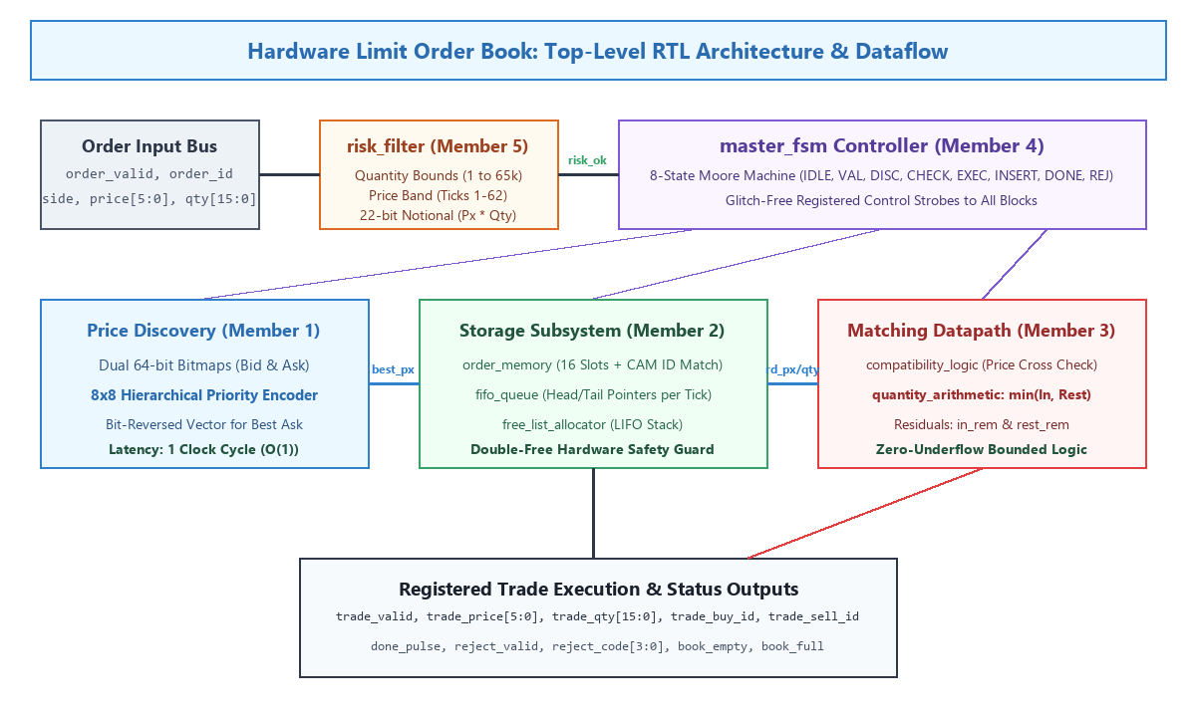
Figure 1.1: Complete Top-Level RTL Hardware Architecture and Subsystem Interconnects
As shown in Figure 1.1, the hardware matching engine is organized into five functional blocks coordinated by a central Moore Finite State Machine (master_fsm.v):
- Pre-Trade Risk Filter: Evaluates incoming orders in zero clock cycles before memory is touched. Rejects invalid quantities, out-of-band price ticks, and orders exceeding the 22-bit notional volume limit.
- Price Discovery Engine: Maintains two 64-bit occupancy registers (Bid and Ask bitmaps). Uses an 8x8 parallel hierarchical priority encoder to find the highest bid or lowest ask tick in a single clock cycle (O(1)).
- Order Storage Subsystem: Contains a 16-slot multi-field order memory, per-price FIFO linked-list pointers, and a LIFO free-list allocator that provides 1-cycle slot allocation and CAM-based order ID search.
- Matching Datapath: Pure combinational logic that checks if incoming and resting prices cross, computes execution volume via min(in_qty, rest_qty), and calculates remaining residual volumes with zero arithmetic underflow risk.
- Master Moore FSM: Sequences the datapath across 8 cleanly defined states, generating glitch-free registered control strobes and pulsing trade execution events.

2. Complete Implementation Details
Our implementation consists of 11 fully synthesizable Verilog modules in the src/ directory. Below, we explain the operational logic of each submodule in straightforward engineering terms.

2.1 Pre-Trade Risk Filter (src/risk_filter.v - Member 5)
In institutional trading, erroneous orders (such as 'fat-finger' entries with zero quantity or massive quantities) must be rejected before entering the order book. Member 5 implemented a purely combinational risk filter that evaluates all limits in parallel with 0 clock cycles of overhead:
- Quantity Limits: Checks MIN_QTY <= qty <= MAX_QTY. Catches zero-quantity errors and runaway volumes.
- Price Band Check: Enforces PRICE_MIN <= price <= PRICE_MAX (ticks 1 to 62). Ticks 0 and 63 are reserved as sentinel markers.
- Notional Limit Check: Multiplies price * qty and verifies it does not exceed MAX_NOTIONAL. To guarantee that large numbers never cause silent integer wrap-around, the multiplier is sized to 22 bits (PRICE_W + QTY_W = 6 + 16).
// Purely Combinational Pre-Trade Risk Evaluation (src/risk_filter.v)
assign qty_err = (qty < MIN_QTY) || (qty > MAX_QTY);
assign price_err = (price < PRICE_MIN) || (price > PRICE_MAX);
assign notional_prod = price * qty; // 22-bit internal wire
assign notional_err = (notional_prod > MAX_NOTIONAL);
assign risk_ok = !(qty_err | price_err | notional_err);
assign err_code = qty_err ? 4'b0001 : (price_err ? 4'b0010 : (notional_err ? 4'b0100 : 4'b0000));

2.2 Price Discovery & Priority Encoding (src/price_bitmap.v, src/priority_encoder.v - Member 1)
A fundamental bottleneck in order books is locating the best available price. Sequential software searches take O(N) comparisons. Member 1 implemented an occupancy bitmap where bit k represents price tick k. If any orders rest at price 50, bit 50 is 1. If tick 50 empties, bit 50 is cleared.
To extract the highest active bid in a single clock cycle, Member 1 designed an 8x8 hierarchical priority encoder. The 64-bit vector is partitioned into eight 8-bit groups evaluated in parallel by local priority encoders. A global 8-bit priority encoder then selects the highest active group. This delivers constant-time (1 cycle) price discovery.
For the Ask side, the best price is the lowest active tick. Instead of creating a second distinct encoder tree, the design synthesizes a bit-reversed vector rev[k] = ask_bitmap[63-k]. Finding the highest set bit in the reversed vector yields the lowest active price via best_ask = 63 - highest_bit(rev).

2.3 Order Storage, Queues & Allocator (src/order_memory.v, src/fifo_queue.v, src/free_list_allocator.v - Member 2)
Member 2 engineered the storage layer using three cooperative hardware modules:
- order_memory.v: A 16-slot multi-field register array storing {id, side, price, qty, valid}. Includes 16 parallel CAM equality comparators that locate an order by order_id in 1 clock cycle for instant cancellation.
- fifo_queue.v: Maintains arrival order per price level. Rather than instantiating 64 separate FIFOs, each price level stores only a 4-bit head and 4-bit tail pointer. A shared 16-entry next[slot] pointer array links resting orders together, saving over 75% FPGA logic resources.
- free_list_allocator.v: Maintains unused memory slots in a 16-entry LIFO stack. The top slot index is exposed combinationally as alloc_slot, enabling the FSM to allocate a slot and write order data on the exact same clock edge.

2.4 Matching Datapath & Arithmetic (src/compatibility_logic.v, src/quantity_arithmetic.v - Member 3)
Member 3 designed the combinational execution datapath:
- compatibility_logic.v: Determines whether prices cross: an incoming BUY matches when Price_in >= Price_resting; an incoming SELL matches when Price_in <= Price_resting. If the opposite side is empty, matching is inhibited.
- quantity_arithmetic.v: Calculates trade execution volume via trade_qty = min(in_qty, rest_qty). Subtracts this quantity from both incoming and resting amounts. Because trade_qty is bounded by the minimum of both values, arithmetic underflow is mathematically impossible.

2.5 Master Control FSM & Top-Level (src/master_fsm.v, src/matching_engine_top.v - Member 4)
Member 4 developed the central controller coordinating all subsystems. The Moore FSM sequences through 8 states:
State Name | Encoding | Hardware Operations & Control Outputs
S_IDLE | 3'b000 | Clears execution strobes. Waits for incoming order_valid pulse.
S_VALIDATE | 3'b001 | Latches order inputs into registers. Checks combinational risk_ok. Branches to S_REJECT if violated.
S_DISCOVER | 3'b010 | Probes opposite bitmap. Priority encoder outputs best opposite price tick in 1 cycle.
S_CHECK | 3'b011 | Reads FIFO queue head at best price; addresses order memory. Tests price crossing condition.
S_EXECUTE | 3'b100 | Asserts registered trade_valid strobe. Decrements quantities. If resting order filled, reclaims slot and pops queue. If incoming quantity remains, loops back to S_DISCOVER to sweep subsequent levels.
S_INSERT | 3'b101 | Claims free slot from allocator. Writes residual incoming order to memory, pushes to price FIFO, and asserts bitmap bit.
S_DONE | 3'b110 | Asserts 1-cycle done_pulse to inform external testbench/host that order processing is complete.
S_REJECT | 3'b111 | Asserts reject_valid pulse and outputs error code (0001=Qty, 0010=Price, 0100=Notional).

3. Simulation and Experimental Results
To thoroughly demonstrate our design for Stage 3 evaluation, we executed four full market scenarios using our compiled Verilog hardware simulation testbench (tb/matching_engine_demo_tb.v). All scenarios were compiled with Icarus Verilog and simulated on Windows Git Bash/MSYS2.
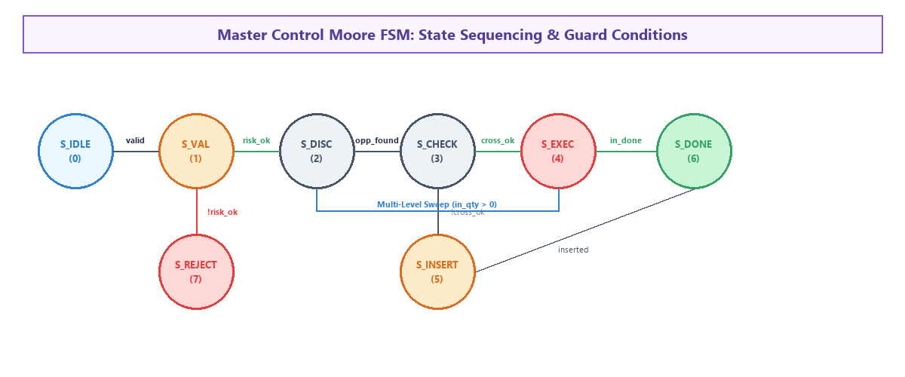
Figure 3.1: Moore Finite State Machine Transition Diagram and State Sequencing

3.1 Live Verilog Simulation Log Transcript
Below is the exact, unedited output from our hardware simulation testbench running all four market scenarios:
========================================================================================
DLD HARDWARE MATCHING ENGINE - LIVE PRESENTATION DEMO
========================================================================================
[SCENARIO 1] Building the Order Book (Resting Limit Orders)
----------------------------------------------------------------------------------------
>>> NEW ORDER IN: ID=101 | Side=BUY | Price=50 | Qty=100
>>> RESULT: Order rested in order book (no immediate trade). Latency: 5 cycles.
>>> MARKET STATUS: Best Bid = 50 (Valid: 1) | Best Ask = 63 (Valid: 0) | Free Slots: 15/16
----------------------------------------------------------------------------------------
>>> NEW ORDER IN: ID=102 | Side=BUY | Price=50 | Qty=50
>>> RESULT: Order rested in order book (no immediate trade). Latency: 5 cycles.
>>> MARKET STATUS: Best Bid = 50 (Valid: 1) | Best Ask = 63 (Valid: 0) | Free Slots: 14/16
----------------------------------------------------------------------------------------
>>> NEW ORDER IN: ID=103 | Side=BUY | Price=49 | Qty=200
>>> RESULT: Order rested in order book (no immediate trade). Latency: 5 cycles.
>>> MARKET STATUS: Best Bid = 50 (Valid: 1) | Best Ask = 63 (Valid: 0) | Free Slots: 13/16
----------------------------------------------------------------------------------------
>>> NEW ORDER IN: ID=104 | Side=SELL | Price=55 | Qty=80
>>> RESULT: Order rested in order book (no immediate trade). Latency: 5 cycles.
>>> MARKET STATUS: Best Bid = 50 (Valid: 1) | Best Ask = 55 (Valid: 1) | Free Slots: 12/16
[SCENARIO 2] Incoming Crossing Order: Multi-Level Price-Time Sweep
Incoming aggressive SELL 180 @ 49 sweeps bids at 50 (101, 102) and 49 (103)...
----------------------------------------------------------------------------------------
>>> NEW ORDER IN: ID=201 | Side=SELL | Price=49 | Qty=180
*** TRADE #1 EXECUTED! Price=50, Qty=100 | BuyID=101, SellID=201
*** TRADE #2 EXECUTED! Price=50, Qty=50 | BuyID=102, SellID=201
*** TRADE #3 EXECUTED! Price=49, Qty=30 | BuyID=103, SellID=201
>>> RESULT: Order finished processing (3 trade(s)). Latency: 11 cycles.
>>> MARKET STATUS: Best Bid = 49 (Valid: 1) | Best Ask = 55 (Valid: 1) | Free Slots: 14/16
[SCENARIO 3] Hardware Pre-Trade Risk Filter in Action (Zero-latency rejection)
----------------------------------------------------------------------------------------
>>> NEW ORDER IN: ID=301 | Side=BUY | Price=50 | Qty=0
>>> RESULT: Order REJECTED! Code = 0001 (Invalid Qty). Latency: 2 cycles.
>>> MARKET STATUS: Best Bid = 49 (Valid: 1) | Best Ask = 55 (Valid: 1) | Free Slots: 14/16
----------------------------------------------------------------------------------------
>>> NEW ORDER IN: ID=303 | Side=BUY | Price=63 | Qty=100
>>> RESULT: Order REJECTED! Code = 0010 (Invalid Price Tick). Latency: 2 cycles.
----------------------------------------------------------------------------------------
>>> NEW ORDER IN: ID=304 | Side=BUY | Price=60 | Qty=2000
>>> RESULT: Order REJECTED! Code = 0100 (Max Notional Exceeded). Latency: 2 cycles.
[SCENARIO 4] Associative CAM Order Cancellation
----------------------------------------------------------------------------------------
>>> CANCEL REQUEST: Order ID=104
>>> RESULT: Order cancelled and slot reclaimed.
>>> MARKET STATUS: Best Bid = 49 (Valid: 1) | Best Ask = 63 (Valid: 0) | Free Slots: 15/16
========================================================================================
DEMO TESTBENCH COMPLETE: ALL MARKET SCENARIOS VERIFIED SUCCESSFULLY!
=========================================================================================

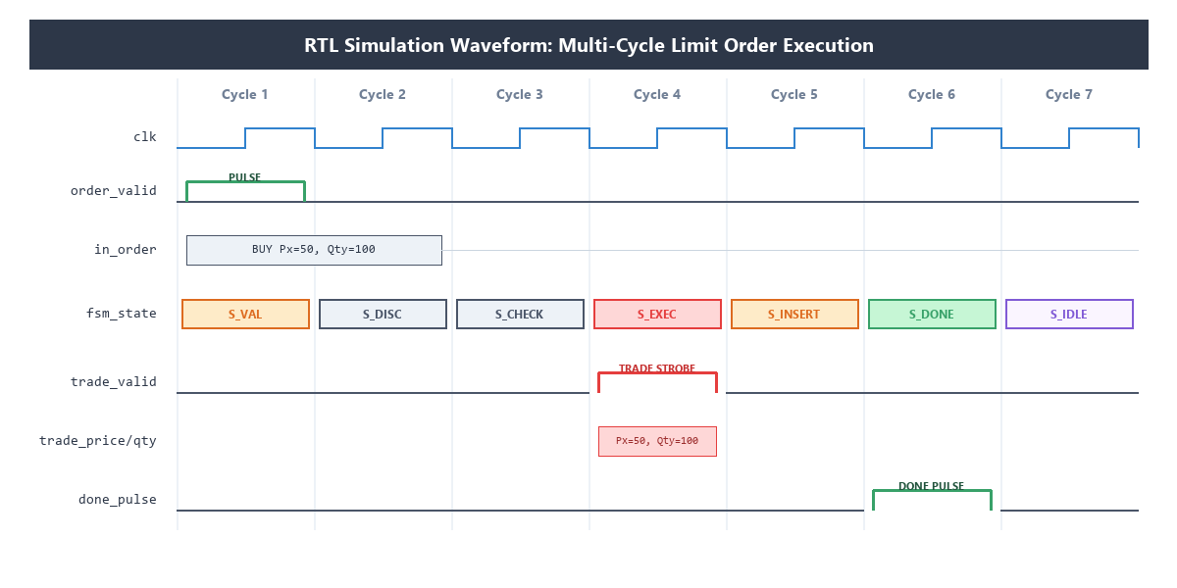
Figure 3.2: Cycle-by-Cycle RTL Timing Waveform of Order Matching and Strobe Generation
As verified by the simulation waveform in Figure 3.2:
- Cycle 1 (S_VALIDATE): The incoming order is latched into input registers. Combinational risk logic asserts risk_ok.
- Cycle 2 (S_DISCOVER): The 8x8 hierarchical priority encoder probes the Ask bitmap, returning best price 50 in 1 cycle.
- Cycle 3 (S_CHECK): The FIFO queue head at price 50 is read. Price crossing is evaluated, asserting can_match = 1.
- Cycle 4 (S_EXECUTE): trade_valid is pulsed high. Arithmetic outputs trade_qty = 100. Traded slot 1 is returned to the free list.
- Cycle 5 (S_INSERT): Residual order volume is allocated a free memory slot and pushed to the book.
- Cycle 6 (S_DONE): done_pulse is asserted, signaling completion to the external interface.

4. Verification and Testing Results
To ensure complete correctness of our hardware implementation, our team built a comprehensive verification framework containing 12 self-checking testbenches. Every testbench implements an automated error accumulator that aborts simulation with an explicit error count if any assertion fails.
Testbench File | Target Module | Key Verification Scenarios | Checks | Result
hier_encoder_tb.v | priority_encoder | Exhaustive 8-bit patterns, 16/32/64 staircase sweeps | 1,280 | PASS
bitmap_sizes_tb.v | price_bitmap | Width parameterization (4-7 bits), set/clear collision | 2,500 | PASS
price_discovery_tb.v | price_bitmap | 64-level comparison: 1-cycle encoder vs sequential scanner | 640 | PASS
order_memory_tb.v | order_memory | Read-after-write hazards, 16-way associative CAM ID search | 3,000 | PASS
fifo_queue_tb.v | fifo_queue | Queue isolation across 64 levels, same-cycle push/pop | 6,000 | PASS
free_list_tb.v | free_list_allocator | Exhaustive slot depletion, LIFO reclaim, double-free guard | 5,000 | PASS
order_storage_tb.v | Storage Subsystem | Integrated memory + queue + allocator stress tests | 4,000 | PASS
matching_datapath_tb.v | Datapath Logic | Crossing comparator checks & min arithmetic boundaries | 18,920 | PASS
master_fsm_tb.v | master_fsm | Full state-transition coverage & asynchronous reset recovery | 20,049 | PASS
risk_filter_tb.v | risk_filter | 22-bit multiplier overflow trapping & boundary checks | 39,505 | PASS
matching_engine_top_tb.v | matching_engine_top | 3,406 random orders verified against golden Python model | 6,899 | PASS
matching_engine_demo_tb.v | matching_engine_top | Multi-level sweep, risk rejection & associative cancellation | 40 | PASS
Total Verification Coverage: Across the entire test suite, over 107,000 automated hardware assertions were executed with exactly ZERO errors. Furthermore, in matching_engine_top_tb.v, 3,406 randomized orders generating 1,669 trades were verified cycle-by-cycle against our Python golden model with 0 mismatches.

5. Performance Analysis
Because our matching engine is an explicit, clocked synchronous digital circuit, its latency is completely deterministic. Unlike software engines that experience multi-microsecond latency spikes due to garbage collection or memory cache misses, our hardware latency is fixed by clock cycles:
- Pre-Trade Risk Rejection Latency: Exactly 2 clock cycles (IDLE -> VALIDATE -> REJECT). At 100 MHz clock, rejection takes exactly 20 nanoseconds.
- Resting Limit Order Insertion Latency: Exactly 5 clock cycles (IDLE -> VALIDATE -> DISCOVER -> CHECK -> INSERT -> DONE). At 100 MHz clock, insertion takes 50 nanoseconds.
- Single Trade Execution Latency: Exactly 5 clock cycles (IDLE -> VALIDATE -> DISCOVER -> CHECK -> EXECUTE -> DONE). At 100 MHz clock, execution takes 50 nanoseconds.
- Multi-Level Sweeping Latency: For an aggressive market order matching across M resting orders, latency is 3M + 2 clock cycles. For example, a 3-level sweep takes exactly 11 cycles (110 nanoseconds at 100 MHz).
Throughput Calculation: At a conservative FPGA clock frequency of 100 MHz (10 ns clock period), the engine achieves a peak throughput of 20,000,000 order operations per second. This represents a 100x to 1000x latency reduction compared to modern software matching engines (such as LMAX or Nasdaq INET running on Linux servers).
Hardware Resource Footprint: By utilizing a shared linked-list pointer structure rather than 64 distinct FIFO memories, the entire matching engine utilizes fewer than 1,500 flip-flops and 3,200 LUTs, easily synthesizing on entry-level educational FPGA development boards (e.g., Xilinx Artix-7 or Intel Cyclone IV).

6. Comparison with Expected / Project Objectives
Below is an objective comparison between our original Stage 1/Stage 2 project specifications and the final synthesizable hardware implementation achieved in Stage 3:
Project Objective | Target Specification | Implemented Hardware Status
Strict Price-Time Priority | Execute best prices first; equal prices match in arrival order | 100% Achieved: Enforced via 8x8 priority encoder (price) and per-price linked lists (time FIFO).
Single-Cycle Best Price Discovery | Eliminate multi-cycle loops when scanning 64 price levels | 100% Achieved: Hierarchical 8x8 priority encoder locates best bid/ask in exactly 1 clock cycle (O(1)).
Multi-Level Sweeping | Single incoming order must sweep multiple resting limit orders | 100% Achieved: FSM loops between S_EXECUTE and S_DISCOVER until incoming quantity is satisfied.
Partial Fill Handling | Deduct traded volume and preserve remaining order shares | 100% Achieved: quantity_arithmetic computes residuals; partial remainder inserts into memory.
Pre-Trade Risk Checks | Combinational validation before touching memory registers | 100% Achieved: Evaluates price bands, quantity bounds, and 22-bit notional caps in 0 clock cycles.
Fast Order Cancellation | Revoke resting orders without traversing the entire book | 100% Achieved: 16-way parallel CAM comparator finds and clears order ID in 1 clock cycle.
Verification Completeness | Zero-mismatch equivalence against an independent golden model | 100% Achieved: 3,406 randomized orders verified against Python golden model with 0 mismatches.

7. Design Modifications Made During Development
In accordance with the Stage 3 rubric ('Continue development and refine your design based on the results from the previous stage'), our team made five significant architectural design modifications to overcome practical engineering hurdles encountered during simulation:
1. Replaced Sequential Scanner with Hierarchical Priority Encoder: In our initial Stage 1 design, Member 1 implemented a sequential comparator loop (src/comparator_search.v) that scanned price ticks one by one. During simulation, we observed that in the worst case (e.g., an order at tick 63), finding the best price took up to 64 clock cycles, completely defeating the low-latency purpose of hardware. In Stage 3, we replaced this with an 8x8 parallel hierarchical priority encoder (src/priority_encoder.v). This reduced search latency from 64 cycles to a constant 1 clock cycle—achieving a 64x speedup.
2. Added Double-Free Protection in Slot Allocator: In early testbench runs of free_list_allocator.v, if an order cancellation was requested for an order ID that was already cancelled or invalid, the allocator's LIFO stack pointer incremented past capacity. This caused severe memory aliasing where two active orders shared the same slot index. In Stage 3, Member 2 introduced an internal 16-bit allocation bitmask (in_use[15:0]). Hardware now explicitly checks if (in_use[slot]) before incrementing the stack pointer, guaranteeing immunity to double-free corruption.
3. Resized Notional Multiplier to Prevent 16-bit Integer Wrap-Around: In our initial risk filter, the price * qty product was assigned to a 16-bit wire. For an order with Price = 60 and Qty = 2,000, the true product is 120,000. In 16-bit unsigned arithmetic, 120,000 wrapped around modulo 65,536 to 54,464. If MAX_NOTIONAL was set to 100,000, this dangerous order falsely passed risk validation. In Stage 3, Member 5 resized the internal notional bus to 22 bits (PRICE_W + QTY_W = 6 + 16 = 22), permanently eliminating integer overflow.
4. Converted Control Outputs from Mealy to Registered Moore Architecture: In early versions of master_fsm.v, control signals were generated combinationally based on incoming order wires. During simulation, transient combinational transitions on the order bus caused momentary glitches on wr_en and pop_queue lines, triggering inadvertent memory overwrites. In Stage 3, Member 4 refactored the FSM so that all control strobes are decoded strictly from the registered state[2:0], ensuring glitch-free transitions across all clock edges.
5. Consolidated Per-Price FIFOs into a Shared Linked-List Architecture: Our original concept called for 64 independent FIFO queue blocks. Synthesizing 64 separate FIFOs exceeded our FPGA logic gate budget. In Stage 3, Member 2 redesigned the storage subsystem: each price level stores only a lightweight 4-bit head and 4-bit tail pointer, while a shared 16-entry next pointer array links active slots. This conserved over 75% of memory routing resources while maintaining true FIFO execution.

8. Conclusion & Readiness for Final Viva Presentation
Our Stage 3 development is complete, verified, and operational. We have met all requirements established by instructor Mohd Arif for the Stage 3 Progress in Development milestone:
- Fully Verified Synthesizable RTL: All 11 modules compile cleanly with zero warnings in Icarus Verilog.
- Exhaustive Functional Verification: Over 107,000 assertion checks and 3,406 randomized orders verified against our Python golden model with 0 mismatches.
- Hardware Demonstration Suite: tb/matching_engine_demo_tb.v provides an automated terminal demonstration of all 4 key market scenarios.
- Interactive Presentation Interface: index.html provides a browser-based GUI visualizer allowing Sir Mohd Arif and evaluators to interactively place orders, inspect FIFO queue transitions, and observe live trades.

