1. **Create connection between java & mysql.**

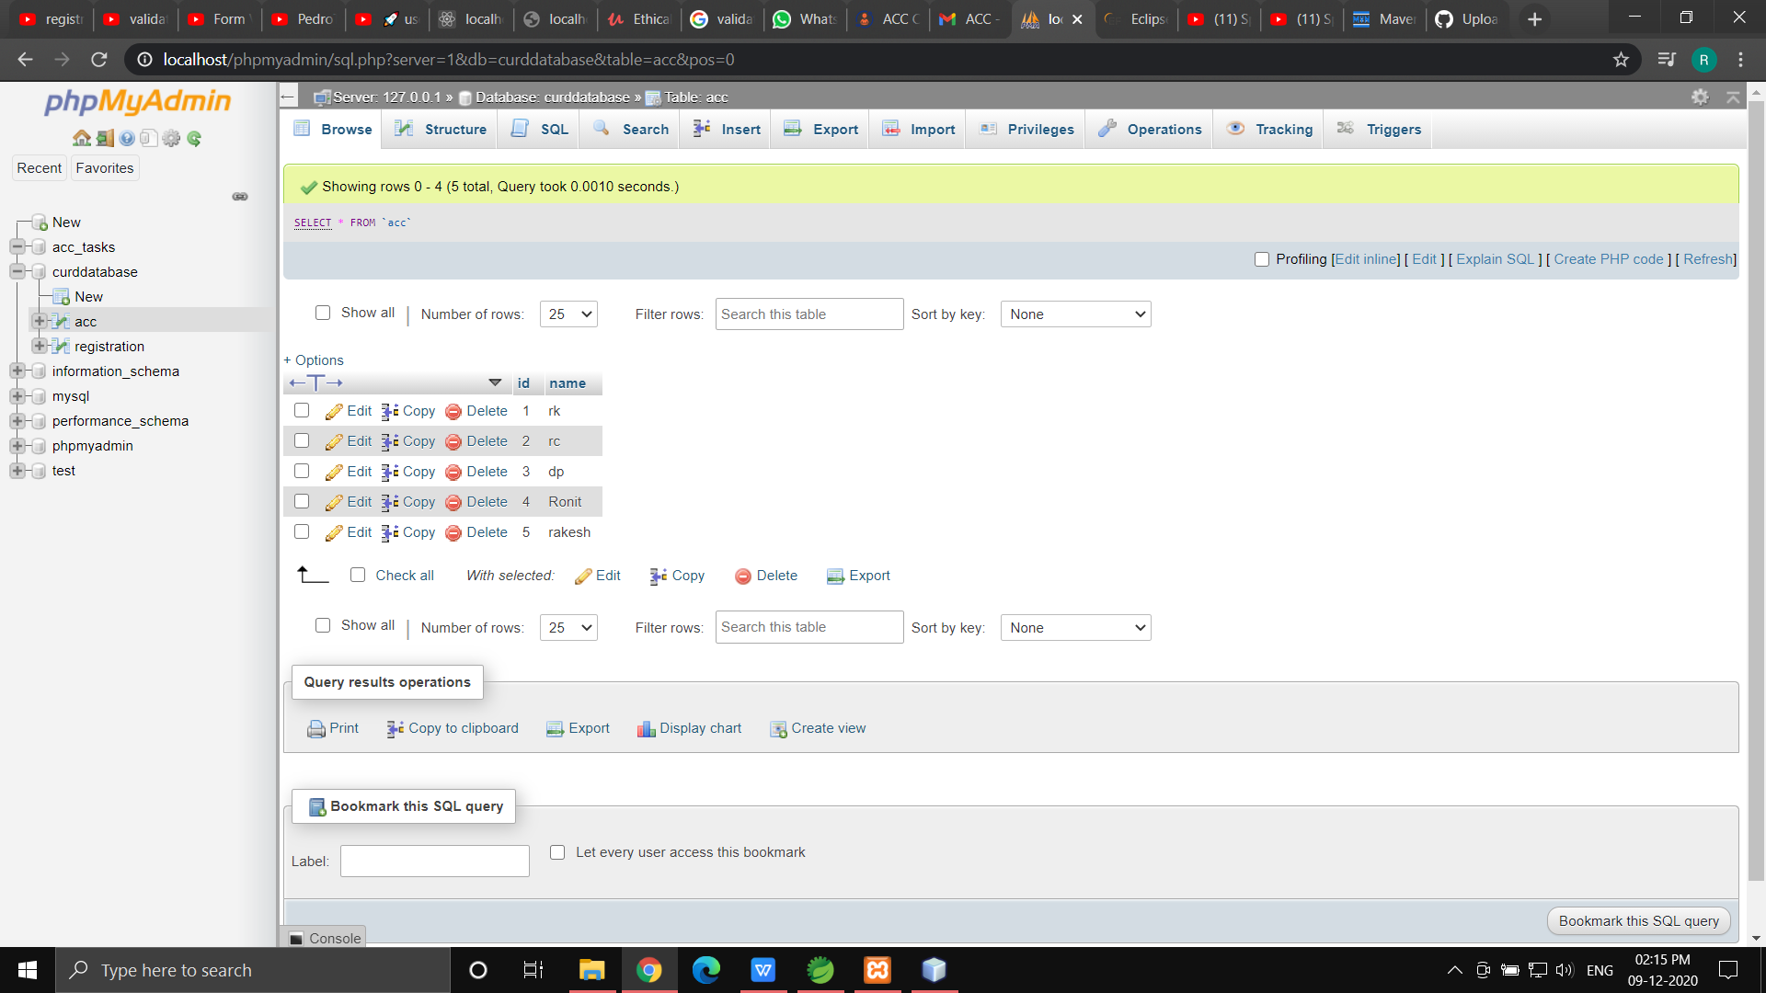

ScreenShot of Database Output.

1. **Create Registration page REST API (create one POST & one Get call api) using Spring boot MVC REST application**

**=> I am new to Spring boot MVC, the second task is not achieved by me.**

**But,whatever I have learned in past 1 day, I undserstood that it is similar to android java(Getter / setter part) , making a database connection and the mapping part which is similar to nodeJS.**

**I also used postman application to send the Get & Post request to the server. But, because of the inexperience there was an error. But if I got more time I would have succesfully done the Task2.**

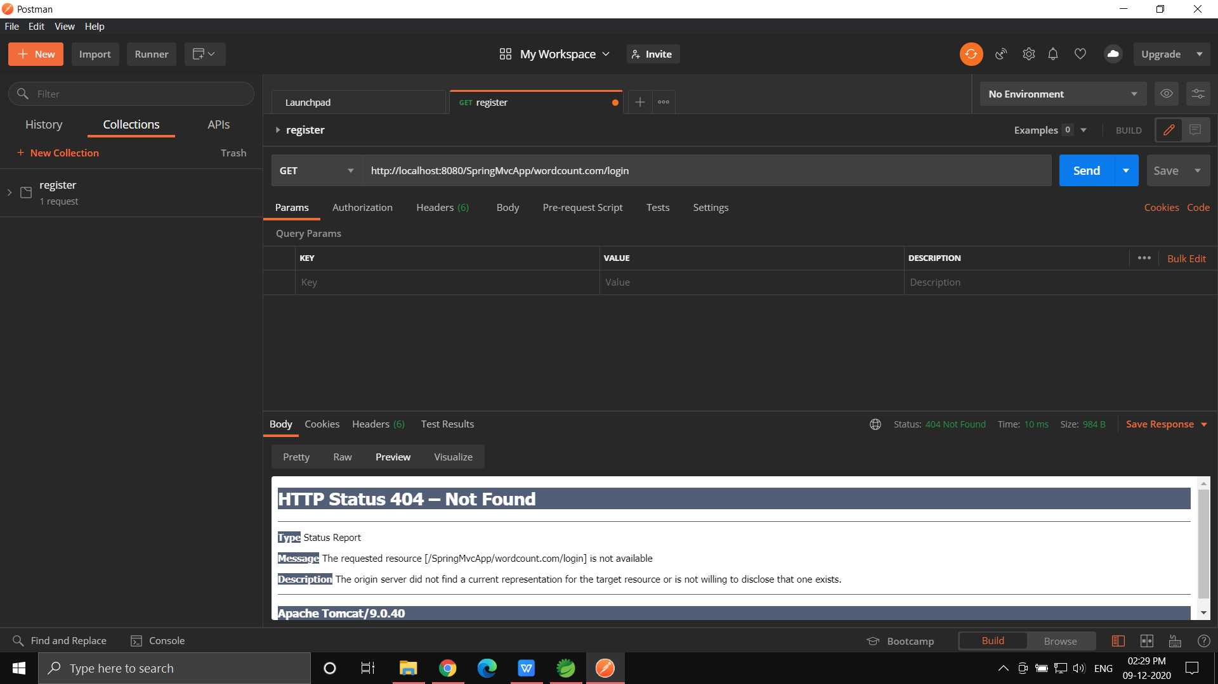

* **Currently I am learning and working on ReactJS and nodeJS, so the**

**Get,Get{},Post,Put,Delete{} concept is known to me.**

1. **Get :- Get the data from the database and show it in the webpage.**
2. **Get{}:- Get a specific data from database.**
3. **Post :- Post is, storing the data into the database.**
4. **Put:- Put is to update the existing data.**
5. **Delete{}:-Delete the data from the database.**