WORK TRACKER

# SEPTEMBER 2019

**WORK TILL NOW**

Hello world app

Covered Text/ImageViews and LinearLayout/RelativeLayout

( Android Basic: User Interface till Practice Set : Building Layouts )

* **25th September**

Completed the User Interface Course. Made a Happy Birthday App as in the course and a Cat Photos App as given below

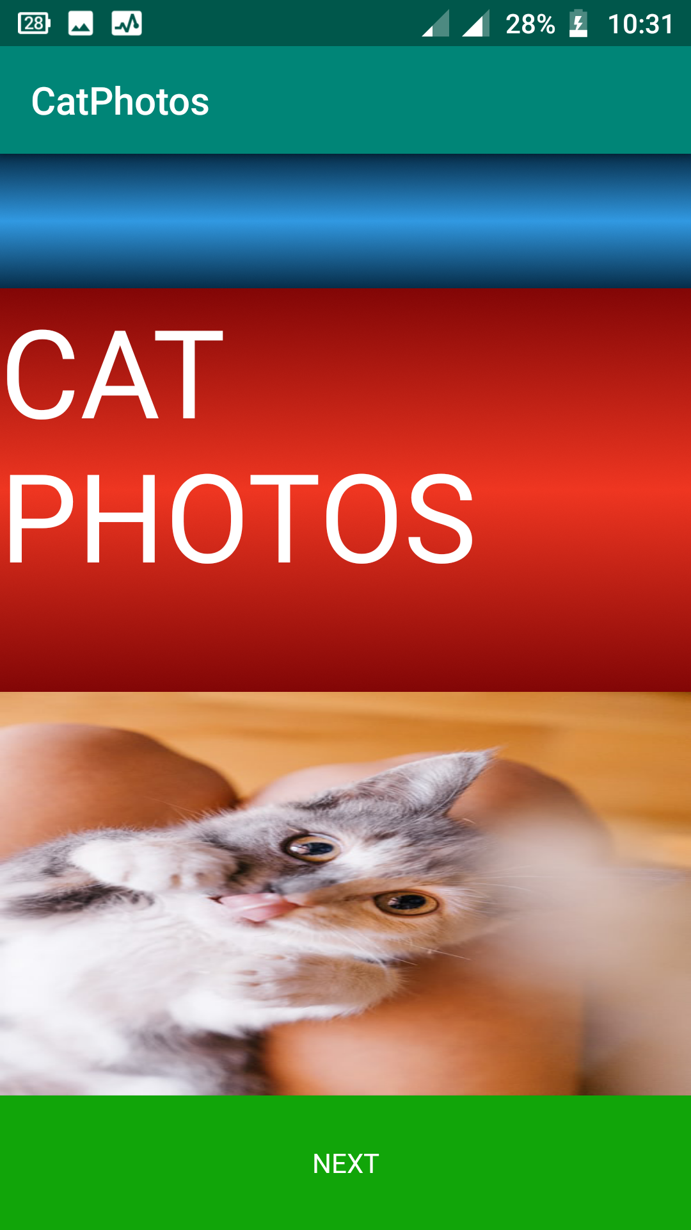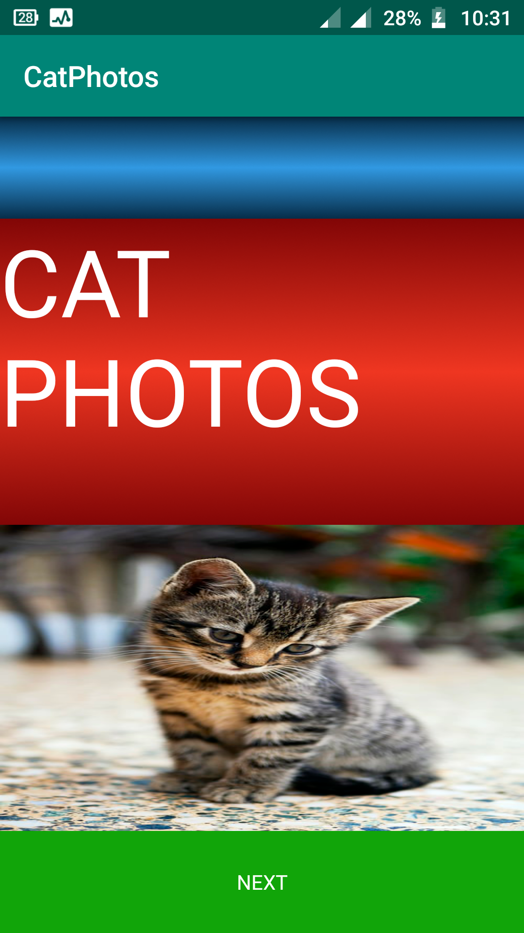

* **27th September**

Started with the “Android Basic: User Input” course.Did till video 8 of Lesson 1