Homework – Methods Involving Lines

Purpose:
To review the use of classes and methods (that have parameters and return a value)

Part 1:
Write a class (saved as Line.java) to calculate the different properties of a line.
The class should include the following methods:

- length – takes the coordinates of a line segment as input and returns its length

- slope – takes the coordinates of a line segment as input and returns its slope
public static double slope (int x1, int y1, int x2, int y2)

Hints:
The formula for calculating the length of a line is 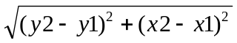
The formula for calculating the slope of a line is 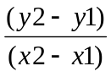
Use Math.sqrt(num) to find the square root of a number

Part 2:
Write a main method that asks the user for the coordinates of two lines, then uses the methods in Part 1 to check if the lines have the same length, and if the lines are parallel or perpendicular.

Here is a sample run:

Please enter the two coordinates of line 1:
Coordinate 1 x-value: 0
Coordinate 1 y-value: 0

Coordinate 2 x-value: 1
Coordinate 2 y-value: 1

Please enter the two coordinates of line 2:
Coordinate 1 x-value: 2
Coordinate 1 y-value: 2

Coordinate 2 x-value: 4
Coordinate 2 y-value: 4

Results:
The two lines do not have the same length.
The two lines are parallel.

