# University Souvenir Store Application

## Part Time Team 4

## 9 April 2016

**Contributors**

**- AMARJEET BRIJNANDAN SINGH**

**- CHENG HAO**

**- GONG SHENGLIANG**

**- HU RENWEN**

**- TANG HAN**

**- ANKUR JAIN**

# Domain diagram

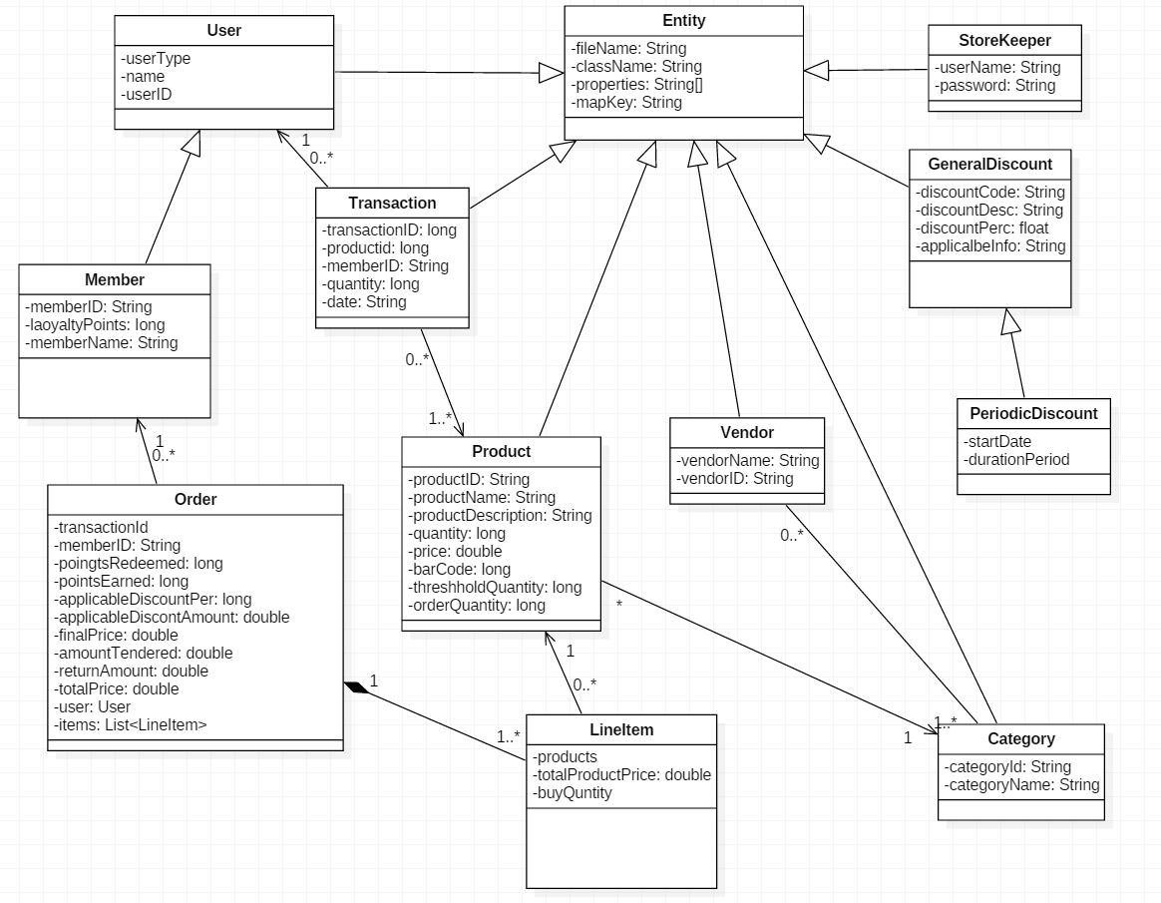

# Assumptions:

## Solution folder name is se24_PT04

## Category ID is always 3 letter in caps

## Member Number is 9 characters.

## System will only show the most preferred vendor when generating purchase order

## 100 member points = $1. Points can be redeemed in multiple of 100 only.

## Every $1 spent will earn one point to user.

## Bar Code is system generated running number

## Label printing only allows up to 99 copies per click

## Numbers like total Price, Final price, discounts will be rounded off to two decimal places.

## Best viewed at resolution 1920 X 1080

# Testing Data:

Storekeeper

|  |  |
| --- | --- |
| User ID | Password |
| stacy | Dean56s |
| johny | A12ysd45 |
| peter | P@33_4$ |
| duck | I@mduck |
| joe | 1qazxsw2!@@! |

Member

|  |  |  |
| --- | --- | --- |
| Member Name | Member Number | Points |
| AmarJeet | S2016001A | 132 |
| Ronn | S2016002B | 200 |
| Boss Test | S2016006Z | 9000 |
| More to look up in Members.dat | | |

Product

|  |  |  |  |  |
| --- | --- | --- | --- | --- |
| Product name | Price | Bar Code | Stock | Threshold |
| Cenetary Jumper,A really nice momento | 19.5 | 1001 | 220 | 200 |
| Uniform,Plumber Uniform | 20.5 | 1002 | 150 | 100 |
| DRK/2,Icelemon Tea,Icelemon Tea can 350ml | 1.5 | 1102 | 54 | 200 |
| DIA/1,NUS diary book,200-page diary book with NUS logo | 7.5 | 4001 | 332 | 150 |
| DIA/2,SG50 diary book,500-page diary book with SG50 design | 10.5 | 4002 | 5 | 50 |
| COM/1,HP powerbook,HP i7 14 inch powerbook | 1500.0 | 5001 | 20 | 10 |
| More to look up in Products.dat | | | | |