Dean Larry Stauffer,

Here is the final design report on the Touchscreen Kiosk project for the 2016 spring semester. This design report outlines our design process and the software and hardware results thus far. Within this report you will find our considered concepts, the accepted concepts, our current software and hardware designs and the future work currently planned.

**Final Design Report for**

**Touchscreen Kiosk**  
_______________________________________

***Team Touchstone***

*Morgan Holbart*

*Guan Feng*

*Robin Rakowski*

*Ronald Rodriguez*

Contact Email: holb5155@vandals.uidaho.edu

**Table of Contents**

Executive Summary

Background

Problem Definition

Project Plan

Concepts Considered

Concept Selection

System Architecture

Future Work

Appendices

**Executive Summary**

Team Touchstone designed and began implementation of the Touchscreen Kiosk for implementation into the Janssen Engineering Building. The Kiosk features cutting edge technology to bring a spotlight on the engineering building to stand out among the other colleges. Through implementation of a rear-facing projector, an infrared sensor and camera, and the designed software the Touchscreen Kiosk will provide an interesting and exciting way for visitors to explore the College of Engineering. With longevity in mind for its design the Touchscreen Kiosk can and will serve as an attraction for the college for years to come.

**Background**

The College of Engineering is home to the best and brightest learning on the cusp of technological advancements. To make the college stand out and prove itself as a bastion to learning we were tasked with constructing a piece of technology to symbolize just that. The Kiosk acts as an information database navigated by touch for up to three simultaneous users. Aimed at visitors to the college, it will provide a way to view the accomplishments of the college, as well as its staff, students, and projects. It will give visitors a unique way to navigate the college and learn about its history. Upon completion the Touchstone Kiosk is expected to attract visitors for its use and entertainment.

**Problem Definition**

* Goals and Deliverables
  + Design a cutting edge piece of technology for display in the Janssen Engineering Building
  + Research hardware and software options to implement the technology
  + Design the software for use with the hardware
  + Implement the software
  + Provide a working setup of the Touchscreen Display
  + Provide a plan and document for building the display into the JEB hallway
  + Provide documentation on the software
  + Provide documentation on how to use the software for future modification and ease of use
* Specifications and Constraints
  + Must fit into the constraints of the hallway size in JEB
  + Must meet building code requirements when put into JEB
  + Must remain within the budget of the project

**Concepts Considered**

**Hardware**

The goal of the project was to provide a piece of cutting edge technology to attract people to use it. Initially we looked at two ideas to use as a basis for our design both of which would provide something unique or exciting will still acting as a useful source of information for the user.

**Large Touchscreen**

We looked at using a large touchscreen either in or mounted on the wall due to ease of interaction, accessibility, familiarity, and ability to be used by multiple people at once. We also looked at two separate implementations of a touch screen both as a wall mounted touchscreen and a projector based touch screen where you touch a wall rather than an actual screen.

We quickly pushed aside a large wall mounted touchscreen due to technological limitations on size and the cost of larger displays.

We opted to focus our research into the projector based touch screen it would let us get a larger screen for a cheaper cost.

Projectors

We decided quickly that we would make use of a rear facing projector to remove the issue of people standing in front of the projector making it difficult and frustrating to use. Through use of a glass panel, a rear screen film, and a rear facing projector we would be able to achieve this. However because of the use of a rear facing projector that would have to go in the wall, we also needed an ultra-short throw projector to fit in the small amount of wall space we have to use.

We decided on the Casio XJ-UT310WN Projector which has the following specs. The Ultra Short Throw .28:1 ratio would give us an adequately short throw distance to fit in the space given to use in the wall.

* 3100 Lumens
* 20,000 hour lamp life
* WXGA (1280 x 800) Native Resolution
* Ultra Short Throw 0.28:1 ratio
* Fixed Lens - Mirror System
* Hybrid Light Source
* Dust Resistant Design

We still had to design this to be a touch screen however, which required either the purchase or implementation of some sort of sensor to detect touch input. We found Ubi Interactive which provides the following sensor and camera.

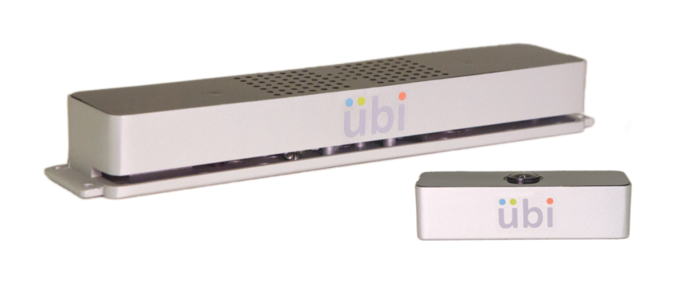

Using the infrared sensor mounted above the glass panel and the camera we can supply touch input to our computer and act as a touch screen display. Ubi supports up to 20 touch points at a time allowing for our simultaneous multiple user interface.

With the rear facing camera and Ubi Interactive used with a glass panel and screen film we would be able to implement a large touch screen display.

**Virtual Reality Kiosk**

Because we were tasked with designing a cutting edge piece of technology we considered the use of virtual reality to give an exciting, unique, and cutting edge experience to the users. We had three possible options for a virtual reality headset.

Oculus Rift

Pros: Functionality, connects to a computer, support (development versions already released)

Cons: Cost would make multiple setups for multiple users difficult, requires a more powerful computer.

Samsung GearVR

Pros: Headset is cheap, already out with support

Cons: Requires a phone to use which isn’t cheap and could be a liability for being stolen.

HTC Vive

Pros: most powerful with the most functionality

Cons: Costs the most, requires the strongest computer

Because the virtual reality headsets were headsets and hooked up to a computer rather than built into the wall, we had to consider the possibility of being stolen or broken, so we would have to design some sort of device to prevent stealing them. However, we did not get this far into the VR design.

**Software**

We needed to choose software for developing the interface to be interacted with which would be run entirely on a computer with consideration for porting it to mobile also.

We initially looked at using either Java or another application to develop the interface in. We looked at the Unity game engine for use in developing the UI due to its recently overhauled UI system and ease of use for building an interface.

For the kiosk’s interface, we considered a web data extraction system, through which we could have the kiosk automatically update itself with current information from the University of Idaho website. We also considered a manual approaching to updating, making the kiosk software an intuitive interface-builder which could be used to alter content and interface design as necessary.

**Concept Selection**

The team’s final selections were based on the requirements and constraints of the project. The Ubi hardware and software allow for a large-scale kiosk with touchscreen interaction, while still remaining within budget, and the Casio XJ-UT310WN Ultra Short-Throw Projector works with the back-projected Ubi touchscreen while fitting in the allotted space in the Janssen Engineering Building.

The team ultimately decided to use Unity to develop our software, due to its UI system and ease of use for interface development. **<MORGAN, MORE INFO ON WHY WE DISCARDED THE OTHERS?>**

The need for longevity of the touchscreen kiosk informed the team’s software design decisions. Although web data extraction would add convenience by making the kiosk self-updating, such a system would require later alterations by people with coding experience to keep the system from becoming obsolete. As this would interfere with the project’s longevity, the interface-building software was chosen instead.

**System Architecture**

**Subheaders If Needed**

<**ADD WORDS HERE**>

**Future Work**

**Hardware**

The camera component of the Ubi hardware has been experiencing occasional glitches and disconnects, which are concerning for the longevity of the project. In the future, the team should either attempt to resolve the issues with this camera, or find a replacement camera if doing so is not possible.

The team still needs to acquire the glass screen and rear projection film to be used in the final touchscreen setup, as well as some form of base or frame to hold the glass screen.

After the space in the Janssen Engineering Building where the kiosk will be located has been remodeled, the team will need install the kiosk’s hardware, and test to make sure that there are no problems with the final setup.

**Software**

Initial content will need to be created for the kiosk before it goes live. Additionally, arrangements for who will keep the kiosk interface content up to date will need to be made.

**Appendices**

**Subheader**

Content