Supporting Information
NOSTOS Prevents Silent Acquisition- and Scale-Specific Failure in Quantitative Microscopy
Yan Jun Lin
This file reports estimator-level validations that support implementation breadth but are not pooled with the four main selective-validity experiments. Every value is read directly from a frozen JSON receipt; public images are not redistributed in the software archive.

S1. Synthetic truth and perturbation validation
Nine analytic constructs encoded programmed orientation, spectral scale, blob, tube, sheet, thickness, roughness, network structure and spatial heterogeneity. Eight primary perturbations were applied to the orientation-scale construct. The five module gates evaluated structure tensor, Hessian morphology, local thickness, network survival and directional spatial range. Mask dilation and erosion were evaluated as sensitivities because invariance to an altered mask is not scientifically expected.
Table S1. Exact programmed-perturbation results.
Perturbation | Magnitude | Angular error | Scale error | Gate
rotation | 17 | 0.0001° | 2.986% | pass
resampling | 0.75 | 0.0001° | 0.772% | pass
crop | 0.8 | 0.0005° | 0.211% | pass
blur | 1 | 0.0000° | 0.772% | pass
noise | 0.1 | 0.0098° | 0.772% | pass
contrast | 0.65 | 0.0000° | 0.772% | pass
psf | 0.75 | 0.0000° | 0.772% | pass
partial volume | 0.7 | 0.0003° | 0.772% | pass

Table S2. Frozen module-by-perturbation gate counts.
Module | Required | Passed | Mask sensitivities
tensor | 5 | 5 | —
hessian | 12 | 12 | —
geometry | 2 | 2 | 2
network | 1 | 1 | —
spatial | 4 | 4 | —

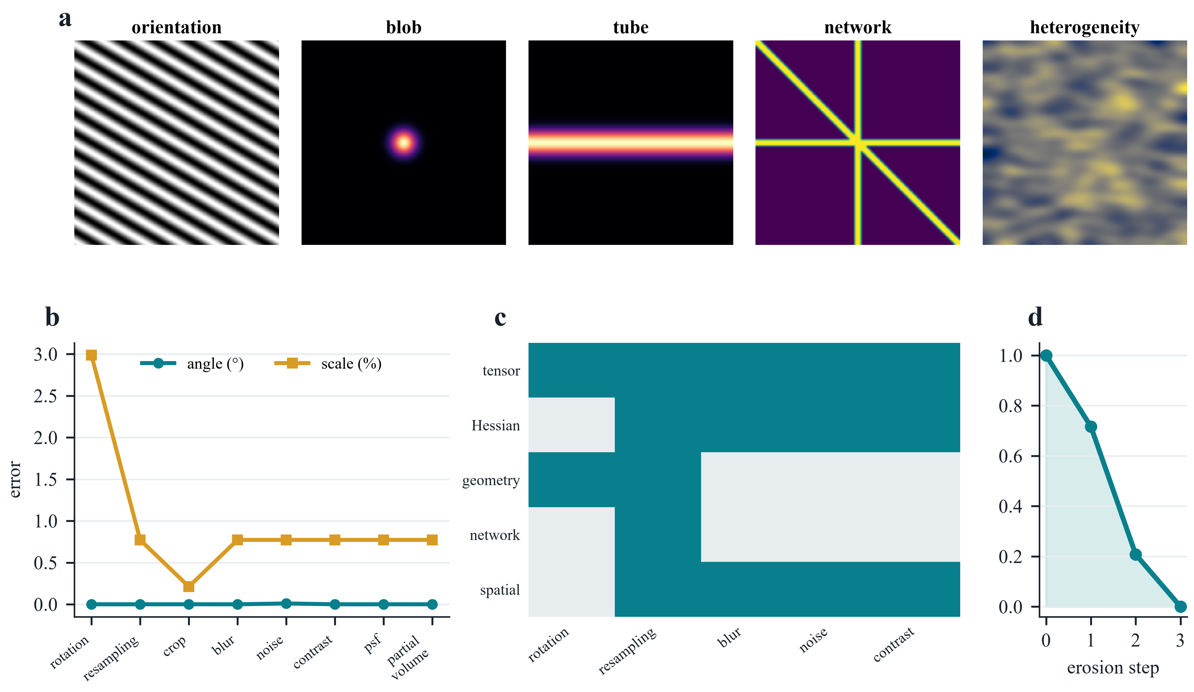
Figure S1. Synthetic operating-envelope validation. a, Programmed analytic constructs. b, Angular and physical-scale errors under the eight primary perturbations. c, Required module-by-perturbation cells; teal denotes a passed required cell and grey denotes a combination not declared by the protocol. d, Monotonic network survival under erosion. All 24 required module tests passed; the two mask-error experiments were retained as sensitivity analyses.

S2. External network measurement on STARE reference masks
Twenty STARE reference masks were analyzed as binary networks. NOSTOS and the independent scikit-image skeletonize comparator used the same mask support. Sampling changes preserved both network erosion survival and skeleton length. The result validates endpoint implementation on supplied masks; it does not validate automatic vessel segmentation or infer vascular biology.
Table S3. STARE network endpoint confirmation.
Endpoint | Independent images | Agreement | Additional diagnostic
erosion-survival AUC | 20 | Spearman ρ = 0.988 | inter-annotator ρ = 0.874
skeleton length | 20 | Spearman ρ = 0.995 | median relative error = 0.018

S3. External trabecular-bone local thickness
Eight public micro-CT volumes from Zenodo record 11061947 were analyzed in physical units. NOSTOS maximal-sphere local thickness was compared first with the archived IPL map and then with BoneJ 1.4.3 executed in a checksum-locked legacy Fiji environment. The independent image volume was the inferential unit. These comparisons establish agreement for local thickness on supplied bone masks, not diagnostic performance or tissue competence.
Table S4. Public trabecular-bone thickness comparisons.
Comparator | Volumes | Primary agreement | Error
archived IPL map | 8 | median voxelwise ρ = 0.927 | mean MAE = 0.0189 mm
BoneJ 1.4.3 | 8 | CCC = 0.926 | mean |Δ| = 0.0157 mm

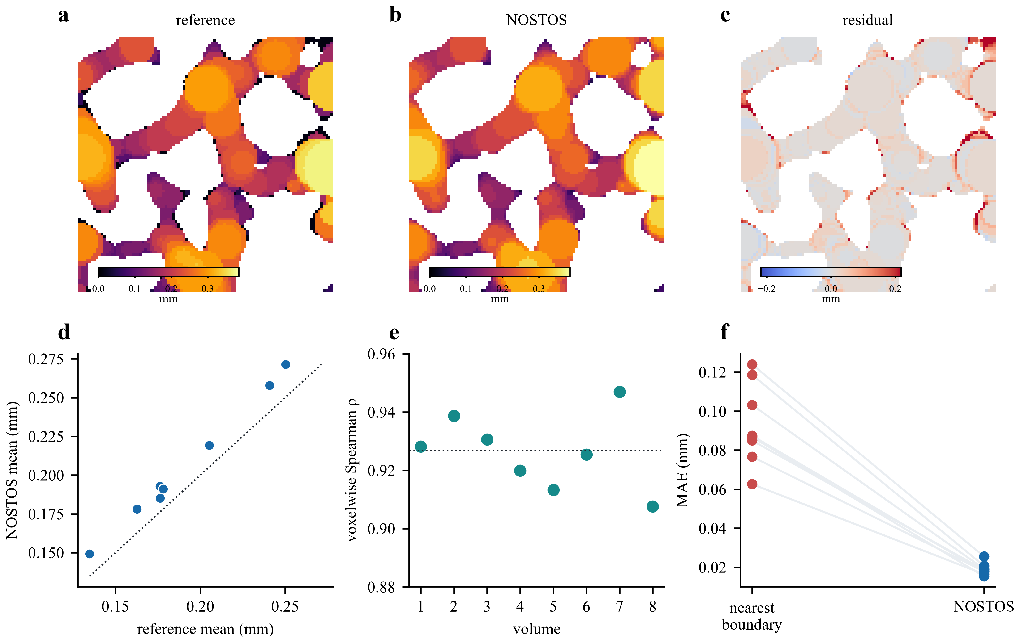
Figure S2. Public trabecular-bone local-thickness validation. a–c, Archived reference, NOSTOS estimate and residual on the same volume plane. d, Volume-level mean thickness. e, Voxelwise rank agreement in eight independent volumes. f, Paired mean absolute error for the nearest-boundary baseline and NOSTOS. The exact one-sided paired Wilcoxon value for the improvement over the baseline was 0.00390625.

S4. Dynamic deformation and spatial-response confirmations
Dynamic and spatial modules were tested separately so that their bounded operating claims could not be mistaken for biological validation. BBBC035 phase-correlation tests used programmed translations derived from public images. Dense deformation used programmed non-rigid fields. BBBC006 spatial responses compared adjacent focal planes with an intentionally defocused plane.
Table S5. Separate dynamic and spatial operating-envelope confirmations.
Module | Independent cases | Frozen result | Boundary
bulk registration | public-image series | maximum error = 0.0 px | programmed translation
dense deformation | 8 | median endpoint error = 0.270 px | comparator = 0.523 px
spatial response | 64 | adjacent-plane ρ = 1.000 | defocus > adjacent in 100%

S5. Label-free and three-dimensional bone stress tests
The bone transfer program exercised orientation, network and scale support on mouse SHG, rat confocal lacuna-canalicular stacks, human synchrotron nanoCT and human ultraviolet photoacoustic microscopy. These analyses were intentionally kept as stress tests. A missing pixel calibration forced the UV-PAM spectrum to remain pixel-domain; insufficient support or unstable topology produced abstention rather than an inferred physical measurement.
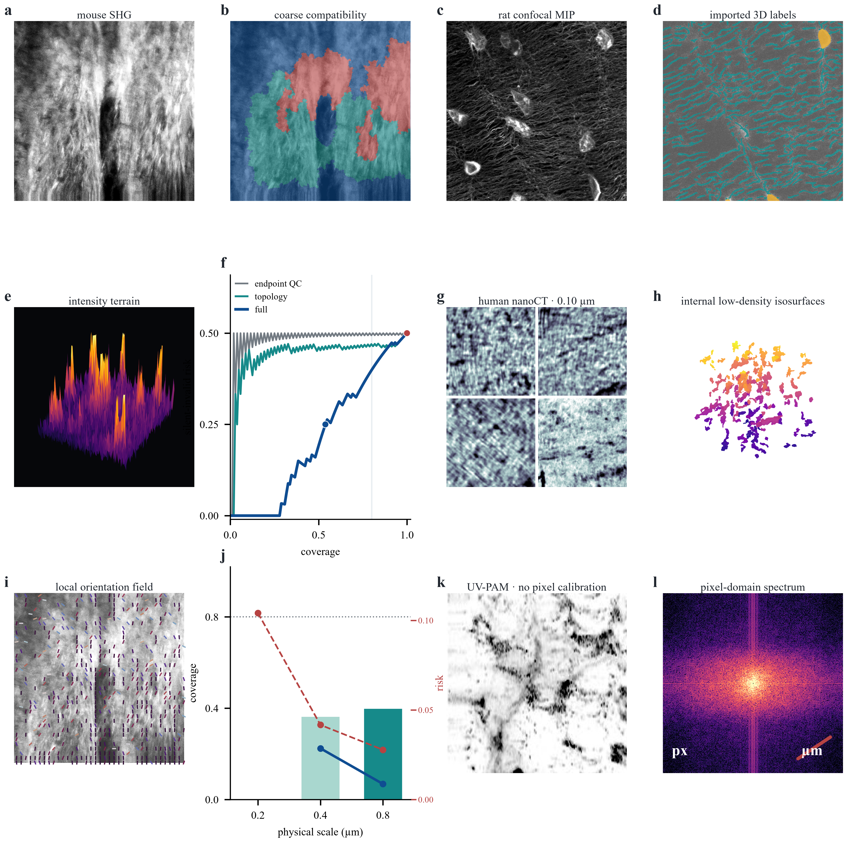
Figure S3. Public bone stress atlas. a,b, Mouse-bone SHG and coarse orientation-compatibility regions. c,d, Rat confocal projection and imported lacuna-canalicular labels. e, Deterministic intensity terrain. f, Risk–coverage curves for endpoint QC, topology-only support and the full contract. g,h, Human nanoCT crops and internal low-density isosurfaces. i,j, Local orientation and its scale-conditioned coverage/risk boundary. k,l, Human-bone UV-PAM and its pixel-domain Fourier spectrum. These exploratory transfers are not pooled with the primary confirmations.

S6. Frozen receipt index
The relative record name and SHA-256 digest below identify the exact machine-readable evidence used to generate this Supporting Information. The release builder verifies these records before packaging and excludes bulk public microscopy.
Table S6. Machine-readable evidence receipts.
Receipt | SHA-256
outputs/nostos0-synthetic-v1/validation.json | f406cce0826032ceb5d5146dc7e7181144ea7dd492ba2b950bd7abc9b98c146b
outputs/nostos0-module-perturbations-v1/module_perturbation_matrix.json | b8de6dacb398b20ba320f3163b4d5d43d5178ed5d5dda23e25c70f47463d44fe
outputs/nostos0-stare-network-confirmation-v1/stare_network_confirmation.json | da9c59ad2508685325ab2ee805b94c23d90b5ce80a583cd51f5b41a0305fdb96
outputs/external-bone-v1/external_bone_validation.json | d0be3f11fb75dbd5221edf6659040e1cb043ddb710a32f66ab20533a05b4288f
outputs/nostos0-bonej-thickness-v1/bonej_thickness_comparator.json | 561f5592e9d05f66240d1c17caa9f1fbd84d18a5af203cabaec37caf499a04f7
outputs/nostos0-bbbc035-dynamic-confirmation-v1/bbbc035_dynamic_confirmation.json | 373a1dfa7bcad32cf272be0b320e21ae5b9b4f9aa4d2c220f7118a5c862a94b4
outputs/nostos0-bbbc035-dense-deformation-confirmation-v1/bbbc035_dense_deformation_confirmation.json | 7babed3f53f28c6a2976169a94f5b17e8d182a5d3fd6f84538499d4e39c11f04
outputs/nostos0-bbbc006-spatial-confirmation-v1/bbbc006_spatial_confirmation.json | 511e1ed21391f082f221d64b76fb39b509b6e9d0f82e0c4848f4227fe91877fb

S7. Resource identifiers and scope
Table S7. External public resources.
Resource | Persistent identifier | Permitted interpretation
STARE | https://cecas.clemson.edu/~ahoover/stare/probing/ | reference-mask network endpoints
trabecular bone | https://doi.org/10.5281/zenodo.11061947 | local thickness on supplied masks
BBBC035 | https://bbbc.broadinstitute.org/BBBC035 | programmed bulk and dense motion
BBBC006 | https://bbbc.broadinstitute.org/BBBC006 | adjacent-plane and defocus response

No result in this file establishes diagnosis, mechanics, clinical usefulness, intraoperative performance, automatic tissue segmentation or a universal biological meaning for any NOSTOS coordinate. The supplementary results establish only the declared estimator-level agreements and perturbation behaviors.

