NOSTOS Prevents Silent Acquisition- and Scale-Specific Failure in Quantitative Microscopy
Yan Jun Lin
Department of Orthopaedic Surgery, University of Pittsburgh Medical Center, Pittsburgh, Pennsylvania, USA
Correspondence: Yan Jun Lin, Linyj2@upmc.edu
Funding: The author received no specific funding for this work.
Keywords: quantitative microscopy, measurement validity, selective prediction, abstention, uncertainty calibration, reproducible software

Abstract
Quantitative microscopy software often reports a value whenever an algorithm can run, although image sampling may not support the requested measurement. NOSTOS compiles paired acquisition–reference data into input-only validity profiles for continuous measurements. On eight untouched BioSR fields, a frozen profile retained 95.0% of eligible tensor-coherence measurements while reducing silent-invalid risk from 0.0735 to 0.0387. In the Fluorescence Microscopy Denoising archive, pooled validation concealed a condition in which every emitted measurement was invalid; hierarchical support removed it on four new fields. In unstained PSHG-TISS, NOSTOS retained 7 invalid outputs versus 47 for acquisition quality control and 24 for endpoint quality control at matched 63.9% coverage. A sealed, independently acquired tendon pSHG archive then tested single-image structural recovery. Across 37 untouched fields, NOSTOS coherence from one mean SHG image correlated with withheld polarization-derived organization (Spearman ρ = 0.891; specimen values 0.904 and 0.842). Under 592 programmed cases, NOSTOS retained 2 invalid outputs among 229 versus 86 and 26 for the comparators. Preregistered coverage and clean-preservation gates were missed, so the experiment remains a qualified failure rather than a converted pass. NOSTOS makes support, abstention and failure history executable without assigning universal biological meaning.

1. Introduction
Microscopy has become a quantitative measurement system, but the software layer rarely behaves like one. Structural descriptors are commonly computed after a small set of image-level quality checks, and a successful return value is then treated as evidence that the measurement was supported. The assumption is unsafe. Focus, contrast and signal-to-noise can be adequate while the requested spatial scale is undersampled, the structure is not identifiable, a perturbation changes the endpoint or the acquisition belongs to an unsupported family. Instrument-quality initiatives have made acquisition calibration and metadata more visible, and image-analysis validation frameworks have clarified the importance of task-appropriate metrics. Neither, by itself, turns a downstream scientific measurement into an object that can refuse unsupported input^{1–4}.
Selective prediction supplies the useful idea of trading coverage for lower risk, and subgroup calibration warns that pooled performance can conceal localized failure^{5–9}. These ideas have largely been developed for class or set prediction. Quantitative microscopy poses a different operational problem. The output is often a continuous physical or image-domain measurement; validity can depend simultaneously on acquisition metadata, endpoint family and the scale or threshold at which the measurement was requested; repeated tiles, captures and scales are nested within a field or specimen; and the deployed software must preserve units, coordinate conventions and provenance. NOSTOS was built to make that measurement-support decision explicit.

2. Results and Discussion

2.1. Executable validity profiles and prospective BioSR confirmation
NOSTOS separates the estimator from its validity profile. The estimator can be any deterministic or learned algorithm that maps an image and declared measurement coordinate to a value. The profile decides whether that value may be emitted. Development rows pair an acquisition with a higher-support reference and record the endpoint error, a frozen invalidity tolerance, the highest available independent group and diagnostics available from the input alone. An invalidity indicator is one when endpoint-specific loss exceeds the declared tolerance. Reference eligibility is evaluated separately so an uninformative reference cannot certify an acquisition.
For each endpoint family, the compiler maps input-only support scores to empirical invalidity risk using quantile bins, Jeffreys smoothing and isotonic calibration. Complete independent groups are assigned to deterministic folds; the operating threshold is chosen only from out-of-group predictions. The selected point maximizes emitted coverage subject to prespecified limits on observed risk, the field- or specimen-clustered bootstrap upper bound and minimum coverage. The serialized profile contains the calibration maps, threshold, supported acquisition strata, development-group receipt, gates and content hash. Confirmation is a separate command that rejects overlapping groups or a modified profile.
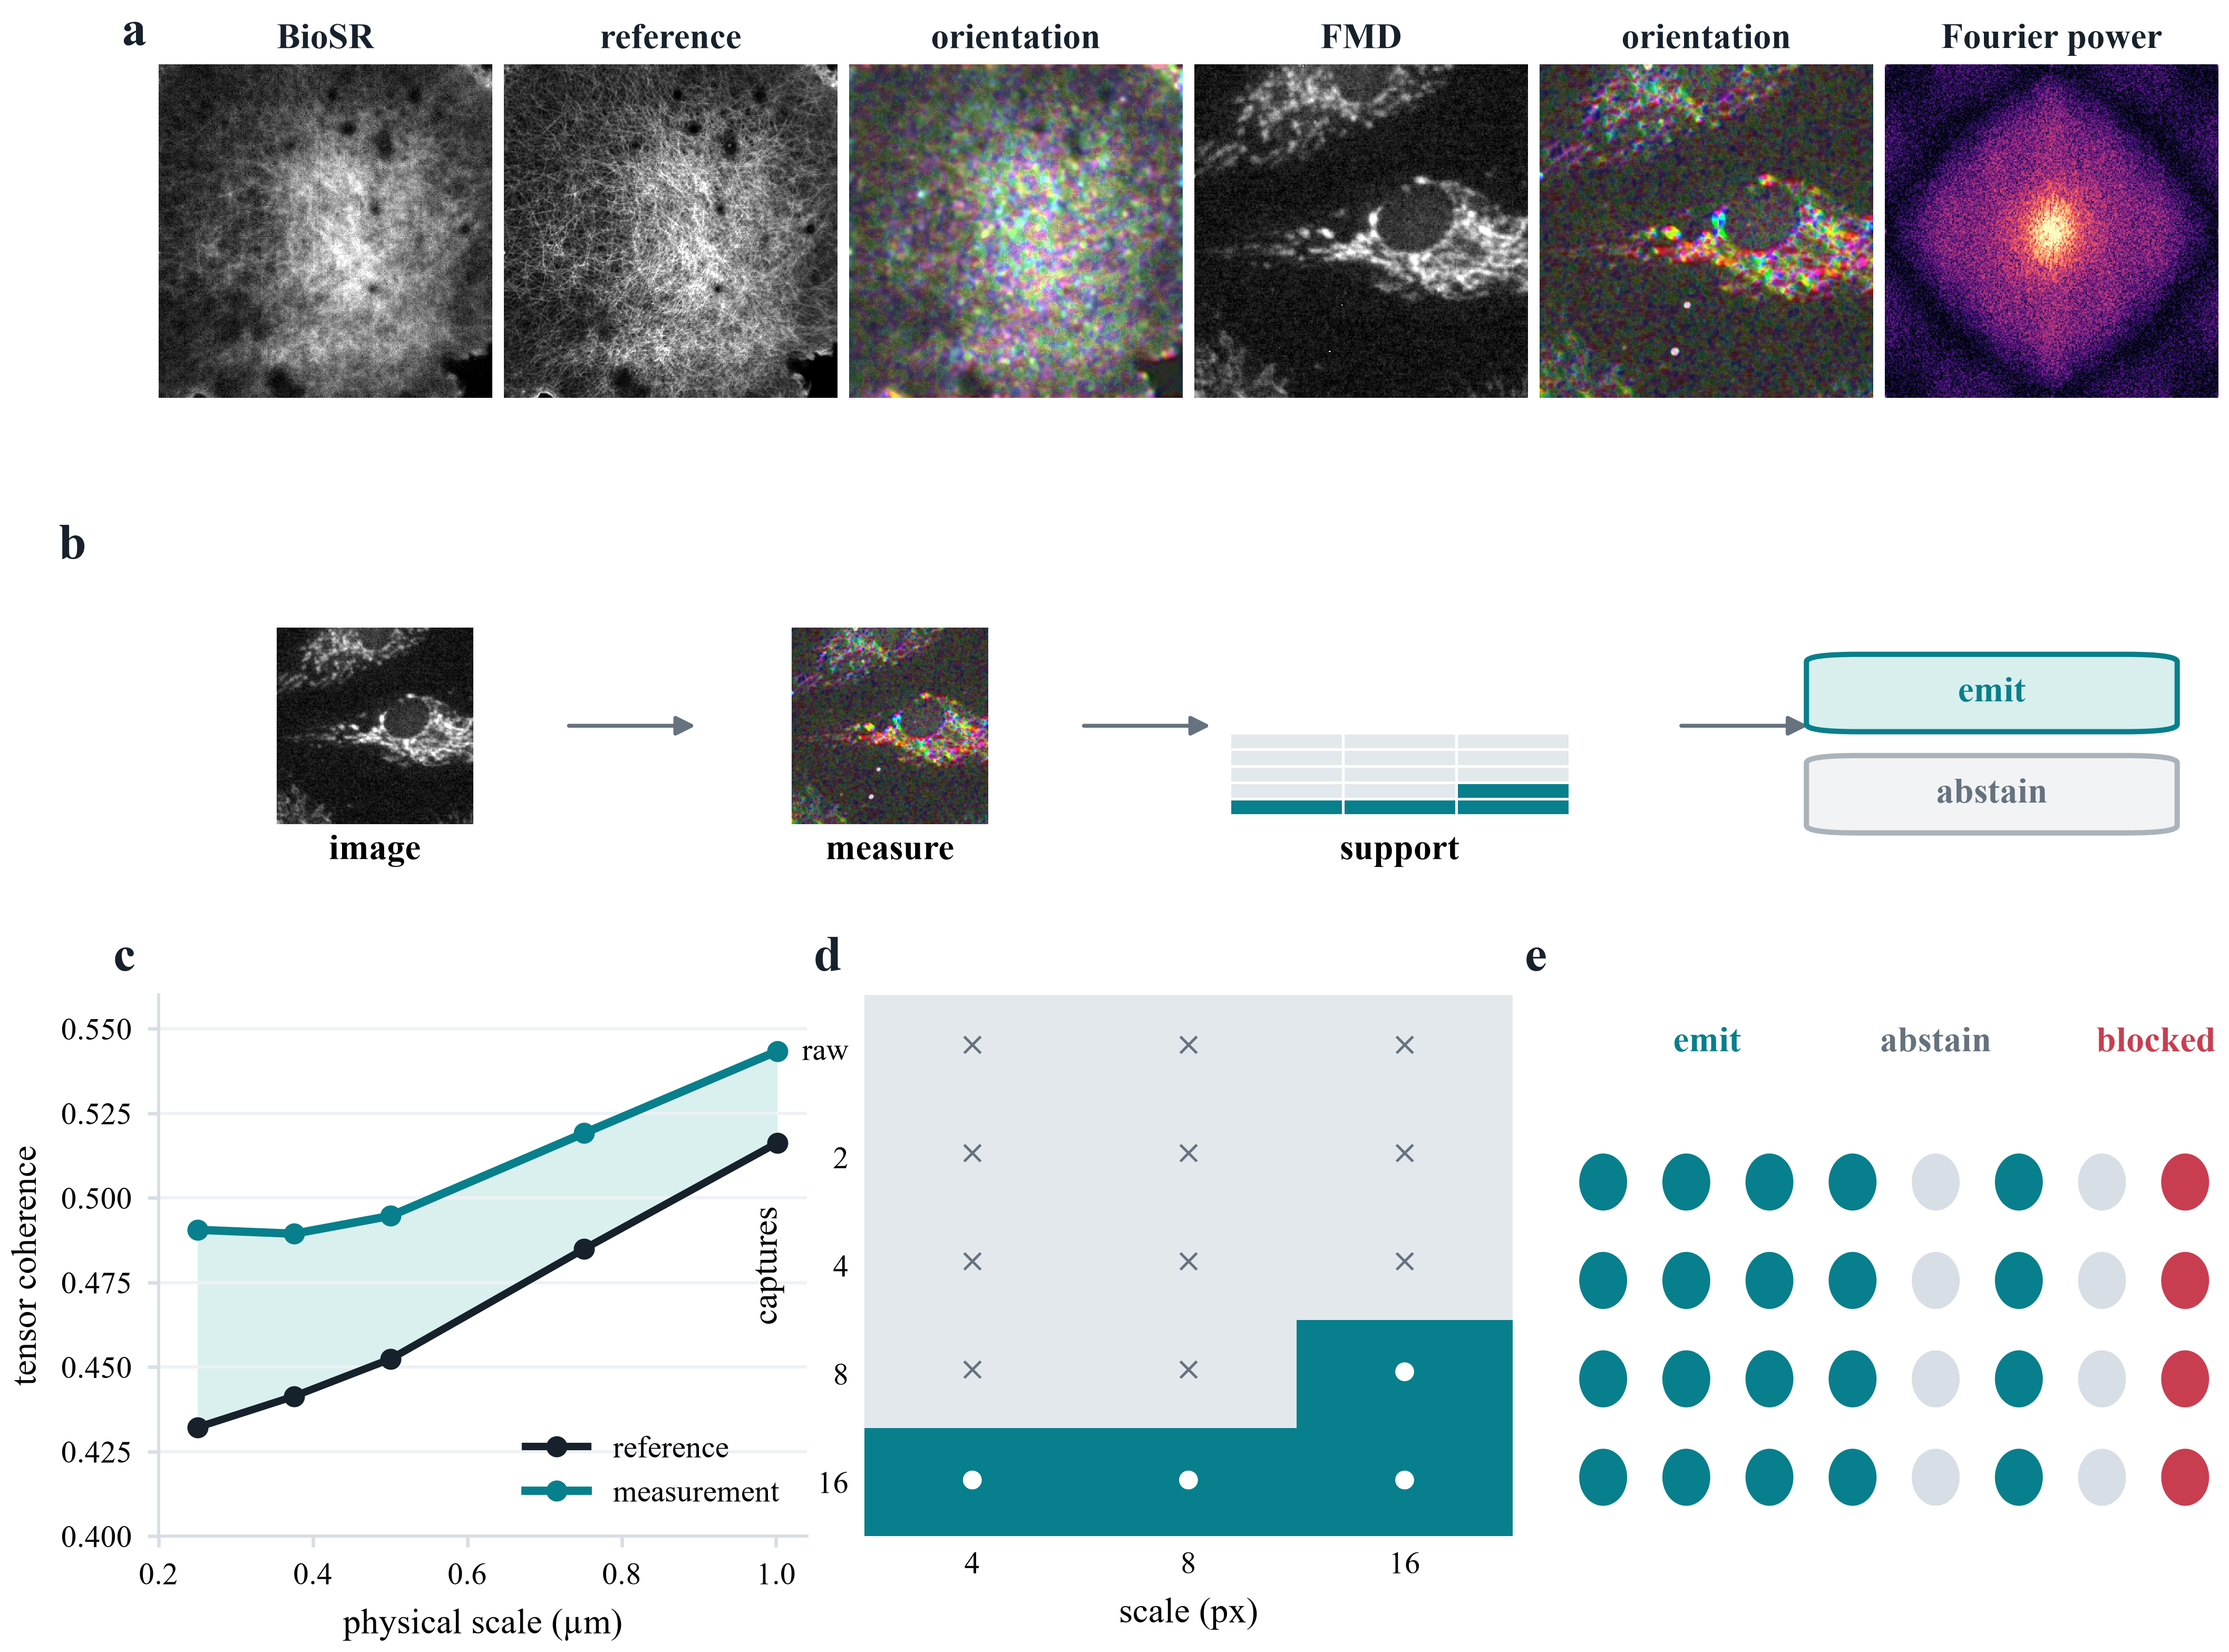
Figure 1. NOSTOS separates computation from measurement validity. a, Authentic BioSR and FMD microscopy, the paired BioSR reference, deterministic orientation fields and Fourier power. FMD remains pixel-relative because spacing is unavailable. b, An authentic FMD image and its deterministic orientation field pass through the frozen acquisition-by-scale support lattice to an emit or abstain decision. c, BioSR tensor-coherence response across declared physical scales. d, Frozen FMD acquisition-by-scale support; white circles denote supported cells and crosses unsupported cells. e, Output states. Every biological pixel originates in the cited public archives; every map and summary is deterministic.
The hierarchical compiler adds a second condition. Base-accepted development rows are partitioned by declared coordinates such as acquisition modality, capture level, endpoint family and requested scale. A cell enters the supported set only when it contains enough accepted measurements from enough independent groups and passes cellwise risk and uncertainty limits. At deployment, a value is emitted only if its hard preconditions pass, its calibrated risk does not exceed the frozen threshold and its declared cell is supported. Unseen, underrepresented or unsafe cells abstain. One failed supported cell fails the complete confirmation even when pooled risk passes.
This design changes the unit of interpretation. NOSTOS does not claim that high tensor coherence, Fourier anisotropy, tubeness or network persistence has the same biological meaning in every sample. It guarantees only that the requested measurement, coordinate system and evidence state travel together. The measurement engine currently exposes spectral organization, structure tensors, scale-normalized Hessian morphology, maximal-sphere local thickness, network erosion survival, directional variograms, bulk registration and dense deformation through a typed response schema. These established estimators are not the methodological novelty; they provide heterogeneous measurement objects on which the validity machinery can operate^{13–26}.
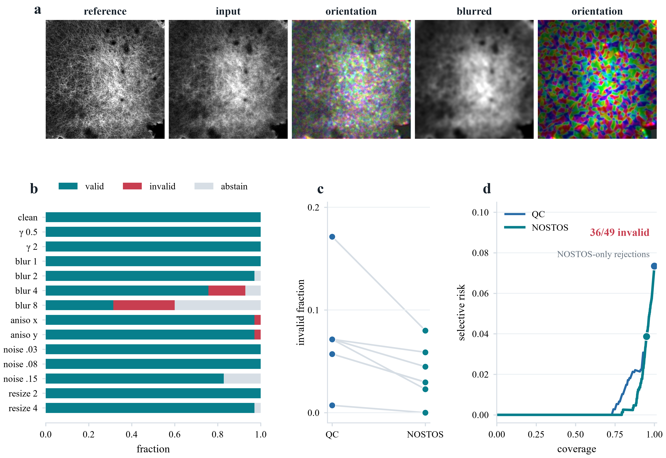
Figure 2. Selective support lowers silent-invalid risk in untouched BioSR fields. a, A paired F-actin reference and ordinary-resolution input, their deterministic orientation field, and a controlled blur challenge. b, Valid emissions, invalid emissions and abstentions across the frozen perturbation panel. c, Invalid-emission risk paired by each of eight independent fields under acquisition quality control and NOSTOS. d, Tied-score risk–coverage curves; 36 of the 49 measurements rejected only by NOSTOS were invalid. Perturbations, scales and signal levels remain nested within fields.
We first tested selective support on BioSR, a public collection of paired ordinary-resolution and ground-truth structured-illumination microscopy¹². The development history contained several failed profiles and calibration repairs; all remain in the evidence ledger. The final v9 confirmation used eight untouched F-actin fields, four linear and four nonlinear, selected by a frozen hash rule after excluding every field opened during earlier versions. Raw SIM phase frames were averaged according to the deposited acquisition layout and compared with the registered ground-truth SIM image. The primary endpoint was tensor coherence at declared physical scales under fixed blur, noise, resampling and contrast challenges. Scale and degradation measurements were nested within field.
Among 980 eligible primary rows, ordinary acquisition QC emitted all 980 and 72 were invalid, for risk 0.0735. The frozen NOSTOS profile emitted 931 rows (95.0% coverage), of which 36 were invalid, for risk 0.0387 and relative risk reduction 47.4%. The field-clustered upper 95% risk estimate was 0.0513. The 49 values rejected only by NOSTOS were enriched tenfold for invalidity and carried 73.5% risk. Difference in risk–coverage area favored the complete contract by 0.00217; the stratified field-bootstrap 95% interval was 0.00092–0.00592. Risk was lower than ordinary QC in both linear and nonlinear F-actin strata. A negative-control set of mild degradations retained complete coverage with zero observed error, arguing against indiscriminate abstention.
The BioSR result establishes bounded selective validity for tensor coherence in one controlled-degradation resource. It is not biological ground truth, a super-resolution benchmark or a universal support rule. Its main role was to show that measurement-aware input diagnostics could remove disproportionately invalid values while preserving useful coverage.

2.2. Hidden FMD failure and hierarchical repair
The FMD archive offered a harder and more revealing test^{10,11}. It contains repeated real fluorescence acquisitions from commercial confocal, two-photon and widefield microscopes. For each field, images formed from one, two, four, eight or sixteen captures can be compared with an average-of-fifty reference. We used the repeated captures as nested technical observations and the field of view as the independent unit. Because pixel spacing is absent, all requested scales are declared in pixels and no physical-scale claim is made.
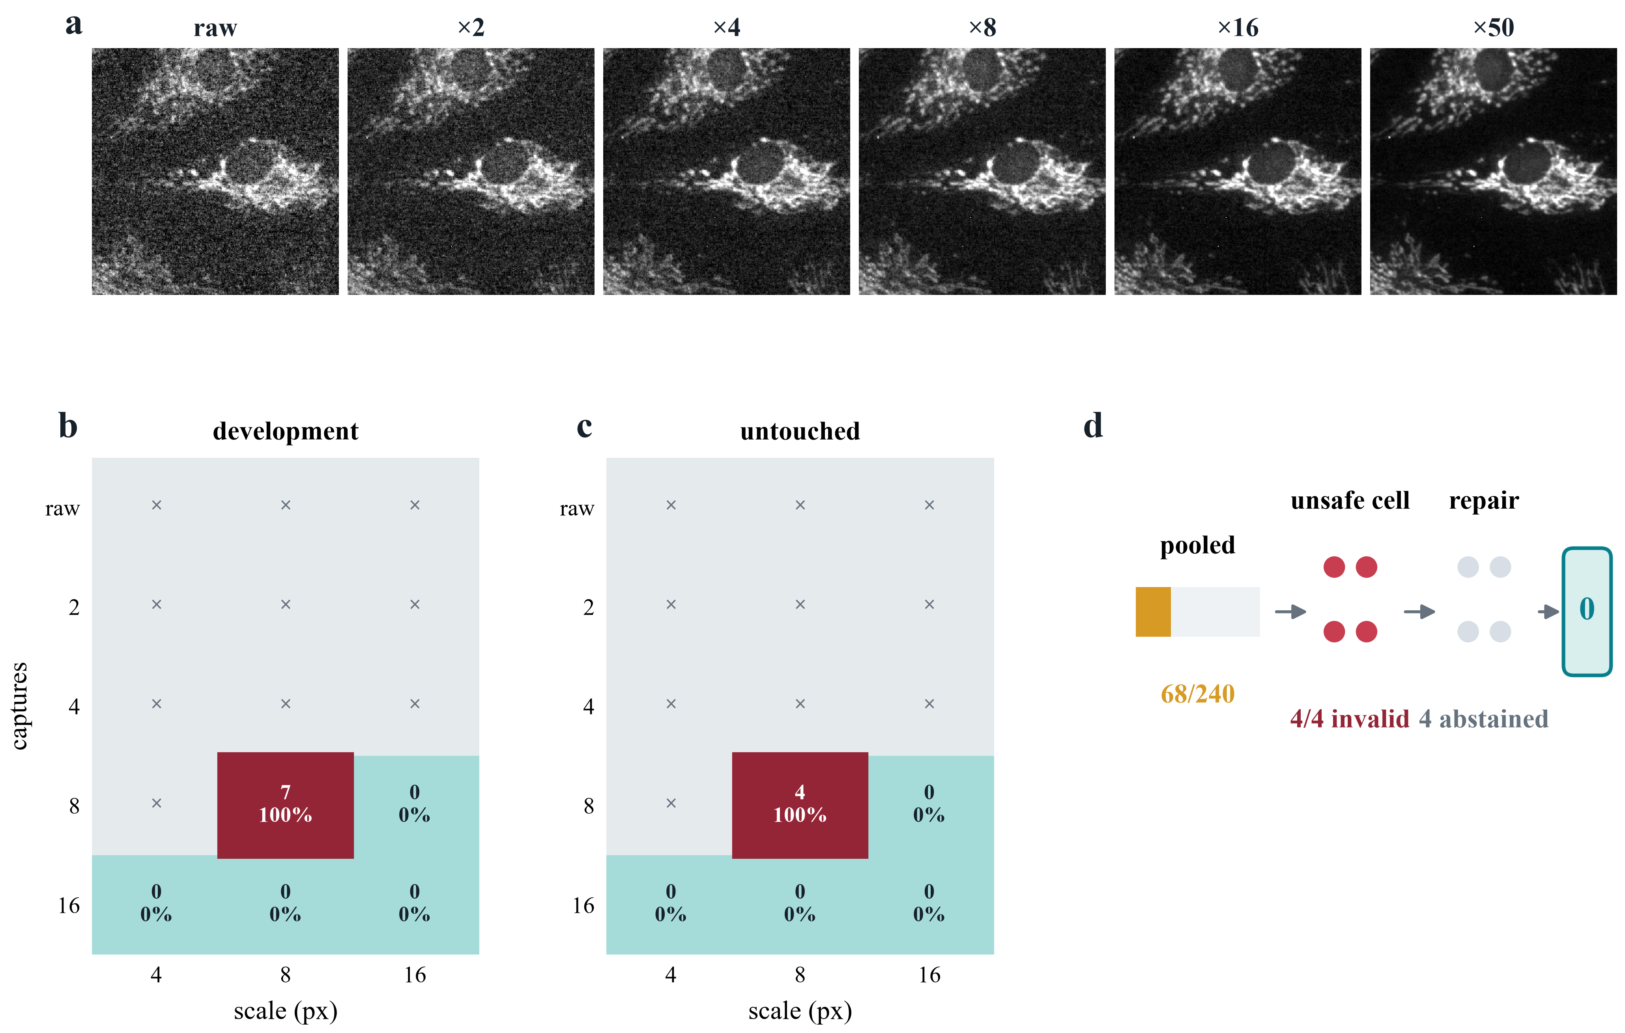
Figure 3. Pooled validation conceals a deterministic acquisition-by-scale failure. a, One FMD field across increasing capture averages and the average-of-50 reference. b, Development localization: every emitted average-of-8 by 8-pixel tensor-coherence measurement was invalid, whereas supported average-of-16 cells had no observed error. c, The same failure recurred on untouched confirmation fields. d, The data-bearing repair sequence: pooled support emitted 68 of 240 measurements, stratification isolated four invalid outputs in four attempts, and the frozen repair abstained from that unsafe cell. All numbers are frozen audit results.
The first complete cross-modality profile passed its frozen aggregate gates. It emitted 142 of 360 eligible primary tensor-coherence values with risk 0.141, compared with 0.303 for matched ordinary QC. That headline was incomplete. A post-confirmation stratified audit showed zero errors among 48 accepted confocal and 46 accepted two-photon values, but 20 errors among 48 accepted widefield values (risk 0.417). The profile was therefore not promoted across modalities. This failure motivated an acquisition-specific widefield profile and a minimum development-field requirement for every declared acquisition stratum.
The frozen widefield v1.3 profile then passed every pooled confirmation gate on four untouched FOVs. It emitted 68 of 240 eligible values (28.3% coverage) with four errors (risk 0.0588), versus 41 errors among 68 values for matched ordinary QC. Yet all seven accepted development errors and all four confirmation errors belonged to one average-of-8-captures by 8-pixel tensor-coherence cell. Within that cell, every emitted value was wrong in both development and confirmation. Safe average-of-16 and coarse-scale values diluted this deterministic failure in the pooled statistic. The v1.3 pass was retained, but it was not accepted as the terminal profile.
This sequence provides a direct empirical reason for hierarchical measurement support. The problem was not a weak global score or an unfavorable average. The acquisition could support some scales and capture levels but not others, and the unsafe combination was known from input metadata. A scalar quality decision could not represent that topology.
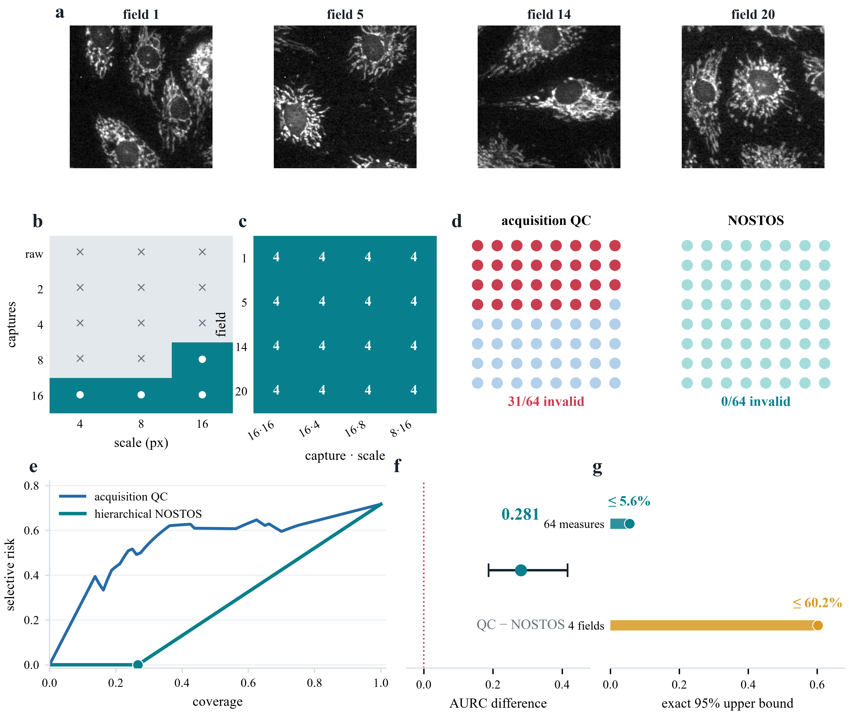
Figure 4. Frozen hierarchical support prevents recurrence on new fields. a, Average-of-16 images from the four untouched confirmation fields. b, Development-only support lattice. c, Each supported capture-by-scale cell emitted four measurements in each field. d, At matched coverage, acquisition quality control emitted 31 invalid values among 64; NOSTOS emitted none. e, Risk–coverage curves. f, Field-bootstrap difference in risk–coverage area, acquisition quality control minus NOSTOS, with the 95% interval. g, Exact two-sided 95% upper limits for 64 nested measurements and four independent field-level any-failure events.
After the v1.3 result was opened, its eight development and confirmation FOVs were explicitly relabelled as v1.4 development. The v1.3 calibrated risk maps, score and threshold remained byte-identical. Before decoding new confirmation pixels, we froze a conditional table over declared capture level and requested tensor-coherence scale. A cell required at least eight accepted cases from at least four independent FOVs, observed risk no greater than 0.10 and a FOV-bootstrap upper 95% risk no greater than 0.30. Four cells were supported: average-of-16 at 4, 8 and 16 pixels, and average-of-8 at 16 pixels. Eleven cells, including the failed average-of-8 by 8-pixel cell, were unsupported and forced to abstain.
The one-shot v1.4 confirmation used four new FOVs selected by the frozen hash rule and four frozen repeat indices at each capture level. The hierarchical profile emitted 64 of 240 eligible primary values (26.7% coverage) with no observed invalid measurement. Every supported cell emitted 16 values spanning all four FOVs and had no observed error. Matched ordinary acquisition QC emitted 31 invalid values among 64 (risk 0.484; tie-robust upper risk 0.500). The relative risk reduction was 1.0. Risk–coverage area was 0.263 for the hierarchical profile and 0.543 for ordinary QC; the observed difference was 0.281, with FOV-bootstrap 95% interval 0.187–0.416 and all 5,000 draws favoring NOSTOS. All ten pooled and cellwise gates passed.
No zero-event result warrants certainty. The percentile cluster bootstrap is identically zero when every observed FOV has zero errors and therefore cannot serve as a population upper confidence limit. A separate exact audit gave a two-sided Clopper–Pearson upper 95% limit of 0.056 for the 64 nested emitted measurements and 0.602 for the proportion of comparable FOVs with any emitted error. Each 16-value cell had an upper limit of 0.206 when its nested rows were treated descriptively. The large FOV-level bound is the correct warning: four independent fields provide a strong technical demonstration of the repaired failure, but narrow evidence for population generalization.

2.3. Selective validity in unstained PSHG tissue
The prior studies established selective validity in fluorescence archives, but they did not test a label-free tissue image against a physically derived local orientation reference. We therefore used the unstained-breast forward-SHG subset of PSHG-TISS³⁰. Each region contains ten frames acquired from 0° to 180° in 20° increments, together with a polarization-fit orientation map and fit-quality maps. The NOSTOS endpoint was the sigma-2-pixel local axial structure-tensor direction. A 90° instrument-to-raster offset had been frozen on a separate skin qualification subset before the breast orientation result.
The 48 breast regions were ordered by a prespecified SHA-256 rule and divided into 24 development and 24 confirmation regions before any shifted image was generated. Fifteen conditions were fixed: clean input; three levels each of blur, noise and circular inter-frame motion; two resampling levels; low contrast; and moderate and severe compound shifts. A case was invalid when its median axial error exceeded 15° or its 75th-percentile error exceeded 30°. Every policy used the same orientation estimator. Policies differed only in input-known acquisition diagnostics, coherence, scale consistency and alternating-frame consistency. The polarization reference and its fit-quality maps were withheld from every deployment decision.
The confirmation contained 360 cases, of which 77 were invalid. At the frozen risk threshold, the complete contract accepted 230 cases (63.9% coverage) and retained 7 invalid outputs (3.04% risk). At the same 230-case coverage, acquisition quality control retained 47 invalid outputs (20.43% risk), whereas endpoint quality control retained 24 (10.43%). Absolute risk reductions were 17.39 and 7.39 percentage points, respectively. Across 5,000 region-level bootstrap samples, the 95% intervals were 0.131–0.245 and 0.047–0.114 for the two matched-risk differences; both risk–coverage-area intervals also excluded zero. Clean-input coverage was 22 of 24 regions, with 7.29° median axial error.
Removing scale consistency increased risk–coverage area by 0.0521. Removing alternating-frame consistency improved it slightly by 0.00035, so that component is not claimed as necessary. Acquisition quality control produced no operating point at the frozen risk cutoff; its matched-coverage comparison is a stable score ranking, not a deployable threshold. A separate audit implementation verified all 312 confirmation source files and exactly reconstructed the split, scores, decisions, summaries and 5,000 bootstraps. This result demonstrates selective validity under programmed shifts in one deposited PSHG acquisition family, not independent-microscope transfer or native clinical degradation.
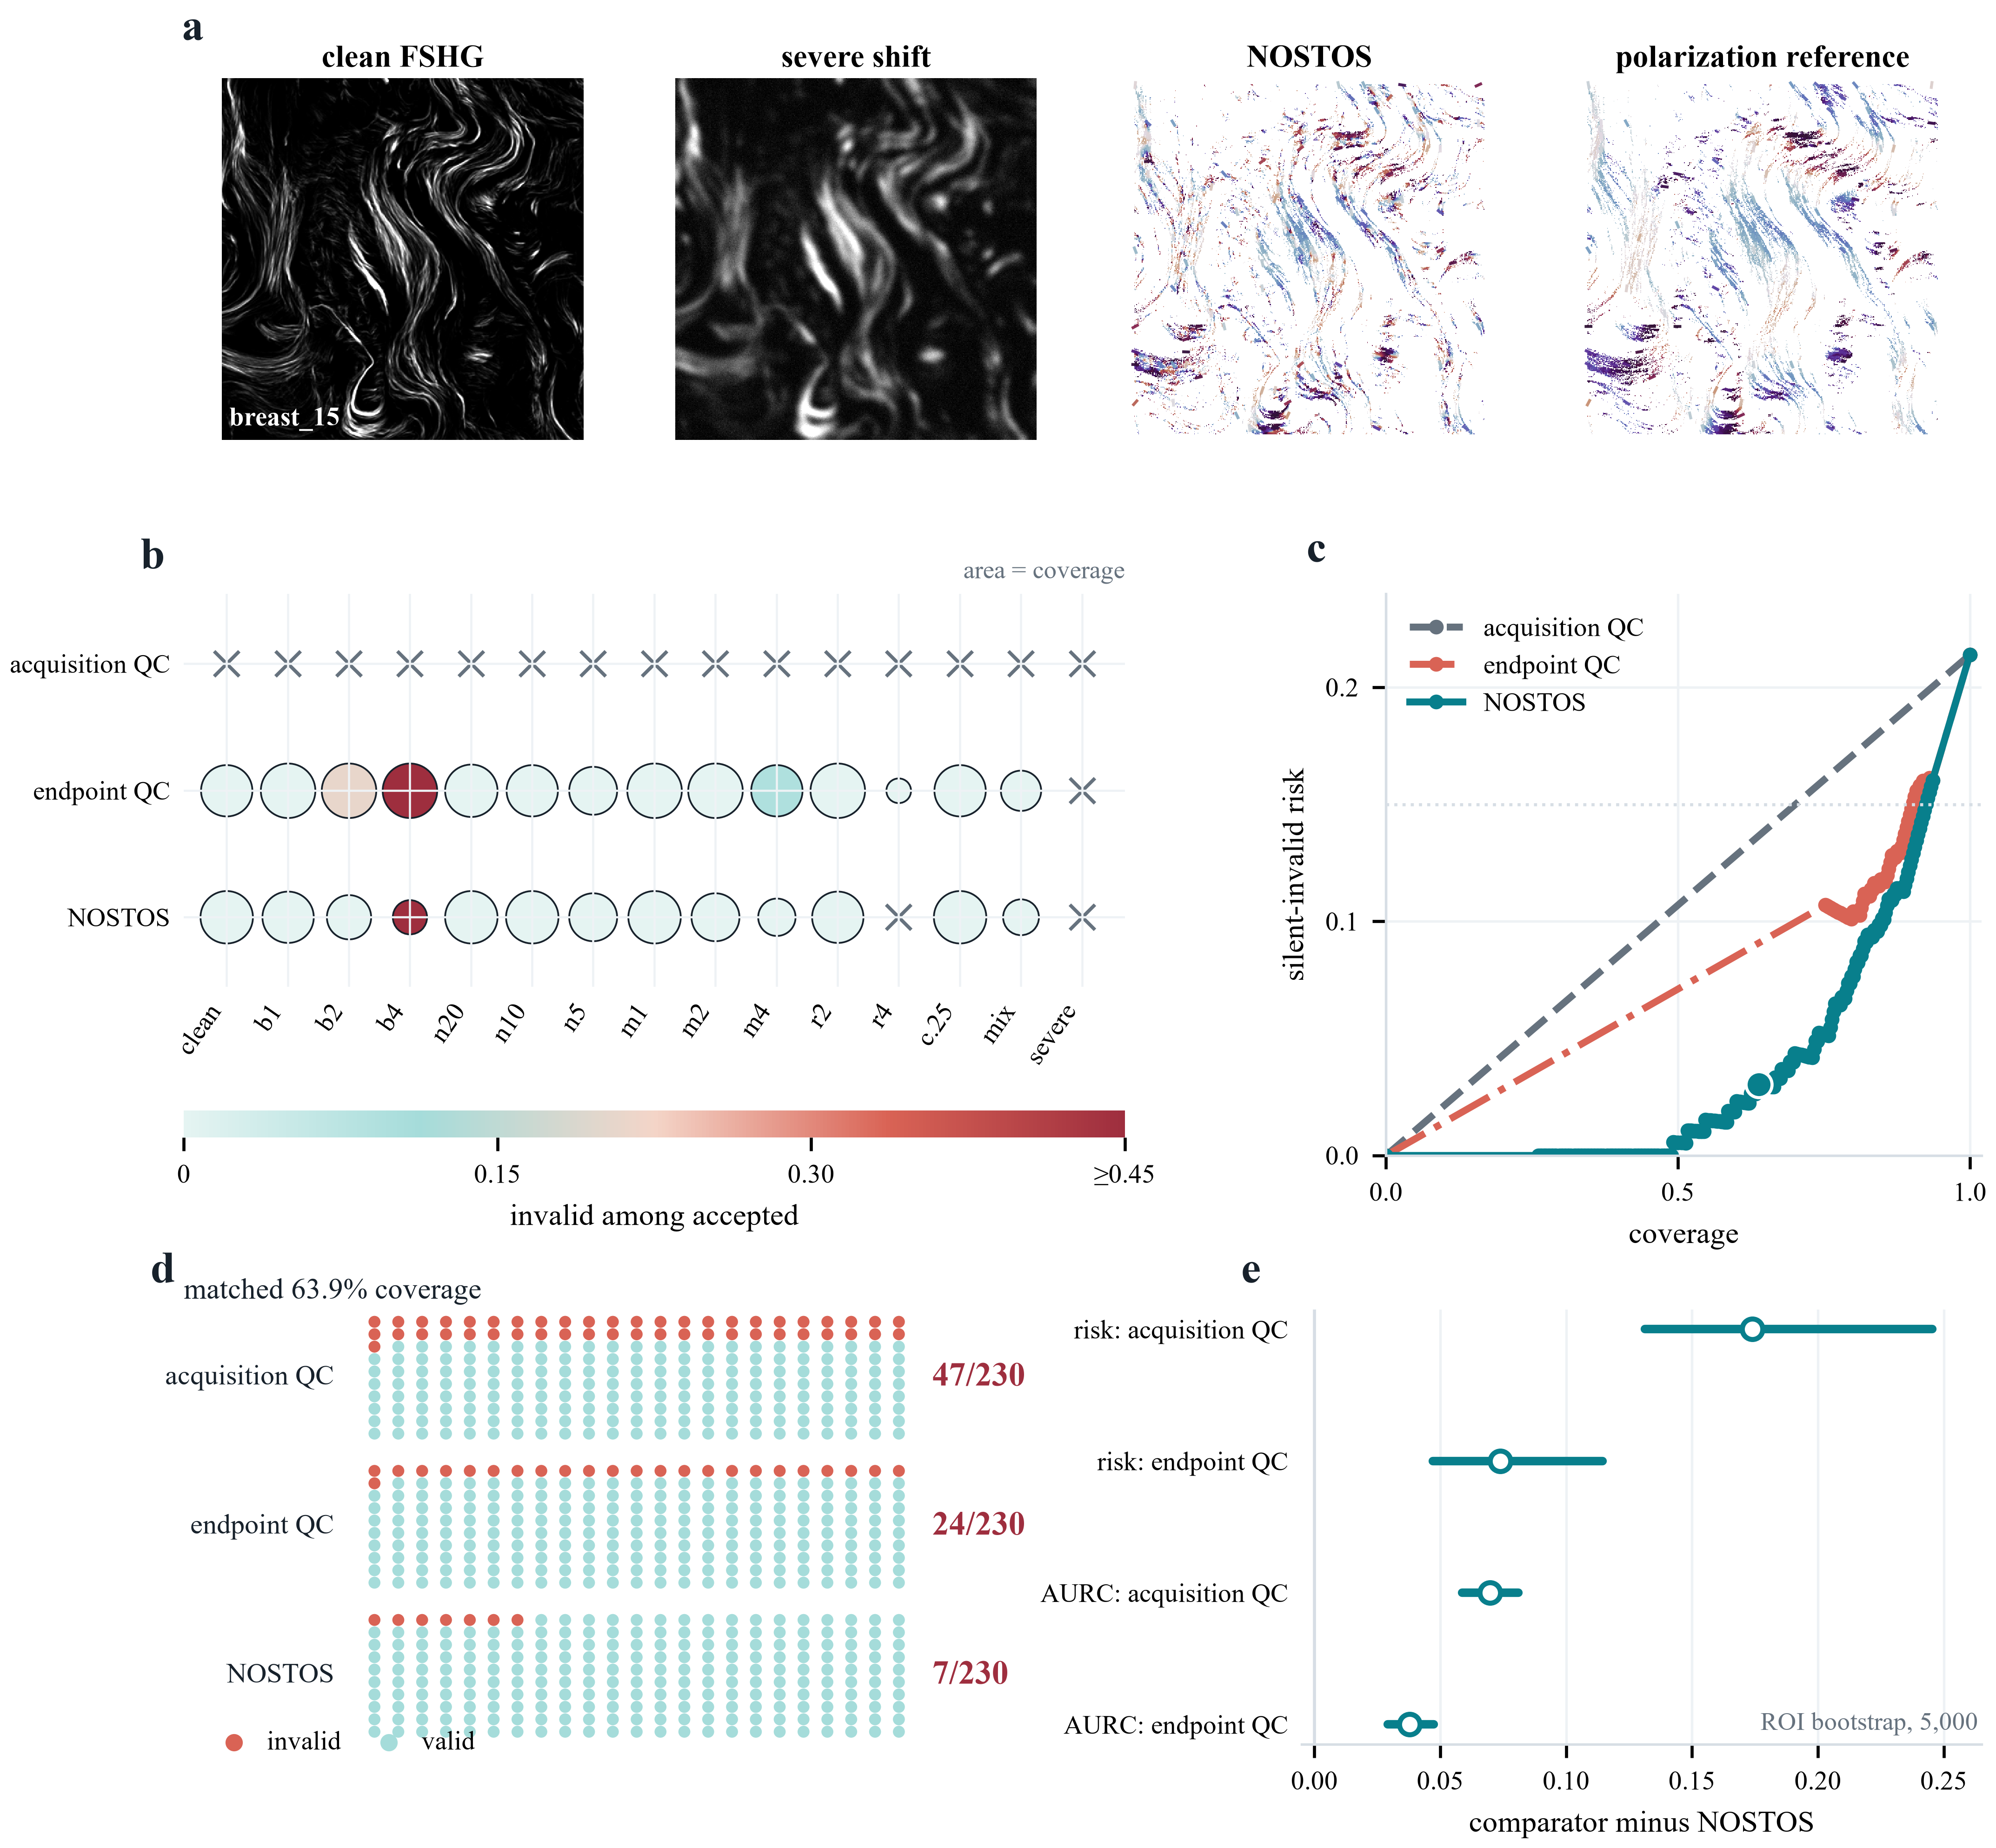
Figure 5. A frozen input-only contract lowers silently invalid orientation outputs in unstained PSHG tissue. a, Authentic clean forward-SHG, the severe compound shift, the deterministic NOSTOS local axial orientation field and the withheld polarization-derived reference for the first region in the frozen confirmation lock. b, Condition-by-policy acceptance; circle area encodes coverage, fill encodes invalidity among accepted cases and crosses denote no accepted cases. c, Tied-score risk-coverage curves. d, Invalid outputs among the same 230 accepted cases: 47 for acquisition quality control, 24 for endpoint quality control and 7 for NOSTOS. e, Region-bootstrap differences for matched risk and risk-coverage area; positive values favor NOSTOS. Conditions are nested within 24 independent regions.

2.4. Single-image structural recovery in independent tendon pSHG
We next asked whether the orientation contract and an interpretable structural coordinate transferred beyond PSHG-TISS. A separate public study deposited mean SHG intensity, polarization-derived orientation (φ₂) and organization (I₂) maps from non-mineralizing, early-mineralizing and late-mineralizing turkey leg tendon, together with synchrotron X-ray measurements of collagen hierarchy^{31,32}. Each 512 × 512-pixel field spans 384.5 × 384.5 µm. Only the mean SHG intensity image entered NOSTOS; φ₂, I₂, zone identity and X-ray measurements were unavailable to the support decision.
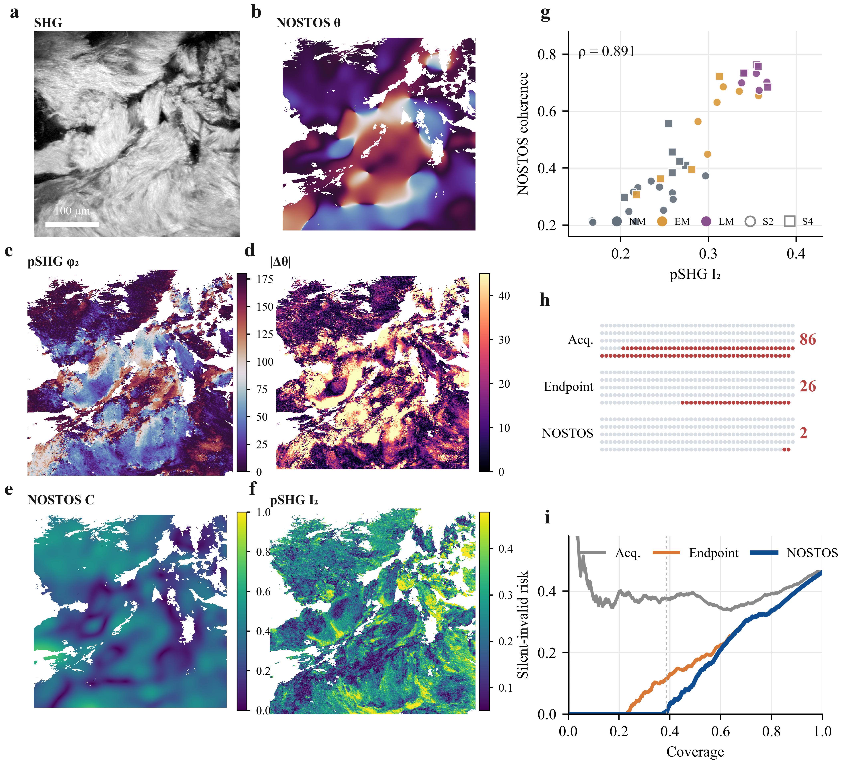
Figure 6. A single SHG image recovers polarization-derived collagen structure in a sealed second acquisition family. a, Deposited mean SHG intensity from the SHA-256-first confirmation field; the scale bar is 100 µm. b, NOSTOS 12 µm local axial orientation from that single image. c, Withheld pSHG φ₂ orientation. d, Pixelwise axial error on common support. e, NOSTOS local coherence. f, Withheld pSHG I₂ organization. g, Field-level NOSTOS coherence versus pSHG I₂ across all 37 untouched clean fields; colors denote mineralization zones and marker shapes denote the two specimens. h, Invalid outputs among complete tied-score groups nearest to the same 229 accepted cases: 86 for acquisition quality control, 26 for endpoint quality control and 2 for NOSTOS. i, Tied-score risk–coverage curves over 592 programmed cases; the vertical line marks NOSTOS coverage. The preregistered overall status remains fail because coverage was 38.68% versus the 40% gate and clean-field retention was 59.46% versus the 70% gate.
The four specimens were separated before array inspection by a deterministic SHA-256 rule. Samples 1 and 3 supplied 36 development fields, while Samples 2 and 4 remained sealed. Development selected a log-intensity transform, a 12 µm primary tensor scale, a 6 µm scale-consistency comparator and zero coordinate offset. An initial smoothed-gradient disagreement component worsened development risk–coverage area and was rejected before confirmation. The locked contract retained acquisition QC, local coherence and physical-scale consistency. Sixteen clean and programmed blur, noise, resampling, contrast and compound conditions were fixed. A field-condition case was invalid when its median axial error exceeded 20° or its 75th-percentile error exceeded 35°.
The sealed confirmation contained 37 fields and 592 cases, of which 273 were invalid. The contract accepted 229 cases and retained 2 invalid outputs (0.87% risk). At the nearest complete tied-score groups with the same 229 cases, acquisition QC retained 86 invalid outputs (37.55%) and endpoint QC retained 26 (11.35%). Absolute risk reductions were 36.68 and 10.48 percentage points. Specimen-bootstrap intervals were 18.35–47.50 and 5.83–10.48 percentage points; with two independent specimens these are descriptive, not population inference. Tied-score risk–coverage areas were 0.4004, 0.1845 and 0.1607, respectively. Removing scale consistency worsened area by 0.0238.
The clean images supplied a second, distinct test. NOSTOS median coherence from one mean SHG image correlated with the withheld polarization-derived I₂ organization value across 37 fields (Spearman ρ = 0.891). Correlations were 0.904 and 0.842 in the two sealed specimens. Mean coherence increased from 0.287 in non-mineralizing Sample2 fields to 0.609 and 0.708 in early- and late-mineralizing fields; Sample4 values were 0.421, 0.446 and 0.734. Deposited I₂ changed in the same direction. Thus a scale-declared single-image coordinate recovered substantial information normally derived from a twelve-angle polarization series.
The experiment did not pass every preregistered gate. Coverage was 38.68%, below the frozen 40% requirement, and 59.46% of clean fields were retained, below the 70% requirement. Accepted clean fields nevertheless had 12.12° median field error, and full-contract risk was 1.67% in Sample2 and zero in Sample4. No threshold was changed after unsealing. An independent code path reconstructed all decisions, tied-score analyses, organization correlations and 5,000 specimen bootstraps; 22 of 22 audit checks passed. The result is therefore a qualified second-acquisition-family confirmation: strong measurement and selective-risk evidence accompanied by explicit deployment coverage failure, not a validated replacement for pSHG.
The generic interface exposes separate commands for profile compilation, confirmation audit, hierarchical compilation and hierarchical confirmation. The latter automatically writes exact finite-sample intervals in addition to the frozen audit and row-level decisions. A terminal independent code-path audit reproduced the FMD field and realization selections, checked all archive member hashes, verified unique row identities and formulae, reapplied the serialized profile exactly and demonstrated reference-label blindness by mutating reference errors without changing deployment decisions. All 17 checks passed. The evidence bundle indexes every required receipt with a checksum and no missing entry.
The FMD programme also preserves the steps that did not work: a metadata failure before endpoint analysis, a performance abort before row export, a development profile with no operating point, the cross-modality pooled pass with widefield failure and the v1.3 pooled pass with a scale-specific failure. A reporting-only label amendment is stored separately and did not recompute a statistic or change a gate. This immutable lineage is not incidental bookkeeping. It prevents the final profile from appearing to have been designed before the failures that motivated it.
NOSTOS remains a broader measurement engine, and supplementary validations exercise its component estimators. Twenty-four analytic module–perturbation tests passed their declared operating envelopes. On supplied reference masks, network erosion survival and skeleton length agreed across sampling in 20 STARE images (Spearman correlations 0.988 and 0.995). In eight public trabecular-bone volumes, local thickness agreed with archived maps and BoneJ (median voxelwise Spearman correlation 0.927; concordance correlation coefficient 0.926). Programmed dense deformation and continuation tracking have separate bounded tests. Negative results—including failed universal response concatenation, failed global Fourier transfer, failed automatic vessel proposals and failed division inference—remain visible. These studies establish implementation breadth and claim discipline; they are not pooled into a universal score.
NOSTOS addresses a simple but neglected distinction: computation is not measurement validity. It turns support for a requested microscopy measurement into a versioned object that can be compiled, frozen, audited and applied without access to reference labels. Its principal contribution is the composition of input-only calibrated risk with acquisition and measurement coordinates, grouped validation and fail-closed behavior. The FMD sequence shows why this composition matters. A conventional pooled analysis passed twice while first hiding an acquisition-family failure and then a deterministic acquisition-by-scale failure. Hierarchical support made the failure explicit and prevented its recurrence in the untouched confirmation. The PSHG-TISS challenge then tested the same governing idea on unstained tissue: a physically adjudicated local orientation field failed under controlled acquisition shifts, and an input-only contract removed most invalid outputs without inspecting the reference. A sealed tendon resource extended the test to a separately acquired pSHG family and a tangible structural endpoint. One mean SHG image recovered polarization-derived collagen organization in both untouched specimens, while the same contract sharply reduced invalid orientation outputs. The missed coverage gates remain equally important: they delimit deployment even when accepted-case accuracy is excellent.
NOSTOS is related to selective prediction but does not claim to have invented abstention or risk–coverage analysis. It differs in the object being governed: a continuous structural measurement whose validity depends on declared units, acquisition conditions and requested coordinates. It is also related to multicalibration, but the current support table is not a general algorithm over arbitrary overlapping subgroups. It implements a deliberately finite hierarchy chosen from scientifically interpretable acquisition and measurement coordinates. Risk-controlling prediction sets and Learn-then-Test provide stronger finite-sample guarantees under their assumptions. The present profiles use prespecified empirical gates, grouped bootstrap inference and exact descriptive intervals; they are not distribution-free guarantees.
The evidence has important limits. BioSR, FMD and PSHG-TISS are public archives with their own reference constructions. FMD v1.4 contains only four independent confirmation FOVs, all from one widefield sample/acquisition family. The average-of-fifty image is a high-support computational reference, not noiseless truth. Pixel spacing is unavailable. The FMD score uses declared capture count, which must be known at deployment. Ordinary acquisition QC is a matched internal comparator, not every possible external QC system. The PSHG-TISS result uses programmed shifts in one microscope family. The tendon resource is independently acquired and provides a second pSHG family, but confirmation contains only two specimens and its degradations are still computational. The tendon contract missed its frozen coverage and clean-preservation gates. The organization correlation is therefore evidence that a single-image coordinate contains polarization-related structural information, not proof that NOSTOS can replace pSHG, infer mechanics or generalize to an unseen instrument population. These boundaries are stated in the serialized profiles and must travel with every output.
The claim evaluated here is computational: measurement validity on paired public data. The present work does not establish biological interpretation, diagnosis, mechanics, clinical usefulness or intraoperative performance, and none should be inferred from software correctness or rapid post-acquisition runtime.
The immediate value of NOSTOS is practical. A method developer can adapt any paired acquisition/reference resource to a small JSONL evidence contract, compile a profile with independent groups intact and distribute the measurement algorithm together with its validity object. A user receives a value, its coordinate system, its evidence maturity and a reason when the method abstains. That workflow makes hidden support assumptions reviewable and makes negative results part of the software rather than an unpublished prelude to it.

3. Conclusion
NOSTOS makes the validity of a requested quantitative microscopy measurement an executable, versioned decision rather than an assumption. Across four public resources, the framework reduced silent-invalid outputs, exposed a pooled pass that concealed deterministic subgroup failure, removed that failure on untouched fields and transferred a scale-declared structural measurement across two unstained pSHG acquisition families. In the second family, a single SHG intensity image recovered polarization-derived collagen organization while the preregistered coverage miss remained visible. NOSTOS is therefore a practical fail-closed measurement layer, bounded to the acquisitions, instruments and coordinates on which each profile was established.

4. Experimental Section

4.1. Software implementation and response schema
NOSTOS 0.3.0 is implemented in Python 3.12 or newer using NumPy, SciPy, scikit-image and scikit-learn^{23–26}. Core dependencies are locked with uv. Each response records module, measurement, axes, units, optional direction, values, stability statistics, validity state, abstention reasons, input identity, configuration identity and software provenance. Physical scales are permitted only when pixel or voxel spacing is supplied. Otherwise, endpoints are explicitly pixel-relative or abstain.
The release is CPU-first. Optional GPU segmentation environments are isolated and are not required for either validity confirmation. The release builder allowlists source, configurations, compact receipts and figure assets; excludes bulk public microscopy; scans staged text for credentials and private absolute paths; and writes a SHA-256 manifest for every file and for the deterministic archive.

4.2. Evidence-row contract and invalidity
One JSONL row represents one endpoint comparison from a paired acquisition and reference. Required fields are a unique case identifier, independent reference group, endpoint family, pair-registration eligibility, reference eligibility, frozen invalidity indicator, input-only score dictionary and input-only hard abstention reasons. Rows may retain measurements, errors, tolerances and reference diagnostics for audit, but those fields are not accessible to the deployed decision.
For endpoint family m, acquisition image I, requested coordinate q, estimator f_m and reference value y, the reported value is y = f_m(I,q). The binary invalidity label is Z = 1 when the prespecified endpoint loss L_m(y,y) exceeds tolerance epsilon_m. Tensor orientation uses axial circular error; tensor coherence and spectral summaries use absolute error; thickness and scale use declared physical or relative errors. Reference eligibility is endpoint specific and is applied before calibration.

4.3. Base-profile compilation
Rows eligible for calibration require both valid pairing and an eligible reference. Complete independent groups are assigned to deterministic, stratified folds using SHA-256 ordering. The number of folds is the smaller of the configured maximum and the number of independent groups available to an endpoint family, with at least two groups required. Within each training fold, scores are quantile binned, bin risks receive a Beta(0.5,0.5) Jeffreys adjustment and isotonic regression enforces monotonic risk. Each held-out group receives predictions from a map that did not use that group. A final map for deployment is fit to all development groups only after out-of-group operating point selection.
Candidate scores share identical folds. A score-specific hard-gate policy prevents comparators from inheriting NOSTOS preconditions. The primary threshold maximizes coverage among out-of-group predictions satisfying the configured observed-risk, clustered upper-risk and minimum-coverage criteria. If no threshold qualifies, the compiler writes a failure audit and no deployable operating point. Supported acquisition strata must contain the configured minimum number of independent development groups; unseen or underrepresented strata hard-abstain.

4.4. Hierarchical conditional support
The conditional compiler consumes an immutable base profile and development rows already scored by that profile. Cell dimensions are declared in the protocol and may draw from acquisition metadata or requested measurement coordinates. The FMD v1.4 dimensions were capture level and requested tensor scale. A cell was supported when it contained at least eight base-accepted rows from at least four FOVs, observed risk at most 0.10 and a FOV-bootstrap upper 95% risk at most 0.30. These values were frozen before v1.4 confirmation.
The deployed acceptance indicator is the conjunction of three input-known conditions: no hard abstention, calibrated risk at or below the frozen base threshold and membership in the supported-cell set. A missing cell coordinate, an unseen cell or an unsupported cell produces an explicit abstention. Cell support is not given to the ordinary acquisition-QC comparator.

4.5. Confirmation statistics
Confirmation first verifies profile schema and content hash, source receipts and disjoint independent groups. Primary coverage is the number emitted divided by eligible rows. Selective risk is the fraction of emitted rows whose frozen invalidity label is one. Ordinary acquisition QC is ranked independently and truncated to the same emitted count; deterministic case-ID ordering resolves a boundary tie, and best- and worst-case invalid counts within the tie are also reported.
Risk–coverage area is computed by ordering eligible rows by calibrated risk and integrating cumulative empirical risk over coverage. Differences are defined as ordinary-QC area minus NOSTOS area, so positive values favor NOSTOS. Bootstrap inference resamples complete independent groups, stratified where declared. Repeated captures, scales, perturbations and endpoints never enter a bootstrap as independent samples.
Percentile cluster bootstrap cannot produce a nonzero upper limit after zero events in every observed group. The confirmation interface therefore also reports exact two-sided Clopper–Pearson intervals for emitted rows and for the proportion of independent groups with at least one failure. The row interval is descriptive because rows are nested; the group-any-failure interval states the independent-unit limitation directly²⁷.

4.6. BioSR v9 confirmation
BioSR version 9 was obtained from Figshare record 13264793. F-actin linear and nonlinear archives were checksum locked. After excluding every cell used by earlier development, four fields per structure were selected by frozen SHA-256 ordering. Nine raw SIM phase frames were arithmetically averaged where required by the deposited layout. Reference construction, MRC header spacing, registration, scale grid, degradation definitions, tensor implementation, error tolerance, score and threshold were frozen in the versioned protocol.
The primary family was tensor coherence. There were 980 reference-eligible rows from eight fields under the primary degradation set and 210 rows under mild negative-control degradations. The independent unit was the field; degradation, signal level and requested scale were nested. The confirmation was executed once. A separate audit rehashed the complete archives and 27 locked artifacts, recomputed all 2,240 endpoint rows and reproduced every gate.

4.7. FMD source and selection
The FMD dataset was obtained from the University of Notre Dame repository (DOI 10.7274/r0-ed2r-4052). The analyzed archive was WideField_BPAE_R.tar (709,232,640 bytes; MD5 e02b07bc4cfcd19dc911bd9d0c4e65a0; SHA-256 4914cd7d951b4ddc1a01f6c7f121b7e9936fd2a7d1505f3e802984ffee69cad7). The tar central directory was indexed without bulk extraction. Selected member payloads were hashed before image decoding.
FOV 19 was excluded because it had supplied an earlier exploratory subset. Remaining FOV identifiers were sorted by SHA-256 of a frozen seed, archive name and FOV identifier. V1.3 used fields 7, 15, 13 and 9 for development and fields 16, 17, 18 and 11 for confirmation. After v1.3 was opened, all eight became explicit v1.4 development. V1.4 confirmation fields 20, 14, 5 and 1 were next in the frozen order and remained unopened until the conditional profile and artifact lock were written. Seven FOVs remain unused.
Within each selected FOV, realization indices 0–49 were ordered by a second frozen SHA-256 rule and the first four were used at every acquisition level. Each split therefore contained four FOVs × four realizations × five capture levels = 80 paired acquisitions. Every pair was evaluated at 4, 8 and 16 pixels for tensor orientation, tensor coherence, spectral anisotropy and spectral entropy, producing 640 endpoint rows per split before reference eligibility. The primary family was tensor coherence.

4.8. FMD measurement and score
The input levels were raw, average-of-2, average-of-4, average-of-8 and average-of-16; avg50.png was the reference. The primary input-only score was a declared capture-stability contract: max(0, sqrt(16/n) − 1) plus measured perturbation instability, where n is the declared number of independent captures in the analyzed average. Capture count is therefore a deployment precondition, not an inferred tissue attribute. The v1.3 base threshold was 0.6303073201.
Reference orientation was eligible only with sufficient resultant and spectral anisotropy, agreement between estimators and stable reference probes. Tensor coherence was invalid when absolute error relative to avg50 exceeded 0.15. Pixel calibration was unavailable, so the 4-, 8- and 16-pixel coordinates must not be converted to micrometres.

4.9. PSHG acquisition-shift confirmation
PSHG-TISS was obtained from OSF record UDTQP³⁰. The analyzed subset comprised all 48 unstained-breast forward-SHG regions. Each 512 × 512-pixel field spans 125 × 125 µm and contains ten polarization frames. Reference support required finite polarization orientation and fit diagnostics, coefficient of determination at least 0.90, signal-to-noise ratio at least 3 dB, positive mean FSHG intensity and an eight-pixel edge exclusion. These quantities were used only to define adjudicable reference pixels, never to accept an output.
Regions were ordered by SHA-256 of the fixed salt and region name; the first 24 formed development and the remaining 24 confirmation. Perturbations were applied in the frozen order blur, inter-frame motion, downsample-and-restore, contrast and additive Gaussian noise. Noise seeds were derived from the frozen seed, region, condition and frame. The primary estimator was the local structure tensor at sigma 2 pixels. Comparators were the identical estimator with acquisition QC only or with acquisition QC plus coherence, and upstream sigma-4 tensor and smoothed-gradient estimators on clean images.
Development used four region-grouped folds, six quantile bins, Jeffreys adjustment and monotone isotonic calibration. The complete raw support score was the maximum of acquisition-QC, minimum-coherence, sigma-2-to-sigma-4 disagreement and alternating-frame disagreement components. The common operating cutoff was calibrated risk at most 0.15. Confirmation compared policies at their frozen threshold and at the exact complete-contract accepted count. Risk–coverage area grouped tied scores. Percentile intervals resampled the 24 regions with replacement for 5,000 draws. The independent audit did not import the confirmation summary functions; it rehashed all artifacts and source files, reconstructed every score and decision with independent interpolation and repeated the bootstrap from the frozen seed.

4.10. Tendon pSHG-XRD transfer
The tendon resource and associated study are available at Zenodo DOI 10.5281/zenodo.10979115 and publication DOI 10.1098/rsfs.2023.0046^{31,32}. Four specimens contain aligned 512 × 512-pixel mean SHG, thresholded φ₂ orientation and thresholded I₂ organization maps from three mineralization zones. The field of view gives 0.75098 µm pixel spacing. SHA-256 ordering of specimen identity under the fixed salt assigned Samples 3 and 1 to development and Samples 2 and 4 to confirmation. All zones and fields from a specimen remained together. Repository byte counts and MD5 checksums were verified before opening confirmation arrays.
The single-image estimator applied log1p to nonnegative SHG intensity and computed local axial structure tensors at 12 and 6 µm integration scales. A 16-pixel edge was excluded. Input support was defined from finite intensity and the twentieth percentile of positive pixels; at least 10,000 pixels were required. Deposited finite φ₂ pixels defined adjudicable reference support only and never entered eligibility. The full support score was the maximum of normalized acquisition-QC, minimum-coherence and interscale-disagreement components, with an emission cutoff of 0.40.
The 16 conditions were clean input; Gaussian blur at 1, 2, 4 and 8 pixels; additive noise at 30, 20, 10 and 5 dB; downsample-and-restore factors 2, 4 and 8; contrast factors 0.5 and 0.25; and moderate and severe compound degradations. Noise seeds were derived from field identity, condition and the frozen seed. Comparators used the identical orientation estimator with acquisition QC alone or acquisition QC plus coherence. Matching retained complete tied-score groups nearest to the full-contract count. Risk–coverage curves never split ties.
Organization recovery was evaluated once on clean confirmation fields. NOSTOS median local coherence was calculated on input-derived support, whereas mean deposited I₂ was calculated independently on finite reference support. Spearman correlation was evaluated pooled and separately in each specimen. Bootstrap draws resampled the two specimens with all nested fields and conditions retained. Because the independent sample count is two, these intervals are explicitly descriptive. The hash lock froze 12 gates, including coverage, matched risk reduction, scale ablation, clean preservation, within-specimen risk, organization correlation and label blindness, before the six confirmation files were downloaded. The independent audit reimplemented source verification, invalidity, policy scores, tied selection, risk–coverage area, correlation and bootstrap calculations without importing the production summary functions.

4.11. Failure lineage and terminal audit
Every protocol revision has a distinct identifier and output directory. Existing results are never overwritten. Confirmation locks record configuration and code hashes, profile identities, selected sources and artifact hashes. The v1.4 terminal audit used a code path separate from the analysis scripts to reproduce selection, check development–confirmation disjointness, verify row counts and uniqueness, re-evaluate scores, reapply the profile and compare all decisions. It also toggled reference-only invalidity and error fields and verified unchanged deployment decisions. Seventeen of seventeen checks passed.

4.12. Synthetic and supplementary estimator validation
Analytic constructs encode programmed orientation, wavelength, blob, tube and sheet morphology, local thickness, roughness, network structure and directional spatial correlation. Registered perturbations include rotation, resampling, crop, blur, noise, contrast, anisotropic point-spread function, partial volume and mask error. Twenty-four required module tests and their tolerances were frozen before execution; mask-error experiments were treated as sensitivities, not invariance claims. External supplementary comparisons use public STARE reference masks, trabecular-bone volumes with archived thickness maps, BBBC time series and isolated upstream software environments. The independent image or volume is used for uncertainty^{20,28,29}.

Data Availability Statement
All microscopy data remain in their originating public repositories. FMD is available under CC BY-SA 4.0 at DOI 10.7274/r0-ed2r-4052; BioSR is available at DOI 10.6084/m9.figshare.13264793; PSHG-TISS is available at DOI 10.17605/OSF.IO/UDTQP; the tendon pSHG-XRD resource is available under CC BY 4.0 at DOI 10.5281/zenodo.10979115. Dataset identifiers, licences, archive and member hashes, frozen selection rules and exact commands are included in the software evidence record. Source code is publicly available at https://github.com/RonnieHappy/NOSTOS under the BSD 3-Clause License. A versioned archival DOI will be added to the accepted manuscript when the submission snapshot is deposited.

Author Contributions
Yan Jun Lin conceived the framework, implemented the software and analyses, curated the evidence record, interpreted the results, generated the figures and wrote the manuscript.

Acknowledgements
Generative AI systems, including OpenAI Codex and Anthropic Claude Code, assisted with code review, statistical-script checks, deterministic figure-generation code, citation verification and language editing. No generated microscopy, biological observation or numerical result appears in the manuscript. All microscopy, maps, plots, numerical labels and statistics derive from the cited public resources and checksum-locked deterministic code. BioRender was used only to explore data-free workflow layouts; those exploratory panels are not present in the final main figures. The author verified the executable results and final text and accepts full responsibility for the work.

Conflict of Interest
The author declares no conflict of interest.

Funding
The author received no specific grant funding for this work.

Ethics Statement
This study is a secondary computational analysis of public de-identified images and analytic data. No participants, specimens or new acquisitions were added.

References
1. Nelson, G. et al. QUAREP-LiMi: a community-driven initiative to establish guidelines for quality assessment and reproducibility for instruments and images in light microscopy. J. Microsc. 284, 56–73 (2021). https://doi.org/10.1111/jmi.13041
2. Faklaris, O. et al. Quality assessment in light microscopy for routine use through simple tools and robust metrics. J. Cell Biol. 221, e202107093 (2022). https://doi.org/10.1083/jcb.202107093
3. Bray, M.-A. & Carpenter, A. E. Quality control for high-throughput imaging experiments using machine learning in CellProfiler. Methods Mol. Biol. 1683, 89–112 (2018). https://doi.org/10.1007/978-1-4939-7357-6_7
4. Maier-Hein, L. et al. Metrics reloaded: recommendations for image analysis validation. Nat. Methods 21, 195–212 (2024). https://doi.org/10.1038/s41592-023-02151-z
5. Geifman, Y. & El-Yaniv, R. Selective classification for deep neural networks. Adv. Neural Inf. Process. Syst. 30 (2017). https://arxiv.org/abs/1705.08500
6. Geifman, Y. & El-Yaniv, R. SelectiveNet: a deep neural network with an integrated reject option. Proc. Mach. Learn. Res. 97, 2151–2159 (2019). https://proceedings.mlr.press/v97/geifman19a.html
7. Bates, S., Angelopoulos, A. N., Lei, L., Malik, J. & Jordan, M. I. Distribution-free, risk-controlling prediction sets. J. ACM 68, 43 (2021). https://doi.org/10.1145/3478535
8. Angelopoulos, A. N., Bates, S., Candès, E. J., Jordan, M. I. & Lei, L. Learn then Test: calibrating predictive algorithms to achieve risk control. https://arxiv.org/abs/2110.01052 (2021).
9. Hébert-Johnson, U., Kim, M. P., Reingold, O. & Rothblum, G. Multicalibration: calibration for the computationally-identifiable masses. Proc. Mach. Learn. Res. 80, 1939–1948 (2018). https://proceedings.mlr.press/v80/hebert-johnson18a.html
10. Zhang, Y. et al. A Poisson-Gaussian denoising dataset with real fluorescence microscopy images. Proc. IEEE/CVF Conf. Comput. Vis. Pattern Recognit., 11710–11718 (2019). https://arxiv.org/abs/1812.10366
11. Howard, S., Mannam, V., Zhang, Y. & Zhu, Y. Fluorescence Microscopy Denoising (FMD) dataset. University of Notre Dame (2020). https://doi.org/10.7274/r0-ed2r-4052
12. Qiao, C. et al. Evaluation and development of deep neural networks for image super-resolution in optical microscopy. Nat. Methods 18, 194–202 (2021). https://doi.org/10.1038/s41592-020-01048-5
13. Zwanenburg, A. et al. The Image Biomarker Standardization Initiative. Radiology 295, 328–338 (2020). https://doi.org/10.1148/radiol.2020191145
14. van Griethuysen, J. J. M. et al. Computational radiomics system to decode the radiographic phenotype. Cancer Res. 77, e104–e107 (2017). https://doi.org/10.1158/0008-5472.CAN-17-0339
15. Carpenter, A. E. et al. CellProfiler: image analysis software for identifying and quantifying cell phenotypes. Genome Biol. 7, R100 (2006). https://doi.org/10.1186/gb-2006-7-10-r100
16. Schneider, C. A., Rasband, W. S. & Eliceiri, K. W. NIH Image to ImageJ: 25 years of image analysis. Nat. Methods 9, 671–675 (2012). https://doi.org/10.1038/nmeth.2089
17. Frangi, A. F., Niessen, W. J., Vincken, K. L. & Viergever, M. A. Multiscale vessel enhancement filtering. In Medical Image Computing and Computer-Assisted Intervention, 130–137 (1998). https://doi.org/10.1007/BFb0056195
18. Sato, Y. et al. Three-dimensional multi-scale line filter for segmentation and visualization of curvilinear structures in medical images. Med. Image Anal. 2, 143–168 (1998). https://doi.org/10.1016/S1361-8415(98)80009-1
19. Hildebrand, T. & Rüegsegger, P. A new method for the model-independent assessment of thickness in three-dimensional images. J. Microsc. 185, 67–75 (1997). https://doi.org/10.1046/j.1365-2818.1997.1340694.x
20. Doube, M. et al. BoneJ: free and extensible bone image analysis in ImageJ. Bone 47, 1076–1079 (2010). https://doi.org/10.1016/j.bone.2010.08.023
21. Mallat, S. Group invariant scattering. Commun. Pure Appl. Math. 65, 1331–1398 (2012). https://doi.org/10.1002/cpa.21413
22. Andreux, M. et al. Kymatio: scattering transforms in Python. J. Mach. Learn. Res. 21, 1–6 (2020). http://jmlr.org/papers/v21/19-047.html
23. Harris, C. R. et al. Array programming with NumPy. Nature 585, 357–362 (2020). https://doi.org/10.1038/s41586-020-2649-2
24. Virtanen, P. et al. SciPy 1.0: fundamental algorithms for scientific computing in Python. Nat. Methods 17, 261–272 (2020). https://doi.org/10.1038/s41592-019-0686-2
25. van der Walt, S. et al. scikit-image: image processing in Python. PeerJ 2, e453 (2014). https://doi.org/10.7717/peerj.453
26. Pedregosa, F. et al. Scikit-learn: machine learning in Python. J. Mach. Learn. Res. 12, 2825–2830 (2011). https://jmlr.org/papers/v12/pedregosa11a.html
27. Clopper, C. J. & Pearson, E. S. The use of confidence or fiducial limits illustrated in the case of the binomial. Biometrika 26, 404–413 (1934). https://doi.org/10.1093/biomet/26.4.404
28. Ljosa, V., Sokolnicki, K. L. & Carpenter, A. E. Annotated high-throughput microscopy image sets for validation. Nat. Methods 9, 637 (2012). https://doi.org/10.1038/nmeth.2083
29. Maška, M. et al. The Cell Tracking Challenge: 10 years of objective benchmarking. Nat. Methods 20, 1010–1020 (2023). https://doi.org/10.1038/s41592-023-01879-y
30. Hristu, R. et al. PSHG-TISS: a collection of polarization-resolved second harmonic generation microscopy images of fixed tissues. Sci. Data 9, 376 (2022). https://doi.org/10.1038/s41597-022-01477-1
31. Zheng, K. et al. Effects of mineralization on the hierarchical organization of collagen—a synchrotron X-ray scattering and polarized second harmonic generation study. Interface Focus 14, 20230046 (2024). https://doi.org/10.1098/rsfs.2023.0046
32. Zheng, K. Raw data of journal paper of Effects of Mineralisation on the Hierarchical Organisation of Collagen—a Synchrotron X-ray Scattering and Polarised Second Harmonic Generation Study. Zenodo (2024). https://doi.org/10.5281/zenodo.10979115

Supporting Information
Supporting Information accompanies this article as a separate editable document and contains the extended validation tables, perturbation definitions, audit receipts and supplementary figures.

Table of Contents
NOSTOS turns quantitative microscopy outputs into measurements that can refuse unsupported input. In a sealed second SHG acquisition family, one intensity image recovered polarization-derived collagen organization across two specimens. At matched coverage, invalid outputs fell from 86 under acquisition quality control and 26 under endpoint quality control to two, while missed preregistered coverage gates remained explicit.
