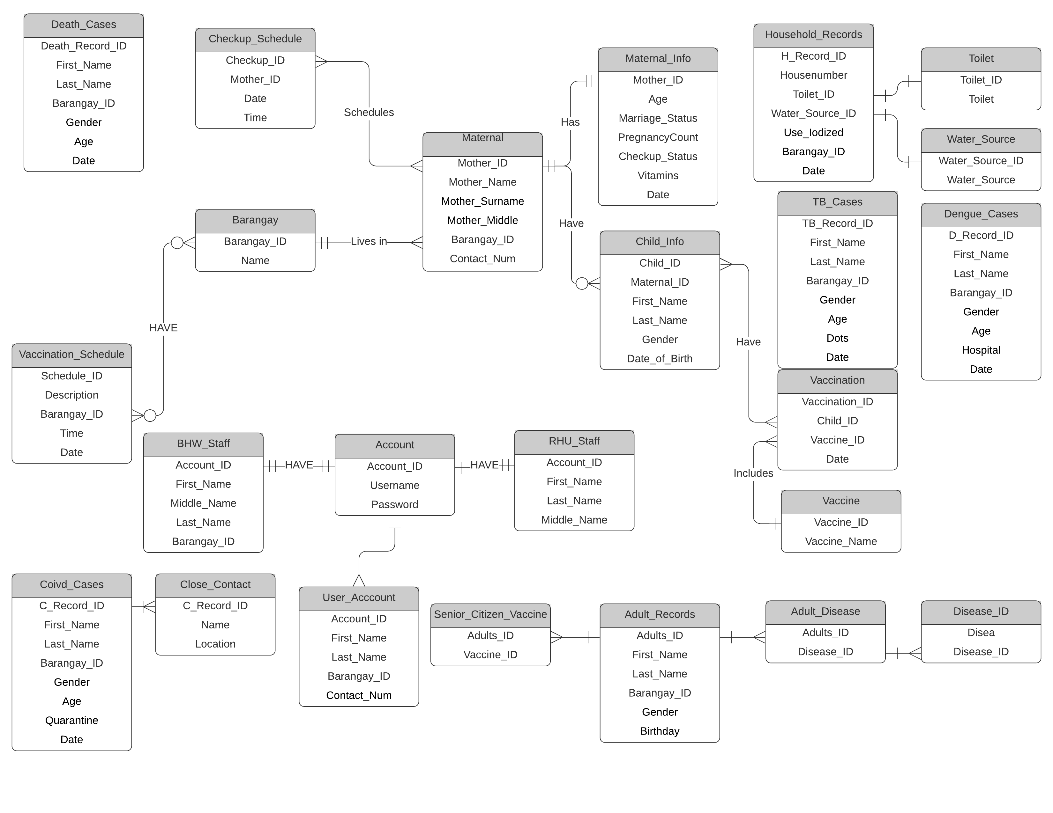

In the image above you can see which table has keys and the relationship of each key table to another table.

Queries :

Querying number of dengue cases in each Barangay.

SELECT COUNT(D_Record_ID) FROM Dengue_Cases GROUP BY Barangay_ID

Querying children that didn’t have any vaccine.

SELECT Child_ID FROM child_info WHERE Child_ID NOT IN(SELECT Child_ID FROM Vaccination)

Getting the age range of Pregnant women

SELECT AGE FROM Maternal_Info