A Real-Time Vision System for Multi-Class Defect Detection in Fused Deposition Modelling Using EfficientNetB0
Ron Nirvin J  Department of Production Technology  Madras Institute of Technology, Anna University  Chennai, India  2023511004 |  | Dharunkumar V  Department of Production Technology  Madras Institute of Technology, Anna University  Chennai, India  2023511007 |  | Lalith Kishore D  Department of Production Technology  Madras Institute of Technology, Anna University  Chennai, India  2023511009
Dr. Pavithra E  Assistant Professor  Department of Production Technology  Madras Institute of Technology, Anna University  Chennai, India |  |  | Dr. Arun Prakash C  Assistant Professor  Department of Production Technology  Madras Institute of Technology, Anna University  Chennai, India

Abstract—Fused Deposition Modelling (FDM) is affordable and widely accessible, but a failed print may continue for a long time before an operator notices it. This wastes filament, machine time, and energy. This paper presents an explainable camera-based monitoring system for eight print conditions: cracking, layer shifting, no defect, off-platform printing, spaghetti failure, stringing, under-extrusion, and warping. The assembled collection contains 4,405 labelled images from compatible public FDM datasets and uses a seeded, stratified image-level split with 3,083 training, 661 validation, and 661 test images. The classifier combines an ImageNet-pretrained EfficientNetB0 backbone with data augmentation, class weighting, transfer learning, and fine-tuning. It achieved 96.52% test accuracy, 96.50% weighted F1, and 96.95% macro F1. The 95% Wilson interval for image-level accuracy was 94.83-97.67%. Grad-CAM provides a visual indication of influential image regions. A local OpenCV dashboard adds continuous monitoring, five-frame probability averaging, uncertainty warnings, defect-specific causes and corrective actions, image upload, and optional OctoPrint telemetry. The retained model has 4.06 million parameters, occupies 41.23 MB, and required a mean of 108.3 ms for single-image CPU inference on the test laptop. The system is therefore practical as low-cost operator decision support. However, correlated images may occur across the image-level subsets, so the reported score must not be treated as proof of cross-printer or cross-session generalisation.
Keywords—additive manufacturing, convolutional neural network, defect classification, EfficientNetB0, FDM, explainable AI, real-time monitoring, transfer learning.
I. INTRODUCTION
Fused Deposition Modelling, also called fused filament fabrication, constructs a component layer by layer by depositing heated thermoplastic through a moving nozzle. The method is common in laboratories, education, prototyping, and small-scale manufacturing because the equipment and material are comparatively inexpensive. That accessibility does not remove process sensitivity. Bed adhesion, extrusion flow, nozzle and bed temperature, cooling, travel motion, belt tension, and mechanical alignment all influence the printed result [1], [2]. A small disturbance can develop into warping, stringing, under-extrusion, layer shifting, cracking, detachment, or a spaghetti-like collapse.
In a normal laboratory, one person may supervise several machines. Direct observation is useful, but it is intermittent and depends on experience. A camera provides a non-contact view without changing the printer mechanism. A convolutional neural network (CNN) can learn visual patterns that are difficult to describe through fixed thresholds, while transfer learning makes this possible with a moderate dataset. Earlier work demonstrated remote stringing detection [3], transfer learning for spaghetti-failure monitoring [4], lightweight object detection for five FFF defects [5], and lightweight CNN classification for FDM defects [6]. These studies establish that vision-based monitoring is feasible, but they also expose recurring problems: limited labelled data, unequal class sizes, restricted computing hardware, changes in camera viewpoint, and models that report a class without helping the operator decide what to inspect.
The purpose of this work is to connect model development with an actual monitoring workflow. A camera frame or uploaded photograph enters the same preprocessing and prediction path. The interface presents the predicted condition, confidence distribution, and a warning when confidence is low. It then shows practical checks associated with the predicted defect. Printer telemetry, when configured, is read separately from OctoPrint; it is never estimated from the image. This separation is important because a visually plausible temperature or axis value would be unsafe if it were invented by the vision model.
This work develops a complete operator-facing system rather than stopping at an offline classifier. Its contributions are:
- An expanded eight-class FDM image-classification dataset and reproducible TensorFlow training pipeline.
- An EfficientNetB0 transfer-learning model evaluated with accuracy, precision, recall, F1-score, a confusion matrix, and Grad-CAM.
- A continuous OpenCV dashboard with temporal prediction averaging and explicit uncertainty handling.
- Defect-specific cause and correction guidance plus optional, clearly separated OctoPrint telemetry.
II. RELATED WORK
Paraskevoudis et al. applied computer vision and artificial intelligence to remote stringing detection and discussed future intervention in printing parameters [3]. Kim et al. compared transfer-learning and fine-tuning strategies for spaghetti-shaped failure using VGG19, InceptionV3, ResNet50, and EfficientNetB0; their best result reached 94% accuracy and was examined using Grad-CAM [4]. Hu et al. developed a lightweight improved YOLOv8 detector for five FFF defects, reporting 97.5% mAP50 with lower computational cost [5]. Their object-detection formulation localizes defects, whereas the present work predicts a global image condition.
Kuriachen et al. proposed lightweight CNNs for real-time multi-class FDM monitoring and highlighted limitations in generalizability [6]. Kozhay et al. also examined CNN-based FDM defect detection [7]. Aktepe and Ergün compared EfficientNetB0 and MobileNetV2 on the original 1,912-image FDM Kaggle dataset, reporting 87.7% and 97% accuracy, respectively [8]. Because that work closely matches the base data source, the contribution claimed here is not the use of transfer learning itself; it is the expanded eight-class dataset, detailed retained-model evaluation, explainability, uncertainty-aware continuous monitoring, and integrated operator feedback.
EfficientNet uses compound scaling to balance network depth, width, and input resolution [9]. This makes EfficientNetB0 a practical transfer-learning backbone for resource-constrained deployment. Grad-CAM uses gradients flowing into the final convolutional layer to produce a class-discriminative localization map without changing or retraining the network [10].
The literature also shows why reported percentages cannot be compared in isolation. Object-detection mAP, binary failure accuracy, and multi-class image accuracy answer different questions. Dataset size, class definitions, train-test separation, and camera conditions further change task difficulty. The present study therefore reports per-class precision, recall, F1, and support for the retained model alongside overall accuracy.
III. MATERIALS AND METHODS
A. Dataset Preparation
The final dataset contains 4,405 images from two compatible public FDM image sources: the FDM 3D Printing Defect Dataset [11] and 3D Printing Errors [12]. The first source contributes cracking, layer shifting, off-platform, stringing, and warping images. The second source provides labelled good, under-extrusion, stringing, and spaghetti images together with process metadata. Folder names, text annotations, and CSV labels were normalised into one folder-per-class structure. The label Good was mapped to No defect. The original labels Under-Extrusion and Off platform were normalised to consistent names. Generic binary labels such as Defected were excluded because mixing them with specific defect labels would make the target categories overlap. No corrupt image was found during inspection.
TABLE I
DATASET DISTRIBUTION AFTER STRATIFIED SPLITTING
Class | Total | Train | Validation | Test
Cracking | 472 | 330 | 71 | 71
Layer shifting | 364 | 255 | 55 | 54
No defect | 900 | 630 | 135 | 135
Off platform | 91 | 64 | 13 | 14
Spaghetti | 240 | 168 | 36 | 36
Stringing | 900 | 630 | 135 | 135
Under-extrusion | 900 | 630 | 135 | 135
Warping | 538 | 376 | 81 | 81
Total | 4,405 | 3,083 | 661 | 661

Images were divided using seeded stratified sampling with random seed 42: 70% for training and 15% each for validation and testing. Stratification preserves the class proportions shown in Table I. The validation set was used for checkpoint selection and learning-rate control. The test set was evaluated only after training. The split does not group frames by recording session; consequently, it measures image-level discrimination and may place visually correlated frames from one print recording in different subsets.
B. Preprocessing and Augmentation
Every image is decoded as three-channel RGB, resized to 224 x 224 pixels, and represented as float32 values. Training-only augmentation applies random horizontal flipping, rotation up to approximately 5% of a full turn, zoom up to 8%, and contrast variation up to 8%. Validation and test images are resized but not randomly augmented. TensorFlow data pipelines use parallel mapping, batching, and prefetching.
The class distribution is strongly imbalanced: off-platform has 91 images, whereas three classes have 900 each. Balanced class weights are therefore computed from the training labels as
w_c = N / (K n_c),
where N is the number of training images, K is the number of classes, and n_c is the number of training samples in class c. The resulting weights range from 0.6117 for the largest classes to 6.0215 for off-platform. This changes the contribution of each training example to the loss; it does not duplicate minority images.
C. Network and Optimization
The classifier uses an ImageNet-pretrained EfficientNetB0 feature extractor [9]. Its original ImageNet classification head is removed. Global average pooling converts the spatial feature maps to a compact vector, after which batch normalisation, dropout (0.25), and an eight-unit softmax layer form the task-specific head. For class c, softmax converts logit z_c into probability
p_c = exp(z_c) / sum_j exp(z_j).
The weighted sparse categorical cross-entropy for a labelled sample is -w_y log(p_y), where y is its true class. Adam optimisation is used in two stages. First, the pretrained backbone is frozen and the new head is trained at an initial learning rate of 0.001. Second, the final 30 backbone layers are made trainable and fine-tuned at 0.00001. A batch size of 32 was used for the retained run. Checkpointing retains the highest validation-accuracy model, early stopping restores the best weights, and reduction on plateau lowers the learning rate when validation loss stops improving.
TABLE II
TRAINING AND MODEL CONFIGURATION
Setting | Retained value
Input resolution | 224 x 224 x 3
Backbone | EfficientNetB0, ImageNet weights
Classification head | GAP, BatchNorm, Dropout, Dense
Output classes | 8
Batch size | 32
Initial / fine-tuning learning rate | 0.001 / 0.00001
Frozen / fine-tuning schedule | 25 / 10 epoch limits
Fine-tuned backbone layers | Final 30
Checkpoint criterion | Highest validation accuracy

D. Evaluation Measures
Accuracy gives the fraction of all correctly classified test images. For each class, precision measures how many images predicted as that class are correct, recall measures how many true images of that class are recovered, and F1 is their harmonic mean:
Precision = TP / (TP + FP), Recall = TP / (TP + FN), F1 = 2PR / (P + R).
Macro averages give every class equal importance, while weighted averages account for test support. This distinction matters for the 14-image off-platform class. A two-sided 95% Wilson interval is also reported for overall accuracy and selected class recalls to show sampling uncertainty rather than presenting point estimates as exact population performance.
E. Explainability and Continuous Monitoring
Grad-CAM is computed from the final spatial feature layer to visualise image regions that influence a selected class [10]. It weights each feature map using the spatially averaged gradient of the selected output, combines the weighted maps, applies a rectified linear unit, and overlays the result on the input image. The heat map is evidence of model attention, not a segmented defect boundary.
For live use, OpenCV reads the local camera and performs inference at a configurable interval. A rolling mean of five probability vectors reduces rapid label changes caused by camera noise or small viewpoint movements. Any top confidence below 60% is marked uncertain and accompanied by a warning against changing printer settings from that frame alone. The upload path uses the same model and preprocessing but does not apply temporal averaging to a single still image.
The dashboard maps a recognised class to a curated description, likely causes, and corrective actions. These recommendations are a fixed engineering knowledge layer rather than unrestricted generated advice. Optional OctoPrint integration reads printer state, nozzle and bed temperatures, completion percentage, and remaining time. Values that the controller does not provide, including some speed or axis fields, remain explicitly unavailable. The software does not automatically move an axis, change a heater, clean a nozzle, or stop a print. Camera capture is released when the final dashboard client disconnects or the server is stopped.

TABLE III
OPERATOR GUIDANCE IMPLEMENTED IN THE DASHBOARD
Predicted class | Visual interpretation | First operator check
Cracking | Split or cracked printed region | Temperature, cooling, and enclosure
Layer shifting | Layers displaced in X or Y | Belts, pulleys, speed, and obstruction
No defect | No trained defect is dominant | Confidence and continued observation
Off platform | Part detached or outside expected bed area | Bed level, Z-offset, and adhesion
Spaghetti | Loose tangled filament after print failure | Stop safely, then inspect adhesion and supports
Stringing | Thin strands between separated regions | Retraction, nozzle temperature, and filament moisture
Under-extrusion | Gaps, sparse lines, or insufficient flow | Nozzle blockage, extruder grip, and flow calibration
Warping | Corners or edges curling upward | Bed temperature, first layer, and cooling

Table III summarises only the first diagnostic direction. The operator must confirm the physical condition before changing a setting, follow the printer and filament limits, and stop or cool the machine safely before touching the hot end.
IV. EXPERIMENTAL RESULTS
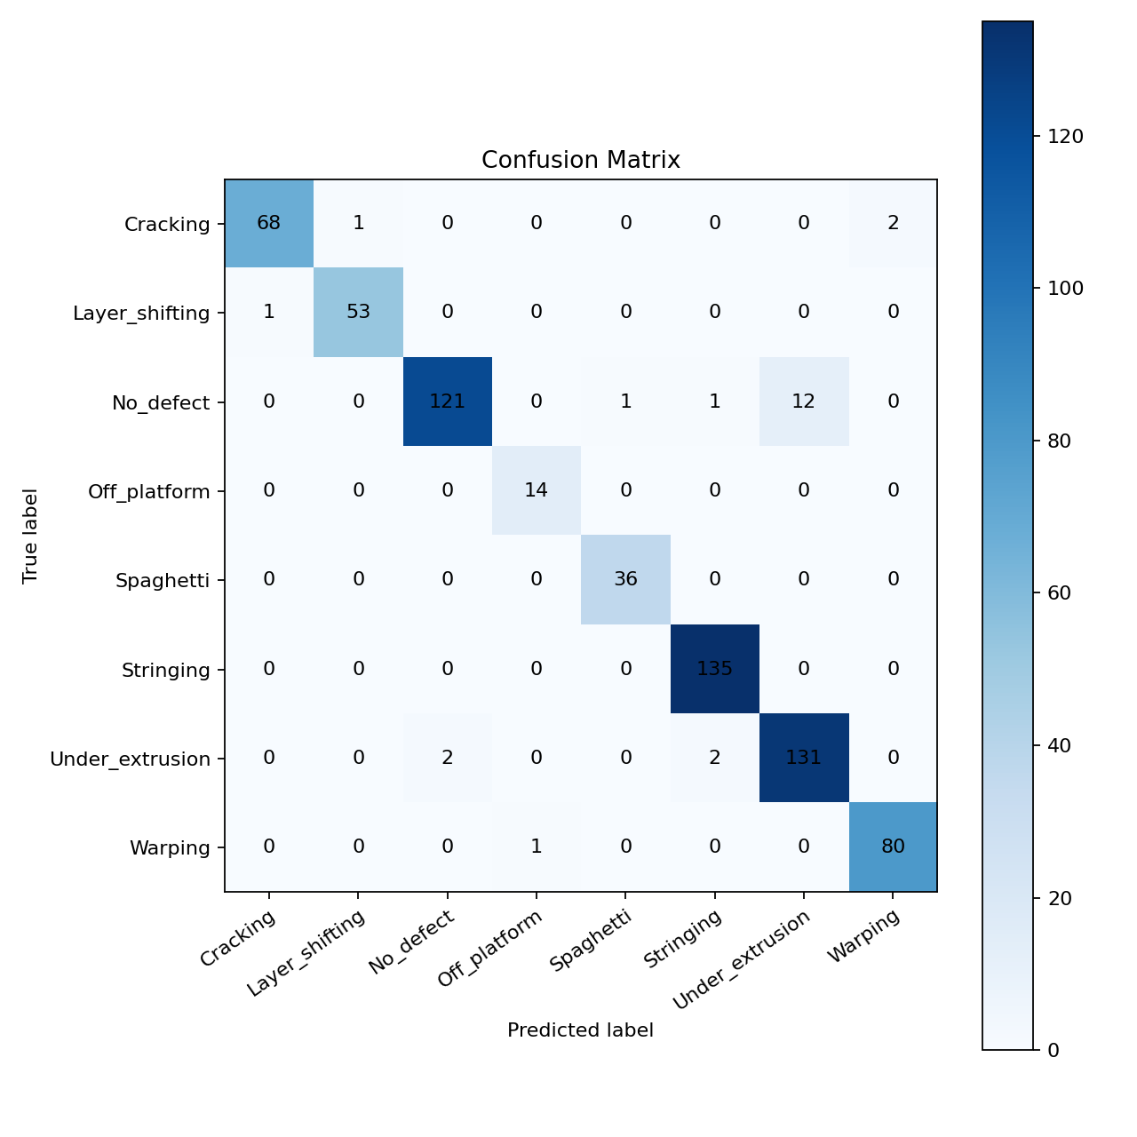
Fig. 1. Confusion matrix for the 661-image held-out test split.
A. Overall Performance
The retained EfficientNetB0 model achieved a test loss of 0.1058 and correctly classified approximately 638 of the 661 held-out images, giving 96.52% accuracy. Macro precision, recall, and F1 were 96.59%, 97.42%, and 96.95%, respectively. Weighted precision, recall, and F1 were 96.62%, 96.52%, and 96.50%. The Wilson 95% interval for image-level accuracy was 94.83-97.67%, which communicates the finite size of the test set more clearly than the point estimate alone.

TABLE IV
PER-CLASS PERFORMANCE ON THE HELD-OUT TEST SPLIT
Class | Precision / Recall / F1 | n
Cracking | 0.9855 / 0.9577 / 0.9714 | 71
Layer shifting | 0.9815 / 0.9815 / 0.9815 | 54
No defect | 0.9837 / 0.8963 / 0.9380 | 135
Off platform | 0.9333 / 1.0000 / 0.9655 | 14
Spaghetti | 0.9730 / 1.0000 / 0.9863 | 36
Stringing | 0.9783 / 1.0000 / 0.9890 | 135
Under-extrusion | 0.9161 / 0.9704 / 0.9424 | 135
Warping | 0.9756 / 0.9877 / 0.9816 | 81

The lowest recall occurred for no-defect images, while the lowest precision occurred for under-extrusion. This pairing is consistent with confusion between subtle flow deficiencies and otherwise acceptable printed regions. Off-platform recall was perfect in the test set, but its support was only 14 images, so this result has high statistical uncertainty.
B. Class-Wise Interpretation
Stringing produced the highest class F1 of 98.90%, followed by spaghetti at 98.63%. Their visual signatures are comparatively strong: thin strands between separated regions for stringing and a large disordered filament mass for spaghetti. Layer shifting and warping also exceeded 98% F1. Cracking reached 97.14% F1, although three of its 71 test images were missed.
The two lowest F1 values were no defect (93.80%) and under-extrusion (94.24%). No-defect recall of 89.63% means 14 of 135 acceptable test images were assigned to a defect class. Under-extrusion recall was 97.04%, but its lower precision of 91.61% indicates that other appearances were sometimes labelled under-extrusion. This is the most important practical error pattern because a false alarm can interrupt a healthy print. It also suggests that future data collection should include more difficult healthy surfaces, early layers, changing illumination, and borderline extrusion cases.
The confusion matrix accounts for all 23 errors. Of the 71 cracking images, one was labelled layer shifting and two were labelled warping. One of 54 layer-shifting images was labelled cracking. The largest error group came from no-defect images: 12 were labelled under-extrusion, one stringing, and one spaghetti. Among under-extrusion images, two were labelled no defect and two stringing. One warping image was labelled off platform. Every off-platform, spaghetti, and stringing test image was correctly recovered. These counts show that most mistakes are concentrated around acceptable versus insufficient-flow appearance, while cross-confusion among dramatic failure modes is limited on this split.
Wilson intervals further show why minority-class scores require care. Off-platform recall was 100%, but with only 14 test images its 95% interval is approximately 78.47-100%. By comparison, stringing also had 100% recall, but its 135-image support gives a narrower interval of approximately 97.23-100%. The point estimates are identical, yet the strength of evidence is not.
C. Deployment Characteristics
The saved model has 4,059,819 parameters and a file size of 41.23 MB. Thirty timed single-image CPU predictions, after five warm-up runs, averaged 108.3 ms; the median was 107.6 ms. This corresponds to approximately 9.2 serial inferences per second on the Ryzen 5 5600H laptop. The small difference between mean and median indicates stable timing during this short benchmark, although operating-system load and image-decoding overhead can change end-to-end latency. The dashboard intentionally predicts less frequently than the camera capture loop to preserve a responsive video stream. These measurements establish feasibility on the project laptop, not a hardware-independent real-time guarantee.
D. Explainability and Interface Behaviour
Project-generated Grad-CAM overlays highlight regions of the printed object that contributed to the selected output instead of concentrating only on empty background. This visual check is useful during demonstration and model debugging, but it does not prove that every prediction is based on a physically meaningful feature. The interface therefore displays Grad-CAM as supporting evidence and keeps the class probabilities visible.
The implemented dashboard was exercised through both continuous camera frames and uploaded still images. Both routes return the same eight-class probability vector. Live predictions use five-frame averaging; uploads produce an immediate unsmoothed result. The interface also separates visual inference from printer data: temperatures and print progress appear only when OctoPrint supplies them. When telemetry is absent, the corresponding fields state that they are unavailable. This behaviour avoids presenting inferred process values as measurements.
V. DISCUSSION
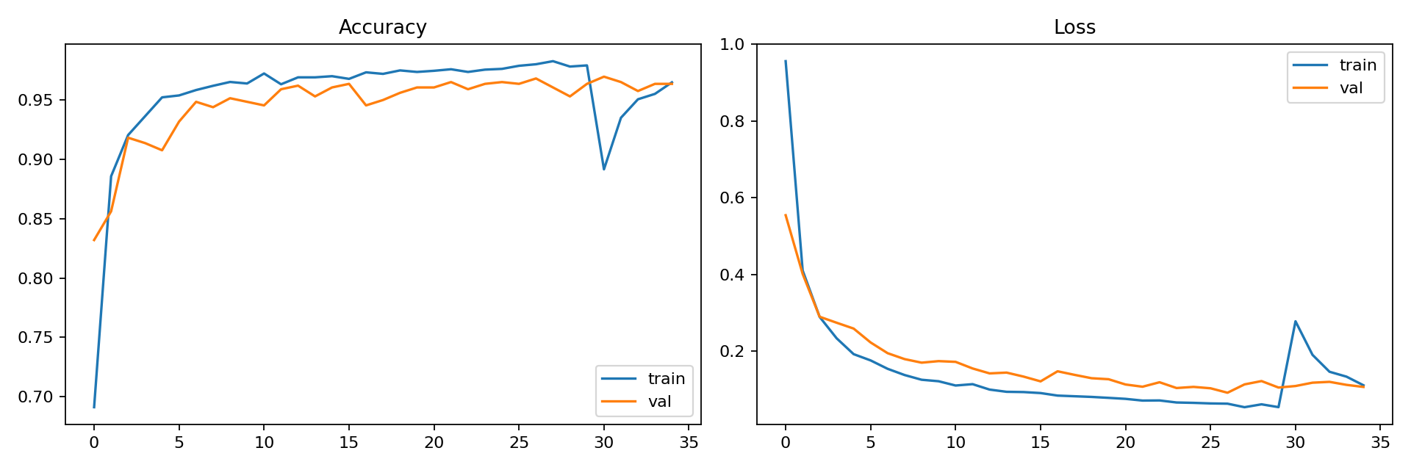
Fig. 2. Training and validation curves for the retained model.
The results show that an EfficientNetB0 transfer-learning model can separate eight visually distinct FDM conditions in the assembled dataset. Transfer learning is valuable here because the dataset is much smaller than general-purpose image corpora, while EfficientNetB0 keeps the deployed model manageable. Class weighting prevents the 91-image off-platform category from contributing only a small fraction of the optimisation objective. The high macro F1 suggests that performance is not carried solely by the three 900-image classes.
The errors are also informative. The most difficult boundary lies between healthy appearance and subtle extrusion deficiency, not between the visually dramatic failure classes. Improving this boundary may require carefully labelled transition frames and process metadata rather than simply training for more epochs. A confidence threshold and temporal averaging improve operator presentation, but neither changes the underlying test accuracy. They should be understood as interface safeguards rather than additional model learning.
The system adds operational context absent from a bare softmax classifier: confidence, uncertainty, root-cause prompts, corrective actions, explainability, image upload, continuous monitoring, and optional printer telemetry. This makes the output more useful during a print while preserving a human decision point. The design intentionally avoids closed-loop intervention. A wrong visual classification should not directly change heater settings or machine motion without independent safety checks.
Comparison with prior work requires care because datasets and metrics differ. The 97.5% mAP50 reported by Hu et al. [5] describes object detection, not image classification. The 94% result reported by Kim et al. [4] concerns spaghetti failure, and Aktepe and Ergün [8] use the original five-class dataset. The present 96.52% accuracy therefore should not be interpreted as direct superiority. Its significance lies in eight-class coverage, transparent class-wise evaluation, and integrated low-cost deployment.
From an application viewpoint, image classification is sufficient when one dominant condition occupies the camera view, but it cannot tell the operator where a local crack begins or identify two defects independently. Object detection or segmentation would be the appropriate extension when location and simultaneous defects become requirements. Likewise, a temporal model could use the development of a print across frames instead of smoothing independent frame predictions after inference.
VI. THREATS TO VALIDITY AND LIMITATIONS
The principal limitation is the stratified image-level split. Images captured close together may share geometry, lighting, printer, and background, allowing session-specific cues to influence the result. A group-aware split by print recording is required for a stronger generalisation claim. The merged sources may also contain different label definitions, and the small off-platform and spaghetti classes produce wider uncertainty than their point estimates suggest. No claim is made that the test images represent every FDM printer, polymer, colour, geometry, or lighting arrangement.
The model performs whole-image classification and does not localise multiple simultaneous defects. Camera views unrelated to FDM printing can still receive a nearest-class score; the low-confidence rule reduces but does not eliminate this open-set problem. Confidence is a softmax score and has not been formally calibrated. Temperature, speed, and axis values cannot be inferred reliably from a single RGB frame, so real telemetry must come from the printer controller. Finally, the current system has not been validated through a long-duration deployment across multiple physical printers, materials, lighting conditions, and camera positions.
The next evaluation should group frames by print recording, reserve at least one printer-camera setup as an external test domain, and report calibration error in addition to F1. Repeated runs with fixed reporting of random seeds would quantify training variance. More minority-class data should be collected before interpreting perfect recall as dependable field performance. These experiments are more valuable than repeatedly fine-tuning on the same image-level split.
VII. CONCLUSION
An explainable eight-class FDM defect-monitoring system was developed using EfficientNetB0 transfer learning. On a 661-image held-out split, the model achieved 96.52% image-level accuracy, 96.50% weighted F1, and 96.95% macro F1. Its mean single-image CPU inference time was 108.3 ms on the project laptop. The practical system combines continuous OpenCV monitoring, photo upload, temporal smoothing, uncertainty warnings, Grad-CAM, defect-specific feedback, and optional OctoPrint telemetry. The result is a usable operator decision-support prototype rather than only a training notebook. The next publication-grade experiment should use recording-grouped splitting and external multi-printer validation. Closed-loop printer control should be considered only after those tests, confidence calibration, and explicit hardware safety validation.
DATA AND CODE AVAILABILITY
Source code, trained model metadata, evaluation reports, and reproducible scripts are available at https://github.com/Ronnirvin2006/fdm-defect-detection. The public training sources are cited in [11] and [12]. Their licenses and redistribution conditions must be checked before republishing merged images.
REPRODUCIBILITY NOTES
The repository separates source data, model artefacts, evaluation outputs, and application code. Dataset inspection records the eight normalised class names, counts, common image sizes, and corrupt-file check. Training uses a fixed random seed of 42 and writes the selected class order beside the Keras model, preventing an interface from silently attaching the wrong label to an output index. The saved metrics record the architecture, input size, batch size, split sizes, test loss, test accuracy, and the class weights used for the retained run.
The reported results can be checked from independent artefacts rather than copied from console text. The classification report contains class-level precision, recall, F1, and support. The confusion matrix preserves the integer error counts discussed in Section IV-B. Training curves show optimisation behaviour, and the Grad-CAM script produces an explanation for a selected image and class. A separate benchmark records the TensorFlow version, parameter count, model size, warm-up count, timed runs, mean latency, median latency, and estimated serial throughput.
For deployment, the same saved model and class-name file are loaded by command-line prediction, photo upload, and continuous camera monitoring. This reduces the risk of evaluating one model while demonstrating another. The dashboard keeps camera inference, feedback rules, and OctoPrint telemetry as separate components. As a result, the visual classifier can be tested without connecting a printer, and telemetry failure does not create invented measurements. Reproduction still depends on obtaining the cited public datasets under their respective conditions; the merged image collection is not claimed as a new independently licensed dataset.
ACKNOWLEDGMENT
The authors thank the Department of Production Technology, Madras Institute of Technology, Anna University, for supporting this project. They also acknowledge the creators of the public FDM image datasets and the maintainers of TensorFlow, Keras, OpenCV, and scikit-learn.
REFERENCES
[1] T. D. Ngo, A. Kashani, G. Imbalzano, K. T. Q. Nguyen, and D. Hui, “Additive manufacturing (3D printing): A review of materials, methods, applications and challenges,” Composites Part B: Engineering, vol. 143, pp. 172–196, 2018, doi: 10.1016/j.compositesb.2018.02.012.
[2] S. Wickramasinghe, T. Do, and P. Tran, “FDM-based 3D printing of polymer and associated composite: A review on mechanical properties, defects and treatments,” Polymers, vol. 12, no. 7, art. 1529, 2020, doi: 10.3390/polym12071529.
[3] K. Paraskevoudis, P. Karayannis, and E. P. Koumoulos, “Real-time 3D printing remote defect detection (stringing) with computer vision and artificial intelligence,” Processes, vol. 8, no. 11, art. 1464, 2020, doi: 10.3390/pr8111464.
[4] H. Kim, H. Lee, and S.-H. Ahn, “Systematic deep transfer learning method based on a small image dataset for spaghetti-shape defect monitoring of fused deposition modeling,” Journal of Manufacturing Systems, vol. 65, pp. 439–451, 2022, doi: 10.1016/j.jmsy.2022.10.009.
[5] W. Hu, C. Chen, S. Su, J. Zhang, and A. Zhu, “Real-time defect detection for FFF 3D printing using lightweight model deployment,” The International Journal of Advanced Manufacturing Technology, vol. 134, pp. 4871–4885, 2024, doi: 10.1007/s00170-024-14452-4.
[6] B. Kuriachen, R. Jeyaraj, D. Raphael, P. Ashok, P. S. S. Sundari, and A. Paul, “Defect detection in fused deposition modelling using lightweight convolutional neural networks,” Engineering Applications of Artificial Intelligence, vol. 141, art. 109802, 2025, doi: 10.1016/j.engappai.2024.109802.
[7] K. Kozhay, S. Turarbek, T. Asselbekova, M. H. Ali, and E. Shehab, “Convolutional neural network-based defect detection technique in FDM technology,” Procedia Computer Science, vol. 231, pp. 119–128, 2024, doi: 10.1016/j.procs.2023.12.183.
[8] E. Aktepe and U. Ergün, “Deep learning application for image-based defect detection in 3D printing processes,” Journal of Materials and Mechatronics: A, vol. 7, no. 1, pp. 109–121, 2026, doi: 10.55546/jmm.1910657.
[9] M. Tan and Q. V. Le, “EfficientNet: Rethinking model scaling for convolutional neural networks,” in Proc. 36th International Conference on Machine Learning, vol. 97, 2019, pp. 6105–6114.
[10] R. R. Selvaraju, M. Cogswell, A. Das, R. Vedantam, D. Parikh, and D. Batra, “Grad-CAM: Visual explanations from deep networks via gradient-based localization,” in Proc. IEEE International Conference on Computer Vision, 2017, pp. 618–626, doi: 10.1109/ICCV.2017.74.
[11] wengmhu, “FDM 3D Printing Defect Dataset,” Kaggle, 2024. [Online]. Available: https://www.kaggle.com/datasets/wengmhu/fdm-3d-printing-defect-dataset. Accessed: Aug. 11, 2026.
[12] nimbus200, “3D Printing Errors,” Kaggle, 2024. [Online]. Available: https://www.kaggle.com/datasets/nimbus200/3d-printing-errors. Accessed: Aug. 11, 2026.

