Mobile Application Development Log
Student Name: DENNIS KIPRUTO
Admission Number: BIT/2025/68242
School : Computing and informatics
Programme: Bachelor of Science Information Technology
Academic year: 2025/2026
Semester: THREE
Lecturer: MR.MICHAEL NYORO

TABLE OF CONTENTS

Week 1: Introduction to Mobile Application Development
Week 2: Mobile Development Environment
Week 3: User Interface Design
Week 4: Event Handling and User Interaction
Week 5: Data Management
Week 6: Networking and APIs

WEEK 1 – Introduction to Mobile Development
Practical activity Undertaken
Tools/Software Used
Task 1: DEVELOPMENT TOOLS
Fig1.1
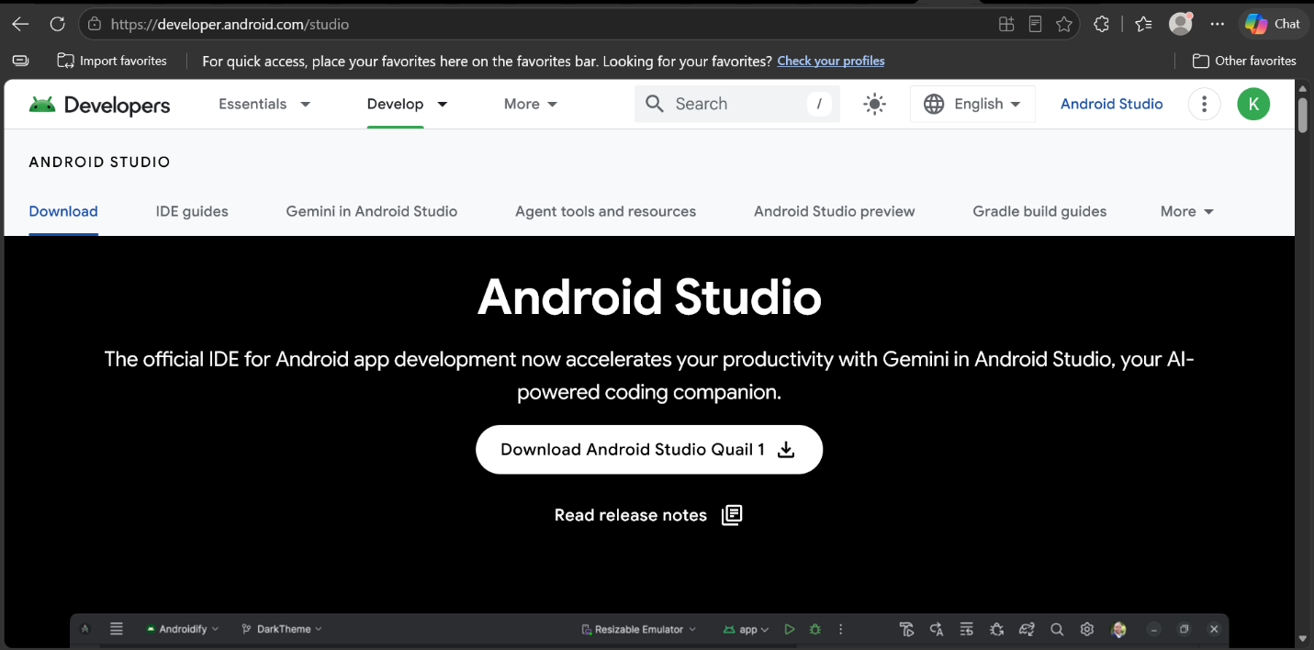

Fig1.2 Emulator working

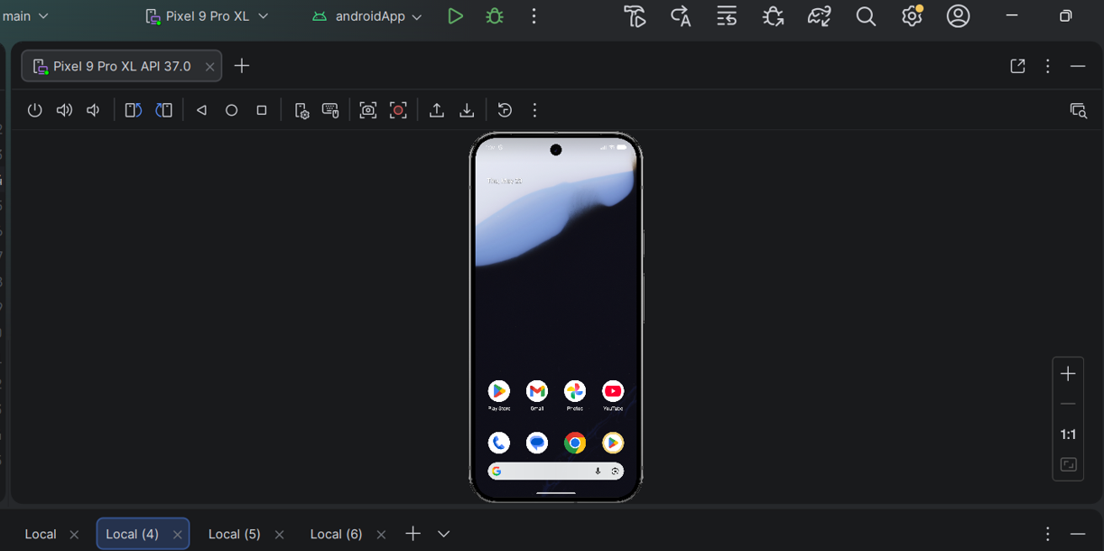
TASK 2. FIRST APP CREATION
App title: My first mobile app
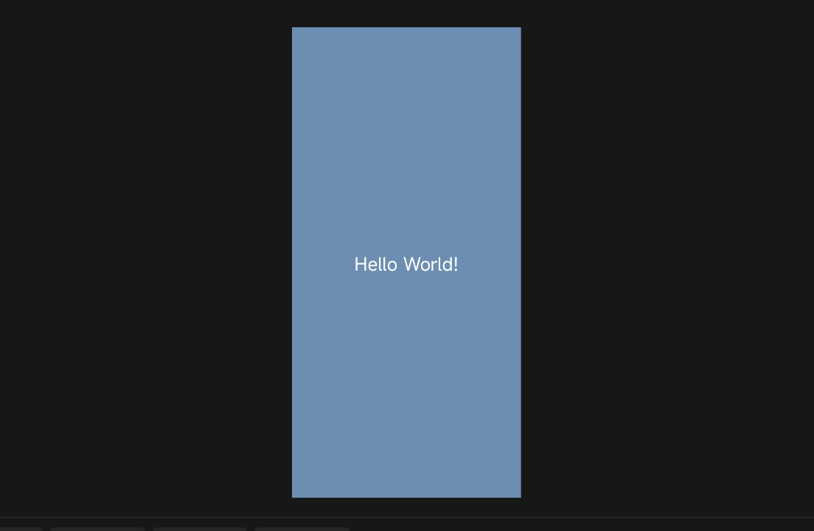
Challenges Faced
- Emulator was slow – fixed by enabling hardware acceleration.
Flutter doctor showed errors – I accepted Android licenses
Solutions Implemented
- Used flutter doctor --android-licenses
- Restarted Android Studio

WEEK 2 – Programming Languages & Frameworks
STUDENT MINI MANAGEMENT

Fig 1.1

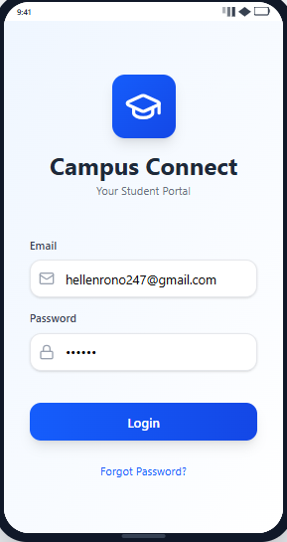
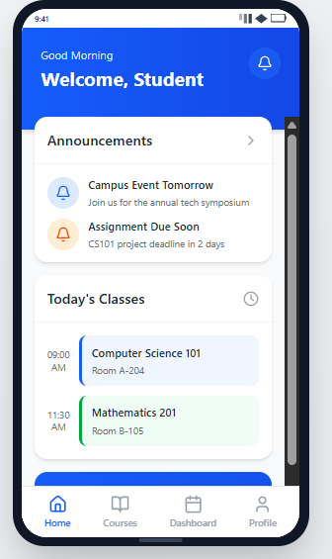

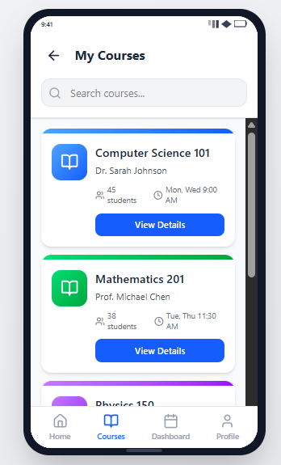
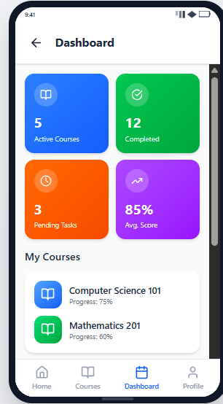

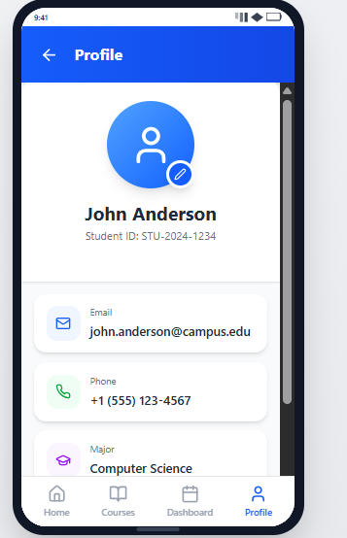

Week 3
FIGMA TASK
Fig 1.1

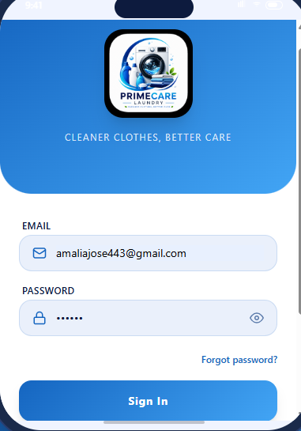
Fig 1.2
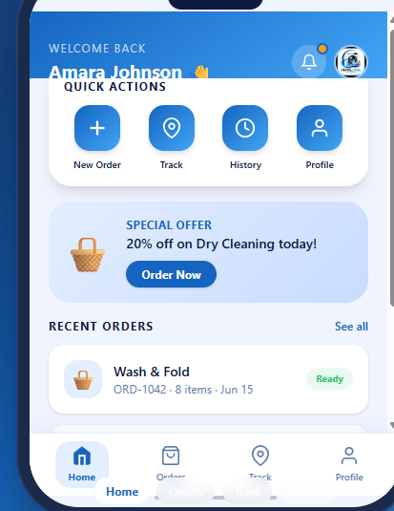

Fig 1.3
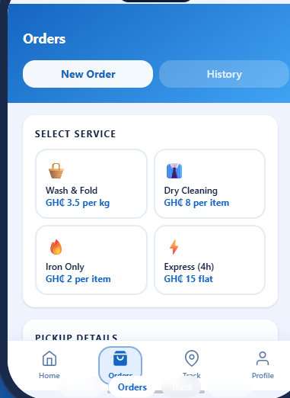

Fig 1.4
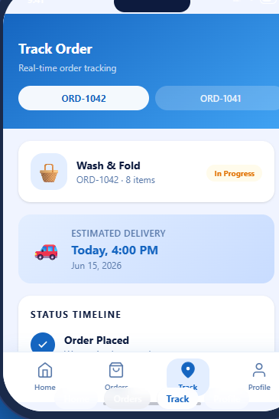

Fig 1.5
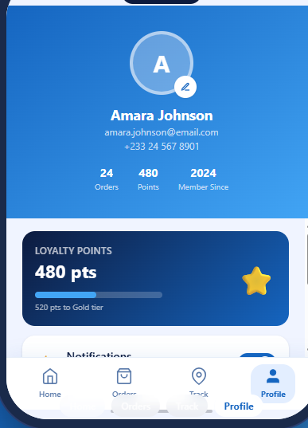

Week 4
DATA MANAGEMENT
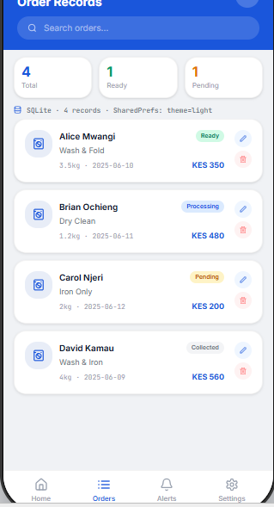

Week 5
NETWORKING
