Mobile Application Development Log
Student Name: DENNIS KIPRUTO
Admission Number: BIT/2025/68242
School : Computing and informatics
Programme: Bachelor of Science Information Technology
Academic year: 2025/2026
Semester: THREE
Lecturer: MR.MICHAEL NYORO

TABLE OF CONTENTS

Week 1: Introduction to Mobile Application Development…………………… page 2
Week 2: Mobile Development Environment ………………………………………. Page 6
Week 3: User Interface Design…………………………………………………………. Page 7
Week 4: User Interaction……………………………………………………….………… page 9
Week 5: Data Management ……………………………………………………………… page11
Week 6: Networking and APIs…………………………………………………………… page12
Week 7: Storage Methods…………………………………………………………………. Page13
Week 8: Event handling……………………………………………………………………. Page 14

WEEK 1 – Introduction to Mobile Development
Practical activity Undertaken
Tools/Software Used
Task 1: DEVELOPMENT TOOLS
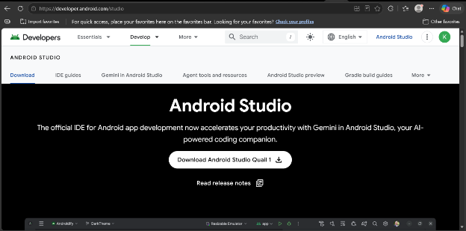

Installation of android studio screenshots
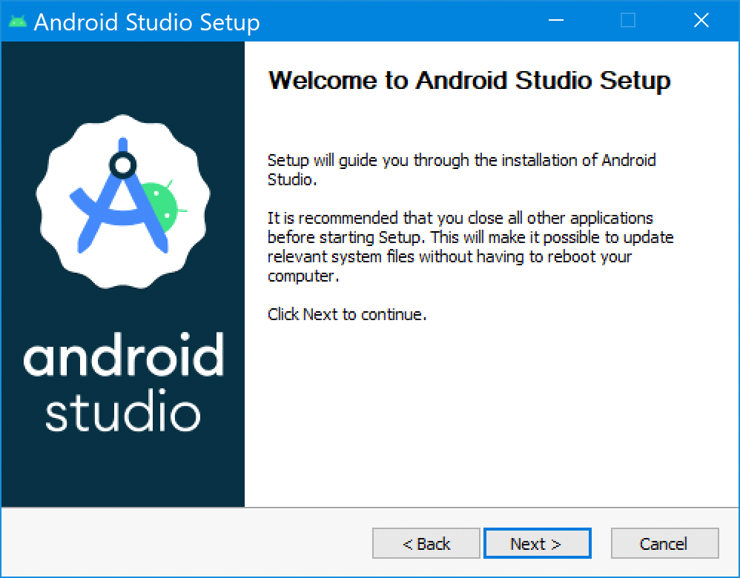

Sdk downloading screenshot
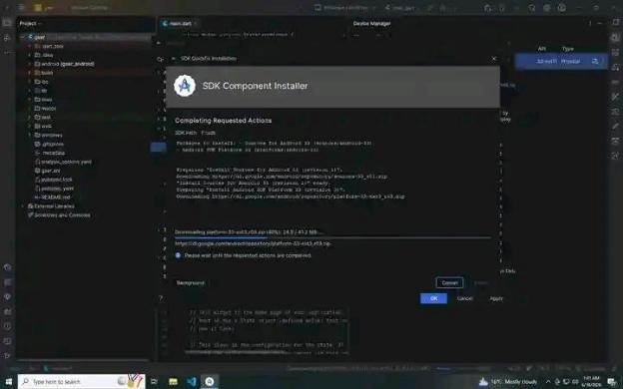

Emulator working screenshoot

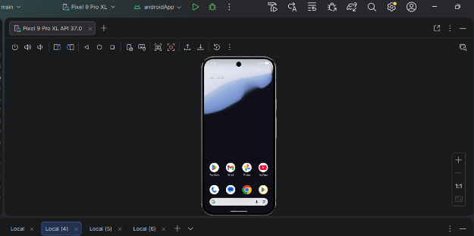

FIRST APP CREATION
App title: My first fluuter mobile app
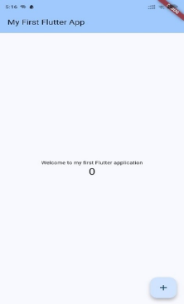

First app hello world screenshot

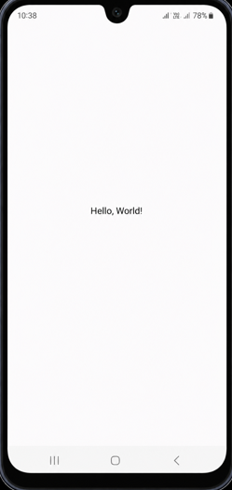

WEEK 2 – Programming Languages & Frameworks

STUDENT MINI MANAGEMENT SCREENSHOTS
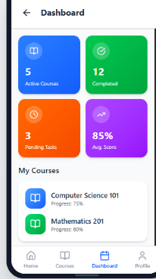
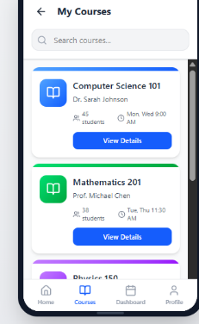
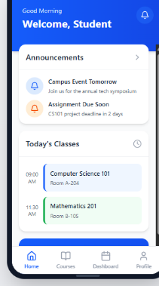

WEEK 3 : My app User Interface Design
FIGMA TASK
login and dashboard screens figma screenshots

Week 3: User Interface Design
Use interactions designs screenshots

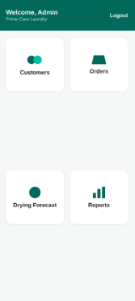
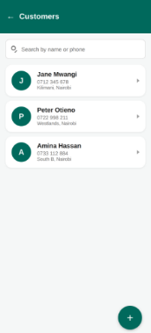
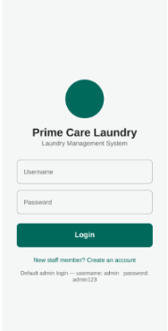

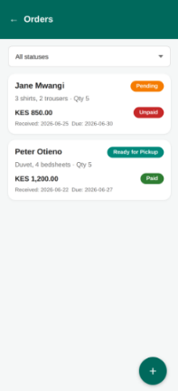
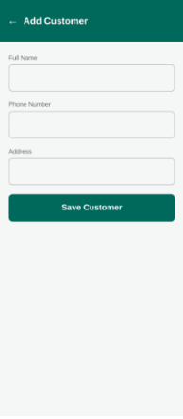

Week 4 : User Interaction
Edit order screenshot
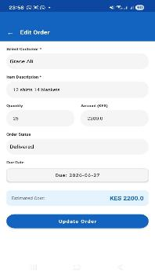

New order screenshot user interaction
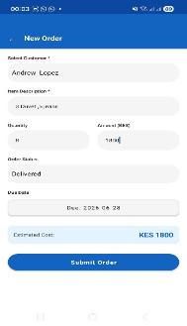

Add new customer user interaction screenshot

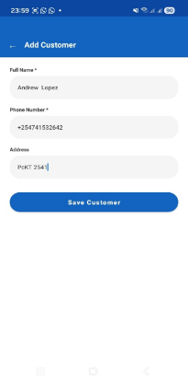

Week 5 DATA MANAGEMENT
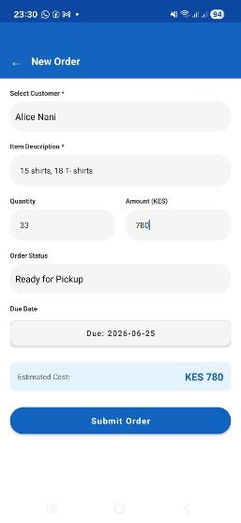
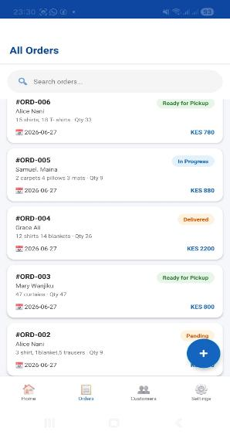

Week 6
NETWORKING AND APIs
Apis connecrion screenshots

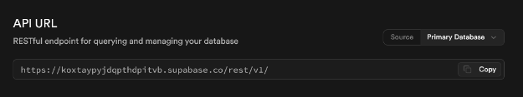
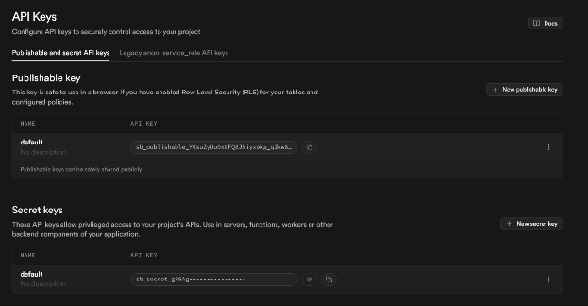

Week 7 STORAGE METHOD
App storage method screenshots
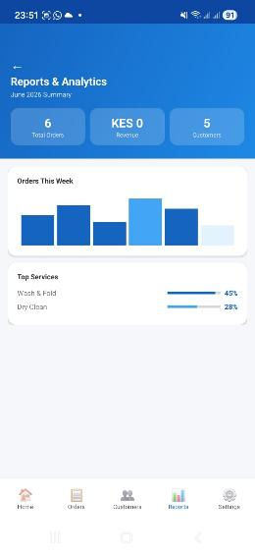
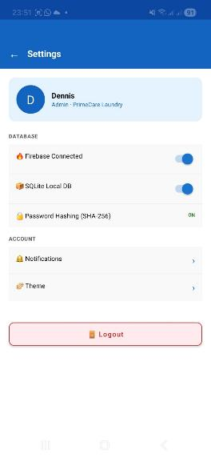

Week 8 Event Handling
Order editing form showing input fields event handling screenshot

Edit order screenshot event handling
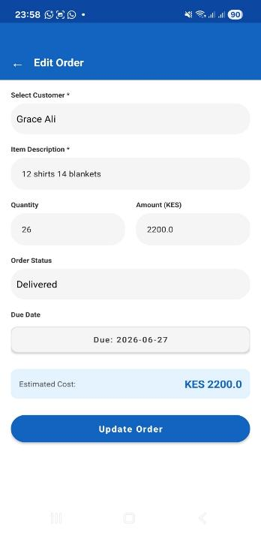

Add customer screenshot event handling
