# Conclusion

The higher the number of iterations for the Tau estimation and the K+ decay simulation, the more accurate the results become.

Also, we expected that the difference between the simulation with and without the spread at the collimator should be quite noticeable. The success rate gets smaller when spreading is enabled and the whole graph gets “shifted” to the right, increasing the optimal distance between the two sensors.

With the multithreaded enabled python script “K2pi.py”, we could simulate the decay for large n quite easily. This is the result for $n = 100’000$ with a spread of $σ_{X}=σ_{y}=1mrad$:

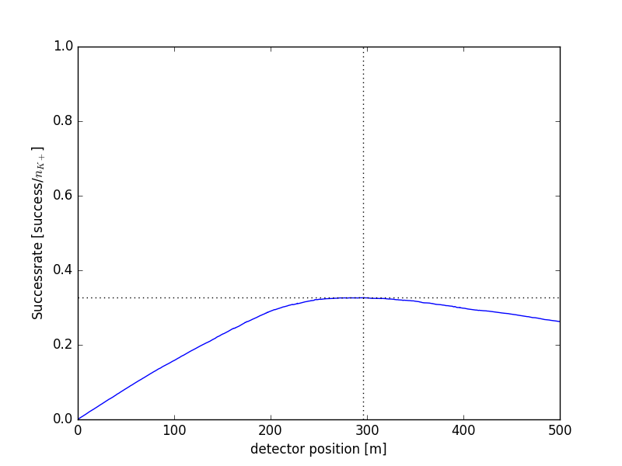

Where the optimal distance is at 295.8m with a maximum efficiency of 32.6%. As we can see the curve is very flat at its peak and therefor the distance between the two sensors doesn’t have to be very precise. Looking at the graph somewhere at $300m±50m$ should be fine and yields only very small differences in the efficiency of the experiment.

With spread = 0 and $n = 100’000$ we get the following result: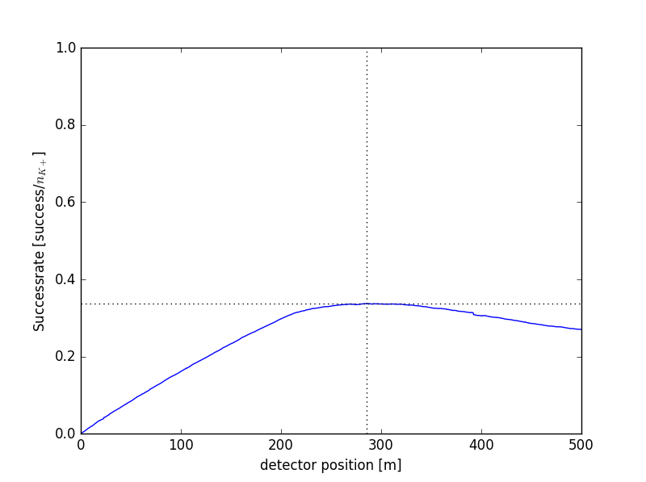

The optimal efficiency is achieved if we place the two sensors at a distance of **285.3m**, where the efficiency lays at **33.7%.** Again, we observe that the curve is very flat at its peak.

These results also confirm our expectations, that with no spread we get a higher maximum efficiency and a shorter optimal distance between the two sensors.