Title:
Forecasting Temperature by Single Exponential Smoothing Model through Python

Group Members:
Chan Ronny Ryan (3036217087)
Poon Brian (3036058493)

Table of Contents

Abstract 3
Motivation 4
Model 5
Data 6
Methodology 7
Analysis 10
Discussion 11
Conclusion 12

Abstract
This project explores the application of the single exponential smoothing (SES) model to forecast average daily temperature, implemented using Python. SES is a simple time series forecasting technique that assigns exponentially weighted importance to past observations, controlled by the smoothing coefficient α. Our program allows users to input historical average temperature data (in days) and select the smoothing coefficient α. The output includes a plot showing both the historical temperature trend and the smoothed trend, along with the forecasted temperature for the next day. This method provides a lightweight approach to demonstrate time series forecasting and data visualization through Python coding.

Motivation

In our real life, there are many factors that we want to estimate their value in the future. We wish to have some simple yet reliable methods to make a reasonable guess of these unknown values. There are several existing methodologies, such as linear regression and time series analysis. To provide a lightweight method for short-term predictions without requiring complex models, we adopted the exponential smoothing method to forecast the future weather in the next 10 days. The program is written in Python, using user-provided temperature data and a customizable smoothing coefficient (α) to generate predictions.

Model
This interactive program aims to forecast the average temperature for the next day through the use of a single exponential smoothing model.

The equation of the model is given by:

(source 1)
where
$ŷ_{T+1|T}$ is the forecast value for time $T+1$,
$y_{T}$ is the actual value of the time series at time $T$,
$ŷ_{T}$ is the forecast value for time $T$,
$α$ is the smoothing coefficient ($0≤α≤1$).

Assumptions of the model:
- There should be no long-term trend.
- No seasonal patterns should be shown in the data
- The mean and variance should be stationary

The user can choose the weighting factor $α$, which controls the weighting on the current observation. The term (1-$α$) is the damping factor, representing the weighting given to the previous forecasted value.

Data
Input:
- Smoothing coefficient (between 0 and 1).
- The temperatures (Unit: °C) of the last X days (decided by the user)
- Lower bound: -50°C
- Upper bound: 60°C

Output
- List of smoothed temperature values
- Forecast for the temperature in the next day
- Data visualization

Methodology
- Algorithm Steps:
  - Initialize with the first observed value.
  - Iteratively compute smoothed values using the SES equation.
  - Generate the forecast for the next period.

- Code Implementation:
Code
import matplotlib.pyplot as plt

def plot_smoothing(temps, smoothed_values, forecast):
days = list(range(1, len(temps) + 1))
plt.figure(figsize=(8, 5))
plt.plot(days, temps, 'o-', label='Original Temperatures')
plt.plot(days, smoothed_values, 's-', label='Smoothed Values (SES)')
plt.plot(len(temps) + 1, forecast, 'r*', markersize=12, label='Forecast (Next Day)')
plt.xlabel('Day')
plt.ylabel('Temperature')
plt.title('Single Exponential Smoothing and Forecast')
plt.legend()
plt.grid(True)
plt.tight_layout()
plt.show()

def read_alpha():
while True:
try:
a = float(input("Please input the smoothing coefficient (0 ≤ a ≤ 1): "))
if 0 <= a <= 1:
return a
else:
print("Invalid input! The number must be between 0 and 1.")
except ValueError:
print("Invalid input! Please enter a numeric value.")

def read_temperatures():
MIN_TEMP = -50 # lower bound
MAX_TEMP = 60 # upper bound

while True:
temps = input(f"Please enter the average temperatures of past days (between {MIN_TEMP} and {MAX_TEMP} °C), separated by spaces: ").split()
if len(temps) < 1:
print("You must enter at least one temperature. Please try again.")
continue
try:
temps_list = [float(t) for t in temps]
# Check range
if all(MIN_TEMP <= t <= MAX_TEMP for t in temps_list):
return temps_list
else:
print(f"Error: All temperatures must be between {MIN_TEMP} and {MAX_TEMP} °C. Please try again.")
except ValueError:
print("Please enter valid numbers for temperatures.")

def exponential_smoothing(temps, alpha):
smoothed_values = [temps[0]]
for t in range(1, len(temps)):
s = alpha * temps[t] + (1 - alpha) * smoothed_values[t-1]
smoothed_values.append(s)
forecast = smoothed_values[-1]
return smoothed_values, forecast

def main():
alpha = read_alpha()
temps_list = read_temperatures()
smoothed_values, forecast = exponential_smoothing(temps_list, alpha)

print("Smoothed values:", [f"{v:.2f}" for v in smoothed_values])
print(f"Forecast for next day: {forecast:.2f}")

print("Displaying plot...")
plot_smoothing(temps_list, smoothed_values, forecast)

if __name__ == "__main__":
main()

- User Interaction:
Explain how the program collects inputs (temperatures, α) and validates them.

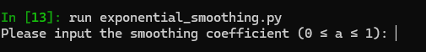

- Data Visualization:

Describe how plot_smoothing() generates comparative plots (original vs. smoothed data + forecast).
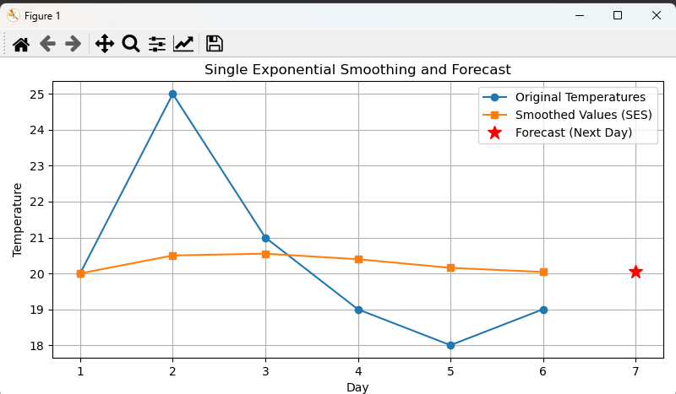

e

Analysis
The implemented program allows users to input their own historical temperature data and select the smoothing coefficient α, providing flexibility in exploring how SES responds to different datasets and parameter choices.
The resulting graph effectively visualizes three key elements: the original temperature values, the smoothed values generated by the SES model, and the forecasted temperature for the next day.
From the graph, it is evident how the smoothed values serve to reduce short-term fluctuations in the original data, producing a smoother curve that highlights the underlying temperature trend. The degree of smoothing is directly influenced by the user's choice of α:
- A lower α results in a smoother curve that less aggressively reacts to recent changes, making the smoothed line lag behind sharp fluctuations but providing a more stable trend estimate.
- A higher α tracks the original data more closely, capturing sudden changes but also reflecting noise or irregularities in the input.
The forecast value, marked distinctly on the graph, represents the predicted temperature for the day following the last input value. This forecast equals the last smoothed value, consistent with the SES model’s assumption that future values will remain stable at the current level.
This interactive setup allows users to experiment with different values of α and observe how the smoothing and forecast change, providing intuitive insight into the trade-off between sensitivity and stability in SES.
However, as observed in some visualizations, the forecast may not adapt well when the original data exhibits strong trends or abrupt shifts, due to SES’s inherent limitation in capturing such patterns. Consequently, while the model provides a useful short-term forecast and smoothing tool, its effectiveness depends on the nature of the input data and the careful choice of the smoothing parameter.

Discussion
While SES is simple and computationally efficient, it has several practical limitations. The model does not incorporate trend or seasonality components, thus it is not well-suited for datasets exhibiting these characteristics, such as long-term climate data or seasonal temperature fluctuations.
Another important consideration is the smoothing coefficient α, which controls the model’s responsiveness to recent observations. A smaller α results in a smoother forecast that responds slowly to changes, whereas a larger α allows the forecast to react quickly but can introduce volatility and noise. Choosing α manually without optimization can lead to suboptimal forecasting results, either over-smoothing or over-reacting to noise.
Additionally, the current implementation assumes complete and continuous data, lacking mechanisms to handle missing or irregular entries. This can affect the accuracy of smoothing and forecasting in real-world datasets.
Finally, SES inherently provides only a one-step-ahead forecast. For multi-step forecasting, it produces constant forecasts equal to the last smoothed value, limiting its practical utility for medium- or long-term planning.

Conclusion
Single Exponential Smoothing offers a straightforward and effective approach for short-term forecasting of stable time series without pronounced trends or seasonality. Its simplicity makes it an accessible entry point for time series analysis and forecasting. However, its limitations in handling trends, seasonality, missing data, and multi-step forecasting restrict its use in more complex or longer-term scenarios.
To enhance forecasting accuracy and practical relevance, especially for temperature data with potential trends or seasonal patterns, more advanced techniques such as Holt-Winters or ARIMA models should be considered. Incorporating automatic parameter tuning and data preprocessing would further improve model robustness and usability.

Reference

Source 1: https://otexts.com/fpp2/ses.html

