**College Enquiry Chatbot**

Under subject of

Design Engineering

(Computer Engineering)

Submitted by:

Sr. Name Id No:

1. Gaurav Usadadiya 16CP023
2. Rohan Borkhatariya 16CP026

Guided by:

**Prof. Mahasweta &**

**Prof. Tanawala**



**BVM ENGINEERING COLLEGE**

**INDEX**

**Sr.No Topic page No.**

1. **Abstract……………………………………… 2**
2. **Introduction……………………………………… 3**
3. **Diagram…………………………………………… 6**
4. **Components……………………………………….. 8**
5. **Work Flow ……...………………………………... 11**
6. **Advanteges …………………..…………………… 12**
7. **Disadvantages …………………………………….. 13**
8. **Conclusion ………………………………………… 14**
9. **Refernces………………………………………….. 15**

**ABSTRACT**

* Chatbots, or conversational interfaces as they are also known, present a new way for individuals to interact with computer systems. Traditionally, to get a question answered by a software program involved using a search engine, or filling out a form. A chatbot allows a user to simply ask questions in the same manner that they would address a human. The most well known chatbots currently are voice chatbots: Alexa and Siri. However, chatbots are currently being adopted at a high rate on computer chat platforms.
* The technology at the core of the rise of the chatbot is Artificial Inteligent Markup Language.Recent advances in machine learning have greatly improved the accuracy and effectiveness of natural language processing, making chatbots a viable option for many organizations. This improvement in NLP is firing a great deal of additional research which should lead to continued improvement in the effectiveness of chatbots in the years to come.
* A simple chatbot can be created by loading an FAQ (frequently asked questions) into chatbot software. The functionality of the chatbot can be improved by integrating it into the organization’s enterprise software, allowing more personal questions to be answered, like“What is my balance?”, or “What is the status of my order?”.
* Most commercial chatbots are dependent on platforms created by the technology giants for their natural language processing. These include Amazon Lex, Microsoft Cognitive Services, Google Cloud Natural Language API, Facebook DeepText, and IBM Watson. Platforms where chatbots are deployed include Facebook Messenger, Skype, and Slack, among many others.

**INTRODUCTION**

* A chat bot (also known as a talk bot, Bot, chatterbox, Artificial Conversational Entity) is a computer program which conducts a conversation via auditory or textual methods. Such programs are often designed to convincingly simulate how a human would behave as a conversational partner, thereby the Turing test.
* Chat bots are typically used in dialog systems for various practical purposes including customer service or information

acquisition.

* Chat bots are often integrated into the dialog systems of, for example, automated online assistants, giving them the ability of, for example, small talking or engaging in casual conversations unrelated to the scopes of their primary expert

systems.

* College Enquiry Chat Bot project will be built using artificial

intelligence algorithms that will analyze user‟s queries and

understand user‟s message. This system will be a web

application which will provide answers to the queries of the

students. Students will just have to select the category for the

department queries and then ask the query to the bot that will

be used for chatting.

* Artificial intelligence will be used to answer the students‟

queries. The student will get the appropriate answers to their

queries. The answers will be give using the built in artificial

intelligence algorithms. Students won‟t have to go to the

college to make the enquiry.

* The system replies using an effective Graphical user interface

which implies that as if a real person is talking to the user. The

user just has to register himself to the system and has to login

to the system. After login user can access to the various

helping pages. Various helping pages has the bot through

which the user can chat by asking queries related to college

activities. The system replies to the user with the help of

effective graphical user interface. The user can query about the college related activities through online with the help of this web application. The user can query college related activities such as date and timing of annual day, sports day, and other cultural activities. This system helps the student to be updated about the college activities.

* The proposed system will also have an online notice board. On

this notice board, any Text notices or PDF documents can be

displayed. This will help the user to be updated with the

important notices. Not much time will be wasted by the user to search for the important notices.

* The answer to the query will be answered on the basis of the

user‟s queries and the knowledge base. The important

keywords will be fetched from the keywords and the answer to

those keywords will be searched in the knowledge base. If the

match is found, the relevant answer will be provided to the

user or the default message will be shown to the user that

“Answer to this query is not available at the moment, please

revert back after some time”. The “Keyword Matching”

algorithm will be used to match the keywords from the

knowledge base

* In some cases, user may find out that the answer given to

his/her query is not relevant. In such cases, the user can mark

this answer as Invalid, and an instance of this invalid answer

will be sent to the Admin panel at the same time. Whenever

Admin will log in, he will get to see the answers which are

marked invalid and then he can do the necessary changes to

the knowledge base so that user will get the proper result when he will ask the same query next time.

**DIAGRAM**

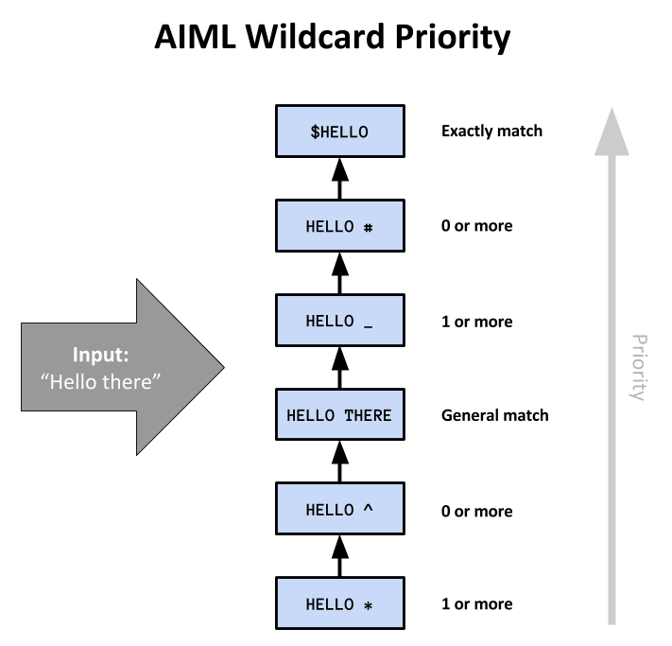

**AIML Process Diagram**

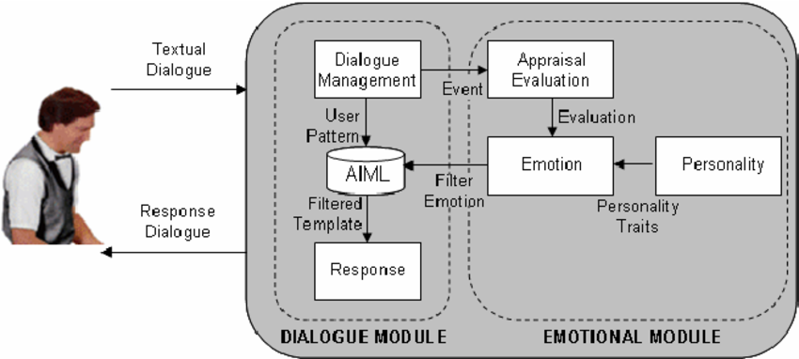

**COMPONENTS**

1. **AIML** :-

According the author [8] the aim of AIML language is

to simplify the modelling process of dialogue. AIML

benefits are access to stimulus-response. In addition,

AIML is an XML-based markup language. AIML defines

a class object that is responsible for modelling the

patterns of conversation. AIML is the most-used chat-bot

language due to its simplicity, ease of learning, ease of

implementation and the availability of pre-authored

AIML sets. It is a simple word pattern-matcher.

* According the author the aim of AIML language is to simplify the modelling process of dialogue. AIML benefits are access to stimulus-response. In addition, AIML is an XML-based markup language. AIML defines a class object that is responsible for modelling the patterns of conversation. AIML is the most-used chat-bot language due to its simplicity, ease of learning, ease of implementation and the availability of pre-authored AIML sets. It is a simple word pattern-matcher.
* The AIML robot responds according connection between the questions set by the user and knowledge located in AIML files. Reasonable interaction of the users and computers is determined by means of construction of knowledge.
* AIML has its advantages and disadvantages. Some of the advantages are: Easy to learn and implement, simplicity and user-friendliness of the system of dialogue, the use of XML for the formal, computer readable representation of knowledge.
* <category>

<pattern>HELLO</pattern>

<template>

Well, hello!

</template>

</category>

1. **Flask** :-

* Flask is considered more Pythonic than the Django web framework because in common situations the equivalent Flask web application is more explicit. Flask is also easy to get started with as a beginner because there is little boilerplate code for getting a simple app up and running.

from flask import Flask

app = Flask(__name__)

@app.route('/')

def hello_world():

return 'Hello, World!'

if __name__ == '__main__':

app.run()

* The above code shows "Hello, World!" on localhost port 5000 in a web browser when run with the python app.py command and the Flask library installed.
* The equivalent "Hello, World!" web application using the [Django](https://www.fullstackpython.com/django.html) [web framework](https://www.fullstackpython.com/web-frameworks.html) would involve significantly more boilerplate code.
* The Pallets Project now serves as the community-driven organization that handles Flask and other related Python libraries such as [Jinja](https://www.fullstackpython.com/jinja2.html) and several others.

**WORK FLOW**

The basic algorithm that will be implemented for working of

this proposed system is as follows:

Step 1: Start.

Step 2: Get the user message. (INPUT)

Step 3: Pre-processing of the query E.g. suppose there is this

message “Give me a sem-3 Computer Science courses.

So, we are going to remove these stop words like "is",

, "the" using pre-processing technique.

Step 4: Fetch the remaining only keywords from the query.

Step 5: Match the fetched keywords with the keywords in

Knowledge base, and provide an appropriate response. The keywords will be matched with the help of keyword matching algorithm.

Step 6: Return the query response as an output to the user.

Step 7: Exit.

**ADVANTAGES**

* Reduced Costs – chatbots eliminate the requirement of any manpower during online interaction and are hence seen as a big advantage by companies receiving multiple queries at once. This also presents companies with the opportunity to save on costs while aligning chatbots with their goals and hence presenting customers with a particular type of interaction leading to conversion.
* 24-7 availability – Unlike humans, chatbots once installed can attend queries at any time of the day. Thus, the customer doesn’t have to wait for the company executive to help them. This also lets companies keep an eye on the traffic during the non-working hours and reach out to them later. On the other hand, while hiring people, there would be no access to these potential customers and could lead to loss of business.
* Learning and Updating – AI-based chatbots are capable of learning from interactions and updating themselves on their own. This is a big benefit when it comes to investing time in educating the executives about the same. Due to machine learning and algorithms capable of updating themselves, the need for same is eliminated while using a Chatbot.
* Multiple Customer Handling – Humans have a limit to the number of clients they can handle at once. However, with chatbots, there is no such constraint and they can handle as many queries as required at once. This is a major benefit of using chatbots as no customer stays unattended and everyone’s problem is being resolved.

**DISADVANTAGES**

* Complex Interface – Chatbots are often seen to be complicated and require a lot of time to understand user’s requirement. It is also the poor processing which is not able to filter results in time that can annoy people.
* Inability to Understand – Due to fixed programs, chatbots can be stuck if an unsaved query is presented in front of them. This can lead to customer dissatisfaction and result in loss. It is also the multiple messaging that can be taxing for users and deteriorate the overall experience on the website.
* Time-Consuming – Chatbots are installed with the motive to speed-up the response and improve customer interaction. However, due to limited data-availability and time required for self-updating, this process appears more time-taking and expensive. Therefore, in place of attending several customers at a time, chatbots appear confused about how to communicate with people.
* Increased Installation Cost – Chatbots are useful programs that help you save a lot of manpower by ensuring the all-time availability and serving to several clients at once. But unlike humans, every chatbot needs to be programmed differently for a new business which increases the initial installation cost. This also increases the time needed to prepare for the program and plan everything effectively. Considering the last-minute changes that can always happen, this is a risky investment as updating the program will invite added costs to it.

**CONCLUSION**

* The main objective of the project is to develop an algorithm that will be used to identify answers related to user submitted questions. The need is to develop a database where all the related data will be stored and to develop a web interface. The web interface developed will have two parts, one for simple users and one for the administrator.
* A background research took place, which included an

overview of the conversation procedure and any relevant chat bots available. A database will be developed, which will store information about questions, answers, keywords, logs and feedback messages. A usable system will be designed, developed and deployed to the web server.

**REFERENCE**

1. Flask : - <http://flask.pocoo.org/docs/1.0/>
2. AIML :- <https://www.tutorialspoint.com/aiml/>
3. SIMPLE_CHAT :- <https://www.devdungeon.com/content/ai-chat-bot-python-aiml>