A

Project Report

On

**SMART DOORBELL USING IOT**

Under subject of

Design Engineering

(Computer Engineering)

Submitted by:

Sr. Name Id No:

1. Jayrajsinh Chudasama 16CP039
2. Mayur Dhameliya 16CP027

Guided by:

**Prof. Hemant Vasava**



**BVM ENGINEERING COLLEGE**

(An Autonomous Institution)

Vallabh vidyanagar-38120

Gujarat INDIA

**INDEX**

**Sr.No Topic page No.**

1. **Abstract……………………………………… 3**
2. **Introduction……………………………………… 4**
3. **Diagram…………………………………………… 6**
4. **Components……………………………………….. 7**
5. **Working Principle………………………………... 13**
6. **Advanteges & DisAdvantages…………………… 14**
7. **Refernces………………………………………….. 15**

**ABSTRACT**

* Internet of things is the communication of anything with any other things.
* This paper aims to monitor and control the home lock using the internet of things.
* The internet of things is used remotely to view the activity and get notification when there is a presence of nearby object without any physical contact and whenever a door bell is pressed and raspberry pi camera module get triggered and capture the photos.
* The photos are sent to an email through Wi-Fi, and through the webserver he can control the door lock /unlock.
* The Arduino UNO stores the data of authorized person. If the PIR sensor senses the person who is authorized then it automatically unlock the door.
* Therefore advantage like these make this application ideal for monitoring homes in absence.
* Keywords—Smart bell, IOT, Arduino UNO, PIR sensor, camera module.

**INTRODUCTION**

* The Internet of Things (IOT) is an important topic in technology industry, policy, and engineering circles and has become headline news in both the specialty press and the popular media.
* This technology is embodied in a wide spectrum of networked products ,systems, and sensors, which take advantage of advancements in computing power, electronics miniaturization, and network interconnections to offer new capabilities not

previously possible.

* An abundance of conferences, reports, and news articles discuss and debate the prospective impact of the “IOT revolution”—from new market opportunities and business models to concerns about security, privacy, and technical interoperability.
* The project idea is to design an automated device for locking and unlocking of the door as nowadays an automated device can replace good amount of human working force, moreover humans are more prone to errors and in intensive conditions the probability of error increases whereas, an automated device can work with diligence, versatility and with almost zero error.
* The system is designed such that the motion of the user will be captured from the camera and the user will be detected and then only he will lock or unlock the door.
* The system will be designed for security purposes. It will work as when bell rings at the door, and also when the motion of human is detected in range by PIR sensor it will act as a trigger to the camera and the camera will capture the image of the person standing in front of the door, that will be shown to the registered user who is away from home and then he will identify the person if he need that person to enter the home he can unlock the door or else it remain lock.
* This increases great security for homes and that too without human intervention.

**DIAGRAM**

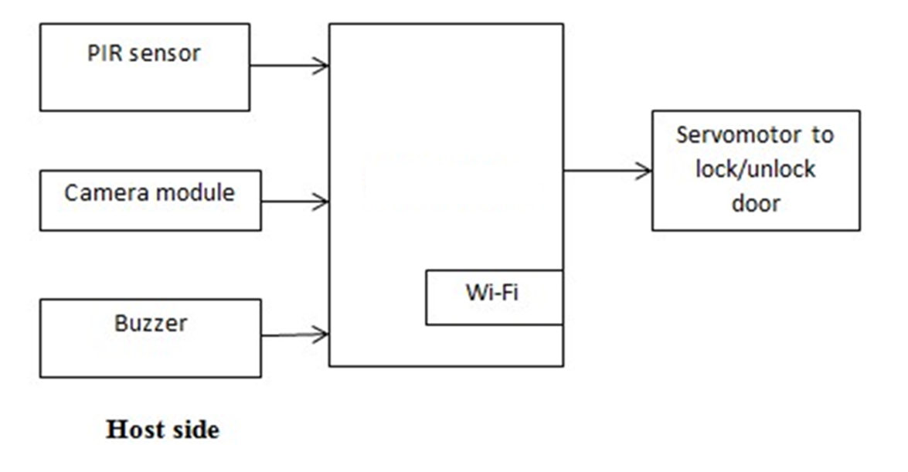

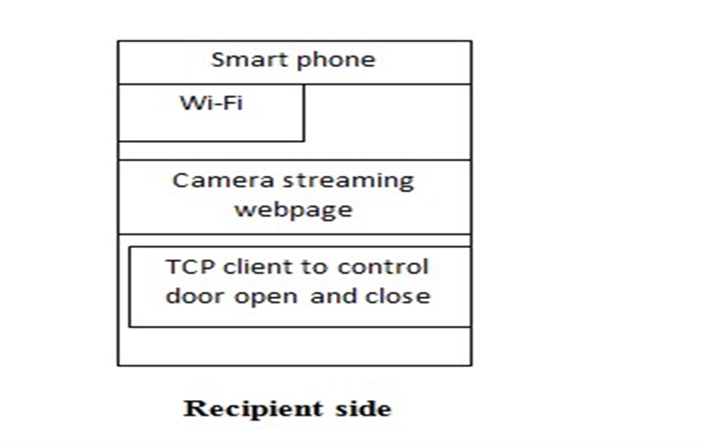

**COMPONENTS**

(1)ARDUINO UNO

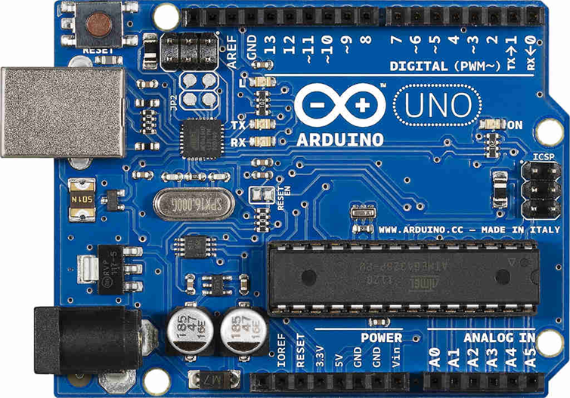

* The Arduino UNO is an open-source microcontroller board based on the microchip ATmega328P microcontroller and developed by Arduino.cc.
* The digital and Analog i/o pins present in this board can be interfaced to various expansion boards and other circuits.
* Serial communication interface is a feature in this board, including USB which will be used to load the programs from computer.

(2) Wi-Fi Module:

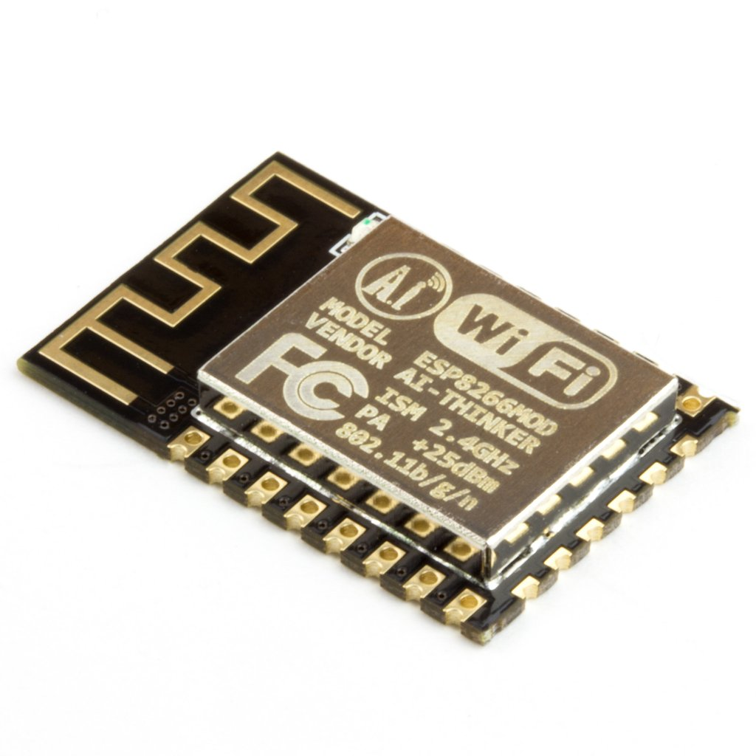

* ESP8266 Wi-Fi module is a complete Wi-Fi network where you can easily connect as a serving Wi-Fi adapter, wireless internet access interface to any microcontroller based design on its simple connectivity through serial communication or UART interface.
* ESP8266 Wi-Fi module is generally used to establish the wireless communication between the devices.
* But this module is not capable of 5-3V logic shifting and will require an external logic level converter.

(3) PIR Sensor:

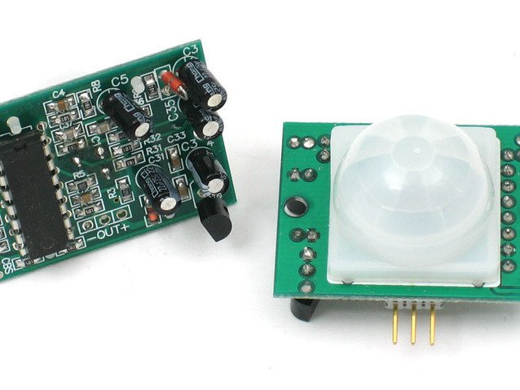

* This electric sensor is used to detect the movements of humans within a certain range (5-12m).
* It actually comprises of pyro electric sensors that detect the levels of infrared radiations.
* The PIR sensor circuit is used in numerous electronics projects which are used to discover a human being entering or leaving the particular area or room.
* These passive infrared sensors are flat control, consists of a wide range of lens, and PIR sensors can be easily interfaced with electronics circuits.

(4) Camera Module:

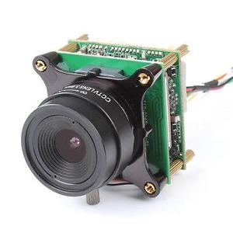

* A camera module will be mounted onto the system to monitor the human activities outside the house.
* High definition camera provides high sensitivity, low crosstalk and low noise image capture in an ultra-small and lightweight design.
* The camera module connects to the Ardino-Uno board via the CSI connector designed specifically for interfacing to cameras.

(5) Piezoelectric Buzzer:



* It is based on the inverse principle of piezo electricity discovered in 1880 by Jacques and Pierre curie.
* A piezoelectric buzzer is a loudspeaker that uses the piezoelectric effect to generate sound.
* It has both a piezo disc and an oscillator inside.
* Whenever the buzzer is powered, the oscillator generates a frequency around 2-4 KHz and the piezo element vibrates accordingly to produce the sound.
* An ordinary Piezo buzzer works between 3 – 12 volts DC.

(6) Servo Motor:

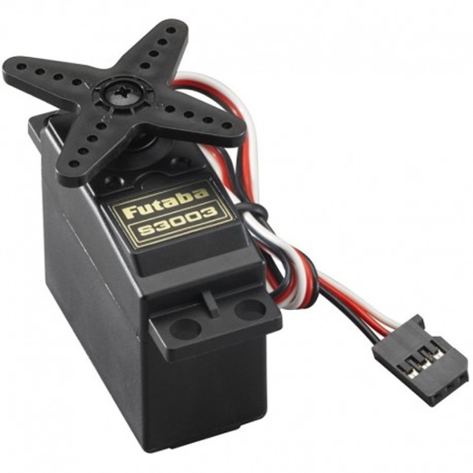

* Servo motor is a rotary actuator.
* That is capable of carrying out precise control of angular or linear position, velocity and acceleration.
* It uses a suitable motor coupled to a sensor for position feedback.
* A servomotor is a closed loop servomechanism that uses position feedback to control its motion and final position. The input to its motion is a signal (either analogue or digital) representing the position commanded for the output shaft.

**WORKING PRINCIPLE**

1. The PIR sensor will be mounted near the door to detect the human activities.
2. Whenever a human activity is detected, the buzzer will switch ON automatically as a door bell.
3. Also the camera gets activated due to the human activity and streams live video to the user.
4. The user can then authentic the entry of the person through an Android App.
5. The servo motors will then receive the command and facilitate unlocking of the door.
6. The data about all of this will be sent to the cloud for storage and analysis.

**ADVANTAGES & DISADVANTAGES**

* Advantages
* See Who is at the Door
* Speak to Visitors without Having to Open the Door
* Track Visitors That Came While You Were Away
* Portability: It can be kept at different places according to the needs
* record and download suspicious activity
* DisAdvantages
* If any animal comes at the door than also alarm bell is ring.
* If owner does not see notification then visitor has to wait untill door is not opened.
* Needs internet connection **24X7.**
* Needs battery also to work it.

**REFERNCES**

[1] Smart lock: A locking system using Bluetooth technology and camera verification by Bhalekar Pandurang1.

[2] <http://.circuitspecialistic.com/blog/tech-tip-using-a-servo-motor>

[3] <https://www.elprocus.com/pir-sensor-basics-applications/>

[4] <https://www.arduinouno.org/magpi/magpi-issue-45-camera/>

[5] <https://en.wikipedia.org/wiki/Buzzer/>