Centralized Medical Product Finder Using PostgreSQL-Full Text Search (FFS)

Reden F. Gabitan, Dick Jude G. Gabion, Ma. Precious Pearl Fulgar,
Nicole G. Hagos

College of Information and Communications Technology Sorsogon State University - Bulan Campus
Bulan, Sorsogon.

E-mails: redengabitan5@gmail.com; dickjudegabion@gmail.com; fulgarmapreciouspearl@gmail.com; nicolehagos18@gmail.com;

1 Introduction

Finding accurate information about medical products can be difficult for patients and healthcare providers. People often struggle to know the correct brand, active ingredients, or where a medicine is available. Manual searching can be slow and confusing, especially with many products in the market.
N
This study proposes a Centralized Medical Product Finder using PostgreSQL Full-Text Search. The system will store medical product information in one database and allow users to quickly search by name, brand, ingredient, or category. Using PostgreSQL Full-Text Search makes searching faster and more accurate than simple keyword searches. The goal of this system is to help users find reliable medical product information easily and efficiently.

Background of the Problem

Health is the fundamental human rights while access to health care is a way of ensuring the fulfillment of this right. [1] Globally, healthcare industry faces many issues in medicine availability, increase by factors such as pandemics, natural disaster, and uneven distribution of pharmaceutical resources. During the Covid-19 pandemic, shortages of critical supply like face masks, sanitizers, and antiviral drugs. Global and regional literature supports the relevance of this approach. The study. The Digital Transformation in Pharmacy: Embracing Online Platforms and the Cosmeceutical Paradigm Shift’ (2024) highlights the global trend toward digitalization of pharmacy services, including online platforms and tele pharmacy. This demonstrates that digital solutions are increasingly important in healthcare delivery, particularly in areas where traditional pharmacies remain offline. It validates that digital pharmacy platforms are increasingly relevant and suggests that there is room for innovation especially where traditional pharmacies remain offline. The community-based web finder you developed plays a role in that transformation.

According to the World Health Organization, digital health system strengthens healthcare service and increase equitable access, particularly for underserved populations [2]. Rae study highlighted that web-based models inform health policies and enable driven decision [3] while Tunc emphasize that web based system enhance patient monitoring, engagement, and healthcare accessibility [4]. Medicine and Medical supply finder let the users to efficiently locate nearby pharmacies efficient searching mechanisms are cruel for retrieving accurate and timely information in web-based healthcare, the linear search algorithm is simply and effective for the small to medium datasets and easy implementation. Also, heuristic and algorithmic approaches improve medical data management in health informatics system [5]. Web-based improve inventory management and reduce stockouts in pharmacies and healthcare institutions digital tools for inventory management minimize human errors and automated medical store further reduce administrative workload [6] [7], enabling pharmacists and institutions to allocate resources more effectively [8].

In many developing regions, patients, workers also pharmacies often face difficulties in locating available medicines and locating nearby pharmacies. Contracting retail pharmacies as a source of essential medicines for public sector clients in low- and middle-income countries: a scoping review of key considerations, challenges, and opportunities (2023) These challenges become more evident especially in unfamiliar places or during emergencies, can be a daunting task. According to the world Health Organization, limited access to essential medicines stays one major problems. [9]Despite of technological progress, many healthcare facilities continue to face challenges in monitoring availability of supply and locations. In recent years, through this issue various system and application development have been developed to help user with the problem. Scan Medicine [10] it is a novel searching system a specialized system for medical resources that allows users to search for medical supplies and information. And multi-Med Chain [11], blockchain-based supply tracking system. Demonstrate how to enhance transparency and accessibility in healthcare logistic. A Framework for locating prescribed medication at pharmacies the primary purpose of this study is to locate the nearby pharmacies in area [12].

Traditionally, patient had manually visited every pharmacy to inquire if the supply is available or not. This method is time consuming, and prone to human error. Although several online pharmacies exists todays but many are limited and outdated. [13]The web-based seeks to address challenges individual faces in identifying convenient pharmacy, especially in situations where time and location are the critical factors also during emergencies and unfamiliar area. Many local health centers and pharmacies stay rely on manual inventory method, this limitation evident in rural municipalities like Bulan, Sorsogon where the access of essential medicine can be delayed due to limited digital platform for locating available products.

This study proposes the development of a web-based medicine and medical supply finder using PostgreSQL full-text search. The full-text search method enables efficient and accurate retrieval of relevant records from large datasets, allowing users to quickly find the availability and location of medicines and medical supplies in real-time. This approach reduces user effort, promotes price transparency, enhances affordability, and suggests essential products for purchase. Furthermore, it supports improved decision-making for both patients and healthcare providers, extending the practical impact of healthcare services.

This study also supports several United Nations Sustainable Development Goals (SDGs), particularly SDG 4: Quality Education and SDG 9: Industry, Innovation, and Infrastructure. Regarding SDG 4, the system provides students, researchers, and health informatics trainees with hands-on experience in developing a practical web-based platform that addresses real-world healthcare challenges. By engaging with the platform, learners gain practical skills in database management, full-text search implementation, and web development, bridging the gap between theoretical knowledge and practical application. In terms of SDG 9, the platform promotes innovation in the healthcare sector by leveraging modern web technologies and database systems to improve access to essential medicines and medical supplies. It demonstrates how digital infrastructure can be effectively utilized to enhance healthcare delivery, particularly for smaller communities, local clinics, and pharmacies. By providing a simple yet effective tool, the system supports technological advancement, encourages the adoption of digital solutions, and strengthens the resilience of healthcare infrastructure.

Statement of the Problem

Digital technology plays a big part for improving healthcare service, many patients struggle to access accurate information about the availability of the medicine and medical supplies they needed. In local communities, particularly in Bulan, Sorsogon pharmacies often rely on manual inventory systems that make it difficult to locate specific medicine and medical supplies. This lack of improvement leads to wasted time for patients who often visit pharmacies to search medicine. The study of Examining community-managed drug outlets' failure in geographically isolated and disadvantaged areas: insights from the consumers' end, Studies show that many community-managed pharmacies in the Philippines struggle to maintain consistent medicine availability, forcing patients to visit multiple outlets to obtain essential drugs. [14]

A knowledge-based system to find over-the-counter medicines for self-medication (Semantic Web / open data approach), this study developed a web-based medicine-query system that helps users search for OTC medicines using semantic search (ontology + data mashup) rather than simple keyword matching [15]. This indicates that there is a history of creating online platforms enabling users (the public) to look for medications. It strengthens the assertion that digital or online tools can enhance access to medical information beyond traditional methods, spreadsheet, or manual methods.

Technology-enabled community pharmacies: qualitative evaluation of a framework for assessing technology solutions, this study evaluated what digital health / ICT platforms community pharmacists need to support their services effectively inventory, communication, patient care, etc [16]. Digital platforms that are integrated are crucial for enhancing the efficiency and service provision of community pharmacies. Centralizing inventory, pricing, and customer data minimizes manual mistakes, enhances operations, and offers quicker, dependable access to medication information. Local and small pharmacies, typically depending on manual or semi-digital methods, do not have a centralized platform that is publicly accessible for real-time availability of medications. The proposed web-based medicine and medical supply locator, leveraging PostgreSQL Full-Text Search, directly addresses this need by enabling pharmacies to manage inventory efficiently while providing residents with fast and accurate access to essential medications.

Pharmacy management system with online ordering & data visualization, the study highlights that in a surveyed municipality, only a small fraction of pharmacies used inventory/sales systems; many relied on manual record-keeping [17]. None offered online ordering or delivery. The authors recommended implementing a web-based pharmacy management system to improve stock tracking, ordering, and customer convenience. This overlaps with your proposed system’s goal showing that in the Philippine context, there is recognized need for digital platforms to improve pharmacy operations and access, supporting the argument for building a user-accessible medicine finder.

Other study focused on developing algorithm-driven system designing for medicine and medical supply for community level. Without this, patient will continues face the same problem every day, lack of knowledge where the right pharmaceutical her/his types of medicine needed, and it can lead to the patient delays in obtaining essential treatment.

Therefore, this study aims to address the issue by developing a web-based medicine and medical supply finder using a Full-Text Search-enabled system. The proposed system seeks to provide real-time information on availability and prices, offering an efficient, accurate, and user-friendly platform that allows users to easily search for the types of medicines they need. By doing this, the study helps users save time when finding medicines, reduces the need to search the entire area, and supports local pharmacies in managing their inventory effectively.

1.3 Objectives

The study aims to design and develop a web-based medicine and medical supply finder using linear search algorithm, specifically the study aims to:

Specific Objectives

- To identify and collect the essential data such as medicine details, prices, quantities, supplier information in the part of customer.

- To develop a system that will provide a web-based platform with features for searching medicines and medical supplies, viewing real-time availability, locating nearby pharmacies, managing supplier inventories.

2.1 To develop a search functionality in the web-based platform that allows users to efficiently find medical products by name, brand, category.

2.2 To display accurate and relevant search results using PostgreSQL Full-Text Search, helping users quickly access medical product information.

- To implement Full-Text Search in PostgreSQL for fast and relevant search results.

- To evaluate the system’s effectiveness and usability using ISO25010.

1.4 Significance of the Study

Customer. This study is important because it helps users and patients easily search for medicines and medical supplies online. Instead of going from one pharmacy to another, they can use the system to check availability, compare prices, and find nearby suppliers. This saves time and effort, especially during emergencies or when certain medicines are hard to find.

Pharmaceutic Owner. The system gives pharmacies and suppliers a way to manage their inventory better and reach more customers. They can update their stocks in real time, making sure users see accurate and updated information. It also helps them promote their products and improve their services through a simple and user-friendly dashboard.

Future Researchers. Future researchers can use this study as a reference when building similar systems. They can improve the search method, add more features like online payment or delivery, or expand the coverage to more areas. This project can be a starting point for more advanced systems in the future.

1.5 Scope and Limitation

This study focuses on creating and developing a web-based tool for locating medicine and medical supplies utilizing a linear search algorithm. The system emphasizes developing a user-friendly online search tool that enables users to find medications and medical supplies in the specified service area. It aims to link customers with licensed pharmacies that can modify and enhance their inventory in real time, guaranteeing that users receive the latest product information. The system prioritizes usability by functioning through standard web browsers without the need for extra software installation. Its goal is to streamline access for users seeking quick information on local pharmacies, enhancing cooperation by connecting customers with suppliers, and boosting communication along with real-time tracking of medical supplies in the covered region. The system’s efficiency is assessed via functional testing, usability evaluation, performance assessment, and satisfaction surveys or questionnaires.

Throughout the system's development, multiple limitations were recognized. The precision of search results relies on prompt updates from collaborating pharmacies, so any lag or mistake in inventory updates may lead to outdated information. Furthermore, employing a linear search algorithm, though easy and clear-cut, can result in decreased performance as the database expands. The system's service area is confined to a particular location and does not reach beyond that boundary. In addition, large medical supplies and equipment such as wheelchairs, hospital beds, and other bulky medical items are not included in the system’s inventory, as the study focuses mainly on commonly available medicines and small to medium medical supplies. Additionally, the platform lacks online payment or delivery options; it operates mainly as an informational resource for finding and identifying medicines and medical supplies. These constraints emphasize opportunities for enhancement in upcoming versions, including adopting more effective search algorithms, broadening service reach, and incorporating extra functionalities like payment and delivery choices.

1.6 Project Dictionary

This section presents the list of technical terms, acronyms, and system-related concepts used in the study. Each term is defined according to its specific function and usage within the developed system to ensure clarity and consistency in interpretation among readers, developers, and users.

Web-Based System. A web-based system is an application that operates through a web-based system and is accessible via the internet, allowing users to interact with a centralized server through standard web technologies. In this study, web-based system refers to the medicine and medical supply finder, which user can access online through any modern browser.

Medicine and Medical Supply Finder. A digital platform designed to assist user in locating specific medicines or healthcare related products within a particular area. In the study the term to the developed web application that enables users to search for medicines and medicine supplies, view their availability, check supplier details, and locate nearby pharmacies.

PostgreSQL Full-Text Search. Full-Text Search is a powerful searching technique that allows databases to find and rank records containing specific words or phrases efficiently. Unlike simple keyword matching, it can search large amounts of text quickly, consider the relevance of results, and handle variations of words. It is widely used in applications that require fast and accurate text retrieval, making it ideal for searching through medical product information in a centralized database.

Database Management System. A software that enables users to efficiently store, organize, retrieve, and manage large amounts of data using structured queries. The project uses a DBMS to store and manage all relevant data, including medicines details, quantities, supplier information, and user accounts, ensuring efficient retrieval during the search process.

Pharmacy. It is a licensed facility where pharmaceutical drugs and medical supplies are prepared, dispensed, and sold to consumers. Within this study, pharmacies refer to registered suppliers that input and update their inventory in the system database to provide users with real-time information on available medicines and medical supplies.

Inventory Management. It involves the systematic control of ordering, storing, and using a company’s inventory, including raw materials and finished products. In this study, inventory management refers to the feature that allows pharmacies to add, update, or remove medicine and medicine supply information within the system to maintain accurate and current records.

Real-Time Availability. Refers to the instantaneous updating and presentation of information as it occurs, allowing user to access current and accurate data without significant delay. The development system displays real-time data on the availability of medicines and medical supplies based on the updates made by pharmacies within the service area.

Usability Testing. A method used to evaluate how easy and effective a system is for users to operate, typically measured through user feedback, performance tasks, and satisfaction surveys. In this study, usability testing is conducted by having selected users interact with the system to evaluate ease of navigation, clarity of functions, and satisfaction with the search results and user interface.

Performance Testing. Assesses how well a software application performs under a particular workload, focusing on responsiveness, stability, stability, and speed. The system undergoes performance testing to determine how efficiently it executes search queries using linear search algorithms and how well it handles increasing amounts of data.

User Registration and Login. User registration and authentication system are mechanisms that verify a user identity and manage access control by requiring unique credentials such as usernames and passwords. In the system, the registration and login module allows both users and suppliers to create accounts.

Supplier Information. Refers to the details about vendors who provide goods or services, typically including their identity, contact details, and product offerings. In this study, supplier information is stored in the system database and includes pharmacy names, addresses, and available products, enabling users to locate nearby sources of needed medicines.

Search Functionality. A software feature that allows to retrieve relevant information by entering specific keywords or phrases into system or database. In the developed system, the search functionality uses the linear search algorithm to find medicines and medical supplies matching the user’s query.

System Evaluation. It involves systematically assessing a system’s performance, usability, reliability, and effectiveness based on established criteria and testing methods. The developed system is evaluated through AI testing, usability, testing, performance testing, and satisfaction surveys to determine its overall functionality and user acceptance.

Service Coverage. Refers to the geographical area within which a digital service or system is available and operational. In this study, service coverage defines the geographic limit of the system’s accessibility, focusing only on the designated service areas where registered pharmacies operate.

Real-Time Monitoring. Real-time monitoring is the continuous observation and updating of data to ensure immediate visibility and responsiveness to changing conditions. Within the system, real-time monitoring allows pharmacies to update inventory data instantly and enables users to view the latest information about medicine availability and supplier status.

2 Review of Related Literature

This chapter presents various studies and scholarly works related to the development of a web-based medicine and medical supply finder. It discusses how previous research contributes to understanding the system’s design, data requirements, applied algorithms, implemented features, and evaluation tools. Reviewing these studies helps establish a foundation for the current project, identify existing research gaps, and justify the use of the chosen technologies and methodologies.

The data requirements for this system include medicine information such as name, dosage, amount, and price, pharmacy or supplier information such as contact details and inventory, user data such as registration, search history, and preferences, and system logs for performance records and data integrity tracking. The system uses PostgreSQL Full-Text Search because it provides fast, accurate, and scalable searching across large datasets. Full-Text Search allows the system to efficiently match user queries with relevant database records, making it ideal for retrieving information about medicines and medical supplies in a centralized database. Compared to basic keyword matching or linear search, Full-Text Search improves search speed, ranking of results, and overall system performance.

The proposed system provides a searchable database where users can input keywords and receive accurate results based on available items. It focuses on solving the difficulty of locating available medicines and supplies in real time through features such as Full-Text Search for efficiently matching queries with database records, real-time availability display to show current stock levels, and a supplier dashboard for managing inventory and ensuring data accuracy. Evaluation tools are also implemented to ensure that the system is both technically sound and user-friendly. The ISO 25010 model provides a framework to assess software quality in terms of usability, functionality, and reliability, while questionnaires are used to evaluate user perceptions of usefulness, satisfaction, and ease of use. By combining ISO 25010 standards for software quality and user feedback through questionnaires, the evaluation process provides a comprehensive assessment of both technical performance and user satisfaction.

2.1 Information Requirements of the System

A medicine and medical supply finder rely heavily on accurate, organized, and up-to-date data to function effectively. The system must provide essential information such as medicine name, dosage, price, availability, pharmacy location, and supplier contact details. Full-text search capabilities, such as those offered by PostgreSQL, enable efficient indexing and querying of this data, ensuring high accuracy and faster retrieval compared to basic pattern matching [18]. This capability directly supports the core functionality of the proposed system by allowing users to quickly find the medicines they need.
Community pharmacies have unique information technology needs that influence system design. Li et al. [19]highlighted that pharmacies require structured access to inventory, pricing, and availability data to serve patients efficiently. These findings align with the present study, which emphasizes providing real-time, organized, and easily searchable information to residents in Bulan, Sorsogon. By addressing these local IT needs, the system improves accessibility and reliability for both patients and pharmacy staff.
Usability is a key consideration for healthcare platforms. Arabian et al. [20] demonstrated that combining expert and user evaluations ensures that electronic health systems are intuitive, efficient, and effective. In line with this, the present system prioritizes clear navigation, simple search functions, and user-friendly interfaces, making it accessible even to users with limited digital experience, including the elderly and rural residents.
Consistency and standardization of data further enhance reliability. Salgado-Baez et al. [21]emphasized the importance of structured, standardized medication datasets for accurate retrieval and interoperability. For the proposed system, this means that all pharmacy data medicine details, prices, and availability, will follow a consistent format, minimize errors and support effective full-text search functionality.
The impact of up-to-date electronic medicine records on pharmacy performance has been well documented. Karimi [22] found that timely and accurate electronic prescription and inventory systems improve operational efficiency and patient satisfaction. By enabling pharmacies to regularly update their stock information, the proposed system ensures that residents can rely on accurate, real-time data for their healthcare needs.
In summary, the reviewed literature from 2020 to 2025 highlights the critical importance of accuracy, accessibility, usability, and standardization in pharmacy information systems. Integrating these insights, the proposed web-based medicine and medical supply finder leverages PostgreSQL full-text search to provide efficient, accurate, and user-friendly access to medicine data, tailored to the needs of the local community in Bulan, Sorsogon. This approach addresses the gap in low-cost, community-centered platforms that are practical for small pharmacies with limited technological infrastructure.

2.2 Algorithm/ CS Principle/ AI Utilized in the Study

The proposed system relies on PostgreSQL Full-Text Search (FTS) as its core mechanism for retrieving medicine and medical supply information from a centralized database. Unlike traditional linear or pattern-matching search methods, PostgreSQL FTS allows for intelligent text searching by creating an index of textual data using structures such as tsvector and tsquery. This enables the system to return relevant results even when users enter partial keywords, misspellings, or brand and generic names interchangeably. As Huda [23]explained, FTS offers a practical and efficient alternative to standard search methods, balancing speed, accuracy, and resource efficiency key factors for small to medium-sized pharmacy datasets that are constantly updated.
In community pharmacies, inventory data is rarely pre-sorted, and product details are frequently changing due to sales, restocking, or supplier updates. Li et al. [24]emphasized that healthcare information systems in such environments must accommodate dynamic and unsorted datasets while still allowing users to find products quickly. PostgreSQL FTS handles these challenges by enabling approximate matches and relevance ranking, which means a search for “Paracetamol 500mg” could return the generic medicine, multiple brand variations, or related dosage forms without requiring exact input. This flexibility significantly improves accessibility for patients and caregivers who may not know precise drug names or formulations.
Another crucial advantage of FTS is its ability to rank results based on relevance. Arabian et al. [25] noted that usability in electronic healthcare systems relies heavily on the speed and clarity of search results. By displaying the most relevant items first, the system reduces the cognitive load on users and ensures that they can locate the medicine they need quickly. Salgado-Baez et al. [26] also highlighted the importance of structured and standardized datasets for accurate retrieval. In this system, consistent data formatting, indexing, and controlled vocabulary ensure that searches return precise and meaningful results. For example, users searching for “amoxicillin suspension” will consistently retrieve products with that exact type, brand, and dosage, even if the data entry used slightly different wording or spelling.
FTS also supports real-time updates, which is particularly important for community pharmacies. [27] demonstrated that providing up-to-date inventory access improves operational efficiency and reduces the risk of stockouts. In the proposed system, pharmacies can update their stock levels directly in the centralized database. Once updated, FTS automatically indexes the changes, ensuring that user searches reflect the most current availability and pricing. This feature addresses a common issue in small-scale pharmacies, where outdated inventory often frustrates patients seeking essential medicines.
PostgreSQL Full-Text Search (FTS) provides a lightweight and resource-efficient solution for searching textual data within relational databases. Unlike AI-driven search engines or predictive algorithms, FTS requires minimal computational power, making it suitable for small communities or developing regions where maintainability and adaptability are crucial [28], [29]. Its simplicity ensures that local pharmacy staff can manage the system without specialized IT expertise. In community healthcare, systems must prioritize usability, accessibility, and low technical overhead to ensure effective adoption and operation [30].
FTS supports complex search queries using logical operators, enabling users to search for multiple criteria simultaneously, e.g., “Paracetamol 500mg OR Ibuprofen 200mg.” This functionality allows staff and patients to locate alternatives or substitutions quickly. It also supports partial word matching and relevance-based ranking, reflecting fundamental information retrieval (IR) principles. IR focuses on retrieving the most relevant information efficiently from large datasets, using ranking and indexing strategies to prioritize results according to their relevance to the user’s query [29]. Applying these IR principles in FTS ensures that users with limited technical knowledge can still obtain accurate and timely results, a critical factor in healthcare delivery.
Studies on clinical IR demonstrate that relevance-based ranking and efficient query processing are essential for effective medical information retrieval. For example, recent research highlights that even in the era of AI, traditional IR principles such as relevance ordering, contextual retrieval, and authoritative results remain essential for user satisfaction and operational efficiency. Moreover, usability evaluations of healthcare information systems show that simple, accessible search interfaces improve adoption and effectiveness, especially for users with limited technical experience [31]. These findings align with the objectives of a community-centered pharmacy platform, where equitable access to medical information and timely retrieval of medicines are critical.
By integrating PostgreSQL FTS into a centralized medical product system, the platform can provide relevance-ranked search results, support logical and partial-match queries, and simplify inventory management for local pharmacies. This ensures equitable access to essential medicines, enhances coordination between patients and suppliers, and reflects IR best practices in a lightweight, maintainable system.

2.3 Features of the system

Modern health platforms aim to give users fast, accessible, and clear ways to find medicines. The Web-Based Medicine and Supply Finder follow this by providing search, basic map display, and user account features. Wondmagegn et al. [32] developed a digital prescription system that connects pharmacies and patients for easy tracking of medicines. The multi-Med Chain project [33]and Scan-Medicine improved traceability in medicine supply chains. accessible on phones and tablets. Karthik [34] showed that even rural healthcare systems benefit from online medicine tracking. Santos [35]highlighted the importance of clear navigation and readable interfaces.
Another critical feature is the provision of personalized feedback, which supports learners in understanding their mistakes and encourages self-paced learning. Studies on adaptive e-learning platforms indicate that real-time feedback helps maintain student engagement and improves knowledge retention. Additionally, user-friendly interfaces and gamification elements are commonly included in systems designed for children to make learning more interactive and enjoyable. For this reason, the proposed system will incorporate features such as adaptive quizzes, personalized feedback mechanisms, and multimedia-rich content.

Modern healthcare delivery platforms increasingly emphasis rapid, accessible, and transparent to locate medical and medicine supply, particularly in areas where supply of medicine information is not visible. Through this underpins the design of our proposed web based which is intended to help peoples to easily find medicine and medical supplies in real time, through a keyword searchable database. The core of the system is conceived to serve the primary problem of difficulties locating the availability of medicine and medical supplies especially to the areas where supply-chain is visibility week. The system has core features and supporting to features to be able to improve user access. The features of the system are grounded in recent literature that highlights the need for user friendly interfaces, digital traceability, and location-based filtering in the medical supply context.

The core features of the system is a searchable database where users like patients, health-care workers and more, can input keywords like medicine name and receive a list of showing the available items from registered suppliers. This functionality reflects best practices in digital medicine availability system [36], it described a crowd sourced platform for the essential medicines that enabled users to query for the availability and obtain up-to-date information. The search functionality is implemented using PostgreSQL's Full Text Search (FTS), which efficiently indexes and queries textual data within the database by tokenizing, stemming, and ranking search results based on relevance [37]. While FTS leverages advanced indexing techniques for faster retrieval compared to basic scans, its integration into PostgreSQL makes it straightforward to implement, maintain, and explain to non-technical stakeholders [38]. This approach aligns with scenarios where the dataset size is moderate and update frequency is manageable, making it appropriate for pilot systems or early-stage deployments [39]. The decision to use FTS is supported by prior work in pharmacy and inventory systems that emphasize usability and reliability over high-throughput complexity in initial phases, prioritizing user-friendly interfaces that do not require advanced search skills or intricate filtering logic. This feature directly addresses the user problem by enabling rapid, accurate results for finding medical products, enhancing accessibility in centralized medical product management.

Real time availability display in this feature shows the listed items current level of stocks at the supplier medicine store. The purpose is the users is not only to see the that the items totally exists but also to see and understand whether it is currently available or out of stock. The real time stock visibility is emphasized in supply-chain literature as a key of operational efficiency and better patient outcomes. The study of Understanding the problem of digital medication inventory visibility in health system, the study report that many health systems still suffer from limited digital visibility of physical inventory which is undermines decision making and delays procurement [40]. Therefore, by providing up-to-date availability information, out system helps reduce search time lowers the incidence of futile visits to out-of-stock suppliers and supports more efficient allocation of user demand to suppliers who have stock coverage. In addition, the platform supports location-based filtering of search results, allowing users to restrict their search to a geographic area, such as a city, municipality, or even a radius in kilometers around their location. This is particularly important in emergencies or urgent situations. Location-aware supply systems are common in modern finder applications, and the literature supports this. For example, a study on digital drug traceability emphasizes that geographic time delays and lack of local visibility are major obstacles.

To the supplier side the system will provide a dashboard for registration supplies giving them the ability to register new items into the inventory, update stock levels, edit item description, and view truncated demand history logs. The supplier dashboard feature supports the data accuracy and ensuring that user will be able to see reliable information and to encourages suppliers to keep inventory details current and aligned with the actual availability. Importance of the supplier uptake and ease to use in systems, founded that online pharmaceutical service implementation must consider the usability and adoption constrains of the supplier. By making the supplier interface intuitive and requiring minimal technical expertise, our system aims to reduce one of the common barriers to adoption.

In addition, the system retains a search history logs or user history logs this will be track the user previous queries, viewed items, and selected supplier. This feature is for supporting characteristic to enhances usability, every user can revisit their history searches, monitor items they previously checked, and possibility flag items for future interest or notification like notify me when it back in stock. From the use experience perspective, the ability to track one of their search histories reduces repletion and helps to build familiarity with the system. This will support the broader goal of increasing user engagement and adoption. Also, it supports to provide the suppliers with aggregated demand trend data, what items are most required, what items generated frequent no stock, which can help them optimize inventory and purchasing decisions, a supply side benefits that supports system sustainability.

User accounts and authentication, this feature allowing the user to create their own account and to save preferences and to receive notification such as stock is available. This supporting features rather than core features but this is also strengthening the system value because personalization and notifications enhance user convenience leading to higher retention and usage. Likewise, from the system architecture viewpoint, having user accounts allows for role-based access control, audit trails, data security and accountability this is important to for ensuring ethical and secure operation of a medicine finder platform. Indeed, in the broader pharmaceutical supply chain context, digital transformation, information sharing and traceability have been shown to improve sustainable supply-chain performance for supported by strong user authentication and inventory visibility mechanisms. Digital transformation mediates found out that improved sustainable supply-chain performance through information sharing and traceability [41].

Together, these features produce substantial benefits for the users and for pharmacists, medical suppliers, and distributors. For users, the system helps them reduce search time, improve access to current inventory data, and providing them the nearest supplier who have stocks. It makes for the findings task faster, more reliable and less frustrating especially to areas where every store only to find its out of stock or mostly relying on word of mouth. For the suppliers, the system organizes inventory data, it allows better visibility and high demand items, support more efficient purchasing and stoke management decisions, and fosters a digital interface with demand insights via searched history logs. From a process improvement standpoint, the platforms help address the challenges in traditional flows, fragment information suppliers not systematically publishing stock data, slow manual searching the users physically visiting or calling many stores, and limited visibility of inventory across multiple locations. In the literature, supply-chain optimization in pharmaceuticals often also identified as requiring improved transparency, digital connectivity, and real-time inventory tracking which our system addresses a foundational level. Gulo [27], conducted a systematic literature review showing that digital technologies for sample AI, Blockchain, and IoT enhance transparency and resilience in pharmaceutical supply chains.

Despite these benefits, the system acknowledges certain limitations. First, the accuracy of search results and availability status depends on the frequency and accuracy of supplier updates. If suppliers fail to update the system promptly, it may display outdated or incorrect data, leading to users losing trust. This concern echoes findings from the visibility study, where many health systems lack full digital inventory visibility [43]. Second, while Full Text Search (FTS) offers simplicity and accessibility, it may become inefficient and slow as the dataset grows—for example, if the system scales to hundreds of thousands of records across dozens of suppliers. In large-scale scenarios, more advanced search approaches, such as those with indexing, tree structures, or binary search, would likely perform better. A study on digital traceability emphasizes that large data volumes and complex query demands require high-efficacy algorithms [44]. Third, the system does not support online payment or delivery services; users can locate suppliers but cannot purchase or have items delivered through the platform. Fourth, the platform's current geographic coverage is limited to registered suppliers within the pilot area, meaning users outside the defined region may not benefit, and the system's network effects (e.g., more suppliers attracting more users) may be constrained until broader rollout. Additionally, although not currently implemented, features such as predictive restocking alerts, machine learning-based demand forecasting, and tie-ins with supply-chain sensors and IoT could further enhance performance and scalability. This aligns with recent studies showing that AI/IoT integration improves supply chain responsiveness and inventory optimization [45].

2.4 Evaluation Tools

System evaluation ensures that a developed platform is not only functional but also easy to use, effective, and responsive to user needs. In the context of healthcare and pharmacy-related systems, proper evaluation is critical because users rely on the accuracy, speed, and reliability of information when locating essential medicines and medical supplies. To assess the technical quality of the developed system, the ISO/IEC 25010 Software Quality Model was utilized [46]. This internationally recognized framework evaluates software systems based on key quality characteristics such as functionality, usability, reliability, performance efficiency, maintainability, and security. The application of ISO/IEC 25010 in this study ensures that the system meets globally accepted standards of software quality while remaining practical and efficient for local implementation. By applying this model, the study guarantees that the system can perform its intended functions accurately, operate consistently, and protect user data from unauthorized access.

In addition to software quality assessment, the USE (Usefulness, Satisfaction, and Ease of Use) Questionnaire was administered to determine users’ perceptions of the system [47]. This standardized survey instrument measures how useful the platform is in accomplishing tasks, how easy it is to operate, and how satisfied users are with their overall experience. The questionnaire focused on essential features such as searching for medicines, checking real-time availability, and locating nearby pharmacies. The results provided quantitative evidence of user acceptance and helped confirm that the system is not only technically sound but also practically beneficial to its target users, including patients, pharmacy staff, and healthcare personnel.

Moreover, usability testing and performance evaluation were conducted to further verify the effectiveness of the system in real-world conditions. Usability testing assessed the clarity of the user interface, ease of navigation, and efficiency of task completion. Performance evaluation examined the system’s response time, stability, and ability to handle multiple requests without significant delays. These tests are crucial, especially in emergency situations where users need fast and reliable access to information. The feedback gathered during these processes guided necessary refinements in both design and functionality, resulting in a more efficient, intuitive, and user-centered platform.

By integrating ISO/IEC 25010 for software quality assessment and the USE Questionnaire for user experience evaluation, this study applied a holistic and comprehensive evaluation approach. This dual-method strategy ensures that the system meets technical standards while also responding to the actual needs and expectations of its users.

3 Methodology

This section describes the overall process and methods employed in conducting the study. It outlines the research design, respondents of the study, data gathering techniques, and the software development life cycle followed in the system’s creation. It also presents the theorems, algorithms, and mathematical models applied in system design, the proposed solution that addresses the identified problem, and the materials and statistical tools used for data analysis and system evaluation. Each subsection provides the rationale and procedures undertaken to ensure the reliability, validity, and technical soundness of the study’s outcomes.

3.1 Research Design

In this study, the researchers adopted a descriptive–developmental research design, which combines both qualitative and quantitative approaches, making it a mixed-methods study. The descriptive phase involved gathering data from community members, pharmacy staff, and pharmacy owners in Bulan, Sorsogon to identify common difficulties in locating medicines, preferred search methods, and inventory management challenges. Surveys, interviews, and observations were conducted to describe user behaviors, pharmacy processes, and the specific features required for an effective medicine finder system. The surveys provided quantitative data, such as the frequency of difficulties or preferred search methods, while interviews and observations provided qualitative insights into real-world problems and user needs.

The developmental approach allowed the researchers to follow a structured procedure that included requirement analysis, user interface design, database creation, implementation of PostgreSQL Full-Text Search, system construction, and evaluation. This approach also enabled iterative refinement of features based on feedback from intended users such as patients, pharmacy staff, and administrators. By integrating descriptive and developmental approaches, the study ensured that the system was built according to user requirements while applying efficient search functionality through Full-Text Search. A purposive sampling method was employed to select participants who were directly involved with or affected by medicine and medical supply management, ensuring that the gathered data were relevant and meaningful. The descriptive component provided both quantitative and qualitative information that guided the design requirements and served as a basis for evaluating the system’s usability, accuracy, and effectiveness.

The developmental phase focused on designing and constructing the web-based medicine and medical supply finder system using the Rapid Application Development (RAD) model. The system incorporates PostgreSQL Full-Text Search to allow users to find medicines by name, brand, category, or active ingredient, and provides real-time availability and pricing information. During development, prototypes and dashboards were iteratively refined based on continuous feedback from users and pharmacy stakeholders. The system then underwent functional testing, usability evaluation, and user satisfaction assessment to determine its technical performance, accuracy, and practicality.

This design was chosen because it allows the researchers to collect real-world data to inform the system’s features and functionality while simultaneously building a practical, technology-driven solution. The descriptive component ensures that the system addresses the actual challenges experienced by users and pharmacies, making it relevant and user centered. Meanwhile, the developmental component enables rapid prototyping, iterative improvements, and early validation of the system’s features and search functionality. By integrating both elements, the study bridges empirical analysis and system development, ensuring that the final product is not only technically functional but also practical, efficient, and responsive to community needs.

3.1.1 Respondents of the Study

The respondents of the study are individuals or groups from whom data were collected to achieve the objectives of the research. They were carefully selected based on their relevance, experience, and direct involvement with the use and management of medicines and medical supplies. Their participation provides critical information that informed the development, usability, and effectiveness of the web-based medicine and medical supply finder system. In this study, the respondents comprised community users, including residents, students, and patients who frequently search for medicines, as well as pharmacy stakeholders such as pharmacists, pharmacy owners, and staff responsible for inventory management and customer service. These respondents contributed valuable insights into current practices, challenges, and needs, which served as the basis for system design and evaluation.

Respondents were deliberately selected using purposive and convenience sampling methods to ensure relevance and availability within the target area. Criterion sampling was applied to choose participants directly involved in the management and usage of medicines and medical supplies, such as licensed pharmacists, pharmacy staff, and consumers. Ethical standards, including informed consent, confidentiality, and protection of personal data, were strictly observed to ensure the validity and reliability of the collected information.

A total of 70 respondents participated in the study. Table 1 shows the distribution of respondents according to their role:

Respondent Type | Number of Respondents | Percentage (%)
Admin | 1 | 1.43
Pharmacy Staff | 3 | 4.29
Pharmacy Owner | 2 | 2.86
Customers | 64 | 91.43
Total | 70 | 100

The System Administrator oversees the operation and maintenance of the platform, ensuring that it functions smoothly and efficiently. Pharmacy staff and owners provided critical input regarding inventory management, product availability, and system functionality from the supplier perspective. Customers, including residents, students, and patients, participated in usability testing and provided feedback on the search functionality, interface design, and overall experience of using the platform.

The inclusion of these respondent groups ensured that the system was developed according to real-world needs. Community users provided insights into user behavior and search preferences, while pharmacy stakeholders helped validate inventory management features and data accuracy. This approach allowed the researchers to design a system that is both user-centered and technically functional, addressing the actual challenges experienced by end-users and pharmacy personnel in Bulan, Sorsogon.

3.1.2 Data Gathering Techniques

The data gathering techniques used in this study were carefully selected to obtain accurate, reliable, and relevant information from potential system users and key pharmacy stakeholders, including pharmacists and pharmacy owners. A structured, self-administered survey questionnaire served as the primary data collection instrument and followed a mixed-methods approach that combined both quantitative and qualitative data. This design allowed the researcher to gather measurable responses while also capturing detailed insights based on the participants’ real experiences.

For pharmacy users, the questionnaire focused on their current methods of searching for medicines and medical supplies. It explored common challenges such as outdated information, long search times, and difficulties in locating available stock in nearby pharmacies. It also gathered information about the features users consider most important in a medicine-finding system, allowing the researcher to better understand the demand-side needs and preferences.

A separate questionnaire was provided to pharmacists and pharmacy owners to assess their existing inventory management practices. This included questions about the frequency of stock updates, methods used in tracking inventory (such as manual record keeping, spreadsheets, software, or POS systems), and how often they experience stock shortages. In addition, the questionnaire examined how customers usually check for medicine availability and how the absence of a centralized search system affects customer satisfaction.

The study also included checklist-based and open-ended questions that collected qualitative information on key inventory challenges. These challenges included outdated records, difficulty monitoring fast-moving items, inaccurate stock reporting, and time-consuming updating processes. Respondents were further asked about their willingness to participate in the proposed system and regularly update their stock information.

Lastly, the survey gathered feedback on the most beneficial system features, such as real-time inventory updates, price display, dashboard management, usage analytics, and low-stock alerts. It also identified major concerns related to the system’s implementation, particularly those involving data privacy, time requirements, system complexity, and internet connectivity. The combination of all collected data enabled the researcher to clearly identify existing problems, define accurate system requirements, validate the proposed features, and address the concerns of stakeholders, ensuring that the developed system is user-centered, practical, and effective.

3.2 Software Development Life Cycle

The Software Development Life Cycle (SDLC) serves as a structured guide for planning, designing, developing, testing, and deploying software systems to ensure they meet user needs efficiently and effectively. For this study, the Rapid Application Development (RAD) methodology was utilized. RAD is an iterative and user-centered approach that emphasizes rapid prototyping, user feedback, and continuous improvement. It is particularly suited for pharmacy systems, such as medicine and medical supply finders, where fast development, accuracy, and usability are critical. By focusing on iterative development, continuous user feedback, and rapid construction of system components, RAD ensures reliable, efficient, and user-friendly solutions.

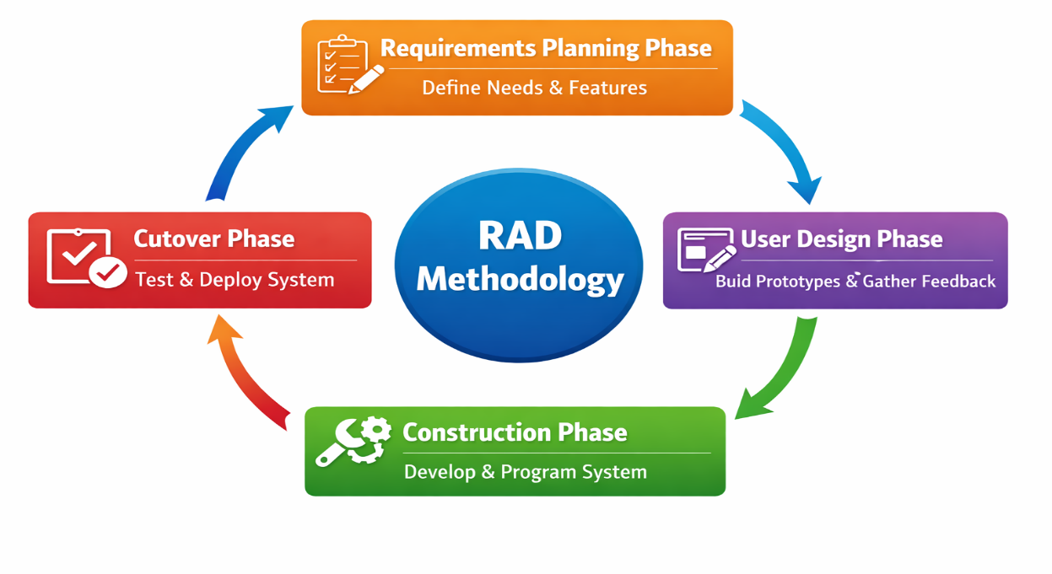
Figure 1 illustrates the four main phases of the RAD methodology, showing the iterative flow from planning to deployment.

Requirements Planning Phase. This phase serves as the foundation of the project, determining the initial scope, functional needs, and user problems. RAD is effective in building clear project requirements because it relies less on heavy documentation and focuses on early-stage user input, which improves efficiency compared to traditional models like Waterfall. For this study, user needs were identified through surveys and interviews with pharmacy staff, owners, and frequent medicine buyers. The general goals of the system, the problems it aims to solve, and essential features were defined during this phase.

User Design Phase. In this phase, the system begins to take shape by presenting prototypes to users. Users are encouraged to interact with the initial drafts and provide feedback. Each round of feedback allows for rapid modifications, ensuring that the design improves quickly and becomes aligned with real-world needs. The RAD methodology emphasizes user involvement and interactive prototyping, making this phase critical for developing an intuitive and user-friendly system.

Construction Phase. Once the design is stable, the system enters the construction phase, which involves building the database structure, implementing core functions, and integrating features based on refined prototypes. For this study, the system was developed using the following technologies:

- Backend: Python (Flask/Django) for server-side programming and business logic
- Database: PostgreSQL with Full-Text Search for fast and relevant medicine search
- Frontend: HTML, CSS, JavaScript (or react) for a responsive and interactive user interface
- Development Tools: VS Code or PyCharm, Git/GitHub for version control and collaboration
- Testing Tools: Unit testing, functional testing, and browser-based testing
- Evaluation Tools: ISO 25010 software quality model and USE Questionnaire for usability and user satisfaction

The flexible nature of RAD allows quick adjustments when requirements change, which is especially useful for features such as search filters, product lists, and real-time availability updates that evolve based on user feedback.

Cutover Phase. During this stage, the system undergoes full testing to ensure it functions smoothly and meets previously identified requirements. Pharmacists and staff are trained to operate the system confidently. Once everything is stable, the system is deployed for everyday use. Any errors discovered during testing are corrected, and performance adjustments are made. RAD’s iterative process allows continuous quality checks, making final testing more effective because feedback and corrections have been incorporated throughout earlier phases.

3.3 Proposed Solution

Communities often face challenges in efficiently locating available medicines and medical supplies. Users frequently spend considerable time visiting multiple pharmacies or calling to check stock availability, while pharmacies struggle to maintain accurate inventory records and respond promptly to customer inquiries. To address these issues, this study proposes a web-based medicine and medical supply finder system that provides real-time information on medicine availability, prices, and pharmacy locations, enabling users to quickly locate required items and allowing pharmacies to manage inventories more effectively.

The system is developed using the Rapid Application Development (RAD) model, which facilitates iterative design, rapid prototyping, and continuous refinement based on user feedback. The system’s conceptual and technical design ensures that it addresses user needs, improves efficiency, and fulfills the objectives of the study through practical and innovative technological solutions.

Key components and features of the system include:
-User Registration and Login: Allows users and pharmacies to create accounts, manage preferences, and maintain search histories.
-Search Functionality: Enables users to search for medicines or supplies by name, type, or category using PostgreSQL Full-Text Search for fast and accurate results.
-Real-Time Inventory Updates: Pharmacies can add, edit, or remove stock items, with alerts for low-stock items, improving accuracy and operational efficiency.
-Basic Map Display: Shows pharmacy locations on a simple map for user reference. It does not calculate shortest paths or provide navigation.
-Additional Features: Feedback forms for users, usage analytics for pharmacies, and simple reporting tools for inventory monitoring.

The system targets community users, such as residents, students, and patients, as well as pharmacy stakeholders, including owners, pharmacists, and staff. Their insights on current practices, challenges, and needs guide the system’s development and evaluation. The main benefits of the system include reducing the time and effort required to locate medicines, improving inventory management for pharmacies, and enhancing healthcare accessibility within the community.

By combining conceptual design (user needs, workflow, and system features) with technical design (system architecture, algorithm implementation, and real-time updates), this solution provides a clear connection between the project’s objectives and the developed prototype. The system is designed to be user-friendly, scalable, and practical, ensuring that it effectively addresses the real-world problems faced by both users and pharmacies in any community setting.

3.3.1 CS Principle, Algorithms, and Mathematical Models

PostgreSQL Full-Text Search (FTS) is an advanced database searching technique that enables the system to efficiently locate relevant records containing specific words or phrases. FTS uses indexing to retrieve and rank results quickly, making it suitable for large and growing datasets. In this system, FTS is applied to efficiently find medicines and medical supplies in the database.
Mathematically, the operation can be represented as:
$$\text{result}=\text{FTS}(T,L)$$
Where:
- $T$is the medicine or medical supply being searched for.
- $L$is the list of all available items stored in the database.
- $\text{result}$returns all relevant matches ranked by relevance.
- If no match exists, the result is empty.

The Full-Text Search algorithm functions as follows: when a user enters a query $T$, the system retrieves the indexed dataset $L$and evaluates it against the query terms. Items containing the target keywords are identified, ranked using PostgreSQL’s tsvector and tsquery mechanisms, and returned with details such as name, price, availability, and pharmacy information.

- tsvector stores the preprocessed text from the database (medicine names, descriptions, etc.) in a searchable format. It breaks text into keywords, removes common stop words, and converts words to their base forms for faster and more accurate search.
- tsquery converts the user’s search input into a format that can be compared against the tsvector index. It supports multiple keywords, logical operators (AND, OR), and prefix searches.

The logic flow of Full-Text Search, illustrated in Figure 2, follows these steps:
- Start Full-Text Search: The user enters a search query.
- Retrieve Indexed Data from Database: The system accesses the pre-indexed dataset (tsvector) for fast searching.
- Parse User Query into Searchable Tokens: The query is transformed into tsquery.
- Match Query Tokens Against Indexed Data: The system identifies records containing the search keywords.
- Rank Results by Relevance: Matches are ranked according to how closely they correspond to the query.
- Return Matched Items with Details: The system provides results including medicine name, price, availability, and pharmacy location.
- No Matches Found: If no records match, the system returns an empty or “not found” result.

This stepwise process guarantees efficient, accurate, and scalable retrieval of medicines and medical supplies, providing a fast and user-friendly experience. By leveraging database indexing, tokenization, and relevance ranking, Full-Text Search ensures that the system can scale effectively as new items are added.

3.3.2 System Design

The System Architecture of the Centralized Medical Product Finder illustrates how the key components—user interface, application logic, and database—work together to deliver accurate and efficient search results. It shows how users interact with the system, how their search queries are processed, and how the database returns the relevant medicine and medical supply information. The architecture serves as a roadmap, ensuring a clear understanding of the flow of data from user input to output results.

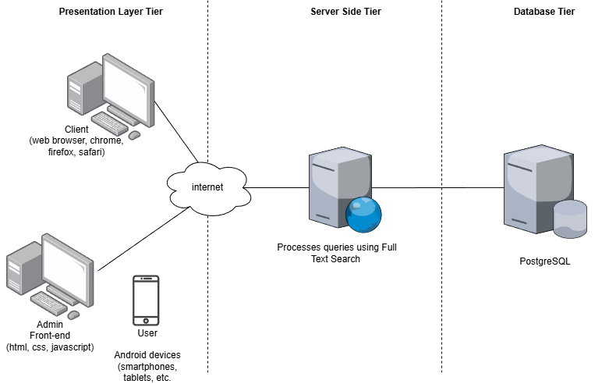Figure 2. System Architecture of the Proposed System
The process begins when a user submits a search query via the web interface. The request is sent to the server, where the core business logic is executed. Using PostgreSQL Full-Text Search, the system efficiently retrieves relevant medicine or supply records from the database. The retrieved results are then sent back to the user interface for display. This structure ensures fast, accurate, and reliable search results while maintaining real-time inventory updates.
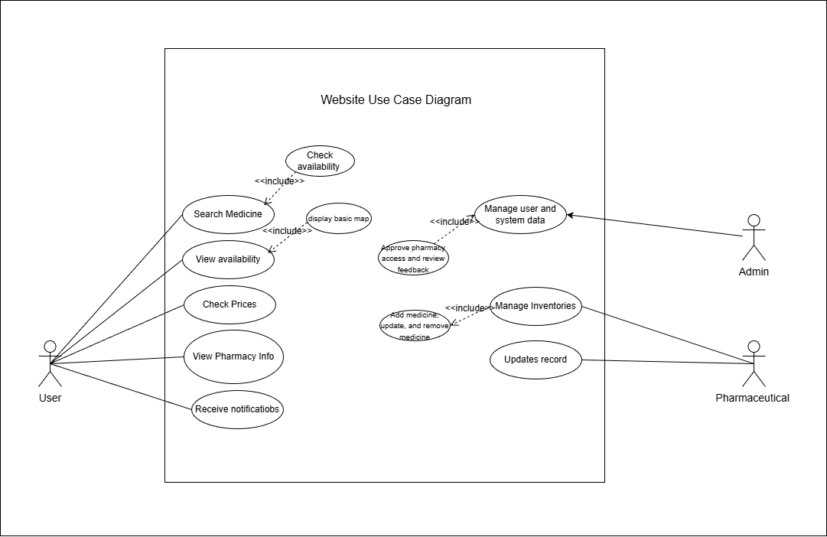
Figure 3. Use Case Diagram of the Proposed System

The Use Case Diagram identifies the main users (actors) and their interactions with the system. In this study, the primary actors include users, pharmacists, and the admin. This diagram highlights the functions each actor can perform, ensuring the system meets all user needs and workflows.
User: Can search for medicines and medical supplies, view real-time availability, check prices, and access basic pharmacy location information.
Pharmacist: Can add, update, or remove medicine and supply records, ensuring inventory is accurate and up to date.
Admin: Oversees the overall system, manages user accounts, and monitors feedback to maintain system integrity.

The system utilizes PostgreSQL Full-Text Search to efficiently handle large datasets, providing fast and relevant results based on keywords or phrases. This method enhances search accuracy by retrieving medicines and medical supplies that closely match user queries, while also managing cases where no exact matches are found through alternative suggestions or notifications. By combining a clear system architecture with defined user roles and advanced database search functionality, the system delivers an efficient, user-friendly, and scalable solution for both community users and pharmacy stakeholders.

3.3.3 Logical Design

The Sequence Diagram illustrates how the pharmacist’s admin and system components interact within the web-based medicine and medical supply finder. The admin manages medicine details, verifies email access, and updates inventory information in the database. When users search for a medicine, the system retrieves matching details, such as brand, description, price, and availability, offering alternative suggestions if no exact match is found.
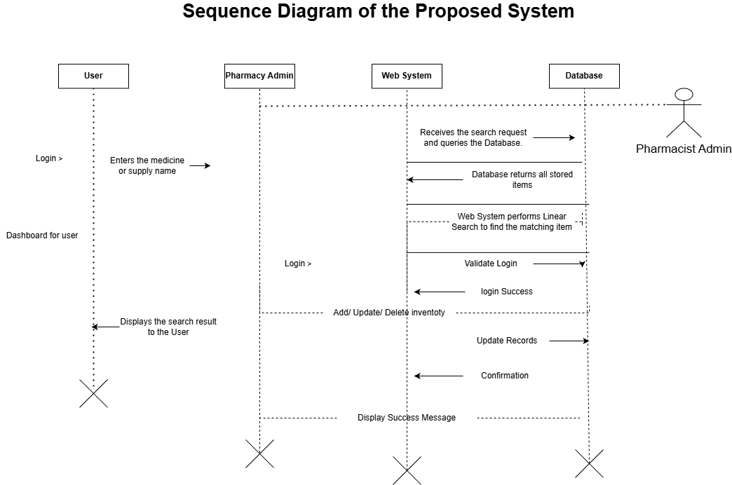
Figure 4: Sequence Diagram of the Proposed System

In this study, the sequence diagram illustrates how the pharmacist’s admin manages the medicine finder system by first accessing the admin dashboard to update or add medicine details. The system interacts with the email service to verify admin actions. Once verified, the admin inputs medicine information such as name, brand, description, price, and stock, which the system stores in the database. On the user side, the system retrieves the user’s search input and performs a PostgreSQL Full-Text Search to efficiently match the requested medicine with available records. If a match is found, the system displays details such as price, brand, description, and availability. If no match is found, the user is prompted with alternative suggestions. This sequence ensures that medicine data is accurately maintained and that users receive fast, relevant, and reliable search results.

The Class Diagram represents the logical structure of the web-based medicine and medical supply finder by defining its cases, attributes, methods, and the relationships among them. It organizes system data and interactions to ensure clarity, stability, and efficient management of medicine and pharmacy information. Together, these classes define how information is structured and how objects collaborate to support searchable and organized access to medical supplies.
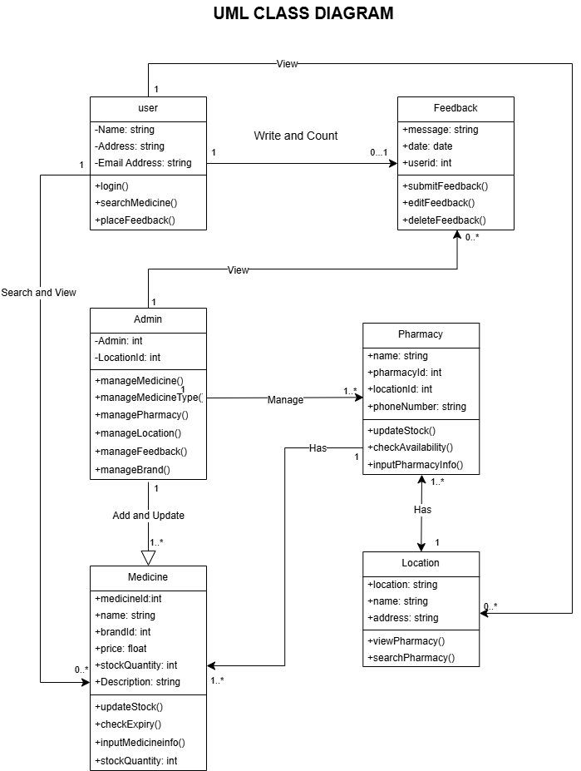

Figure 5. Class Diagram of the Proposed System

The Class Diagram for this study shows the User class containing personal information and functions for searching medicines and submitting feedback. The Medicine and Pharmacy classes store essential details about medical supplies and their availability. The admin class is responsible for managing all system data, ensuring that information is accurate and up to date. A simplified Location class supports associating pharmacies with general areas or neighborhoods, helping users identify nearby options without implementing complex routing or mapping. The Feedback class records user comments and experiences. The relationships between the Admin, Pharmacy, and Medicine classes ensure that users can reliably access current medicine and pharmacy information, supporting a consistent, data-driven process for searching and managing medical supplies efficiently.

3.3.4 Technical Background

This section provides a detailed overview of the technological foundations, tools, and systems that specifically support the development of a Centralized Medical Product Finder Using PostgreSQL Full-Text Search (FTS). It discusses the hardware, software, programming languages, and development platforms relevant to the system, explaining how each component contributes to achieving the project’s objectives, particularly in medicine inventory management and efficient search functionality.

Table 1. System Hardware Requirements

Particular | Recommended Specification
Memory | 8 GB – 16 GB RAM
Processor | Intel Core i5 / AMD Ryzen 5, 2.5 GHz or higher
System Type | 64-bit OS, dual-core or quad-core CPU
Storage | 250-500 GB HDD/SSD

To ensure the system runs smoothly during development and daily use, a reliable computer setup is required. The minimum requirement for this project is a desktop or laptop with a dual-core or quad-core processor and at least 8 GB of RAM. This configuration is sufficient to run PostgreSQL with Full-Text Search, backend servers, frontend frameworks, and testing tools simultaneously. A 64-bit operating system is required to support all modern software components, and stable storage of 250–500 GB is sufficient for project files, database storage, and testing data. A stable internet connection is necessary for system updates, collaboration, and online testing, and a standard set of peripherals (mouse, keyboard) completes the setup.

Table 2. System Software Requirements

Particular | Recommended Specification
Code Editor | Visual Studio Code (Version 1.106.3 or later)
Version Control | Git (Version 2.52.0 or later)
Web Browser | Google Chrome or Mozilla Firefox
Database Management | PostgreSQL with Full-Text Search enabled
Front-End Frameworks | HTML, CSS, JavaScript, Bootstrap
Back-End Language | Node.js / Python (Flask or Django)
Testing Tools | Postman for API testing, browser developer tools
Documentation | Microsoft Office Suite

The system development integrates multiple software tools and platforms to ensure smooth operation and maintainability. The frontend is built using HTML, CSS, JavaScript, and Bootstrap to provide a responsive and user-friendly interface. The backend is developed using Node.js or Python, which allows seamless communication with the PostgreSQL database that leverages Full-Text Search for efficient and accurate retrieval of medicine and medical supply information. Visual Studio Code serves as the main development environment, while Git manages version control and team collaboration. Testing and debugging are carried out using Postman and browser developer tools, and Microsoft Office Suite is used for documentation purposes.

3.3.5 Work Plan/ Timeline

The Work Plan / Timeline section serves as the foundational blueprint for the entire project, meticulously presenting a systematic, comprehensive schedule that guides every phase of development, from the initial stages of inception through to final completion. This schedule is designed to ensure that the project develops properly, maintaining alignment with the project's core objectives and overarching goals. The implementation of a well-structured timeline is paramount, as it allows the development team and stakeholders to effectively track progress, efficiently allocate necessary resources, and maintain consistent quality and accuracy across the various stages of system development namely requirements analysis, system design, construction, and final deployment.

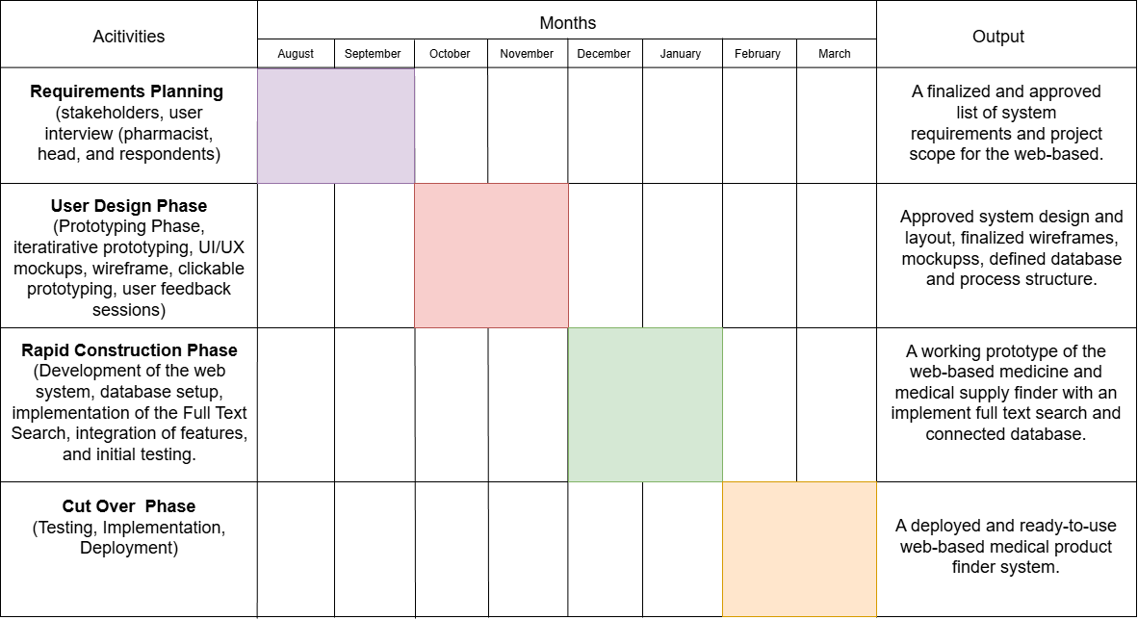
Figure 6: Table 2. Gantt chart

The project for developing the Centralized Medical Product Finder using PostgreSQL Full-Text Search will span eight months and is structured around four main phases.

The first phase is Requirements Planning, which will take place from January to February 2026. During this phase, the researchers will conduct stakeholder and user interviews, finalize the system requirements, and gather essential data such as medicine details, stock availability, and supplier information. The second phase is User Design, scheduled from March to April 2026. In this phase, the team will create UI/UX prototypes, design the database schema optimized for Full-Text Search, collect user feedback, and ensure that the system design meets the needs of both community users and pharmacy stakeholders. The third phase is Rapid Construction, taking place from May to June 2026. The development team will build the web-based system, implement PostgreSQL Full-Text Search for efficient and accurate search results, integrate the backend with the frontend, and produce a working prototype. Finally, the Testing and Cutover Phase will occur from July to August 2026. During this period, the system will undergo usability and performance testing, necessary refinements will be applied, users will be trained, and the system will be deployed and officially launched for community and pharmacy use.

3.3.6 Proposed Prototype

The Centralized Medical Product Finder using PostgreSQL Full-Text Search is a responsive web application designed to help users quickly locate medicines and medical supplies across participating pharmacies and suppliers. The system’s primary function is a search engine that leverages PostgreSQL Full-Text Search (FTS) to efficiently retrieve relevant inventory records based on user queries. This approach ensures fast and accurate results even with large datasets. Users can search by medicine name, brand, generic term, or optional filters such as dosage form, quantity, price range, and availability. Search results display key details including stock levels, price, supplier or pharmacy name, and an “available now” indicator, along with a direct option to request a reservation or contact the supplier.

The prototype is organized into core modules that align with the project objectives and users’ needs. The User Module supports registration, secure login, and profile management. The Pharmacy/Supplier Module allows vendors to manage inventory records, set availability status, and receive reservation notifications. The Admin Module handles user and supplier approvals, system monitoring, and basic analytics. The Full-Text Search engine runs on the server side, scanning the database for matching records and ensuring relevant results are returned quickly. Search performance is monitored to measure response times and accuracy.

To support usability and adoption, the interface is built with a responsive design suitable for desktop, tablet, and mobile devices. Interactive result cards include stock summaries, an option to request a hold or contact the supplier, and a feedback control so users can report accuracy or satisfaction. This feedback is used to improve the system during usability testing. Security measures include hashed passwords, role-based access control, and input validation to prevent incorrect data entry. Collectively, these features create a lightweight, scalable, and efficient prototype, suitable for pilot testing in a limited geographic area. The pilot will focus on verifying the Full-Text Search approach, measuring search performance, ensuring inventory accuracy, and collecting user feedback for further improvements.

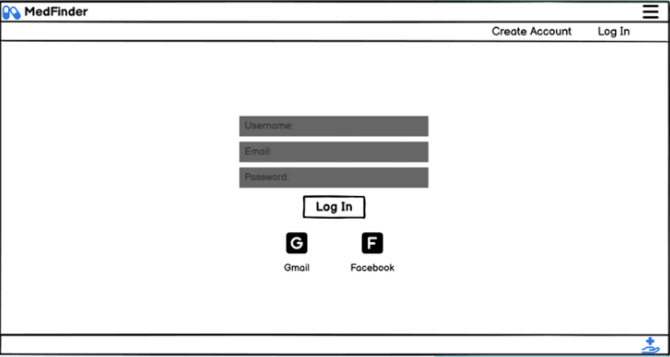
Figure 7: Create Account and Log In system
The MedFinder login and registration system is designed to be a simple, by placing the Username, Email, and Password fields front and center, the design ensures that new users can sign up and returning users can log in using the same familiar space. To save time, the prototype includes Gmail and Facebook shortcut buttons, allowing users to skip typing entirely by linking to an account they already own.

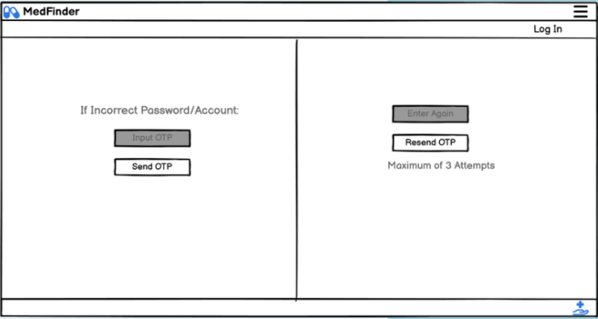

Figure 8: OTP verification
The MedFinder OTP verification system serves as a secure recovery bridge, allowing users to verify their identity and regain account access after a failed login attempt. By providing a clear "Send OTP" trigger, the interface ensures that a unique security code is delivered directly to the user's registered contact method to confirm their ownership of the account. To maintain high security standards, the system includes a "Maximum of 3 Attempts" constraint to prevent unauthorized access while offering "Resend OTP" and "Enter Again" options to assist legitimate users who encounter delivery delays or input errors.

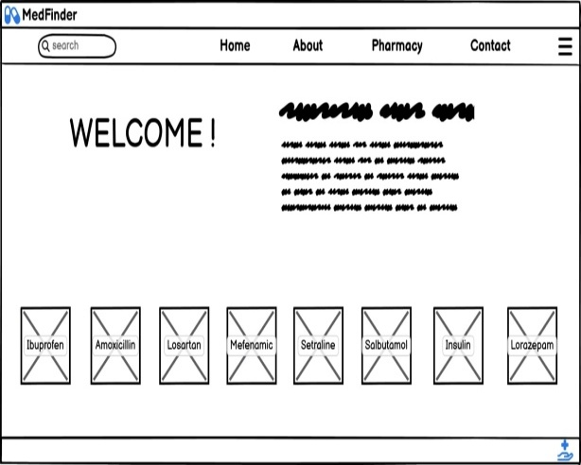

Figure 9: MedFinder website
The MedFinder website starts with a simple login and sign-up page where users can enter their details or use quick buttons for Gmail and Facebook to get started. If a user has trouble logging in, the system moves to a security screen that sends a unique OTP code to their phone or email to prove who they are. This safety feature allows for a maximum of three tries and includes buttons to "Resend" the code or "Enter Again" if there is a mistake. Once logged in, users reach a friendly homepage that features a search bar and a "WELCOME!" message to help them feel at ease. From here, they can easily click on different medicine categories, such as Ibuprofen or Insulin, to find the exact health information they need.
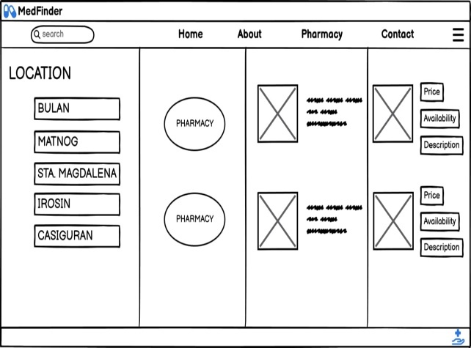

Figure 10: Pharmacy page

The Pharmacy page is a dedicated section of the website where users can choose a specific location to find medical supplies. Once a location is selected, the interface displays a list of available pharmacies in that area. Users can then view important medicine details, including the price, current availability, and a description of the product.
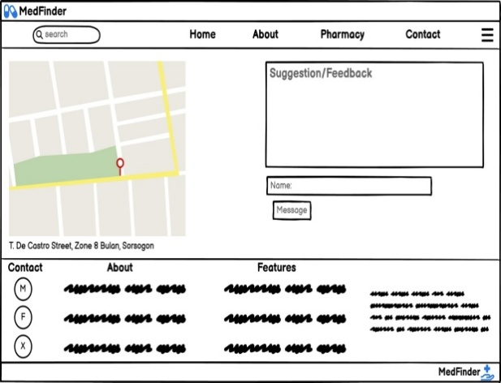
Figure 11: MedFinder Contact & Feedback
The MedFinder Contact & Feedback page uses a split layout to help users find physical locations and share their thoughts. On the left side, a simple map shows a specific location, such as T. De Castro Street, Zone 8 Bulan, Sorsogon. On the right side, a form with a "Name" field and a "Message" button allows users to send in their suggestions or feedback.

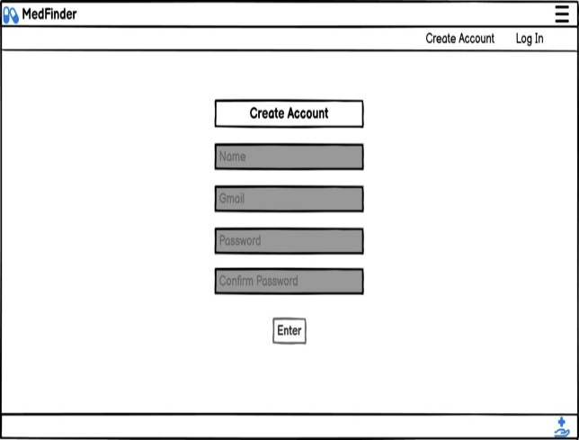

Figure 13: DASHBOARD FOR ADMIN CREATE ACCOUNT

The MedFinder Admin Dashboard provides a secure way for pharmacy managers to manage their business through a specialized Pharmacy Create Account page where they register using their name, email, and password. To protect sensitive inventory data, any failed login attempt triggers an OTP verification screen that requires a unique code to confirm the admin's identity. This security layer enforces a maximum of 3 attempts while offering buttons to "Resend OTP" or "Enter Again" to help authorized users regain access safely.

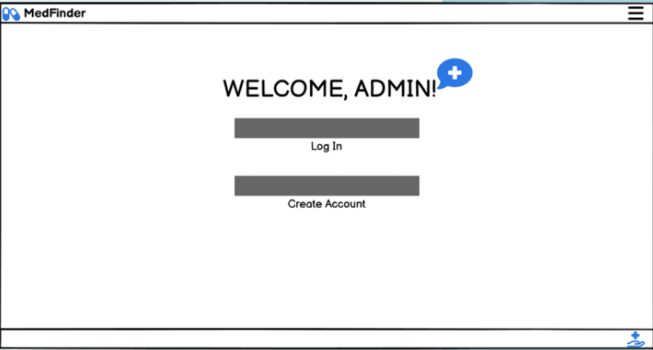

Figure 14: ADMIN DASHBOARD
The MedFinder system starts with an Admin Log in page where the administrator must sign in to manage and update stocks. Once logged in, the Homepage displays a "WELCOME!" message and a search bar for navigating the site.
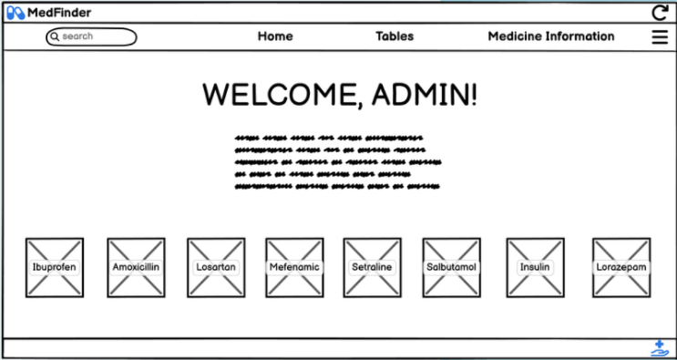

Figure 15: MedFinder Admin Dashboard
The MedFinder Admin Dashboard is a streamlined management portal featuring a central navigation bar, a personalized greeting for system administrators, and a quick-access grid of medication categories designed for efficient inventory oversight.
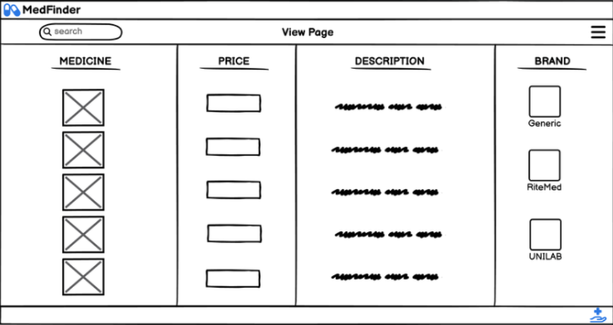
Figure 16: MedFinder View Page / Inventory List

The MedFinder View Page is an organized inventory management interface, four-column data table that provides at-a-glance visibility into medicine imagery, unit pricing, comprehensive descriptions, and brand-specific options like Generic, RiteMed, and UNILAB.
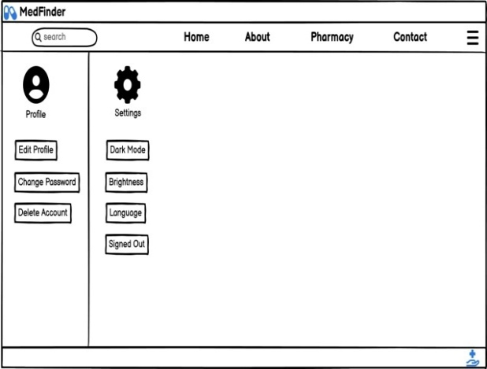
Figure 17: MedFinder Profile & Settings

The MedFinder Profile and Settings dashboard feature a dual-paneled layout that allows admin to manage account security through profile editing and password changes on the left, while simultaneously adjusting system preferences like dark mode, brightness, and language on the right.

3.4 Evaluation Tool(s)

This study employs the ISO 25010 Software Quality Model as the primary instrument to evaluate the system. ISO 25010 provides a structured framework to assess software quality across multiple dimensions, including functionality, usability, reliability, performance efficiency, security, maintainability, and user satisfaction. By applying this model, the study ensures that the Medicine Finder system meets established standards for technical excellence and provides consistent, high-quality performance for users searching for medicines, viewing availability, and identifying nearby pharmacies.
The evaluation focuses on the following indicators:

ISO Indicator |  | Description
Functionality |  | Measures how well the system performs the required functions such as searching medicines, viewing availability, and displaying pharmacy information correctly and completely.
Usability |  | Assesses how easy and user-friendly the system is, including navigation, clarity of interface, and overall user experience for both users and pharmacy staff.
Reliability |  | Evaluates the system’s ability to perform consistently and accurately without errors, crashes, or data loss during normal use.
Performance Efficiency |  | Determines how fast the system responds to user searches and requests, especially when accessing and displaying data using the linear search algorithm.
Security |  | Measures the protection of user data and system access, including login security and prevention of unauthorized access to the pharmacy/admin panel.
Maintainability |  | Evaluates how easy it is to update, modify, or improve the system when changes in inventory, features, or requirements are needed.
User Satisfaction |  | Determines the level of satisfaction of users and pharmacy staff based on feedback collected through surveys or questionnaires.

Using ISO 25010 as the sole evaluation tool provides a comprehensive assessment of the system’s technical quality, operational stability, and user satisfaction, ensuring that the Medicine Finder system is both effective and reliable for its intended community use.

