Description of Python code projects

1. “Volatility_search.py”

Purpose of this script is to search and filter through stocks within the S&P500 that meet the user defined volatility criteria. The default settings for user input are for low volatility ranging in between -1 and +1 %, and high volatility ranging from anything greater than the absolute value of 10%. The period in which the script searches through historical data is defined to be 22 data points or roughly 1 month of trading. This script is useful in finding stocks which have not moved as of recent allowing profitable opportunity in options trading through the selling of Iron Condor credit spreads.

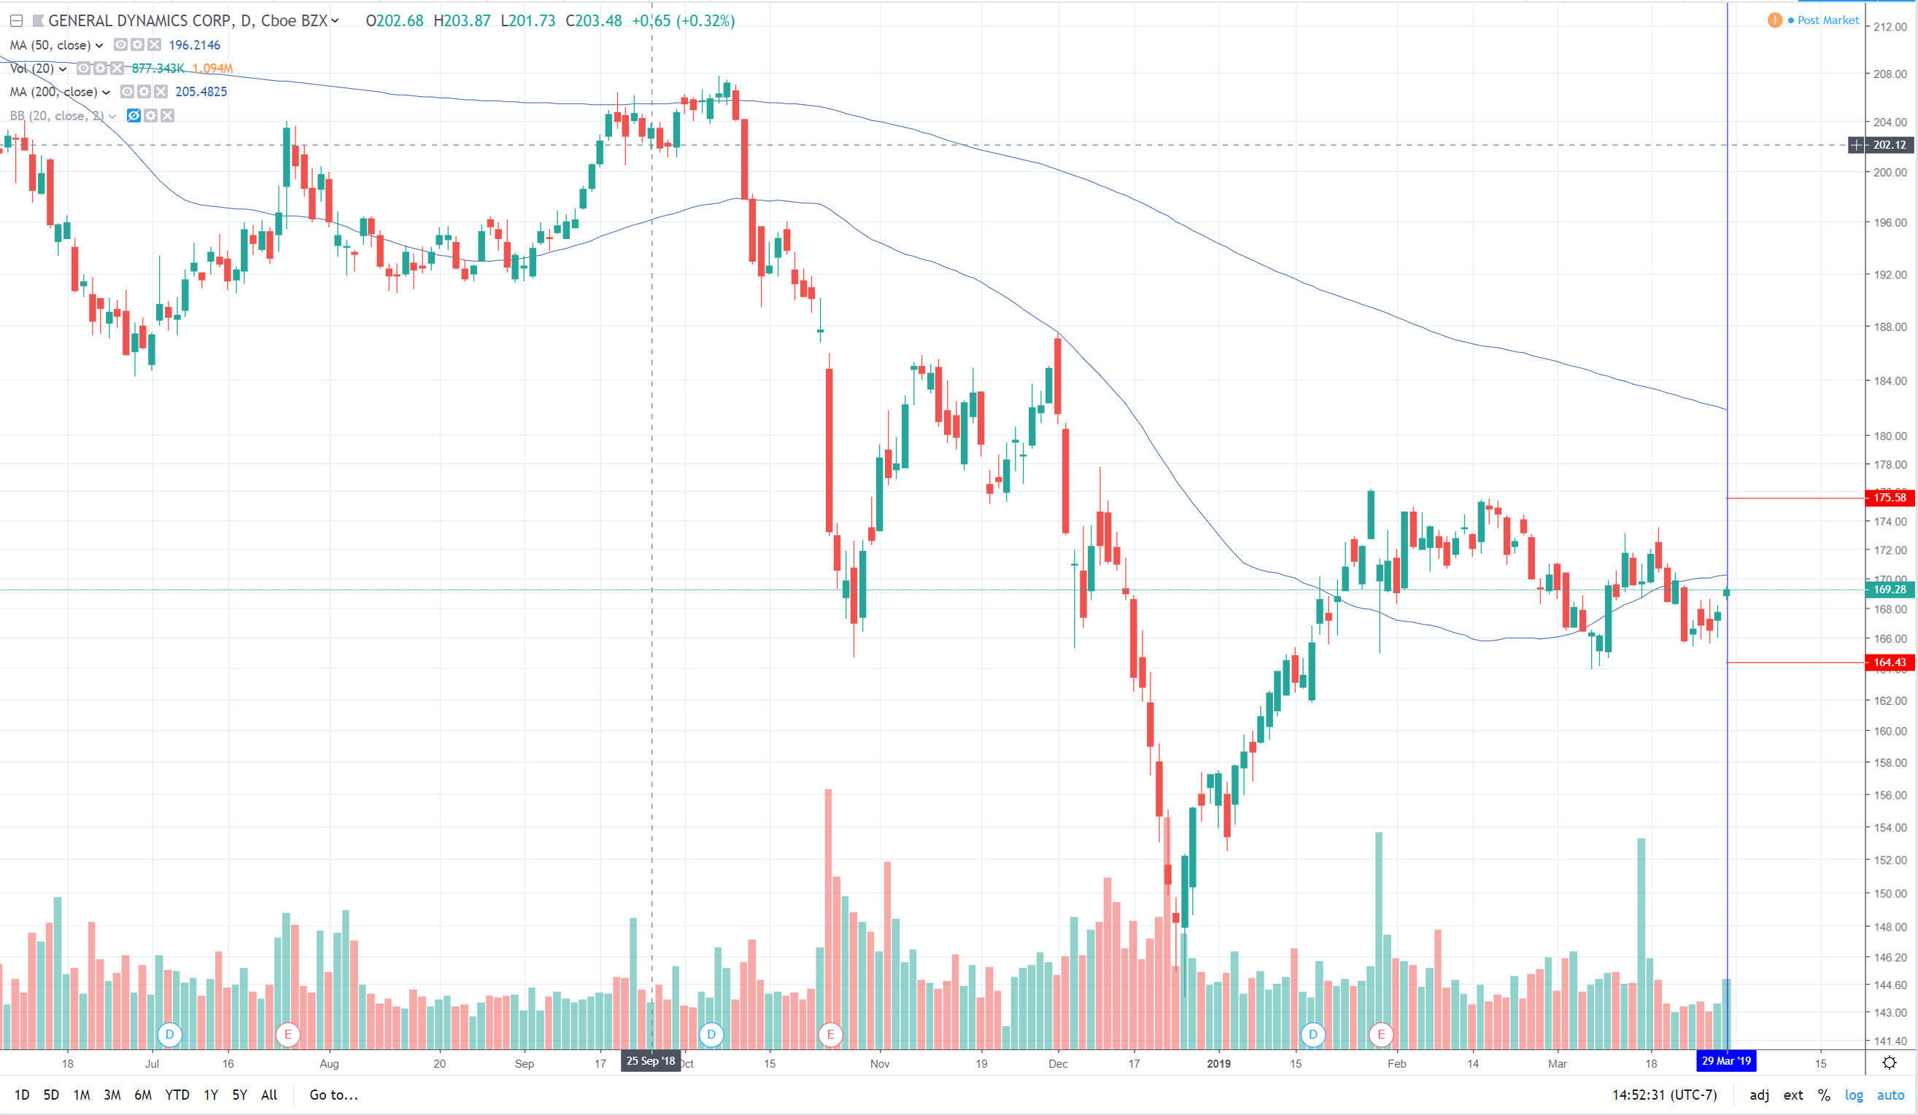

1. “Hedge_finder.py”

Purpose of this script is to find a few stocks within the S&P500 which can be used to hedge against a user given ticker symbol. Hedging is important in that it provides protection for any investment in the case it does not play out as planned. The script is searching through stocks to find ones that are most positively and negatively correlated. Hedging can be described through extreme positive or negative correlation in that a hedge should either move directly with or against the investment it is being hedged against. The script allows for the period of comparisons to be changed as well. The ultimate purpose of this script is to provide recent correlations between stocks which will allow for risk management based on statistics rather than emotion and generality (“example just hedge it with gold”).

1. “Bollinger_search.py”

Purpose of this script is to search and filter through stocks within the S&P500 that are at or past the extremes of the stocks Bollinger-bands. Bollinger-bands use historical stock data to define a highly likely range for the stock to lie within. The band is made up of a 20-day moving average in the center followed by an upper and lower band which lie 2 standard deviations from the center line in each direction. Stocks in general will have explosive moves up or down but will typically revert back to the mean. It is with this assumption that opportunity of profits are available for stocks deviating from its historical average by selling credit spreads which favor the stock to revert back to its mean.

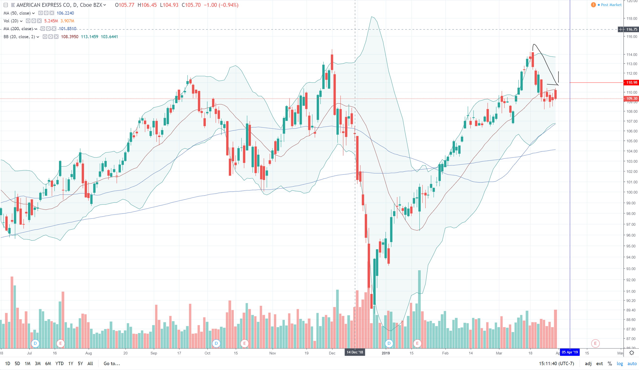

1. “Moving_Average_Buy_Sell.py”

Script shows the results of an Agent buying and selling a stock based on the crossing of short-term and long-term moving averages (moving averages are customizable by user). Strategy is simple and fundamental and Agents results of net-worth throughout back-test is shown at the end of simulation.

1. “stock_sma.py”

Graphs three user defined simple moving averages for a given ticker symbol. Time-frame, length of moving average, and ticker symbol is customizable through user-input.

1. “Fibonacci_Agent.py”

This script is a back-test of an Agent who uses the bullish Fibonacci retracement strategy. User is able to input the timeframe and ticker symbol which agent implements and back-tests this strategy. At the end of the simulation the Agents net-worth and overall percent return is graphed along with records of all transactions made by the Agent over the tested time period. Fibonacci strategy assumes that stocks have primary and intermediary trends in which retracements occur as they continue along these trends. The Agent acts accordingly to the buy and sell targets for the stock which are calculated based on Fibonacci ratios along with lows and highs of a defined period.

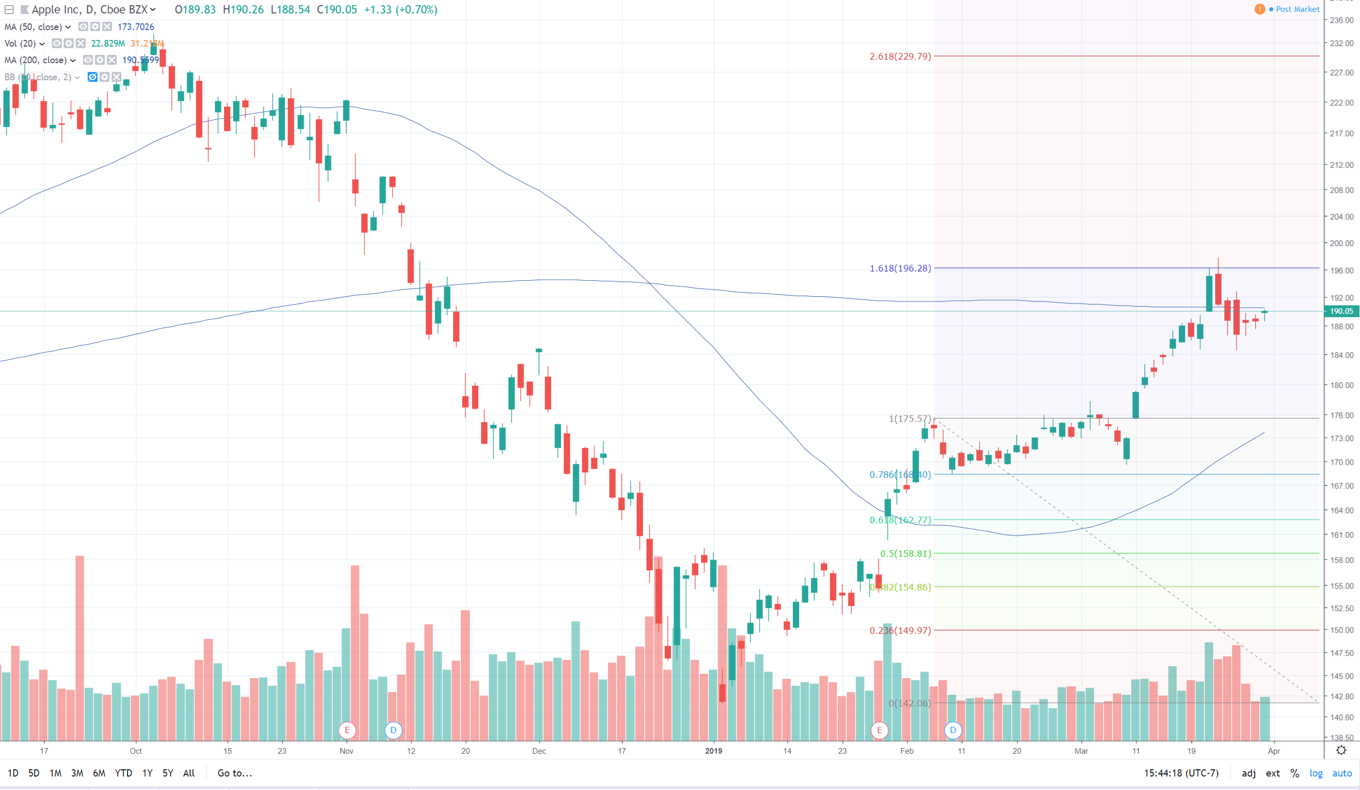

1. “death_cross_stats.py”

The Death-cross is known in the financial industry as when the 50-day moving average of security crosses below the 200-day moving average of that same security. When this occurs, it is often a technical indicator that the overall economy is not doing well and a possible recession is on the way. The script scans through the S&P index from 1970 to 2019 and outputs the crossing and re-crossing of the moving averages. It also graphs the year which it occurred and the duration in which the cycle of the 50-day moving average stayed below the 200-day moving average. The script was made to compare with historical Death-crosses and its relation to which overall economic recessions occurred.

