**Blockchain Technology SWOT Analysis**

Strengths

* It is a peer to peer system that takes away the need for a third party to mediate transactions

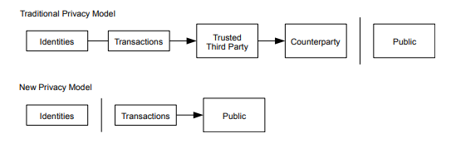

* It has data that is immutable once written so no central source has the authority to change the data once its been posted on the ledger
* Any type of documentation can be stored on the blockchain such as property ownership, customer information, etc.….
* Solves the double spending problem

Weaknesses

* Blockchain involves encryption of data being stored which can take time
* It would require a large amount of computing power depending on the number of nodes that make up the system
* Scalability would be a problem for peer to peer or business to business transactions because of time consumption

Opportunities

* There would be less third parties involved for transactions
* Developing ones own blockchain technology would be an investment that can pay off in the long run
* Develop a front-end product that is scalable and a back-end product that is secure
* Ripple like solution can be a front-end solution that would leave customers satisfied in terms of speed and the banks would also over time not need to pay for the third parties high fees for taking care of the transactions
* The back end can use a developed blockchain that stores any internal corporate documentation
* International Banking possibilities through fast cross-border transactions, customers that travel abroad will appreciate their banking needs are not limited within borders

Threats

* The competition in ones’ own industry such as JPMC having a $9 billion dollar IT budget and other Fintech Banks that are emerging
* Development of Quantum Computing that will threaten the security of blockchain technology
* Time is the most essential threat because if others in the financial industry are much further ahead then catching up will be difficult