# Data Science Mini-Project 2022/23 - Individual Reflective Report

# Yujie Wang – 24 May 2023

## Summary

I contributed to approximately 50% of the overall project effort. The contributions were primarily from two members. My contributions were spread across coding, analysis, writing, and meeting. I attended all the group sessions. I contributed to most of the coding activities as shown on Github. For the written report, I involved in most parts of Methodology, Data Preparation, and Results.(All contents concerning with the ARIMA Model, LSTM Model and Mid-Price predictions).And the parts about Mid-Price tasks were all done by myself. Furthermore, I gave 1/3 of the oral formative and summative presentations. I consistently contributed every week via either Github or WhatsApp (and sometimes via Teams). In addition to this information, I have attached my weekly activity logs.

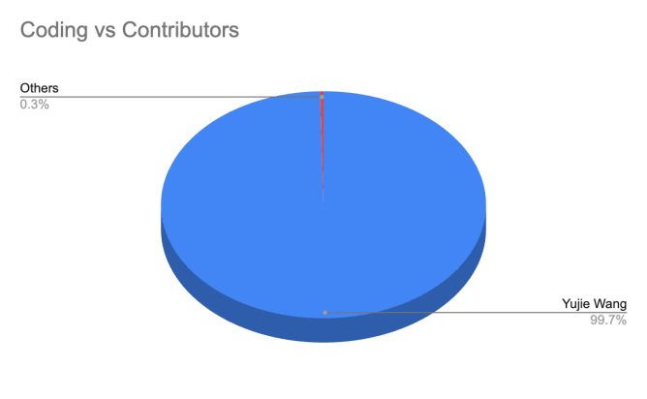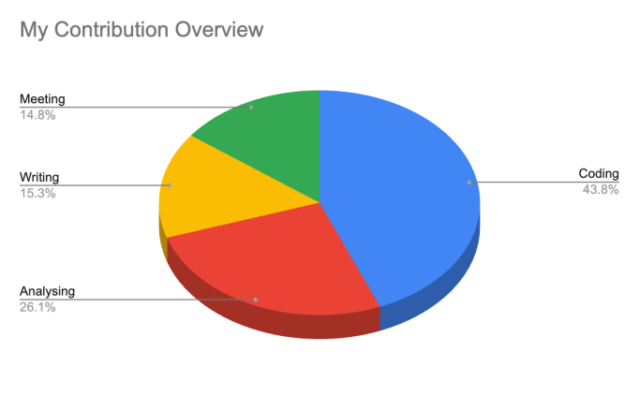

## Github Details

I did have some activity on Github, where I primarily added data and codes. Many of the images were derived from Excel.

Our coding work includes the data processing, EDA, predicting stock price with ARIMA model and LSTM model, predicting the Mid-Price with ARIMA model and other models, predicting the Mid-Price changes with various models (including two-class classification problemand thed three-class problem), and the simulators. I did almost all the coding work except EDA, simulators, and using the LSTM model to predict the stock price.

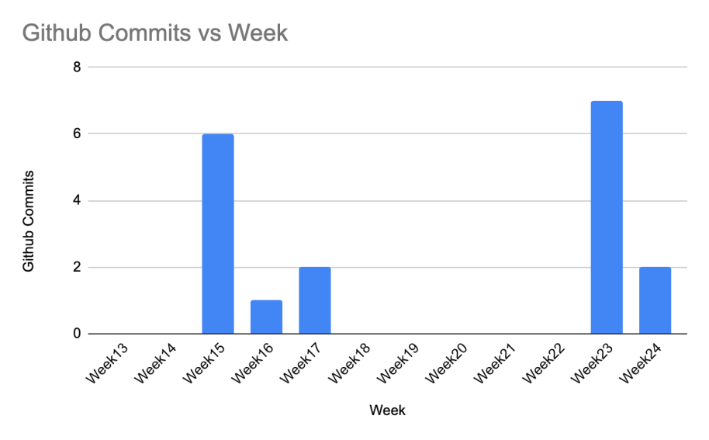

Based on the records shown on the Github, I contributed to 18 commits, including 5052301 additions and 3293 deletions.

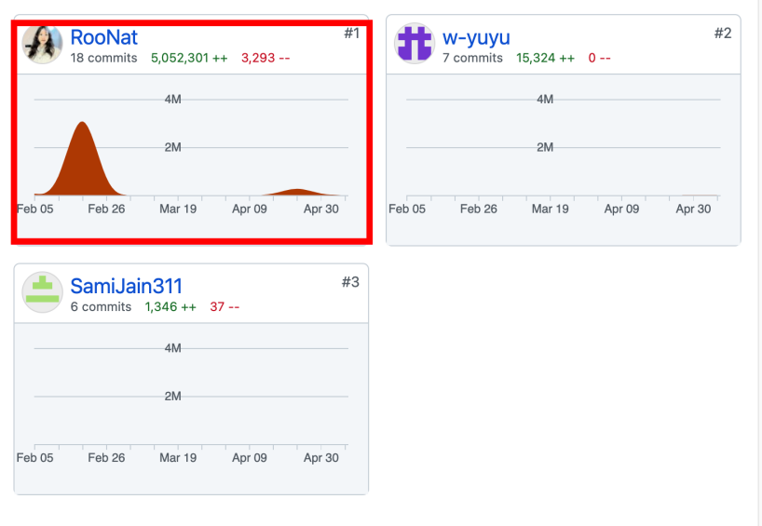

## Activities

For the first several weeks, I spent most of the time on reading paper, data processing and analysing the data format. Basically, we had the meetings once or twice a week. I always performed actively over the period. After the spring break, I spent most time on feature engineering and model optimizing. Therefore, I did provide abundant papers and materials for members to write the report.

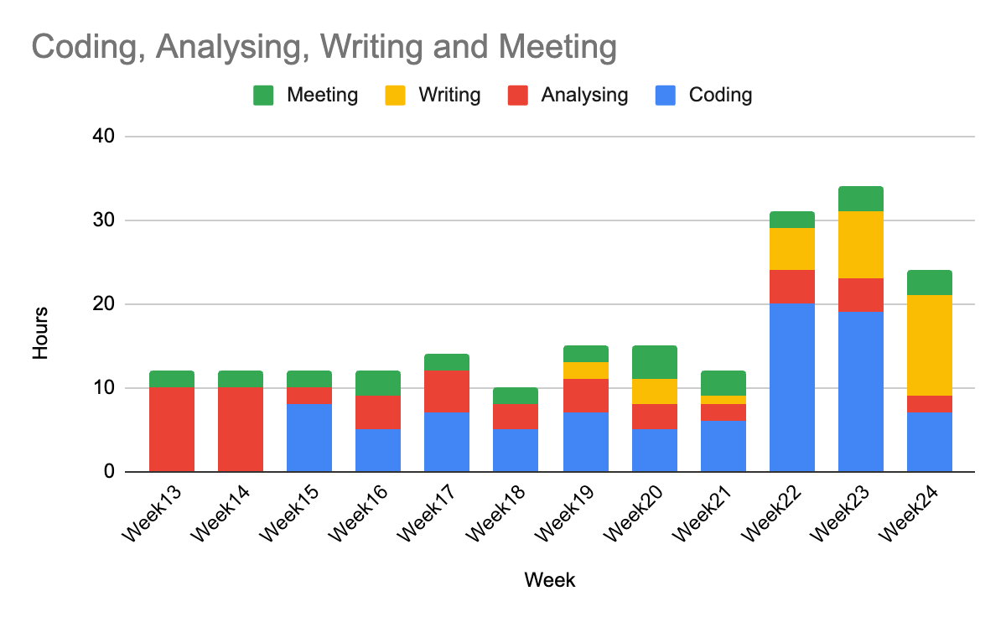

Appendices： Log Activities

