A simple how to use the nmea converter plugin.

Enable en open preference dialog.
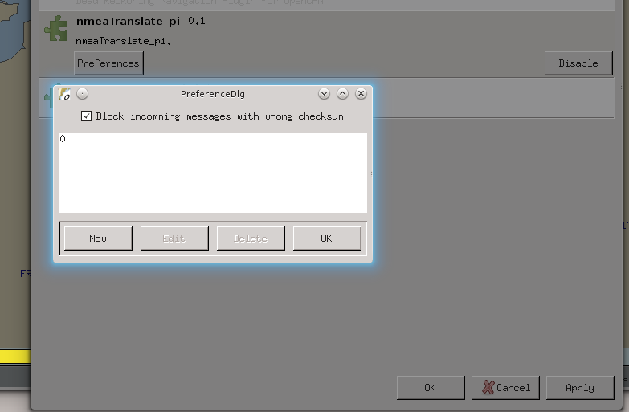
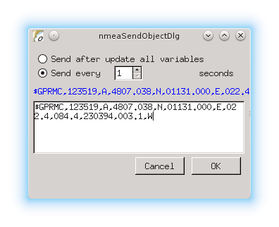
Press New.

Here I instructed the plugin to send every 1 second a $GPRMC messages. Nothing special yet, but usefull for testing. In the nmea debug window it will look like this.
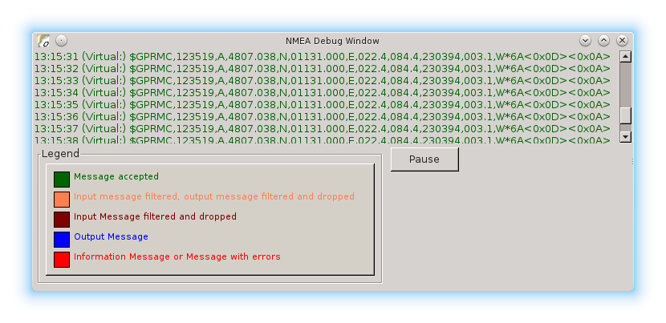
The reason I started this plugin was that I wanted the dashboard to show the air temperature. I do have an Airmar PB200 that sends a $WIMDA messages including data for air temp. The Dashboard however is expecting a $xxMTA sentence.

A MTA looks like this: $WIMDA,30.1029,I,1.0194,B,11.3,C,,,,,,,18.6,T,18.5,M,5.8,N,3.0,M*2D
the wanted sentense should look like: $xxMTA,11.3,C
The data needed is in the WIMDA fields 5 and 6
Making a new nmea object like this does the trick:
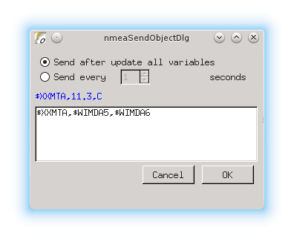
This will send a new made MTA sentence with the data taken from the MDA sentence.
As soon new data becomes available the new sentence is transmitted.

This could come handy with hardware that is picky with the nmea data.

