A simple how to use the nmea converter plugin.

Enable en open preference dialog.
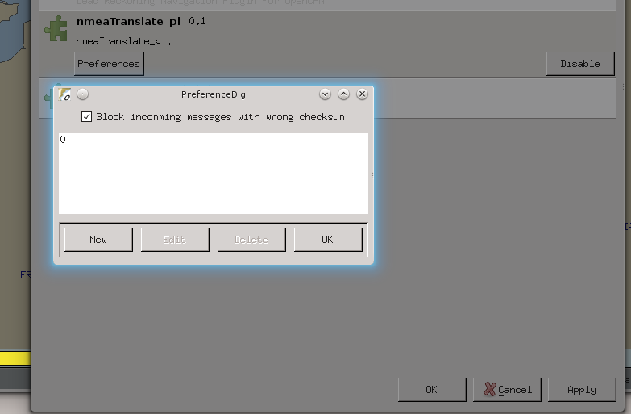
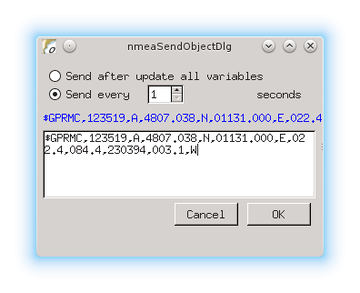
Press New.

Here I instructed the plugin to send every 1 second a $GPRMC messages. Nothing special yet, but usefull for testing. In the nmea debug window it will look like this.
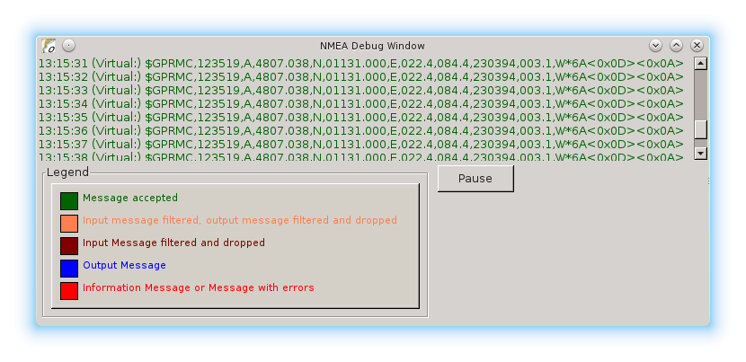
The reason I started this plugin was that I wanted the dashboard to show the air temperature. I do have an Airmar PB200 that sends a $WIMDA messages including data for air temp. The Dashboard however is expecting a $xxMTA sentence.

A MTA looks like this: $WIMDA,30.1029,I,1.0194,B,11.3,C,,,,,,,18.6,T,18.5,M,5.8,N,3.0,M*2D
the wanted sentense should look like: $xxMTA,11.3,C
The data needed is in the WIMDA fields 5 and 6
Making a new nmea object like this does the trick:
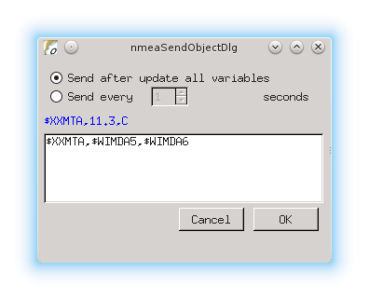
This will send a new made MTA sentence with the data taken from the MDA sentence.
As soon new data becomes available the new sentence is transmitted.

This could come handy with hardware that is picky with the nmea data.
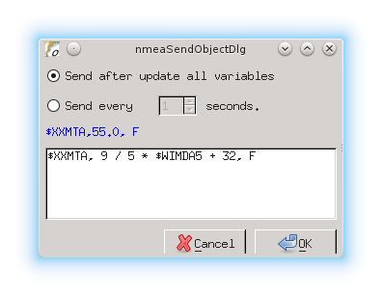
But what if I want the temp reading in degrees Fahrenheit.
Simple do: (see left)

You could also calculate true wind from apearrent wind, speed and course.

Or depth from meters to fathoms and corrected for depth of tranducer.

Or …..........

Supported functons:
Normal functions
- abs : the absolute value, it removes the sign
- ceil : the smallest integer greater than or equal to x
- cub : x^3, safe way to compute such an exponent
- deg : converts from radian to degree
- exp : the exponential value
- hvi : Heaviside's function, =0 if x<0, =1 if x>=0
- int : the largest integer less than or equal to x
- inv : inverts, 1/x
- floor : not supported, see int
- ln : the neperian logarithm
- lnep : see ln
- log : the logarithm base 10
- rad : converts from degree to radian
- sgn : the sign, -1 or +1. Zero returns +1.
- sqr : x^2, safe way to compute such an exponent
- sqrt : the root square

Trigonometric functions
- acos : the secant (inverse of cosine)
- acsh : the inverse of the hyperbolic cosine
- asin : the cosecant (inverse of sine)
- asnh : the inverse of the hyperbolic sine
- atan : the cotangent (inverse of tangent)
- atnh : the inverse of the hyperbolic tangent
- cos : the cosine
- cosh : the hyperbolic cosine
- sin : the sine
- sinc : the cardinal sine (radian)
- sinh : the hyperbolic sine
- tan : the tangent
- tanh : the hyperbolic tangent

