**TTM AUDIT TRAINING**

**12 December**

**&**

**20 February**

This course aims to:

* Increase safety for the road users (pedestrians, cyclists and drivers) on Wellington City roads by identifying shortcomings in temporary traffic management at sites in the WCC road corridor
* Clarify the required use of other site documentation and practices

Ensure operators use best practice standards and understand the need to comply with health and safety regulations and requirements of the NZTA CoPTTM 4th edition



Clarify the role of the auditor; develop practical skills and knowledge to carry out the duties of a TTM worksite auditor in a constructive and effective manner



Equip auditors with the methodology and tools to be confident in this role and with the audit procedures



ABOUT THE TRAINING

Participants will acquire skills and knowledge by:

Carrying out practical assessments of TTM worksites using the *Audit Forms (Short and Full)*



Identifying the elements of a roadwork site that do not conform to NZTA CoPTTM 4th edition standards



* Identifying specific elements of the MBIE safety guidelines on site that may be omitted or not carried out
* Identifying and assessing required onsite documents
* Learning how to give clear, constructive feedback of the audit results to personnel responsible for the site

Learning how to reach agreement on all actions needed including dealing with confrontation



Learning strategies for managing the audit when elements are identified as dangerous



Using the *Non-Conformance Form*



COURSE STRUCTURE

One day 8am – 4.30pm - course delivery in two parts:



Part One: Interactive workshop (classroom based)



* Part Two: Practical Site Audits & Interactive Assessment



COURSE OVERVIEW

**TRAINING ASPIRATIONS LTD**

**P**  +64 4 386 3575

**E** 021 386 357

**E** office@trainingaspirations.com

**W** trainingaspirations.com

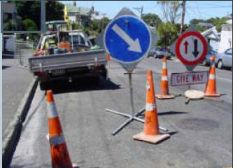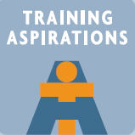

**TTM AUDIT TRAINING**

continued

**12 December**

**&**

**20 February**

COURSE CONTENT (Classroom-based)

* WCC summary of recent site issues
* Audit rationale and principles
* Documents that must be onsite and practically adhered to
* The audit process
* Completing the short and full audit forms
* How to give feedback onsite
* Powers and delegations
* Practice in the training room



PRACTICAL SESSION & ASSESSMENT

Participants complete two practical onsite audits to help reinforce the learning of the audit process and procedures. Our facilitators assess participant’s accuracy in using the audit tools blended with the audit style.

On satisfactory completion of the course, participants are issued with their *Auditor Card* authorizing them to carry out the *WCC* *Auditing Procedure* on behalf of Wellington City Council. The card is issued within a fortnight of completing the assessment.

Participants are given the *Audit Forms pad* at the course. Further copies can be ordered on-line from *www.trainingaspirations.com*

MATERIALS PROVIDED

Course workbook



*Audit* *Forms pad*



**WCC Auditors must hold a current L1 STMS qualification, or registered to complete STMS training within 4 weeks of this course. The *WCC Auditors Card* cannot be issued until the STMS training is successfully completed.**

**COST**

$350 per person plus GST

**Additional cost applies for copy of Local Road Supplement to NZTA CoPTTM as needed**

