UPDATE NOTES 0.0.2

Due to the inability to click a node and creating subsequent nodes from the clicked node, I had to redesign how this tool works.

If there is any issues with it please let me know.

1. When creating a journey, the user now has the ability to create additional paths. When the Recording is stopped (by clicking the red ‘recording’ text ), a brand new panel with all the creating nodes/path will appear. 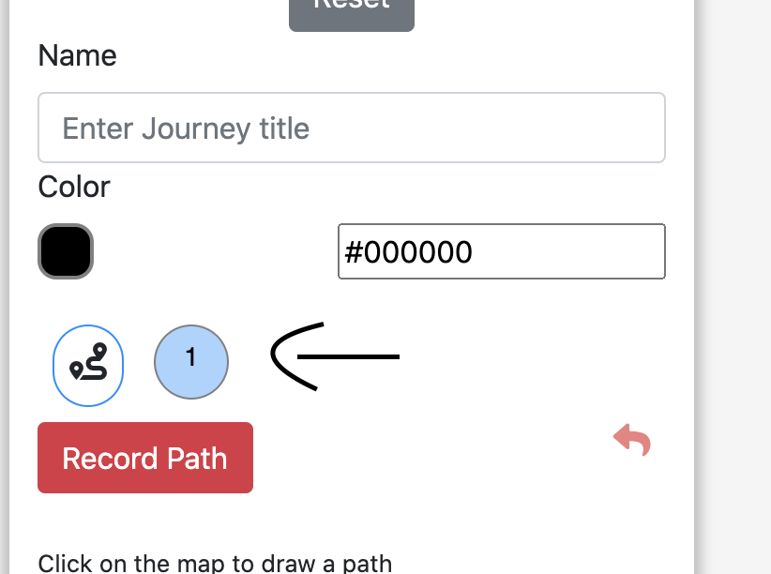
2. The current path will be highlighted blue, and when the other node-bubble is selected IT becomes the active path, you can go back to any created path and edit the color or the nodes. This makes drawing alternative paths easier as well. 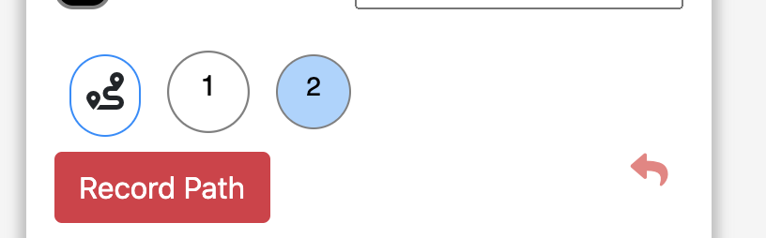
3. Save To Json is no longer needed and has been removed, to save the current journey click the ‘save File’ button.

These are the main changes to the tool, if you have any query don’t hesitate to ask