

CSUSB Mobile Navigation App
Software Project Management Plan
Revision 1.3
February 19, 2015

Prepared by:
Michael Monaghan (Project Manager)
Kyle Summers (Assistant Project Manager) Advisor: Dr. Arturo Concepcion.

Contents:

1. Overview:
1.1 Project summary
1.1.1 Purpose, scope, and objectives
1.1.2 Assumptions and constraints
1.1.3 Project deliverables
1.1.4 Schedule and budget summary
1.2 Evolution of the plan
2. References
3. Definitions
4. Project organization
4.1 External interfaces
4.2 Internal structure
4.3 Roles and responsibilities
5. Managerial process plans
5.1 Start-up plan
5.1.1 Staffing plan
5.1.2 Resource acquisition plan
5.1.3 Project staff training plan
5.2 Work plan
5.2.1 Work activities
5.2.2 Schedule allocation
5.2.3 Resource allocation
5.3 Control plan
5.3.1 Requirements control plan
5.3.2 Schedule control plan
5.3.3 Budget control plan
5.3.4 Quality control plan
5.3.5 Reporting plan
5.4 Risk management plan
5.5. Closeout plan
6. Technical process plans
6.1 Process model
6.2 Methods, tools, and techniques
6.3 Infrastructure plan
6.4 Product acceptance plan
7. Supporting process plans
7.1 Configuration management plan
7.2 Verification and validation plan
7.3 Documentation plan
7.4 Quality assurance plan
7.5 Reviews and audits
7.6 Problem resolution plan

1. Overview

1.1 Project summary

1.1.1 Purpose, scope, and objectives
This Software Project Management Plan outlines the management of the Room Quest android app development. This document contains the requirements, the development cycle plans, protocols for testing, and other details for the application. The intended audience for the SRS is Dr. Concepcion.

With a 430 acre campus and the constant ongoing construction of new buildings and facilities, you may want to refer to a map that will help you find your way around.
The software to be designed will be an Android app to aid students unfamiliar with parts of the campus in locating classrooms and offices.The application will allow students to search buildings for rooms and offices by imputing either the room name, faculty member's name, or office name. The information regarding room names and faculty names will be hosted on a server so the app will not need to be updated when room names and faculty offices change.
The first iteration of the app will only include Jack Brown Hall as it includes
many different offices and classrooms.

1.1.2 Assumptions and constraints
- The programmers are following the SRS.
- The client responds in a reasonably timely manner
- The Team members attend lab meetings
- The Team members allocate time outside of class for development of the project.
- GitLab and GitHub as a backup remain online

1.1.3 Project deliverables
- Documentation
  - SRS
  - SPMP
  - SQAP
  - Software Architecture
  - Interface
  - Design
  - Repository commitments
- The Room Quest Android app
  - Browsing building layouts
  - Displaying Classroom and Office location
  - Office and Room searching

1.1.4 Schedule and budget summary
No budget has been given for this project. Prototype #1 will be delivered on 25 Feb 2015 and Prototype #2 will be delivered on 25 Mar 2015.

1.2 Evolution of the plan
There will be two different iterations of development. The first iteration will include initial development of a prototype. The prototype will then be presented to QA for approval. The second iteration will resolve issues pointed out by the QA team as well as include any new features requested by the client and the advisor.
Each version of the SPMP will be submitted to Dr. Arturo Concepcion for approval. Upon return, the SPMP will be revised.

2. References
Software Project Management Plan IEEE 1058-1998
Sample SPMP: Student Advising, Winter 2014
Room Quest SRS 1.1, Winter 2015

3. Definitions

Android
A Linux-based operating system designed primarily for touchscreen mobile devices such as smartphones and tablet computers.

Android 4.0 (Ice Cream Sandwich)
The 15th version of the Android Operating System dubbed Android 4.0 Ice Cream Sandwich. According to the Google developer statistics more than 90% of active devices run this version or newer. Each version of the Android operating system has an additional number of features available which is why android versions below a certain number are not supported by certain applications.

API (Application Programing Interface)
A set of routines, protocols, and tools for building software applications.

CSV
A Comma Separated Values file is an industry standard, file format Microsoft Excel can export to. CSV files contain a single table with information such as Professor name and office number.

Disk space
Long term storage for data. This is where music, apps, photos, and other information is kept.

GPS
Global Positioning System. A satellite-based navigation system.

HTTPS
Hyper Text Transfer Protocol Secure; A standard protocol for transmitting information over the Internet which encrypts information to prevent eavesdropping.

IEEE
Institute of Electrical and Electronics Engineers

iOS
An operating system manufactured by Apple to be used on mobile devices.

MB/MiB
Often used interchangeably, the megabyte (MB) and mebibyte (MiB) is a multiple of the unit byte which is the fundamental unit of measurement for digital information. A megabyte is 1,000,000 bytes and a mebibyte is 1,048,576 bytes.

Pixel Density
The number of pixels per unit area. Devices with high pixel density will use more memory.

QA (Quality Assurance)
The team responsible for verifying that the application produced by the software team meets its
requirements.

RAM (Random Access Memory)
A type of computer memory used for fast access during program operation.

Server
A server is a computer that provides data to other computers or devices.

UI
A User Interface is everything designed into an information device though with which a human may interact with.

WiFi
A local area wireless technology that allows an electronic device to participate in computer networking.

4. Project organization

4.1 External interfaces
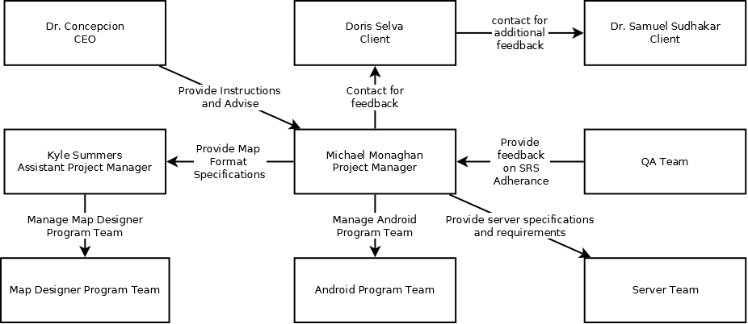

4.2 Internal structure

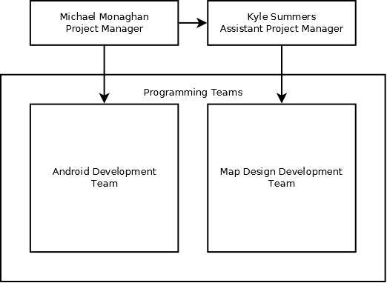

4.3 Roles and responsibilities

Name: | Role: | Responsibility:
Michael Monaghan | Project Manager | Conduct meetings.  Communicate with client.  Oversees all teams.  Ensure adherence of the app to the SRS.
Kyle Summers | Assistant Manager | Oversees Map Designer team.  Manages Time Line.
Patricio Torres | Programmer | Android Programming
Brian Ackley | Programmer | Android Programming
Alden Amoranto | Programmer | Map Design
David Perez | Programmer | Map Design
Joseph Hook | Art Intern | Graphics Design  Provide any additional graphics required.  Assist in designing a UI

5. Managerial process plans

5.1 Start-up plan
The start up plan consists of creating the specifications, researching the required technologies, learning enough Java for android development, setting up the development environment and setting up a version control system.

5.1.1 Staffing plan
A team for Room Quest was selected through a survey administered in the first week of class. Roles would later be assigned based on each student’s specific abilities.

5.1.2 Resource acquisition plan
Servers and workstations provided by the CSE department. Android devices for testing will be provided by other team members and Dr. Concepcion if needed.

5.1.3 Project staff training plan
The team spend the following week on android development training. Training for the Room Quest development included reading documentation and tutorials from the Android development site for the android programming team and the Qt documentation for the Map Designer team. No future training will be required.

5.2 Work plan

5.2.1 Work activities
- Prototype: Develop an early working build of the application that will demonstrate the core functions outlined in the SRS.
- Graphic Design: Develop the layout, styles, Icons, and graphics for the map and the android app UI.
- Programming: Develop code for the UI, parsing, searching, etc.
- Testing: Verify application reliability and functionality.
- Documentation: Keep the application easily maintainable for future programmers as well as operable by the end user.

5.2.2 Schedule allocation
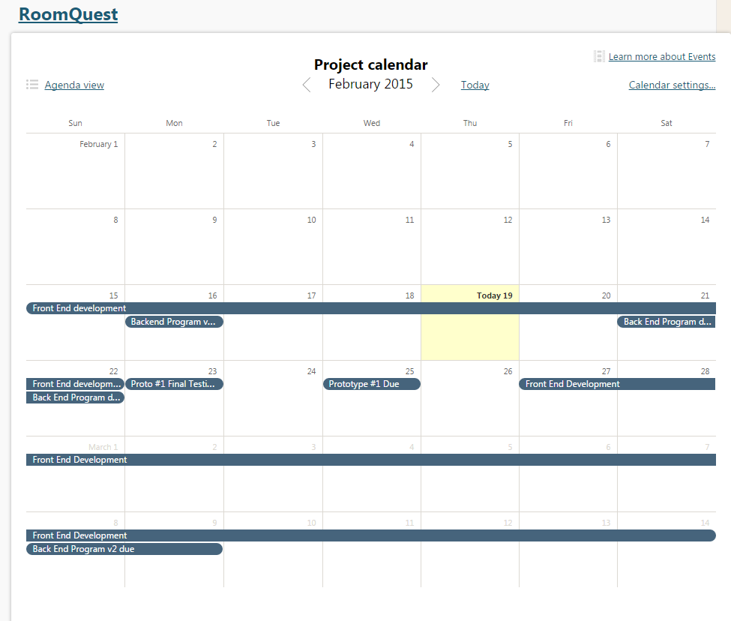
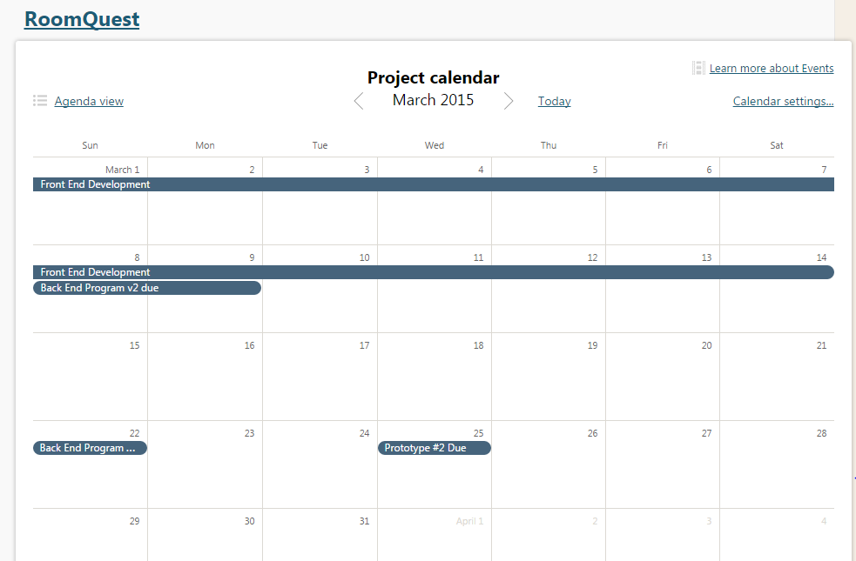

5.2.3 Resource allocation
Building layouts as well as professor and department office locations and names will need to be obtained.

5.3 Control plan

5.3.1 Requirements control plan
Meetings will be conducted bi-weekly with our team.The client will be updated about prototypes and any changes or modifications. A change in requirements will be handled to the best ability of the team to meet the clients needs and wishes.

5.3.2 Schedule control plan
Dr. Concepcion will conduct meetings with Project Managers and Assistant Managers. Michael Monaghan and Kyle Summers will inform Dr. Concepcion of the teams progress. Teams progress will be evaluated continuously. A change of schedule will be handled by the Project Managers, if the need arises.

5.3.3 Budget control plan
There will be no budget to manage.

5.3.4 Quality control plan
Michael Monaghan continuously check adherence with the project and the SRS. He will also consult the client for any specifics.

In order for a mobile app to meet high quality standards, the Quality Assurance (QA) team will test the product and verify if the product meets the steps listed in the Software Quality Assurance Plan (SQAP). All products must be delivered in the repositories of the development teams and these will be tested on Android and/or Apple iOS devices. The QA team will use Bugzilla to help keep track of any bugs found in a product. Any errors recorded during the testing of a product will be reported to the respective Project Manager to be repaired. The testing scenarios for each project are derived from the Software Requirement Specifications (SRS) from the development teams.

5.3.5 Reporting plan
Meetings will be held by Dr. Concepcion to report the progress and status of the application in detail and time line. Team members will report to their managers respectively during class meetings on Mondays and Wednesdays.

5.4 Risk management plan
Several procedures will be used to manage risks.

In the case of loss or inavailability of team members:
• Management will pick up slack
• Members from other projects may be utilized

In the case of Equipment Loss:
- Project team are held individually liable for any physical equipment loss
Server Unavailability:
- The application will be designed to cache data retrieved from the server previously.
- The server team will be contacted via email to inform the team about the unavailability.

5.5. Closeout plan
- Presentation of deliverables to Dr. Concepcion
- Presentation of application to Client
- Final documentation review
- Audit of software
- Submittance of maintenance manual
- Transfer of assets to Dr. Concepcion

6. Technical process plans

6.1 Process model
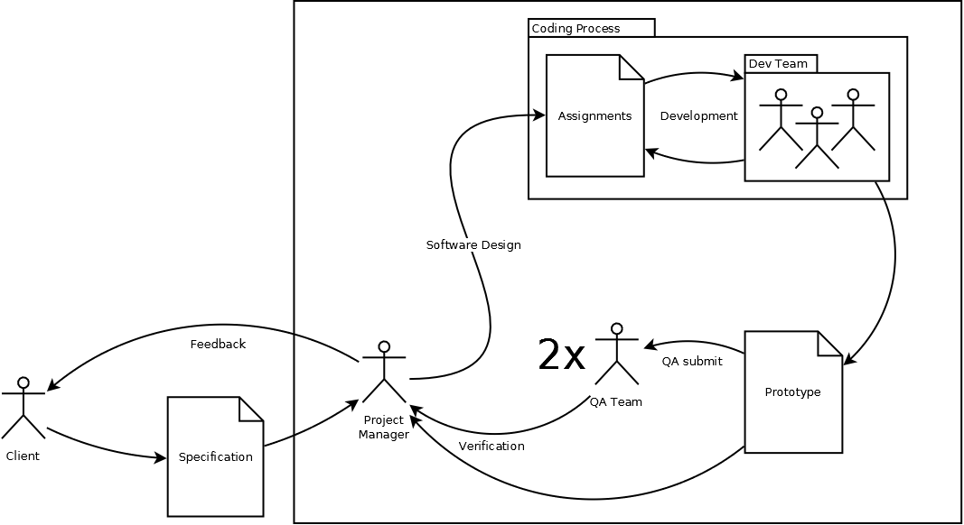
First, Requirements will be designed and compiled into an SRS document with heavy involvement of the client and project manager. According to requirements outlined in the SRS, a system will then be designed. The project manager will then take the role as the software designer. The project manager will assign tasks to each member of the team. Once all the tasks are complete, The project manager will integrate the code together and submit to QA for verification of the first prototype. This process will be repeated again for the final prototype. In the end, documentation, operation manuals, etc. will be compiled for further development and maintenance.

6.2 Methods, tools, and techniques
Methods:
- Agile software development
- Extreme programming
Tools
- Android SDK
- Dia
- Qt Creator
Techniques
- Unit testing
- design and code reviews

6.3 Infrastructure plan
Further development plans will be assessed upon completion of the app.
An HTTPS server with SFTP will be provided for Room Quest by the server team. Server team will manage the creation of the server.

6.4 Product acceptance plan
The clients, Doris Casillas and Dr. Sudhakar, will test the final product.
The main areas of focus are:

- Intuitive UI
- Responsive UI
- Functional design
- Proof of concept

7. Supporting process plans

7.1 Configuration management plan

All of the projects documentation or any building block of the overall project will be considered configuration items. They will be named after the document (SRS, SPMP, SQAP), followed by a version number. Each code revision will be submitted to a respective development branch on Git to be inspected then merged with the project by Michael Monaghan.

7.2 Verification and validation plan
The project will be submitted to the quality assurance team for assessment.

7.3 Documentation plan
Michael Monaghan and Kyle Summers will document the project using Standard Javadocs. Michael Monaghan will review the documentation.

7.4 Quality assurance plan
The team will submit its code to the quality assurance team for assessment. The team will test the application individually to find and fix any errors or bugs found.

7.5 Reviews and audits
Michael Monaghan will review and audit all code, documentation and other files before merged into the master development branch.

7.6 Problem resolution plan
Problems will be resolved among the entire development team internally. If there is an issue resolving an issue internally, Dr. Concepcion will be consulted.

7.7 Subcontractor Management Plan
Not applicable.

7.8 Process Improvement Plan

