

CSUSB Mobile Navigation App

Software Requirements Specification
Revision 1.0
January 30, 2015

Prepared by:

Michael Monaghan (Project Manager)

Kyle Summers (Assistant Project Manager)

David Perez

Brian Ackley

Patricio Torres

Alden Amoranto

Joseph Hook (Graphics Intern)

Garry Lawrence (Server Team) Advisor: Dr. Arturo Concepcion

Contents:

1. Introduction
1.1 Purpose
1.2 Scope
1.3 Definitions, Acronyms, and Abbreviations
1.4 References
1.5 Overview

2. Overall Description
2.1 Product Perspectives
2.1.1 System Interfaces
2.1.2 User Interfaces
2.1.3 Software Interfaces
2.1.4 Communication Interfaces
2.1.5 Memory
2.1.6 Operation
2.1.7 Site Adaptation requirements
2.2 Product Functions
2.3 User Characteristics
2.4 Constraints
2.5 Assumptions and Dependencies

3. Specific Requirements
3.1 External Interface Requirements
3.1.1 User Interfaces
3.1.2 Hardware Interfaces
3.1.3 Software Interfaces
3.1.4 Communication interfaces
3.2 Functional Requirements
3.2.1 Searching Functionality
3.2.2 Map Display Functionality
3.3 Performance Requirements
3.4 Design Constraints
3.5 Software System Attributes
3.6 Security Requirements
3.7 Document Approval

1. Introduction

1.1 Purpose
This document gives an overview of the functionality, specifications, and requirements of the application being developed. This application has been requested for development by Doris Casillas and Dr. Samuel Sudhakar. The development and progress of this project will be overseen by Dr. Concepcion, and will be done as part of the class requirement for CSE455 Software Engineering.

1.2 Scope of the Project
With a 430 acre campus and the constant ongoing construction of new buildings and facilities, you may want to refer to a map that will help you find your way around.

The software to be designed will be an Android app to aid students unfamiliar with the campus or parts of the campus to locate classrooms and faculty offices.

The application will allow students to search the campus for rooms and offices given the room name or faculty name.

The information regarding room names and faculty names will be hosted on a server so the app will not need to be updated when room names and faculty offices change.

1.3 Definitions, Acronyms, and Abbreviations

Android
A Linux-based operating system designed primarily for touchscreen mobile devices such as smart phones and tablet computers.

Android 4.0 (Ice Cream Sandwich)
The 15th version of the Android Operating System dubbed Android 4.0 Ice Cream Sandwich. According to the Google developer statistics more than 90% of active devices run this version or newer. Each version of the Android operating system has an additional number of features available which is why android versions below a certain number are not supported by certain applications.

API (Application Programing Interface)
A set of routines, protocols, and tools for building software applications.

CSV
A Comma Separated Values file is an industry standard, file format Microsoft Excel can export to. CSV files contain a single table with information such as Professor name and office number.

Disk space
Long term storage for data. This is where music, apps, photos, and other information is kept.

GPS
Global Positioning System. A satellite-based navigation system.

HTTPS
Hyper Text Transfer Protocol Secure; A standard protocol for transmitting information over the Internet which encrypts information to prevent eavesdropping.

IEEE
Institute of Electrical and Electronics Engineers

iOS
An operating system manufactured by Apple to be used on mobile devices.

MB/MiB
Often used interchangeably, the megabyte (MB) and mebibyte (MiB) is a multiple of the unit byte which is the fundamental unit of measurement for digital information. A megabyte is 1,000,000 bytes and a mebibyte is 1,048,576 bytes.

Pixel Density
The number of pixels per unit area. Devices with high pixel density will use more memory.

QA (Quality Assurance)
The team responsible for verifying that the application produced by the software team meets its
requirements.

RAM (Random Access Memory)
A type of computer memory used for fast access during program operation.

Server
A server is a computer that provides data to other computers or devices.

UI
A User Interface is everything designed into an information device though with which a human may interact with.

WiFi
A local area wireless technology that allows an electronic device to participate in computer networking.

1.4 References
- IEEE Std 830-1998 Software Requirements Specification
- Google Developer Website: developer.android.com
- CSUSB School Colors Policies Document: http://policies.csusb.edu/schoolcolors.htm

1.5 Overview
This rest of this document is made up of two sections. Section 2 is an overview of the entire application, describing the interfaces, constraints, functions, and dependencies. Section 3 describes detailed requirements regarding the implementation of the application.

2. Overall Description

2.1 Product Perspectives
The following are the core features that will be added to the application:
- Android phone/tablet compatibility.
- Access to building layouts with labeled room numbers and doors.
- Locating rooms within a building given a room number e.g. JB358.
- Locating offices given a faculty member’s name.
If time allows, an attempt will be made to implement the following optional features:
- iOS Compatibility
- Way point navigation to rooms and offices

2.1.1 System Interfaces

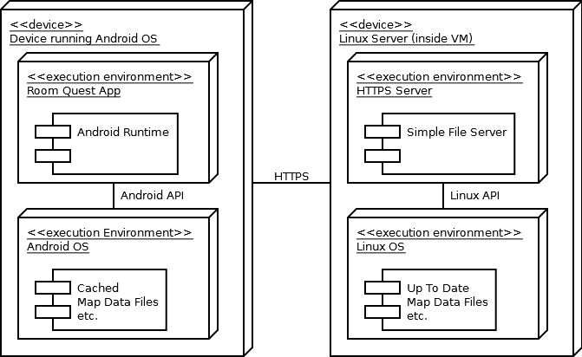
Figure 1: Room Quest Deployment Diagram

The map data will change quite frequently making it a requirement to reside on a server.

2.1.2 User Interfaces
The user interface will provide the user with a map of the building that they are looking for or are currently inside of, and will provide the ability to search for and locate rooms within that building. This will be separated into two different user interfaces.

2.1.3 Software Interfaces
Room Quest will be programed entirely in the Java programming language. The server side will be programed in whatever programming language is preferred by the programmer for the specific task at hand.

2.1.4 Communication Interfaces
Once downloaded over WiFi or a cellular data connection, the app will download files from the server so the app will not need to be updated every time a faculty office or room number changes.

2.1.5 Memory
RAM usage will vary based on several factors such as pixel density and Android version. High pixel density devices usually have a larger RAM footprint, however to compensate these devices usually have more RAM installed. Keeping this in mind, and considering that this is a graphically intensive application, the RAM usage should not exceed 100MiB.

When all maps are downloaded, the application should not use more than 20MiB of disk space.

2.1.6 Operation
The operation of the app is as follows:
- The user will download the app from the Google Play store over WiFi or a cellular data connection.
- The user opens the app and inputs either the faculty name or room number.
- The location of the room is presented to the user alongside with the estimated current location.

2.1.7 Site Adaptation Requirements
There will be no need for any adaptation.

2.2 Product Functions

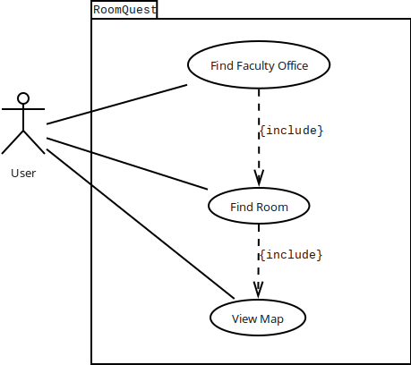
Figure 2: Room Quest Use Case Diagram

2.3 User Characteristics
The application will be used by faculty, students, and visitors of the campus. All users should be able to access all the same information to locate any given room location in a building.

Since this application is being developed for Android, it will be distributed on the Google Play store, and at this time will only be developed on the Android platform.

2.4 Constraints
- Room Quest will be limited to running on devices running Android 4.0 or greater.
- Precise Location will require the device to have GPS capabilities.
- Accessing a new map may require an Internet connection.

2.5 Assumptions and Dependencies
The technologies used for this app at the moment will not change. The location of the WiFi sources might change, either adding, removing, or change of location. This will affect the locating capabilities of the app slightly.

3. Specifications Requirements

3.1 External Interface Requirements

3.1.1 User Interfaces
All Icons and the overall theme will cohere to CSUSB policies regarding school colors. The policies can be found here: The general theme will be blue, white, black, and grey. Main shades of blue and grey will be Pantone® 300 and 60% Grey.

Figure 3: Color Theme

Room Quest will follow the standard Android design patterns described here: https://developer.android.com/design/patterns/index.html.

The following graphic demonstrates some concepts of the user interface.

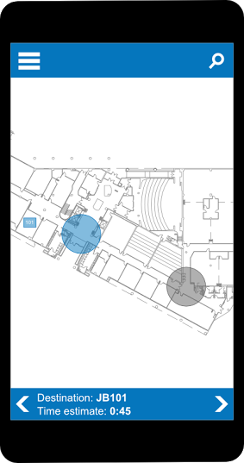
Figure 4: Concept graphic for Jack Brown Hall floor 1 map user interface

The user will be presented with a search button they can use to search the CSUSB campus for faculty offices and rooms.

A map will display the location of the room previously searched for.

This is a general overlay of the building one would be in with the room being showed with its room number and a location of the user being provided with the circle.

3.1.2 Hardware Interfaces
The application will be using WiFi and GPS together in an attempt to locate the user’s general location.

3.1.3 Software Interfaces
The software interface will be created using the floor plans of the university’s buildings to provide students with an idea of where offices and classrooms are and how to get there.

3.1.4 Communication Interfaces
If successful, the GPS function will be implemented into the application

3.2 Functional Requirements
The following features will be available in the application:

3.2.1 Searching
- Input professor’s name to display where the office is located in the building or campus.
- Input desired building to display on the map.

3.2.2 Display Map
- Room locations will be provided on top of the floor plan to indicate were each room is located.
- Floor plan of the building will be provided to the user.
- Indicate the users general location on the map.

3.3 Performance Requirements
The app must respond reasonably quickly to user input. The app must not take longer than 20 seconds to download immediately relevant data from the server.

3.4 Design Constraints
There are many different buildings on campus with many different rooms. Time will be a factor in implementing every room to every building of the campus.
GPS can be very inaccurate indoors and may occasionally cause confusion.

3.5 Software System Attributes
The application should be able to run on Android 4.0 (Ice Cream Sandwich), API level 15, and newer. The system must also be able to have some type of WiFi access.

3.6 Security Requirements
As patterns of information accessed could potentially reveal information about the user’s movements, all information will be delivered over HTTPS to prevent eavesdropping.

3.7 Document Approval
This document must be approved by:

- Doris Casillas - Client
- Dr. Samuel Sudhakar - Client
- Michael Monaghan - Project Manager
- Dr. Arturo Concepcion - Project Advisor

