User Manual for RoomQuest Application



Development team:

Michael Monaghan (Project Manager)

Kyle Summers (Assistant Project Manager)

David Perez

Brian Ackley

Patricio Torres

Alden Amoranto

Joseph Hook (Graphics Intern) Advisor: Dr. Arturo Concepcion

Overview of the App

The application will help you find your way around California State University of San Bernardino and allow students to search buildings for rooms and offices by imputing either the room name, faculty member's name, or office name.

Functions of the application
- The display of building maps around the campus of California State University of San Bernardino:
- The user can select a building from around campus and the building selected will appear to the user with the floor plan of the first floor with room numbers appearing for each room.
- The user can select a floor they wish to view.
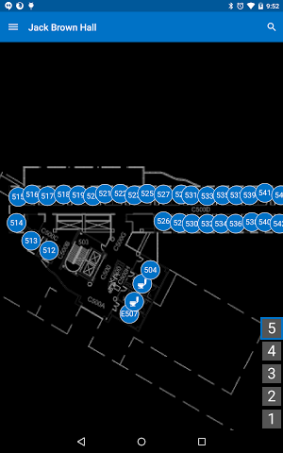
- Searching capabilities to find the specific room being searched for.
2. Wifi locator:
- The application locates the user via a wifi locator within the building the user is located in.
3. Server Synchronization:
- The application, on startup, synchronizes with the server to obtain the maps and locations of rooms. This allows for easy maintenance and updates to the files.
- A sync button located in the application to make sure all map information is the most up to date.
4. Navigation:
- You navigate through the app using the tab bar that appears at the left side of the main screens of the app. Will displays the buildings available throughout the campus.
- You have a search button on the top right corner to easily search for a building, room number or professor name without using the tab bar.
5. Zoom capability:
- The application has the ability of zooming in and out, to achieve a closer view of the image.

Maintenance
Please reference the maintenance manual for the maintaining of the application and/or updating of the application.

