# Summer 2023 anime

# Series

## Am I Actually the Strongest?

### 7 episodes



## Atelier Ryza: Ever Darkness & the Secret Hideout

### 9 episodes



## Ayaka

### 9 episodes



## Baki: Son of Ogre 2

### 27 episodes

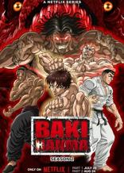

## BanG Dream! It's MyGO!!!!!

### 11 episodes



## Bastard!! Heavy Metal, Dark Fantasy Season 2

### 15 episodes

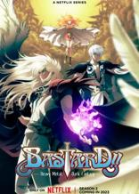

## Bleach: Thousand-Year Blood War: Part II - The Separation

### 8 episodes



## Bleach: Thousand-Year Blood War: Part II - The Separation Recap

### 0 episodes



## Bungo Stray Dogs 5th Season

### 7 episodes



## Cardfight!! Vanguard: overDress 5th Season

### 7 episodes



## Classroom for Heroes

### 7 episodes



## Cute Executive Officer R

### 8 episodes



## Dark Gathering

### 7 episodes



## FLCL: Grunge

### 0 episodes



## Gamera: Rebirth

### 0 episodes

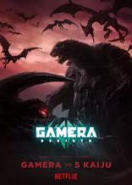

## Helck

### 7 episodes



## Horimiya: The Missing Pieces

### 9 episodes



## Hyakushou Kizoku

### 8 episodes



## Ikimono-san

### 7 episodes



## Jujutsu Kaisen 2nd Season

### 5 episodes



## Kyoukai Senki: Kyokkou no Souki

### 2 episodes

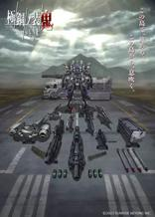

## Level 1 Demon Lord and One Room Hero

### 8 episodes



## Liar Liar

### 9 episodes



## Malevolent Spirits: Mononogatari - Part II

### 8 episodes



## Masamune-kun's Revenge R

### 8 episodes



## Mushoku Tensei: Jobless Reincarnation 2nd Season

### 7 episodes



## My Happy Marriage

### 8 episodes



## My Tiny Senpai

### 7 episodes



## My Tiny Senpai Mini Anime

### 5 episodes



## My Unique Skill Makes Me OP even at Level 1

### 8 episodes



## Naruto (New)

### 0 episodes



## Odekake Kozame

### 4 episodes



## Phoenix: Eden17

### 0 episodes



## Pokemon: Paldean Winds

### 0 episodes



## Puchi! Tokyo Mew Mew New～♡: Tart no Tanjoubi

### 1 episodes



## Reborn as a Vending Machine, I Now Wander the Dungeon

### 8 episodes



## Reign of the Seven Spellblades

### 8 episodes



## Rent-a-Girlfriend Season 3

### 7 episodes



## Rurouni Kenshin (2023)

### 8 episodes



## Saint Cecilia and Pastor Lawrence

### 7 episodes



## Seirei Gensouki: Spirit Chronicles Season 2 Mini Anime

### 1 episodes



## Shadowverse Flame: Seven Shadows-hen

### 8 episodes



## Spy Classroom 2nd Season

### 7 episodes



## Sugar Apple Fairy Tale: Part II

### 8 episodes



## Sweet Reincarnation

### 9 episodes



## Synduality Noir

### 7 episodes



## TenPuru

### 8 episodes



## TenPuru x Rent-a-Girlfriend Collab Mini Anime

### 4 episodes



## The Devil is a Part-Timer!! (2023)

### 7 episodes



## The Dreaming Boy is a Realist

### 8 episodes



## The Duke of Death and His Maid 2nd Season

### 7 episodes



## The Gene of AI

### 7 episodes



## The Girl I Like Forgot Her Glasses

### 8 episodes



## The Great Cleric

### 8 episodes



## The Masterful Cat is Depressed Again Today

### 7 episodes



## The Most Heretical Last Boss Queen: From Villainess to Savior

### 8 episodes



## The Seven Deadly Sins: Grudge of Edinburgh - Part II

### 1 episodes

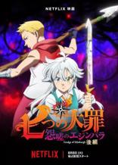

## TONIKAWA: Over The Moon For You - High School Days

### 4 episodes



## Undead Murder Farce

### 8 episodes



## Yamishibai: Japanese Ghost Stories 11th Season

### 7 episodes



## Yohane The Parhelion: Sunshine in the Mirror

### 9 episodes



## Zom 100: Bucket List of the Dead

### 5 episodes



## Zom 100: Bucket List of the Dead Recap

### 0 episodes



# Movies

## Crayon Shin-chan Movie 31: Chounouryoku Daikessen - Tobe Tobe Temakizushi

### 1 episodes



## Love Live! Nijigasaki High School Idol Club: Next Sky

### 1 episodes



## Osomatsu-san: Tamashii no Takoyaki Party to Densetsu no Otomarikai

### 1 episodes



## Rascal Does Not Dream of a Sister Venturing Out

### 1 episodes



## Resident Evil: Death Island

### 1 episodes



## Sand Land

### 1 episodes



## Sound! Euphonium: Special Edition - Ensemble Contest

### 1 episodes



## The Boy and the Heron

### 1 episodes



## The Quintessential Quintuplets∽

### 1 episodes



# OVA/Specials

## Azur Lane: Queen's Orders

### 2 episodes



## Fate/strange Fake: Whispers of Dawn

### 1 episodes



## Mushoku Tensei: Jobless Reincarnation 2nd Season - Guardian Fitz

### 1 episodes



## One Piece: Recapping Fierce Fights! The Countercharge Alliance vs. Big Mom

### 1 episodes



## Rhapsody

### 0 episodes



## The Devil is a Part-Timer! From Sasazuka to Ente Isla!

### 1 episodes

