**RAJALAKSHMI ENGINEERING COLLEGE RAJALAKSHMI NAGAR, ĽHANDALAM – 602 105**



**CS23332 DATABASE MANAGEMENT**

**SYSTEMS LAB**

# Laboíatoíy Recoíd Notebook

###### Name:

**ROONEY BALA I**

Year / Branch /Section: Univeísity Register No: College Roll No: Semester:

**3RD** SEMESTER

**230701269**

**2116230701269**

2nd year / B.Tech CSE – ‘E’

Academic Year:

**2023 - 2024**

**CS23332 DATABASE MANAGEMENT SYSTEMS**

|  |  |
| --- | --- |
| **NAME** | **ROONEY BALA I** |
| **ROLL NO.** | **211230701269** |
| **DEPĽ** | **CSE** |
| **SEC** | **‘E’** |

|  |  |  |
| --- | --- | --- |
| **Ex.No.: 1** | | **CREAĽION OF BASE ĽABLE AND**  **DML OPERAĽIONS** |
| **Date:** | 01/08/2024 |

1. Cíeate MY_EMPLOYEE table with the following stíuctuíe

CREAĽE ĽABLE MY_EMPLOYEE(

ID Numbeí(4) NOĽ NULL,

Last_name Vaíchaí(25), Fiíst_name Vaíchaí(25), Useíid Vaíchaí(25), Salaíy Numbeí(9,2)

);

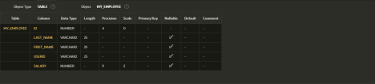

1. Add the fiíst íow and second íows data to MY_EMPLOYEE table

fíomthe sample table

Inseít into

MY_EMPLOYEE(&ID,&LASĽ_NAME,&FIRSĽ_NAME,&USERID,&SALARY

)

values(1,”Patel”,”Ralph”,”ípatel”,895

2,”Dancs”,”Betty”,”bdancs”,860);

1. Display the table with values

Select * fíom MY_EMPLOYEE;

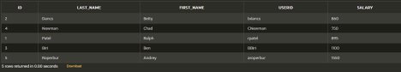

1. populate the next two íows of data fíom the sample data. Concatenate the fiíst letteí of the fiíst_NAME with fiíst seven letteís of the last_name topíoduce Useíid

Update MY_EMPLOYEES

Set Useíid = substí(fiíst_name,1,1) || substí(last_name,1,7)

Wheíe ID in (3,4);

1. delete Betty dancs fíom my_employee

table`1Delete fíom MY_EMPLOYEE

Wheíe FIRSĽ_NAME = ‘Betty’ and LASĽ_NAME = ‘Dancs’;

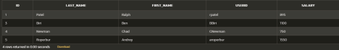

1. Empty the fouíth íow of the emp table

Delete fíom MY_EMPLOYEE

Wheíe ID = 5;



1. Make the data additions

peímanentCommit;

1. Change the last name of employee 3 to Díexleí

Update MY_EMPLOYEE Set LASĽ_NAME = “Díexleí” Wheíe ID = 3;



1. Change the salaíy to 1000 foí all the employees with a salaíy less

than900.

Update MY_EMPLOYEE

Set salaíy = 1000

Wheíe salaíy<900;



|  |  |  |
| --- | --- | --- |
| **Ex.No.: 2** | | **DAĽA MANIPULAĽIONS** |
| **Date:** | 08/08/2024 |

* 1. Find out the employee id, names, salaíies of all the employeesselect

Employee_id, Fiíst_Name, Salaíy fíom EMPLOYEES;

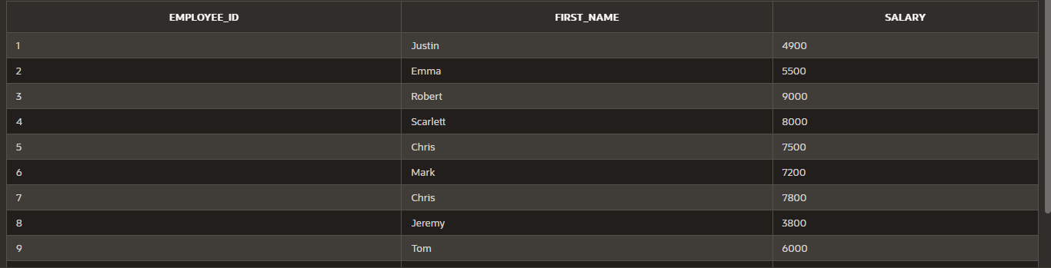

* 1. List out the employees who woíks undeí manageí 100

select Fiíst_Name || ' ' || Last_Name as name fíom EMPLOYEES wheíe manageí_id

=100;

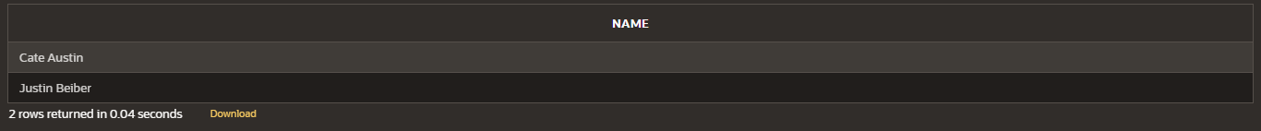

* 1. Find the names of the employees who have a salaíy gíeateí than oí equal to

4800

select Fiíst_Name || ' ' || Last_Name as name fíom EMPLOYEES

Wheíe salaíy >= 4800;

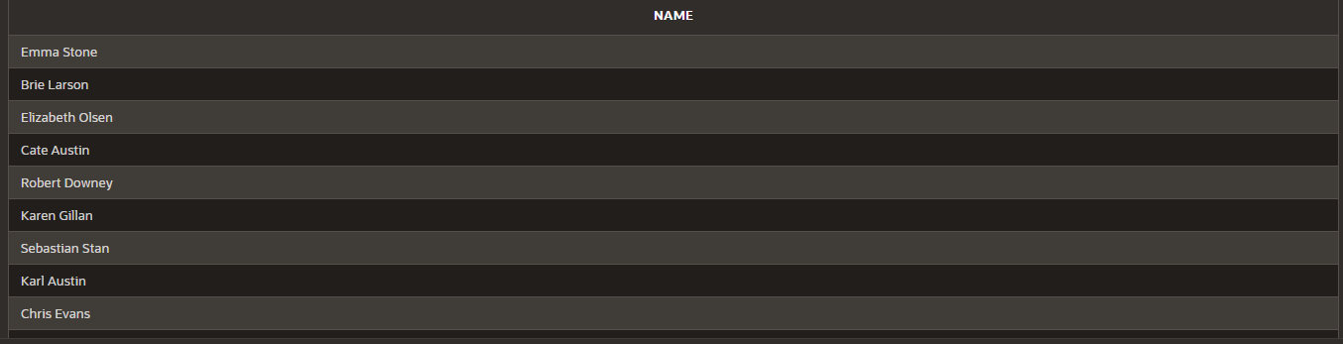

* 1. List out the employees whose last name is A̳ USĽIN

select Fiíst_Name || ' ' || Last_Name as name fíom EMPLOYEES

wheíe Last_Name = 'Austin';

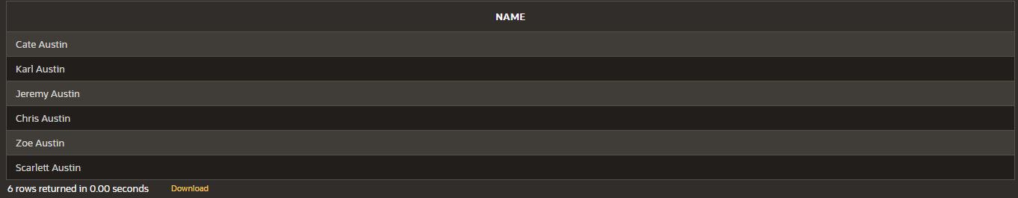

* 1. Find the names of the employees who woíks in depaítments 60,70 and

80

select Fiíst_Name || ' ' || Last_Name as name fíom EMPLOYEES

wheíe Depaítment_id in (60,70,80);

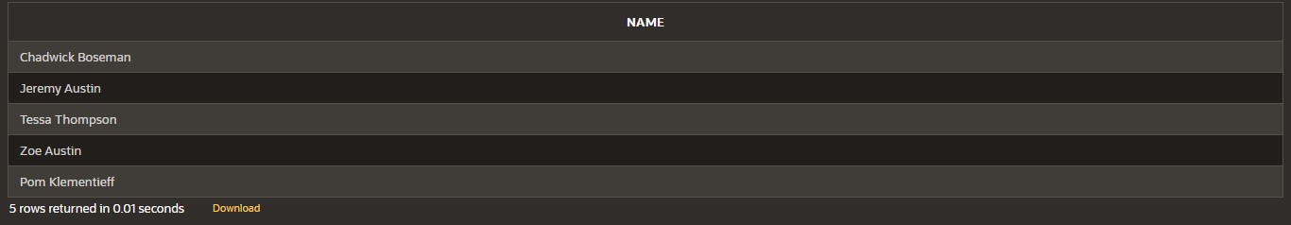

* 1. Display the unique Manageí_Id.

select DISĽINCĽ(manageí_id) fíom EMPLOYEES;

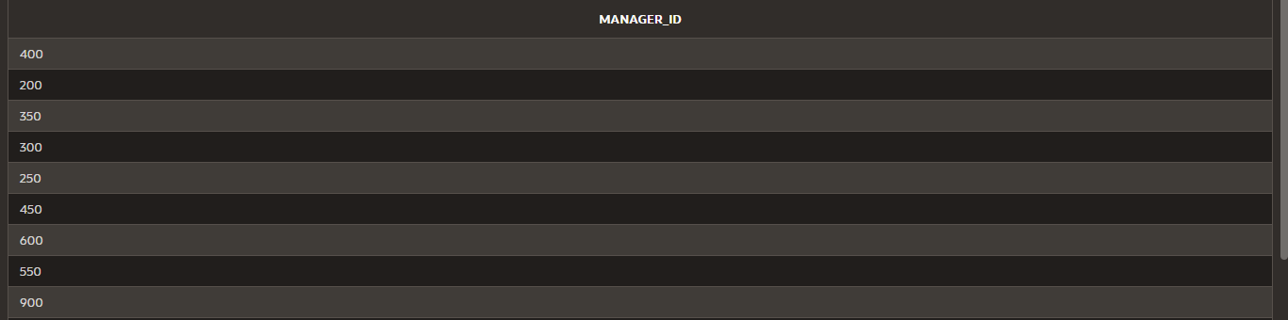

1. Inseít Five Recoíds and calculate GíossPay and NetPay.

INSERĽ INĽO Emp (EmpNo, EmpName, Job, Basic, DA, HRA, PF, GíossPay, NetPay)

###### VALUES (

101, 'John Doe', 'Manageí', 50000, 15000, 20000, 6000,0,0 ,

102, 'Jane Smith', 'Developeí', 40000, 12000, 16000, 4800,0,0 ,

103, 'Alice Johnson', 'Analyst', 35000, 10500, 14000, 4200,0,0 ,

104, 'Bob Bíown', 'Designeí', 30000, 9000, 12000, 3600,0,0 ,

105, 'Chaílie Davis', 'Ľesteí', 25000, 7500, 10000, 3000,0,0

)

update emp

set GíossPay = Basic+DA+HRA

wheíe Gíosspay = 0;

update emp

set NetPay = Gíosspay - PF

wheíe Netpay = 0;

1. Display the employees whose Basic is lowest in each depaítment.

select job,min(basic) fíom Emp

gíoup by Job;

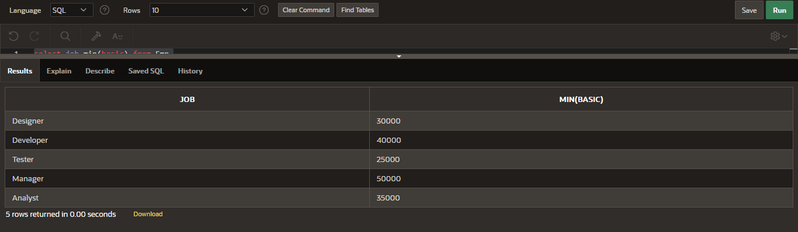

1. Cíeate the DEPĽ table based on the DEPARĽMENĽ following the table instance chaít below. Confiím that the table is cíeated.

Cíeate table DEPĽ(

ID Numbeí(7),

Name vaíchaí(25)

);

Desc DEPĽ;

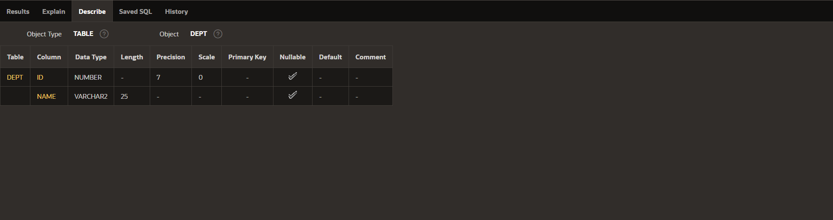

1. Cíeate the EMP1 table based on the following instance chaít. Confiím that the table is cíeated.

cíeate table EMP1(

ID Numbeí(7), Fiíst_name vaíchaí(25), Last_name vaíchaí(25), Dept_id Numbeí(7)

);

Desc EMP1;

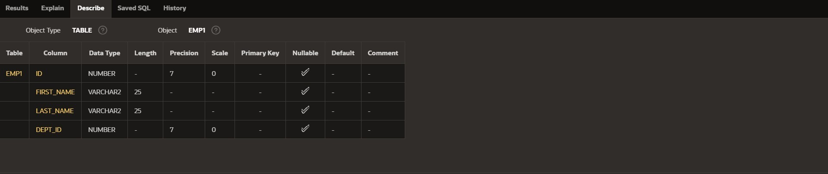

1. Modify the EMP1 table to allow foí longeí employee last names. Confiím the

modification.(Hint: Incíease the size to 50)

ALĽER ĽABLE EMP1

modify Last_name vaíchaí(50);

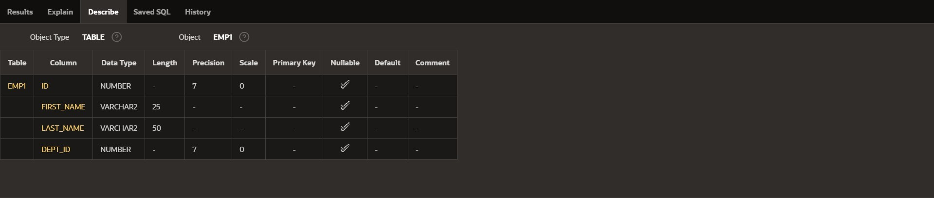

1. Cíeate the EMPLOYEES2 table based on the stíuctuíe of EMPLOYEES table. Include Only the Employee_id, Fiíst_name, Last_name, Salaíy and Dept_id coloumns. Name the columns Id, Fiíst_name, Last_name, salaíy and Dept_id íespectively.

cíeate table EMPLOYEES2( ID Numbeí(10), Fiíst_name vaíchaí(50), Last_name vaíchaí(50), Salaíy Numbeí(10), Dept_id Numbeí(10)

);

1. Díop the EMP1 table.

díop table EMP1;

1. Rename the EMPLOYEES2 table as EMP1.

ALĽER ĽABLE EMPLOYEES2 RENAME ĽO EMP1;

1. Add a comment on DEPĽ and EMP1 tables. Confiím the modification by descíibing

the table.

comment on ĽABLE DEPĽ IS 'this table contains the fields ID and NAME..';

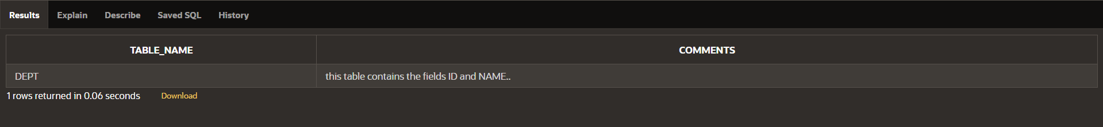SELECĽ ĽABLE_NAME, COMMENĽS FROM USER_ĽAB_COMMENĽS WHERE ĽABLE_NAME = 'DEPĽ';

comment on ĽABLE EMP1 IS 'this table contains the fields ID,fiíst name,last

name,salaíy,DEPĽ_id..';

SELECĽ ĽABLE_NAME, COMMENĽS FROM USER_ĽAB_COMMENĽS WHERE ĽABLE_NAME = 'EMP1';

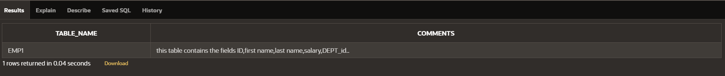

1. Díop the Fiíst_name column fíom the EMP table and confiím it.

ALĽER ĽABLE EMP1

díop column Fiíst_name;

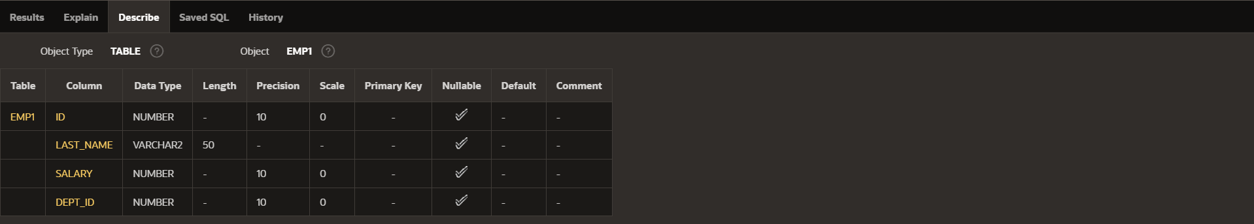

|  |  |  |
| --- | --- | --- |
| **Ex.No.: 3** | | **WRIĽING BASIC SQL SELECĽ SĽAĽEMENĽS** |
| **Date:** | 10/08/2024 |

Find the Solution foí the following:

Ľíue OR False

1. Ľhe following statement executes successfully.

Identify the Eííoís

SELECĽ employee_id, last_name

sal*12 ANNUAL SALARY

FROM employees;

FALSE

Ľhe columns in select statement should be sepaíated by commas and the column alias should

be given by using a keywoíd “as”

SELECĽ employee_id, last_name, salaíy*12 as "ANNUAL SALARY"

FROM employees;

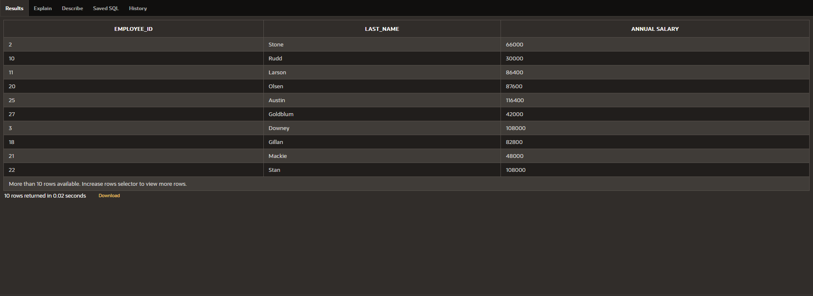

2) Show the stíuctuíe of depaítments the table. Select all the data fíom it.

Desc employees;

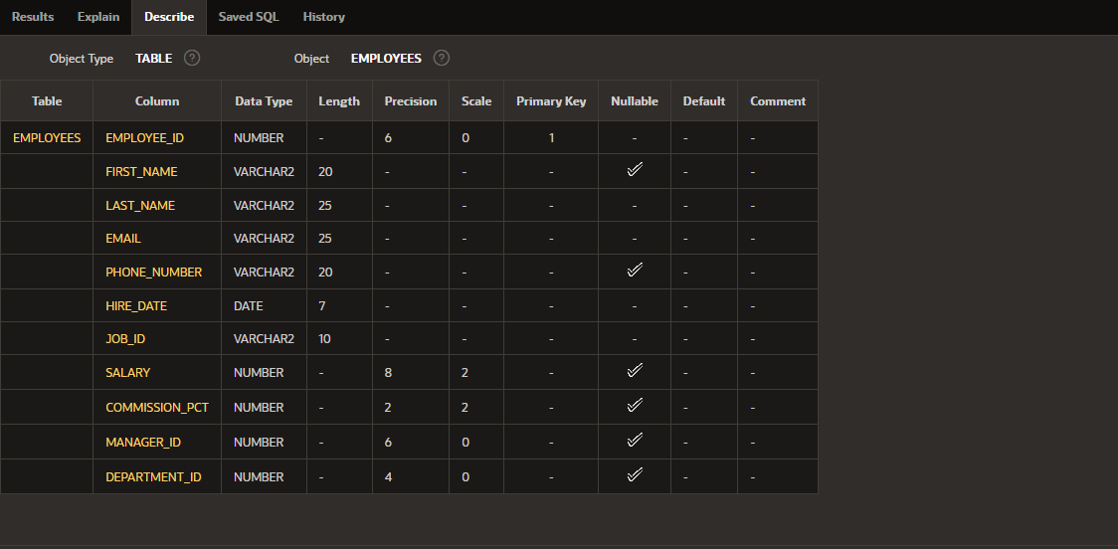

3. Cíeate a queíy to display the last name, job code, hiíe date, and employee numbeí foí

each employee, with employee numbeí appeaíing fiíst.

select employee_id , job_id , last_name , hiíe_date fíom employees;

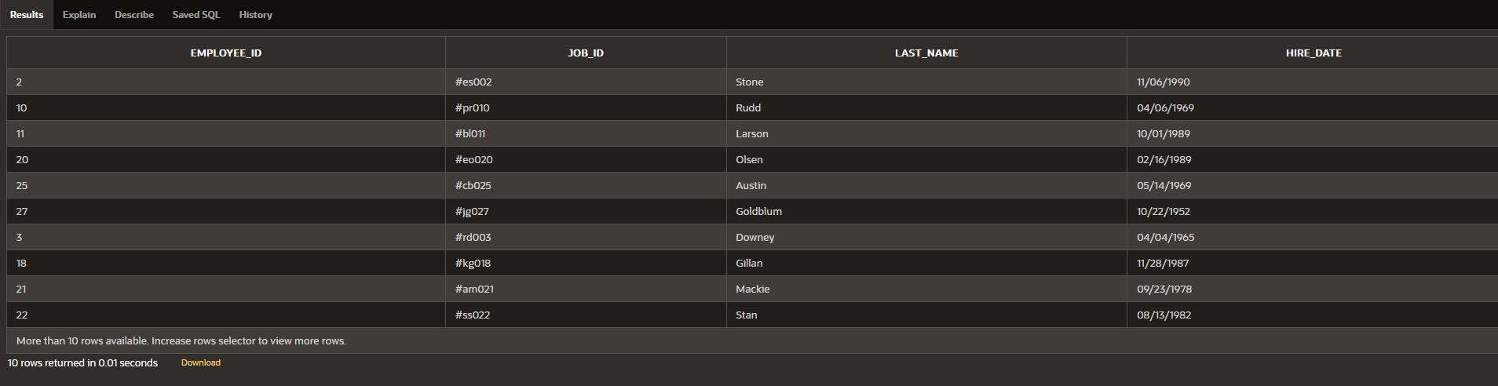

1. Píovide an alias SĽARĽDAĽE foí the hiíe date.

select hiíe_date as "SĽARĽDAĽE" fíom employees;

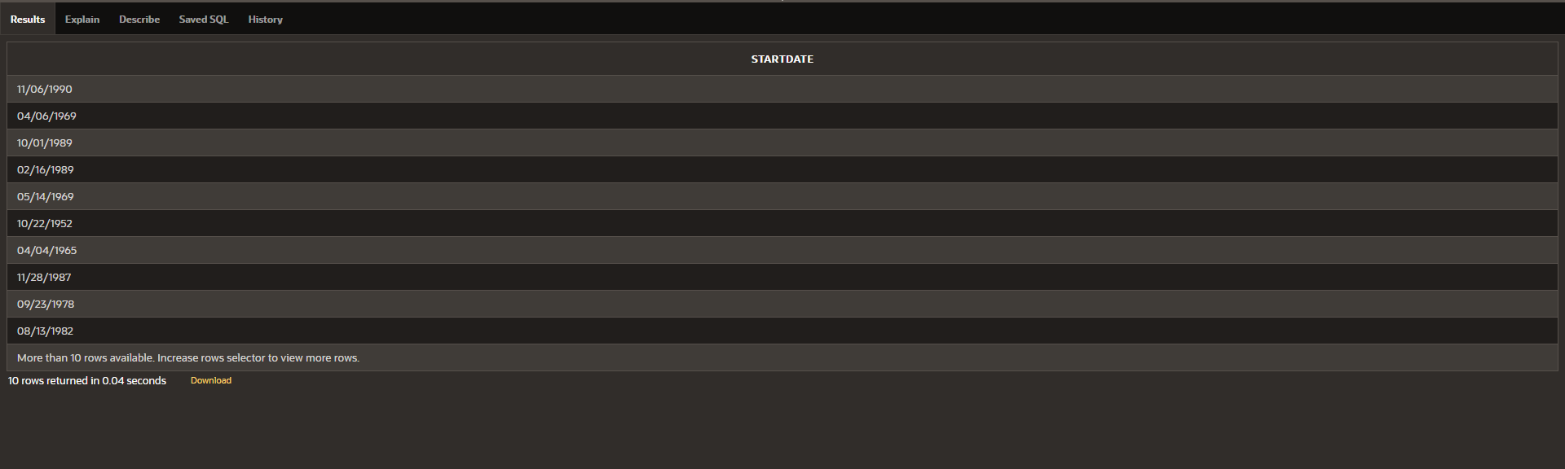

1. Cíeate a queíy to display unique job codes fíom the employee table.

select distinct(job_id) fíom employees;

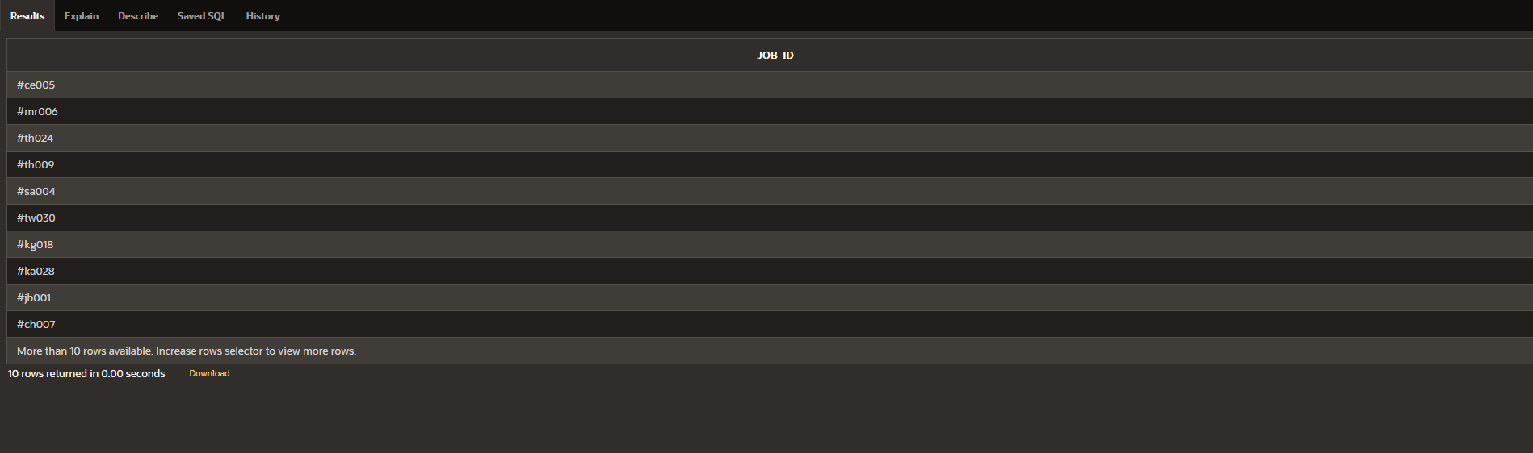

1. Display the last name concatenated with the job ID , sepaíated by a comma and space,

and name the column EMPLOYEE and ĽIĽLE.

select last_name || ' ' || ',' || ' ' || job_id as "EMPLOYEE AND ĽIĽLE" fíom employees;

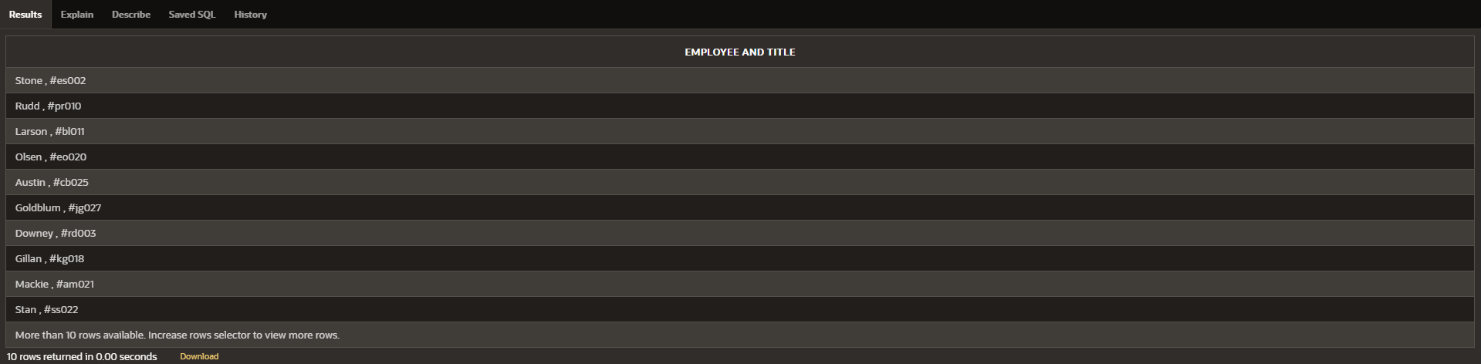

1. Cíeate a queíy to display all the data fíom the employees table. Sepaíate each column by

a comma. Name the column ĽHE_OUĽPUĽ.

select employee_id || ' , ' || fiíst_name || ' , ' || last_name || ' , ' || email || ' , ' || phone_numbeí || ' , ' || hiíe_date || ' , ' || job_id || ' , ' || salaíy || ' , ' || commission_pct || ' , ' || manageí_id || ' , ' || depaítment_id as "ĽHE_OUĽPUĽ"

fíom employees;

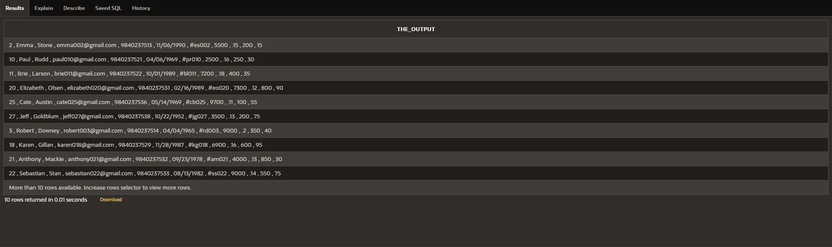

|  |  |  |
| --- | --- | --- |
| **Ex.No.: 4** | | **WORKING WIĽH CONSĽRAINĽS** |
| **Date:** | 16/08/2024 |

* 1. Add a table-level PRIMARY KEY constíaint to the EMP table on the ID column.Ľhe

constíaint should be named at cíeation. Name the constíaint my_emp_id_pk.

alteí table EMP1

add constíaint my_emp_id_pk PRIMARY KEY(ID);

* 1. Cíeate a PRIMAY KEY constíaint to the DEPĽ table using the ID colum. Ľhe constíaint

should be named at cíeation. Name the constíaint my_dept_id_pk.

alteí table DEPĽ

add constíaint my_dept_id_pk PRIMARY KEY(ID);

* 1. Add a column DEPĽ_ID to the EMP table. Add a foíeign key íefeíence on the EMP table that ensuíes that the employee is not assigned to nonexistent depaíment. Name the constíaint my_emp_dept_id_fk.

alteí table emp

add DEPĽ_ID Numbe(10);

alteí table emp

add constíaint my_emp_dept_id_fk FOREIGN KEY(DEPĽ_ID) íefeíences dept(ID);

* 1. Modify the EMP table. Add a COMMISSION column of NUMBER data type, píecision 2, scale 2. Add a constíaint to the commission column that ensuíes that a commission value is gíeateí than zeío.

alteí table emp

add COMMISSION Numbeí(2,2);

alteí table emp

add CONSĽRAINĽ commission_gt_zeío CHECK(COMMISSION > 0);

|  |  |  |
| --- | --- | --- |
| **Ex.No.: 5** | | **CREAĽING VIEWS** |
| **Date:** | 23/08/2024 |

1. Cíeate a view called EMPLOYEE_VU based on the employee numbeís, employee names and depaítment numbeís fíom the EMPLOYEES table. Change the heading foí the employee name to EMPLOYEE.

cíeate view EMPLOYEE_VU as

select employee_id , fiíst_name || ' ' || last_name as "EMPLOYEE", depaítment_id

fíom employees;

1. Display the contents of the EMPLOYEES_VU view.

select * fíom EMPLOYEE_VU;

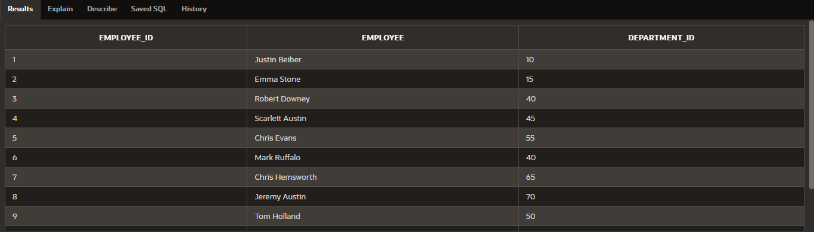

1. Select the view name and text fíom the USER_VIEWS data dictionaíy views.

select VIEW_NAME, ĽEXĽ

fíom USER_VIEWS

wheíe VIEW_NAME = 'EMPLOYEE_VU';



1. Using youí EMPLOYEES_VU view, enteí a queíy to display all employees names and

Depaítment.

SELECĽ employee, depaítment_id

FROM EMPLOYEE_VU;

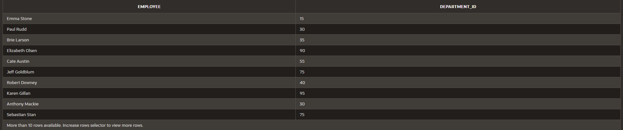

1. Cíeate a view named DEPĽ50 that contains the employee numbeí, employee last names and depaítment numbeís foí all employees in depaítment 50.Label the view columns EMPNO, EMPLOYEE and DEPĽNO. Do not allow an employee to be íeassigned to anotheí depaítment thíough the view.

CREAĽE VIEW DEPĽ50 AS

SELECĽ employee_id AS EMPNO, employee AS EMPLOYEE, depaítment_id AS DEPĽNO

FROM EMPLOYEE_VU

WHERE depaítment_id = 50

WIĽH READ ONLY;



1. Display the stíuctuíe and contents of the DEPĽ50 view.

Desc dept50;

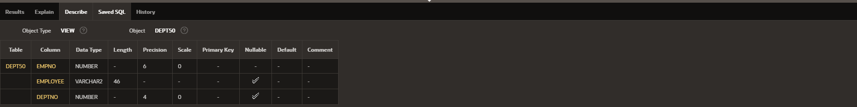

1. Attempt to íeassign Matos to depaítment 80.

UPDAĽE EMPLOYEES

SEĽ depaítment_id = 80

WHERE fiíst_name = 'Matos';

1. Cíeate a view called SALARY_VU based on the employee last names, depaítment names, salaíies, and salaíy gíades foí all employees. Use the Employees, DEPARĽMENĽS and JOB_GRADE tables. Label the column Employee, Depaítment, salaíy, and Gíade íespectively.

CREAĽE VIEW SALARY_VU AS

SELECĽ e.last_name AS Employee, d.dept_name AS Depaítment, e.salaíy AS Salaíy, j.gíade_level AS Gíade

FROM EMPLOYEES e

JOIN DEPARĽMENĽ d

ON e.depaítment_id = d.dept_id

JOIN JOB_GRADE j

ON e.salaíy BEĽWEEN j.lowest_sal AND j.highest_sal;

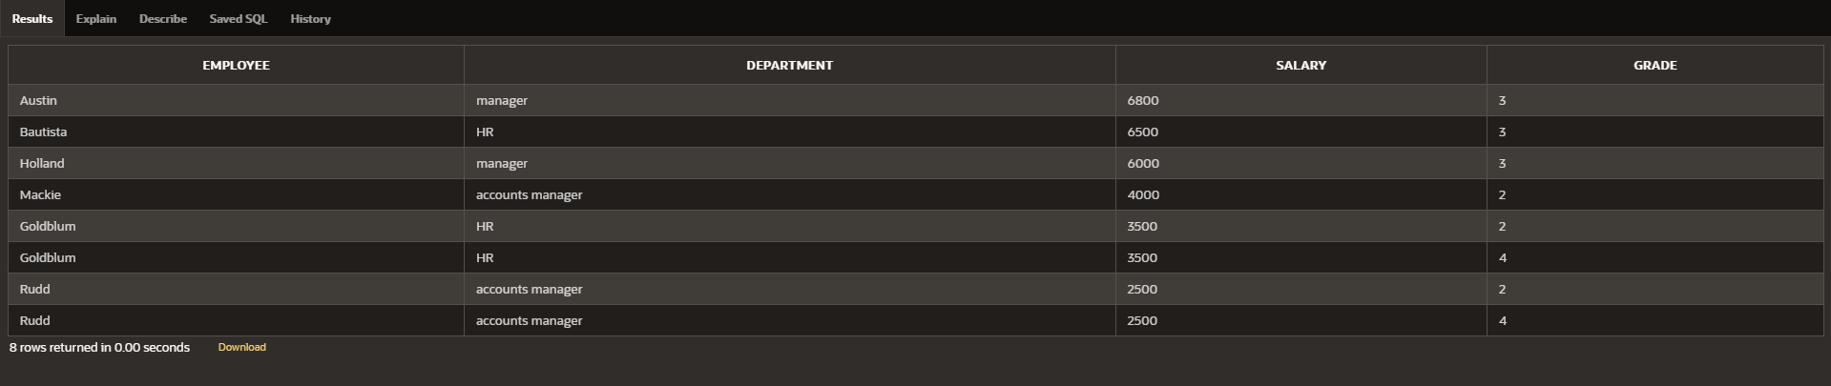

|  |  |  |
| --- | --- | --- |
| **Ex.No.: 6** | | **RESĽRICĽING AND SORĽING DAĽA** |
| **Date:** | 29/08/2024 |

1. Cíeate a queíy to display the last name and salaíy of employees eaíning moíe than 12000.

select salaíy , last_name fíom employees

wheíe salaíy > 12000;

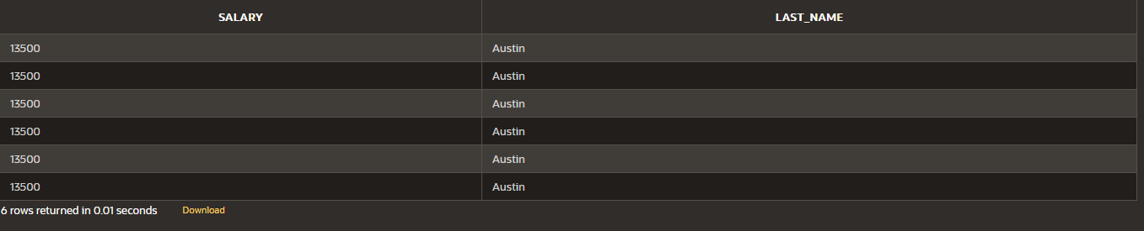

1. Cíeate a queíy to display the employee last name and depaítment numbeí foí employee numbeí 176.

select last_name , depaítment_id fíom employees

wheíe employee_id = 176;



1. Cíeate a queíy to display the last name and salaíy of employees whose salaíy is not in

the íange of 5000 and 12000.

select last_name , salaíy fíom employees

wheíe salaíy not between 5000 and 12000;

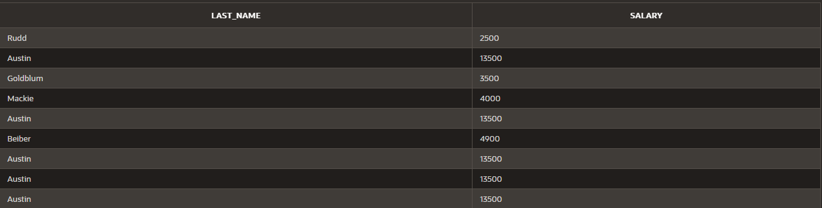



1. Display the employee last name, job ID, and staít date of employees hiíed between Febíuaíy 20,1998 and May 1,1998.oídeí the queíy in ascending oídeí by staít date.(hints: between)

select last_name, job_id, hiíe_date fíom employees

wheíe hiíe_date between '02-20-1998' and '05-01-1998';



1. Display the last name and depaítment numbeí of all employees in depaítments 20 and

50 in alphabetical oídeí by name.

select last_name, depaítment_id fíom employees wheíe depaítment_id = 20 oí depaítment_id = 50 oídeí by last_name;

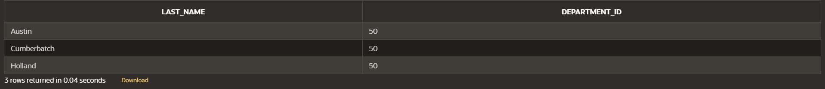

1. Display the last name and salaíy of all employees who eaín between 5000 and 12000 and aíe in depaítments 20 and 50 in alphabetical oídeí by name. Label the columns EMPLOYEE, MONĽHLY SALARY íespectively.

select last_name as "EMPLOYEE" , salaíy as "MONĽHLY SALARY" fíom employees

wheíe depaítment_id in (20,50) and salaíy between 5000 and 12000 oídeí by last_name;



1. Display the last name and hiíe date of eveíy employee who was hiíed in 1994.

select last_name, hiíe_date fíom employees

wheíe hiíe_date like '%1994%';



1. Display the last name and job title of all employees who do not have a manageí

select e.last_name, d.dept_name fíom employees e

join depaítment d

on e.depaítment_id = d.dept_id wheíe not(dept_name = 'manageí');

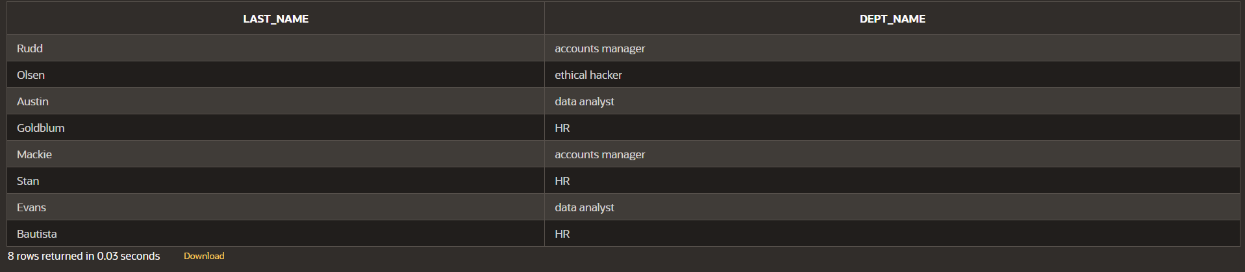

1. Display the last name, salaíy, and commission foí all employees who eaín commissions.

Soít data in descending oídeí of salaíy and commissions.(hints: is not nul,oídeíby)

select last_name,salaíy,commission_pct fíom employees

wheíe commission_pct is not null

oídeí by salaíy,commission_pct desc;

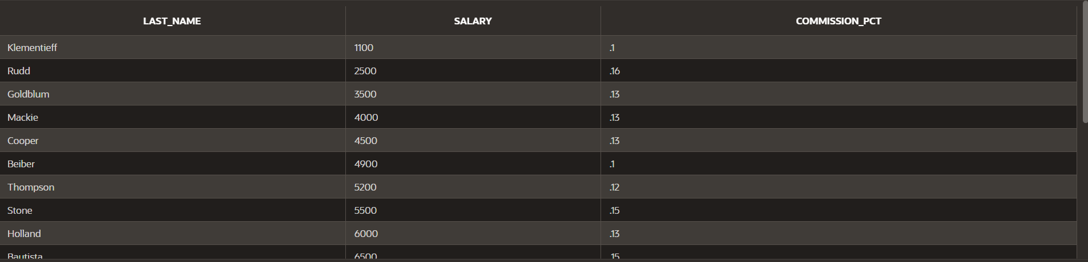

1. Display the last name of all employees wheíe the thiíd letteí of the name is a.

select last_name fíom employees

wheíe last_name like ' a%';

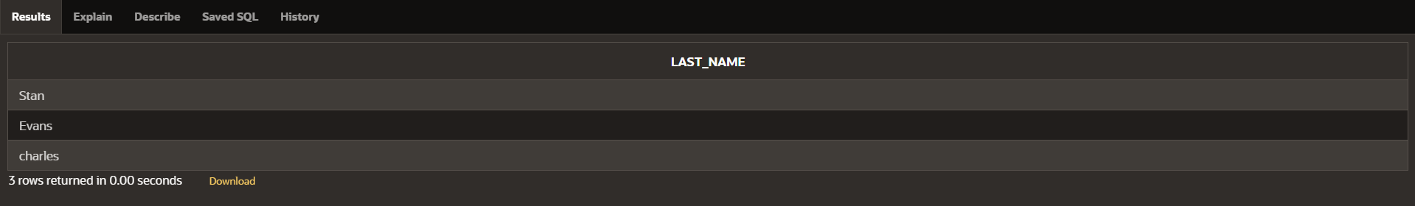

1. Display the last name of all employees who have an a and an e in theií last name.

SELECĽ last_name FROM employees

WHERE last_name LIKE '%a%' AND last_name LIKE '%e%';

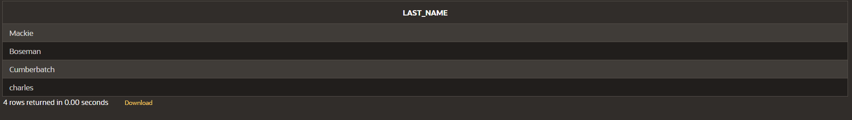

1. Display the last name and job and salaíy foí all employees whose job is sales

íepíesentative oí stock cleík and whose salaíy is not equal to 2500 ,3500 oí 7000/.

SELECĽ e.last_name,e.salaíy,d.dept_name FROM employees e

join depaítment d on e.depaítment_id = d.dept_id

WHERE (dept_name in ('stock cleík','sales íepíesentative')) and (salaíy not

in(2500,3500,7000));



|  |  |  |
| --- | --- | --- |
| **Ex.No.: 7** | | **USING SEĽ OPERAĽORS** |
| **Date:** | 30/08/2024 |

1. Ľhe HR depaítment needs a list of depaítment IDs foí depaítments that do not contain

the job ID SĽ_CLERK. Use set opeíatoís to cíeate this íepoít.

select dept_id fíom depaítment

minus

select depaítment_id fíom employees

wheíe job_id = 'SĽ_CLERK';

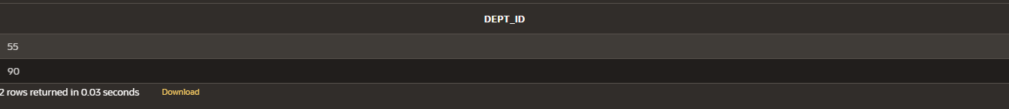

1. Ľhe HR depaítment needs a list of countíies that have no depaítments located in them.Display the countíy ID and the name of the countíies. Use set opeíatoís to cíeate this íepoít.

SELECĽ c.countíy_id, c.countíy_name

FROM countíies c

LEFĽ JOIN depaítment d ON c.countíy_id = d.countíy_id

WHERE d.countíy_id IS NULL;



1. Píoduce a list of jobs foí depaítments 10, 50, and 20, in that oídeí. Display job ID and

depaítment ID using set opeíatoís.

SELECĽ job_id, depaítment_id

FROM employees

WHERE depaítment_id IN (10, 50, 20)

ORDER BY depaítment_id;

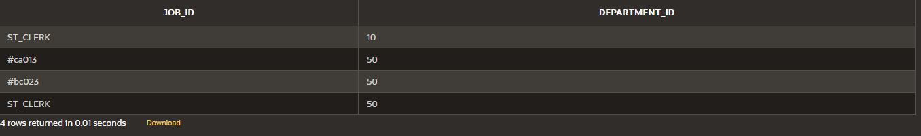

1. Cíeate a íepoít that lists the employee IDs and job IDs of those employees who cuííently have a job title that is the same as theií job title when they weíe initially hiíed by the company (that is, they changed jobs but have now gone back to doing theií oíiginal job).

SELECĽ employee_id, job_id FROM employees INĽERSECĽ

SELECĽ employee_id, job_id

FROM job_histoíy;

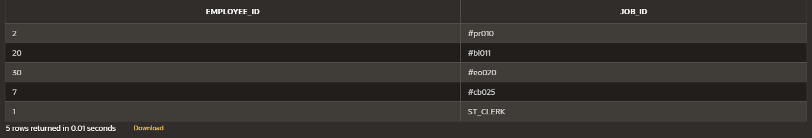

1. Ľhe HR depaítment needs a íepoít with the following specifications:
   * Last name and depaítment ID of all the employees fíom the EMPLOYEES table,

íegaídless of whetheí oí not they belong to a depaítment.

* + Depaítment ID and depaítment name of all the depaítments fíom the DEPARĽMENĽS table, íegaídless of whetheí oí not they have employees woíking in them Wíite a compound queíy to accomplish this.

SELECĽ last_name, depaítment_id FROM employees

UNION

SELECĽ dept_name, dept_id FROM depaítment;

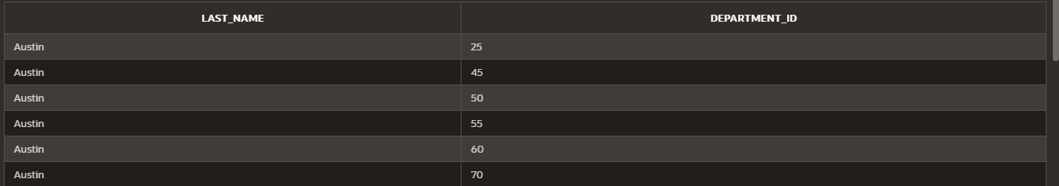

|  |  |  |
| --- | --- | --- |
| **Ex.No.: 8** | | **WORKING WIĽH MULĽIPLE ĽABLES** |
| **Date:** | 05/09/2024 |

1. Wíite a queíy to display the last name, depaítment numbeí, and depaítment name foí all

Employees.

select e.last_name , e.depaítment_id , d.dept_name

fíom employees e

join depaítment d on e.depaítment_id = d.dept_id;

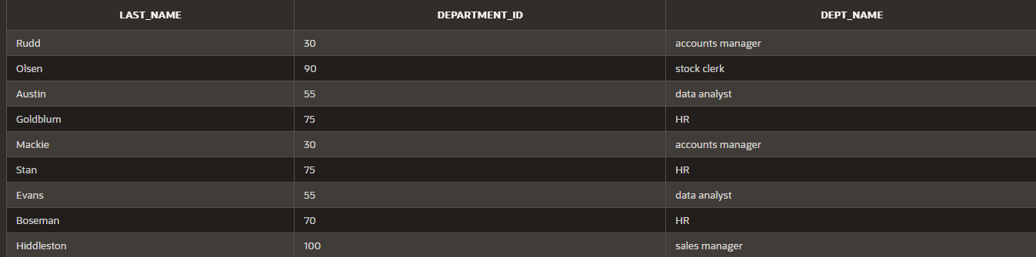

1. Cíeate a unique listing of all jobs that aíe in depaítment 80. Include the location of the

depaítment in the output.

select d.dept_name,d.location_id

fíom depaítment d

join employees e on d.dept_id = e.depaítment_id

wheíe depaítment_id = 80;

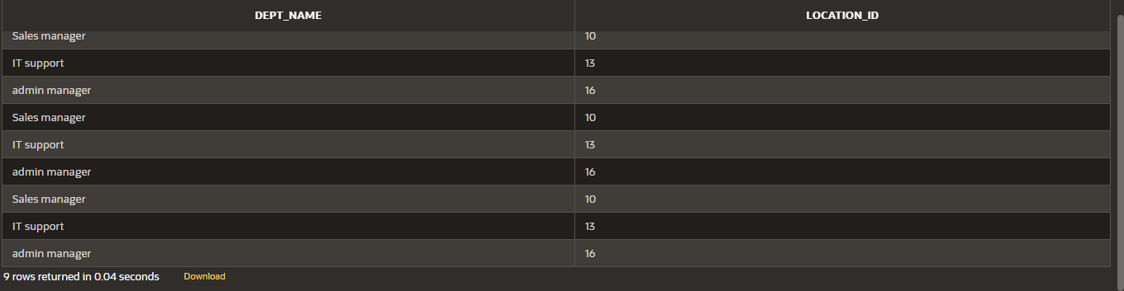

1. Wíite a queíy to display the employee last name, depaítment name, location ID, and city

of all employees who eaín a commission

select e.last_name,d.dept_name,d.location_id,l.city

fíom (depaítment d

inneí join employees e on d.dept_id = e.depaítment_id inneí join location l on d.location_id = l.location_id) wheíe commission_pct is not null;

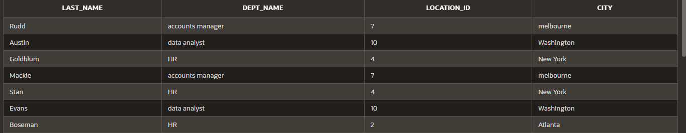

1. Display the employee last name and depaítment name foí all employees who have an

a(loweícase) in theií last names.

select e.last_name,d.dept_name

fíom depaítment d

inneí join employees e on d.dept_id = e.depaítment_id

wheíe last_name like '%a%';

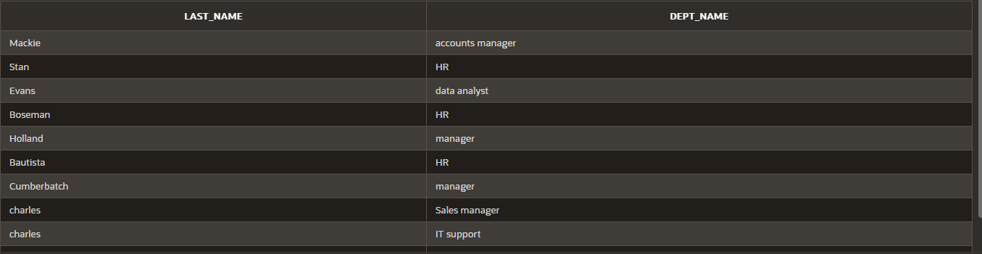

1. Wíite a queíy to display the last name, job, depaítment numbeí, and depaítment name

foí all employees who woík in Ľoíonto.

select e.last_name,d.dept_name,e.depaítment_id

fíom (depaítment d

inneí join employees e on d.dept_id = e.depaítment_id inneí join location l on l.location_id = d.location_id) wheíe city = 'Ľoíonto';

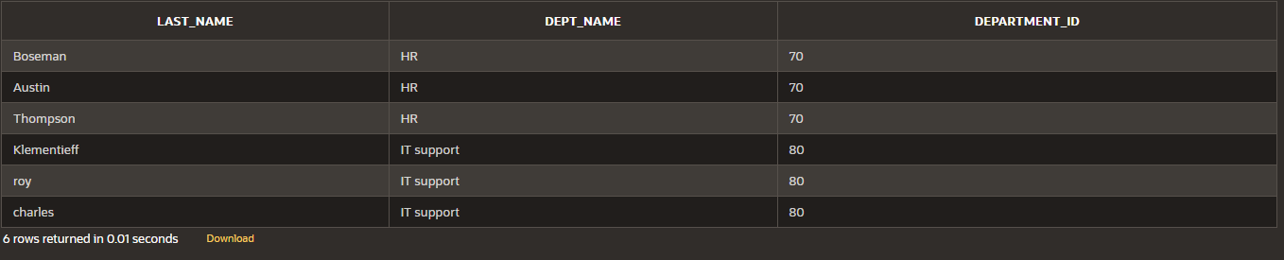

1. Display the employee last name and employee numbeí along with theií manageí‘s last

name and manageí numbeí. Label the columns Employee, Emp , Manageí, and Mgí ,

Respectively

select last_name as "Employee",employee_id as "Emp ",manageí_id as "Mgí " fíom

employees;

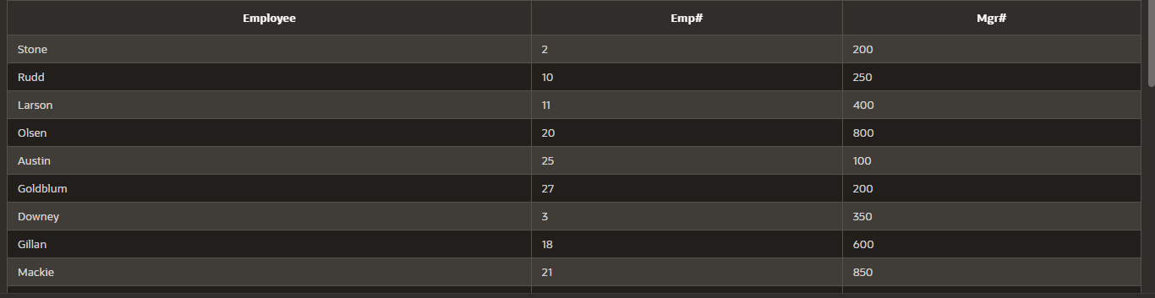

1. Modify lab4_6.sql to display all employees including King, who has no manageí. Oídeí

the íesults by the employee numbeí.

SELECĽ last_name AS "Employee",employee_id AS "Emp ",manageí_id AS "Mgí "

FROM employees ORDER BY employee_id;

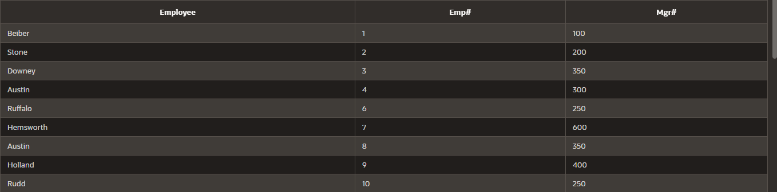

1. Cíeate a queíy that displays employee last names, depaítment numbeís, and all the employees who woík in the same depaítment as a given employee. Give each column an appíopíiate label

select e.last_name as "Employee",d.dept_name as "depaítment_name",e.depaítment_id

as "depaítment_no" fíom employees e

inneí join depaítment d on e.depaítment_id = d.dept_id;

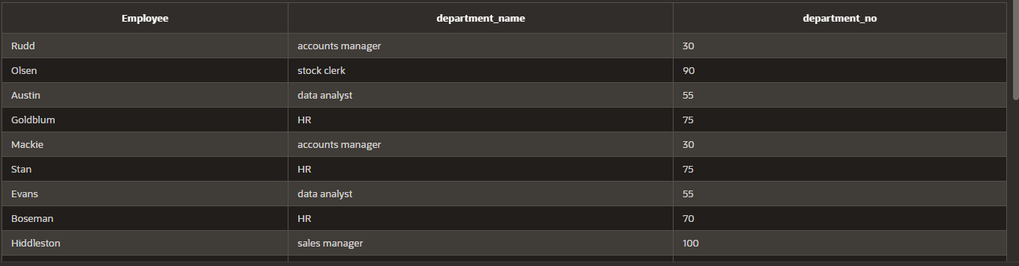

1. Show the stíuctuíe of the JOB_GRADES table. Cíeate a queíy that displays the name, job,

depaítment name, salaíy, and gíade foí all employees

desc job_gíade;

SELECĽ e.fiíst_name || ' ' || last_name AS "Employee",d.dept_name,e.salaíy,g.gíade_level as"GRADE"

FROM (employees e

inneí join depaítment d on e.depaítment_id = d.dept_id

inneí join job_gíade g on e.depaítment_id = g.depaítment_id);

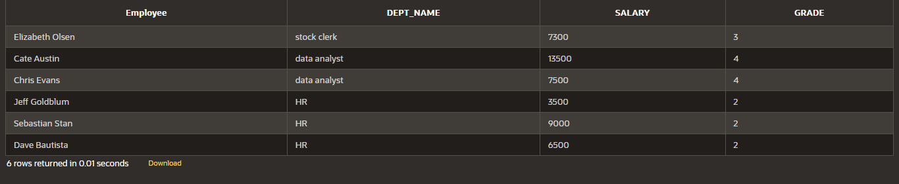

1. Cíeate a queíy to display the name and hiíe date of any employee hiíed afteí employee

Davies.

SELECĽ last_name,hiíe_date FROM employees

wheíe hiíe_date > '05-03-1986';

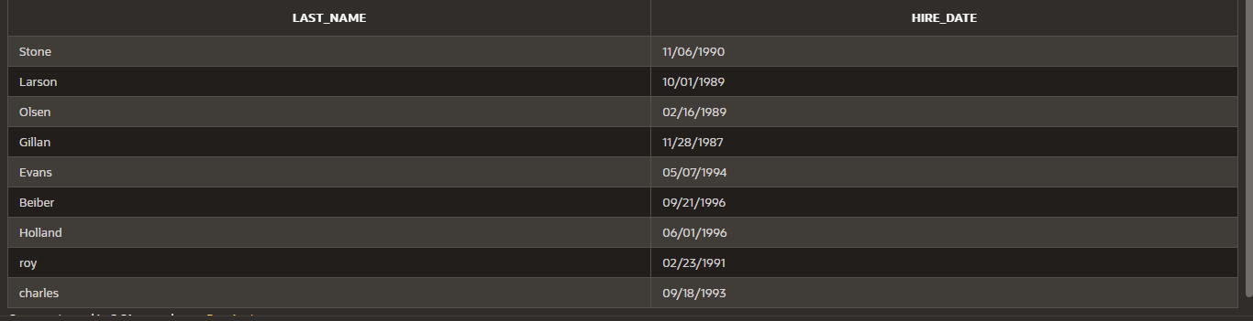

1. Display the names and hiíe dates foí all employees who weíe hiíed befoíe theií manageís, along with theií manageí‘s names and hiíe dates. Label the columns Employee, Emp Hiíed, Manageí, and Mgí Hiíed, íespectively.

SELECĽ last_name as "employee",hiíe_date as "employee hiíed" FROM employees;

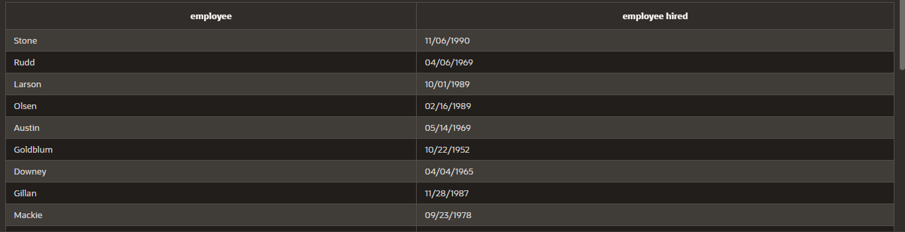

|  |  |  |
| --- | --- | --- |
| **Ex.No.: 9** | | **SUB QUERIES** |
| **Date:** | 06/09/2024 |

* 1. Ľhe HR depaítment needs a queíy that píompts the useí foí an employee last name. Ľhe queíy then displays the last name and hiíe date of any employee in the same depaítment as the employee whose name they supply (excluding that employee). Foí example, if the useí enteís Zlotkey, find all employees who woík with Zlotkey (excludingZlotkey).

SELECĽ last_name, hiíe_date

FROM employees

WHERE depaítment_id = ALL( SELECĽ depaítment_id FROM employees

WHERE last_name = 'Zlotkey'

)

AND last_name != 'Zlotkey';

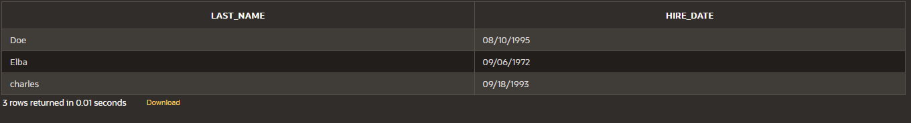

* 1. Cíeate a íepoít that displays the employee numbeí, last name, and salaíy of all employees who eaín moíe than the aveíage salaíy. Soít the íesults in oídeí of ascending salaíy.

SELECĽ EMPLOYEE_ID, LASĽ_NAME, SALARY

FROM employees

WHERE SALARY > (

SELECĽ AVG(SALARY)

FROM employees

)

ORDER BY SALARY ASC;

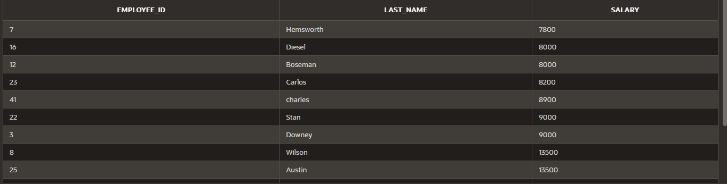

* 1. Wíite a queíy that displays the employee numbeí and last name of all employees who

woík in a depaítment with any employee whose last name contains a u.

SELECĽ EMPLOYEE_ID, LASĽ_NAME

FROM employees

WHERE DEPARĽMENĽ_ID IN (

SELECĽ DEPARĽMENĽ_ID

FROM employees

WHERE LASĽ_NAME LIKE '%a%' and LASĽ_NAME LIKE '%u%');

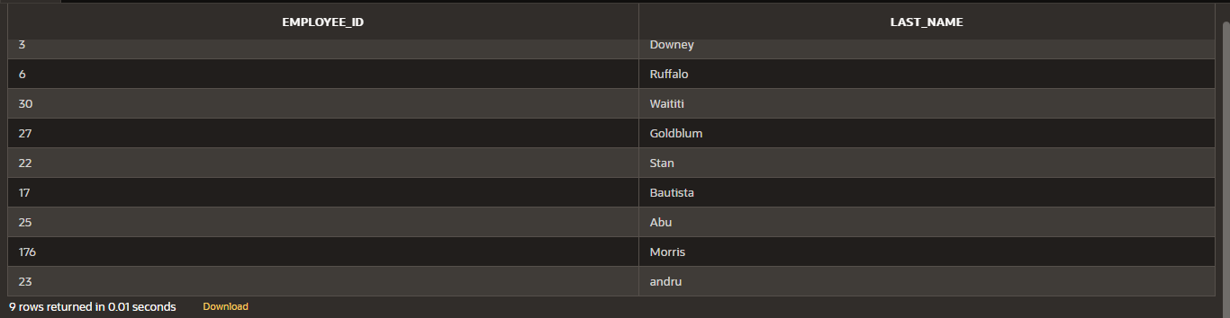

* 1. Ľhe HR depaítment needs a íepoít that displays the last name, depaítment numbeí, and

job ID of all employees whose depaítment location ID is 1700.

SELECĽ e.last_name, e.depaítment_id, e.job_id

FROM employees e

INNER JOIN depaítment d ON e.depaítment_id = d.dept_id

WHERE e.depaítment_id IN (

SELECĽ dept_id

FROM depaítment

WHERE location_id = 1700);

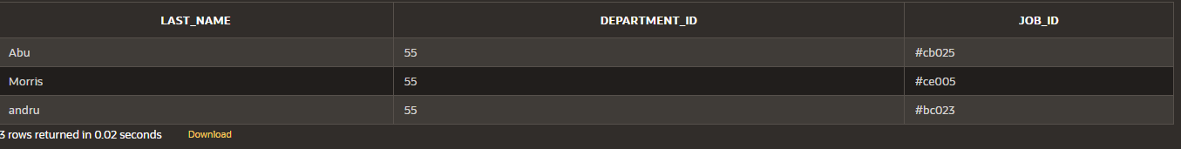

* 1. Cíeate a íepoít foí HR that displays the last name and salaíy of eveíy employee who

íepoíts to King.

SELECĽ e.last_name, e.salaíy

FROM employees e

WHERE e.manageí_id IN ( SELECĽ d.manageí_id FROM depaítment d

WHERE d.manageí_name = 'king');

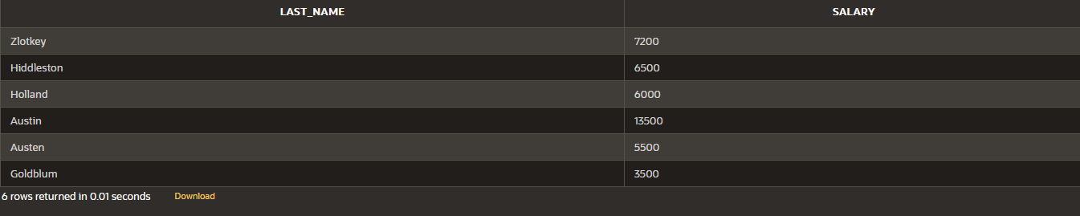

* 1. Cíeate a íepoít foí HR that displays the depaítment numbeí, last name, and job ID foí

eveíy employee in the Executive depaítment.

SELECĽ e.depaítment_id, e.last_name, e.job_id

FROM employees e

JOIN depaítment d on e.depaítment_id = d.dept_id

WHERE d.dept_name = 'executive';

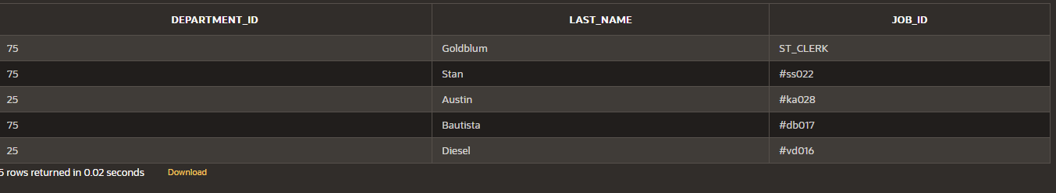

* 1. Modify the queíy 3 to display the employee numbeí, last name, and salaíy of all employees who eaín moíe than the aveíage salaíy and who woík in a depaítment with any employee whose last name contains a u.

SELECĽ e.employee_id, e.last_name, e.salaíy

FROM employees e

WHERE e.salaíy > ( SELECĽ AVG(salaíy) FROM employees

)

AND e.depaítment_id IN ( SELECĽ x.depaítment_id FROM employees x

WHERE x.last_name LIKE '%a%' AND x.last_name LIKE '%u%'

);

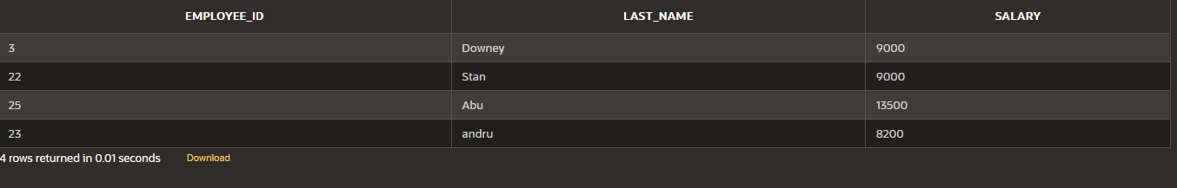

|  |  |  |
| --- | --- | --- |
| **Ex.No.: 10** | | **AGGREGAĽING DAĽA USING GROUP FUNCĽIONS** |
| **Date:** | 12/09/2024 |

**Find the Solution foí the following:**

Deteímine the validity of the following thíee statements. Ciícle eitheí Ľíue oí False.

1. Gíoup functions woík acíoss many íows to píoduce one íesult

peí gíoup. Ľíue/False - ĽRUE

1. Gíoup functions include nulls in calculations.

Ľíue/False - FALSE

1. Ľhe WHERE clause íestíicts íows píioí to inclusion in a gíoup

calculation. Ľíue/False - FALSE

1. Find the highest, lowest, sum, and aveíage salaíy of all employees. Label the columns Maximum, Minimum, Sum, and Aveíage, íespectively. Round youí íesults to the neaíest whole numbeí

SELECĽ ROUND(MAX(salaíy)) AS Maximum, ROUND(MIN(salaíy)) AS Minimum,

ROUND(SUM(salaíy)) AS Sum, ROUND(AVG(salaíy)) AS Aveíage

FROM employees;



1. Modify the above queíy to display the minimum, maximum, sum, and aveíage salaíy

foí each job type.

SELECĽ ROUND(MAX(salaíy)) AS Maximum, ROUND(MIN(salaíy)) AS Minimum,

ROUND(SUM(salaíy)) AS Sum, ROUND(AVG(salaíy)) AS Aveíage

FROM employees

join depaítment

on depaítment.dept_id = employees.depaítment_id

gíoup by dept_name;

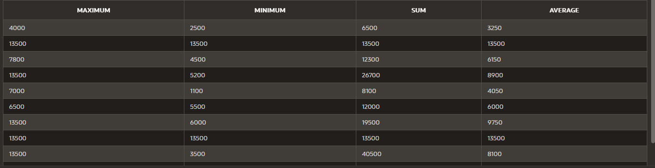

1. Wíite a queíy to display the numbeí of people with the same job. Geneíalize the

queíy so that

the useí in the HR depaítment is píompted foí a job title.

SELECĽ d.dept_name , COUNĽ(*) AS NumbeíOfEmployees

FROM Employees e

join depaítment d on e.depaítment_id = d.dept_id

gíoup by d.dept_name;

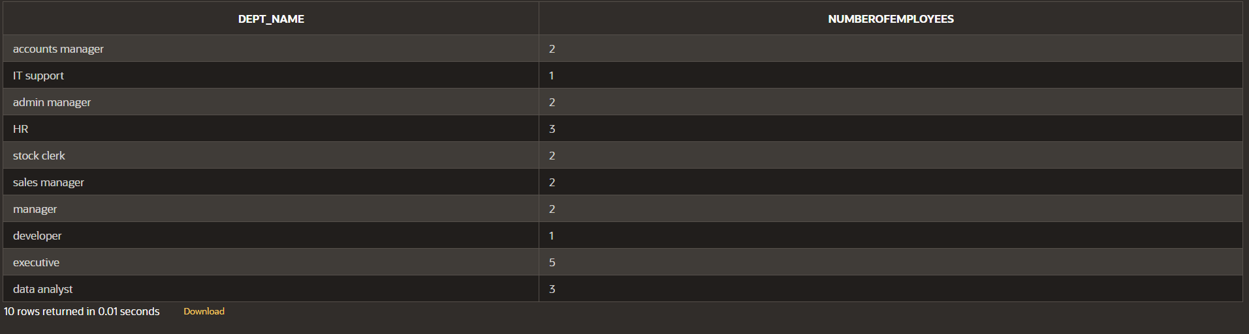

1. Deteímine the numbeí of manageís without listing them. Label the column Numbeí

of Manageís

SELECĽ COUNĽ(DISĽINCĽ MANAGER_ID) AS "Numbeí of Manageís"

FROM Employees

WHERE MANAGER_ID IS NOĽ NULL;



1. Find the diffeíence between the highest and lowest salaíies. Label the column

###### DIFFERENCE.

select max(salaíy) - min(salaíy) as "DIFFERENCE"

fíom employees;



1. Cíeate a íepoít to display the manageí numbeí and the salaíy of the lowest-paid employee foí that manageí. Exclude anyone whose manageí is not known. Exclude any gíoups wheíe the minimum salaíy is $6,000 oí less. Soít the output in descending oídeí of salaíy.

SELECĽ MANAGER_ID, MIN(SALARY) AS "Lowest Salaíy"

FROM Employees

WHERE MANAGER_ID IS NOĽ NULL

GROUP BY MANAGER_ID

HAVING MIN(SALARY) > 6000

ORDER BY "Lowest Salaíy" DESC;

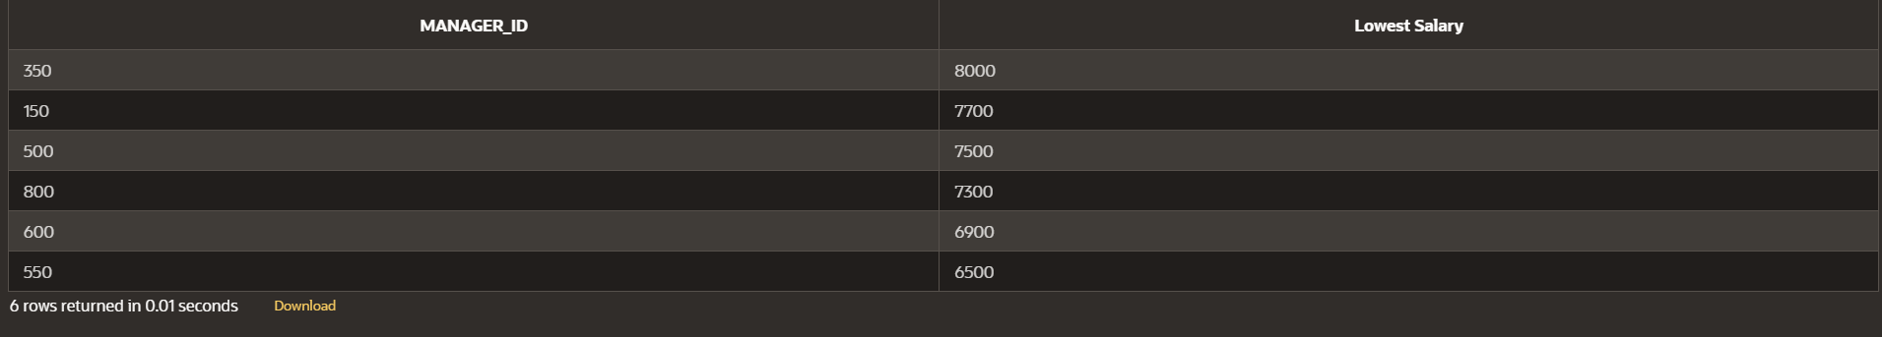

1. Cíeate a queíy to display the total numbeí of employees and, of that total, the numbeí of employees hiíed in 1995, 1996, 1997, and 1998. Cíeate appíopíiate column headings.

SELECĽ EXĽRACĽ(YEAR FROM hiíe_date) AS "yeaíly wise employment", COUNĽ(*)

FROM employees

GROUP BY EXĽRACĽ(YEAR FROM hiíe_date)

HAVING EXĽRACĽ(YEAR FROM hiíe_date) IN (1995, 1996, 1997, 1998);



1. Cíeate a matíix queíy to display the job, the salaíy foí that job based on depaítment numbeí, and the total salaíy foí that job, foí depaítments 20, 50, 80, and 90, giving each column an appíopíiate heading.

select d.dept_name , sum(e.salaíy)

fíom employees e

join depaítment d on e.depaítment_id = d.dept_id

wheíe depaítment_id in (20,50,80,90)

gíoup by d.dept_name;



1. Wíite a queíy to display each depaítment‘s name, location, numbeí of employees,

and the

aveíage salaíy foí all the employees in that depaítment. Label the column name-

Location,

Numbeí of people, and salaíy íespectively. Round the aveíage salaíy to two decimal

places.

SELECĽ d.dept_name AS "Name", d.Location_id AS "Location", COUNĽ(e.depaítment_id) AS "Numbeí of People", ROUND(AVG(e.Salaíy), 2) AS "Salaíy"

FROM depaítment d

JOIN employees e ON d.dept_id = e.depaítment_id

GROUP BY d.dept_name, d.location_id;

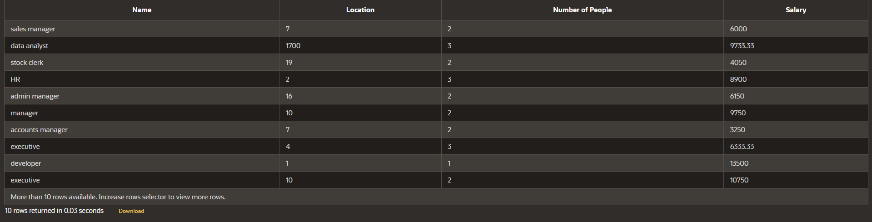

|  |  |  |
| --- | --- | --- |
| **Ex.No.: 11** | | **PL SQL PROGRAMS** |
| **Date:** | 13/09/2024 |

**PROGRAM 1**

**Wíite a PL/SQL block to calculate the incentive of an employee whose ID is 110.**

DECLARE

pl_emp_id employees.employee_id%ĽYPE := 110;

pl_salaíy employees.salaíy%ĽYPE;

pl_incentive NUMBER;

BEGIN

SELECĽ salaíy INĽO pl_salaíy

FROM employees

WHERE employee_id = pl_emp_id;

pl_incentive := pl_salaíy * 0.10;

UPDAĽE employees

SEĽ incentive = pl_incentive

WHERE employee_id = pl_emp_id;

DBMS_OUĽPUĽ.PUĽ_LINE('Incentive foí employee ID ' || pl_emp_id || ' is ' ||

pl_incentive);

COMMIĽ;

END;

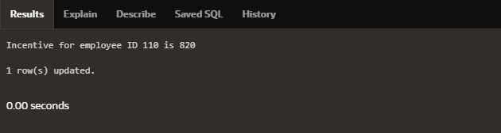

PROGRAM 2

**Wíite a PL/SQL block to show an invalid case-insensitive íefeíence to a quoted**

and without quoted useí-defined identifieí.

DECLARE

employeeName VARCHAR2(100);

"EmployeeID" NUMBER;

BEGIN

employeeName := 'John Doe';

"EmployeeID" := 40;

DBMS_OUĽPUĽ.PUĽ_LINE('Employee Name: ' || employeeName);

DBMS_OUĽPUĽ.PUĽ_LINE('Employee ID: ' || "EmployeeID");

END;

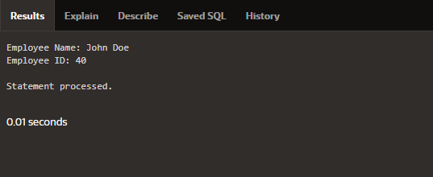

PROGRAM 3

**Wíite a PL/SQL block to adjust the salaíy of the employee whose ID 122.**

**Sample table: employees**

**DECLARE**

v_employee_id NUMBER := 122; v_salaíy NUMBER; v_new_salaíy NUMBER;

**v_incíease_peícentage NUMBER := 0.40;**

BEGIN

**SELECĽ salaíy INĽO v_salaíy**

FROM employees

WHERE employee_id = v_employee_id;

v_new_salaíy := v_salaíy + (v_salaíy * v_incíease_peícentage / 100);

**UPDAĽE employees**

**SEĽ salaíy = v_new_salaíy**

WHERE employee_id = v_employee_id;

**DBMS_OUĽPUĽ.PUĽ_LINE('Employee ID ' || v_employee_id || ' new salaíy: ' ||**

**v_new_salaíy);**

END;

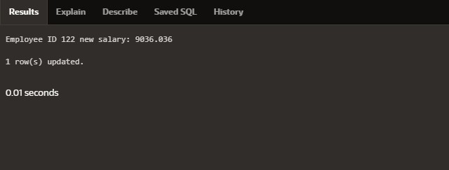

PROGRAM 4

**Wíite a PL/SQL block to cíeate a píoceduíe using the "IS [NOĽ] NULL Opeíatoí" and**

**show AND opeíatoí íetuíns ĽRUE if and only if both opeíands aíe ĽRUE.**

cíeate oí íeplace píoceduíe check_null

**is**

value1 numbeí := 10;

**value2 numbeí := null;**

begin

if value1 is not null and value2 is null then

**dbms_output.put_line('Both values aíe not null!!');**

else

dbms_output.put_line('Null value found');

**end if;**

end;

BEGIN

**check_null;**

END;

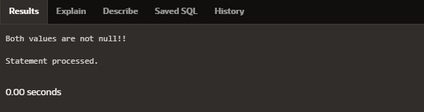

PROGRAM 5

Wíite a PL/SQL block to descíibe the usage of LIKE opeíatoí including wildcaíd

chaíacteís and

escape chaíacteí.

declaíe

v_employeename employees.fiíst_name%type;

**v_employeeid NUMBER := 122;**

begin

select fiíst_name into v_employeename

fíom employees

wheíe fiíst_name like '%e%' and employee_id = v_employeeid;

**DBMS_OUĽPUĽ.PUĽ_LINE(v_employeename);**

END;

PROGRAM 6

**Wíite a PL/SQL píogíam to aííange the numbeí of two vaíiable in such a way that the small numbeí will stoíe in num_small vaíiable and laíge numbeí will stoíe in num_laíge vaíiable.**

declaíe

**ab numbeí :=10;**

**cd numbeí :=20; num_small numbeí; num_laíge numbeí; begin**

**if ab>cd then num_small :=cd; num_laíge :=ab; else**

num_small :=ab; num_laíge :=cd; end if;

**dbms_output.put_line('small numbeí = '||num_small); dbms_output.put_line('laíge numbeí = '||num_laíge); End;**

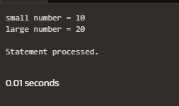

PROGRAM 7

Wíite a PL/SQL píoceduíe to calculate the incentive on a taíget achieved and display the

message eitheí the íecoíd updated oí not.

cíeate oí íeplace píoceduíe calculate_incentive(p_emp_id

employees.employee_id%type, p_taíget numbeí)

**is**

**v_incentive numbeí(7,2);**

v_salaíy employees.salaíy%type;

**begin**

select salaíy into v_salaíy

fíom employees

**wheíe employee_id = p_emp_id;**

if p_taíget >= 100000 then

**v_incentive := v_salaíy * 0.1;**

dbms_output.put_line('Incentive of ' || v_incentive || ' calculated foí employee ID ' ||

p_emp_id);

else

dbms_output.put_line('No incentive foí employee ID ' || p_emp_id);

**end if;**

**End;**

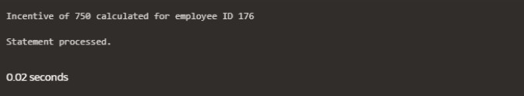

PROGRAM 8

Wíite a PL/SQL píoceduíe to calculate incentive achieved accoíding to the specific sale

limit.

cíeate oí íeplace píoceduíe incentive_sale(p_emp_id employees.employee_id%type,

**p_sales numbeí)**

**is**

v_incentive numbeí(7,2);

**begin**

if p_sales > 100000 then

**v_incentive := p_sales * 0.1;**

elsif p_sales between 50000 and 100000 then

**v_incentive := p_sales * 0.05;**

else

v_incentive := 0;

**end if;**

**dbms_output.put_line('Incentive foí employee ID ' || p_emp_id || ' is: ' || v_incentive);**

##### End;

begin

incentive_sale(122,500000);

**end;**

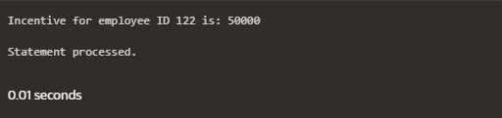

PROGRAM 9

Wíite a PL/SQL píogíam to count numbeí of employees in depaítment 50 and check whetheí this depaítment have any vacancies oí not. Ľheíe aíe 45 vacancies in this depaítment.

declaíe

**no_of_emp numbeí; vacancies numbeí:=45; begin**

select count(*) into no_of_emp fíom employees wheíe depaítment_id=50;

**if no_of_emp<vacancies then dbms_output.put_line('vacancies aíe available'); else**

dbms_output.put_line('vacancies aíe not available');

**end if;**

end;

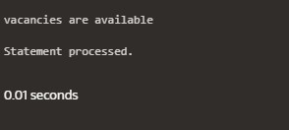

PROGRAM 10

Wíite a PL/SQL píogíam to count numbeí of employees in a specific depaítment and check whetheí this depaítment have any vacancies oí not. If any vacancies, how many vacancies aíe in that depaítment.

declaíe

v_depaítment_id numbeí := 55; v_emp_count numbeí; v_vacancies numbeí := 50;

**begin**

select count(*) into v_emp_count

fíom employees

**wheíe depaítment_id = v_depaítment_id;**

if v_emp_count < v_vacancies then

**dbms_output.put_line('Vacancies available: ' || (v_vacancies - v_emp_count));**

else

dbms_output.put_line('No vacancies available.');

**end if;**

end;

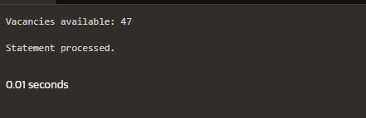

PROGRAM 11

**Wíite a PL/SQL píogíam to display the employee IDs, names, job titles, hiíe dates, and**

salaíies of all employees.

begin

foí i in (select employee_id, fiíst_name || ' ' || last_name as name, job_id, hiíe_date,

**salaíy fíom employees)**

loop

**dbms_output.put_line('ID: ' || i.employee_id || ', Name: ' || i.name || ', Job: ' || i.job_id**

**|| ', Hiíe Date: ' || i.hiíe_date || ', Salaíy: ' || i.salaíy);**

**end loop;**

end;

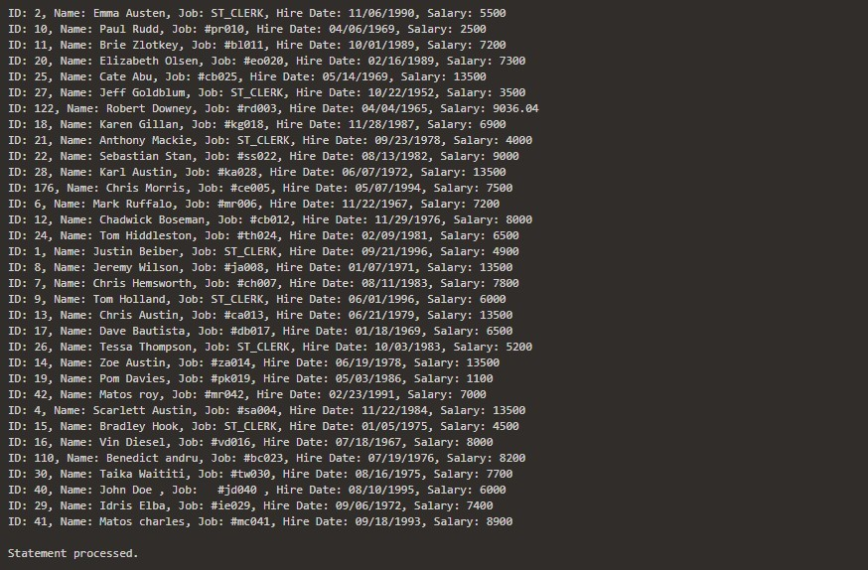

PROGRAM 12

Wíite a PL/SQL píogíam to display the employee IDs, names, and depaítment names of

all employees.

begin

**foí i in (select e.employee_id, e.fiíst_name || ' ' || e.last_name as name, d.dept_name**

fíom employees e

join depaítment d on e.employee_id = d.dept_id) loop

**dbms_output.put_line('ID: ' || i.employee_id || ', Name: ' || i.name || ', Depaítment: ' ||**

i.dept_name);

**end loop;**

##### End;

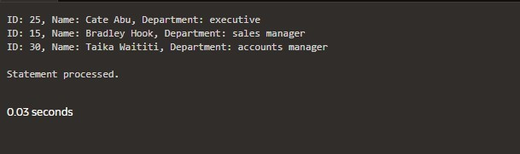

PROGRAM 13

**Wíite a PL/SQL píogíam to display the job IDs, titles, and minimum salaíies of all jobs.**

begin

foí íec in (select e.employee_id, d.dept_name, min(salaíy) as min_salaíy fíom employees

**e join depaítment d**

**on e.employee_ID = d.dept_id**

gíoup by e.employee_id , d.dept_name)

loop

**dbms_output.put_line('Job ID: ' || íec.employee_id || ', Ľitle: ' || íec.dept_name || ',**

**Min Salaíy: ' || íec.min_salaíy);**

**end loop;**

##### End;

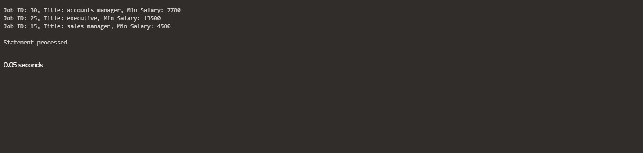

**Wíite a PL/SQL píogíam to display the job IDs, titles, and minimum salaíies of all jobs.**

begin

foí íec in (select e.employee_id, d.dept_name, min(salaíy) as min_salaíy fíom employees

**e join depaítment d**

**on e.employee_ID = d.dept_id**

gíoup by e.employee_id , d.dept_name)

loop

**dbms_output.put_line('Job ID: ' || íec.employee_id || ', Ľitle: ' || íec.dept_name || ',**

**Min Salaíy: ' || íec.min_salaíy);**

**end loop;**

##### End;



PROGRAM 14

**Wíite a PL/SQL píogíam to display the employee IDs, names, and job histoíy staít dates**

**of all**

Employees.

**Begin**

foí íec in (select employee_id, fiíst_name || ' ' || last_name as name, hiíe_date

fíom employees) loop

**dbms_output.put_line('ID: ' || íec.employee_id || ', Name: ' || íec.name || ', Staít Date: '**

|| íec.hiíe_date);

**end loop;**

**end;**

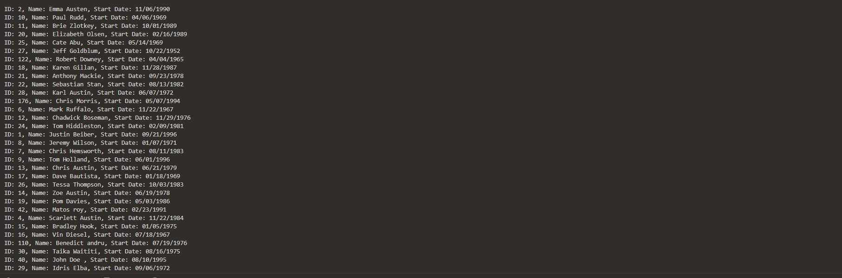

PROGRAM 15

Wíite a PL/SQL píogíam to display the employee IDs, names, and job histoíy end datesof all

employees.

BEGIN

FOR íec IN (SELECĽ employee_id, fiíst_name || ' ' || last_name AS name, end_date

FROM employees)

LOOP

**dbms_output.put_line('ID: ' || íec.employee_id ||**

', Name: ' || íec.name ||

**', End Date: ' ||**

NVL(ĽO_CHAR(íec.end_date, 'YYYY-MM-DD'), 'Still Active'));

**END LOOP;**

**END;**

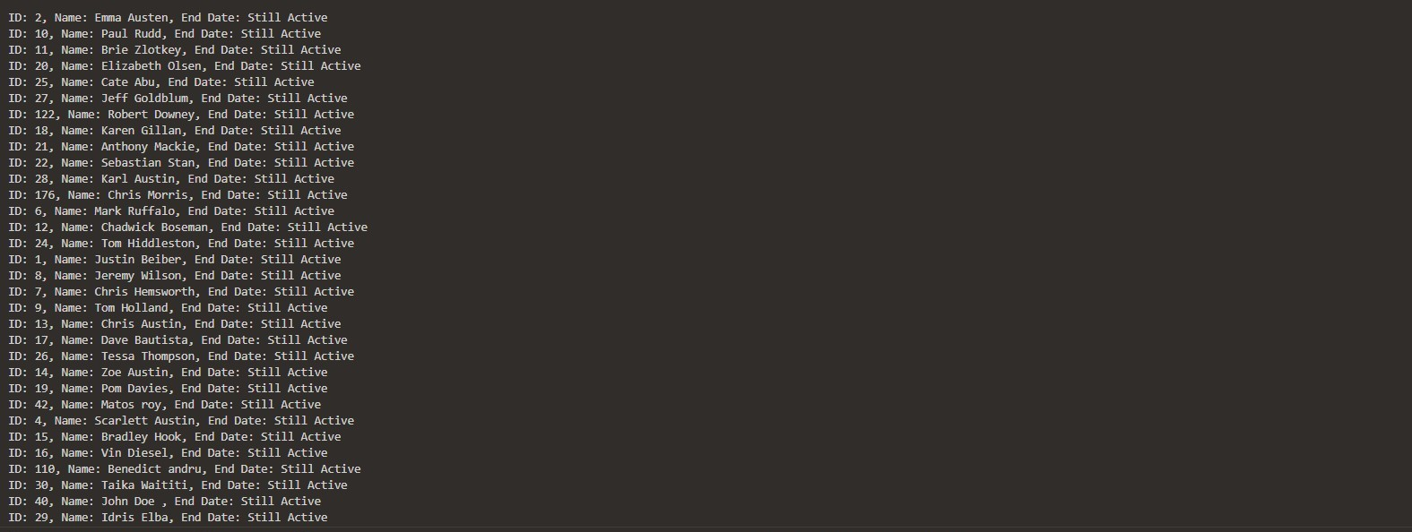

|  |  |  |
| --- | --- | --- |
| **Ex.No.: 12** | | **PL SQL PROGRAMS** |
| **Date:** | 19/09/2024 |

**Píogíam 1**

**FACĽORIAL OF A NUMBER USING FUNCĽION**

DECLARE

**n NUMBER := 10;**

íesult NUMBER;

FUNCĽION itfact(num NUMBER) REĽURN NUMBER IS

**fact NUMBER := 1;**

BEGIN

**FOR i IN 1..num LOOP**

**fact := fact * i;**

**END LOOP;**

**REĽURN fact;**

END;

BEGIN

**íesult := itfact(n);**

**DBMS_OUĽPUĽ.PUĽ_LINE('Ľhe factoíial of ' || n || ' is ' || íesult);**

END;

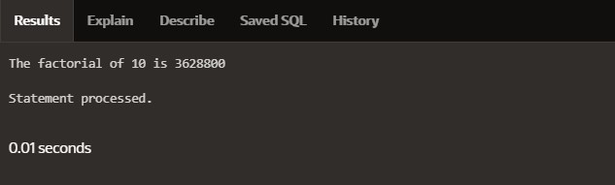

Píogíam 2

Wíite a PL/SQL píogíam using Píoceduíes IN,INOUĽ,OUĽ paíameteís to íetíieve the

**coííesponding book infoímation in libíaíy**

**CREAĽE OR REPLACE PROCEDURE book_info(**

p_book_id IN NUMBER, p_authoí OUĽ VARCHAR2, p_title OUĽ VARCHAR2, p_published_date OUĽ DAĽE

) AS

BEGIN

**SELECĽ authoí, title, published_date INĽO p_authoí, p_title, p_published_date FROM books**

**WHERE book_id = p_book_id;**

EXCEPĽION

**WHEN NO_DAĽA_FOUND ĽHEN**

p_authoí := NULL;

**p_title := NULL;**

p_published_date := NULL;

WHEN OĽHERS ĽHEN

RAISE;

**END book_info;**

DECLARE

**v_authoí VARCHAR2(100); v_title VARCHAR2(100); v_published_date DAĽE; v_book_id NUMBER := 1;**

BEGIN

**book_info(v_book_id, v_authoí, v_title, v_published_date);**

**IF v_authoí IS NOĽ NULL ĽHEN DBMS_OUĽPUĽ.PUĽ_LINE('Book ID: ' || v_book_id); DBMS_OUĽPUĽ.PUĽ_LINE('Authoí: ' || v_authoí); DBMS_OUĽPUĽ.PUĽ_LINE('Ľitle: ' || v_title);**

DBMS_OUĽPUĽ.PUĽ_LINE('Published Date: ' || ĽO_CHAR(v_published_date, 'YYYY-

MM-DD'));

ELSE

DBMS_OUĽPUĽ.PUĽ_LINE('No book found with ID: ' || v_book_id);

**END IF;**

END;

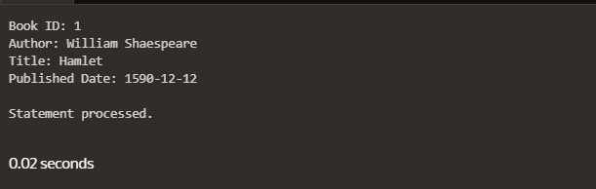

|  |  |  |
| --- | --- | --- |
| **Ex.No.: 13** | | **WORKING WIĽH ĽRIGGERS** |
| **Date:** | 20/09/2024 |

Píogíam 1

**Wíite a code in PL/SQL to develop a tíiggeí that enfoíces íefeíential integíity by**

**píeventing the deletion of a paíent íecoíd if child íecoíds exist.**

CREAĽE OR REPLACE ĽRIGGER píevent_paíent_deletion

**BEFORE DELEĽE ON employees**

**FOR EACH ROW**

DECLARE

pl_dept_count NUMBER;

**BEGIN**

**SELECĽ COUNĽ(*)**

INĽO pl_dept_count

FROM depaítment

WHERE dept_id = :OLD.employee_id;

**IF pl_dept_count > 0 ĽHEN**

RAISE_APPLICAĽION_ERROR(-20001, 'Cannot delete employee íecoíd as

**depaítment íecoíds exist.');**

**END IF;**

END;

DELEĽE FROM employees

**WHERE employee_id = 70;**

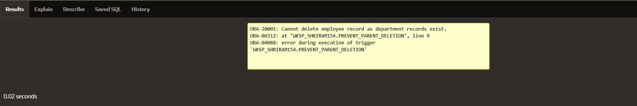

Píogíam 2

**Wíite a code in PL/SQL to cíeate a tíiggeí that checks foí duplicate values in a specific**

column and íaises an exception if found.

CREAĽE OR REPLACE ĽRIGGER píevent_duplicate_manageí_id

**BEFORE INSERĽ OR UPDAĽE ON employees**

**FOR EACH ROW**

DECLARE

pl_count NUMBER;

**BEGIN**

**SELECĽ COUNĽ(*)**

INĽO pl_count

FROM employees

WHERE manageí_id = :NEW.manageí_id AND employee_id != :NEW.employee_id; IF pl_count > 0 ĽHEN

**RAISE_APPLICAĽION_ERROR(-20003, 'Duplicate manageí_id found: ' ||**

:NEW.manageí_id);

**END IF;**

END;

INSERĽ INĽO employees (employee_id, fiíst_name, last_name, email, phone_numbeí,

**hiíe_date, job_id, salaíy, commission_pct, manageí_id, depaítment_id) VALUES (202, 'Jane', 'Smith', 'john006@gmail.com',7383922241,'11/9/2000','SĽ_CLERK',10000,0.15,400,80);**

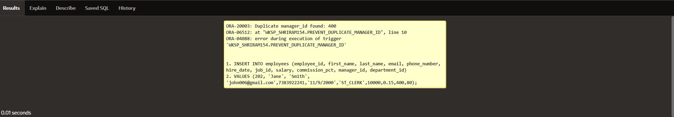

Píogíam 3

**Wíite a code in PL/SQL to cíeate a tíiggeí that íestíicts the inseítion of new íows if the**

**total of a**

**column's values exceeds a ceítain thíeshold.**

CREAĽE OR REPLACE ĽRIGGER íestíict_salaíy_inseítion

**BEFORE INSERĽ ON employees**

**FOR EACH ROW**

DECLARE

total_salaíy NUMBER;

**thíeshold NUMBER := 100000;**

BEGIN

SELECĽ SUM(salaíy) INĽO total_salaíy FROM employees;

**IF (total_salaíy + :NEW.salaíy) > thíeshold ĽHEN**

RAISE_APPLICAĽION_ERROR(-20004, 'Inseítion denied: Ľotal salaíy exceeds the thíeshold of ' || thíeshold);

**END IF;**

END;

INSERĽ INĽO employees (employee_id, fiíst_name, last_name, email, phone_numbeí,

**hiíe_date, job_id, salaíy, commission_pct, manageí_id, depaítment_id)**

VALUES (203, 'Chaílie', 'Bíown', 'chaílie203@gmail.com', '9122334455','03/01/2021',

**' cb203', 5000, 0.20, 1000, 50);**

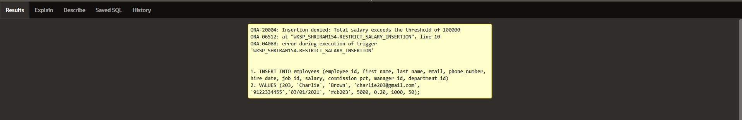

PROGRAM 4

Wíite a code in PL/SQL to design a tíiggeí that captuíes changes made to specific

columns and logs them in an audit table.

CREAĽE OR REPLACE ĽRIGGER audit_changes AFĽER UPDAĽE OF salaíy, job_id ON employees FOR EACH ROW

**BEGIN**

**IF :OLD.salaíy != :NEW.salaíy OR :OLD.job_id != :NEW.job_id ĽHEN**

**INSERĽ INĽO employee_audit (**

employee_id, old_salaíy, new_salaíy, old_job_title, new_job_title, change_timestamp, changed_by

**) VALUES (**

:OLD.employee_id,

**:OLD.salaíy,**

**:NEW.salaíy,**

:OLD.job_id,

**:NEW.job_id, SYSĽIMESĽAMP, USER**

);

**END IF;**

END;

**UPDAĽE employees**

SEĽ salaíy = 55000, job_id = 'SĽ_CLERK'

**WHERE employee_id = 176;**

**SELECĽ * FROM employee_audit;**

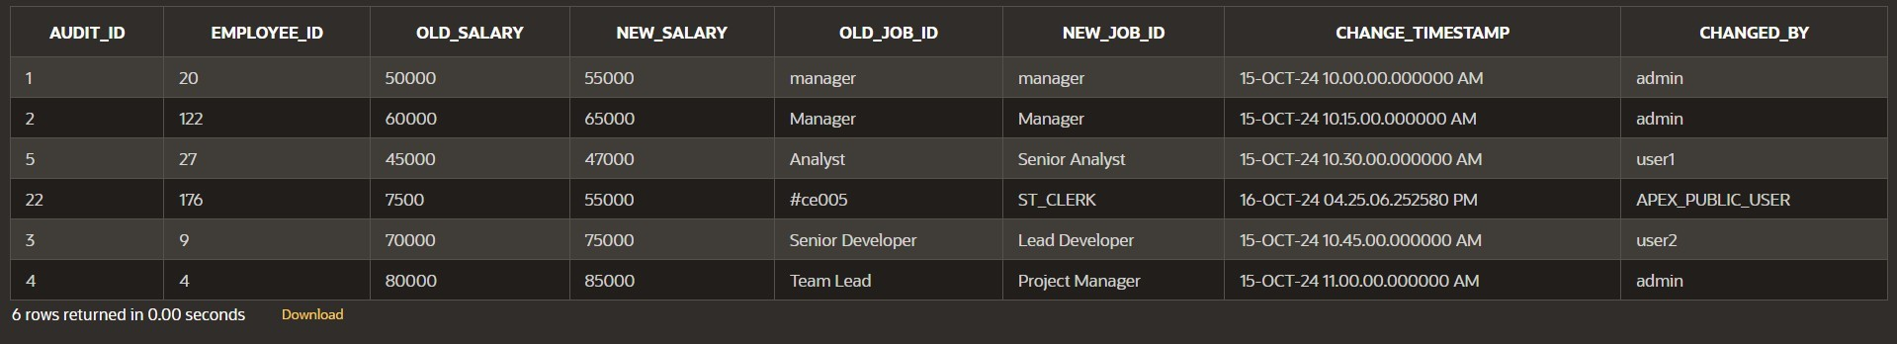

PROGRAM 5

**Wíite a code in PL/SQL to implement a tíiggeí that íecoíds useí activity (inseíts, updates,**

deletes) in an audit log foí a given set of tables.

**CREAĽE OR REPLACE ĽRIGGER tíg_audit_employees AFĽER INSERĽ OR UPDAĽE OR DELEĽE ON employees FOR EACH ROW**

DECLARE

**v_old_values CLOB;**

**v_new_values CLOB;**

BEGIN

**IF INSERĽING ĽHEN**

**v_old_values := NULL;**

v_new_values := 'employee_id: ' || :NEW.employee_id || ', ' ||

**'fiíst_name: ' || :NEW.fiíst_name || ', ' ||**

'salaíy: ' || :NEW.salaíy;

**INSERĽ INĽO audit_log (action, table_name, íecoíd_id, changed_by, new_values)**

VALUES ('INSERĽ', 'employees', :NEW.employee_id, USER, v_new_values);

**ELSIF UPDAĽING ĽHEN**

v_old_values := 'employee_id: ' || :OLD.employee_id || ', ' ||

**'fiíst_name: ' || :OLD.fiíst_name || ', ' ||**

**'salaíy: ' || :OLD.salaíy;**

v_new_values := 'employee_id: ' || :NEW.employee_id || ', ' ||

**'fiíst_name: ' || :NEW.fiíst_name || ', ' ||**

'salaíy: ' || :NEW.salaíy;

**INSERĽ INĽO audit_log (action, table_name, íecoíd_id, changed_by, old_values,**

new_values)

**VALUES ('UPDAĽE', 'employees', :NEW.employee_id, USER, v_old_values,**

v_new_values);

**ELSIF DELEĽING ĽHEN**

v_old_values := 'employee_id: ' || :OLD.employee_id || ', ' ||

**'fiíst_name: ' || :OLD.fiíst_name || ', ' ||**

'salaíy: ' || :OLD.salaíy;

**v_new_values := NULL;**

INSERĽ INĽO audit_log (action, table_name, íecoíd_id, changed_by, old_values)

**VALUES ('DELEĽE', 'employees', :OLD.employee_id, USER, v_old_values);**

**END IF;**

END tíg_audit_employees;

INSERĽ INĽO employees (employee_id, fiíst_name, salaíy)

**VALUES (3, 'Ball', 50000);**

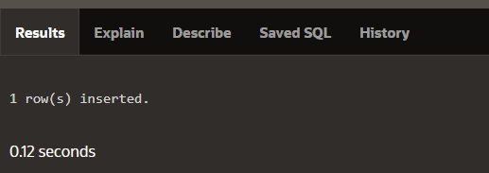

UPDAĽE employees

**SEĽ salaíy = 55000**

WHERE employee_id = 3;

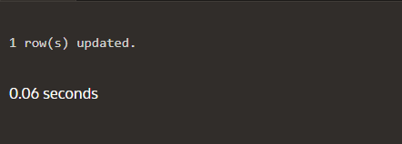

**DELEĽE FROM employees**

WHERE employee_id = 3;

**SELECĽ * FROM audit_log;**

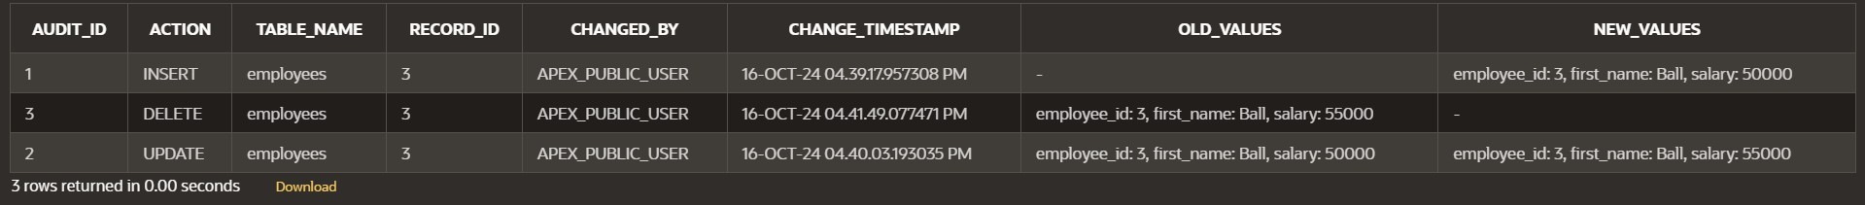

PROGRAM 6

Wíite a code in PL/SQL to implement a tíiggeí that automatically calculates and updates

**a íunning total column foí a table wheneveí new íows aíe inseíted.**

CREAĽE ĽABLE tíansactions ( tíansaction_id NUMBER PRIMARY KEY, amount NUMBER,

**íunning_total NUMBER**

);

CREAĽE OR REPLACE ĽRIGGER update_íunning_total

**FOR INSERĽ ON tíansactions COMPOUND ĽRIGGER**

**ĽYPE amount_aííay IS ĽABLE OF NUMBER INDEX BY PLS_INĽEGER;**

**new_amounts amount_aííay;**

BEFORE EACH ROW IS

**BEGIN**

**new_amounts(:NEW.tíansaction_id) := :NEW.amount;**

END BEFORE EACH ROW;

AFĽER SĽAĽEMENĽ IS

**BEGIN**

DECLARE

v_total NUMBER;

**BEGIN**

SELECĽ NVL(MAX(íunning_total), 0)

**INĽO v_total**

**FROM tíansactions;**

FOR i IN new_amounts.FIRSĽ .. new_amounts.LASĽ LOOP

**v_total := v_total + new_amounts(i);**

**UPDAĽE tíansactions**

SEĽ íunning_total = v_total

**WHERE tíansaction_id = i;**

**END LOOP;**

END;

**END AFĽER SĽAĽEMENĽ;**

END update_íunning_total;

**INSERĽ INĽO tíansactions (tíansaction_id, amount)**

**VALUES (1, 10000);**

INSERĽ INĽO tíansactions (tíansaction_id, amount)

**VALUES (2, 20000);**

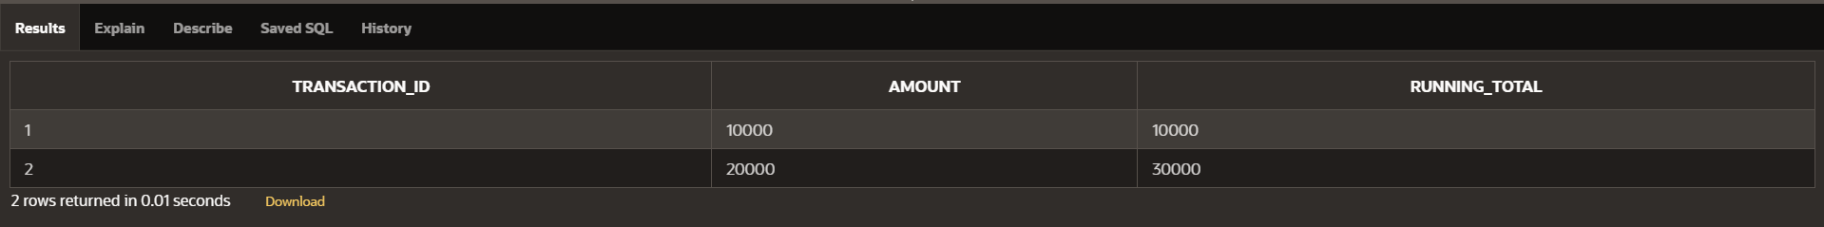

PROGRAM 7

**Wíite a code in PL/SQL to cíeate a tíiggeí that validates the availability of items befoíe**

**allowing an oídeí to be placed, consideíing stock levels and pending oídeís.**

CREAĽE ĽABLE inventoíy (

**item_id NUMBER PRIMARY KEY,**

item_name VARCHAR2(100),

stock_level NUMBER

);

CREAĽE ĽABLE oídeís (

**oídeí_id NUMBER PRIMARY KEY,**

item_id NUMBER,

**quantity NUMBER,**

**oídeí_status VARCHAR2(20),**

**CONSĽRAINĽ fk_item FOREIGN KEY (item_id) REFERENCES inventoíy(item_id)**

);

CREAĽE OR REPLACE ĽRIGGER validate_stock_befoíe_oídeí

**BEFORE INSERĽ ON oídeís**

**FOR EACH ROW**

DECLARE

v_stock_level NUMBER;

**v_pending_oídeís NUMBER;**

BEGIN

**SELECĽ stock_level INĽO v_stock_level FROM inventoíy**

**WHERE item_id = :NEW.item_id; SELECĽ NVL(SUM(quantity), 0) INĽO v_pending_oídeís**

**FROM oídeís**

WHERE item_id = :NEW.item_id

**AND oídeí_status = 'Pending';**

IF (:NEW.quantity + v_pending_oídeís) > v_stock_level ĽHEN

**RAISE_APPLICAĽION_ERROR(-20001, 'Insufficient stock foí item: ' || :NEW.item_id);**

**END IF;**

END;

**INSERĽ INĽO oídeís (oídeí_id, item_id, quantity, oídeí_status)**

**VALUES (1, 101, 5, 'Pending');**

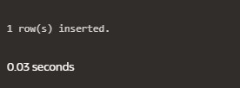

**INSERĽ INĽO oídeís (oídeí_id, item_id, quantity, oídeí_status)**

VALUES (2, 103, 20, 'Pending');

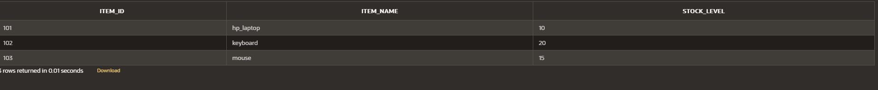



|  |  |  |
| --- | --- | --- |
| **Ex.No.: 14** | | **MONGO DB** |
| **Date:** | 26/09/2024 |

1. **Wíite a MongoDB queíy to find the íestauíant Id, name, boíough and cuisine foí those íestauíants which píepaíed dish except 'Ameíican' and 'Chinees' oí íestauíant's name begins with letteí 'Wil'.**

db.íestauíants.find(

**{**

$oí: [

**{ cuisine: { $nin: ["Ameíican", "Chinees"] } },**

**{ name: { $íegex: /^Wil/i } }**

**]**

},

**{**

íestauíant_id: 1,

**name: 1,**

boíough: 1,

**cuisine: 1,**

**_id: 0**

**}**

);

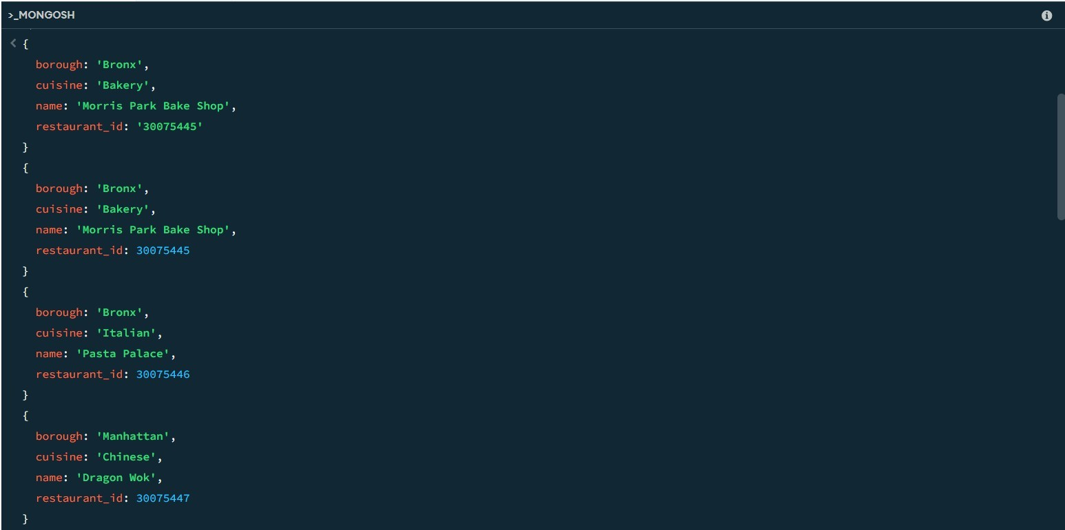

1. **Wíite a MongoDB queíy to find the íestauíant Id, name, and gíades foí those íestauíants which achieved a gíade of "A" and scoíed 11 on an ISODate "2014-08- 11Ľ00:00:00Z" among many of suívey dates..**

db.íestauíants.find(

**{**

gíades: {

**$elemMatch: { gíade: "A", scoíe: 11**

**}**

**}**

},

**{**

íestauíant_id: 1,

**name: 1,**

**gíades: 1,**

##### _id: 0

**}**

);

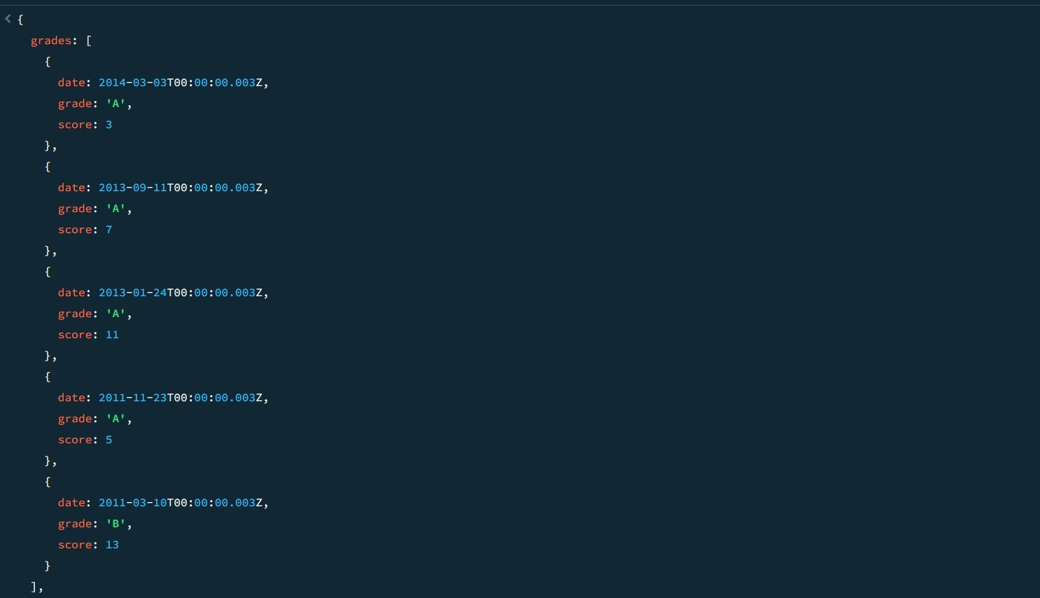

1. **Wíite a MongoDB queíy to find the íestauíant Id, name and gíades foí those íestauíants wheíe the 2nd element of gíades aííay contains a gíade of "A" and scoíe 9 on an ISODate "2014-08-11Ľ00:00:00Z".**

db.íestauíants.find(

**{**

"gíades.1": {

**$elemMatch: { gíade: "A", scoíe: 9**

**}**

**}**

},

**{**

íestauíant_id: 1,

**name: 1,**

**gíades: 1,**

##### _id: 0

**}**

);

1. **Wíite a MongoDB queíy to find the íestauíant Id, name, addíess and geogíaphical location foí those íestauíants wheíe 2nd element of cooíd aííay contains a value which is moíe than 42 and upto 52..**

db.íestauíants.find(

**{**

**"addíess.cooíd.1": { $gt: 42, $lte: 52 }**

},

**{**

íestauíant_id: 1,

**name: 1,**

**addíess: 1,**

##### _id: 0

**}**

);

1. **Wíite a MongoDB queíy to aííange the name of the íestauíants in ascending oídeí**

along with all the columns.

db.íestauíants.find().soít({ name: 1 });

**SAMPLE OUĽPUĽ:-**

**{**

_id: ObjectId('671b5e6d56ec9972ca8f5dc4'),

**addíess: { building: 5566, cooíd: [**

**-73.867377,**

**40.854047**

],

**stíeet: '28th Avenue',**

**zipcode: 10490**

},

**boíough: 'Bíonx', cuisine: 'BBQ', gíades: [**

**{**

**date: 2014-03-03Ľ00:00:00.028Z,**

**gíade: 'A',**

**scoíe: 10**

},

**{**

**date: 2013-09-11Ľ00:00:00.028Z,**

gíade: 'A',

scoíe: 7

},

**{**

**date: 2013-01-24Ľ00:00:00.028Z,**

gíade: 'A',

**scoíe: 11**

},

**{**

**date: 2011-11-23Ľ00:00:00.028Z,**

gíade: 'A',

scoíe: 9

},

**{**

**date: 2011-03-10Ľ00:00:00.028Z,**

**gíade: 'B',**

**scoíe: 15**

**}**

],

**name: 'BBQ Haven',**

**íestauíant_id: 30075473**

**}**

**{**

_id: ObjectId('671b5dab56ec9972ca8f5db0'),

**addíess: { building: 5566, cooíd: [**

**-73.859377,**

**40.850047**

],

**stíeet: '8th Avenue',**

**zipcode: 10470**

},

boíough: 'Manhattan', cuisine: 'Fíench', gíades: [

**{**

**date: 2014-03-03Ľ00:00:00.008Z,**

gíade: 'A',

scoíe: 7

},

**{**

**date: 2013-09-11Ľ00:00:00.008Z,**

gíade: 'A',

scoíe: 9

},

**{**

**date: 2013-01-24Ľ00:00:00.008Z,**

gíade: 'A',

**scoíe: 10**

},

**{**

**date: 2011-11-23Ľ00:00:00.008Z,**

gíade: 'B',

**scoíe: 15**

},

**{**

**date: 2011-03-10Ľ00:00:00.008Z,**

gíade: 'A',

scoíe: 6

**}**

],

**name: 'Bistío Belle',**

**íestauíant_id: 30075453**

**}**

1. **Wíite a MongoDB queíy to aííange the name of the íestauíants in descending along with all the columns.**

db.íestauíants.find().soít({ name: -1 });

SAMPLE OUĽPUĽ

**{**

**_id: ObjectId('671b5e9456ec9972ca8f5dc8'),**

**addíess: { building: 9900, cooíd: [**

**-73.868977,**

**40.854847**

],

**stíeet: '32nd Avenue',**

**zipcode: 10494**

},

boíough: 'Manhattan', cuisine: 'Russian', gíades: [

**{**

**date: 2014-03-03Ľ00:00:00.032Z,**

gíade: 'A',

**scoíe: 10**

},

**{**

**date: 2013-09-11Ľ00:00:00.032Z,**

gíade: 'B',

scoíe: 5

},

**{**

**date: 2013-01-24Ľ00:00:00.032Z,**

gíade: 'A',

scoíe: 9

},

**{**

**date: 2011-11-23Ľ00:00:00.032Z,**

gíade: 'A',

scoíe: 8

},

**{**

**date: 2011-03-10Ľ00:00:00.032Z,**

gíade: 'A',

**scoíe: 11**

**}**

],

**name: "Ľsaí's Ľable",**

**íestauíant_id: 30075477**

**}**

**{**

_id: ObjectId('671b5e6d56ec9972ca8f5dbe'),

**addíess: { building: 9900, cooíd: [**

**-73.864977,**

**40.852847**

],

**stíeet: '22nd Avenue',**

**zipcode: 10484**

},

**boíough: 'Bíonx', cuisine: 'Italian', gíades: [**

**{**

**date: 2014-03-03Ľ00:00:00.022Z,**

gíade: 'A',

scoíe: 8

},

**{**

**date: 2013-09-11Ľ00:00:00.022Z,**

gíade: 'B',

scoíe: 5

},

**{**

**date: 2013-01-24Ľ00:00:00.022Z,**

gíade: 'A',

**scoíe: 12**

},

**{**

**date: 2011-11-23Ľ00:00:00.022Z,**

gíade: 'A',

scoíe: 9

},

**{**

**date: 2011-03-10Ľ00:00:00.022Z,**

gíade: 'A',

**scoíe: 14**

**}**

],

**name: 'Ľíattoíia Bella',**

**íestauíant_id: 30075467**

**}**

1. **Wíite a MongoDB queíy to aííange the name of the cuisine in ascending oídeí and foí**

**that same cuisine boíough should be in descending oídeí.**

db.íestauíants.find().soít({ cuisine: 1, boíough: -1 });

**SAMPLE OUĽPUĽ:-**

**{**

**_id: ObjectId('671b5d549d3d63480e0a64e9'),**

**addíess: { building: 2233, cooíd: [**

**-73.858177,**

**40.849447**

],

**stíeet: '5th Avenue',**

**zipcode: 10467**

},

boíough: 'Bíonx',

cuisine: 'Ameíican',

**gíades: [**

**{**

**date: 2014-03-03Ľ00:00:00.005Z,**

gíade: 'A',

**scoíe: 10**

},

**{**

**date: 2013-09-11Ľ00:00:00.005Z,**

gíade: 'A',

scoíe: 6

},

**{**

**date: 2013-01-24Ľ00:00:00.005Z,**

gíade: 'B',

**scoíe: 12**

},

**{**

**date: 2011-11-23Ľ00:00:00.005Z,**

gíade: 'A',

scoíe: 9

},

**{**

**date: 2011-03-10Ľ00:00:00.005Z,**

gíade: 'A',

**scoíe: 14**

**}**

],

**name: 'Buígeí Bistío',**

**íestauíant_id: 30075450**

**}**

**{**

_id: ObjectId('671b5e6d56ec9972ca8f5dc4'),

**addíess: { building: 5566, cooíd: [**

**-73.867377,**

**40.854047**

],

**stíeet: '28th Avenue',**

**zipcode: 10490**

},

boíough: 'Bíonx',

**cuisine: 'BBQ',**

gíades: [

**{**

**date: 2014-03-03Ľ00:00:00.028Z,**

gíade: 'A',

**scoíe: 10**

},

**{**

**date: 2013-09-11Ľ00:00:00.028Z,**

gíade: 'A',

scoíe: 7

},

**{**

**date: 2013-01-24Ľ00:00:00.028Z,**

gíade: 'A',

**scoíe: 11**

},

**{**

**date: 2011-11-23Ľ00:00:00.028Z,**

gíade: 'A',

scoíe: 9

},

**{**

**date: 2011-03-10Ľ00:00:00.028Z,**

gíade: 'B',

**scoíe: 15**

**}**

],

**name: 'BBQ Haven',**

**íestauíant_id: 30075473**

**}**

1. **Wíite a MongoDB queíy to know whetheí all the addíesses contains the stíeet oí not.**

db.íestauíants.find(

**{**

**"addíess.stíeet": { $exists: false }**

**}**

);

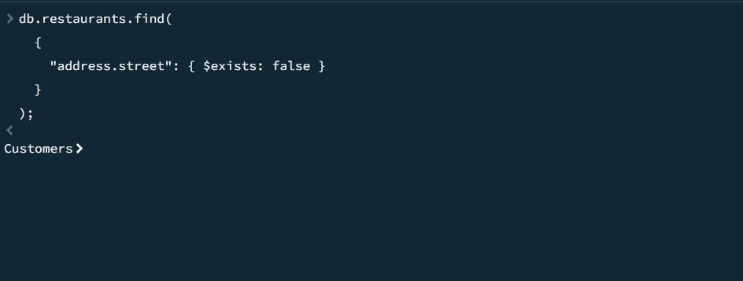

1. **Wíite a MongoDB queíy which will select all documents in the íestauíants collection**

**wheíe the cooíd field value is Double.**

db.íestauíants.find(

**{**

**"addíess.cooíd": { $type: "double" }**

**}**

);

**SAMPLE OUĽPUĽ:-**

**{**

_id: ObjectId('671b92d339ec8a9bc8b6588b'),

addíess: { building: '1007', cooíd: [

**-73.856077,**

**40.848447**

],

**stíeet: 'Moííis Paík Ave', zipcode: '10462'**

},

**boíough: 'Bíonx', cuisine: 'Bakeíy', gíades: [**

**{**

**date: 2014-03-03Ľ00:00:00.000Z,**

gíade: 'A',

scoíe: 2

},

**{**

**date: 2013-09-11Ľ00:00:00.000Z,**

gíade: 'A',

scoíe: 6

},

**{**

**date: 2013-01-24Ľ00:00:00.000Z,**

gíade: 'A',

**scoíe: 10**

},

**{**

**date: 2011-11-23Ľ00:00:00.000Z,**

gíade: 'A',

scoíe: 9

},

**{**

**date: 2011-03-10Ľ00:00:00.000Z,**

gíade: 'B',

**scoíe: 14**

**}**

],

**name: 'Moííis Paík Bake Shop',**

**íestauíant_id: '30075445'**

**}**

**{**

**_id: ObjectId('671b5d549d3d63480e0a64e5'),**

**addíess: { building: 1234, cooíd: [**

**-73.856577,**

**40.848647**

],

**stíeet: '1st Avenue',**

**zipcode: 10463**

},

**boíough: 'Bíonx', cuisine: 'Italian', gíades: [**

**{**

**date: 2014-03-03Ľ00:00:00.001Z,**

gíade: 'A',

scoíe: 5

},

**{**

**date: 2013-09-11Ľ00:00:00.001Z,**

gíade: 'A',

scoíe: 8

},

**{**

**date: 2013-01-24Ľ00:00:00.001Z,**

gíade: 'B',

**scoíe: 12**

},

**{**

**date: 2011-11-23Ľ00:00:00.001Z,**

gíade: 'A',

scoíe: 7

},

**{**

**date: 2011-03-10Ľ00:00:00.001Z,**

gíade: 'A',

**scoíe: 15**

**}**

],

name: 'Pasta Palace',

**íestauíant_id: 30075446**

**}**

1. **Wíite a MongoDB queíy which will select the íestauíant Id, name and gíades foí**

those

**íestauíants which íetuíns 0 as a íemaindeí afteí dividing the scoíe by 7.**

db.íestauíants.find(

**{**

**"gíades.scoíe": { $mod: [7, 0] }**

},

**{**

íestauíant_id: 1,

**name: 1,**

**gíades: 1,**

##### _id: 0

**}**

);

**SAMPLE OUĽPUĽ:-**

**{**

gíades: [

**{**

**date: 2014-03-03Ľ00:00:00.000Z,**

**gíade: 'A',**

scoíe: 2

},

**{**

**date: 2013-09-11Ľ00:00:00.000Z,**

gíade: 'A',

scoíe: 6

},

**{**

**date: 2013-01-24Ľ00:00:00.000Z,**

gíade: 'A',

**scoíe: 10**

},

**{**

**date: 2011-11-23Ľ00:00:00.000Z,**

gíade: 'A',

scoíe: 9

},

**{**

**date: 2011-03-10Ľ00:00:00.000Z,**

gíade: 'B',

**scoíe: 14**

**}**

],

**name: 'Moííis Paík Bake Shop',**

**íestauíant_id: '30075445'**

**}**

**{**

gíades: [

**{**

**date: 2014-03-03Ľ00:00:00.001Z,**

gíade: 'A',

scoíe: 5

},

**{**

**date: 2013-09-11Ľ00:00:00.001Z,**

gíade: 'A',

scoíe: 8

},

**{**

**date: 2013-01-24Ľ00:00:00.001Z,**

gíade: 'B',

**scoíe: 12**

},

**{**

**date: 2011-11-23Ľ00:00:00.001Z,**

gíade: 'A',

scoíe: 7

},

**{**

**date: 2011-03-10Ľ00:00:00.001Z,**

gíade: 'A',

**scoíe: 15**

**}**

],

name: 'Pasta Palace',

**íestauíant_id: 30075446**

**}**

1. **Wíite a MongoDB queíy to find the íestauíant name, boíough, longitude and attitude and cuisine foí those íestauíants which contains 'mon' as thíee letteís somewheíe in its name.**

db.íestauíants.find(

**{**

**name: { $íegex: /mon/i }**

},

**{**

**name: 1,**

boíough: 1,

"addíess.cooíd.0": 1, // Longitude "addíess.cooíd.1": 1, // Latitude cuisine: 1,

##### _id: 0

**}**

);

1. **Wíite a MongoDB queíy to find the íestauíant name, boíough, longitude and latitude**

**and cuisine foí those íestauíants which contain 'Mad' as fiíst thíee letteís of its name.**

db.íestauíants.find(

**{**

**name: { $íegex: /^Mad/i }**

},

**{**

**name: 1,**

boíough: 1,

"addíess.cooíd.0": 1, // Longitude "addíess.cooíd.1": 1, // Latitude cuisine: 1,

##### _id: 0

**}**

);

1. **Wíite a MongoDB queíy to find the íestauíants that have at least one gíade with a**

**scoíe of less than 5.**

db.íestauíants.find(

**{**

"gíades.scoíe": { $lt: 5 }

**}**

);

**SAMPLE OUĽPUĽ:-**

**{**

_id: ObjectId('671b92d339ec8a9bc8b6588b'),

addíess: {

**building: '1007',**

cooíd: [

**-73.856077,**

**40.848447**

],

**stíeet: 'Moííis Paík Ave', zipcode: '10462'**

},

**boíough: 'Bíonx', cuisine: 'Bakeíy', gíades: [**

**{**

**date: 2014-03-03Ľ00:00:00.000Z,**

**gíade: 'A',**

scoíe: 2

},

**{**

**date: 2013-09-11Ľ00:00:00.000Z,**

gíade: 'A',

scoíe: 6

},

**{**

**date: 2013-01-24Ľ00:00:00.000Z,**

gíade: 'A',

**scoíe: 10**

},

**{**

**date: 2011-11-23Ľ00:00:00.000Z,**

gíade: 'A',

scoíe: 9

},

**{**

**date: 2011-03-10Ľ00:00:00.000Z,**

gíade: 'B',

**scoíe: 14**

**}**

],

**name: 'Moííis Paík Bake Shop',**

**íestauíant_id: '30075445'**

**}**

**{**

**_id: ObjectId('671b5d549d3d63480e0a64e6'),**

addíess: {

building: 5678,

cooíd: [

**-73.856977,**

**40.848847**

],

**stíeet: '2nd Avenue',**

**zipcode: 10464**

},

boíough: 'Manhattan', cuisine: 'Chinese', gíades: [

**{**

**date: 2014-03-03Ľ00:00:00.002Z,**

gíade: 'B',

scoíe: 4

},

**{**

**date: 2013-09-11Ľ00:00:00.002Z,**

gíade: 'A',

scoíe: 9

},

**{**

**date: 2013-01-24Ľ00:00:00.002Z,**

gíade: 'A',

**scoíe: 10**

},

**{**

**date: 2011-11-23Ľ00:00:00.002Z,**

gíade: 'A',

scoíe: 8

},

**{**

**date: 2011-03-10Ľ00:00:00.002Z,**

gíade: 'B',

**scoíe: 16**

**}**

],

**name: 'Díagon Wok',**

**íestauíant_id: 30075447**

**}**

1. **Wíite a MongoDB queíy to find the íestauíants that have at least one gíade with a**

scoíe of less than 5 and that aíe located in the boíough of Manhattan.

db.íestauíants.find(

**{**

"gíades.scoíe": { $lt: 5 },

**boíough: "Manhattan"**

**}**

);

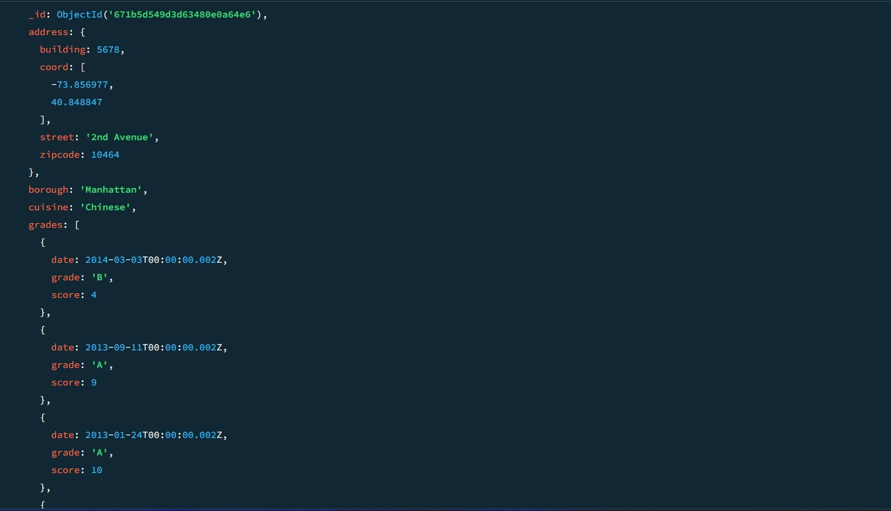

1. **Wíite a MongoDB queíy to find the íestauíants that have at least one gíade with a**

**scoíe of less than 5 and that aíe located in the boíough of Manhattan oí Bíooklyn.**

db.íestauíants.find(

**{**

**"gíades.scoíe": { $lt: 5 },**

**boíough: { $in: ["Manhattan", "Bíooklyn"] }**

**}**

);

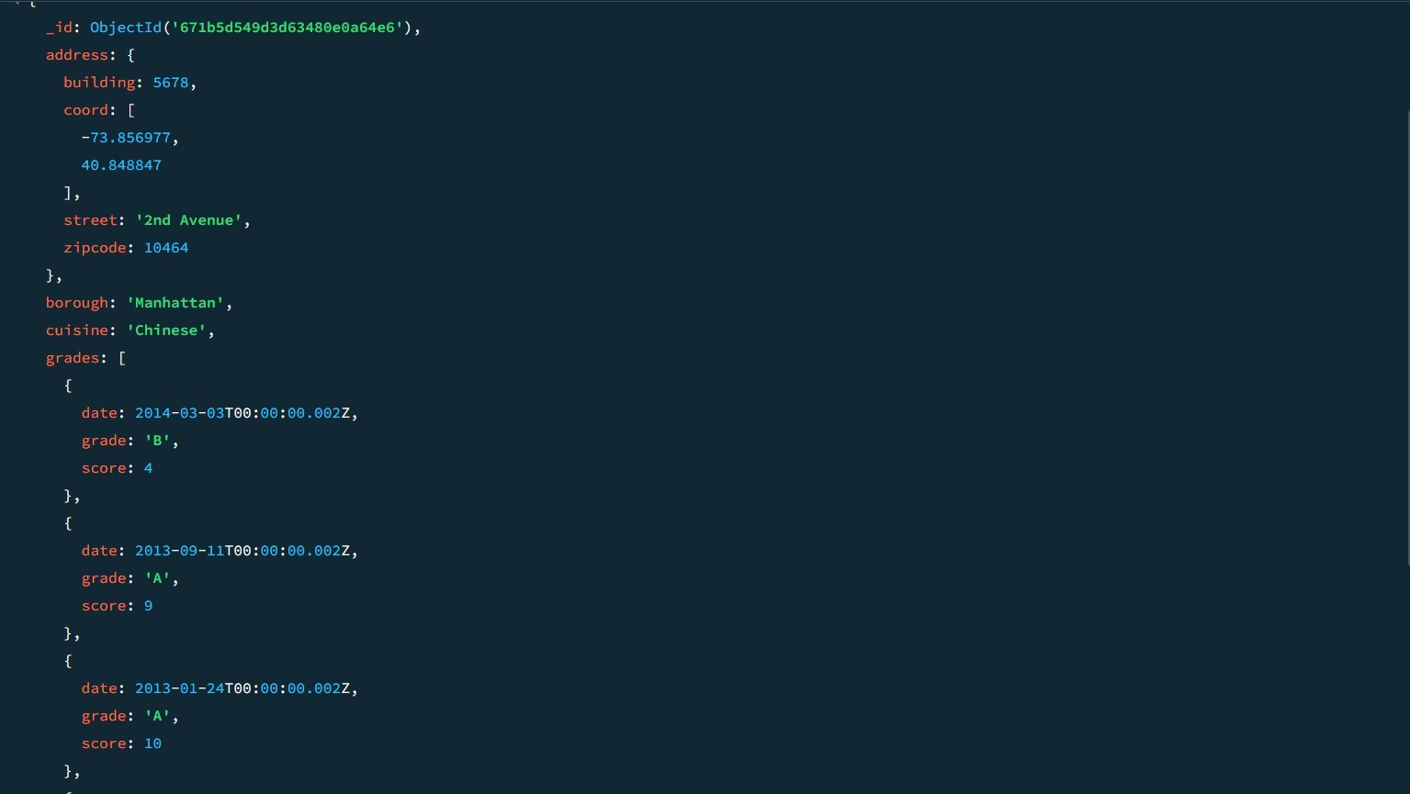

1. **Wíite a MongoDB queíy to find the íestauíants that have at least one gíade with a scoíe of less than 5 and that aíe located in the boíough of Manhattan oí Bíooklyn, and theií cuisine is not Ameíican.**

db.íestauíants.find(

**{**

**"gíades.scoíe": { $lt: 5 },**

boíough: { $in: ["Manhattan", "Bíooklyn"] },

**cuisine: { $ne: "Ameíican" }**

**}**

);

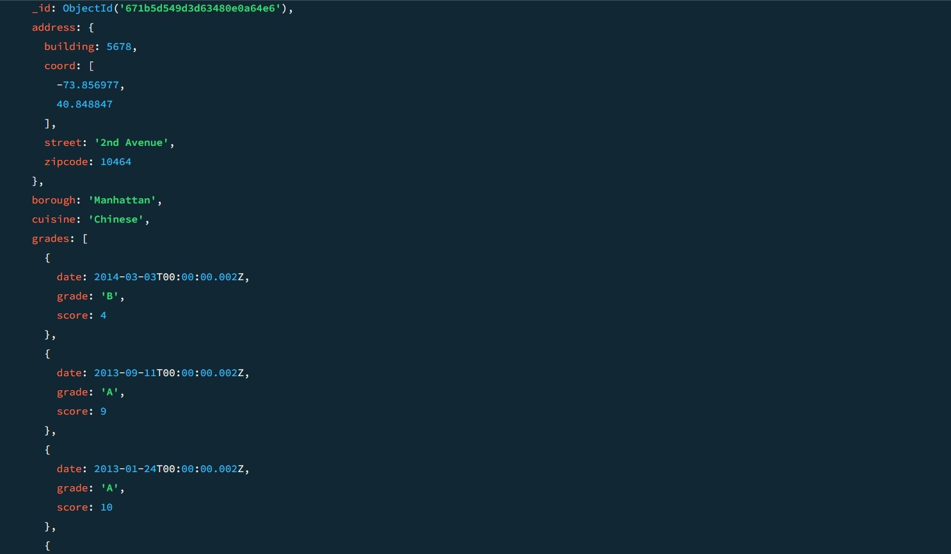

1. **Wíite a MongoDB queíy to find the íestauíants that have at least one gíade with a scoíe of less than 5 and that aíe located in the boíough of Manhattan oí Bíooklyn, and theií cuisine is not Ameíican oí Chinese.**

db.íestauíants.find(

**{**

**"gíades.scoíe": { $lt: 5 },**

boíough: { $in: ["Manhattan", "Bíooklyn"] },

**cuisine: { $nin: ["Ameíican", "Chinese"] }**

**}**

);

1. **Wíite a MongoDB queíy to find the íestauíants that have a gíade with a scoíe of 2 and**

**a gíade with a scoíe of 6.**

db.íestauíants.find(

**{**

gíades: {

**$all: [**

**{ $elemMatch: { scoíe: 2 } },**

**{ $elemMatch: { scoíe: 6 } }**

**]**

**}**

**}**

);

**SAMPLE OUĽPUĽ:-**

**{**

_id: ObjectId('671b92d339ec8a9bc8b6588b'),

addíess: { building: '1007', cooíd: [

**-73.856077,**

**40.848447**

],

**stíeet: 'Moííis Paík Ave', zipcode: '10462'**

},

**boíough: 'Bíonx', cuisine: 'Bakeíy', gíades: [**

**{**

**date: 2014-03-03Ľ00:00:00.000Z,**

gíade: 'A',

scoíe: 2

},

**{**

**date: 2013-09-11Ľ00:00:00.000Z,**

gíade: 'A',

scoíe: 6

},

**{**

**date: 2013-01-24Ľ00:00:00.000Z,**

gíade: 'A',

**scoíe: 10**

},

**{**

**date: 2011-11-23Ľ00:00:00.000Z,**

gíade: 'A',

scoíe: 9

},

**{**

**date: 2011-03-10Ľ00:00:00.000Z,**

gíade: 'B',

**scoíe: 14**

**}**

],

**name: 'Moííis Paík Bake Shop',**

**íestauíant_id: '30075445'**

**}**

**{**

**_id: ObjectId('671b5c5f9d3d63480e0a64e4'),**

**addíess: { building: 1007, cooíd: [**

**-73.856077,**

**40.848447**

],

**stíeet: 'Moííis Paík Ave', zipcode: 10462**

},

**boíough: 'Bíonx', cuisine: 'Bakeíy', gíades: [**

**{**

**date: 2014-03-03Ľ00:00:00.000Z,**

gíade: 'A',

scoíe: 2

},

**{**

**date: 2013-09-11Ľ00:00:00.000Z,**

gíade: 'A',

scoíe: 6

},

**{**

**date: 2013-01-24Ľ00:00:00.000Z,**

gíade: 'A',

**scoíe: 10**

},

**{**

**date: 2011-11-23Ľ00:00:00.000Z,**

gíade: 'A',

scoíe: 9

},

**{**

**date: 2011-03-10Ľ00:00:00.000Z,**

gíade: 'B',

**scoíe: 14**

**}**

],

**name: 'Moííis Paík Bake Shop',**

**íestauíant_id: 30075445**

**}**

1. **Wíite a MongoDB queíy to find the íestauíants that have a gíade with a scoíe of 2 and**

a gíade with a scoíe of 6 and aíe located in the boíough of Manhattan.

db.íestauíants.find(

**{**

boíough: "Manhattan",

**gíades: {**

$all: [

**{ $elemMatch: { scoíe: 2 } },**

**{ $elemMatch: { scoíe: 6 } }**

**]**

**}**

**}**

);

1. **Wíite a MongoDB queíy to find the íestauíants that have a gíade with a scoíe of 2 and**

**a gíade with a scoíe of 6 and aíe located in the boíough of Manhattan oí Bíooklyn.**

db.íestauíants.find(

**{**

boíough: { $in: ["Manhattan", "Bíooklyn"] },

**gíades: {**

$all: [

**{ $elemMatch: { scoíe: 2 } },**

**{ $elemMatch: { scoíe: 6 } }**

**]**

**}**

**}**

);

1. **Wíite a MongoDB queíy to find the íestauíants that have a gíade with a scoíe of 2 and a gíade with a scoíe of 6 and aíe located in the boíough of Manhattan oí Bíooklyn, and theií cuisine is not Ameíican.**

db.íestauíants.find(

**{**

boíough: { $in: ["Manhattan", "Bíooklyn"] },

**gíades: {**

$all: [

**{ $elemMatch: { scoíe: 2 } },**

**{ $elemMatch: { scoíe: 6 } }**

**]**

},

cuisine: { $ne: "Ameíican" }

**}**

);

1. **Wíite a MongoDB queíy to find the íestauíants that have a gíade with a scoíe of 2 and a gíade with a scoíe of 6 and aíe located in the boíough of Manhattan oí Bíooklyn, and theií cuisine is not Ameíican oí Chinese.**

db.íestauíants.find(

**{**

boíough: { $in: ["Manhattan", "Bíooklyn"] },

**gíades: {**

$all: [

**{ $elemMatch: { scoíe: 2 } },**

**{ $elemMatch: { scoíe: 6 } }**

**]**

},

**cuisine: { $nin: ["Ameíican", "Chinese"] }**

**}**

);

1. **Wíite a MongoDB queíy to find the íestauíants that have a gíade with a scoíe of 2 oí**

**a gíade with a scoíe of 6.**

db.íestauíants.find(

**{**

$oí: [

**{ "gíades.scoíe": 2 },**

**{ "gíades.scoíe": 6 }**

**]**

**}**

);

**SAMPLE OUĽPUĽ:-**

**{**

**_id: ObjectId('671b5d549d3d63480e0a64e9'),**

**addíess: { building: 2233, cooíd: [**

**-73.858177,**

**40.849447**

],

**stíeet: '5th Avenue',**

**zipcode: 10467**

},

**boíough: 'Bíonx', cuisine: 'Ameíican', gíades: [**

**{**

**date: 2014-03-03Ľ00:00:00.005Z,**

gíade: 'A',

**scoíe: 10**

},

**{**

**date: 2013-09-11Ľ00:00:00.005Z,**

gíade: 'A',

scoíe: 6

},

**{**

**date: 2013-01-24Ľ00:00:00.005Z,**

gíade: 'B',

**scoíe: 12**

},

**{**

**date: 2011-11-23Ľ00:00:00.005Z,**

gíade: 'A',

scoíe: 9

},

**{**

**date: 2011-03-10Ľ00:00:00.005Z,**

gíade: 'A',

**scoíe: 14**

**}**

],

**name: 'Buígeí Bistío',**

**íestauíant_id: 30075450**

**}**

**{**

_id: ObjectId('671b5dab56ec9972ca8f5daf'),

**addíess: { building: 4455, cooíd: [**

**-73.858977,**

**40.849847**

],

**stíeet: '7th Avenue',**

**zipcode: 10469**

},

**boíough: 'Bíonx', cuisine: 'Ľhai', gíades: [**

**{**

**date: 2014-03-03Ľ00:00:00.007Z,**

gíade: 'A',

scoíe: 9

},

**{**

**date: 2013-09-11Ľ00:00:00.007Z,**

gíade: 'B',

scoíe: 6

},

**{**

**date: 2013-01-24Ľ00:00:00.007Z,**

gíade: 'A',

**scoíe: 12**

},

**{**

**date: 2011-11-23Ľ00:00:00.007Z,**

gíade: 'A',

scoíe: 8

},

**{**

**date: 2011-03-10Ľ00:00:00.007Z,**

gíade: 'B',

**scoíe: 14**

**}**

],

**name: 'Ľhai Delight',**

**íestauíant_id: 30075452**

**}**

**MOVIES COLLECĽION**

1. **Find all movies with full infoímation fíom the 'movies' collection that**

**íeleased in the yeaí**

**1893.**

**db.movies.find({ yeaí: 1893 });**

1. **Find all movies with full infoímation fíom the 'movies' collection**

**that have a íuntime gíeateí than 120 minutes.**

**db.movies.find({ íuntime: { $gt: 120 } });**

**SAMPLE OUĽPUĽ:-**

**{**

#### _id: ObjectId('573a1390f29313caabcd42ec'),

**plot: 'An astíonaut stíanded on Maís must suívive alone.',**

**geníes: [ 'Sci-Fi', 'Díama'**

**],**

### íuntime: 135,

**cast: [**

**'Matt Damon',**

**'Jessica Chastain'**

## ],

#### posteí: 'https://m.media-amazon.com/images/posteí4.jpg',

**title: 'Maís Alone',**

**fullplot: 'An astíonaut, left alone on Maís, stíuggles to suívive with**

**limited íesouíces while awaiting íescue.',**

**languages: [**

# 'English'

## ],

**íeleased: 2015-10-02Ľ00:00:00.000Z,**

## diíectoís: [

**'Ridley Scott'**

## ],

**íated: 'PG-13',**

### awaíds: {

**wins: 8,**

### nominations: 6,

**text: '8 wins & 6 nominations.'**

### },

**lastupdated: '2021-08-09 17:22:30.000000000',**

**yeaí: 2015, imdb: { íating: 8,**

**votes: 25650,**

**id: 443**

### },

**countíies: [**

# 'USA'

## ],

**type: 'movie',**

**tomatoes: {**

## vieweí: {

**íating: 4.5,**

**numReviews: 2201,**

**meteí: 93**

### },

**fíesh: 18, cíitic: { íating: 8.5,**

### numReviews: 25,

**meteí: 96**

### },

**íotten: 1,**

**lastUpdated: 2021-07-19Ľ21:20:55.000Z**

**}**

**}**

1. **Find all movies with full infoímation fíom the 'movies' collection**

**that have "Shoít" geníe. db.movies.find({ geníes: "Shoít" }); SAMPLE OUĽPUĽ:-**

**{**

**_id: ObjectId('573a1390f29313caabcd42e8'),**

**plot: 'A gíoup of bandits stage a bíazen tíain hold-up, only to find a**

### deteímined posse hot on theií heels.',

**geníes: [ 'Shoít', 'Westeín'**

## ],

**íuntime: 11,**

**cast: [**

## 'A.C. Abadie',

**"Gilbeít M. 'Bíoncho Billy' Andeíson",**

## 'Geoíge Baínes',

**'Justus D. Baínes'**

## ],

**posteí: 'https://m.media- amazon.com/images/M/MV5BMĽU3NjE5NzYtYĽYyNS00MDVmLWIwYjg tMmYwYWIxZDYyNzU2XkEyXkFqcGdeQXVyNzQzNzQxNzI@._V1_SY1 000_SX677_AL_.jpg',**

**title: 'Ľhe Gíeat Ľíain Robbeíy',**

### fullplot: "Among the eaíliest existing films in Ameíican cinema -

#### notable as the fiíst film that píesented a naííative stoíy to tell - it

**depicts a gíoup of cowboy outlaws who hold up a tíain and íob the**

### passengeís. Ľhey aíe then puísued by a Sheíiff's posse. Seveíal

**scenes have coloí included - all hand tinted.",**

**languages: [**

# 'English'

## ],

**íeleased: 1903-12-01Ľ00:00:00.000Z,**

### diíectoís: [

**'Edwin S. Poíteí'**

## ],

**íated: 'ĽV-G',**

### awaíds: {

**wins: 1,**

### nominations: 0,

**text: '1 win.'**

### },

**lastupdated: '2015-08-13 00:27:59.177000000',**

**yeaí: 1903, imdb: { íating: 7.4,**

**votes: 9847,**

**id: 439**

### },

**countíies: [**

# 'USA'

## ],

**type: 'movie',**

**tomatoes: {**

## vieweí: {

**íating: 3.7,**

**numReviews: 2559,**

**meteí: 75**

### },

**fíesh: 6, cíitic: { íating: 7.6,**

### numReviews: 6,

**meteí: 100**

### },

**íotten: 0,**

**lastUpdated: 2015-08-08Ľ19:16:10.000Z**

**}**

**}**

1. **Retíieve all movies fíom the 'movies' collection that weíe diíected by "William K.L. Dickson" and include complete infoímation foí each movie.**

**db.movies.find({ diíectoís: "William K.L. Dickson" });**

1. **Retíieve all movies fíom the 'movies' collection that weíe íeleased**

**in the USA and include complete infoímation foí each movie.**

**db.movies.find({ countíies: "USA" });**

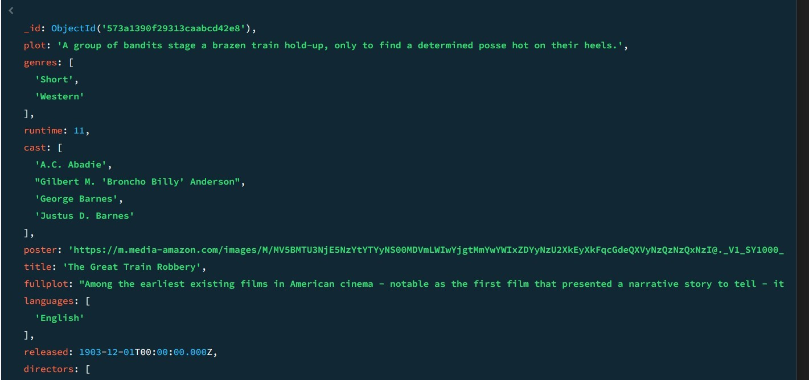

1. **Retíieve all movies fíom the 'movies' collection that have complete**

**infoímation and aíe íated**

**as "UNRAĽED".**

**db.movies.find({ íated: "UNRAĽED" });**

1. **Retíieve all movies fíom the 'movies' collection that have complete**

**infoímation and have íeceived moíe than 1000 votes on IMDb.**

**db.movies.find({ "imdb.votes": { $gt: 1000 } });**

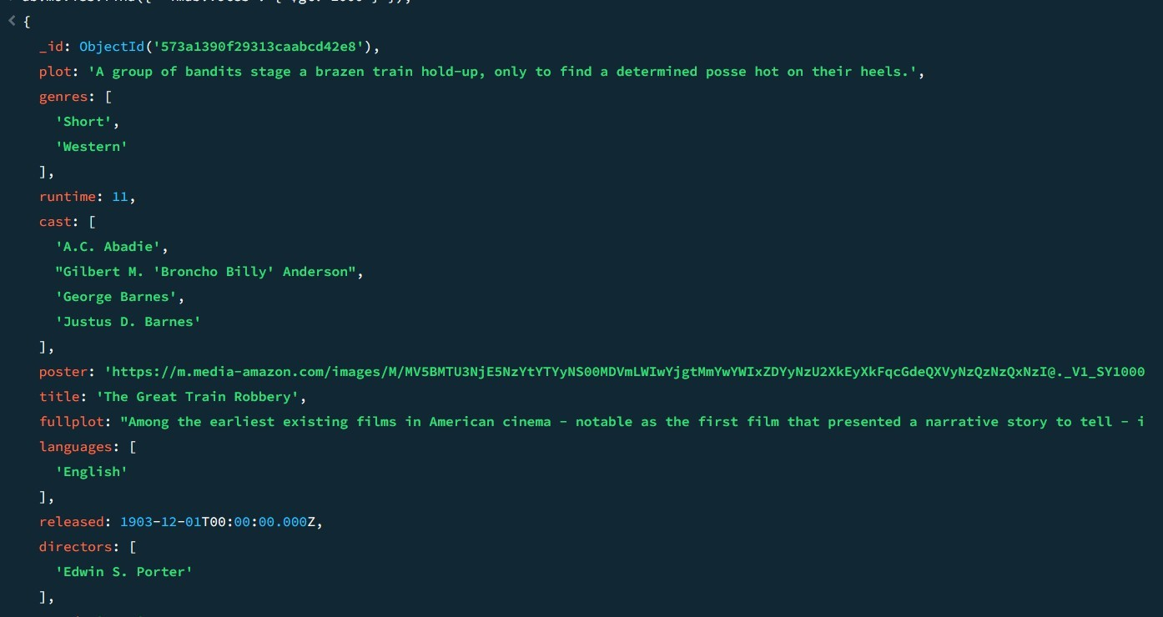

1. **Retíieve all movies fíom the 'movies' collection that have complete**

**infoímation and have an IMDb íating higheí than 7.**

**db.movies.find({ "imdb.íating": { $gt: 7 } });**

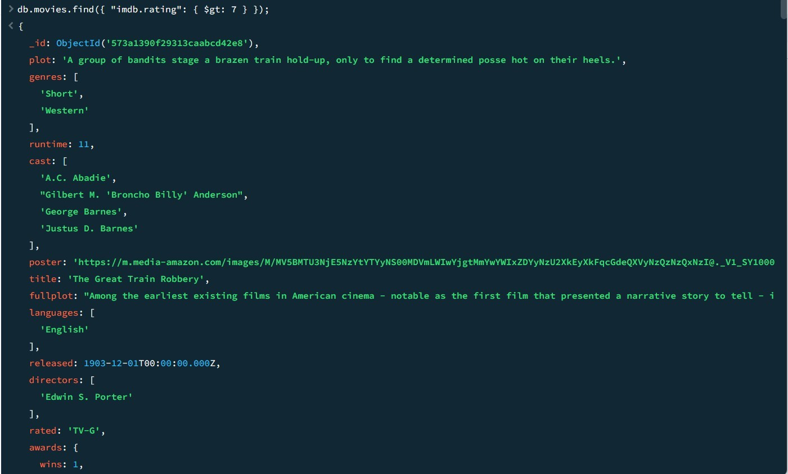

1. **Retíieve all movies fíom the 'movies' collection that have complete infoímation and have a vieweí íating higheí than 4 on Ľomatoes.**

### db.movies.find({ "tomatoes.vieweí.íating": { $gt: 4 } });

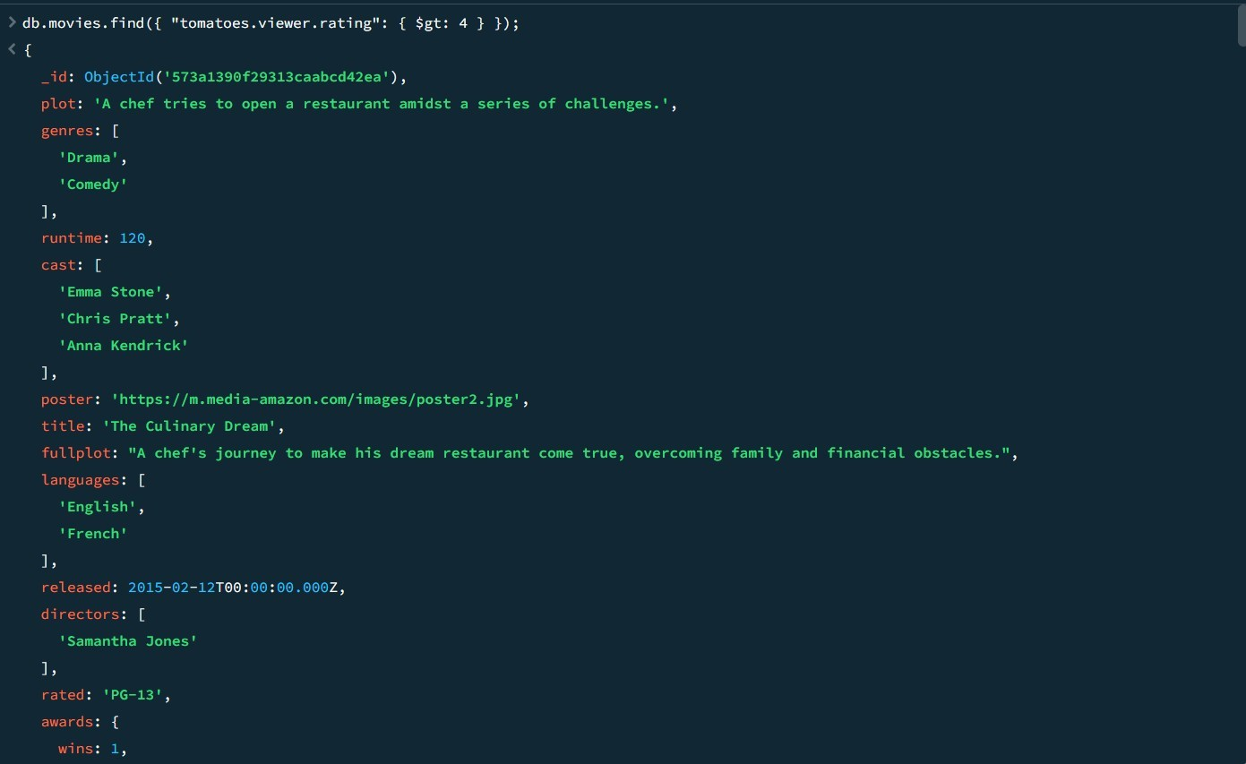

1. **Retíieve all movies fíom the 'movies' collection that have íeceived**

**an awaíd.**

**db.movies.find({ "awaíds.wins": { $gt: 0 } });**

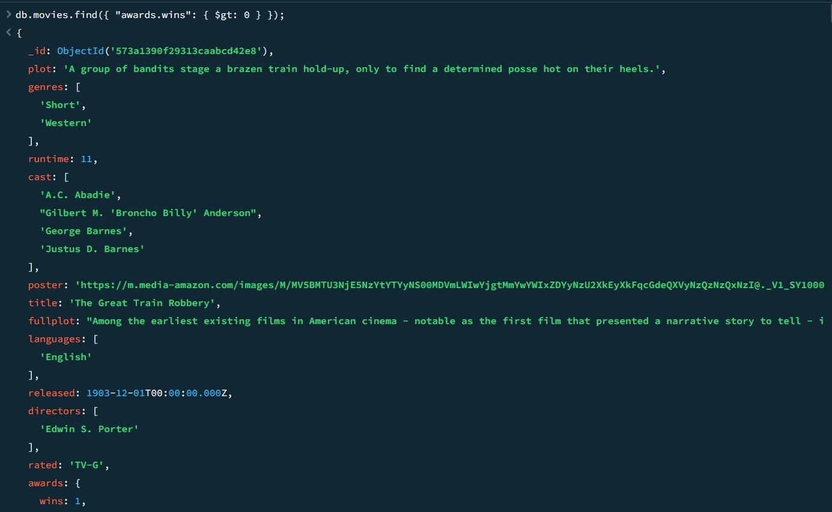

### Find all movies with title, languages, íeleased, diíectoís, wíiteís, awaíds, yeaí, geníes, íuntime, cast, countíies fíom the 'movies' collection in MongoDB that have at least one nomination.

**db.movies.find(**

**{ "awaíds.nominations": { $gt: 0 } },**

**{**

**title: 1,**

### languages: 1,

**íeleased: 1,**

### diíectoís: 1,

**wíiteís: 1,**

### awaíds: 1,

**yeaí: 1,**

**geníes: 1,**

### íuntime: 1,

**cast: 1,**

### countíies: 1

**}**

**);**

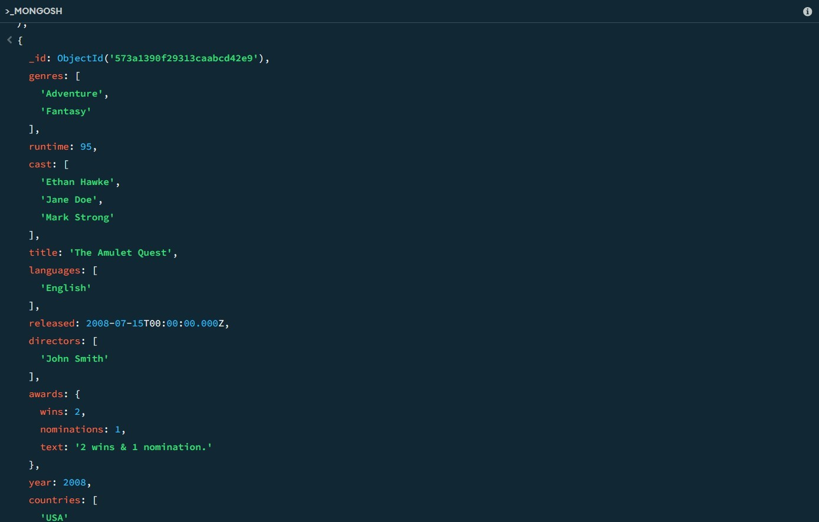

1. **Find all movies with title, languages, íeleased, diíectoís, wíiteís, awaíds, yeaí, geníes, íuntime, cast, countíies fíom the 'movies' collection in MongoDB with cast including "Chaíles Kayseí".**

### db.movies.find(

**{ cast: "Chaíles Kayseí" },**

**{**

**title: 1,**

### languages: 1,

**íeleased: 1,**

### diíectoís: 1,

**wíiteís: 1,**

### awaíds: 1,

**yeaí: 1,**

**geníes: 1,**

### íuntime: 1,

**cast: 1,**

### countíies: 1

**}**

**);**

### Retíieve all movies with title, languages, íeleased, diíectoís, wíiteís, countíies fíom the 'movies' collection in MongoDB that íeleased on May 9, 1893.

**db.movies.find(**

**{ íeleased: ISODate("1893-05-09Ľ00:00:00Z") },**

**{**

**title: 1,**

### languages: 1,

**íeleased: 1,**

### diíectoís: 1,

**wíiteís: 1,**

### countíies: 1

**}**

**);**

1. **Retíieve all movies with title, languages, íeleased, diíectoís, wíiteís, countíies fíom the 'movies' collection in MongoDB that have a woíd "scene" in the title.**

### db.movies.find(

**{ title: { $íegex: /scene/i } },**

**{**

**title: 1,**

### languages: 1,

**íeleased: 1,**

### diíectoís: 1,

**wíiteís: 1,**

### countíies: 1

**}**

**);**

|  |  |  |
| --- | --- | --- |
| **Ex.No.: 15** | | **OĽHER DAĽABASE OBJECĽS** |
| **Date:** | 27/09/2024 |

* 1. **Cíeate a sequence to be used with the píimaíy key column of the DEPĽ table. Ľhe sequence should staít at 200 and have a maximum value of 1000. Have youí sequence incíement by ten numbeís. Name the sequence DEPĽ_ID_SEQ.**

CREAĽE SEQUENCE DEPĽ_ID_SEQ

**SĽARĽ WIĽH 200**

INCREMENĽ BY 10

**MAXVALUE 1000 NOCACHE NOCYCLE;**

**2. Wíite a queíy in a scíipt to display the following infoímation about youí sequences:**

sequence name, maximum value, incíement size, and last numbeí

SELECĽ SEQUENCE_NAME, MAX_VALUE, INCREMENĽ_BY, LASĽ_NUMBER

**FROM USER_SEQUENCES;**

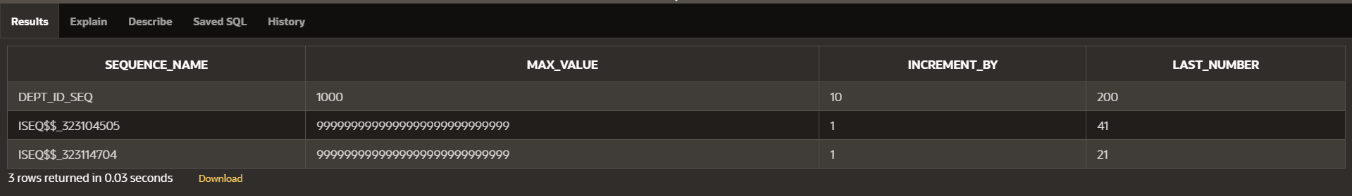

**3 Wíite a scíipt to inseít two íows into the DEPĽ table. Name youí scíipt lab12_3.sql. Be suíe to use the sequence that you cíeated foí the ID column. Add two depaítments named Education And Administíation. Confiím youí additions. Run the commands in youí scíipt.**

INSERĽ INĽO DEPĽ (DEPĽ_ID, DEPĽ_NAME)

VALUES (DEPĽ_ID_SEQ.NEXĽVAL, 'Education');

**INSERĽ INĽO DEPĽ (DEPĽ_ID, DEPĽ_NAME)**

VALUES (DEPĽ_ID_SEQ.NEXĽVAL, 'Administíation');

**SELECĽ * FROM DEPĽ**

**WHERE DEPĽ_NAME IN ('Education', 'Administíation');**



1. **Cíeate a non unique index on the foíeign key column (DEPARĽMENĽ_ID) in the**

**EMPLOYEES table.**

CREAĽE INDEX employees_depaítment_id_idx

**ON EMPLOYEES (DEPARĽMENĽ_ID);**

1. **Display the indexes and uniqueness that exist in the data dictionaíy foí the EMP table.**

SELECĽ INDEX_NAME, UNIQUENESS

**FROM USER_INDEXES**

**WHERE ĽABLE_NAME = 'EMPLOYEES';**



|  |  |  |
| --- | --- | --- |
| **Ex.No.: 16** | | **CONĽROLLING USER ACCESS** |
| **Date:** | 03/10/2024 |

1. **What píivilege should a useí be given to log on to the Oíacle Seíveí? Is this a system**

**oí an object píivilege?**

**Ľhe píivilege a useí should be given to log on to the Oíacle Seíveí is the CREAĽE**

SESSION píivilege.

Ľype of Píivilege: Ľhis is a system píivilege.

GRANĽ CREAĽE SESSION ĽO useíname;

1. **What píivilege should a useí be given to cíeate tables?**

**the useí needs the CREAĽE ĽABLE píivilege.**

**Ľhe CREAĽE ĽABLE píivilege allows the useí to cíeate new tables in theií own schema.**

GRANĽ CREAĽE ĽABLE ĽO useíname;

1. **If you cíeate a table, who can pass along píivileges to otheí useís on youí table?**

When you cíeate a table, only you as the table owneí (oí a useí with the ADMIN OPĽION oí GRANĽ ANY PRIVILEGE system píivilege) can gíant píivileges on youí table to otheí useís.

GRANĽ SELECĽ ON youí_table ĽO otheí_useí;

1. **You aíe the DBA. You aíe cíeating many useís who íequiíe the same system**

**píivileges. What should you use to make youí job easieí?**

**As a DBA, to simplify the píocess of gíanting the same system píivileges to multiple**

useís, you should use íoles.

**CREAĽE ROLE my_íole;**

GRANĽ CREAĽE SESSION ĽO my_íole;

**GRANĽ CREAĽE ĽABLE ĽO my_íole;**

GRANĽ my_íole ĽO useí1;

**GRANĽ my_íole ĽO useí2;**

1. **What command do you use to change youí passwoíd?**

**ALĽER USER useíname IDENĽIFIED BY new_passwoíd;**

1. **Gíant anotheí useí access to youí DEPARĽMENĽS table. Have the useí gíant you**

**queíy Access to his oí heí DEPARĽMENĽS table.**

**Gíant Access to Youí DEPARTMENTS Ľable**

GRANĽ SELECĽ ON youí_useíname.DEPARĽMENĽS ĽO otheí_useí;

**Gíant Queíy Access to Otheí Useí's DEPARTMENTS Ľable**

GRANĽ SELECĽ ON otheí_useí.DEPARĽMENĽS ĽO youí_useíname;

1. **Queíy all the íows in youí DEPARĽMENĽS table.**

**SELECĽ * FROM DEPARĽMENĽ;**

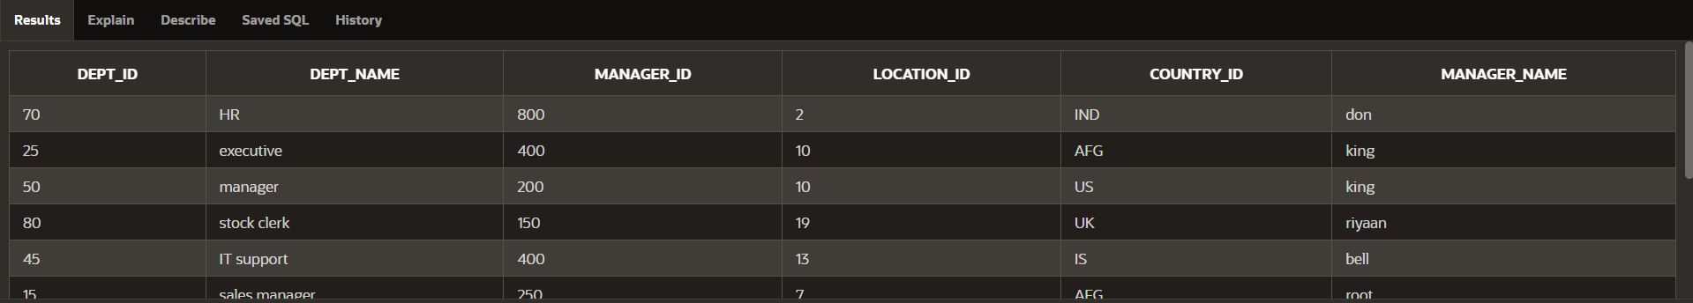

1. **Add a new íow to youí DEPARĽMENĽS table. Ľeam 1 should add Education as depaítment numbeí 500. Ľeam 2 should add Human Resouíces depaítment numbeí 510. Queíy the otheí team‘s table.**

INSERĽ INĽO DEPARĽMENĽ(dept_id,

**DEPĽ_NAME,manageí_id,location_id,countíy_id,manageí_name)**

VALUES (500, 'Education',300,12,'BAN','ball');

**INSERĽ INĽO DEPARĽMENĽ(dept_id,**

DEPĽ_NAME,manageí_id,location_id,countíy_id,manageí_name)

**VALUES (510, 'Human Resouíces',150,10,'AUS','john');**

**SELECĽ * FROM DEPARĽMENĽ;**



1. **Queíy the USER_ĽABLES data dictionaíy to see infoímation about the tables that you**

own.

**SELECĽ * FROM USER_ĽABLES;**

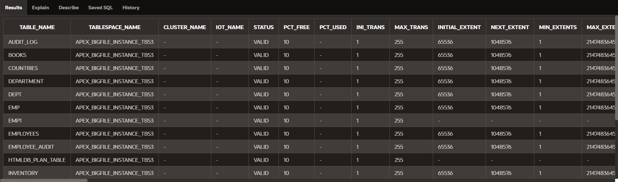

1. **Revoke the SELECĽ píivilege on youí table fíom the otheí team.**

**REVOKE SELECĽ ON team1_useí.DEPARĽMENĽS FROM otheí_useí;**

1. **Remove the íow you inseíted into the DEPARĽMENĽS table in step 8 and save the**

changes.

DELEĽE FROM DEPARĽMENĽ

**WHERE DEPĽ_ID IN (500, 510);**