**Q5. “Ohh, but this website is very hard to read on my iPhone. Is there any solution to it? Can you please fix it with the solution?”**

In order to make this webpage work with most functionality, which means, as you have asked, to be able to see the content of it in your iPhone, I have made a few changes in the code configuration.

I have added the “<meta name="viewport" content="width=device-width, initial-scale=1.0">” tag in the head section of the html file code in order to adjust the width of the website with respect to the width of the device in which the page is being viewed.

Secondly, I have made a couple of changes in the CSS code file like adding a couple of media queries to the it like the following:

@media only screen and (max-width: 600px) {

header nav ul li {

margin: 0 20px;

font-size: 16px;

padding: 10px;

}

header nav ul {

margin: 20px 0;

display: list-item;

}

}

Using this, we can accommodate the data and content of this webpage in your iPhone too, Mr. Einstein!

This is how it looks like now on your iPhone:



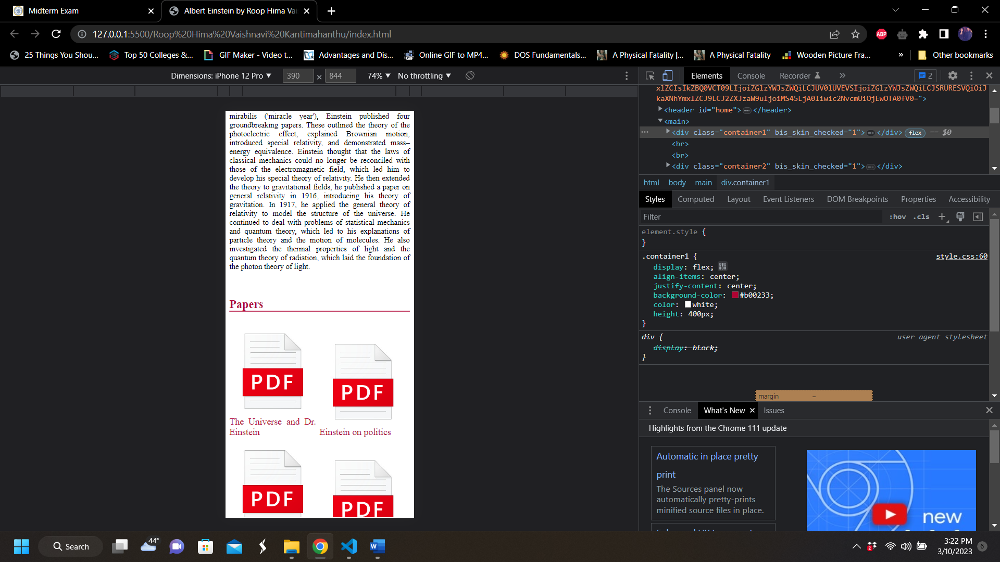

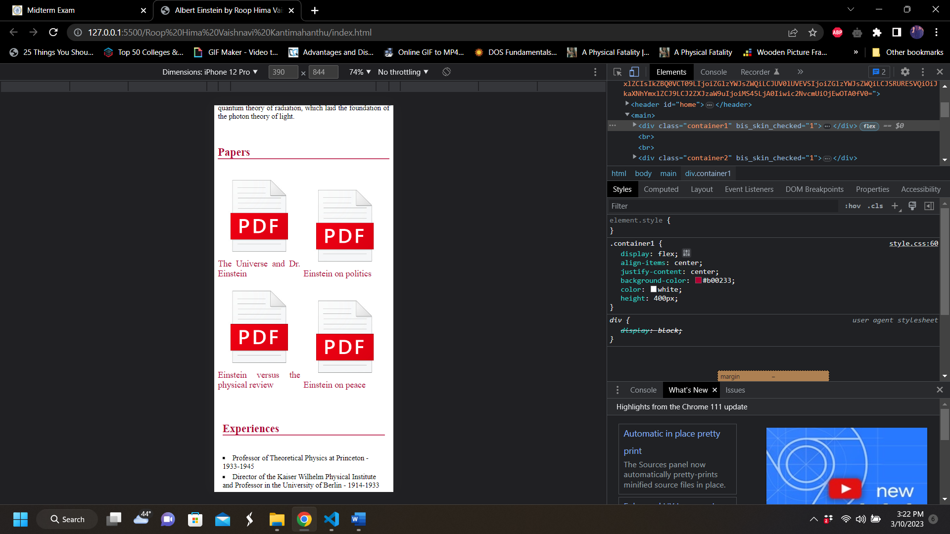

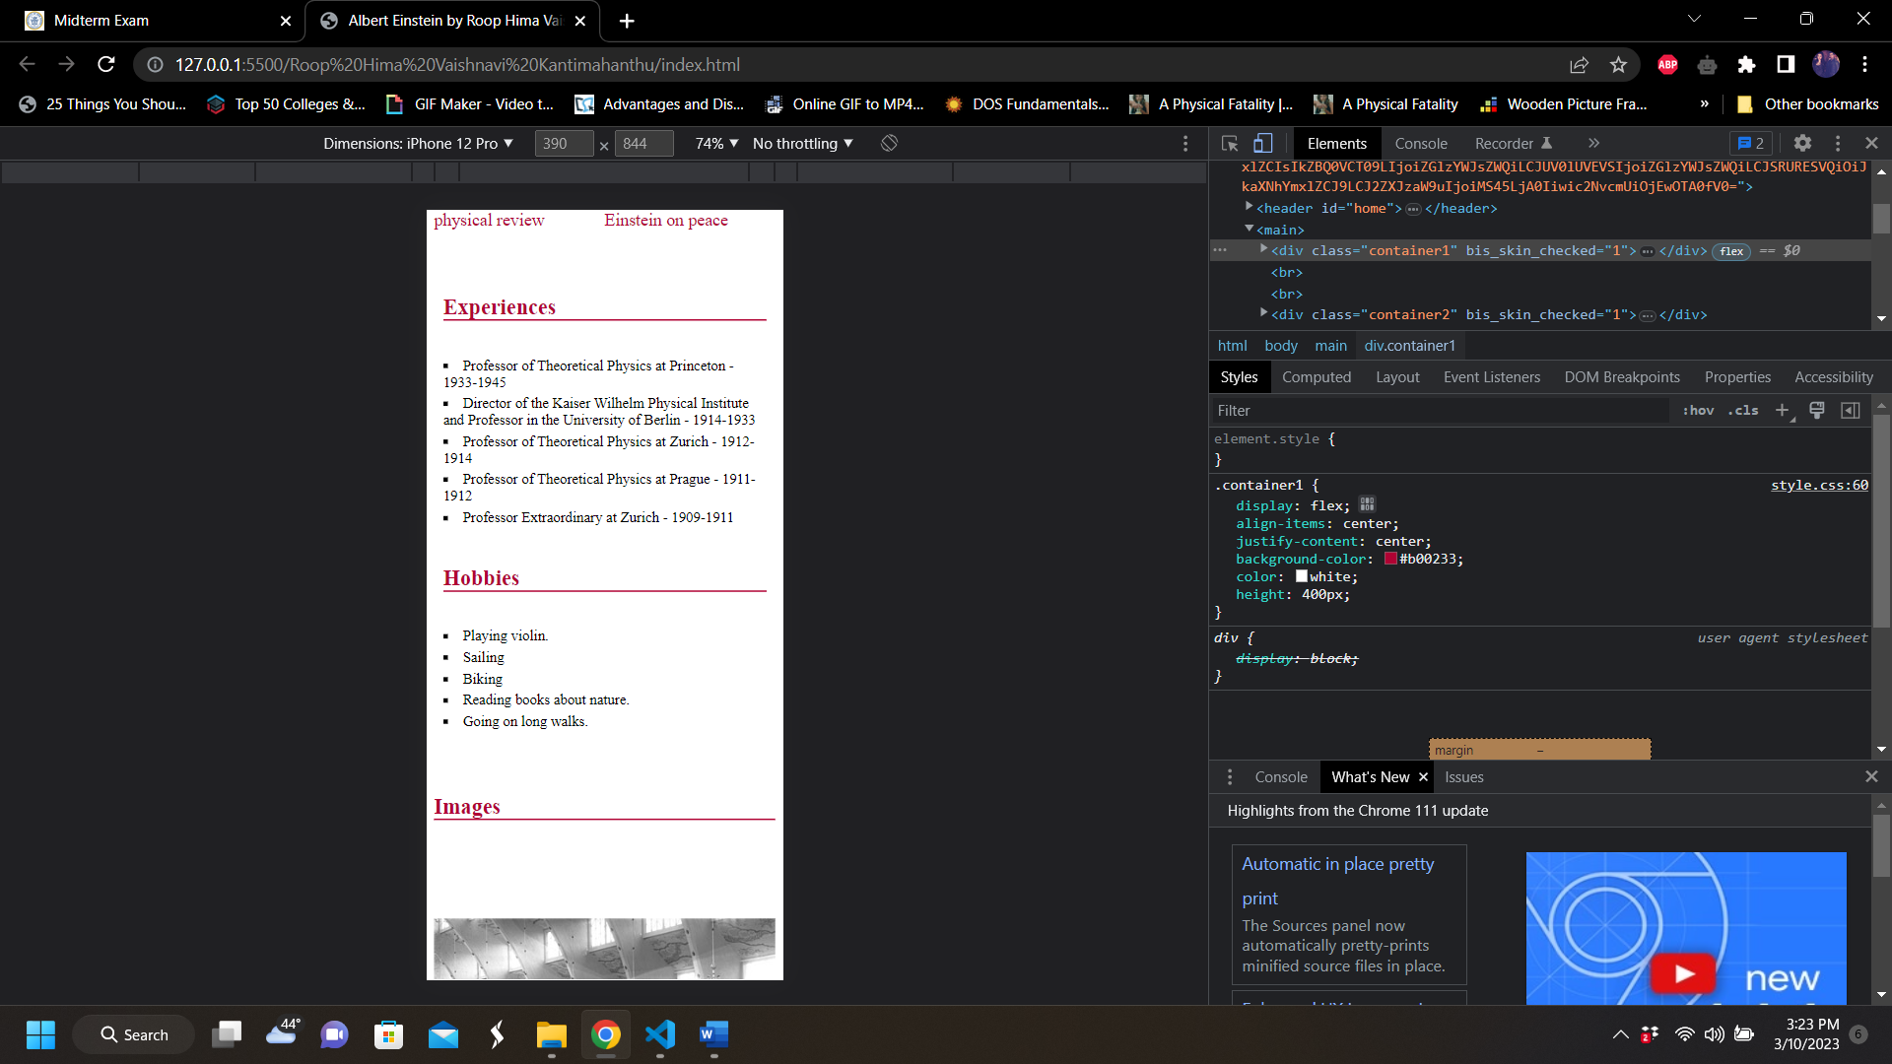

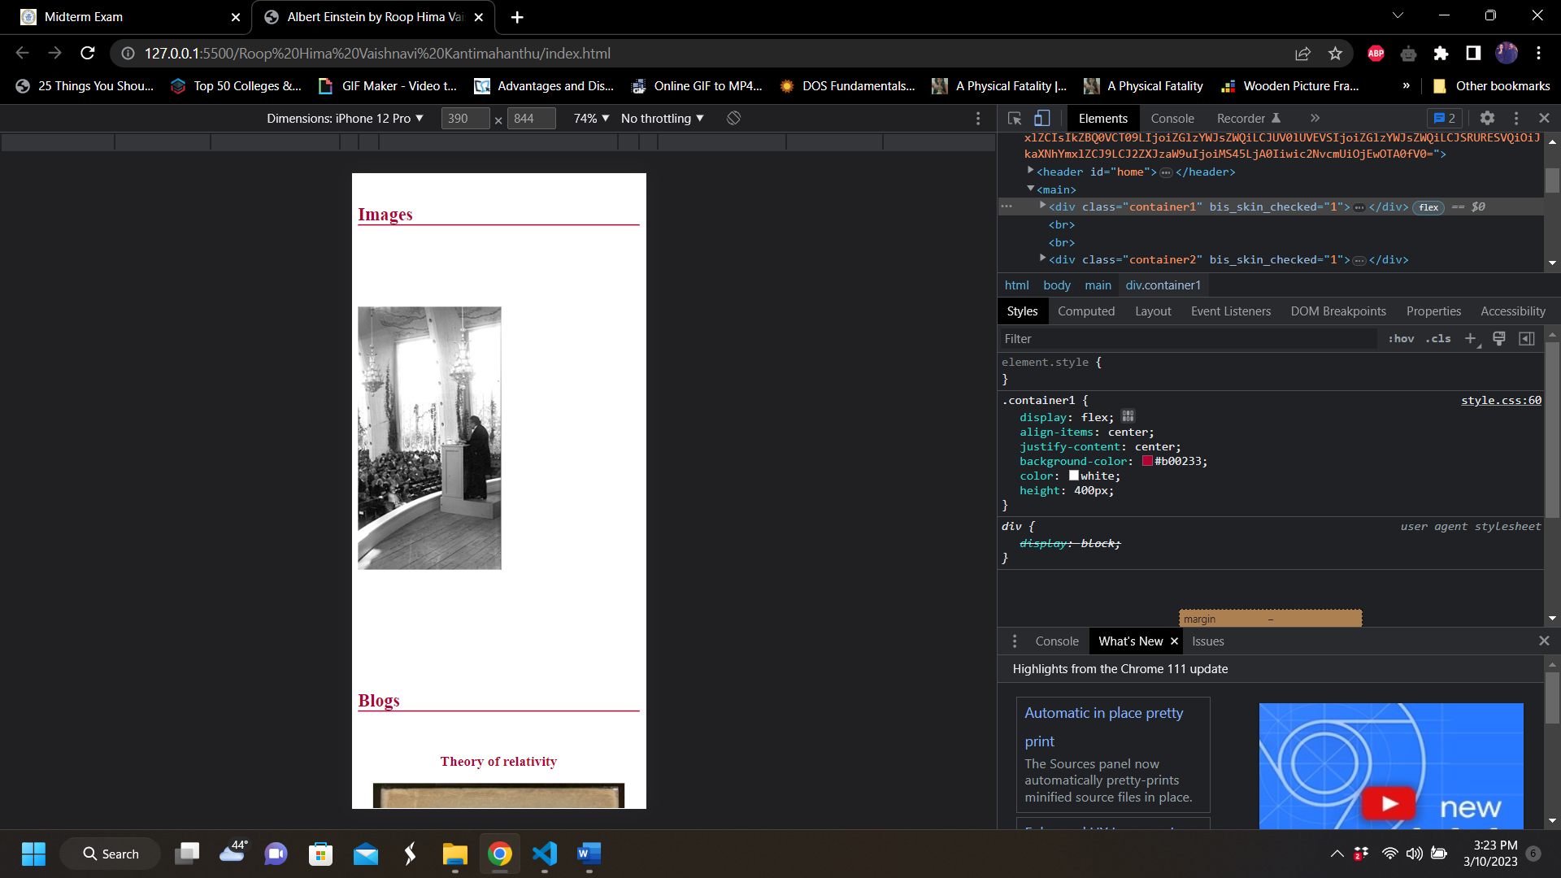

(Note: Images are in middle of a slide-show)

