**MINI-PROJECT REPORT**

Salary Management System



# NAME: - Roopa Gudumalla

**TABLE OF CONTENTS**

|  |  |  |
| --- | --- | --- |
| **SERIAL No.** | **CONTENT** | **PAGE No.** |
| 1 | Introduction | 3 |
| 2 | Objective | 3 |
| 3 | Features | 3 |
| 4 | 4 W’s 1H | 4 |
| 5 | SWOT Analysis | 4 |
| 6 | Requirements | 6 |
| 7 | Architecture | 7 |
| 8 | Use case diagram | 8 |
| 9 | Expected results/Outcomes | 9 |

# Introduction

Cashflow Manager is an application the enables users have a track of their day to day cash inflow and outflow. This application will help to get a clear idea of their income and expenses. The application makes users aware of unnecessary expense and helps to understand money management.

This helps you predict how much money will be available to your business in the future. It also helps you identify how much money your business needs to cover debts, like paying employees and suppliers.

# Objective:

The primary objective of cash flow statement is to supply the necessary information relating to generation of cash to the users of financial statement. It also highlights the future or prospective cash positions i.e. cash or cash equivalent.

# Benefits:

There are many application available in market but this application is user-friendly and can be easy managed by uses to keep track of their savings after their expenses being deducted from the various sources of income of the user.

* You won't run out of cash. no doubt this is the biggest advantage of good cash flow management.
* You can pay your staff on time.
* You can purchase all the raw ingredients you need to fulfill your orders.
* You'll have peace of mind.
* You can avoid overspending.
* You can grow your business.

# Features

* Name of the user
* Income to be added
* Grocery Expense
* Other Expense
* Will ask for option to confirm if you have Other sources of income
* if yes then u will have to add the income generates
* With the data given it will show the monthly saving done by the user after balancing

the cashflow.

* This will be really helpful for budget planning for users for upcoming months and any event.

# Who:

This is everyone who is ready to manage his cashflow and make himself aware of the money management.

# What:

Cashflow application will give the exact saving done by the user after calculated all the incomes and expenses done by the user

# Where:

This is used by the user in day to day life where they can track their expenses and incomes generated daily or monthly

# How:

This is fulfilled in very simple manner here as user need to enter his details like name and further go on by entering the incomes that he has earned and expenses that he is making to finally go to the conclusion of the saving that he is doing in his day to day life.

# SWOT Analysis Strengths

* User friendly tracking of money
* Multiple incomes can be included
* Multiusers can manage expenses
* Accurate application with great service.

# Weaknesses

* Cash flow is not for particular user
* Better than excel and creating csv for tracking expenses.
* Complete house expense tracking but has no timestamp.

# Opportunities

* Creates awareness about saving and money management
* Allows user to do budgeting in efficient way
* Can plan for upcoming big events with increasing the saving and avoiding extra expenses.

# Threats

* Trend of investing is good for inflation but frequent use can add to changes transaction charges and tax for the wealth created.
* Financial plans needs to be created for better money management.
* Varied daily income should be clearly indicated with reduction of tax as an expense.

# REQUIREMENTS



**High Level Requirements**



|  |  |  |  |
| --- | --- | --- | --- |
| **ID**    HR01 HR02 HR03 HR03 HR04  HR05 | **Description**    New customer can create account Customer can mantain a Balance Customer information can be displayed Customer can pay the bill from e-wallet  Customer can maintain money in account's wallet    The last transaction amount of the custmoer in the store have to be maintained | **Category**  Techinal Technical Technical Techinal technical  Technical | **Status**    **Implemented**    **Implemented**  **Implemented**  **Implemented**  **Implemented**  **Implemented** |
| HR06 | Customer can opt for home delivery | Technical | FUTURE |

# Low Level Requirements



|  |  |  |  |
| --- | --- | --- | --- |
| **ID**    LR01    LR02  LR03 LR04 | **Description**    For Each new account a new array cell of structure type have to be created    Balance can be mantanied by creating a structure array each cell holding information of the user and their balance    Customer information can be displayed by printing the structure array    When paying bill the balance attribute is modified and updated | **HRID**  HR01  HR02  HR03 HR04 | **Status**    **Implemented**    **Implemented**    **Implemented**  **Implemented** |
| LR05 | The home delivery option cane be implemented by taking the address of the customer | HR06 | FUTURE |

**Architecture:**

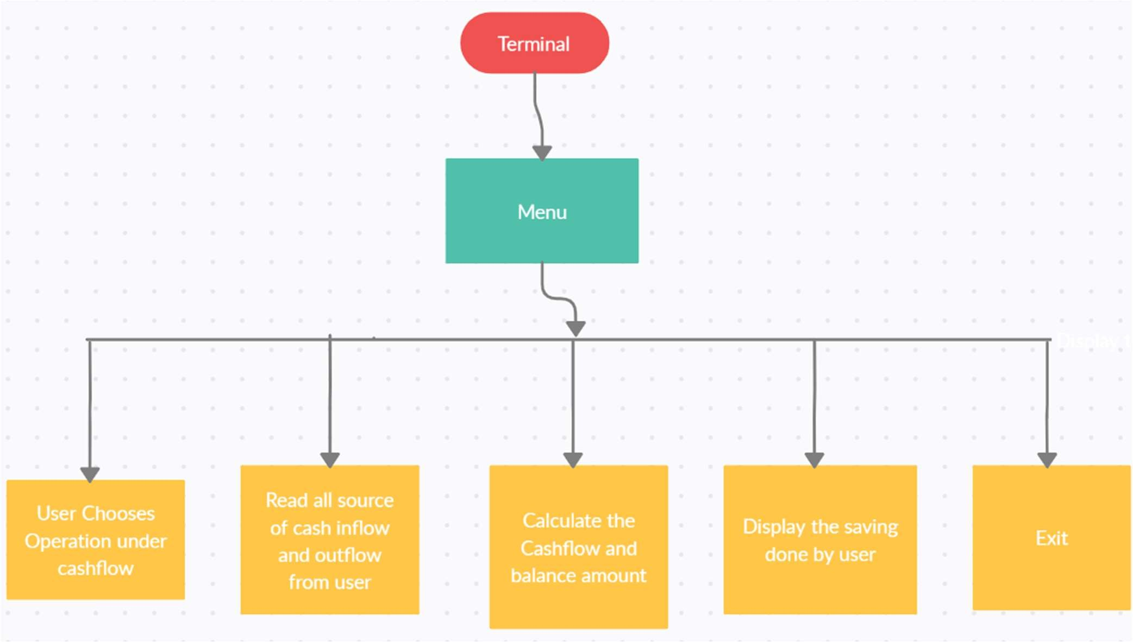

# Use Case Diagram

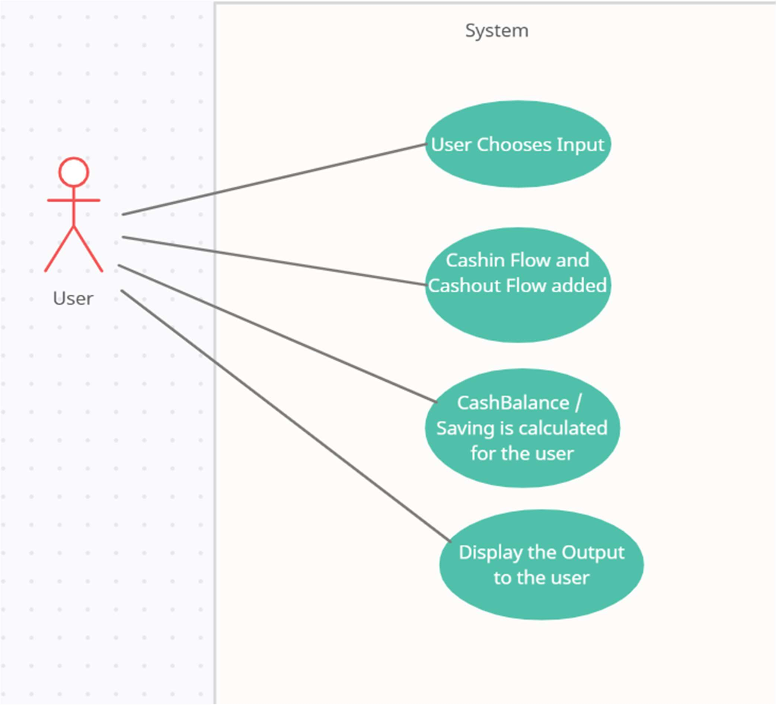

**Output Images:**

