**VOLVO CARS**

|  |
| --- |
| **Volvo Cars Safety Feature**  **Automation Test Design Specification** |

**Introduction**

**1.1 Purpose**

This document gives an overview of the automation test written for Volvo Safety Page using WebDriverIO.

**1.2 Scope of the document**

This document covers the Overview of the design followed to setup an Automation Test for Volvo Safety Page. It also covers the Method to execute the test cases in parallel and generating allure Report out of it.

**1.3 Architectural Design of Automation Test**

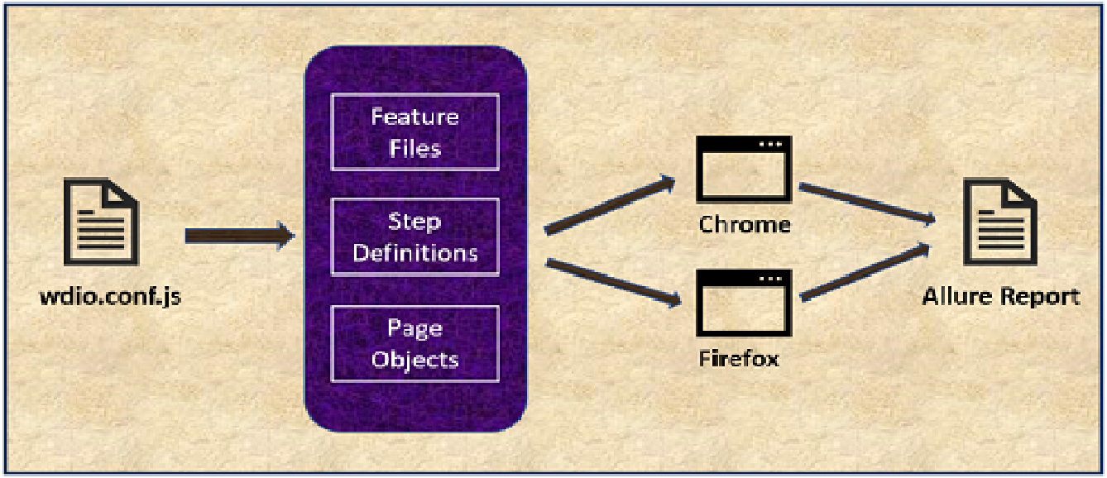

* + 1. **Development Environment**
* Following Design has been followed to set up Automation Test for Volvo Safety Page:
* “Webdriver IO” has been used as a Test Framework.
* It developed using “cucumber” framework.
* “TypeScript” has been used as a compiler.
* “Page Object Model” has been followed to define the HTML element and action.
* Report has been generated by using “spec and allure”.
* “chromedriver” is used as a service foo the test setup.
* Config file (wdio.conf.js) has been defined to run the test parallelly in Chrome and Firefox browser.
* volvo.feature file contains the list of scenario to be tested.
* Each Scenarios are defined in **Given When Then** Format.
* Each test is written by adhering to **AAA => Arrange Act Assert** Rules.
* Step Definition folder holds the list of Step typescript file (volvoStep.ts, recharge.ts) which address the logical definition for the each Scenarios defined in the volvo.feature and recharge.feature file.
* Here we can add multiple typescript file by giving the single responsibility and not merging the Functionality.
* pageobjects folder, holds the list of Pages (VolvoPage.ts )which defines the “Page Object Model” for HTML element and its action.
* Use can access the HTML element directly from this page and also the HTML element action can be performed by defining the methods.
* Advantage would be same element, or the clickable action can be utilized by different test file.
* Parallel execution can also be archived by writing the independent test in different step definition file, so that all test runs in different browser which takes less time to execute total number of test cases.
* To Achieve the parallel test, added two feature files, recharge.feature which takes care of ‘Recharge feature’ of Volvo Safety Page and volvo.feature takes care of main page feature of Volvo Safety Page. Test parallelly runs in different browser.
  1. **How To Run Test**
* Install npm and node in the machine where this test is running.
* Install Webdriver IO CLI file by following this command:

npm install @wdio/cli

* Navigate to the repository where this test is hosted.
* From command line run the below command.
* npx wdio run test/wdio.conf.ts
* User should be able to see the Test Result.
  1. **How To Generate Report**
* Run below command to clean the existing report

npx allure –clean

* We can generate and open the report by using below command:

npx allure open