**Eadulakanti Roopa**

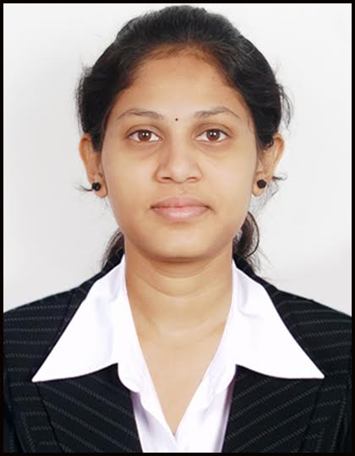

|  |  |
| --- | --- |
| **Title:** | **Senior Consultant** |
| **Location:** | **Hyderabad, India** |
| **Languages:** | **English, Hindi & Telugu** |

# Experience Summary

Have 8 years of experience in Software testing with sound knowledge on Testing Techniques, Test Planning, Validation, Test Evaluation and Documentation. Have knowledge in automation testing using Selenium Web driver.

**KEY SKILLS:**

**Functional:** Participated in sprint planning, standups with Project team and co-ordination with clients.

Experience in testing the Functionality, Database, Regression testing.

Hands on Experience in Defect Tracking, Evaluating Defects and Reporting using Defect tracking tools like Jira and HP ALM

**Technical:** Knowledge on Selenium web driver, Core Java, Test NG, Maven and webservices

# Experience

Have 8 years of experience in Software testing with sound knowledge on domain (Banking, IME and Insurance). Experience in testing the Functionality, Database, Regression testing. Well acquainted with Software Development Life Cycle (SDLC), emerging software disciplines like AGILE SCRUM. Good communication & interpersonal skills with proven abilities in resolving complex issues. Quick Learner with the ability to grasp new technologies. Have experience in handling huge projects individually.

|  |  |  |
| --- | --- | --- |
| **01** | **Type of Industry:** | Banking |
|  | **Project:** | SMART |
|  | **Client :** | DBS |
|  | **Description:** | SMART-Statement Management at Real time Building is an ‘in-house’ Statement management system as a ‘de-risking’ solution to replace current external licensed products and mainframe systems.This new architecture consists of Finacle, data migration ETL system, data transformation module, data reporting web-service, data encryption web-service, middleware’s and customer communication system. |
|  | **Role/Title:** | Functional Tester |
|  | **Project Duration:** | 2.5 Years |
|  |  | **Responsibilities:**   * Developing manual Test Scenarios, Execution of user stories both in SIT and UAT given in Sprint which last for 2 weeks. * Created automation scripts using Rest-Assured library for API Testing. * Executed API test cases manually using postman tool. * Maintaining Regression Suite * Reporting and Tracking defects using Jira. * Monitoring test execution and Reporting test results to clients. * Involved in daily calls to coordinate with onsite team and clients. * Responsible for Execution of Test Scripts and publishing results. |
|  | **Operating Systems:** | : Windows 10/Linux |
|  | **Software / Languages** | : Core Java |
|  | **Special Tools:** | : Selenium web driver, Test NG, Maven, Jira, GitHub, Postman |
| **02** | **Type of Industry:** | Information Media and Entertainment |
|  | **Project:** | Ez-Rez |
|  | **Client:** | NBCU |
|  | **Description:** | Ez-Rez is a Ticketing Application, which primarily focuses on Ticketing of a parking application. This Project Mainly focuses on how to place orders for Tickets like Entry Tickets, Food tickets and Parking Tickets using Web Application, Windows Applications and Mobile Application Devices (Both iOS and Android). This process also deals with calculation of revenue validation for a particular day on tickets sold in the park and describes about the flow of revenue from VGS to ODS. |
|  | **Role/Title:** | Automation Tester/Functional Tester |
|  | **Project Duration:** | 2 Years 6 months |
|  |  | **Responsibilities:**   * Developing Selenium Test Automation Frameworks using WebDriver, java, TestNG and Extent Reports. * Developing test scripts using Selenium WebDriver, Java and TestNG. * Reporting and Tracking defects using Jira. * Monitoring test execution and Reporting test results to clients. * Involved in daily calls to coordinate with onsite team and clients. * Converting Regression Test cases to Automation scripts. * Responsible for Execution of Test Scripts and publishing results. * Responsible for sending Automation team daily status report. |
|  | **Operating Systems:** | : Windows 10/Linux |
|  | **Software / Languages** | : Core Java |
|  | **Special Tools:** | : Selenium web driver, Test NG, Maven, Jira, HP ALM, GitHub |

|  |  |  |
| --- | --- | --- |
| **03** | **Type of Industry** | **Insurance** |
|  | **Project:** | FutureYou |
|  | **Client:** | Zurich |
|  | **Description:** | FutureYou is Zurich UK Life’s strategic initiative to provide an improved and consistent Omni-channel customer experience, to create a digital-centric business model of adviser services including both auto-advice and adviser provided information to achieve ‘ideal retirement’. |
|  | **Role/Title:** | Functional Tester |
|  | **Project Duration:** | 2 year and 4 months |
|  | **Responsibilities:** | * Played a Key role in the project as a Functional Tester. * Understanding the Requirements and Functional Specifications of the Project. * Identified Test scenarios required for testing. * Prepared Test case by analyzing the requirement. * Prepared query tracker, review comments tracker and Peer review findings report * Prepared Test Data Coverage Matrix and RTM * Performed various black box testing Methodologies like Functional Testing, System Testing, Smoke Testing, Ad hoc Testing and Regression Testing. * Prepared UAT Test Case for Customer Point of view Acceptance testing. * Preparing Bug Reports and Status reports. * Involved in Bug tracking and execution by using JIRA and HP ALM. |
|  | **Operating Systems:** | : Windows 10 /Linux |
|  | **Special Tools:** | : Jira, HP ALM and MySQL |

# Higher Education

* B.Tech. (Computer Science and Engineering) from Nalla Malla Reddy Engineering College, Ghatkesar, Hyderabad, JNTU in 2014 with 70%
* 12th from Sarath Junior College, Nallakunta, Hyderabad, Board of Intermediate Education, AP in 2010 with 92%
* 10th from Chaitanya Bharathi High School, Ramanthapur, Hyderabad, Board of Secondary Education, AP in 2008 with 83 %