Why not using two separate service for read and write:
- 10 writes per second
- 50,000 reads per second
Then you scale read service horizontally without scaling write service.

Different scaling requirements
Write:
- Strong consistency
- Smaller CPU
- Lower traffic
Read:
- Heavy caching
- Aggregation queries
- Analytics
Due to an issue with my docker engine running, I had to use simple cache:
My previous configuration was with Redis:
spring:
application:
name: theatre-service

cache:
type: redis
redis:
time-to-live: 600000 # 10 minutes

autoconfigure:
exclude:
- org.springframework.boot.autoconfigure.jdbc.DataSourceAutoConfiguration
- org.springframework.boot.autoconfigure.orm.jpa.HibernateJpaAutoConfiguration

datasource:
write:
jdbc-url: jdbc:mysql://localhost:3306/theatre_db_write
username: root
password: roopa
driver-class-name: com.mysql.cj.jdbc.Driver
hikari:
maximum-pool-size: 10

read:
jdbc-url: jdbc:mysql://localhost:3306/theatre_db_read
username: root
password: roopa
driver-class-name: com.mysql.cj.jdbc.Driver
hikari:
maximum-pool-size: 10
data:
redis:
host: localhost
port: 6379

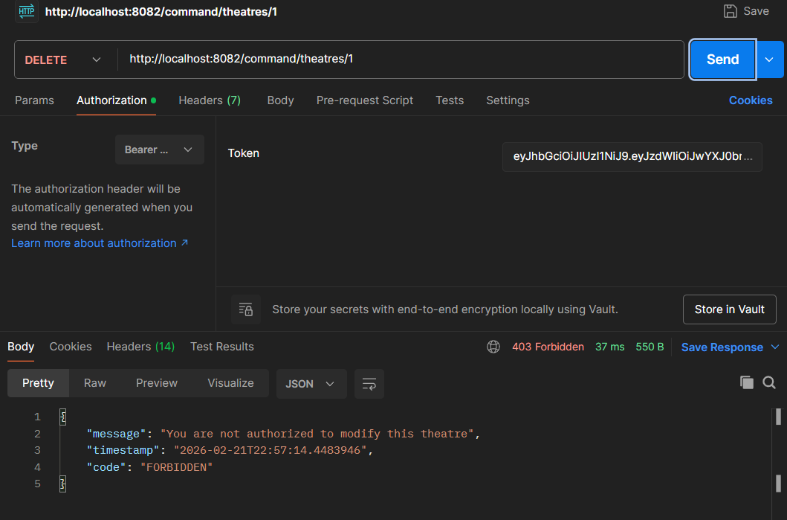

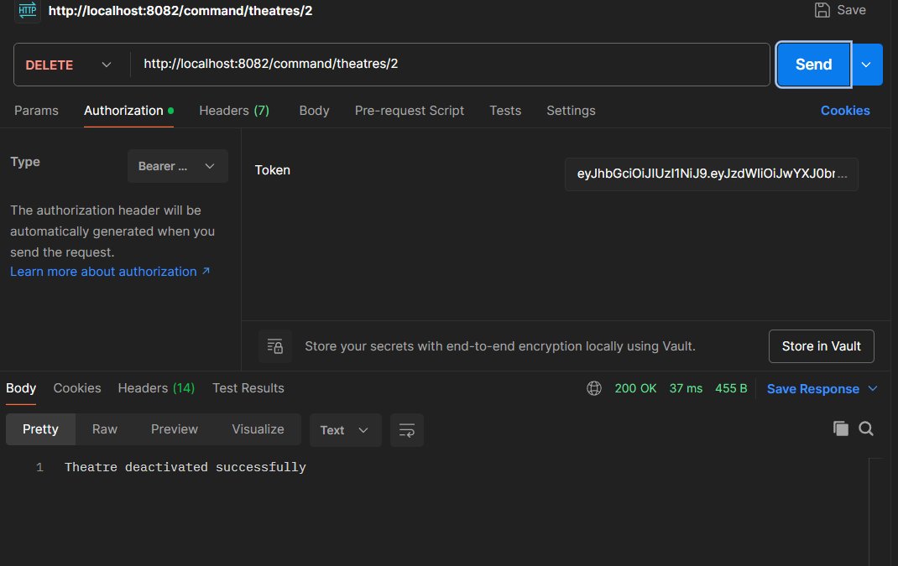

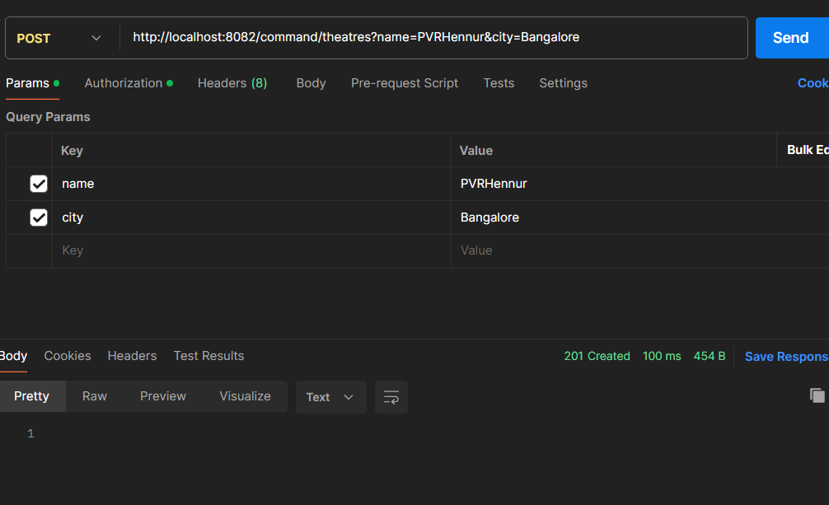
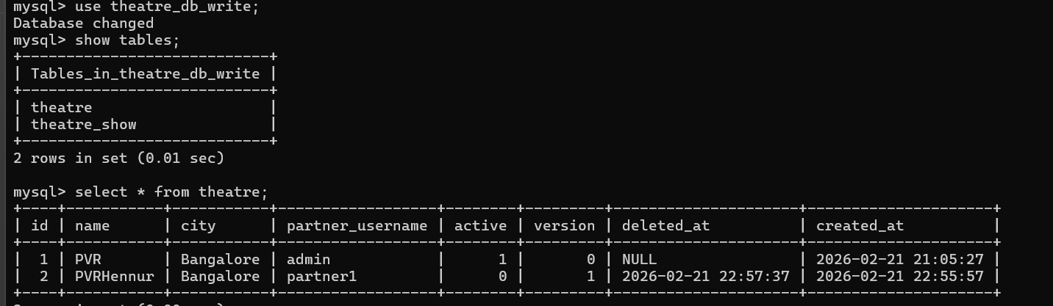
http://localhost:8082/command/shows
http://localhost:8082/command/shows?theatreId=1&movieName=Jailer&language=Tamil&genre=Action&showDate=2026-02-22&showTime=18:30

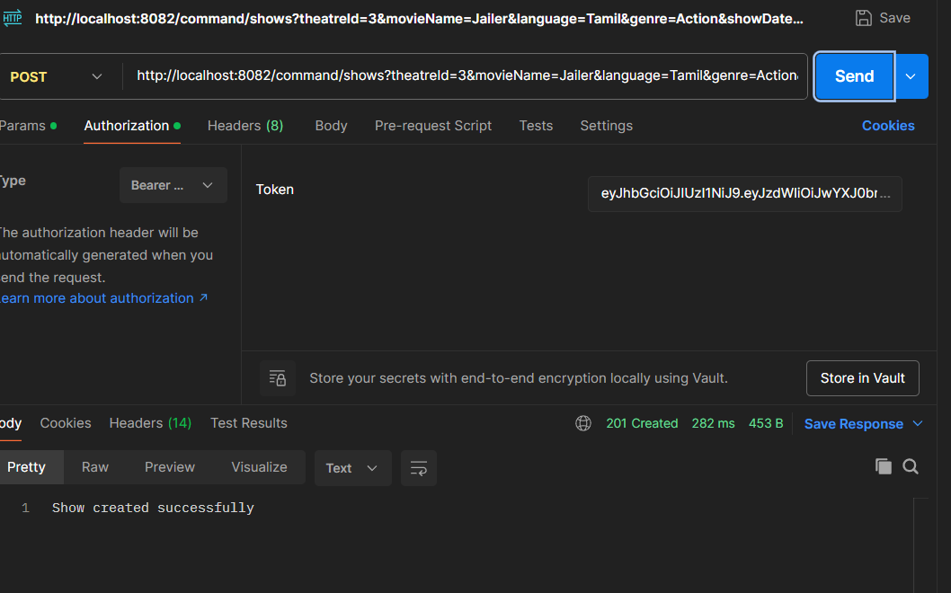
ADMIN can also create theatre
http://localhost:8082/command/theatres?name=PVR&city=Bangalore&owner=partner1
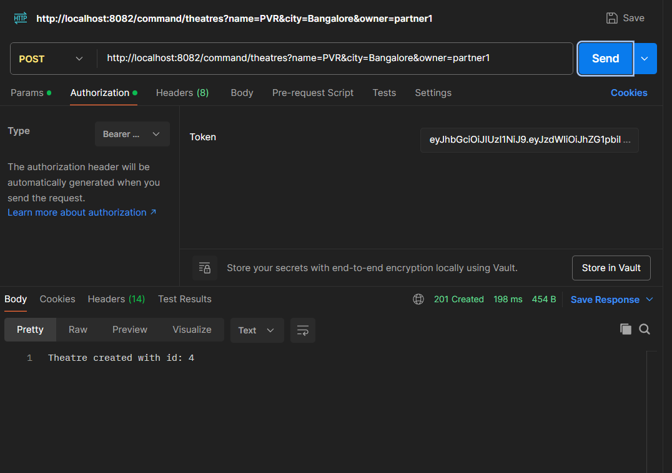
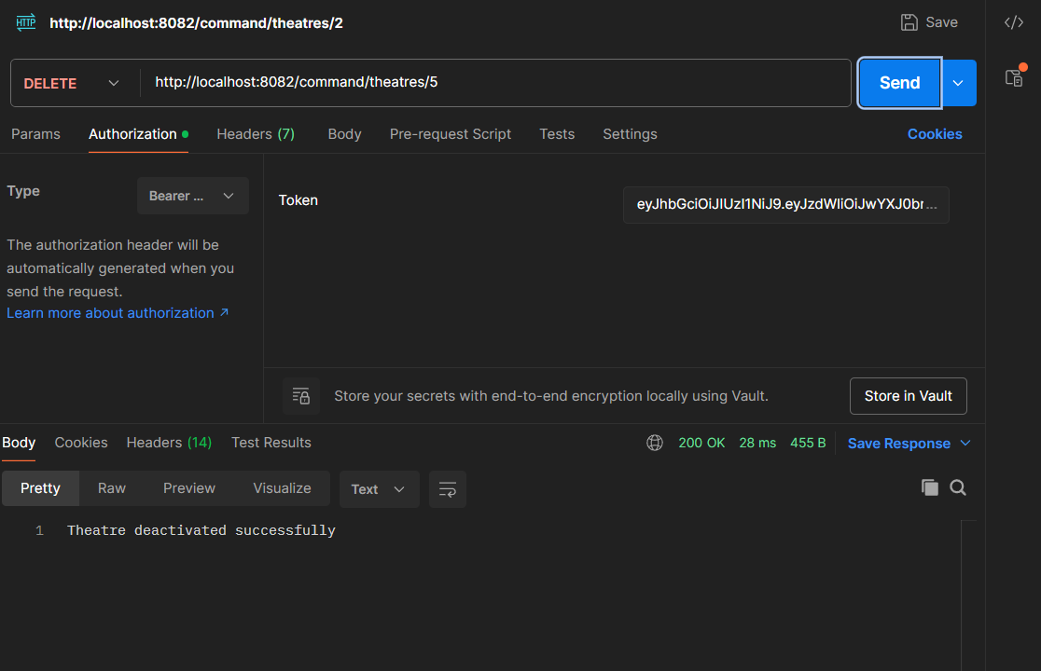

http://localhost:8082/query/theatres?city=Bangalore

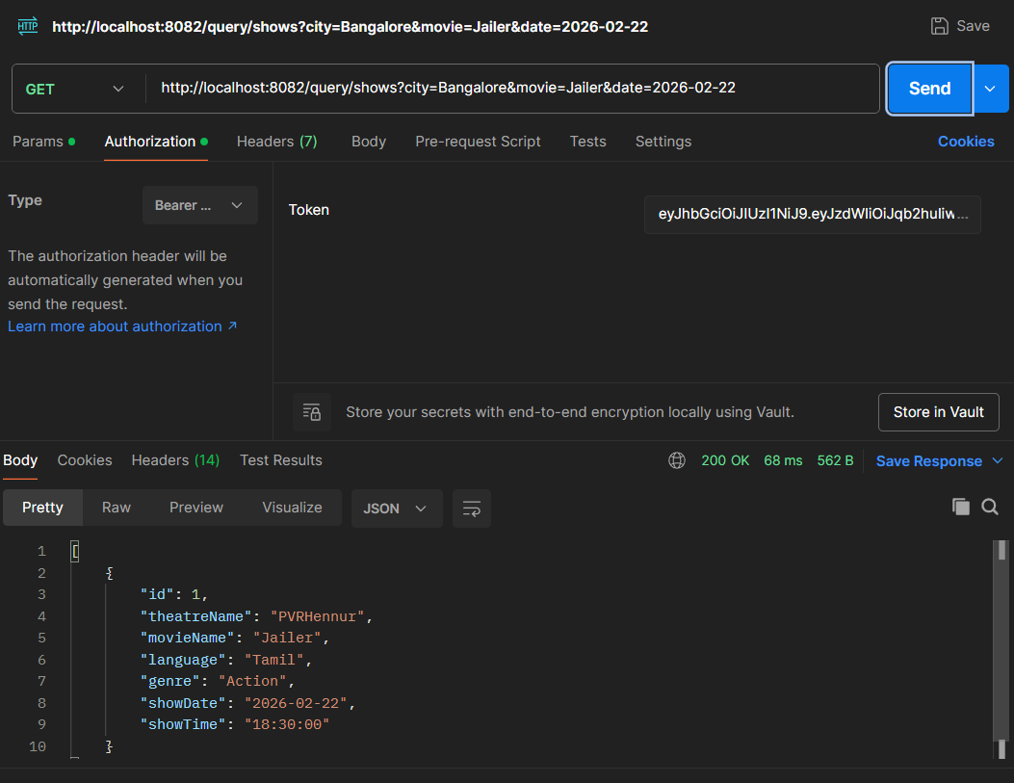
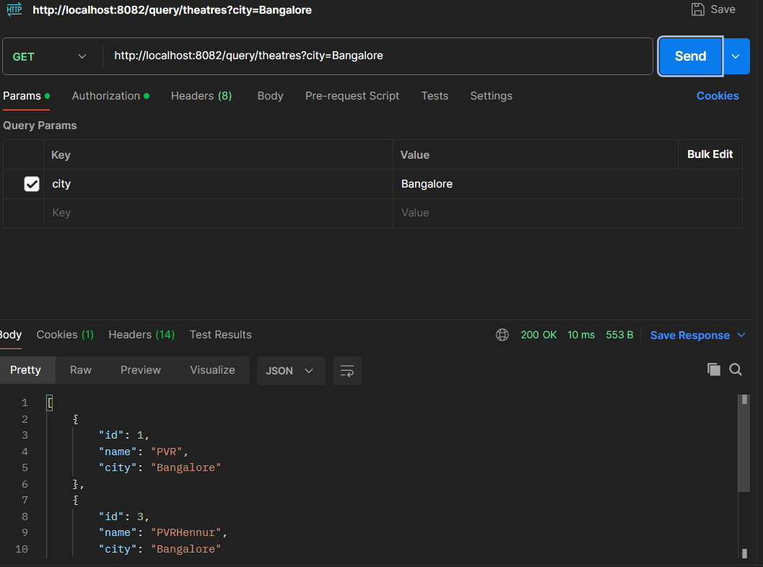
http://localhost:8082/query/shows?city=Bangalore&movie=Jailer&date=2026-02-22

My read database synced up automatically

